Michael Rawding

ELEG 305

Computer Assignment #2

3 May 2018

In this computer assignment, we were tasked with analyzing the frequency and step response of a a second order low pass filter. This second order low pass filter are common in both RLC circuits and mechanical systems such as low pass filters. The second order differential equation we were given is below:

𝑑2y(t)/dt2 +2𝜁𝜔n𝑑𝑦(𝑡)/𝑑𝑡+ 𝜔n2(𝑡) = 𝜔nx(t)

With 𝜔n =

And

𝜁 = $\frac{v}{2\sqrt{km}}$

The system was specified as m = 1 and 𝜁 = $\frac{1}{\sqrt{2}}$

k and v are the spring constant and the viscosity of the dash pot, respectively

This allowed students to analyze the frequency response H(jw) at different frequencies, but also with different undamped natural frequencies 𝜔n. To alter the 𝜔n, different spring constants and viscosityies were used. It was analyzed at k =1, k = 0.09, and k = 4

In part A, the frequency response of the system was analytically calculated. The asymptotes of the frequency response were also found. Below shows the derivation of everything from part A.

In part B of the assignment, the frequency response was plotted using python code and the plib.py. sci.py, and pylab libraries. By creating an array of the numerator and denominator polynomial coefficients in arrays b and a, respectively. We can create an array of the real and complex components of the frequency response and store them in an array using the freqs(b,a, 𝜔) where 𝜔 is the frequencies from logspace(-2,2,100).

In part C, after determining the different frequency responses of k =1, k = 0.09, and k = 4. The three frequency responses were plotted on a Bode plot. On the Bode plot, it is the power of the frequency response vs. log(𝜔). The power is denoted by 10log(|H(j𝜔)|2) = 20log(h(j𝜔). A layerd Bode plot of the three different frequency responses are shown below.

H1(j𝜔) is denoted by the red circles, H2(j𝜔) is denoted by the blue triangles, and H3(j𝜔) is represented by the green dashes.

***Figure #1 – Bode plot of frequency responses***

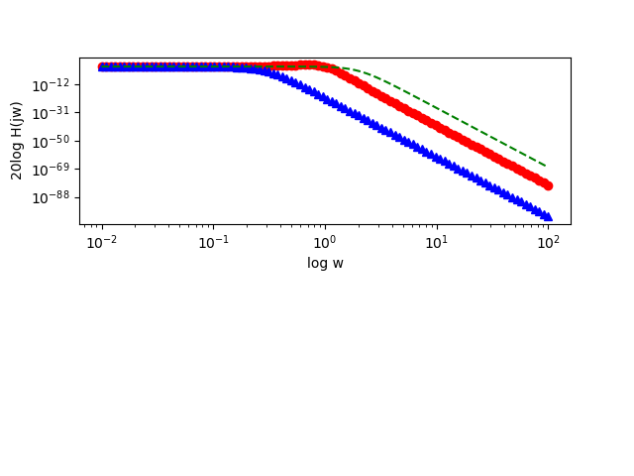

From the plo, it is very apparent that he natural undamped frequency 𝜔n is about equal to the cutoff frequency of 𝜔. From the H1(j𝜔), we can see that the cutoff frequency is about 1 rad/second . Which is = 𝜔n = = 1. And with H2(j𝜔) we see that the cutoff freuqncy decreases to about 𝜔n = = 0.3 rad/ sec. Since the 𝜔scale is logarithmic it isn’t very clear where the exact 𝜔 points are, but we can assume that the cutoff is fairly close to 0.3 Also the asymptotes clearly agree with the asymptotes determined in part A. The frequency responses clearly do not pass the y axis, because the power will never be less than 0. And then after the cutoff frequency cutoff, the power decreases at a rate of 40 per 𝜔. This is obvious because all three frequency responses agree as they all decrease in parallel lines as 𝜔 increases towards infinity.

In the next part of the assignment, python code was used to calculate and plot the step responses over a specific time interval. Using the coefficients of the numerator and denominator polynomials from before, the step2((b,a),T=t), where t was an array value from 0-30 using the linespace function. After the arrays of the step responses were determined, they were plotted against time using the plt.plot functions. The step responses are shown below.

Where h1(t) is in red, h2(t) is in blue and h3(t) is in green

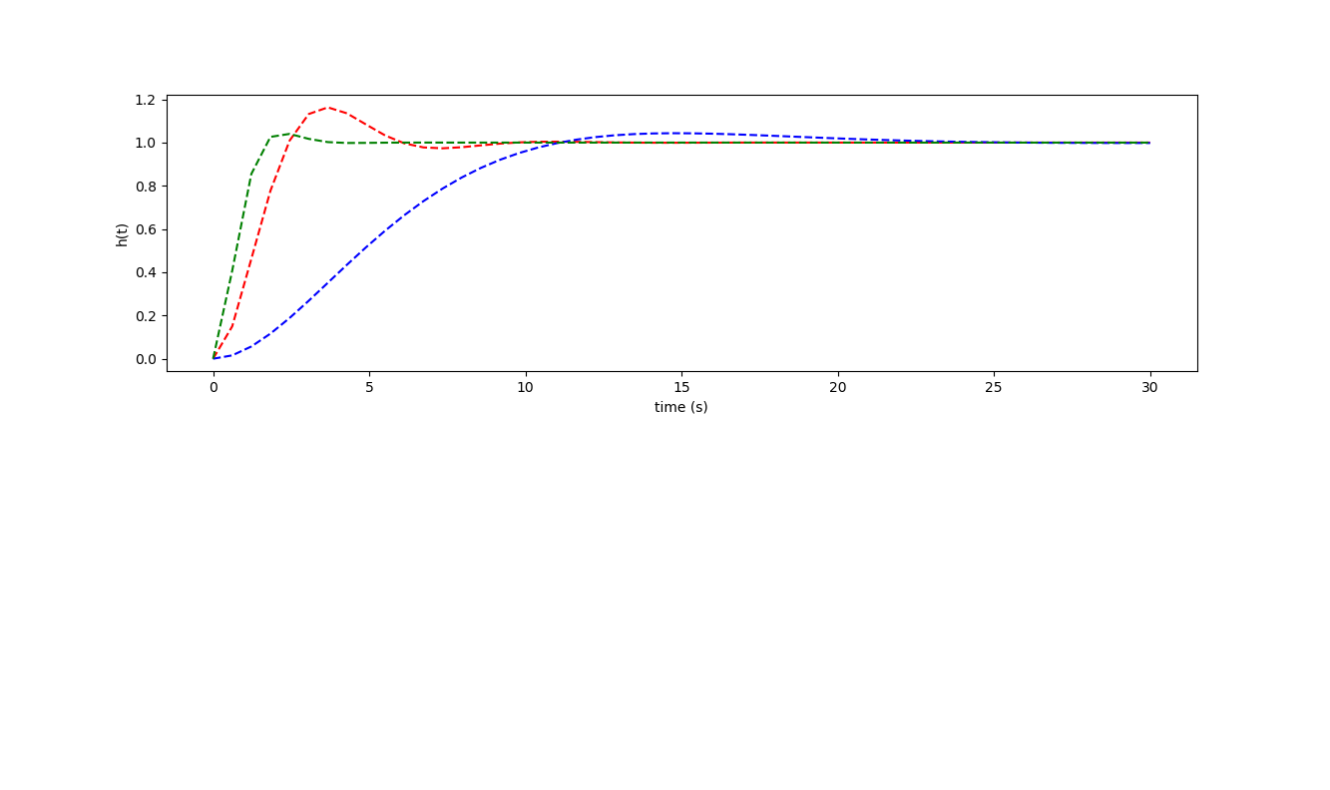



From the step responses, we see that a larger spring constant spring constant k, which increases the natural undamped frequency, corresponds to a shorter rise time to the steady state value. Since h3(t) has the highest natural undraped frequency, 𝜔n, it also has the shortest rise time to the steady state value. And when comparing the step responses to he frequency responses, we see that a shorter rise time corresponds to a higher bandwidth of the frequency response. Meaning that rise time and cut-off frequencies have an inverse relationship. In terms of a shock absorber, if the shock absorber were to have a small band-width, then it would react slowly to the external force. If we were to think about it in terms of stiffness of the spring or k, which also affects the 𝜔n , bandwidth, and rise time, a stiffer spring would have a faster reaction time to the external force because the spring moves less in response to the external force x(t) and oscillates more rapidly as it returns to its steady state, i.e. the bandwidth is greater. Thus, a quick reacting shock absorber has a larger bandwidth and are relatively stiff. This is why there are very thick, metal coils on car suspensions and heavy impact machinery.