SFC-Team404NotFound

Project Documentation
Student budgeting and expense tracking web application
Prepared as an editable report workbook from the project source and supplied Software Requirements Specification.

Project: SFC-Team404NotFound
Stack: MongoDB, Express, React, Node.js |
Team Members: [Aliyan, Uroosa]
Aptech SFC
Faculty:- Rehan Kapaya

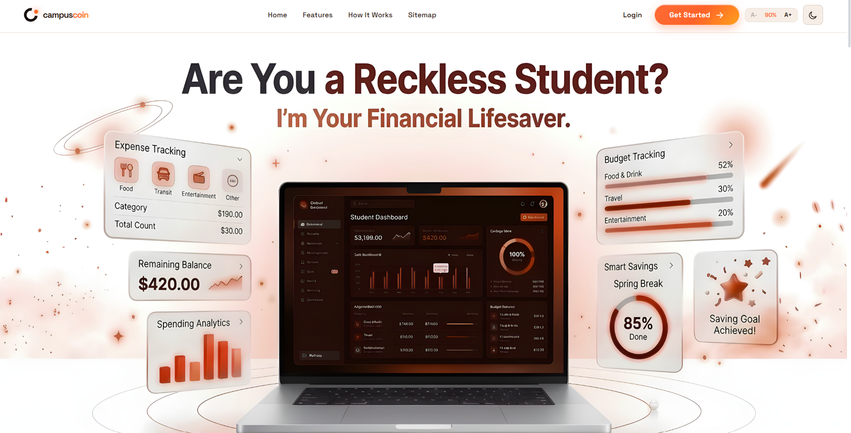
Campus Coin landing page concept

1 Project overview
Campus Coin is a responsive web application for students to record income and spending, set category budgets, and understand their habits through reports and suggestions. This report describes the current implementation, its design, database, setup, and evaluation evidence. It is intended to help a reviewer install the project and follow the main student and administrator workflows.
The implementation uses a React client, an Express and Node.js API, and MongoDB through Mongoose. Students can manually add transactions, import CSV history, scan receipt images, and review dashboards and reports. Rule based services produce category suggestions, saving tips, forecasts, and anomaly flags. An optional external AI provider can rewrite monthly insight summaries; without its key, a local summary writer is used.

Problem definition
Students often receive money from irregular sources and spend it across food, transport, housing, academic costs, subscriptions, and social activities. Without a simple record of these transactions, it is difficult to see where money goes or whether spending is approaching a personal limit. Campus Coin addresses this by keeping manual and imported records in one student account and presenting them as category breakdowns, budget progress, and monthly summaries.
Our project was motivated by the financial management challenges faced by college and university students, particularly those who receive pocket money, monthly allowances, scholarships, or part-time income. Many students do not maintain a proper record of their daily expenses and often struggle to understand where their money is being spent.
For example, a student may receive a monthly allowance but spend small amounts on cafeteria meals, transportation, mobile packages, and other activities without tracking them. By the end of the month, the student may run out of money without realizing which category consumed most of their budget.
We identified the need for a simple and accessible platform that allows students to track their income and expenses, monitor budgets, and make better financial decisions. This motivated us to develop Campus Coin.

Objectives
- Make income and expense entry quick and understandable.
- Help each student review spending by category and month.
- Provide budgets, alerts, and practical saving suggestions.
- Support student and administrator roles with separate access.
- Keep the project runnable from its supplied client, API, and database setup.
In addition to the listed objectives, our team established the following objectives:
- AI-Based Category Suggestions: Suggest suitable transaction categories automatically based on the student's transaction description.
- Receipt Scanning: Allow students to scan receipt images and extract transaction information to reduce manual data entry.
- CSV Import: Enable students to import previous transaction records in bulk.
- Financial Insights: Generate monthly financial summaries, spending forecasts, anomaly flags, and personalized saving suggestions.
- Data Visualization: Present financial information through interactive charts and dashboards to make spending patterns easier to understand.
- Secure Data Management: Ensure that each student can access only their own financial records.
Success Criteria:
We considered the project successful when all major features worked correctly during testing and evaluation. Our success criteria included:
- Students could register, log in, and manage their transactions successfully.
- Income and expense records were correctly saved and displayed.
- Category budgets and spending summaries reflected accurate calculations.
- CSV imports and receipt scanning worked as expected.
- AI-based category suggestions and financial insights provided useful results.
- Student and administrator roles had the appropriate access permissions.
- The application ran successfully with the supplied frontend, backend, and MongoDB configuration.
The final evaluation was based on functional testing, database verification, user workflow demonstrations, and successful execution of the main project features.

2 Scope and users

Student capabilities implemented
Area | Current application behavior
Account and profile | Student registration and sign-in; profile, academic year, allowance baseline, savings goal, password, currency and accessibility preferences.
Transactions | Create, edit, soft-delete, restore and filter income/expense records; recurring weekly or monthly entries; transaction history.
Categories and budgets | System and personal categories; monthly category caps; progress and threshold notifications.
Reports and insights | Category breakdowns, six-month comparisons, daily/weekly summaries, filters, PDF/PNG export, email sharing, monthly insight history.
Student assistance | Rule based category suggestions, personalized tips, forecasts and anomaly/duplicate flags; optional AI-written monthly narrative.
Additional tools | CSV preview and import, receipt scanning, notes, bookmarks, recent activity and notifications.
Accessibility | Light/dark themes, adjustable text size, breadcrumbs, loading states, keyboard reachable controls and reduced-motion support.

Administrator capabilities implemented
Administrators have a separate sign-in route and control panel for default categories, student accounts, announcements, system settings, and usage statistics. Role checks are enforced by the API as well as the interface.

Boundaries
The application does not connect to bank accounts, verify banking identities, or move real money. Financial entries are manually entered or imported. Suggestions and generated summaries are informational and should not be treated as certified financial advice.

Project Assumptions, Limitations and Out-of-Scope Features
During the development of Campus Coin, our team made the following assumptions and identified certain limitations:
Project Assumptions:
- Students have access to a device with a modern web browser and a stable internet connection.
- Users provide accurate income and expense information when entering transactions manually.
- Imported CSV files follow the supported file format and contain valid transaction data.
- Each student uses an individual account to maintain personal financial records.
- Category suggestions and financial insights depend on the accuracy and availability of transaction data.
Known Limitations:
- The application does not directly connect to banking systems or automatically retrieve bank transactions.
- Receipt scanning may require manual correction if images are unclear or text extraction is inaccurate.
- AI-generated insights depend on the availability of the external AI provider; a local summary writer is used when the provider API key is unavailable.
- Financial forecasts and anomaly detection are based on recorded transaction history and may not always predict actual spending behavior.
- The application does not provide certified financial, investment, or banking advice.
- Database backups depend on the backup procedure configured for the evaluation environment; automated backup functionality is not implemented.
Features Outside the Submission Scope:
- Direct bank account integration and automatic bank synchronization.
- Real-money transfers, online payments, and payment gateway integration.
- Bank identity verification and credit score checking.
- Automatic synchronization with external financial applications.
- Native Android and iOS mobile applications.
- Advanced financial planning, investment management, and tax calculation.
These boundaries helped our team maintain a realistic development scope and focus on delivering a functional student expense management system with transaction tracking, budgeting, reporting, and financial insights.
.

3 Requirements and implementation status
The table maps major requirements in the supplied SRS to the inspected application. “Implemented” means the relevant screens or server routes and services are present in the project. The final evaluator should still see each workflow demonstrated in the submitted video.
SRS area | Status | Implementation evidence / note
Student authentication and profile | Implemented | Registration/login, role checks, password reset, editable profile and preferences.
Transactions and categories | Implemented | CRUD, personal categories, retained soft-deleted history, recurring entries.
Dashboard and budgets | Implemented | Monthly totals, category widgets, progress, threshold alerts and notifications.
Reports and exports | Implemented | Date/category filtering, six-month trends, PDF/PNG export and optional email sharing.
CSV import | Implemented | Preview, suggested categories, row correction and explicit commit step.
AI categorization | Adapted | Category suggestions learn from corrections using deterministic local scoring; no external AI is used for this feature.
Monthly insight summary | Implemented with optional provider | Local writer works without an API key; optional DeepSeek configuration rewrites a limited set of summary figures.
Tips, bookmarks and notes | Implemented | Personalized rule-based tip ranking, pin/dismiss/bookmark and notes.
Admin management | Implemented | Default categories, users, announcements, settings and usage statistics.
System intelligence | Partially implemented | Forecast, unusually large transaction and possible duplicate detection are present. Verify recently viewed/edited tracking against the live build.
Receipt scan | Additional feature | Receipt image upload and confirmation flow; configured vision provider is required for scanning.
Sitemap on application home page | Confirm in running app | The project documentation describes routes/screens; verify that a user-facing sitemap is visible on the home page before submission.
Hosted public application | Not confirmed | No public deployment URL is recorded in the inspected project files. Enter it only after deployment.
Demonstration video | Not included here | SRS requires a video showing the implemented functional workflows; add the final MP4 to the submission package.

Before submission, resolve the three “confirm / not confirmed” items by checking the live app, then update this table to match the version the evaluator will access.

4 Design specifications

Architecture
The system uses three layers. The React client renders student and administrator screens. The Express API validates requests, applies authentication and role rules, and delegates work to controllers and services. MongoDB stores user, transaction, budget, category, and related records through Mongoose models.
Layer | Technology | Responsibilities
Presentation | React 18, Vite, JavaScript, CSS | Routes and forms, dashboard, charts, preferences, notices, report export.
Application | Node.js, Express, Mongoose | Authentication, validation, role guards, business services, imports and API responses.
Data | MongoDB | User accounts, transactions and related application records with indexes and validators.

Data flow overview
- Student or administrator submits an action in the browser.
- The client sends a JSON or file request to the API. Protected requests include a signed session token.
- The API checks authentication, role, and ownership, then runs the relevant controller and service.
- Mongoose reads or updates MongoDB; the API returns a JSON result.
- The client updates the screen and shows a success, validation, or error state.
For CSV uploads, the preview is shown before the student commits rows. For receipt scans, an image is submitted for extraction, the student reviews the proposed details, and confirmation creates the transaction.

Important Design Decision
One of the most important design decisions our team made was to use a modular client-server architecture with React for the frontend, Node.js and Express for the backend, and MongoDB with Mongoose for database management.
We chose this architecture because it separates the user interface, business logic, and database operations, making the application easier to develop, maintain, test, and expand.
Another important consideration was implementing user-based data ownership. Each transaction is linked to the authenticated user's ID, and the API verifies ownership before allowing access or modifications. This ensures that students can manage their own financial records without accessing another student's data.
We also decided to include a preview and confirmation step before saving imported CSV records or receipt-scanned transactions. This allows students to review and correct extracted information, reducing incorrect entries in the database.
These decisions made Campus Coin more organized, secure, user-friendly, and suitable for future improvements.

5 Main workflows

Record a transaction
Step | Student action | Application response
1 | Open the dashboard or transactions screen. | Shows totals and recent records.
2 | Choose income or expense and enter amount, date, description and category. | May offer a category suggestion.
3 | Review and save. | Validates the entry and stores it for the signed-in user.
4 | Open reports or dashboard. | Refreshes totals, category views and relevant budget progress.

Import a CSV
Choose a CSV file, review the parsed rows and proposed categories, correct rows where needed, then confirm the import. Invalid rows are reported and not silently treated as valid transactions.

Review a budget alert
Set a monthly cap for a category, record expenses, and review progress on Budgets. When configured thresholds are reached, the application adds an in-app notification. The service records which threshold alerts were already sent for the month.

Administrator workflow
Sign in through the administrator entrance, open the control panel, and manage shared categories, notices, student account status, or system settings. Student routes require a student role; administrative routes require an administrator role.

6 Data design
MongoDB is accessed through Mongoose. The repository includes an executable schema definition at server/schema/campuscoin-schema.js with collection validators and indexes. The project has models for users, categories, transactions, budgets, recurring payments, insights, tips, notifications, announcements, notes, activity logs, category hints, merchant mappings, and system settings.
Entity group | Purpose
User | Identity, role, profile fields, savings targets, preferences and account state.
Category | Shared default or user-owned income/expense categories.
Transaction | Amount, type, date, category, description/source, suggestion metadata and soft-delete state.
Budget and recurring payment | Monthly category limits and scheduled transaction rules.
Insight, tip and notification | Generated monthly summaries, saving suggestions and budget/account notices.
Administration and learning | Announcements, system settings, activity log, category hints and merchant mappings.

Student-owned records carry a user reference. API queries scope student data to the authenticated user. Unique and lookup indexes support account uniqueness and common date/category queries.
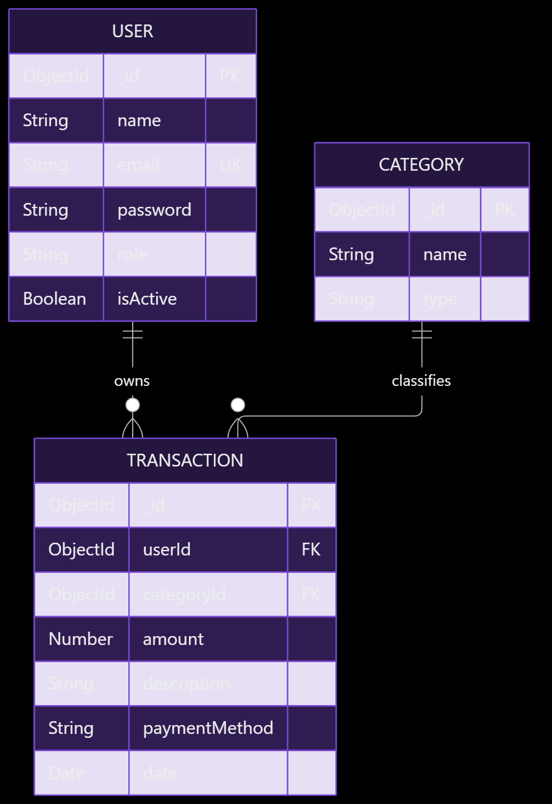

Security, Privacy and Reliability – Evaluation Plan
During evaluation, our team will protect demo accounts and the database through the following measures:
- Demo Accounts: We will use dedicated evaluation accounts with limited access and replace all default or seeded passwords before sharing the project outside the evaluation team.
- Password Security: All passwords are stored as bcrypt hashes, ensuring that original passwords are not stored in plain text.
- Authentication and Authorization: Signed JWT tokens will be used for authentication, while role-based middleware will restrict access to authorized users. Disabled accounts will not be allowed to access the system.
- Data Privacy: Students will only be able to access their own transaction records. We will avoid using real personal or financial information during demonstrations.
- Environment Variables: API keys, JWT secrets, and MongoDB credentials will remain in the server .env file and will never be committed to GitHub or exposed in screenshots or reports.
- Database Protection: We will restrict database access to authorized team members and take a MongoDB backup before evaluation using the backup procedure configured for the evaluation environment.
- API Security: Helmet security headers, restricted CORS origins, and rate limiting will help protect the API against common security threats and excessive requests.
These measures will help maintain the confidentiality of demo accounts, protect database records, and ensure a secure and reliable evaluation environment.

8 Installation and launch
Prerequisites: Node.js 18 or later and a reachable MongoDB database. Use a local MongoDB instance or a MongoDB Atlas database. The steps below are based on the repository setup instructions.
Order | Setup action
1 | Open a terminal in the project folder and enter the server directory.
2 | Install server packages using npm install.
3 | Copy server/.env.example to server/.env. Set MONGODB_URI and a strong JWT_SECRET. Set CLIENT_URL to the client address. Configure SMTP or AI keys only if those optional features are needed.
4 | Run npm run seed to create the administrator, demo students, default data and sample history.
5 | Start the API with npm start; its default local port is 5000.
6 | In a second terminal, enter the client directory and run npm install.
7 | Start the client with npm run dev and open the address printed by Vite (normally http://localhost:5173).

Do not copy production secrets into this report. Keep server/.env private. Change demo passwords and JWT_SECRET before deployment.

Deployment
The client can be built with npm run build from the client directory and served as static files. Run the API as a separate service or behind the same host, configure the database, set NODE_ENV=production, use a strong JWT_SECRET, and set CLIENT_URL to the deployed front-end origin.
YOUR INPUT Enter the actual evaluator setup used by your team (OS, database host type, and any project-specific configuration). Do not include passwords or secret keys.

9 Test data and evaluation
The seed script creates one administrator and two demo student accounts with sample transaction history, budgets, recurring subscriptions and derived dashboard data. The importer also provides a sample CSV containing valid and malformed rows for preview testing.
Role | Demo account | Sign-in path | Password handling
Administrator | admin@campuscoin.app | /admin/login | Seed default; rotate before sharing.
Student | ayesha@student.campuscoin.app | /login | Seed default; rotate before sharing.
Student | daniyal@student.campuscoin.app | /login | Seed default; rotate before sharing.

The seed defaults are documented in the project README and test-data note. This workbook intentionally does not repeat clear-text passwords. For a private evaluation handout, provide the current temporary passwords through the channel required by your instructor and change them after evaluation.

Evaluation checklist
Scenario | Expected evidence | Result / notes
Sign in as student | Student reaches dashboard; invalid or disabled account is rejected. | [record result]
Add/edit/delete/restore | Entry changes totals; deleted record can be restored. | [record result]
Budget warning | Progress and in-app notification match the configured limit. | [record result]
CSV preview and commit | Rows and suggested categories are reviewed before import. | [record result]
Report and export | Filters work and a PDF or image export is produced. | [record result]
Admin control panel | Admin can manage a shared category, notice or student. | [record result]
Accessibility preferences | Theme and text size can be changed and persist. | [record result]
Receipt scan | Image can be scanned and reviewed when provider configuration is available. | [record result]

YOUR INPUT Fill the result column from your own run. Record the date and environment and explain any failed or skipped scenario.

10 Screenshots and demonstration evidence
Replace each grey image panel with a screenshot captured from the current build. Use seeded sample data, hide email addresses if required by your instructor, and crop out browser tabs, secrets, and unrelated personal information. Add a one-sentence caption explaining what the image demonstrates. Eight supplied images have been inserted. The student dashboard and administrator panel still need screenshots.
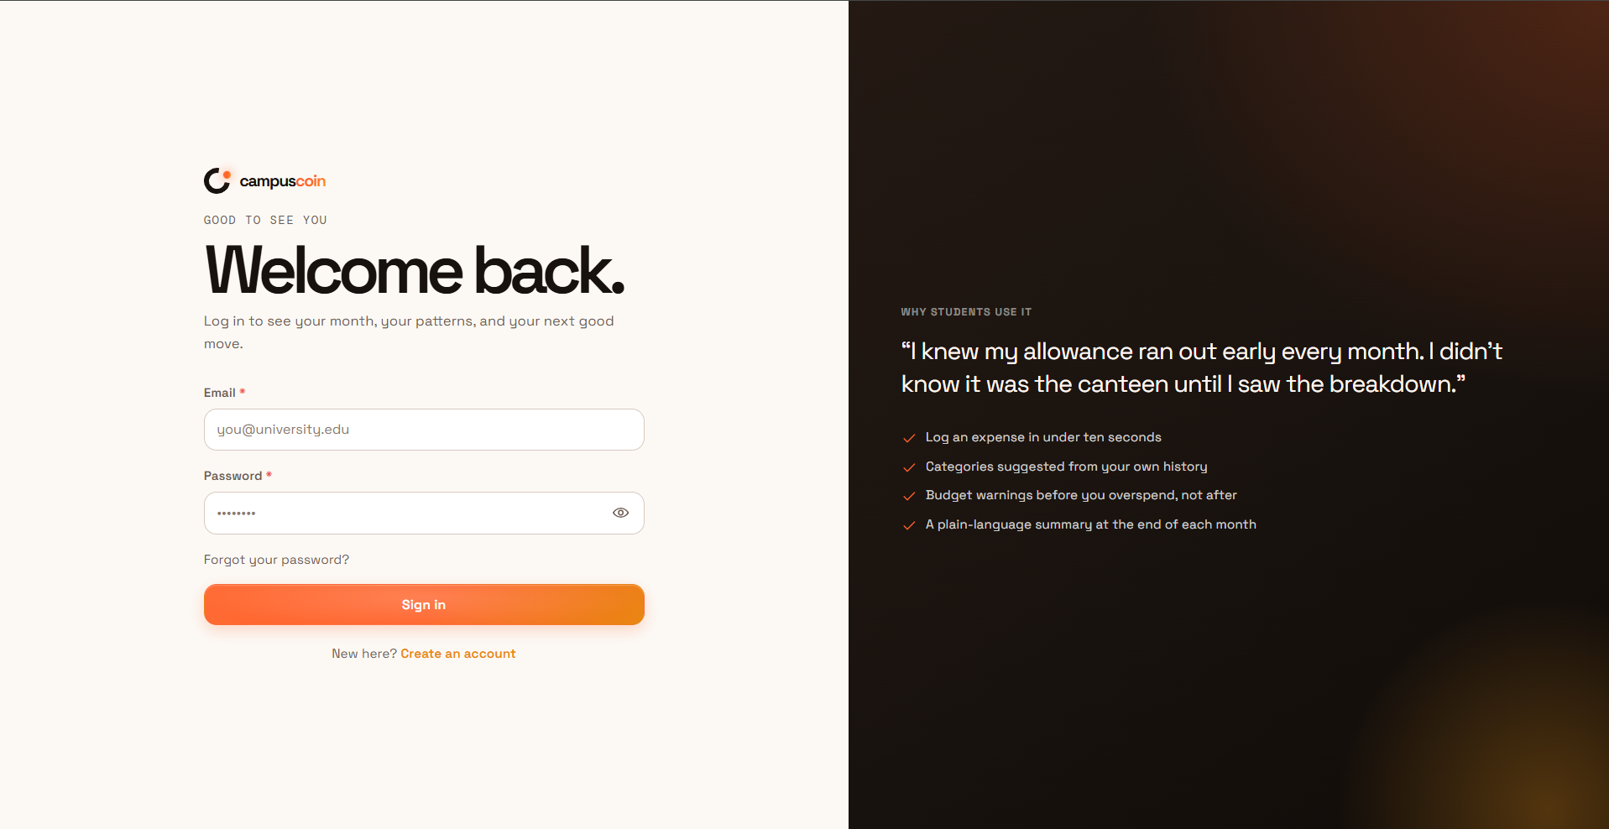
Student sign-in

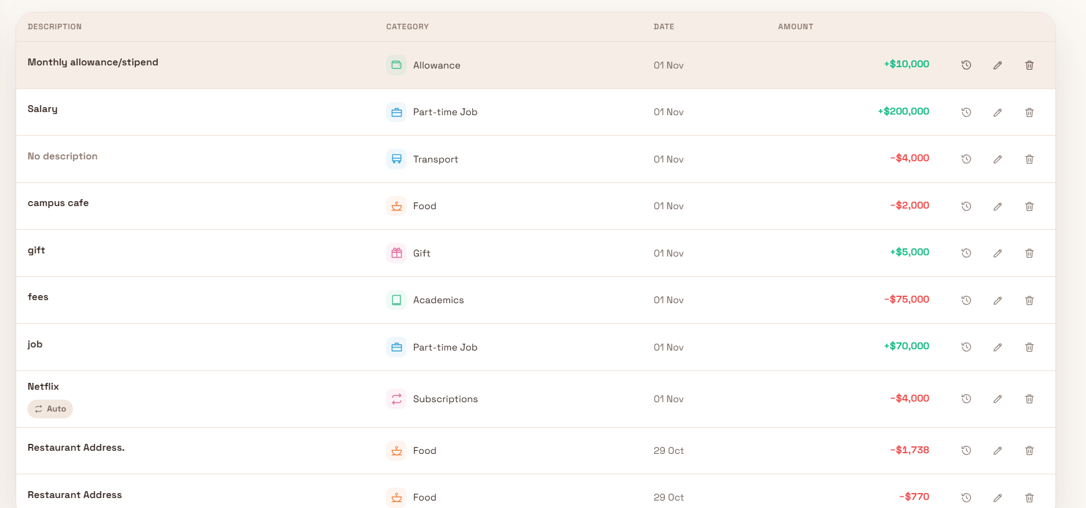Student dashboard with monthly totals and budget widget

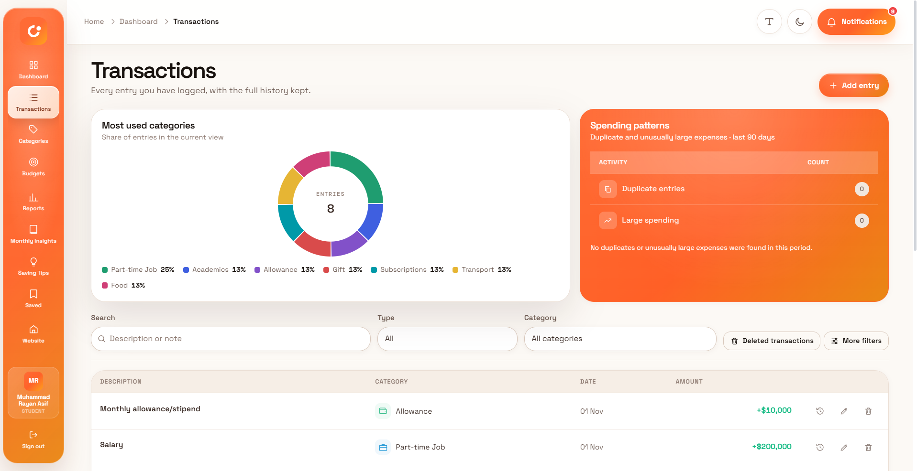
Transactions list

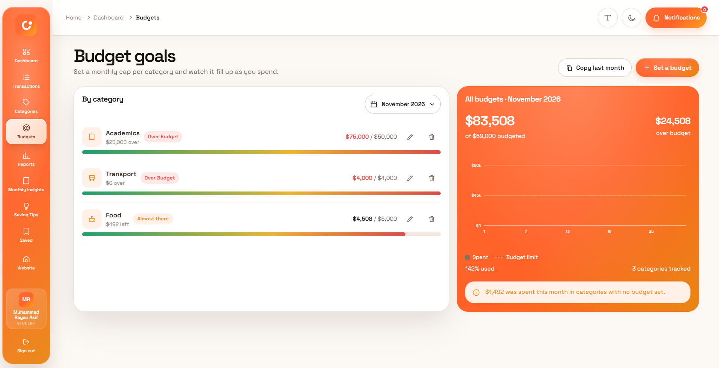
Budget goals

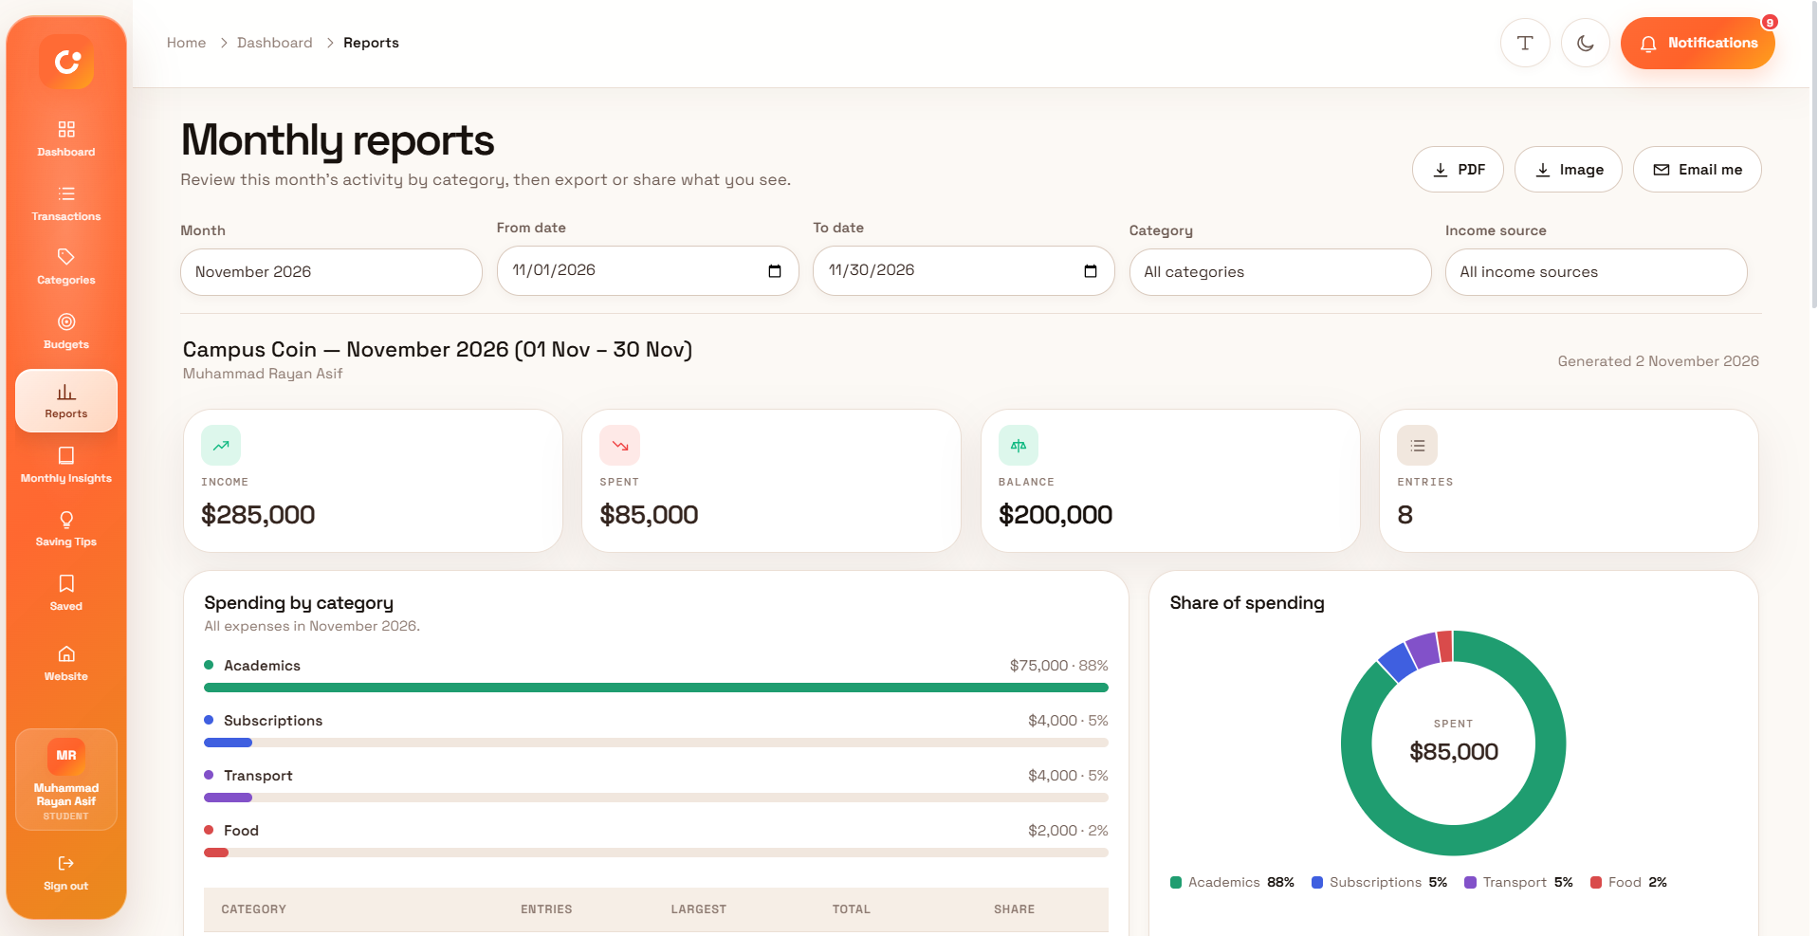
Monthly reports

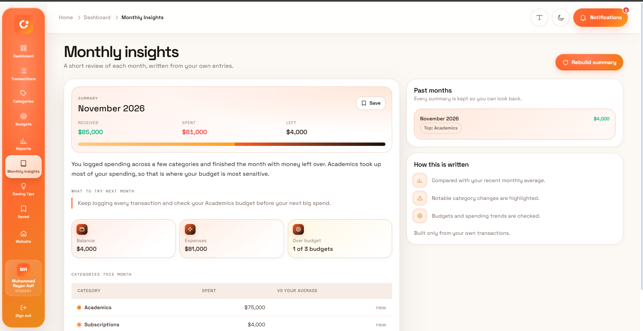
Monthly insights

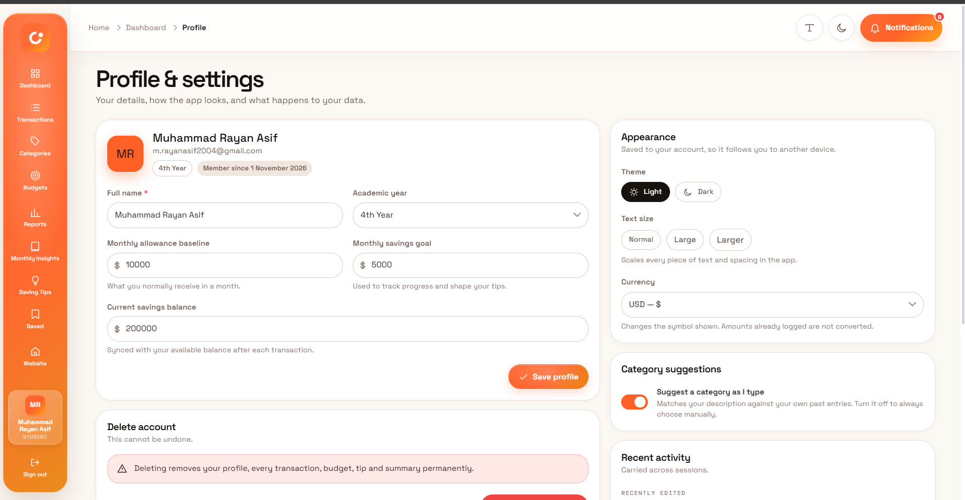
Profile and settings

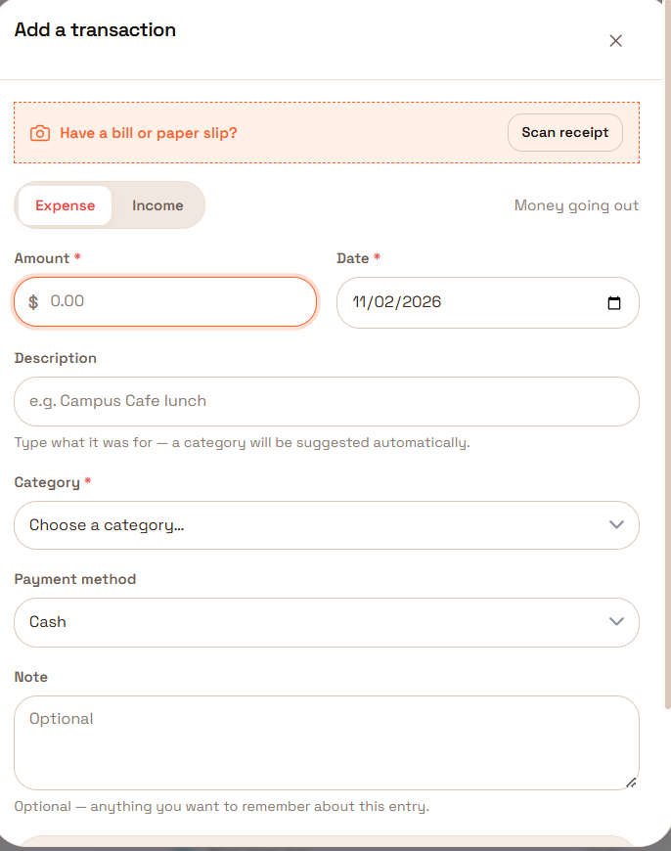
Add a transaction
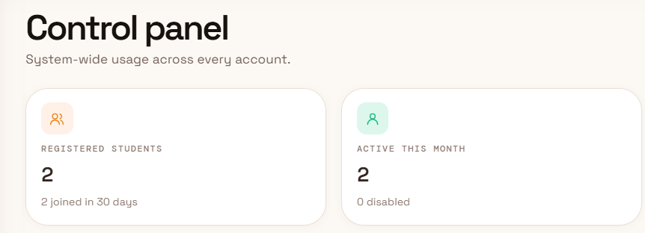Administrator dashboard or category/user management screenshot.

11 Project deliverables and submission checklist
- Project source folder with client and server.
- Database schema definition and database design description.
- This report completed with author details, evaluation results and screenshots.
- Credentials for all evaluation roles supplied securely after temporary passwords are set.
- ReadMe file listing setup assumptions and prerequisites.
- A demonstration MP4 covering the implemented functional requirements.
- Hosted evaluation URL, if deployed and approved for review.
- AI tools used acknowledged accurately. The repository notes Claude was used as a coding assistant; add any additional tools actually used by your team.

References and project materials
Primary project specification: Campus Coin End-to-End Web Solutions Software Requirements Specification, version 1.0, supplied with the project. Implementation details were cross-checked against the repository README, API reference, database schema, test-data note, server routes and model definitions.

