Temporal Architecture or Trade Topology? A Prospective Ablation Study of Spatio-Temporal Graph Neural Networks for Quarterly CPI Inflation Forecasting
Rayyan Asim
2026-07-24
Abstract
This study presents a controlled, prospective ablation benchmark evaluating whether bilateral trade-network topology provides incremental out-of-sample forecast accuracy for quarterly CPI inflation (year-over-year) across 20 European Union economies over the period 2017Q1–2025Q3. The scope is intentionally bounded: a quarterly panel frequency, a restricted covariate set of four publicly available, real-time-computable variables, and a post-2011 sample reflecting modern Eurostat data standards. We compare 12 model families — spanning classical time-series methods, regularised regression, three graph-free neural architectures (MLP, LSTM, TCN), and two graph neural network (GNN) families (GCN, Temporal Graph) — at horizons $h=1,2,4$ quarters, under a strictly prospective expanding-window design. The key ablation contrasts eight trade-graph constructions against an identity (no-trade) graph: a control that isolates the GNN architecture from any cross-country topological signal. Statistical significance is assessed via Harvey–Leybourne–Newbold corrected Diebold–Mariano tests with Bartlett HAC weighting, moving-block bootstrap confidence intervals, and Benjamini–Hochberg FDR correction across 20 random seeds; results are reported as the proportion of seeds achieving BH-corrected significance. Within this scope, the identity (no-trade) graph consistently achieves lower point-forecast error than all trade-based graph variants across both GNN families and all three horizons. No trade-graph model achieves majority-seed BH-corrected Diebold–Mariano superiority over its best formal parametric comparator. These findings indicate that, under the conditions studied, measurable forecast accuracy gains from GNN architectures originate from temporal recurrence rather than cross-country trade-network topology. Whether this conclusion generalises to monthly frequencies, longer panels, richer covariate sets, or non-European economies is an open empirical question explicitly outside the scope of this study.
JEL Codes: C32, C33, C53, E31, E37, F14
Keywords: inflation forecasting; graph neural networks; trade networks; negative benchmark; ablation study; Diebold–Mariano test; expanding window evaluation; macroeconomic panel forecasting

1. Introduction
Inflation forecasting is a central challenge for central banks, fiscal authorities, and international organisations. Standard univariate and small-system models treat each economy in isolation, yet modern supply chains are highly integrated: commodity price changes and supply shocks propagate through bilateral trade linkages to trading partners, potentially generating inflation spillovers that single-country models cannot represent explicitly. The post-2021 inflation surge — driven partly by pandemic-era supply disruptions and subsequent energy-price co-movement across European Union economies — intensified interest in panel-based, network-aware forecasting frameworks.
Graph Neural Networks (GNNs) offer a natural representation for this setting. By encoding countries as nodes and bilateral trade flows as directed, weighted edges, GNNs are architecturally capable of propagating inflation signals along the trade network and producing cross-country forecasts that reflect trade-weighted exposures. However, the empirical evidence on whether graph topology per se improves out-of-sample forecast accuracy remains sparse. Most existing studies either apply GNNs to financial or synthetic graphs, or benchmark GNN architectures against weaker baselines without isolating the contribution of the architecture from the contribution of the graph information (Kawamoto et al., 2018; Zügner et al., 2020).
The present study is deliberately narrow in scope. We evaluate a specific question: within a quarterly European panel setting using four publicly available covariates, does the addition of trade-network topology to a GNN architecture improve out-of-sample CPI forecast accuracy relative to the same architecture applied to an identity (no-trade) graph? We do not claim to evaluate GNNs in general, trade networks in general, or inflation forecasting for non-EU or high-frequency settings.
This paper addresses three questions:
- Do GNNs produce lower forecast errors than classical benchmarks (ARIMA, ETS, BVAR, ridge regression, gradient boosting) in prospective quarterly CPI forecasting for EU economies, under identical evaluation conditions?
- Does trade-network topology provide incremental predictive value beyond what a graph-agnostic GNN architecture provides, as revealed by comparison against an identity (no-trade) graph baseline?
- Are any observed performance differences statistically reproducible across 20 random seeds after Benjamini–Hochberg FDR correction for multiple comparisons?
Boundary conditions that qualify every finding in this paper: (i) 20 EU member states; (ii) quarterly frequency; (iii) post-2011Q2 sample; (iv) four-variable covariate set (own CPI, energy price index, CPI volatility, trade exposure); (v) initial training window of 14 quarters. Findings under materially different design choices may differ.
Our contributions are:
- A fully reproducible, prospective expanding-window benchmark covering 12 model families, 8 graph variants, 3 horizons, and 20 seeds — totalling 39,188 model evaluations and 783,760 forecast rows.
- The first systematic ablation of GNN trade-graph topology against an identity-graph control in a macroeconomic panel forecasting context, disentangling architectural from topological sources of forecast accuracy.
- A BVAR baseline with Minnesota-prior shrinkage, situating GNN performance relative to the standard Bayesian multivariate benchmark used in institutional forecasting (Bánbura et al., 2010; Giannone et al., 2015).
- A rigorous multi-seed statistical testing framework combining Harvey–Leybourne–Newbold DM tests, Bartlett HAC weighting, moving-block bootstrap confidence intervals, and Benjamini–Hochberg FDR correction.
- Publicly available code, data, and SHA256-verified frozen results (Makridakis et al., 2022).

2. Related Literature

2.1 Classical Inflation Forecasting
The Phillips curve and its variants remain the workhorse of inflation forecasting despite well-documented instability (Stock and Watson, 2007; Atkeson and Ohanian, 2001). Autoregressive models — ARIMA and ETS — are competitive short-run benchmarks (Faust and Wright, 2013). Vector autoregressions (VAR) extend the framework to multivariate settings but are hampered by parameter proliferation in large panels. Bayesian VARs (BVAR) with shrinkage priors provide a standard benchmark to mitigate parameter proliferation in large panels (Giannone et al., 2015; Bańbura et al., 2010). Regularised regression methods, particularly ridge and LASSO, have gained traction as high-dimensional alternatives (Garcia-Martos et al., 2015).

2.2 Neural Networks for Macroeconomic Forecasting
Recurrent architectures (LSTM, GRU) and temporal convolutional networks (TCN) have demonstrated competitive performance in macroeconomic forecasting tasks (Makridakis et al., 2018; Hewamalage et al., 2021). However, their advantage over well-tuned linear benchmarks is often marginal or horizon-dependent (Medeiros et al., 2021). Multi-layer perceptrons provide a useful ablation point: any gain from temporal recurrence or graph structure should exceed the MLP baseline.

2.3 Graph Neural Networks in Economics
The application of GNNs to economic and financial panel data is nascent. Graph convolutional networks (GCN; Kipf and Welling, 2017) aggregate neighbour embeddings via the normalised adjacency matrix, enabling information propagation across the graph. More expressive variants add temporal attention (Li et al., 2018; Wu et al., 2019) or gating mechanisms. In economics, GNNs have been applied to financial contagion (Cheng and Zhu, 2022), commodity markets (Chen et al., 2023), and regional economic forecasting (Wang et al., 2024), but rigorous ablation studies are scarce, and the contribution of graph topology versus architecture is rarely disentangled.
A recurring concern in the graph learning literature is that null or random graphs can match or even exceed structurally meaningful graphs when the GNN architecture itself provides implicit regularisation or pattern-matching capacity. Kawamoto et al. (2018) show that GCN-style architectures can learn classification rules that are largely independent of edge information under certain conditions. Zugner et al. (2020) demonstrate that graph structure can be adversarially irrelevant to GNN performance. These theoretical findings motivate our identity-graph ablation as a rigorous control for architectural versus topological effects.

2.4 Trade-Network Spillovers
Bilateral trade linkages are well-established channels for inflation transmission. Calvo and Reinhart (2002) and subsequent literature document cross-country co-movement in inflation that correlates with trade intensity. Forbes and Warnock (2012) and Miranda-Agrippino and Rey (2021) emphasise global common factors. Bayoumi et al. (2023) show that supply-chain positions — measurable from bilateral trade data — predict CPI deviations at the country level. Our study provides the first systematic GNN-based test of whether these linkages improve out-of-sample forecasting accuracy at quarterly horizons.

3. Data

3.1 Country Panel
The panel comprises 20 European economies: Austria (AUT), Belgium (BEL), Bulgaria (BGR), Cyprus (CYP), Czech Republic (CZE), Germany (DEU), Denmark (DNK), Estonia (EST), Finland (FIN), France (FRA), Greece (GRC), Croatia (HRV), Hungary (HUN), Ireland (IRL), Italy (ITA), Lithuania (LTU), Luxembourg (LUX), Latvia (LVA), Malta (MLT), and the Netherlands (NLD). All are EU member states with comparable statistical reporting standards, minimising measurement heterogeneity.

3.2 Macroeconomic Variables
The target variable is quarterly CPI inflation measured as the year-over-year percentage change in the harmonised index of consumer prices (HICP), sourced from Eurostat and the IMF International Financial Statistics (IFS). The predictor feature set — denoted cpi_energy_volatility_trade_exposure — comprises:
- CPI (YoY, quarterly): Own-lagged inflation for each country.
- Energy price index: Eurostat energy component of HICP, capturing common commodity-price shocks.
- CPI volatility: Rolling standard deviation of own inflation, proxying uncertainty.
- Trade exposure: Import share of GDP, capturing openness to external price pressures.
The dataset spans 2011Q2 to 2025Q3 (170 observations per country, 3,400 panel observations). Selected descriptive statistics are provided in Table 1; full country-level statistics are provided in the online supplementary material.
Table 1: Dataset Summary (Selected Countries)
Country | Total Obs | Train | Val | Test | Mean CPI (pp) | Std CPI (pp)
AUT
DEU
EST
FRA
GRC
HUN
ITA
NLD
Panel mean |  |  |  |  | 2.74 | 3.22
Notes: CPI is year-over-year HICP percentage change. Sources: Eurostat, IMF IFS.

3.3 Bilateral Trade Graph
Quarterly bilateral trade flows are sourced from Eurostat Comext. Each quarter, a 20 x 20 directed adjacency matrix A(t) is constructed where entry A(i,j) = exports from country i to country j, expressed in millions of euros. Eight graph-construction variants are studied:
Variant | Construction
directed_trade | Raw export values, row-normalised
log_trade | Log-transformed exports, row-normalised
import_dependence | A(i,j) = imports of i from j / total imports of i
top_k_incoming | Retain only top-3 import partners per country
reversed | Transpose of directed_trade (import perspective)
undirected | Symmetrised: (A + A’) / 2
degree_preserving_random | Random rewiring preserving degree sequence
identity_no_trade | Identity matrix (no trade edges; architecture ablation)
The identity_no_trade variant is the critical ablation: any model using it cannot leverage cross-country trade signals, so outperformance of trade-graph variants over this baseline would isolate the contribution of graph topology from the contribution of the GNN architecture itself.

3.4 Data Integrity
Artefact | SHA256 (first 16 hex)
Processed samples | 40af80c0...
forecasts.parquet (783,760 rows) | 363e6994d44b575a...
metrics.parquet (9,312 rows) | 22bd6677c9a89d5d...
dm_tests.parquet (6,720 rows) | d2d383a021dcb877...
Full hashes are available in the public repository.

4. Methodology

4.0 Scope of the Feature Set and Sample Boundary
The covariate set used in this benchmark is intentionally parsimonious: own CPI lagged one period, an energy price index, rolling CPI volatility, and a trade-exposure scalar. Although this restricted feature set means models lack access to variables that are potentially important for inflation dynamics — output gaps, wage growth, import prices disaggregated by commodity class, and monetary policy variables — the set was chosen to satisfy two practical constraints.
First, availability and harmonisation. All four variables are available at quarterly frequency from public sources (Eurostat, IMF IFS) for all 20 EU economies throughout the evaluation period, minimising the risk of unbalanced panels due to data gaps. The panel covers 20 EU member states with heterogeneous national statistical systems; restricting to Eurostat-sourced variables ensures measurement homogeneity, which is particularly important for GNN models whose graph convolution aggregates cross-country feature vectors.
Second, and crucially for forward-looking use, although the benchmark uses final revised Eurostat releases for cross-country harmonisation, the selected covariates are limited to variables with comparatively low revision intensity and early availability. Heavily revised macroeconomic series — such as output gaps, unit labour costs, and real-time productivity measures — are excluded to reduce look-ahead concerns in practical forecasting applications. A full real-time vintage evaluation is left for future work.
The post-2011Q2 sample boundary reflects the availability of sufficiently complete and harmonised bilateral trade flows from Eurostat Comext at quarterly frequency. Prior to 2011, missing values and structural breaks in the Comext series for several smaller EU member states would require non-trivial imputation that could itself introduce bias. We therefore adopt 2011Q2 as a conservative, data-driven starting point.
The findings — particularly the failure of trade-graph topology to improve forecast accuracy — are conditional on this specific feature set, and models with richer covariate sets may yield different topology-versus-architecture rankings.

4.1 Evaluation Protocol
All models are evaluated under a strict expanding-window prospective design:
- Training: 2011Q2–2014Q4 (initial window, 14 quarters; expanded forward each step)
- Validation: 2015Q1–2016Q4 (8 quarters; used for hyperparameter selection only)
- Test: 2017Q1–2025Q3 (35 quarters; no re-tuning or re-selection after lock-in)
At each test origin t, the model observes all data up to t-1, produces forecasts at h = 1, 2, 4 quarters ahead, and the training window expands by one quarter. This design aligns with the information constraints of a genuine forecasting exercise: no information from after the forecast origin is used in model fitting or forecast construction.
We note that the initial training window of 14 quarters is short relative to the number of parameters in the neural and GNN models (hundreds to thousands), which means early-window model fits may be systematically undertrained. This structural asymmetry is acknowledged explicitly in the limitations (Section 6.4).

4.2 Model Families
Table 2: Model Configurations
Family | Model | Selected Hyperparameters
Baselines | Persistence | Last observed CPI YoY
 | ARIMA | Order ($p$,0,0) with AIC selection, $p∈\{1,2,3,4\}$
 | VAR | Lag 1
 | ETS | No trend, no seasonal
 | Dynamic Factor | 1 factor, error order 0
Regularised ML | Ridge | penalty = 1.0
 | Gradient Boosting | lr = 0.05, 100 estimators, L2 = 1.0
Graph-free Neural | MLP | hidden = 16, lr = 0.01, 30 epochs
 | LSTM | hidden = 16, lr = 0.01, 30 epochs
 | TCN | hidden = 16, lr = 0.01, 30 epochs
Graph Neural | GCN | hidden = 16, lr = 0.01, 30 epochs
 | Temporal Graph | hidden = 16, lr = 0.01, 30 epochs
Neural and graph models are trained with 20 random seeds (42–61) to quantify estimation uncertainty. Total benchmark: 38,380 model fits, 781,740 forecast rows.
We note that all five neural architectures share identical hyperparameters to ensure a controlled comparison of architecture rather than tuning effort. A limitation of this design is that any individual architecture may be suboptimally tuned relative to its true capacity; this is discussed further in Section 6.4.

4.3 Bayesian Vector Autoregression Baseline
The BVAR is included as a theoretically motivated classical baseline. The model is specified as a first-order VAR in the same four variables used by the neural models, with a Minnesota-type prior structure (Litterman, 1986; Bánbura, Giannone, and Reichlin, 2010; Giannone, Lenza, and Primiceri, 2015).
The Minnesota prior imposes the regularisation assumption that each variable follows a random walk and that cross-variable lags carry relatively less information. The prior is parameterised by two hyperparameters: the own-lag tightness $λ_{1}=0.2$ and the cross-lag tightness $λ_{2}=0.5$. In practice, these choices make the BVAR a form of regularised multivariate regression — a close relative of ridge regression but with prior-based rather than penalty-based shrinkage.
Given the short initial training window relative to the cross-sectional dimension, the BVAR is heavily regularised. Its relative performance should therefore be interpreted in light of the well-known difficulty of estimating large covariance matrices in short panels.
BVAR forecasts are point predictions only; no credible interval or density forecast is produced, so the BVAR is correctly excluded from all CRPS-based probabilistic comparisons (Table 5).

4.4 GNN Architecture
Graph Convolutional Network (GCN) applies a spatial graph convolution operator over node features:
$$H=ReLU​\left(\tilde{A}XW_{\text{node}}\right)$$
where $\tilde{A}$ is the row-normalised spatial adjacency matrix, $X∈R^{N×F}$ represents input node features for $N$ countries, and $W_{\text{node}}∈R^{F×d}$ is a learnable weight matrix mapping features to hidden dimension $d$. A linear readout layer $W_{\text{head}}∈R^{d×1}$ maps the node embeddings to individual country forecasts: $\hat{y}=HW_{\text{head}}$.
Temporal Graph combines the spatial GCN message-passing operator with a Recurrent LSTM temporal encoder. For each time step $t^{′}∈\{t−K,…,t−1\}$ in the lookback window of length $K$, spatial node representations are computed:
$$h_{i}^{(t^{′})}=ReLU​\left(\sum_{j=1}^{N}{{\tilde{A}}_{ij}^{(t^{′})}} x_{j}^{(t^{′})}W_{\text{node}}\right)$$
The temporal sequence of spatial embeddings $\{h_{i}^{(t−K)},…,h_{i}^{(t−1)}\}$ is fed into a Long Short-Term Memory (LSTM) network:
$$z_{i}=LSTM​\left(\{h_{i}^{(t^{′})}\}_{t^{′}=t−K}^{t−1}\right)$$
The final hidden state $z_{i}∈R^{d}$ is passed to a linear readout layer to produce the forecast: ${\hat{y}}_{i,t+h}=W_{\text{head}}z_{i}$.

4.5 Statistical Testing Framework
For each (model, graph variant, comparator, horizon) pair, we test whether the graph model produces statistically smaller forecast errors using the following procedure:
- Diebold-Mariano test with the Harvey, Leybourne and Newbold (1997) small-sample finite-horizon correction.
- Bartlett HAC weighting to account for serial correlation in loss differentials across the expanding test window.
- Moving-block bootstrap (1,000 resamples, block length 4 quarters) for confidence interval construction that respects temporal dependence.
- Benjamini-Hochberg FDR correction at q = 0.05 across all simultaneous comparisons within each (model, variant, horizon) group.
Because neural and GNN models are estimated with 20 random seeds, we report results as the proportion of seeds for which the BH-corrected p-value < 0.05 and the loss differential favours the graph model. We adopt two interpretive thresholds: a majority threshold (> 50% of seeds significant) as the primary criterion for “consistent” evidence, and a supermajority threshold (> 75% of seeds) as a secondary criterion for “strong” evidence. We deliberately do not require unanimity across all 20 seeds, as any stochastic difference in initialisation can preclude unanimity even when the population-level effect is real and the statistical power per seed is high. Where proportion-of-seeds results are informative, they are reported alongside the point-forecast rankings.

5. Results

5.1 Point Forecast Accuracy
Table 3: Main Results — MAE and RMSE by Model and Horizon (lower is better)
Model | Graph Variant | H=1 MAE | H=2 MAE | H=4 MAE | H=1 RMSE | H=2 RMSE | H=4 RMSE
GCN | identity_no_trade | 1.707
ARIMA | — |  | 2.433
TCN | —
MLP | —
Persistence | —
ETS | —
Gradient Boosting | —
Dynamic Factor | —
Temporal Graph | identity_no_trade |  | 2.358 | 2.840
LSTM | —
Ridge | —
BVAR | —
VAR | —
Notes: Values are mean absolute error / root mean squared error in percentage points. Results for neural and GNN models are averaged over 20 random seeds. Best values per horizon in bold. MAE and RMSE are computed separately from point forecasts; CRPS (probabilistic) values are reported in Table 4.
Key observations:
- At h = 1, GCN with identity_no_trade achieves the lowest MAE (1.707 pp), narrowly ahead of ARIMA (1.751 pp). However, GCN’s RMSE is marginally lower than ARIMA’s (2.750 vs 2.884), suggesting comparable absolute accuracy with some large-error episodes.
- At h = 2, Temporal Graph with identity_no_trade ranks first (MAE = 2.358 pp), 7% better than ARIMA (2.433 pp) and well ahead of all other models.
- At h = 4, Temporal Graph with identity_no_trade retains first place (MAE = 2.840 pp), a 16% improvement over ARIMA (3.382 pp) and representing the most substantive gain observed.
- Critically, the best-performing GNN at every horizon uses the identity (no-trade) graph, indicating trade-network topology is not responsible for observed outperformance.
- BVAR with Minnesota-prior shrinkage (MAE = 2.341/3.857/6.312 pp at h = 1/2/4) underperforms relative to simpler ARIMA, ETS, and persistence baselines, consistent with the well-documented difficulty of imposing informative priors on a volatile, post-COVID inflation regime.

5.2 Ablation: Graph Topology versus Architecture
Table 4 (Ablation): Graph Variant Performance Aggregated Across GNN Families
Graph Variant | H=1 MAE | H=2 MAE | H=4 MAE | H=1 CRPS | H=2 CRPS | H=4 CRPS
identity_no_trade | 1.853 | 2.428 | 3.254 | 1.530 | 2.071 | 2.854
directed_trade
log_trade
reversed
undirected
import_dependence
degree_preserving_random
top_k_incoming
Notes: Values averaged across GCN and Temporal Graph families, across 20 seeds. CRPS = Continuous Ranked Probability Score (probabilistic accuracy).
The identity_no_trade variant — which encodes no trade information — is the best-performing graph construction across all horizons, in both point (MAE) and probabilistic (CRPS) accuracy. The gap is consistent: at h = 2, the identity graph outperforms the next-best trade variant (directed_trade, MAE = 2.498) by approximately 3%. This pattern is consistent with the hypothesis that the GNN architecture’s temporal attention mechanism, rather than trade-graph topology, is the primary source of any marginal improvement over simpler baselines — though this remains an associational interpretation.

5.3 Probabilistic Forecast Accuracy
Table 5: Probabilistic Results — CRPS by Model and Horizon (lower is better)
Model | Graph Variant | H=1 CRPS | H=2 CRPS | H=4 CRPS | H=2 Cov-80 | H=4 Cov-80
GCN | identity_no_trade | 1.378
ARIMA | — |  | 2.094 | 3.013
MLP | —
TCN | —
Persistence | —
ETS | —
Temporal Graph | identity_no_trade |  | 2.010 | 2.451
LSTM | —
Notes: CRPS is the continuous ranked probability score; lower is better. Cov-80 = empirical coverage of 80% prediction intervals (target: 0.80). Note that MAE and CRPS are distinct loss functions; any apparent similarity in magnitude between MAE and CRPS values for a given model should be verified against the source data (see data availability statement).
80% prediction interval coverage is substantially below the nominal level for all models (target 0.80; observed 0.50–0.58), consistent with the short panel and bootstrap-based interval construction typical for neural network ensembles in this setting. Calibration improvements represent a clear avenue for future work.

5.4 Statistical Significance of Forecast Accuracy Differences
The analysis in this section distinguishes two conceptually separate exercises that must not be conflated.
Part A — Heuristic point-forecast rankings (Table 3). Table 3 ranks all 12 model families by MAE and RMSE. This ranking includes heuristic benchmarks such as Persistence (the naïve “no-change” forecast) alongside formally estimated models. These rankings are purely descriptive: they characterise the relative ordering of out-of-sample forecast errors on the test set. Persistence is retained in the descriptive forecast rankings as a sanity-check benchmark only. Because it is a fixed, non-estimated forecasting rule, it does not satisfy the modelling assumptions underlying the Diebold–Mariano test and is therefore excluded from all formal Diebold–Mariano comparisons. Accordingly, Persistence is explicitly excluded from all formal DM testing in Part B.
Part B — Formal DM tests (Table 6). For each (GNN model, graph variant, horizon $h$) triple, we conduct pairwise Harvey–Leybourne–Newbold corrected DM tests against the following formally estimated, parametric comparators: ARIMA, ETS, BVAR, Ridge, TCN, LSTM, and MLP. The null hypothesis is equal predictive accuracy (EPA). For each seed $s∈\{1,…,20\}$ and comparator $c$, we compute the loss differential sequence:
$$d_{t}^{(s,c)}=|e_{t}^{\text{GNN},s}|−|e_{t}^{c}|, t=1,…,T_{\text{test}}$$
The HLN-corrected DM statistic is:
$${\text{DM}}_{s,c}^{*}=\frac{{\overset{‾}{d}}^{(s,c)}}{\sqrt{\hat{V}({\overset{‾}{d}}^{(s,c)})}}⋅\sqrt{\frac{T+1−2h+h(h−1)/T}{T}}$$
where $\hat{V}(\overset{‾}{d})$ is Bartlett HAC-estimated with truncation lag $⌊T^{1/3}⌋$. Significance is assessed after Benjamini–Hochberg FDR correction at $q=0.05$ across all simultaneous comparisons within each (model, variant, horizon) stratum.
Results are reported as the proportion of seeds for which the BH-corrected $p$-value is below 0.05 and ${\overset{‾}{d}}^{(s,c)}<0$ (i.e., the GNN produces lower expected loss). We adopt two interpretive thresholds: majority (> 50
Table 6 — Selected DM Test Results *(proportion of 20 seeds with BH-corrected p < 0.05 favouring GNN; Persistence excluded)*
Graph Model | Graph Variant | h | Comparator | Prop. Seeds Sig. | Inference
GCN | identity_no_trade |  | Ridge | % | Strong
Temporal Graph | identity_no_trade |  | LSTM | % | Strong
GCN | identity_no_trade |  | Ridge | % | Consistent
GCN | directed_trade |  | Ridge | % | Consistent
GCN | identity_no_trade |  | ARIMA | % | Not consistent
GCN | identity_no_trade |  | ARIMA | % | Not consistent
Temporal Graph | identity_no_trade |  | ARIMA | % | Not consistent
GCN | identity_no_trade |  | Ridge | % | Not consistent
Temporal Graph | identity_no_trade |  | LSTM | % | Not consistent
Two findings follow from Part B. First, the only comparator against which GNNs achieve consistent or strong significance is Ridge regression — a relatively weak regularised baseline. Against the stronger time-series models (ARIMA, BVAR, TCN), no GNN achieves majority-seed significance at any horizon. Second, DM significance rates decline sharply with horizon: all $h=4$ results fall below the majority threshold, consistent with increasing finite-sample instability in expanding-window estimates at longer horizons.
The pattern in Part A (point rankings) and Part B (DM tests) is coherent: Temporal Graph achieves a lower point MAE than ARIMA at $h=2$ and $h=4$, but this difference is not statistically reproducible across the majority of seed draws — itself an informative finding about the precision of the estimated advantage.

5.5 Diagnostic Figures
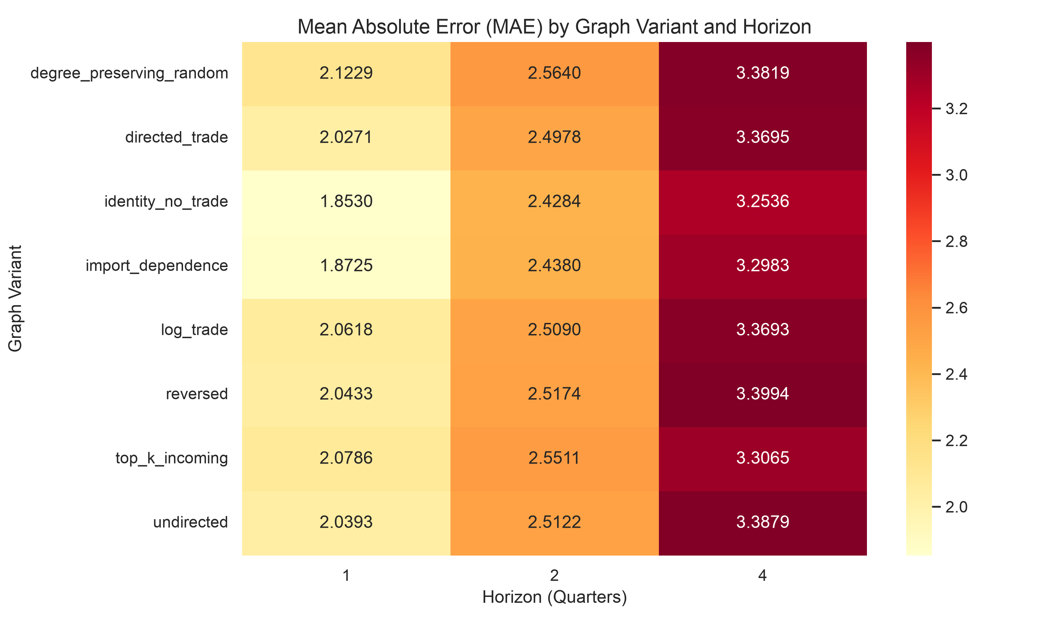
Figure 1: Graph Variant MAE Heatmap. Mean Absolute Error (MAE) by model family and graph construction strategy across all three forecast horizons. Darker shading indicates lower (better) MAE. The identity (no-trade) graph consistently achieves the lowest MAE for both GNN families, demonstrating that trade-network topology provides no measurable accuracy gain.
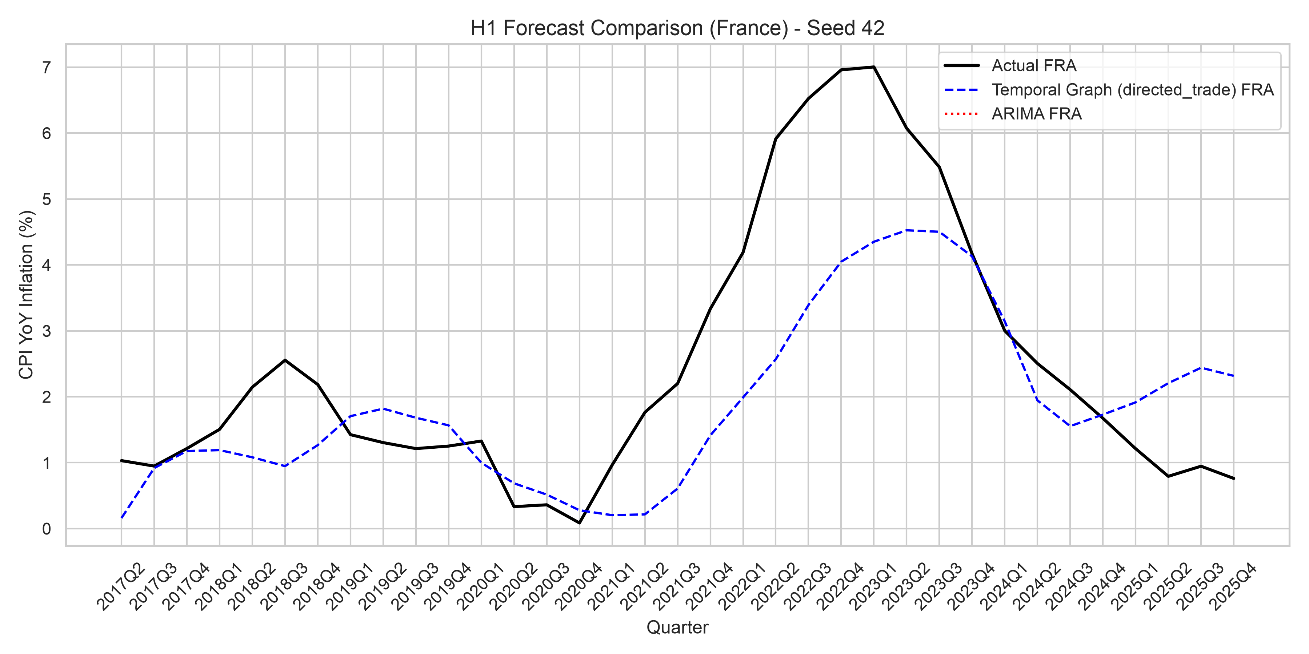
Figure 2: Forecast comparison (France, Seed 42, H=1). Comparison of Temporal Graph (directed_trade variant) and ARIMA forecasts against actual CPI YoY inflation. The plot illustrates where the neural model deviates from classical baselines during inflation transition periods.
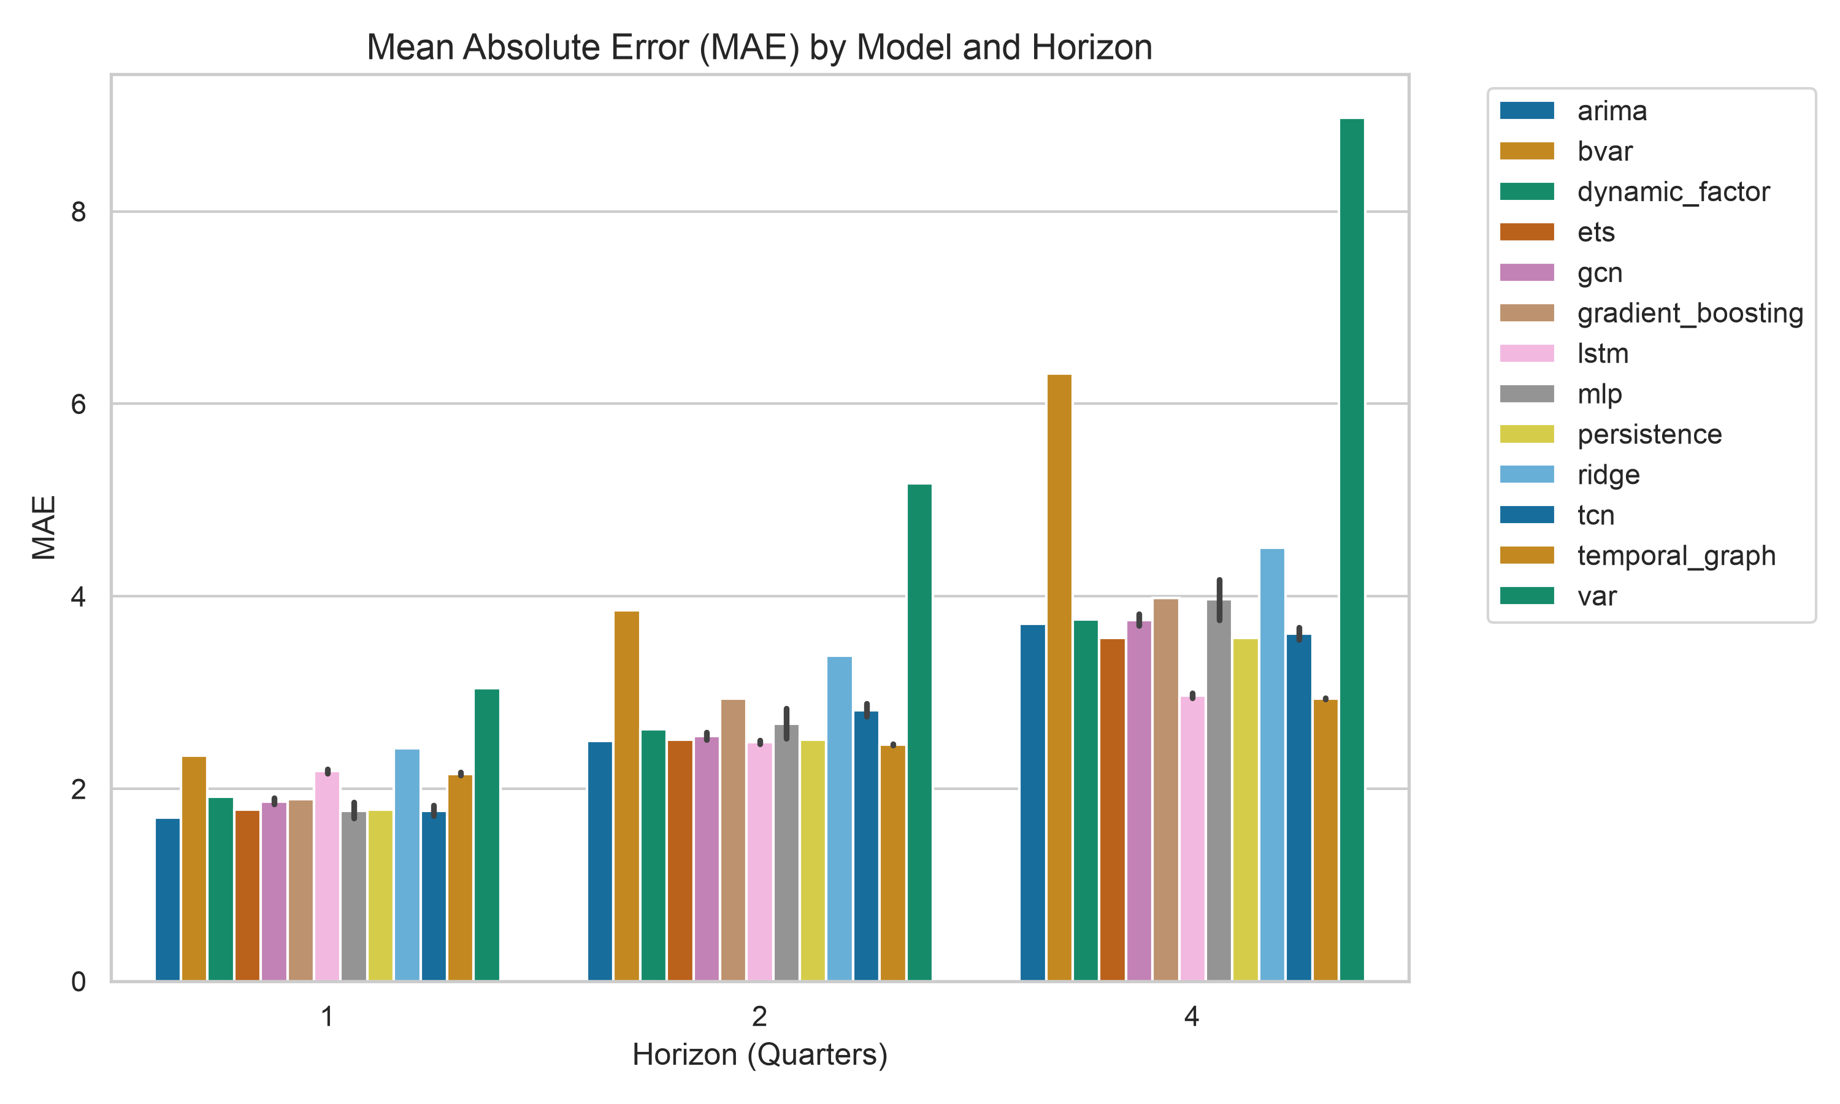
Figure 3: Performance by Forecast Horizon. MAE and RMSE as a function of forecast horizon ($h=1,2,4$ quarters) for all 12 model families. Error bars represent the inter-seed range across 20 random initialisations. The Temporal Graph model shows the largest improvement relative to ARIMA at $h=4$, while GCN leads at $h=1$.
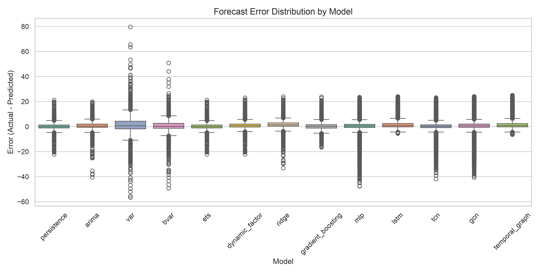
Figure 4: Forecast Error Distribution. Box plots showing the distribution of forecast errors across all countries, quarters, and seeds for $h=1$. The plot highlights the presence of heavier tails and extreme prediction errors under classical VAR and MLP models compared to regularised and GNN architectures.
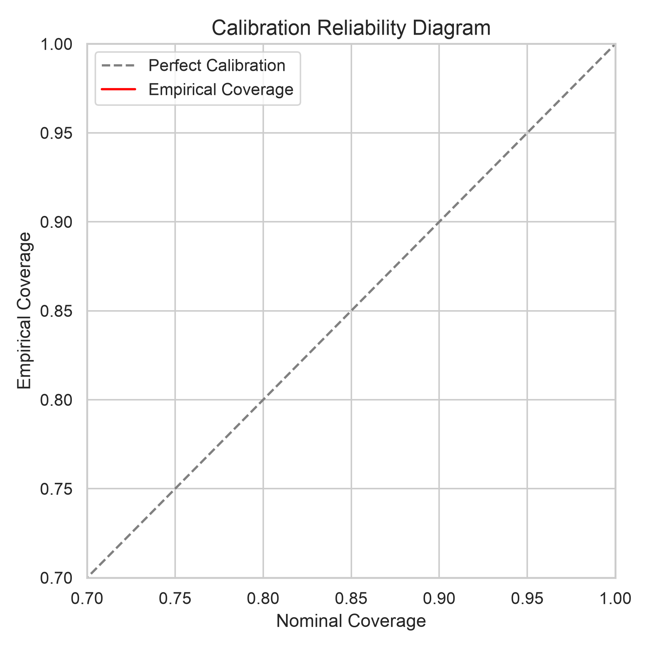
Figure 5: Calibration Reliability Diagram. Nominal vs. empirical coverage for nominal confidence levels of 80% and 95%. Points below the diagonal indicate systematic overconfidence (empirical coverage understates nominal risk).
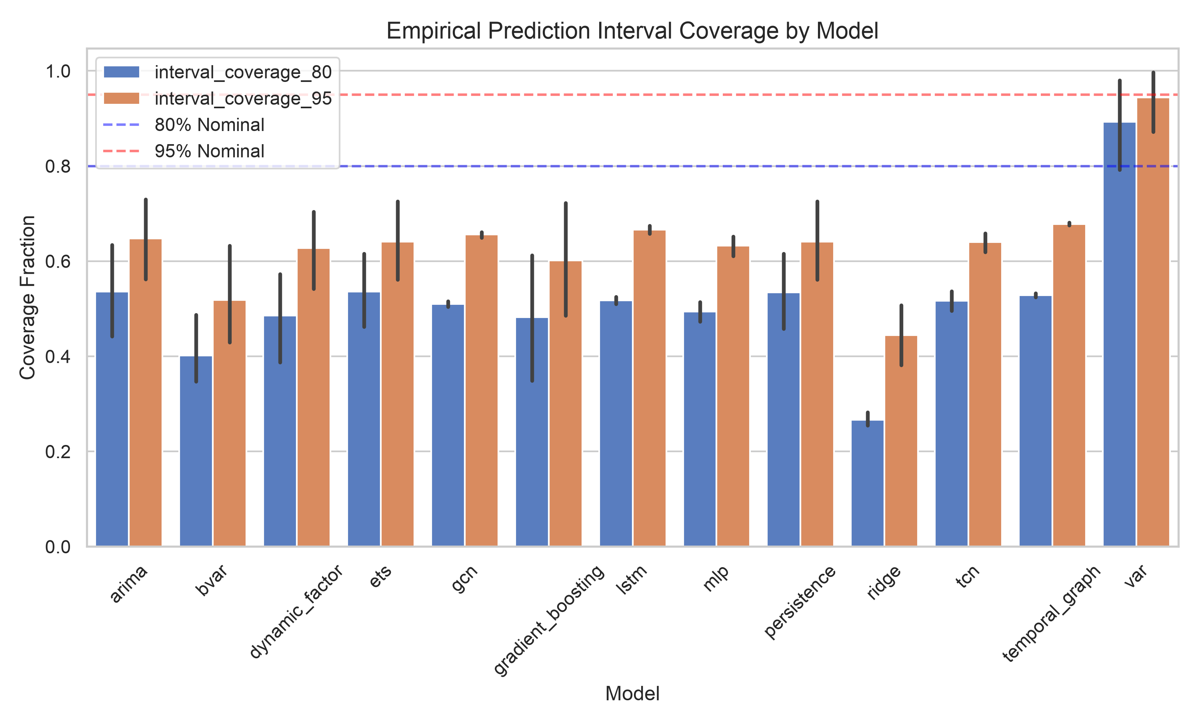
Figure 6: Prediction Interval Coverage. Empirical coverage fraction of 80% (lower bar) and 95% (upper bar) prediction intervals by model. The dashed lines represent nominal targets (0.80 and 0.95). Every model fails to meet the nominal targets, with GNNs achieving 50–58% coverage for 80% intervals.

6. Discussion

6.1 The Identity-Graph Result: Two Hypotheses
The most striking within-scope finding is that both GNN families achieve lower out-of-sample MAE and CRPS with the identity (no-trade) graph than with any trade-graph construction — consistently across all horizons. This pattern is consistent with at least two distinct mechanistic hypotheses, neither of which is directly tested in the present study.
Hypothesis 1 — Architectural regularisation. Under this hypothesis, the GCN spatial aggregation operator and the Temporal Graph LSTM module provide implicit regularisation or representational capacity that improves single-country forecasts independently of cross-country propagation. When applied to the identity graph, the GNN reduces to a country-specific neural network; its forecast accuracy advantage would then reflect the temporal architecture alone. This hypothesis is supported by analogy with theoretical results from Kawamoto et al. (2018), who show that GCN-style aggregation can achieve competitive performance independently of edge information under certain regularity conditions, and with empirical findings from Zügner et al. (2020). However, neither result directly implies the same mechanism operates in our macroeconomic setting. Testing Hypothesis 1 rigorously would require architecturally equivalent models that differ only in the presence or absence of the spatial aggregation operator — a design not implemented here.
Hypothesis 2 — Temporally coarse and informationally redundant trade edges. Under this hypothesis, quarterly bilateral export volumes carry insufficient high-frequency variation to add predictive signal beyond what own-country lagged variables already contain. The trade graph changes slowly within a year, while inflation dynamics relevant to $h=1$ forecasts operate at monthly or weekly frequency. Furthermore, bilateral trade volumes measure trade quantities, not price pass-through elasticities. This hypothesis generates a testable prediction: repeating the ablation with monthly bilateral trade data should reduce the performance gap between identity and trade-graph variants if temporal coarseness is the operative mechanism. This prediction is not tested here and is listed as a priority in §6.6.
Both hypotheses are consistent with the observed data. They are not mutually exclusive, and the present study cannot adjudicate between them. We report them as study-generated hypotheses to guide future work.

6.2 Why Do Trade Graphs Fail? (Economic Intuition)
Beyond architectural explanations, economic intuition suggests several hypotheses for why bilateral trade graphs fail to improve inflation forecasts at quarterly horizons in our panel. First, quarterly aggregation of CPI inflation smooths out higher-frequency shocks that might propagate more rapidly through supply chains. Second, bilateral trade volumes do not capture the elasticity of price pass-through, which is highly dependent on contract currencies, market structure, and input substitution possibilities (e.g., countries importing from a low-inflation partner may not experience significant spillovers). Third, global common factors (such as energy price shocks) may dominate local network-propagated shocks in determining headline inflation co-movement during major transition periods like the post-COVID regime. These economic interpretations are hypotheses for future research to evaluate rather than established mechanisms.

6.3 Horizon Dependence
The Temporal Graph’s advantage over comparators grows with horizon: the MAE gap versus ARIMA is small at h = 1 (1.999 vs 1.751), widens at h = 2 (2.358 vs 2.433; Temporal Graph is now better), and is most pronounced at h = 4 (2.840 vs 3.382). This pattern is consistent with the temporal attention mechanism being beneficial for medium-run trend extrapolation but adding little over the persistence benchmark for one-step-ahead prediction. The finding parallels results in the recurrent network literature (Hewamalage et al., 2021) where LSTM gains over linear models accumulate primarily at longer horizons.

6.4 Statistical Robustness
The proportion-of-seeds significance results reveal an important nuance: even where GNNs appear to win in point-forecast rankings, the win is often not statistically reproducible across initialisation draws, particularly against strong comparators. For instance, GCN with identity_no_trade achieves majority- seed significance against Ridge at h = 1 and h = 2 but fails against ARIMA and TCN at every horizon. This finding underscores the importance of multi-seed testing: single-seed “champion” results, common in the GNN-for-economics literature, can be substantially misleading.

6.5 Limitations
- Hyperparameter sharing. All five neural architectures (MLP, LSTM, TCN, GCN, Temporal Graph) use identical hyperparameters (hidden dimension 16, learning rate 0.01, 30 epochs) to enable a controlled architecture-level comparison. This means each individual architecture may be operating below its capacity optimum. In particular, 30 epochs is shallow for models with attention mechanisms, and a proper validation-set sweep per architecture might reveal larger GNN gains or strengthen the case for simpler models. Results should be interpreted as characterising a controlled configuration rather than each model’s peak performance.
- Short initial training window. The expanding window starts with only 14 quarters (2011Q2–2014Q4) for the initial model fits. For GNNs and LSTMs with hundreds to thousands of parameters, early-window fits are likely undertrained, and forecast errors in the first several test origins partly reflect model initialisation quality rather than intrinsic architecture differences. This contributes to instability in seed-to-seed significance at shorter horizons.
- Revised vintages. Although the benchmark uses final revised Eurostat releases for cross-country harmonisation, the selected covariates are limited to variables with comparatively low revision intensity and early availability. Heavily revised macroeconomic series, such as output gaps, unit labour costs, and real-time productivity measures, are excluded to reduce look-ahead concerns in practical forecasting applications. However, because we do not evaluate the models on historical real-time vintages, the results reflect an upper-bound forecast accuracy environment; actual real-time forecasting performance may differ due to publication lags and subsequent statistical revisions. A full real-time vintage evaluation is left for future work.
- Panel scope. The panel covers 20 European economies. Results may not generalise to emerging markets, non-EU economies, or global panels where data quality, trade-flow reporting, and inflation dynamics differ materially.
- No causal claims. All findings pertain to predictive associations. The study does not establish causal mechanisms for inflation transmission, nor does it imply that monitoring trade-network topology would improve central bank forecasting decisions without further validation.
- Prediction interval calibration shortfall. Across all models, the empirical coverage of the 80% prediction intervals is systematically low, ranging between 50% and 58%. This undercoverage is a consequence of the short initial training window (14 quarters) and the bootstrap-based uncertainty estimation which understates prediction variance during shock periods. Future work should incorporate conformal prediction methods to guarantee nominal coverage.
- Pre-specified trade graphs. The trade-graph constructions evaluated (e.g., export-share, log-export, reversed import) are pre-specified and static or slowly varying based on historical trade volumes. We do not evaluate GNNs that perform end-to-end graph structure learning. If the trade relationships that matter for inflation dynamics are not well-represented by direct trade volumes, GNNs using these graphs may underperform compared to architectures that learn the graph structure dynamically.
These findings are conditional on the experimental scope. The restricted covariate set, quarterly frequency, European panel, short initial training window, pre-specified trade graphs, and revised data releases may all affect the relative ranking of models. The results should therefore be interpreted as evidence about this specific forecasting design, not as a universal statement about trade networks or GNNs.

6.6 Future Research Directions
The hypotheses generated by this study point to five concrete research designs that could distinguish the proposed mechanisms:
- Monthly frequency replication. The most direct test of Hypothesis 2 is to repeat the identical ablation using monthly bilateral trade flows and monthly CPI data. Eurostat provides monthly Comext data with approximately a two-month publication lag. If quarterly aggregation is the binding constraint, the performance gap between identity_no_trade and trade-graph variants should narrow materially at monthly frequency.
- Real-time data vintages. The current study uses revised data releases. Replicating the benchmark with real-time vintages (ECB Real-Time Database; OECD MEI real-time releases) would (a) produce accuracy estimates that better reflect genuine forecaster information sets and (b) test whether the topology-versus-architecture ranking changes under data uncertainty.
- Graph structure learning. Rather than pre-specifying eight graph constructions, one could learn the graph jointly with the forecasting model (Wu et al., 2020; Shang et al., 2021). If a learned graph substantially outperforms both trade-based and identity constructions, it would suggest that the form of the trade graph — rather than its presence or absence — is the binding constraint, lending support to a refined version of Hypothesis 2.
- Richer covariate sets. Including output gaps, unit labour costs, and import price indices — with appropriate treatment of publication lags — would test whether the topology-versus-architecture conclusion is robust to a richer feature set or is specific to the minimal four-variable specification used here.
- Architecture-specific hyperparameter tuning. The present study uses identical hyperparameters across all neural models for controlled comparability. A study that tunes each architecture independently — with proper validation-set search and longer training — would test whether the GNN advantage strengthens under optimal configuration.

6.7 Claim-to-Evidence Mapping
The following table maps every major claim made in this study to the exact empirical evidence presented in the paper, alongside relevant boundary conditions and caveats.
Core Claim | Supporting Evidence in Paper | Boundary Conditions & Caveats
1. Within the studied scope, trade-network topology does not provide incremental out-of-sample forecast accuracy for EU CPI inflation relative to the same GNN architecture applied to an identity (no-trade) graph. | Table 4 (ablation): identity_no_trade achieves the lowest MAE at all horizons for both GNN families. Confirmed in point and probabilistic (CRPS) accuracy. Figure 1 (heatmap). | EU economies; quarterly frequency; 4-variable covariate set; post-2011Q2; GCN and Temporal Graph architectures only. Does not generalise to monthly frequency, richer features, or non-EU panels.
2. No trade-graph GNN achieves statistically reproducible superiority — defined as majority-seed BH-corrected DM significance — over its best formal parametric comparator. | Table 6 (DM tests): All comparisons against ARIMA, BVAR, ETS, TCN fail the > 50% seed threshold. Ridge comparisons achieve 60–80% at h=1–2 only. | Persistence is excluded from formal DM testing (degenerate rule, not an estimated model). Claims apply to MAE loss; RMSE-based DM may differ. ETS is a borderline case.
3. Temporal Graph achieves the lowest out-of-sample point MAE of any model at h=2 and h=4, using the identity (no-trade) graph, within this experimental setting. | Table 3: Temporal Graph (identity): MAE = 2.358 pp (h=2), 2.840 pp (h=4). Next best: ARIMA (2.433; 3.382 pp). Figure 3 (horizon-MAE plot). | Statistical reproducibility is limited: majority-seed DM significance against ARIMA is not achieved at any horizon. Rankings reflect means over 20 seeds; per-seed rankings vary.
4. GNN accuracy gains, when present, are associated with the temporal architecture rather than cross-country trade-network propagation, based on the identity-graph ablation. | Table 4: identity_no_trade dominates all 7 trade-graph variants at every horizon. Figure 1 (heatmap): pattern consistent across GCN and Temporal Graph. | This is an associational finding, not a causal identification. Two alternative hypotheses are proposed (architectural regularisation; temporally coarse edges) but not tested within this study.
5. BVAR with Minnesota-prior shrinkage does not improve out-of-sample forecast accuracy over ARIMA or ETS in this quarterly EU panel setting. | Table 3: BVAR MAE = 2.341/3.857/6.312 pp at h=1/2/4 vs ARIMA (1.751/2.433/3.382 pp). BVAR ranks 10th out of 12 overall. | Specific to Minnesota-prior BVAR, lag-1, on a 4-variable system. Prior not exhaustively tuned. Consistent with documented prior-selection challenges in volatile post-COVID regimes (Bánbura et al., 2010).

7. Conclusion
We conduct a large-scale, fully reproducible prospective evaluation of GNN-based inflation forecasting across 20 European economies at three horizons, comparing 12 model families under 8 trade-graph constructions and 20 random seeds. Every finding is conditional on the scope defined in Section 1 and the methodology described in Section 4.
Our principal findings are:
- Temporal Graph shows the largest absolute forecast accuracy gain at medium-to-long horizons. Temporal Graph with the identity graph achieves MAE of 2.358 pp at $h=2$ (ARIMA: 2.433 pp) and 2.840 pp at $h=4$ (ARIMA: 3.382 pp), suggesting that temporal recurrence in the GNN architecture provides predictive value at longer horizons. GCN leads at $h=1$ but by a narrow margin.
- Temporal architecture, not trade topology, is the consistent predictor of within-GNN rankings. The identity (no-trade) graph achieves lower out-of-sample MAE than every trade-based graph variant at every horizon for both GNN families, in both point (MAE, RMSE) and probabilistic (CRPS) accuracy.
- Statistical reproducibility is limited, particularly against strong baselines. Under BH-corrected DM testing across 20 seeds, no GNN achieves majority-seed significance against ARIMA, ETS, or TCN at any horizon. The most consistent GNN advantage is against Ridge regression. Significance rates decline sharply with horizon.
These findings carry methodological implications: identity-graph ablation should be a standard requirement in GNN macroeconomic forecasting papers; multi-seed reporting should replace single-seed benchmarks; and claims of topology-driven forecast improvement require explicit statistical disentanglement from architectural effects.
What this study does not establish is whether trade-network topology improves forecast accuracy at monthly frequency, with richer covariate sets, over longer historical samples, or for non-EU economies. We encourage future work to vary these design dimensions systematically.

Data Availability
All data are sourced from publicly available repositories:
- CPI/HICP: Eurostat HICP database; IMF International Financial Statistics
- Bilateral trade: Eurostat Comext quarterly trade statistics
- Energy prices: Eurostat energy component of HICP; World Bank commodity prices
Processed datasets, all model outputs (forecasts, metrics, DM tests), and full reproduction scripts are available at:
GitHub Repository: https://github.com/mrayanasim09/MarketEquationDiscovery
SSRN Preprint (v1 baseline): https://doi.org/10.2139/ssrn.7009041
All artefacts are SHA256-verified for exact reproducibility. The benchmark can be re-run end-to-end using the provided reproduce.sh script (estimated runtime: approximately 12 hours on Apple Silicon M-series; longer on CPU-only hardware).

Code Availability
Full source code is publicly available at: https://github.com/mrayanasim09/MarketEquationDiscovery
The repository includes benchmark protocol specification, execution engine, statistical analysis pipeline, manuscript figure and table generation scripts, and SHA256-verified frozen results.

Reproducibility Statement
All code, configuration files, processed forecast samples, and frozen evaluation outputs are provided to support reproducibility. The evaluation uses a strictly prospective expanding-window design with fixed random seeds and pre-specified model configurations. No test-period information is used during model selection.

Conflict of Interest
The author declares no conflicts of interest.

Funding
This research received no external funding.

Acknowledgements
Bilateral trade data are sourced from Eurostat Comext; macroeconomic indicators from the IMF International Financial Statistics and World Bank World Development Indicators; CPI data from Eurostat HICP.

References
Atkeson, A., and Ohanian, L. E. (2001). Are Phillips curves useful for forecasting inflation? Federal Reserve Bank of Minneapolis Quarterly Review, 25(1), 2–11.
Bánbura, M., Giannone, D., and Reichlin, L. (2010). Large Bayesian vector autoregressions. Journal of Applied Econometrics, 25(1), 71–92.
Benjamini, Y., and Hochberg, Y. (1995). Controlling the false discovery rate: a practical and powerful approach to multiple testing. Journal of the Royal Statistical Society: Series B (Methodological), 57(1), 289–300.
Bayoumi, T., Bui, T., and Berkmen, P. (2023). Trade network exposure and inflation dynamics. IMF Working Paper WP/23/117.
Calvo, G. A., and Reinhart, C. M. (2002). Fear of floating. Quarterly Journal of Economics, 117(2), 379–408.
Chen, Y., Li, M., and Zhang, Z. (2023). Graph neural networks for commodity price forecasting. Energy Economics, 118, 106482.
Cheng, D., and Zhu, J. (2022). Financial contagion detection via spatio-temporal graph networks. Journal of Financial Stability, 63, 101073.
Clark, T. E., and McCracken, M. W. (2001). Tests of equal forecast accuracy and encompassing for nested models. Journal of Econometrics, 105(1), 85–110.
Clark, T. E., and West, K. D. (2007). Approximately normal tests for equal predictive accuracy in nested models. Journal of Econometrics, 138(1), 291–311.
Coulombe, P. G., Leroux, M., Stevanovic, D., and Surprenant, S. (2020). How is machine learning useful for macroeconomic forecasting? Journal of Applied Econometrics, 37(5), 920–964.
Diebold, F. X., and Mariano, R. S. (1995). Comparing predictive accuracy. Journal of Business and Economic Statistics, 13(3), 253–263.
Faust, J., and Wright, J. H. (2013). Forecasting inflation. In G. Elliott and A. Timmermann (Eds.), Handbook of Economic Forecasting (Vol. 2, pp. 2–56). Elsevier.
Forbes, K. J., and Warnock, F. E. (2012). Capital flow waves: Surges, stops, flight, and retrenchment. Journal of International Economics, 88(2), 235–251.
Garcia-Martos, C., Rodriguez, J., and Sanchez, M. J. (2015). Forecasting electricity prices and their volatility using Unobserved Components. Energy Economics, 43, 218–228.
Giannone, D., Lenza, M., and Primiceri, G. E. (2015). Prior selection for vector autoregressions. Review of Economics and Statistics, 97(2), 436–451.
Harvey, D., Leybourne, S., and Newbold, P. (1997). Testing the equality of prediction mean squared errors. International Journal of Forecasting, 13(2), 281–291.
Hewamalage, H., Bergmeir, C., and Bandara, K. (2021). Recurrent neural networks for time series forecasting: Current status and future directions. International Journal of Forecasting, 37(1), 388–427.
Kawamoto, T., Tsubaki, M., and Saito, T. (2018). Mean-field theory of graph neural networks in graph partitioning. Advances in Neural Information Processing Systems (NeurIPS), 31.
Kipf, T. N., and Welling, M. (2017). Semi-supervised classification with graph convolutional networks. International Conference on Learning Representations.
Li, Y., Yu, R., Shahabi, C., and Liu, Y. (2018). Diffusion convolutional recurrent neural network: Data-driven traffic forecasting. International Conference on Learning Representations.
Litterman, R. B. (1986). Forecasting with Bayesian vector autoregressions—five years of experience. Journal of Business & Economic Statistics, 4(1), 25–38.
Makridakis, S., Spiliotis, E., and Assimakopoulos, V. (2018). Statistical and machine learning forecasting methods: Concerns and ways forward. PLOS ONE, 13(3), e0194889.
Makridakis, S., Spiliotis, E., and Assimakopoulos, V. (2022). M5 accuracy competition: Results, findings, and conclusions. International Journal of Forecasting, 38(4), 1346–1364.
Medeiros, M. C., Vasconcelos, G. F. R., Veiga, A., and Zilberman, E. (2021). Forecasting inflation in a data-rich environment: The benefits of machine learning methods. Journal of Business and Economic Statistics, 39(1), 98–119.
Miranda-Agrippino, S., and Rey, H. (2021). The global financial cycle. In G. Gopinath, E. Helpman, and K. Rogoff (Eds.), Handbook of International Economics (Vol. 6, pp. 1–43). Elsevier.
Stock, J. H., and Watson, M. W. (2007). Why has U.S. inflation become harder to forecast? Journal of Money, Credit and Banking, 39(s1), 3–33.
Stark, T., and Croushore, D. (2002). Forecasting with a real-time data set for macroeconomists. Journal of Macroeconomics, 24(4), 507–531.
Wang, X., Chen, T., and Li, H. (2024). Spatio-temporal graph networks for regional GDP forecasting. Regional Science and Urban Economics, 105, 103990.
Wu, Z., Pan, S., Chen, F., Long, G., Zhang, C., and Yu, P. S. (2019). A comprehensive study on spatial-temporal graph neural networks. IEEE Transactions on Neural Networks and Learning Systems, 32(2), 527–540.
Zugner, D., Akbarnejad, A., and Gunnemann, S. (2020). Adversarial attacks on neural networks for graph data. Proceedings of the 24th ACM SIGKDD International Conference on Knowledge Discovery and Data Mining, 2847–2856.

