Syllabus Assessment Project AY 2009-2010
By
James D. Sellmann and Troy McVey
With the assistance of Dee Leon Guerrero and Mary L. Spencer

“The ultimate reward from assessment occurs when faculty use assessment evidence to improve their programs.” Catherine Palomba

“The most important thing about assessment is that it promotes dialogue among faculty.” R.L. Miller
Quotes taken from Mary J. Allen. 2002. Outcomes Assessment Handbook.

Abstract: The course syllabus is both a contract between the students and the professor, and the instructor’s first attempt to introduce the subject matter. As a gateway into the subject, the course syllabus can impact student learning. In an attempt to document improvements made to course syllabi at the University of Guam, the authors developed 16 survey questions, and implemented a study in academic year 2009-10. The survey was developed to answer the research question: “Over time, will engaging faculty in an assessment of the quality of course syllabi influence the improvement of syllabi concerning best practice criteria as described in the survey questions?”

This survey is a new baseline study for assessing improvements in syllabi for the coming WASC review in 2015. A similar survey was conducted in academic years 2004-05 and 2005-06 as baselines for the 2006-7 comparative results. The previous surveys found direct evidence that course syllabi were improved by including more language concerning students’ rights under the Americans with Disabilities Act (ADA) and a clear statement regarding plagiarism. The results of this survey will serve as the baseline for future syllabus results for the current WASC review cycle.

Introduction: In the context of this study, the term “assessment” does not mean “evaluation.” The authors endorse an environment of assessment, which promotes confidence and security. A vibrant assessment environment ensures faculty and others that gathering assessment data on any aspect of their courses, programs or professional development are intended to improve student learning and instruction. The results from our study shows that some improvements continue to be made and that other improvements are developing.

Research Question: Over time, will engaging faculty in an assessment of the quality of course syllabi influence the improvement of syllabi concerning best practice criteria as described in the survey questions?

Method: In Fall 2009, we intiated the survey with the assistance of the Office of the Institutional Researcher to conducted the survey online through Survey Monkey software. Notice of the survey was sent to all 257 full-time and adjunct faculty, 46 responded.

Analysis: This is a baseline study. The research question will require a later comparison to be administered. The results from the Fall 2009 survey have compared to previous surveys in Appendix III. Because the identities of our respondents are unknown, only general changes for the entire sample can be reported. The subsequent report could include: 1) a percentage or an overall average of responses increased or decreased in the survey; 2) an average or percentage of “yes” answers for the total and the individual items of interest across all survey administrations; 3) the next survey will include a question that asks something to the effect that: “Answer this item if you participated in two previous syllabus assessment surveys: Did your participation in the syllabus project help you improve your syllabi? ___yes ___no. Please comment: ___”; 4) examples of pre-survey and post-survey syllabi will illustrate various types of improvement.

Preliminary Results for Fall 2009: A total of 46 instructors responded to the survey—32 full-time and 14 part-time. Respondents came from both colleges and the schools. Data results can be found in Appendix I and written responses in Appendix II.

The responses to question 14 show that a sizable majority of faculty members (78%) included a statement concerning student’s rights under the Americans with Disabilities Act (ADA). The responses to question 12 show that a majority of faculty members (59%) cite a clear statement regarding plagiarism. In response to question 13, 24 out of 46 (52%) explain the learning outcome assessment in the syllabus. In response to question 11 concerning rubrics, 32 out of 46 (70%) reported that their syllabi explain their grading rubrics.

It was stated in the last report that more work needed to be done to show significant improvements in linking the syllabi to grading rubrics and student learning outcomes assessment projects. This improvement was evident in the new findings.

Discussion: The expectation is that when this survey is conducted again, then a majority of faculty will respond positively that their syllabi contain: 1) an ADA accommodation statement; 2) a reference to a student learning assessment project in their course; and 3) a direct link between the readings and other assignments, and student learning. It is noted that because plagiarism and cheating are increasing across the nation, we would better serve our students if the University’s plagiarism policy is stated on every syllabus. Most of these expectations were fulfilled again by the Fall 2009 survey.

The expectation is that when this survey is conducted again, in addition to increasing the percentages of the faculty members reporting positively on the above three goals, a majority of faculty will report that their syllabi contain: a plagiarism policy as well as a direct link between the readings and other assignments and student learning. At that time, we will also have historical trend data to review, specifically, what aspects of syllabus construction need further guidance and reinforcement. We could analyze the percentage of items improved, or more interestingly we could analyze the percentage of faculty members who improved on each item. In the mean time, academic administrators will work with faculty members to improve their syllabi so faculty members demonstrate an understanding of the link between a good syllabus and the realities of student learning.

Bibliography

Mary J. Allen, et al. 2002. Outcomes Assessment Handbook. California State University, Institute for Teaching and Learning, Long Beach, California. at http://www.academicprograms.calpoly.edu/assessment/assessplanguide.htm

Mary J. Allen. 2004. Assessing Academic Programs in Higher Education. Anker Publishing Co. Inc. Bolton, Massachusetts.

Peggy L. Maki. 2004. Assessing for Learning: Building a Sustainable Commitment Across the Institution. Stylus: Sterling Virginia.

Judith Grunert O’Brien, et al. 2008. The Course Syllabus: A Learning-Centered Approach. 2nd ed. Jossey-Bass. San Fransisco, California.

Appendix I
Data Charts from 2009 Survey Responses

ALL of my syllabi explain my criteria/rubrics used to evaluate student work:
Answer Options | Response Percent | Response Count
yes | 69.6% | 32
no | 23.9% | 11
only some syllabi | 6.5% | 3
answered question |  | 46
skipped question |  | 0

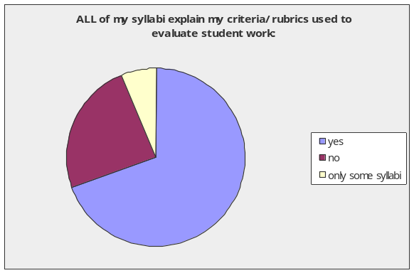

The course(s) I teach is/are offered by the: (if you teach for more than one college/school, select a primary location)
Answer Options | Response Percent | Response Count
College of Liberal Arts and Social Sciences (CLASS) | 55.6% | 25
College of Natural and Applied Sciences (CNAS) | 26.7% | 12
School of Business and Public Administration (SBPA) | 6.7% | 3
School of Education (SOE) | 6.7% | 3
School of Nursing and Health Sciences (SNHS) | 4.4% | 2
answered question |  | 45
skipped question |  | 1

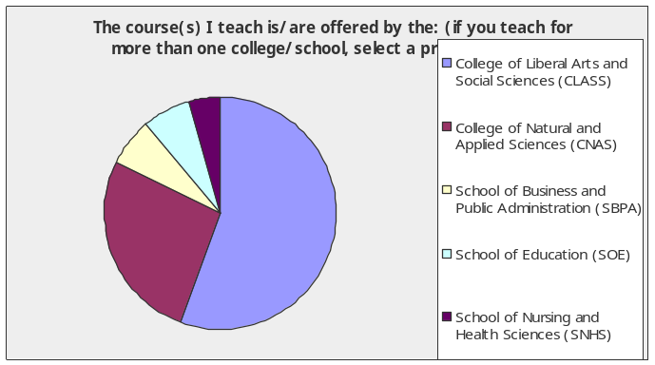

I have taught for:
Answer Options | Response Percent | Response Count
1-5 years | 41.3% | 19
6-10 years | 10.9% | 5
11-15 years | 13.0% | 6
16-20 years | 10.9% | 5
21-25 years | 8.7% | 4
26-more years | 15.2% | 7
answered question |  | 46
skipped question |  | 0

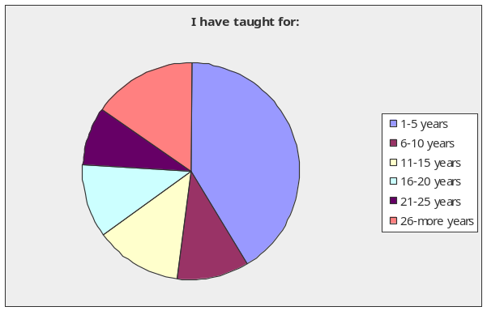

The BOR/AFT Agreement requires that a syllabus be distributed:
Answer Options | Response Percent | Response Count
before midterm | 0.0% | 0
the first week of classes | 33.3% | 15
the first day of class | 53.3% | 24
none above | 0.0% | 0
don't know | 13.3% | 6
answered question |  | 45
skipped question |  | 1

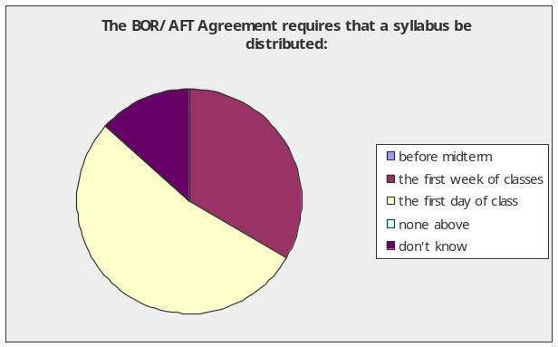

ALL of my syllabi quote the Catalog Course Description:
Answer Options | Response Percent | Response Count
yes | 78.3% | 36
no | 10.9% | 5
only some syllabi | 10.9% | 5
answered question |  | 46
skipped question |  | 0

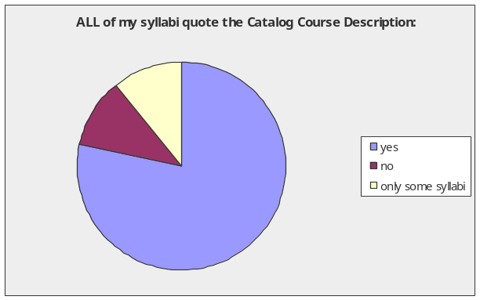

ALL of my syllabi state the course learning objectives:
Answer Options | Response Percent | Response Count
yes | 100.0% | 46
no | 0.0% | 0
only some syllabi | 0.0% | 0
answered question |  | 46
skipped question |  | 0

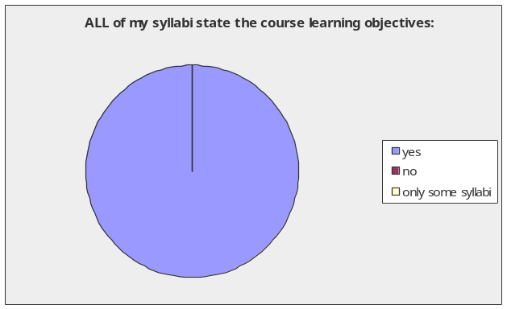

ALL of my syllabi contain a detailed course calendar:
Answer Options | Response Percent | Response Count
yes | 78.3% | 36
no | 8.7% | 4
only some syllabi | 13.0% | 6
answered question |  | 46
skipped question |  | 0

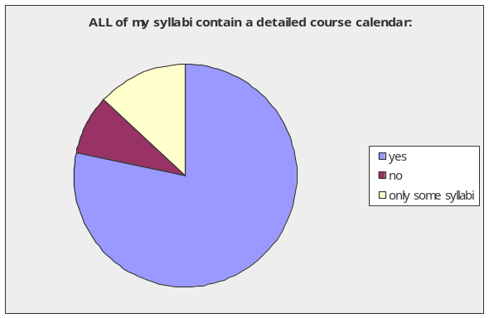

ALL of my syllabi relate the course readings to student learning, stating something like the following “after reading chapter 1 be able to define key terms and analyze the subject”:
Answer Options | Response Percent | Response Count
yes | 32.6% | 15
no | 63.0% | 29
only some syllabi | 4.3% | 2
answered question |  | 46
skipped question |  | 0

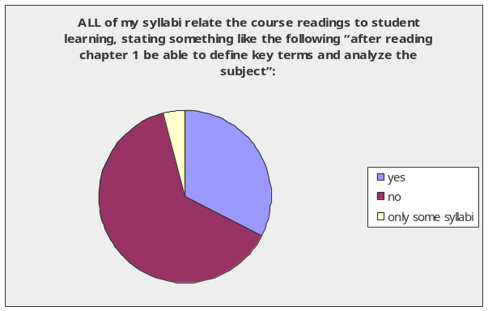

ALL of my syllabi explain the percentage each assignment contributes to the students’ final grade:
Answer Options | Response Percent | Response Count
yes | 97.8% | 45
no | 2.2% | 1
only some syllabi | 0.0% | 0
answered question |  | 46
skipped question |  | 0

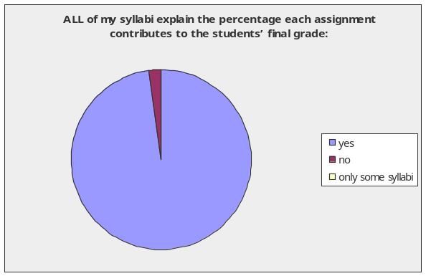

ALL of my syllabi explain my attendance policy:
Answer Options | Response Percent | Response Count
yes | 93.5% | 43
no | 4.3% | 2
only some syllabi | 2.2% | 1
answered question |  | 46
skipped question |  | 0

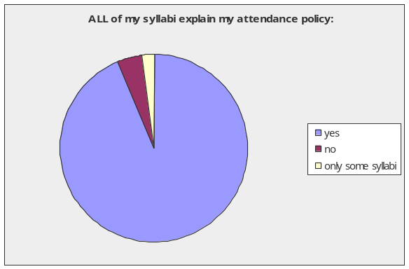

ALL of my syllabi give specific instructions on some aspect of the course requirements, such as, classroom rules, how to complete assignments, how to read, speed read, or write reports:
Answer Options | Response Percent | Response Count
yes | 82.6% | 38
no | 15.2% | 7
only some syllabi | 2.2% | 1
answered question |  | 46
skipped question |  | 0

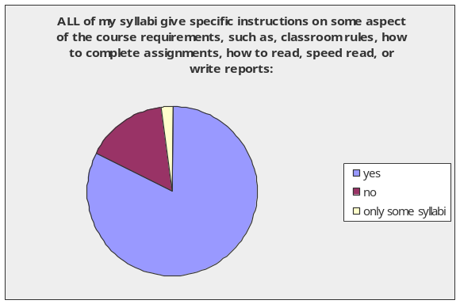

ALL of my syllabi explain my criteria/rubrics used to evaluate student work:
Answer Options | Response Percent | Response Count
yes | 69.6% | 32
no | 23.9% | 11
only some syllabi | 6.5% | 3
answered question |  | 46
skipped question |  | 0

ALL of my syllabi quote the University's plagiarism policy:
Answer Options | Response Percent | Response Count
yes | 60.0% | 27
no | 33.3% | 15
only some syllabi | 6.7% | 3
answered question |  | 45
skipped question |  | 1

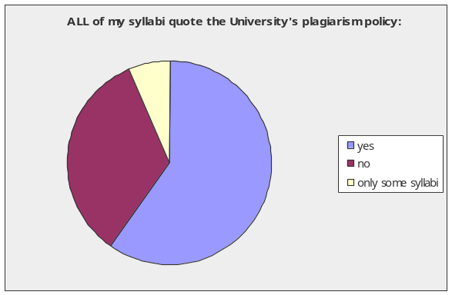

ALL of my syllabi explain my student learning outcomes assessment project for the course:
Answer Options | Response Percent | Response Count
yes | 55.8% | 24
no | 41.9% | 18
only some syllabi | 2.3% | 1
answered question |  | 43
skipped question |  | 3

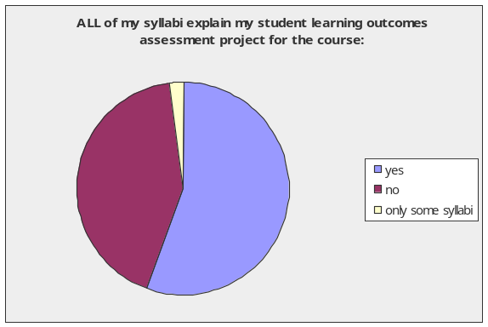
ALL of my syllabi contain an ADA accommodation statement:
Answer Options | Response Percent | Response Count
yes | 80.0% | 36
no | 15.6% | 7
only some syllabi | 4.4% | 2
answered question |  | 45
skipped question |  | 1

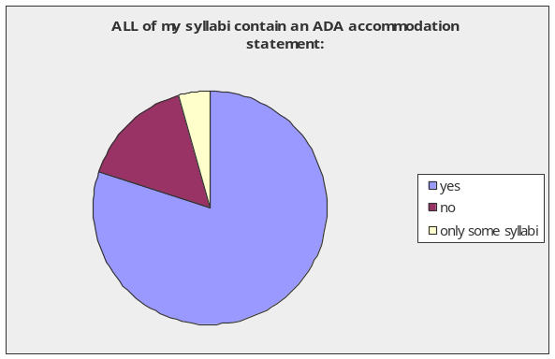

Answer this item if you participated in two or more syllabus assessment surveys: did your participation in the syllabus survey help you improve your syllabi?
Answer Options | Response Percent | Response Count
yes | 36.4% | 8
no | 63.6% | 14
Please comment |  | 10
answered question |  | 22
skipped question |  | 24

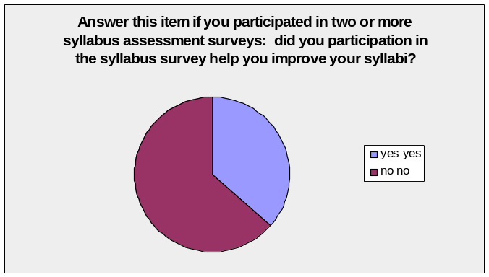

Appendix II
Written Responses / Comments

Is there something special you would like to report about your syllabi?
Information on office hour should also be a major component in survey
The number of years taught should be clarified; at UoG or including other colleges.
I only teach graduate courses, so some of these criteria may not apply, as such. I have a different set of expections for graduate students regarding what I can assume they already know, and graduate courses are sometimes more flexible and fluid in their structure. This should be considered in my answers, above.
While I may not include the specifics of student learning regarding assessment, they are included on my course webpage. This would include other information I may have responded "no" to in the survey. The course syllabus for each of the courses I teach are available electronically rather than in hard copy.
An accurate student learning outcomes assessment project cannot provide a detailed explanation to the subjects of the assessment project.
Because of alternative learning styles, I do not anticipate that any specific student learning objective is achieved by reading assignments alone. If that were true, we could eliminate human instructors and simply make everything self-study.
"The course syllabus is the contract between students and faculty."
I never heard of assessment referred to as a "student learning outcomes assessment project"
I find some of the items above to which I answered "no" somewhat inapplicable to the courses that I teach. For example,I don't require my students to write reports so I don't find it necessary to quote in my syllabi the University Plagiarism policy. In Item No. 14, I answered "no" because I don't require an assessment project in my course. I just require my students to get an overall rating of at least 60% in the long quizzes and final exam that I give to the class. My syllabi contain the number of long quizzes and the coverage of the final exam as well as the letter-grade equivalency of the ratings that the students may get.
I include a short list of helpful websites on my syllabi.
I always provide guidelines on how to write the critical review essays.
For this semester, we were instructed to include the HINI addendum info. and I did include.
They were prepared for WASC. I never give them to students. I have other handouts that cover the important aspects of the courses - and even several of those in the WASC syllabi.
My syllabus is on the course MOODLE. So detailed course calendar IS the MOODLE -- not on a separate set of papers.
My syllabi are long. Sometimes rubrics are separate. I assign students to read and mark up my syllabi. In class we discuss and clarify. Each student tells class an important part. Sometimes students write or respond to a syllabus quiz.
7. Schedule is distributed separately. Syllabus is already 16 pages!!
9. My syllabus includes a breakdown of the grading to categories not to individual assignments.
12. Rubrics are distributed separately.
13. If there is a university policy (besides "Don't!) I'd like to know where it is; when I redid my syllabus I tried to find it and asked several people who ought to have known.

Answer this item if you participated in two or more syllabus assessment surveys: did your participation in the syllabus survey help you improve your syllabi?
Please comment
I believe that this survey suggests that there are more items I would need to add to my already 10-page syllabi. Making some of the information available is important, but I don't necessarily agree that they all need to be included in the course syllabus. Afterall, what is the purpose of a course syllabus, a course catalog, a student handbook, etc.
The correct choices in this survey should not be Yes, No, and Only Some Syllabi, since "No" and "Only some syllabi" are potentially identical responses to the statement, "All of my syllabi... etc." The correct wording should be: "Do your syllabi include x, y, and z?" with the choices being "Yes, they all do.", "Yes, some of them do," and "No, none of my syllabi include x,y,z."
Some of the items that I didn't include in the past, I now include them for students to know from the first of day.
I just changed the dates on the syllabi I have.
they were already well done.
It improved the way I stated the student learning outcomes. It also improved the way I described the activities and the workload that the student is expected to do in order to fulfill the requirements of the course.
It gave me a more strong sense of accountability and what inclusions have I missed or important info have I omitted.
I learned what WASC insisted on, and wrote them accordingly. That desired by WASC isn't greatly pertinent to my handouts or my courses.
I have used the 'best practices' for all of my syllabi.
I’ve been editing and revising (perfecting?) syllabi for years. It’s good that some parts of UOG are asking some questions about syllabi. Much more needs to be done.
didn't previously include the ADA statement, plagiarism policy, and the UOG catalog descriptions.

Appendix III
Comparison of Responses from Surveys to Date

#1. Faculty status | 09 responses  n = 46 | 06 responses  n=40 | 04 responses  n=48
full-time | 32 | 33 | 32
part-time | 14 | 7 | 16

#2. Years of teaching | 09 responses  n = 46 | 06 responses  n=40 | 04 responses  n=48
1-5 years | 19 | 12 | 12
6-10 years | 5 | 9 | 8
11-15 years | 6 | 5 | 8
16-20 years | 5 | 6 | 3
21-25 years | 4 | 2 | 6
26 or more years | 7 | 6 | 11

#3. The BOR/AFT Agreement requires syllabi distribution by | 09 responses  n = 45 | 06 responses  n=40 | 04 responses  n=48
before midterm | 0 | 0 | 0
the first week of classes | 15 correct answer | 19 correct answer | 17 correct answer
the first day | 24 | 19 | 11
none above | 0 | 0 | 3
don't know | 6 | n/a | n/a
no response | 1 | 2 | 5

#4. All my syllabi quote Catalog course description | 09 responses  n = 46 | 06 responses  n=40 | 04 responses  n=48
Yes | 36 | 32 | 34
No | 5 | 6 | 12
Some | 5 | 2 | 2
no response | 0 | 0 | 0

#5. All syllabi state learning objectives | 09 responses  n = 46 | 06 responses  n=40 | 04 responses  n=47
Yes | 46 | 37 | 43
No | 0 | 1 | 2
Some | 0 | 2 | 1
no response | 0 | 0 | 1

#6. All syllabi contain a course calendar | 09 responses  n = 46 | 06 responses  n=40 | 04 responses  n=48
Yes | 36 | 32 | 43
No | 4 | 4 | 2
Some | 6 | 4 | 3
no response | 0 | 0 | 0

#7. All syllabi relate reading to learning | 09 responses  n = 46 | 06 responses  n=40 | 04 responses  n=48
Yes | 15 | 15 | 14
No | 29 | 14 | 28
Some | 2 | 10 | 4
no response | 0 | 1 | 2

#8. All syllabi explain assignment percentages | 09 responses  n = 46 | 06 responses  n=40 | 04 responses  n=48
Yes | 45 | 34 | 45
No | 1 | 3 | 2
Some | 0 | 2 | 0
no response | 0 | 1 | 1

#9. All syllabi explain attendance policy | 09 responses  n = 46 | 06 responses  n=40 | 04 responses  n=48
Yes | 43 | 36 | 44
No | 2 | 3 | 3
Some | 1 | 1 | 1
no response | 0 | 0 | 0

#10. All syllabi give specific instructions on requirements | 09 responses  n = 46 | 06 responses  n=40 | 04 responses  n=48
Yes | 38 | 31 | 32
No | 7 | 5 | 9
Some | 1 | 3 | 1
no response | 0 | 1 | 6

#11. All syllabi explain rubrics to evaluate work | 09 responses  n = 46 | 06 responses  n=40 | 04 responses  n=48
Yes | 32 | 21 | 23
No | 11 | 10 | 18
Some | 3 | 8 | 7
no response | 0 | 1 | 0

#12. All syllabi quote plagiarism policy | 09 responses  n = 46 | 06 responses  n=40 | 04 responses  n=48
Yes | 27 | 24 | 9
No | 15 | 14 | 36
Some | 3 | 2 | 3
no response | 1 | 0 | 0

#13. All syllabi explain SLO assessment project | 09 responses  n = 46 | 06 responses  n=40 | 04 responses  n=48
Yes | 24 | 10 | 16
No | 18 | 19 | 30
Some | 1 | 9 | 1
no response | 3 | 2 | 1

#14. All syllabi contain an ADA statement | 09 responses  n = 46 | 06 responses  n=40 | 04 responses  n=48
Yes | 36 | 30 | 5
No | 7 | 6 | 40
Some | 2 | 3 | 2
no response | 1 | 1 | 1

