STUDENT SUCCESS/FAILURE RATES IN MATHEMATICS FOR
FALL 2004, SPRING 2005, FALL 2005 AND SPRING 2006

BY: HENRY J. TAIJERON, Ph.D.
ASSOCIATE PROFESSOR OF MATHEMATICS
INTERIM ASSOCIATE DEAN, CNAS
FINAL VERSION SUBMITTED: JANUARY 3, 2007

1. Introduction. The primary goal of this work is to investigate the effectiveness of our mathematics placement test recommendations and that of our prerequisite mathematics courses. We summarize the success/failure rates of students placed in these courses by the placement test recommendations and those students enrolled in these courses by meeting math prerequisites.

The Mathematical Association of America’s (MAA’s) Basic Algebra Test is the placement test that students take. Twenty-five (25) questions are on the test and students are placed in math courses based on the number of correct answers that they score on the test. The placement cutoffs recommendations place students in MA085-Level I, MA085-Level II, MA088/MA110/MA151 or MA161a/MA165. Three different cutoffs recommendations have been used to determine the placement of students. These proposed cutoffs (Cutoffs I, II and III) are given in Section 2.1. The question of which cutoffs are most effective and most beneficial for students is constantly being addressed. This is the reason why several cutoffs recommendations have been proposed since the MAA test was first implemented during the early part of the 1990’s. The current cutoffs that we are using for students are given in Table 2.1-3 (referred to as Cutoffs III). These are the cutoffs recommended by Dr. Patrick Perry (Dr. Patrick Perry, Associate Professor of Mathematics, was employed at UOG from August, 1993 to July, 2002. He was Chair for the Division of Mathematical Sciences during the latter part of his tenure at UOG). Table 2.1-1 (referred to as Cutoffs I) are the very first cutoffs used for placing students in our math courses. Cutoffs I was recommended by Dr. Arlo Schurle (Dr. Arlo Schurle, Professor of Mathematics, was employed at UOG from August, 1991 to May, 2000. He was also Chair for the Division of Mathematical Sciences during the latter part of his tenure at UOG). The Cutoffs given in Table 2.1-2 (referred to as Cutoffs II) are the cutoffs recommended when the MAA test was re-instated during the academic year (AY) 2003-2004. Cutoffs II was recommended by Prof. Martin DeBeer (Professor Martin DeBeer, Associate Professor of Mathematics, is currently the Unit Representative for the Mathematical Sciences Unit). It suffices to note that all three cutoffs recommendations meet MAA’s placement recommendations.

We summarize the success/failure rates of students exiting mathematics courses for fall 2004, spring 2005, fall 2005 and spring 2006. The data were forwarded to us by the Registrar’s Office. We analyze the data as follows:

- In Section 2, we summarize the success/failure rates of students placed in math courses by the placement test recommendations. The three cutoffs recommendations mentioned above are given in Table 2.1-1, Table 2.1-2 and Table 2.1-3. We present a summary of the success/failure rates of students enrolled in MA110, MA151, MA161a and MA165. We also present the table used to compute the mean number of semesters it took students placed in MA085 to exit MA085 and the standard deviation.
- In Section 3, we summarize the success/failure rates of students enrolled in math courses by meeting math prerequisites. These courses include MA110, MA151, MA161a-b, MA165, MA203, MA204, MA205, MA302, MA341, MA375, MA385, MA411, MA421, MA422 and MA451.
- In Section 4, we present a summary of the math placement results taken by students from some of our local public and private high schools.
- In Section 5, we present Prof. Han Tower Chen’s preliminary assessment study results and Dr. Chu-Tak Tseng’s preliminary assessment study results on students enrolled in MA110 and PH251, respectively.
- In Section 6, we present a summary of our overall results. This section also includes concerns that need to be addressed.
- Finally, in Section 7, we present recommendations that the mathematics faculty should review and discuss to make changes toward improving the learning environment of our students.

Note that this study is not about assessing learning objectives using direct measures of assessment (except for possibly Prof. Chen’s and Dr. Tseng’s assessment results in Section 5). It was initially done to determine the most effective cut-offs recommendations of the math placement test that would most benefit students. The study was motivated during the spring 2005 semester when Registrar forwarded to our office the grades of students enrolled in math courses for the fall 2004 semester. It was observed that 27% of students who enrolled in MA085 exited MA085 within one semester (See Table 2.2-3 for a percentage comparison of “MA085 one-semester completers” based on the three recommended cutoffs). We believe that a significant percentage of these students could have passed MA110/MA151 without having to enroll in MA085. For this reason, we recommended to Prof. Martin DeBeer, Mathematical Sciences Unit Representative, that we implement Dr. Perry’s recommended Cutoffs III since it would have placed most of these students in MA110/MA151 rather than in MA085. We will follow-up by observing how the change affected the success rates of students placed in college-level math courses (MA110, MA151, MA161a and MA165). This follow-up is presented in Sections 2.3, 2.4 and 2.5.

2. Success/Failure Rates of Students Placed in Mathematics Courses by the Mathematics Placement Test Cutoffs Recommendations. In this section, we present the three cutoffs recommendations (Cutoffs I, II and III) and a summary of results on how these cutoffs recommendations affected students. The summary includes the percentage breakdown of students placed in MA085, MA110, MA151, MA161a and MA165. It includes a summary of the percentages of “MA085 one-semester completers.” Most importantly, we present a summary of the percentages of the success/failure rates of students placed in our college-level mathematics courses by our mathematics placement test. The mean number of semesters that it took students to exit MA085 and the standard deviation are also included in this section. Finally, we also present preliminary assessment studies done by Prof. Han Tower Chen for MA110 and Dr. Chu-Tak Tseng for PH251.

2.1. MAA Mathematics Placement Test Recommended Cutoffs. The recommended cutoffs used previously are given in Tables 2.1-1 (Cutoffs I) and 2.1-2 (Cutoffs II). Table 2.1-3 gives the cutoffs recommendations that are currently being used (Cutoffs III).

TABLE 2.1-1 (CUT-OFFS I)
Cutoffs used when the MAA Basic Algebra Test was first administered
(Recommended by Dr. Arlo Schurle*)
Range of Scores (correct answers) | Placement
15 – 25 | MA161a, MA165
11 – 14 | MA088, MA110, MA151
6 – 10 | MA085, LEVEL II
0 – 5 | MA085, LEVEL I
*Dr. Arlo Schurle, Professor of Mathematics, was employed at UOG from August, 1991 to May, 2000.

TABLE 2.1-2 (CUT-OFFS II)
Cutoffs used when the MAA Basic Algebra Test was re-instated during the AY 03-04
(Recommended by Prof. Martin DeBeer*)
Range of Scores (correct answers) | Placement
22 – 25 | MA161a, MA165
18 – 21 | MA088, MA110, MA151
11 – 17 | MA085, LEVEL II
0 - 10 | MA085, LEVEL I
*Professor Martin DeBeer, Associate Professor of Mathematics, is currently the Unit Representative of
the Mathematical Sciences Unit.

TABLE 2.1-3 (CUT-OFFS III)
Cutoffs that are currently being used
(Recommended by Dr. Patrick Perry)*
Range of Scores (correct answers) | Placement
20 – 25 | MA161a, MA165
14 – 19 | MA088, MA110, MA151
10 – 13 | MA085, LEVEL II
0 - 9 | MA085, LEVEL I
*Dr. Patrick Perry, Associate Professor of Mathematics, was employed at UOG from August, 1993 to
July, 2002.

Remark 2.1-1: The concepts covered in MA085, Level I are concepts covered in most elementary schools. MA085, Level II are concepts covered in most middle school and in freshman high school Algebra I.

  - Percentage Breakdown of Students Placed in Math Courses Using Cutoffs II/Cutoffs III and MA085 “One-Semester Completers” Using Cutoffs I/II/III. In this section, we present the percentage breakdown of students placed in our math courses for the AY 04-05 (Cutoffs II) and for the AY 05-06 (Cutoffs III). Table 2.2-1 gives a summary of the math placement percentage breakdown using Cutoffs II. Table 2.2-2 gives a summary of the math placement percentage breakdown using Cutoffs III. We also present in Table 2.2-3 the percentage breakdown of students who exited the Developmental Math Program within one semester (or would have exited this program depending on the cutoffs recommendations used).

Table 2.2-1
Math Placement Percentage Breakdown using Cutoffs II Recommendations
(fall 2004/spring 2005)
PLACEMENT (CORRECT ANSWERS) | NO. OF STUDENTS | PERCENT
MA085, Level I (0-10) | 562 | 56.7%
MA085, Level II (11-17) | 294 | 29.6%
MA110/MA151 (18-21) | 77 | 7.8%
MA161a/MA165 (22-25) | 59 | 5.9%
TOTAL | 992
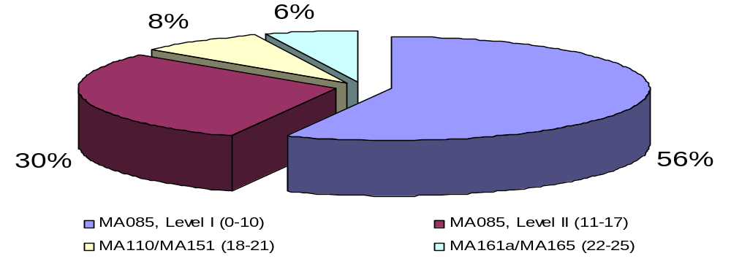

Remark 2.2-1: From Table 2.2-1, we see that with cutoffs II recommendations, approximately 86% of students were placed in MA085.

Table 2.2-2
Math Placement Percentage Breakdown using Cutoffs III Recommendations (fall 2005/spring 2006):
PLACEMENT (CORRECT ANSWERS) | NO. OF STUDENTS | PERCENT
MA085, Level I (0-9) | 283 | 37.3%
MA085, Level II (10-13) | 193 | 25.5%
MA110/MA151 (14-19) | 176 | 23.2%
MA161a/MA165 (20-25) | 106 | 14.0%
TOTAL | 758
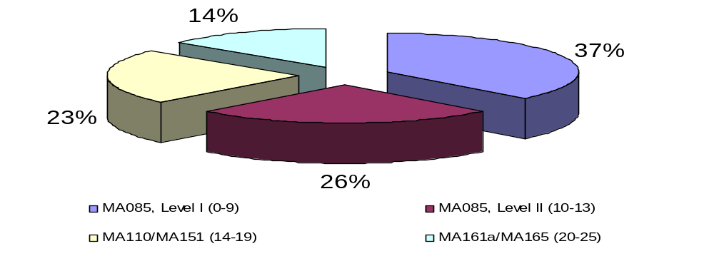

Remark 2.2-2: From Table 2.2-2, we see that with cutoffs III recommendations, approximately 63% of students were placed in MA085.

Table 2.2-3
Students Exiting the Developmental Math Program within One Semester.
(Comparison of passing rates depending if Cutoffs I, II or III is used)
SEMESTER | MATH PLACEMENT RECOMMENDATIONS  (CORRECT ANSWERS FOR MA085 PLACEMENT) | # OF STUDENTS ENROLLED IN MA085 FOR 1ST TIME | # OF STUDENTS COMPLETING IN ONE SEMESTER | % OF STUDENTS WHO EXITED IN ONE SEMESTER
FA 04 | CUTOFFS I (0 – 10) | 233 | 20 | 8.6%
 | CUTOFFS II (0 – 17) * | 368 | 101 | 27.4%
 | CUTOFFS III (0 – 13) | 299 | 56 | 18.7%
SP 05 | CUTOFFS I (0 – 10) | 105 | 8 | 7.6%
 | CUTOFFS II (0 – 17) * | 148 | 26 | 17.6%
 | CUTOFFS III (0 – 13) | 133 | 16 | 12.0%
FA 05 | CUTOFFS I (0 – 10) | 154 | 23 | 14.9%
 | CUTOFFS III (0 – 13) * | 241 | 63 | 26.1%
SPR 06 | CUTOFFS I (0 – 10) | 108 | 11 | 10.2%
 | CUTOFFS III (0 – 13) * | 162 | 21 | 13.0%
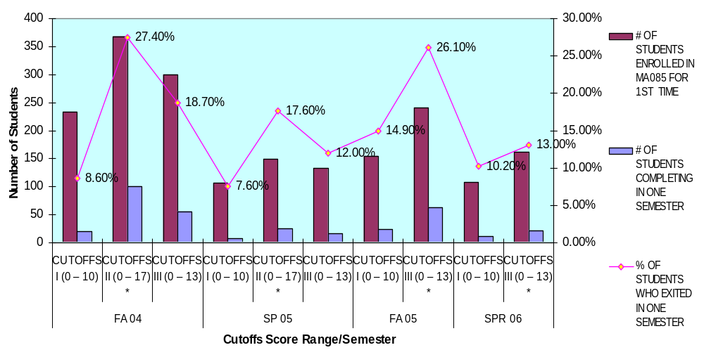

Remark 2.2-3: Table 2.2-3 gives a summary of the math placement percentage breakdown of students who exited MA085 in one semester depending on whether Cutoffs I, II or III is used.
In Table 2.3-3, * indicates the cutoffs that were used for the indicated semester. From Table 2.2-3, we see that:

- Approximately 10% of students exited MA085 within one semester if Cutoffs I is used.
- Approximately 25% of students exited MA085 within one semester if Cutoffs II is used.
- Approximately 19% of students exited MA085 within one semester if Cutoffs III is used.

2.3. Success/Failure Rates of Students Placed in MA110 Via the Math Placement Test Recommendations. In this section, we present a summary of results for those students who enrolled in MA110 placed in this course via Cutoffs II (AY 04-05) and Cutoffs III (AY 05-06).

TABLE 2.3-1
MA110 SUCCESS/FAILURE RATES
PLACEMENT USING CUTOFFS II (FALL 2004, SPRING 2005)
MATH PLACEMENT  SCORE | NO. OF A’S | NO. OF B’S | NO. OF C’S | NO. OF D’S | NO. OF F’S | NO. OF W/UW/ OTHER | TOTAL
< 17 | 2 | 0 | 1 | 0 | 3 | 2 | 8
18 – 21 | 23 | 10 | 5 | 6 | 4 | 2 | 50
22-25 | 4 | 1 | 2 | 0 | 1 | 1 | 9
TOTAL | 29 | 11 | 8 | 6 | 8 | 5 | 67
PERCENT | 43.3% | 16.4% | 11.9% | 9.0% | 11.9% | 7.5%
18-21 (Percent) | 46% | 20% | 10% | 12% | 8% | 4% | 100%
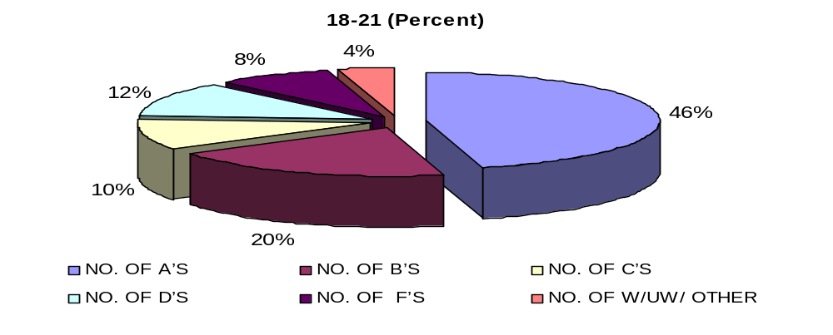

Remark 2.3-1: From Table 2.3-1, we note that:
- 8 students “illegally” enrolled in MA110 (They had less than 18 correct answers).
- 9 enrolled in MA110 who scored more than 21 correct answers (could have enrolled in MA161a or MA65).
- For students scoring 18-21 (students who actually placed in MA110 using CUTOFFS II):
  - Approximately 76% passed the course with a grade of C or better (about 88% passed with a grade of D or better).
  - Approximately 8% received a grade of F for the course.
  - Approximately 4% did not complete the course.
- Overall results for fall 2004, spring 2005:
  - Approximately 72% passed the course with a grade of C or better (about 81% passed with a grade of D or better).
  - Approximately 12% received a grade of F for the course.
  - Approximately 8% did not complete the course.

TABLE 2.3-2
MA110 SUCCESS/FAILURE RATES
PLACEMENT USING CUTOFFS III (FALL 2005, SPRING 2006)
MATH PLACEMENT SCORE | NO. OF A’S | NO. OF B’S | NO. OF C’S | NO. OF D’S | NO. OF F’S | NO. OF W/UW/ OTHER | TOTAL
< 13 | 1 | 1 | 1 | 0 | 0 | 1 | 4
14 – 17 | 11 | 9 | 13 | 7 | 7 | 22 | 69
18 – 19 | 12 | 4 | 3 | 1 | 2 | 9 | 31
20 – 25 | 3 | 1 | 0 | 1 | 0 | 0 | 5
TOTAL | 27 | 15 | 17 | 9 | 9 | 32 | 109
PERCENT | 24.8% | 13.8% | 15.6% | 8.3% | 8.3% | 29.4%
14-19 (Total ) | 23 | 13 | 16 | 8 | 9 | 31 | 100
14-19 (Percent) | 23% | 13% | 16% | 8% | 9% | 31% | 100%
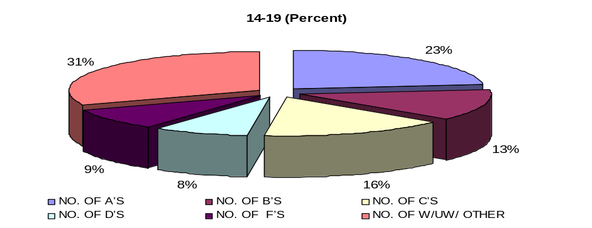

Remark 2.3-2: From Table 2.3-2, we note that:

- 4 students “illegally” enrolled in MA110 (They had less than 14 correct answers).
- 5 enrolled in MA110 who scored more than 19 correct answers (could have enrolled in MA161a or MA65).
- For students scoring 14-19 (students who actually placed in MA110 using CUTOFFS III):
  - Approximately 52% passed the course with a grade of C or better (about 60% passed with a grade of D or better).
  - Approximately 9% received a grade of F for the course.
  - Approximately 31% did not complete the course.
- Overall results for fall 2005, spring 2006:
  - Approximately 54% passed the course with a grade of C or better (about 63% passed with a grade of D or better).
  - Approximately 8% received a grade of F for the course.
  - Approximately 29% did not complete the course.
- About 48% of students who scored in the range 14-17 successfully passed MA110 with a grade of C or better (about 58% passed with a grade of D or better). These students would have been placed in MA085 if Cutoffs II was used.
- Although 3 of the 4 illegal students received a grade of C or better (75%), it is a major concern that “illegal students” are being allowed to enroll in courses.

2.4. Success/Failure Rates of Students Placed in MA151 Via the Math Placement Test. In this section, we present a summary of results for those students who enrolled in MA151 via Cutoffs II (AY 04-05) and Cutoffs III (AY 05-06).

TABLE 2.4-1
MA151 SUCCESS/FAILURE RATES
PLACEMENT USING CUTOFFS II (FALL 2004, SPRING 2005)
MATH PLACEMENT SCORE | NO. OF A’S | NO. OF B’S | NO. OF C’S | NO. OF D’S | NO. OF F’S | NO. OF W/UW/ OTHER | TOTAL
< 17 | 0 | 0 | 0 | 0 | 0 | 0 | 0
18 – 21 | 5 | 12 | 5 | 1 | 0 | 7 | 30
22 – 25 | 2 | 2 | 0 | 0 | 0 | 1 | 5
TOTAL | 7 | 14 | 5 | 1 | 0 | 8 | 35
PERCENT | 20% | 40% | 14.3% | 2.9% | 0% | 22.9%
18-21 (Percent) | 16.7% | 40% | 16.7% | 3.3% | 0% | 23.3% | 100%
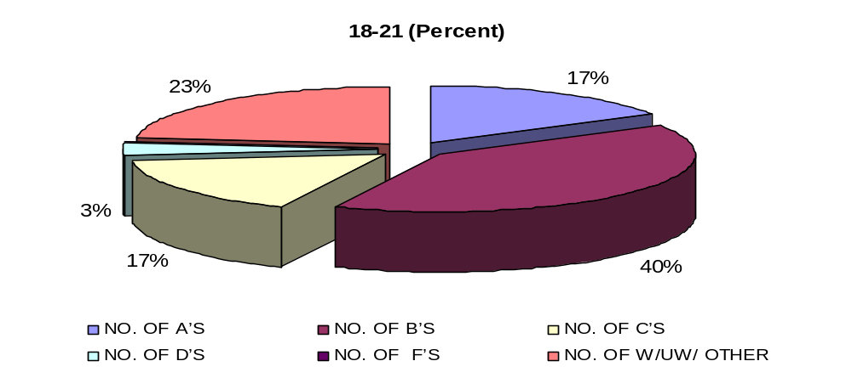

Remark 2.4-1: From Table 2.4-1, we see that:
- For students scoring 18-21 (students who actually placed in MA151 using CUTOFFS II):
  - Approximately 73% passed the course with a grade of C or better (about 77% passed with a grade of D or better).
  - No one received an F for the course.
  - Approximately 23% did not complete the course.
- Overall results for fall 2004, spring 2005
  - Approximately 74% passed the course with a grade of C or better (about 77% passed with a grade of D or better).
  - No one received an F grade for the course.
  - Approximately 23% did not complete the course.

TABLE 2.4-2
MA151 SUCCESS/FAILURE RATES
PLACEMENT USING CUTOFFS III (FALL 2005, SPRING 2006)
MATH PLACEMT SCORE | NO. OF A’S | NO. OF B’S | NO. OF C’S | NO. OF D’S | NO. OF F’S | NO. OF W/UW/ OTHER | TOTAL
< 13 | 1 | 1 | 0 | 0 | 0 | 0 | 2
14 – 17 | 5 | 10 | 7 | 6 | 9 | 4 | 41
18 – 19 | 1 | 5 | 7 | 2 | 1 | 1 | 17
20 – 25 | 7 | 2 | 3 | 0 | 0 | 0 | 12
TOTAL | 14 | 18 | 17 | 8 | 10 | 5 | 72
PERCENT | 19.4% | 25.0% | 23.6% | 11.1% | 13.9% | 6.9%
14-19 (Total ) | 6 | 15 | 14 | 8 | 10 | 5 | 58
14-19 (Percent) | 10.3% | 25.9% | 24.1% | 13.8% | 17.2% | 8.6% | 100%
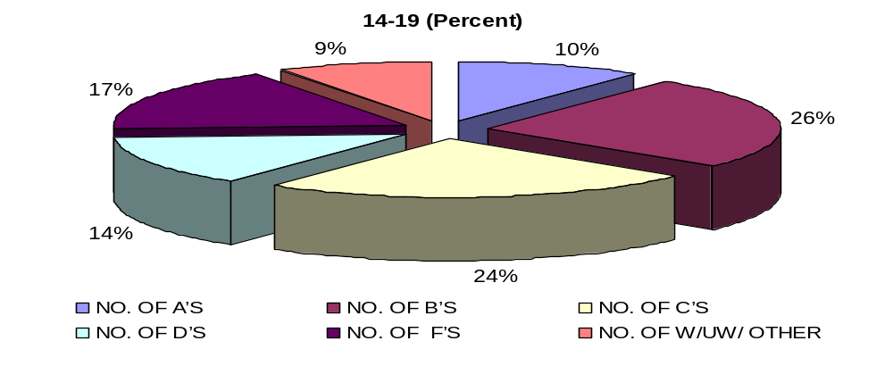

Remark 2.4-2: From Table 2.4-2, we note that:
- 2 students “illegally” enrolled in MA151 (They had less than 14 correct answers).
- For students scoring 14-19 (students who actually placed in MA151 using CUTOFFS III):
  - Approximately 60% passed the course with a grade of C or better (about 74% passed with a grade of D or better).
  - Approximately 17% received a grade of F for the course.
  - Approximately 9% did not complete the course.
- Overall results for fall 2005, spring 2006:
  - Approximately 68% passed the course with a grade of C or better (about 79% passed with a grade of D or better).
  - Approximately 14% received a grade of F for the course.
  - Approximately 7% did not complete the course.
- About 54% of students who scored in the range 14-17 successfully passed MA151 with a C or better (about 68% passed with a grade of D or better). These students would have been placed in MA085 if Cutoffs II was used.
- Although both “illegal” students received passing grades, we are still very concern that “illegal” students are being allowed to enroll in courses.

2.5. Success/Failure Rate of Students Placed in MA161a/MA165 Via the Math Placement Test. In this section, we present a summary of results for those students who enrolled in MA161a/MA165 via Cutoffs II and Cutoffs III.

TABLE 2.5-1
MA161a/MA165 SUCCESS/FAILURE RATES
PLACEMENT USING CUTOFFS II (FALL 2004, SPRING 2005)
PLACEMENT USING CUTOFFS III (FALL 2005, SPRING 2006)
COURSE | SEMESTER | NO. OF A’S | NO. OF B’S | NO. OF C’S | NO. OF D’S | NO. OF F’S | NO. OF W/UW/ OTHER | TOTAL
MA161a | FA04/SP05 | 6 | 5 | 7 | 1 | 1 | 2 | 22
 | PERCENT | 27.3% | 22.7% | 31.8% | 4.5% | 4.5% | 9.1%
 | FA05/SP06 | 12 | 9 | 9 | 3 | 2 | 9 | 44
 | PERCENT | 27.3% | 20.5% | 20.5% | 6.8% | 4.5% | 20.5%
MA165 | FA04/SP05 | 2 | 3 | 5 | 0 | 0 | 3 | 13
 | PERCENT | 15.4% | 23.1% | 38.5% | 0% | 0% | 23.1%
 | FA 05/SP06 | 9 | 11 | 3 | 2 | 1 | 2 | 28
 | PERCENT | 32.1% | 39.3% | 10.7% | 7.1% | 3.6% | 7.1%
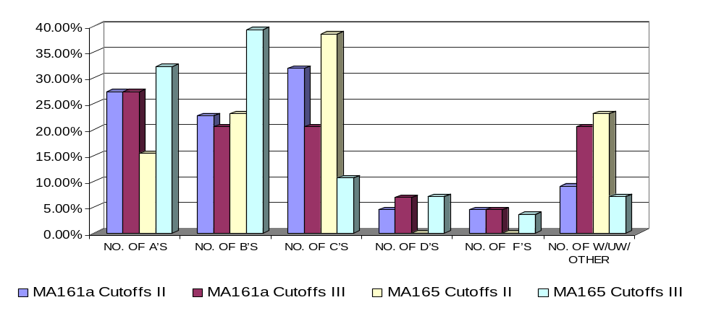

Remark 2.5-1: From Table 2.5-1, we see that:
- MA161a success/failure rates:
  - Approximately 82% of students placed in MA161a using Cutoffs II passed the course with a grade of C or better (about 86% passed with a grade of D or better).
  - Approximately 68% of students placed in MA161a using Cutoffs III passed the course with a grade of C or better (about 75% passed with a grade of D or better).
  - Approximately 5% of students placed in MA161a using Cutoffs II received an F for the course.
  - Approximately 5% of students placed in MA161a using Cutoffs III received an F for the course.
  - Approximately 9% of students placed in MA161a using Cutoffs II were not successful in completing the course.
  - Approximately 21% of students placed in MA161a using Cutoffs III were not successful in completing the course.
- MA165 success/failure rates:
  - Approximately 77% of students placed in MA165 using Cutoffs II passed the course with a grade of C or better (No one received a D).
  - Approximately 82% of students placed in MA165 using Cutoffs III passed the course with a grade of C or better (about 89% passed with a grade of D or better).
  - Approximately 23% of students placed in MA165 using Cutoffs II were not successful in completing the course (No one received an F).
  - Approximately 4% of students placed in MA165 using Cutoffs III received an F for the course.
  - Approximately 7% of students placed in MA165 using Cutoffs III were not successful in completing the course.

TABLE 2.5-2
MA161a/MA165 SUCCESS/FAILURE RATES
PLACEMENT USING CUTOFFS III -FALL 2005, SPRING 2006
(These students would have been placed in MA110 using CUTOFFS II)
COURSE | MATH PLACEMT SCORE | NO. OF A’S | NO. OF B’S | NO. OF C’S | NO. OF D’S | NO. OF F’S | NO. OF W/UW/ OTHER | Total
MA161A | 20-21 | 2 | 4 | 4 | 0 | 2 | 5 | 17
 | PERCENT | 11.8% | 23.5% | 23.5% | 0.0% | 11.8% | 29.4%
MA165 | 20-21 | 3 | 0 | 2 | 0 | 1 | 1 | 7
 | PERCENT | 42.9% | 0.0% | 28.6% | 0.0% | 14.3% | 14.3%
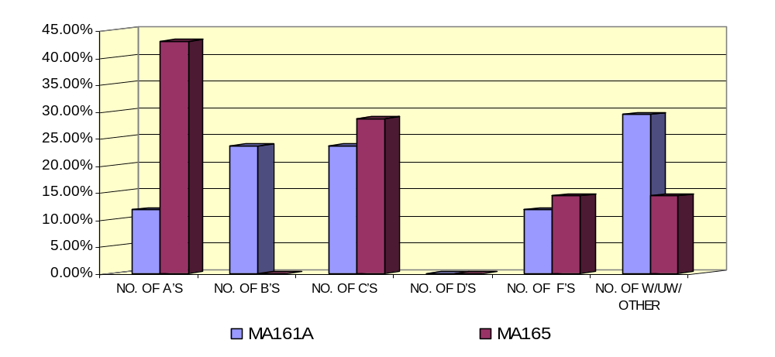
Remark 2.5-2: Table 2.5-2 is constructed to observe how the change from Cutoffs II to Cutoffs III affected students in these two college-level math courses. Students who scored in the range 20-21 would not have been allowed to enroll in these classes if Cutoffs II was used. They would need to enroll in MA110 first. From Table 2.5-2, we see that:
- Students enrolled in MA161a:
  - Approximately 59% of students who scored in the range 20-21 successfully passed MA161a with a C or better (No one received a D).
  - Approximately 12% of these students received an F for MA161a.
  - Approximately 29% of these students did not complete MA161a.
- Students enrolled in MA165:
  - Approximately 72% of students who scored in the range 20-21 successfully passed MA165 with a C or better (No one received a D).
  - Approximately 14% of these students received an F for MA165.
  - Approximately 14% of these students did not complete MA165.
- Also for the record, two “illegal” students with a score of 14 and one “illegal” student with a score of 19 (all three received a grade of a “B”) were enrolled in MA165. Perhaps these students show some evidence that we should consider reverting back to Dr. Schurle’s Cutoffs I. However, it is still a concern that “illegal” students are being allowed to enroll in courses.

2.6. Mean Number of Semesters for Students to Exit MA085 (and Standard Deviation). In this section, we compute the mean number of semesters it took students to exit MA085 and the standard deviation using Table 2.6-1.

TABLE 2.6-1
Frequency Distribution of MA085 Completers
# of Semesters to exit MA085 | # of Students Exiting Fa 04 | # of Students Exiting Sp 05 | # of Students Exiting Fa 05 | # of Students Exiting Sp 06 | TOTAL
1 | 102 | 26 | 66 | 22 | 216
2 | 9 | 30 | 11 | 26 | 76
3 | 5 | 9 | 10 | 9 | 33
4 | 1 | 4 | 4 | 4 | 13
5 | 2 | 0 | 2 | 0 | 4
6 | 1 | 1 | 0 | 2 | 4
7 | 1 | 0 | 0 | 0 | 1
8 | 1 | 1 | 0 | 1 | 3
9 | 0 | 0 | 1 | 0 | 1
11 | 0 | 0 | 1 | 0 | 1
13 | 0 | 0 | 0 | 1 | 1
TOTAL | 122 | 71 | 95 | 65 | 353

Remark 2.6-1: Using Table 2.6-1, we find that the mean number of semesters it took students to exit MA085 is approximately 2 semesters. The standard deviation is approximately 1.48.

3. Success/Failure Rates of Students Enrolled in Math Courses Meeting Math Prerequisites. The success/failure rates of students who took math courses meeting math prerequisites are presented in this section. These courses include MA110, MA151, MA161a-b, MA165, MA203, MA204, MA205, MA302, MA341, MA375, MA385, MA411, MA421, MA422 and MA451.

3.1. Success/Failure Rates of Students Enrolled in MA110/MA151 by Meeting Math Prerequisites. In this section, we present the success/failure rates of students enrolled in MA110 and MA151 who passed MA084b (Initially taught as MA094b) or MA085-Level II.

Table 3.1-1
MA110/MA151 Success/Failure Rates (fall 2004 – spring 2006)
Course | Semester | # OF A’s | # OF B’s | # OF C’s | # OF D’s | # OF F’s | # OF W/UW/OTHER | TOTAL
MA110 | FA04 | 12 | 22 | 18 | 7 | 9 | 21 | 89
 | SP05 | 18 | 16 | 28 | 14 | 4 | 36 | 116
 | FA05 | 19 | 17 | 21 | 7 | 5 | 29 | 98
 | SP06 | 12 | 11 | 23 | 4 | 4 | 34 | 88
 | TOTAL | 61 | 66 | 90 | 32 | 22 | 120 | 391
 | % | 15.6% | 16.9% | 23.0% | 8.2% | 5.6% | 30.7%
MA110 | FA04 | 1 | 2 | 2 | 1 | 1 | 12 | 19
(ILLEGAL | SP05 | 1 | 0 | 7 | 0 | 5 | 7 | 20
ENTRIES | FA05 | 0 | 2 | 3 | 1 | 1 | 5 | 12
FROM | SP06 | 1 | 2 | 4 | 1 | 3 | 6 | 17
MA085) | TOTAL | 3 | 6 | 16 | 3 | 10 | 30 | 68
 | % | 4.4% | 8.8% | 23.5% | 4.4% | 14.7% | 44.1%
MA151 | FA04 | 6 | 14 | 12 | 4 | 0 | 6 | 42
 | SP05 | 2 | 3 | 9 | 3 | 3 | 7 | 27
 | FA05 | 6 | 14 | 10 | 3 | 3 | 7 | 43
 | SP06 | 8 | 21 | 18 | 2 | 2 | 5 | 56
 | TOTAL | 22 | 52 | 49 | 12 | 8 | 25 | 168
 | % | 13.1% | 31.0% | 29.2% | 7.1% | 4.8% | 14.9%
MA151 | FA04 | 0 | 0 | 0 | 1 | 0 | 0 | 1
(ILLEGAL | SP05 | 0 | 0 | 1 | 0 | 0 | 3 | 4
ENTRIES | FA05 | 0 | 2 | 1 | 0 | 0 | 4 | 7
FROM | SP06 | 0 | 3 | 0 | 1 | 0 | 1 | 5
MA085) | TOTAL | 0 | 5 | 2 | 2 | 0 | 8 | 17
 | % | 0.0% | 29.4% | 11.8% | 11.8% | 0.0% | 47.1%
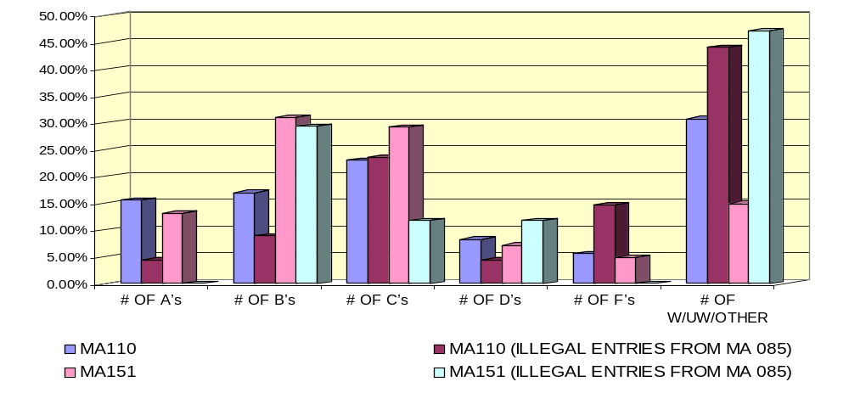

Remark 3.1-1: From Table 3.1, we see that:
- MA110 success/failure rates:
  - Approximately 56% passed the course with a grade of C or better (about 64% passed with a grade of D or better).
  - Approximately 6% received an F for the course.
  - Approximately 31% did not complete the course.
  - For those students who entered illegally in MA110 (enrolled in MA110 without passing MA085 or equivalent math courses mentioned above):
    - Approximately 37% passed the course with a grade of C or better (about 41% passed with a grade of D or better).
    - Approximately 15% received an F for the course.
    - Approximately 44% did not complete the course (At least 59% will need to retake MA110 again).
- MA151 success/failure rates:
  - Approximately 73% passed the course with a grade of C or better (about 80% passed with a grade of D or better).
  - Approximately 5% received an F for the course.
  - Approximately 15% did not complete the course.
  - For those students who entered illegally in MA151 (enrolled in MA151 without passing MA085 or equivalent math courses mentioned above):
    - Approximately 41% passed the course with a grade of C or better (about 53% passed with a grade of D or better).
    - No one received an F for the course.
    - Approximately 47% did not complete the course (At least 47% will need to retake MA151 again).

3.2. Success/Failure Rates of Students Enrolled in MA161a-b and MA165 by Meeting Math Prerequisites. In this section, we present the success/failure rates of students enrolled in MA161a and MA165 who passed MA110 with a grade of B or better. Students enrolled in MA161b passed MA161a with a grade of C or better.

Table 3.2-1
MA161a-b/MA165 Success/Failure Rates (fall 2004 – spring 2006)
Course | Semester | # OF A’s | # OF B’s | # OF C’s | # OF D’s | # OF F’s | # OF W/UW/OTHER | TOTAL
MA161a | FA04 | 13 | 2 | 4 | 3 | 5 | 4 | 31
 | SP05 | 5 | 7 | 10 | 1 | 4 | 8 | 35
 | FA05 | 1 | 8 | 2 | 2 | 9 | 8 | 30
 | SP06 | 0 | 3 | 4 | 4 | 2 | 15 | 28
 | TOTAL | 19 | 20 | 20 | 10 | 20 | 35 | 124
 | % | 15.3% | 16.1% | 16.1% | 8.1% | 16.1% | 28.2%
MA161b | FA04 | 1 | 3 | 6 | 3 | 0 | 3 | 16
 | SP05 | 2 | 2 | 4 | 0 | 1 | 4 | 13
 | FA05 | 1 | 2 | 3 | 6 | 1 | 4 | 17
 | SP06 | 0 | 1 | 3 | 1 | 1 | 16 | 22
 | TOTAL | 4 | 8 | 16 | 10 | 3 | 27 | 68
 | % | 5.9% | 11.8% | 23.5% | 14.7% | 4.4% | 39.7%
MA165 | FA04 | 1 | 0 | 2 | 1 | 2 | 8 | 14
 | SP05 | 3 | 6 | 2 | 7 | 3 | 4 | 25
 | FA05 | 1 | 4 | 5 | 2 | 1 | 5 | 18
 | SP06 | 4 | 1 | 5 | 0 | 2 | 4 | 16
 | TOTAL | 9 | 11 | 14 | 10 | 8 | 21 | 73
 | % | 12.3% | 15.1% | 19.2% | 13.7% | 10.9% | 28.8%
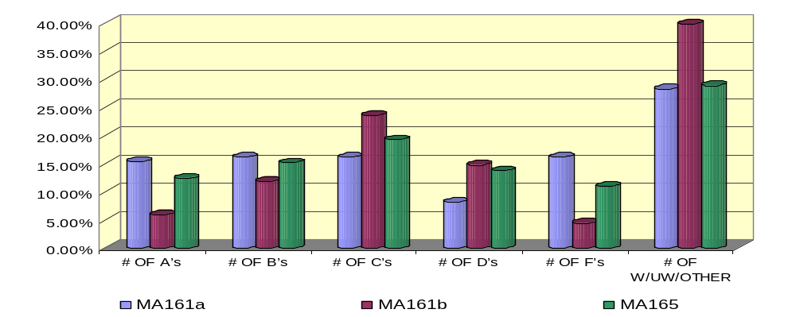

Remark 3.2-1: Beginning with this section, we only present the success/failure rates using Tables 3.2-1 through 3.5-1. We leave it to the reader to compute from each of these tables the following:

- The approximate percentage that passed the course with a grade of C or better.
- The approximate percentage that passed the course with a grade of D or better.
- The approximate percentage that received an F for the course.
- The approximate percentage that did not complete the course.

3.3. Success/Failure Rates of Students Enrolled in MA203, MA204 and MA205 by Meeting Math Prerequisites. In this section, we present the success/failure rates of students enrolled in MA203 who passed MA161b or MA165 with a grade of C or better. Students enrolled in MA204 and MA205 passed MA203 and MA204 with a grade of C or better, respectively.

Table 3.3-1
MA203/ MA204/MA205 Success/Failure Rates (fall 2004 – spring 2006)
Course | Semester | # OF A’s | # OF B’s | # OF C’s | # OF D’s | # OF F’s | # OF W/UW/OTHER | TOTAL
MA203 | FA04 | 3 | 5 | 4 | 3 | 1 | 9 | 25
 | SP05 | 5 | 8 | 6 | 8 | 2 | 2 | 31
 | FA05 | 7 | 6 | 7 | 4 | 2 | 3 | 29
 | SP06 | 5 | 5 | 6 | 5 | 2 | 3 | 26
 | TOTAL | 20 | 24 | 23 | 20 | 7 | 17 | 111
 | % | 18.0% | 21.6% | 20.7% | 18.0% | 6.3% | 15.3%
MA204 | FA04 | 6 | 2 | 0 | 1 | 0 | 0 | 9
 | SP05 | 2 | 3 | 4 | 0 | 1 | 1 | 11
 | FA05 | 0 | 1 | 2 | 2 | 1 | 3 | 9
 | SP06 | 1 | 2 | 4 | 2 | 0 | 2 | 11
 | TOTAL | 9 | 8 | 10 | 5 | 2 | 6 | 40
 | % | 22.5% | 20.0% | 25.0% | 12.5% | 5.0% | 15.0%
MA205 | FA04 | 1 | 3 | 5 | 3 | 1 | 1 | 14
 | SP05 | 0 | 0 | 0 |  | 0 | 0 | 0
 | FA05 | 13 | 4 | 1 | 2 | 0 | 0 | 20
 | SP06 | 0 | 0 | 0 | 0 | 0 | 0 | 0
 | TOTAL | 14 | 7 | 6 | 5 | 1 | 1 | 34
 | % | 41.2% | 20.6% | 17.6% | 14.7% | 2.9% | 2.9%
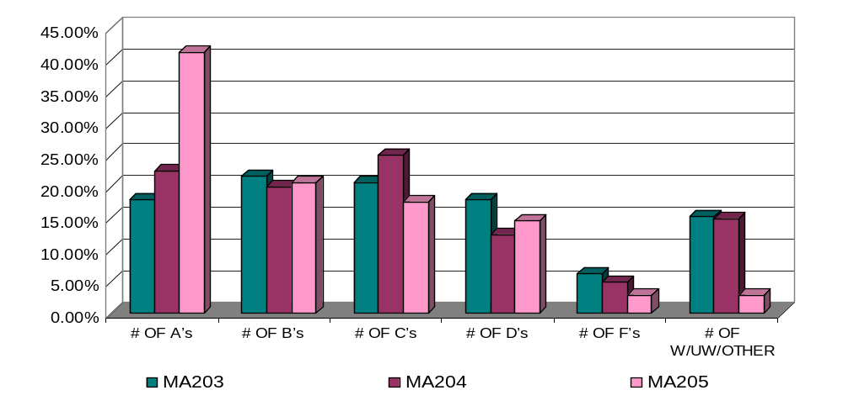

3.4. Success/Failure Rates of Students Enrolled in MA302, MA375 and MA385 by Meeting Math Prerequisites. In this section, we present the success/failure rates of students enrolled in MA302, MA341, MA375 and MA385 by meeting math prerequisites. Students enrolled in MA302 passed MA205 with a grade of C or better. Students enrolled in MA341 passed MA204 with a grade of C or better. Students enrolled in MA375 passed MA204, MA341 and CS201 or CS202 with a grade of C or better. Students enrolled in MA385 passed MA151 with a grade of C or better.

Table 3.4-1
MA302/MA341/MA375/MA385 Success/Failure Rates (fall 2004 – spring 2006)
Course | Semester | # OF A’s | # OF B’s | # OF C’s | # OF D’s | # OF F’s | # OF W/UW/OTHER | TOTAL
MA302 | FA04 | 0 | 0 | 0 | 0 | 0 | 0 | 0
 | SP05 | 1 | 1 | 9 | 0 | 2 | 2 | 15
 | FA05 | 0 | 0 | 0 | 0 | 0 | 0 | 0
 | SP06 | 8 | 4 | 1 | 0 | 0 | 0 | 13
 | TOTAL | 9 | 5 | 10 | 0 | 2 | 2 | 28
 | % | 32.1% | 17.9% | 35.7% | 0.0% | 7.1% | 7.1%
MA341 | FA04 | 1 | 1 | 5 | 0 | 0 | 3 | 10
 | SP05 | 0 | 0 | 1 | 0 | 0 | 0 | 1
 | FA05 | 6 | 7 | 4 | 0 | 0 | 1 | 18
 | SP06 | 0 | 0 | 0 | 0 | 0 | 0 | 0
 | TOTAL | 7 | 8 | 10 | 0 | 0 | 4 | 29
 | % | 24.1% | 27.6% | 34.5% | 0.0% | 0.0% | 13.8%
MA375 | FA04 | 0 | 0 | 0 | 0 | 0 | 0 | 0
 | SP05 | 14 | 4 | 1 | 0 | 2 | 0 | 21
 | FA05 | 0 | 1 | 0 | 0 | 0 | 0 | 1
 | SP06 | 0 | 0 | 0 | 0 | 0 | 0 | 0
 | TOTAL | 14 | 5 | 1 | 0 | 2 | 0 | 22
 | % | 63.6% | 22.7% | 4.5% | 0.0% | 9.1% | 0.0%
MA385 | FA04 | 31 | 13 | 3 | 1 | 1 | 6 | 55
 | SP05 | 9 | 9 | 7 | 2 | 3 | 1 | 31
 | FA05 | 22 | 14 | 15 | 0 | 0 | 2 | 53
 | SP06 | 10 | 13 | 6 | 1 | 0 | 4 | 34
 | TOTAL | 72 | 49 | 31 | 4 | 4 | 13 | 173
 | % | 41.6% | 28.3% | 17.9% | 2.3% | 2.3% | 7.5%
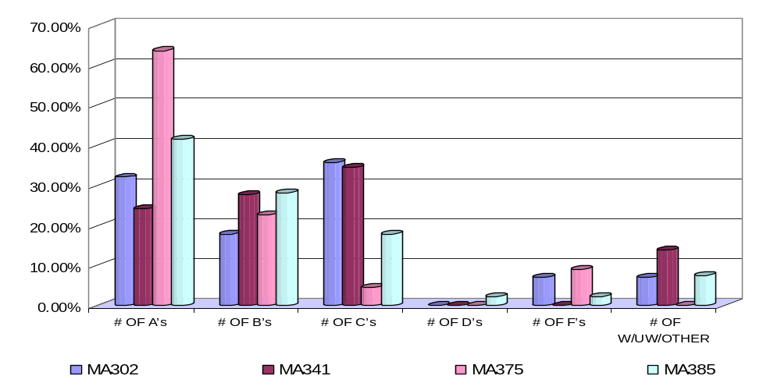

3.5. Success/Failure Rates of Students Enrolled in MA411, MA421, MA422 and MA451 by Meeting Math Prerequisites. In this section, we present the success/failure rates of students enrolled in MA411, MA421, MA422 and MA451 by meeting math prerequisites. Students enrolled in MA411 passed MA205 and MA302 with a grade of C or better. Students enrolled in MA421 passed MA205 and MA302 with a grade of C or better. Students enrolled in MA422 passed MA421 with a grade of C or better. Students enrolled in MA451 passed MA302 with a grade of C or better and also passed MA151 with a C or better.

Table 3.5-1
MA411/MA421/MA422/MA451 Success/Failure Rates (fall 2004 – spring 2006)
Course | Semester | # OF A’s | # OF B’s | # OF C’s | # OF D’s | # OF F’s | # OF W/UW/OTHER | TOTAL
MA411 | FA04 | 1 | 1 | 5 | 0 | 0 | 3 | 10
 | SP05 | 0 | 0 | 3 | 3 | 1 | 0 | 7
 | FA05 | 0 | 0 | 1 | 0 | 0 | 0 | 1
 | SP06 | 0 | 1 | 0 | 2 | 1 | 0 | 4
 | TOTAL | 1 | 2 | 9 | 5 | 2 | 3 | 22
 | % | 4.5% | 9.1% | 40.9% | 22.7% | 9.1% | 13.6%
MA421 | FA04 | 0 | 3 | 3 | 0 | 0 | 0 | 6
 | SP05 | 0 | 0 | 0 | 0 | 0 | 0 | 0
 | FA05 | 0 | 0 | 0 | 0 | 0 | 0 | 0
 | SP06 | 0 | 0 | 0 | 0 | 0 | 0 | 0
 | TOTAL | 0 | 3 | 3 | 0 | 0 | 0 | 6
 | % | 0.0% | 50.0% | 50.0% | 0.0% | 0.0% | 0.0%
MA422 | FA04 | 0 | 0 | 0 | 0 | 0 | 0 | 0
 | SP05 | 0 | 3 | 3 | 0 | 0 | 0 | 6
 | FA05 | 0 | 0 | 0 | 0 | 0 | 0 | 0
 | SP06 | 0 | 0 | 0 | 0 | 0 | 0 | 0
 | TOTAL | 0 | 3 | 3 | 0 | 0 | 0 | 6
 | % | 0.0% | 50.0% | 50.0% | 0.0% | 0.0% | 0.0%
MA451 | FA04 | 1 | 3 | 1 | 1 | 0 | 1 | 7
 | SP05 | 0 | 0 | 0 | 0 | 0 | 0 | 0
 | FA05 | 0 | 0 | 0 | 0 | 0 | 0 | 0
 | SP06 | 0 | 0 | 0 | 0 | 0 | 0 | 0
 | TOTAL | 1 | 3 | 1 | 1 | 0 | 1 | 7
 | % | 14.3% | 42.9% | 14.3% | 14.3% | 0.0% | 14.3%
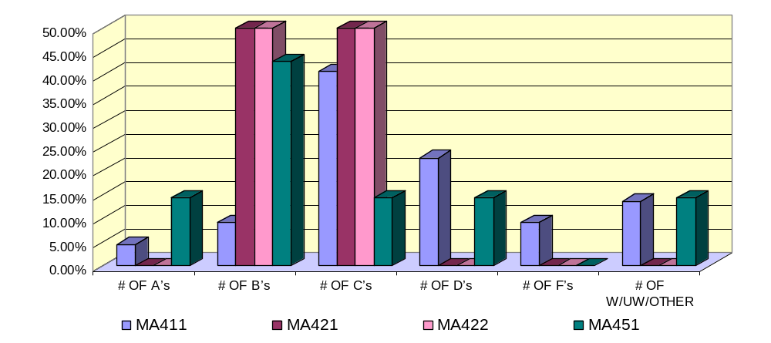

4. High School Math Placement Results. In this section, we present some of the results of students who took the math placement from several high schools (HS). High schools included are: The Academy of Our Lady Guam HS (AOLG), Father Duenas HS (FDHS), Notre Dame HS (NDHS), St. Paul HS (ST PAUL), George Washington HS (GWHS), John F. Kennedy HS (JFKHS), Simon Sanchez HS (SSHS) and Southern HS (SOUTH HS).

TABLE 4.1-1
Mean/SD/ Math Placement Percentage Breakdown of High School Students (CUTOFFS II: AY 04-05)
HS | MEAN* | SD* | # PLACED IN 085-I | # PLACED IN 085-II | # PLACED IN 110/151 | # PLACED IN 161a/165 | TOTAL
ALOG | 12 | 9.99 | 11 | 9 | 2 | 4 | 26
% | - | - | 42.3% | 34.6% | 7.7% | 15.4%
FDHS | 16 | 4.96 | 5 | 11 | 7 | 6 | 29
% |  |  | 17.2% | 37.9% | 24.1% | 20.7%
NDHS | 11 | 3.89 | 17 | 7 | 7 | 1 | 32
% | - | - | 53.1% | 21.9% | 21.9% | 3.1%
ST PAUL | 9 | 10.53 | 14 | 7 | 0 | 1 | 22
% |  |  | 63.6% | 31.8% | 0.0% | 4.6%
GWHS | 11 | 7.87 | 50 | 23 | 12 | 12 | 97
% | - | - | 51.5% | 23.7% | 12.4% | 12.4%
JFKHS | 10 | 8.00 | 65 | 25 | 10 | 6 | 106
% | - | - | 61.3% | 23.6% | 9.4% | 5.7%
SSHS | 10 | 10.07 | 49 | 44 | 7 | 4 | 104
% |  |  | 47.1% | 42.3% | 6.7% | 3.8%
SOUTH HS | 9 | 8.53 | 38 | 16 | 4 | 1 | 59
% | - | - | 64.4% | 27.1% | 6.8% | 1.7%
OVERALL | 11 | 6.36 | 249 | 142 | 49 | 35 | 475
% |  |  | 52.4% | 29.9% | 10.3% | 7.4%
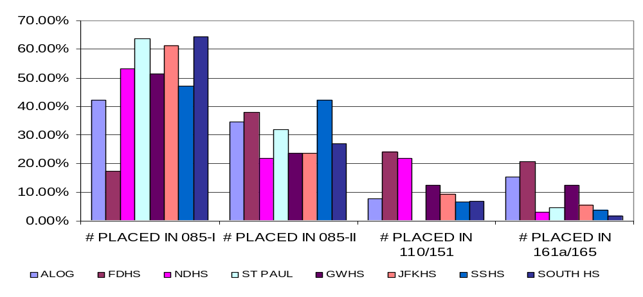
*These are approximate computations using grouped data based on Cutoffs II recommendations.

TABLE 4.1-2
Mean/SD/Math Placement Percentage Breakdown of High School Students (CUTOFFS III: AY 05-06)
HS | MEAN* | SD* | # PLACED IN 085-I | # PLACED IN 085-II | # PLACED IN 110/151 | # PLACED IN 161a/165 | TOTAL
ALOG | 13 | 4.83 | 9 | 15 | 19 | 7 | 50
% | - | - | 18.0% | 30.0% | 38.0% | 14.0%
FDHS | 17 | 4.37 | 1 | 5 | 18 | 12 | 36
% | - | - | 2.8% | 13.9% | 50.0% | 33.3%
NDHS | 13 | 4.38 | 6 | 5 | 10 | 2 | 23
% | - | - | 26.1% | 21.7% | 43.5% | 8.7%
ST. PAUL | 8 | 4.53 | 13 | 5 | 3 | 0 | 21
% |  |  | 61.9% | 23.8% | 14.3% | 0.0%
GWHS | 13 | 6.54 | 42 | 30 | 28 | 28 | 128
% | - | - | 32.8% | 23.4% | 21.9% | 21.9%
JFKHS | 11 | 5.03 | 38 | 28 | 21 | 7 | 94
% | - | - | 40.4% | 29.8% | 22.3% | 7.5%
SSHS | 13 | 6.24 | 43 | 33 | 29 | 23 | 128
% | - | - | 33.6% | 25.8% | 22.7% | 18.0%
SOUTH HS | 11 | 5.30 | 33 | 18 | 21 | 8 | 80
% | - | - | 41.3% | 22.5% | 26.3% | 10.0%
OVERALL | 12 | 6.41 | 185 | 139 | 149 | 87 | 560
% | - | - | 33.0% | 24.8% | 26.6% | 15.5%
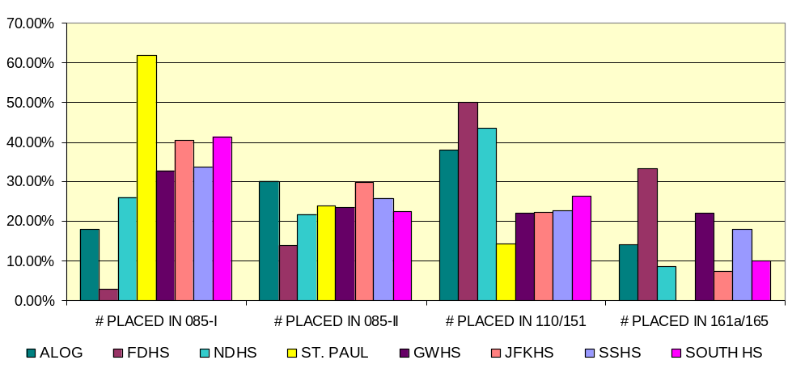
*These are computations computed directly from the submitted raw data (not grouped) for each high school based on Cutoffs III.

5. Prof. Han Tower Chen’s MA110 Preliminary Assessment Study/ Dr. Chu-Tak Tseng’s
PH251 Preliminary Assessment Study. In this section, we present some preliminary learning assessment studies done by Prof. Han Tower Chen and Dr. Chu-Tak Tseng. These studies were submitted as part of the evidences in their Executive Summary CFES report. With their permission, their results are presented in this section.

  - Prof. Han Tower Chen’s MA110 Preliminary Assessment Study. Prof. Chen’s pre-test
consists of math problems that students should know by the time they enroll in MA110. The students who took the MA110 pre-test were students enrolled in four MA110 classes during the fall semester of 2001. There were a total of 180 students which included 65 students who passed MA085-Level II, 96 students who were placed in MA110 via Cutoffs I recommendations and 19 others (students who were retaking MA110 or were placed in either MA161a or MA165). Table 5.1-1 gives the questions that students were asked to do (column 1), the percentage of students who exited MA085-Level II who answered the question correctly (column 2), the percentage of students who were placed in the course by our math placement test who answered the question correctly (column 3), the percentage of students who enrolled by other means who answered the question correctly (column 4) and the overall percentage of students who answered the question correctly (column 5). Note that:

- Questions Q1 – Q5 are problems that students should know by the time they exit MA085, Level I. These problems are usually covered or introduced in elementary schools and students should be able to work these problems by the time they exit middle school (eighth grade). See Remark 2.1-1, page 3.

- Questions Q6 – Q10 are problems that students should know by the time they exit MA085, Level II. These problems are covered or introduced in middle/high school and students should be able to work these problems by the time they exit 9th or 10th in high school (These problems are covered in high school Algebra I and students should be familiar with these problems by the time they enroll in high school algebra II). See Remark 2.1-1, page 3.

Table 5.1-1
PERCENTAGE OF STUDENTS WHO ANSWERED EACH QUESTION CORRECTLY
QUESTION | STUDENTS WHO PASSED MA085 | STUDENTS WHO PLACED IN MA110 BY MATH PLACEMENT TEST | OTHER | OVERAL RESULTS (FOR ALL STUDENTS WHO TOOK PRE-TEST)
Q1. CALCULATE: (-5) + (3x7) – 4 + 8 | 61.5% | 77.0% | 89.0% | 72.7%
Q2. CALCULATE: 4x3 + (7x(-8))-6x(-4)) | 36.9% | 51.0% | 57.8% | 46.7%
Q3. CALCULATE:  ₍ 3 _{x} 7 _{) ÷} 8  5 4 3 | 21.5% | 41.6% | 52.6% | 35.6%
Q4. CALCULATE:  3 _ 7  5 5 | 36.9% | 58.3% | 89.5% | 62.8%
Q5. CALCULATE:  5 ₊ 7  9 12 | 52.3% | 58.3% | 73.6% | 57.8%
Q6. EXPAND: (3x + 2y)(5x + 4y) | 61.5% | 69.8% | 68.4% | 66.7%
Q7. EXPAND: (3x – 5y)² | 23.0% | 39.6% | 36.8% | 33.7%
Q8. FACTOR: x² + 4xy -12y² | 38.5% | 40.6% | 42.1% | 40.0%
Q9. FACTOR: 4x² – 9y² | 40.0% | 67.7% | 47.4% | 55.5%
Q10. SIMPLIFY  3 x² ₊ __5__  Y² z x²y z³ | 0.0% | 5.2% | 26.3% | 5.6%
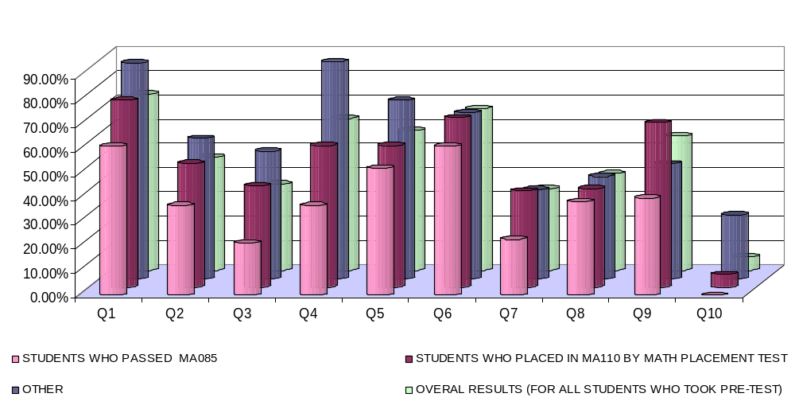

Remark 5.1-1: The percentage of students who exited MA085 who answered each question correctly is a concern (Less than 62% of students in this category answered each question correctly with a significant percentage of these students showing strong weaknesses in the arithmetic operations of fractions: a concept covered as early as 4th - 5th grade in most elementary schools!). It is also very troubling to see that not a single student who exited MA085 worked question Q10 correctly. Finally, it suffices to note that the results in Prof. Chen’s pre-test show students placed in the four MA110 classes via Cutoffs I appear to do significantly better than those students who exited our MA085 classes.

5.2 Dr. Chu-Tak Tseng’s PH251 Preliminary Assessment Study (Fall 2005). The problems in Dr. Tseng’s pre-test and post-test are problems that students should know by the time they enroll in his PH251 (except for possibly his differentiation and integration problems since these problems are problems covered in MA203. Students are allowed to take his PH251 concurrently with MA203. It was pointed out in his report, however, that more than three quarters of the students took and passed calculus in high school.). The contents of the test are similar to that of the Math-Statics (physics) Baseline Test (MSBT) developed by Dr. Scott Danielson of Arizona State University and Dr. Sudhir Mehta of North Dakota State University in 2004. Totally, fourteen problems were grouped into six categories: Fractions, Algebra, Trigonometry, Geometry, Analytic Geometry and Calculus. A total of 40 students took the pretest during the fall semester of 2005. Row 1 of Table 5.2-1 gives the type of problem asked in the test. Row 2 and Row 3 give the percentage of students who answered each question correctly for his post-test and pre-test, respectively. Row 4 gives the improvement (if any) after a three-week comprehensive review of the basic math that his students should know for his class. Note that:

- Questions Q1-Q12 are questions that students should know by the time they exit high school or by the time they exit MA161a-b or MA165.

- Q13 and Q14 are basic calculus problems covered in MA203.

Table 5.2-1
Q1: FRAC-TION | Q2: LIN-EAR EQTN | Q3:  QUA-DRATIC EQTN | Q4:  BINO-MIAL EXPAN-SION | Q5:  SINE EXPAN-SION | Q6:  CO-SINE LAW | Q7:  CIRCU-LAR AREA | Q8:  AREA OF TRIAN-GLE | Q9:  SPHERI-CAL VOL-UME | Q10:  LINE SLOPE | Q11:  PARA-BOLIC MIN. | Q12:  EL-LIPSE FOCI | Q13:  DIFF | Q14:  INTE-GRAL
53% | 79% | 90% | 92% | 53% | 11% | 8% | 89% | 21% | 55% | 59% | 10% | 21% | 32%
(32%) | (75%) | (75%) | (77%) | (17%) | (3%) | (8%) | (27%) | (10%) | (37%) | (38%) | (0%) | (17%) | (10%)
21% | 4% | 15% | 15% | 36% | 8% | 0% | 62% | 11% | 18% | 21% | 10% | 4% | 22%
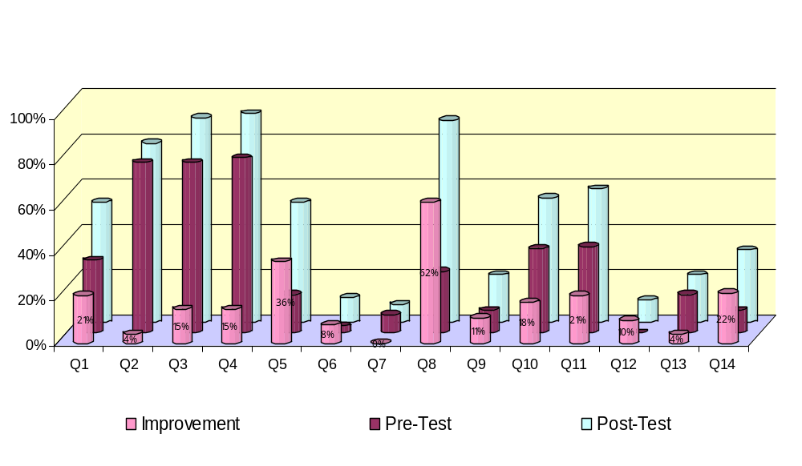

Remark 5.2-1: Since MA203, Basic Calculus, is a corequisite for PH251, it is very troubling to see that for the pre-test:

- Fewer than 10% of the students knew the area of a circle with a given radius.

- Less than one third of the students can simplify a fraction.

- Only one of the 40 students knew the law of cosines.

- Summary of Results. We summarize the overall results of this study as follows (See Graphs 6-1 through 6-6 in the Appendix for some of the statistics presented in this section):

- We expect that it will take about 2 semesters for students placed in MA085 to exit the Developmental Math Program.

- The computed mean for students taking the placement test is approximately 12 correct answers out of 25 with a standard deviation of about 6.41. Using this mean and standard deviation and Remark 2.2-3, page 5, we expect that:

  - If we continue to use Cutoffs III recommendations:

    - Approximately 63% of students will be placed in MA085.
    - Approximately 19 % of students placed in MA085 will exit MA085 in one semester.

  - If we revert back to Cutoffs II recommendations:

    - Approximately 86% of students will be placed in MA085.
    - Approximately 25% of students placed in MA085 will exit MA085 in one semester.

  - If we revert back to Cutoffs I recommendations:

    - Approximately 44% of students will be placed in MA085.
    - Approximately 10% of students placed in MA085 will exit MA085 in one semester.

There are some major concerns that were encountered during the study. These are:

  - Students enrolled in college-level math courses with math placement score requirement not met.

  - Students enrolled in college-level courses even if they have not yet exited the developmental program. By Remark 3.1-1, about 59% of these “illegal” students enrolled in MA110 received an F for the course or did not complete the course and 47% enrolled in MA151 failed to complete the course.

  - At least one student was enrolled for both MA085 and MA110.

  - Prof. Han Tower Chen’s and Dr. Chu-Tak Tseng’s assessment studies are studies that assess the concepts that students should have learned in their prerequisite courses. The findings in their studies are troubling. For example, Prof. Chen’s MA110 assessment study showed that a significant percentage of the students could not solve problems covered in MA084a/MA085, Level I (See Remark 5.1-1, page 22). Similarly, Dr. Tseng’s PH251 assessment study showed that a significant percentage of the students could not solve problems that are covered in pre-calculus, our MA161a-b/MA165 (See Remark 5.2-1, page 23). MA203 is a corequisite for PH251 and pre-calculus is the prerequisite for MA203. Our findings in this study essentially support their findings.

Recall that the primary goal of this work is to study the effectiveness of our mathematics placement test recommendations and that of our prerequisite mathematics courses. Table 6.1-1 provides an overall summary of the success/failure rates of students placed in these courses by the placement test recommendations and those students enrolled in these courses by meeting math prerequisites. See Graph 6-1 through Graph 6-5 in the Appendix for a geometric presentation of the overall success/failure rates of students. Also see Graph 6-6 for the success/failure rates of students placed in MA110/MA151 by Cutoffs III who would have been placed in MA085 by Cutoffs II and the success/failure rates of students placed in MA161a/MA165 by Cutoffs III who would have been placed in MA110 by Cutoffs II.

TABLE 6.1-1
COMPARISON OF STUDENT SUCCESS/FAILURE RATES: CUTOFFS II VS CUTOFFS III VS MATH PREREQUISITES
CLASS | ENROLLMENT VIA | % PASSING WITH “C” OR BETTER | % PASSING WITH “D” OR BETTER | % RECEIVING GRADE OF “F” OR NOT COMPLETING THE COURSE
MA110 | CUTOFFS II | 76% | 88% | 12%
 | CUTOFFS III | 52% | 60% | 40%
 | PASSING MA085 | 56% | 64% | 36%
MA151 | CUTOFFS II | 73% | 77% | 23%
 | CUTOFFS III | 60% | 74% | 26%
 | PASSING MA085 | 73% | 80% | 20%
MA161a | CUTOFFS II | 82% | 86% | 14%
 | CUTOFFS III | 68% | 75% | 25%
 | PASSING MA110 | 48% | 56% | 44%
MA165 | CUTOFFS II | 77% | 77% | 23%
 | CUTOFFS III | 82% | 89% | 11%
 | PASSING MA110 | 47% | 60% | 40%
SOPHOMORE LEVEL COURSES (MA203, MA204, MA205) | PASSING PREREQUISITES | 65% | 82% | 18%
JUNIR LEVEL COURSES (MA302, MA341, MA375, MA385) | PASSING PREREQUISITES | 88% | 89% | 11%
SENIOR LEVEL COURSES (MA411, MA421, MA422, MA451) | PASSING PREREQUISITES | 71% | 85% | 15%

A closer observation of Table 6.1-1 shows that the math placement Cutoffs II and III recommendations are showing significantly better student success rates in MA161a/MA165 than those who were enrolled in these classes by meeting our MA110 math prerequisite.

7. Recommendations. In this section, we present recommendations that the mathematics faculty should review and discuss with a view toward “improving the learning environment of our students.” In Sections 7.1, 7.2 and 7.3, we present our recommendations regarding our mathematics placement test, our mathematics prerequisite courses and the concerns encountered in this study, respectively. See Graphs 6-1 through 6-6 in the Appendix for some of the statistics presented in this section.

7.1 Mathematics Placement Test Recommendations. Recall that this study was initially done
to determine which of the proposed cutoffs recommendations of the math placement test would most benefit our students. It is, indeed, very crucial that our students are placed in “an environment where learning can take place.” Although the “learning environment for our students” should be the outmost priority, the mathematics faculty must also consider the cutoffs recommendations that would “financially minimize the expenses” for both our students and UOG. With these comments in mind, we urge the mathematics faculty to seriously consider the following:

- Continue using Cutoffs III Recommendations based on the following findings:

a. Although the success rates of students placed in courses by Cutoffs II
recommendations were consistently higher than those placed in courses by Cutoffs III (Cutoffs II recommendations, after all, are the highest of the three cutoffs recommendations), recall that approximately 86% of students who took the mathematics placement test using Cutoffs II recommendations were placed in MA084a-b/MA085, while only 63% were placed in these courses using Cutoffs III recommendations. The total number of developmental classes that need to be offered would significantly increase if we revert back to Cutoffs II recommendations. Any significant increase in the number of MA084a-b/MA085 classes would be a major problem. We are currently exhausting our entire mathematics faculty, both full-time and part-time, to teach these developmental mathematics classes each semester using Cutoffs III recommendations.

- A significant percentage of students placed in our mathematics courses by Cutoffs III recommendations that would have been placed in lower level mathematics courses by Cutoffs II recommendations were successful in passing the college-level mathematics courses that they were placed in. During the fall 2005/spring 2006 semesters, about 58% of the students who scored 14–17 correct answers successfully passed MA110. These students were placed in MA110 by Cutoffs III recommendations, but would have been placed in MA084a-b/MA085 if Cutoffs II recommendations were used instead. This is a significant number of students who passed MA110 and it would be unfair to these students if they had to take MA084a-b/MA085 first especially since the mean number of semesters that students take to complete these courses is two semesters. Similarly, about 68% of students who scored 14-17 correct answers passed MA151 during fall 2005/spring 2006 semesters. These students were placed in MA151 using Cutoffs III recommendations, but would have been placed in MA084a-b/MA085 if Cutoffs II recommendations were used instead. A similar argument can be made for those students who were placed in MA161a/MA165 by Cutoffs III recommendations (scored 20-21 correct answers), but would have been placed in MA110 by Cutoffs II recommendations. Approximately 59%/72% of these students successfully passed MA161a/MA165, respectfully.

- As mentioned earlier, the success rates of students placed in courses by Cutoffs II recommendations were consistently higher than those placed by Cutoffs III or those meeting our mathematics prerequisite courses. However, students placed in mathematics courses by Cutoffs III were doing just as well or even better than those who met our mathematics prerequisites. For example, 68% of students placed in MA161a by Cutoffs III passed with C’s or better, while only 48% of students who met the MA110 prerequisite passed this course with C’s or better. Similarly, 82% of students placed in MA165 by Cutoffs III passed with C’s or better, while only 47% of students who met the MA110 prerequisite passed this course with C’s or better. If students directly from high school who are placed in our college-level courses by Cutoffs III recommendations are doing just as well or significantly better than students who meet our mathematics prerequisites, further studies need to be made before any further action or decision is made regarding our math placement cutoffs recommendations.

- Implementation of Programs to Decrease the Number of Students Placed in the Developmental Mathematics Program.

- The mathematics faculty need to establish a program to work more closely with high schools not only on Guam, but with high schools in the Northern Marianas and the other Micronesia Islands as well. All high school students entering UOG must have a sound background in at least Algebra II if they are to succeed in passing college-level mathematics courses. We see from Section 7.1-1c above, that a significant percentage of students placed in our college-level math courses by our math placement test were successful in passing these courses. Most of these students came prepared from the high schools that they graduated from. So there are statistical evidences of student successes in the college-level courses if students come prepared at the high school level. If UOG can develop a program to work more closely with the teachers from the above aforementioned high schools, we can succeed in significantly decreasing the percentage of students placed in our Developmental Math Program. Some efforts are currently being made by the math faculty since we do have Dr. Alicia Aguon working with our local Guam public high school teachers. We, however, need to have more math faculty members involved, at least on a consultation basis, to try and decrease the large number of students being placed in the Developmental Math Program.

- The mathematics faculty should re-visit Dean Yudin’s proposal to implement a summer math camp program designed to assist our incoming freshmen pass our mathematics placement test. A review of the mathematical concepts required by our placement test during this summer session would definitely be beneficial for these new students in being placed in college-level courses.

7.2 Mathematics Prerequisite Courses Recommendations. As mentioned in Section 7.1, it is
very crucial that our students are placed in “an environment where learning can take place.” Our prerequisite mathematics courses must effectively prepare our students for the next level of mathematics class that they are required to take. We note that the overall success rate of students who passed with C’s or better enrolled in freshmen level courses (MA110, MA151, MA161a-b and MA165) who met our mathematics prerequisites is about 56%. The overall success rate of students who passed with C’s or better enrolled in sophomore level courses (MA203, MA204 and MA205) who met mathematics prerequisites is approximately 65%. For junior level courses and senior level courses, the overall success rates of students who passed with C’s or better who met mathematics prerequisites are 88% and 71%, respectively. It is apparent that the bulk of the work that the mathematics faculty need to initially address are the prerequisite courses for our freshmen/sophomore level courses. The mathematics faculty have addressed some of these problems for MA110 and MA161a/MA165. We urge the mathematics faculty to seriously consider the following recommendations regarding our mathematics prerequisites:

- MA085: Prerequisite Course for MA110/MA151.
The effectiveness of the “self-paced” format method used in MA085 has always been questioned since MA085 was first implemented. Prof. Han Tower Chen’s assessment study that he did for MA110 showed that a significant percentage of these students still showed weaknesses in solving problems that are covered in MA085-Level I. The findings on this study supported Prof. Chen’s findings since only 56% of the students who exited MA085, Level II passed MA110 with C’s or better. A survey was conducted asking students if they would enroll in a “lecture-based” course. Approximately 37% of these students said that they would do so. As a consequence, lecture-based courses, MA084a-b are now being offered for our students. MA084a and MA084b are equivalent to MA085, Level I and MA085, Level II, respectively. MA084b, as MA085, Level II, is also a prerequisite for MA110 and MA151. The mathematics faculty should follow-up on the MA110/MA151 success/failure rates of students exiting MA084b. The follow-up study should investigate if there is any significant difference between the MA110/MA151 success rates of students exiting MA084b versus the success rates of students exiting MA085, Level II.

- MA110: Prerequisite Course for MA161a/MA165.
The effectiveness of MA110 as a prerequisite course for MA161a/MA165 has always been questioned since this course was first implemented. MA110 was initially designed to be the GE course in mathematics and basically a “last semester course” for most of our students. This was one of the reasons why MA100 (which was later changed to MA160) was introduced along with MA110 as also a prerequisite course for MA161a/MA165. The required concepts for MA161a/MA165 are covered in the “one-year high school level Algebra II course.” Since Algebra II is a high school level course, MA160 was later changed to MA088. MA088 is an intermediate algebra course (Algebra II in high school) and all of the concepts in Algebra II are “rigorously” covered in detail in MA088. As a consequence, MA088 will better prepare our students for MA161a/MA165. During the fall 2006 semester, the mathematics faculty submitted a proposal to CNAS-AAC to have MA088 be the prerequisite for MA161a/MA165 and not MA110. A follow-up study should be done to determine if there is any significant difference between the MA161a/MA165 success rates of students exiting MA088 versus the current success rates of students exiting MA110.

- Follow-up of Prof. Han Tower Chen’s and Dr. Chu-Tak Tseng’s Studies.
The results of the assessment studies of Prof. Han Tower Chen and Dr. Chu-Tak Tseng need to be addressed. The results of this study support their results and conclusions. Follow-up assessment studies should be done by the mathematics faculty on what students are learning in MA085 and what students are learning in at least our MA161a-b or MA165 (and up through our MA203 since this is the corequisite for PH251).

- Dr. Grazyna Badowski’s Proposal Developed by Dr. Uri Treisman at UC Berkeley.
To try and improve on the success/failure rates of our mathematics classes, the mathematics faculty should seriously consider the proposal submitted by Dr. Grazyna Badowski that is based on the “Workshop” concept developed by Dr. Uri Treisman at UC Berkeley, and is run at many universities. Although the proposed program is designed for “Emerging Scholars Program (ESP) and assigned as an “honors course”, we can modify this proposal to fit our students. We should try and apply this teaching method for our students in MA110, MA161a-b, MA165 and MA203 courses. It is proven to be a very effective teaching method in mathematics. Math is a problem-solving field and if we provide the opportunity for students to be able to work more problems with the assistance of qualified TA’s in addition to the lecture class, then students will have a better chance of learning the concepts that they need to learn for the course. I taught MA161a using a similar teaching method during the summer of 2005 to high school students who were allowed to enroll in this course. I provided an hour “workshop lab session” after each class time with assigned qualified teaching assistants for the course. It was very successful since everyone in the course received a “C or better.” In addition, the mean for the pre-test that I administered for this class was about 54%, while the mean for the post-test was about 91%. For a more detailed description of Dr. Grazyna’s proposal, visit:

www.collegeboard.com/repository/calcandcomm_3947.pdf.

It suffices to note that Drs. Grazyna Badowski/Alicia Aguon will be conducting this
teaching method for their MA165/MA161a classes, respectively, this coming spring 2007
semester. The mathematics faculty should closely monitor the success rates of the students in these classes for comparison purposes.

7.3 The Concerns Encountered in the Study. There are major concerns that were encountered in this study. CNAS needs to immediately address these concerns:

1. Students enrolled in college-level math courses with math placement score requirement not met.

2. Students enrolled in college-level courses even if they have not yet exited the developmental program.

3. Student enrolled in both MA085 and MA110 (How is it possible for a student to enroll for both the course and its prerequisite simultaneously?).

Although some of these “illegal students” did pass, our concern is the strong possibility that most of these students will not succeed in passing these college-level math courses even if they enroll several times. For example, we had a student in spring 2006 that enrolled in MA110 without exiting MA085. She did this since the fall semester of 1998 and as of spring 2006, she is still trying to pass MA110. She again enrolled in MA110 this summer 2006. As of summer 2006, this is the only course that she needed for graduation. UOG needs to take care of this problem and make sure that this does not happen in the future. If a student placed in a course that she/he is not prepared for, then it is almost impossible for “learning to take place.” This is most especially true in mathematics.

Acknowledgments. We would like to thank Ms. Deborah Leon Guerrero, Registrar, for providing us with the data that we needed to complete this study. We extend a “Dankulo na si Yuos Maasi” to Ms. April Flores (computer science teaching assistant) and Mr. Ryan Flores (math teaching assistant) for the numerous hours that they dedicated to compile the data. We would like to especially thank Ryan for his patience in following the instructions to recompile and reconstruct the necessary tables that were needed to make this work easier. We most especially thank him for the construction of all of the impressive graphs displayed in this report. Without April and Ryan, this report would never have been completed. We also extend our thanks to Prof. Han Tower Chen and Dr. Chu-Tak Tseng for allowing us to present their results on the preliminary assessment studies that they did in their MA110 and PH251 courses, respectively. Finally, thanks to Dr. Lee S. Yudin, Dean, CNAS, for his support and his recommended suggestions in this endeavor.

APPENDIX

- Graph 6-1: MA110 Success/Failure Rates Comparison (CUTOFFS II vs.
CUTOFFS III vs. PASSING MA085)
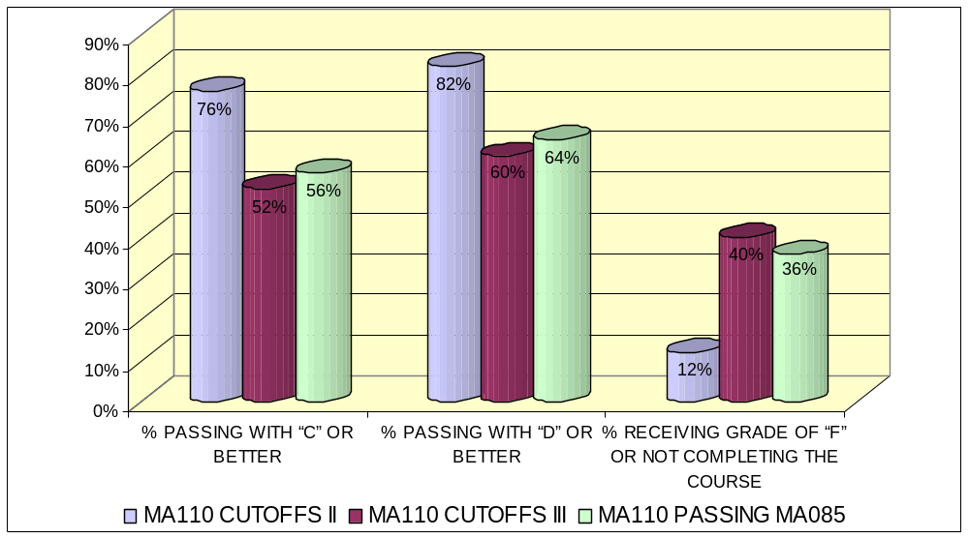

- Graph 6-2: MA151 Success/Failure Rates Comparison (CUTOFFS II vs.
CUTOFFS III vs. PASSING MA085)
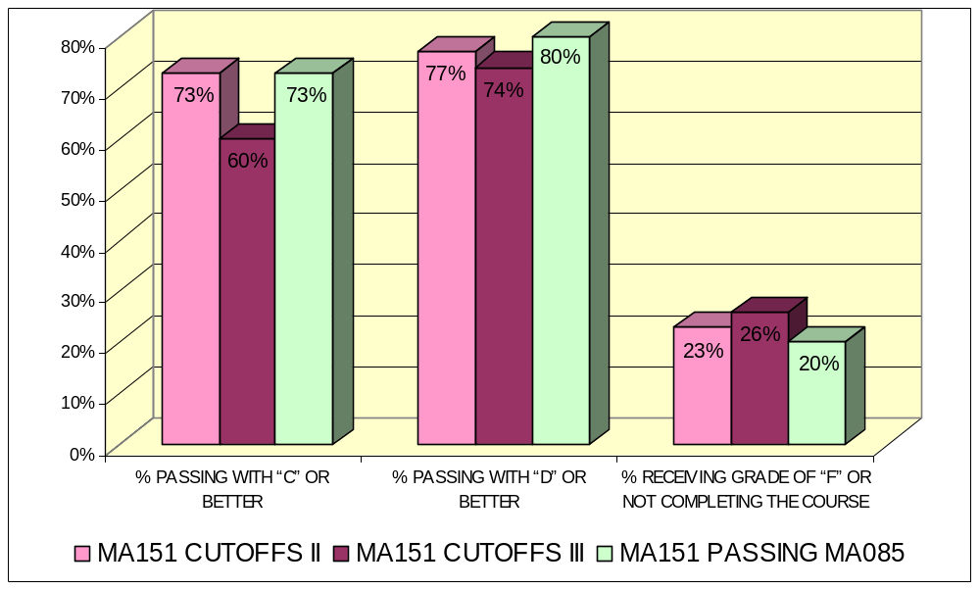

- Graph 6-3: MA161a Success/Failure Rates Comparison (CUTOFFS II vs.
CUTOFFS III vs. PASSING MA110)
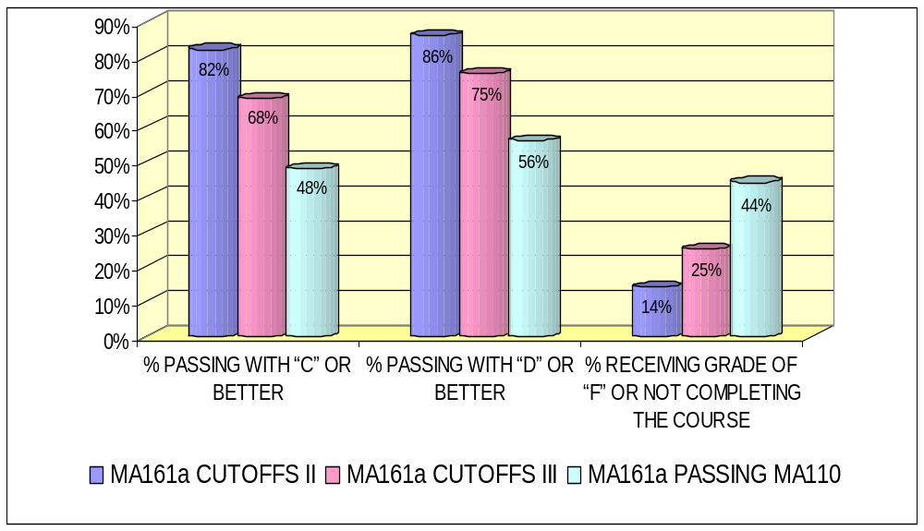

- Graph 6-4: MA165 Success/Failure Rates Comparison (CUTOFFS II vs.
CUTOFFS III vs. PASSING MA110)
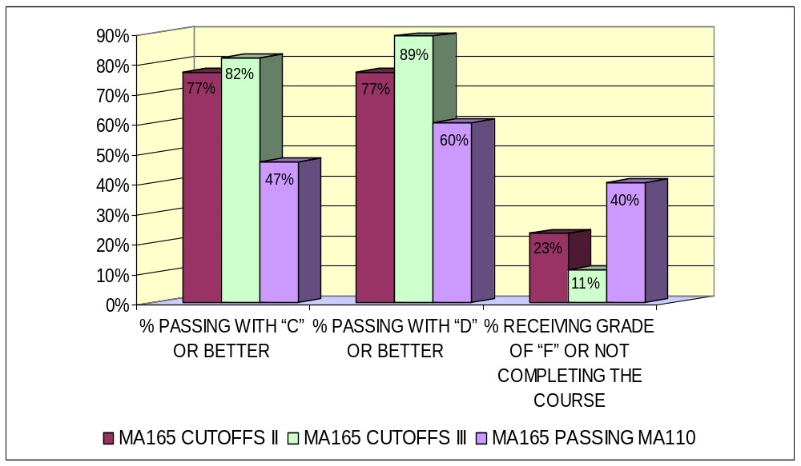
- Graph 6-5: Overall Student Success/Failure Rates who Met Math
Prerequisites
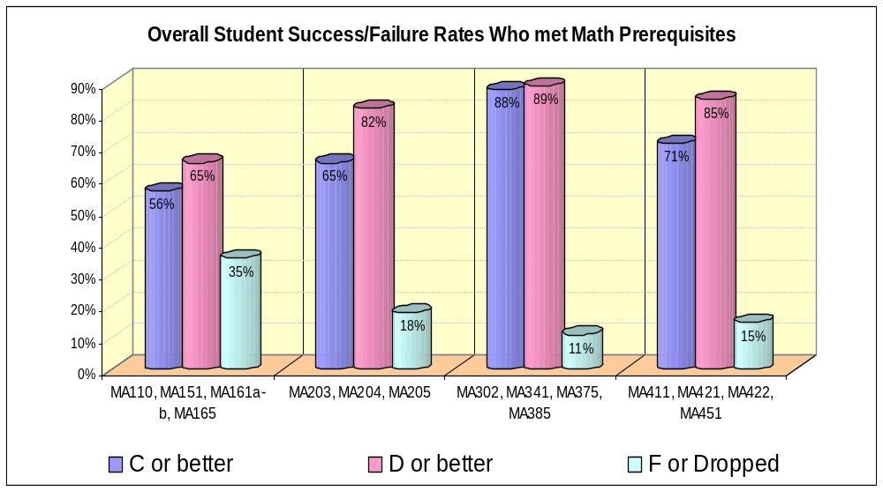

- Graph 6-6: Student Success/Failure Rates by Cutoffs III
