Tropical Agricultural Science Program (TASP) Assessment--Qualitative Data

1. External Recognition and measures of quality of Program.
Local recognition of the agriculture program need, quality and importance:
Our program is targeted primarily to the needs of the agricultural and natural resources management sector on Guam and the region, and towards preparing students for post-graduate studies. Letters and output of local needs assessments, documenting the critical need for a small but regular stream of graduates, can be provided on request. Many of the research/extension grants have made it possible to support many TASP students with employment during their education at University of Guam.
- Awards:
•2005 Senator Brown monetary award to Dr. Golabi’s composting program ($50,000)
•ESCOP/ECOP Leadership workshop (Multiple faculty have participated in this program.)
•CSREES Summer Fellowships (Multiple faculty have participated in this.)
•LEAD 21 participants (2 faculty; leadership training relating to the tripartite land grant mission; Partially funded by ADAP awards)
•Numerous USDA grants awarded to faculty in AES and CES, which generate information relevant to TASP.
- External Reviews: We plan to have an external review conducted this coming semester as part of the regular program review process.

- Standard: (a) All course outlines have been revised to reflect both program and course Student Learning Outcomes and (b) assessment plans in place.
Table 1. shows the current status of TASP courses in relation to SLOs and meeting program goals. We realize that we need to work more for this aspect. Our current Program Objectives (Goals) are the following:
Objective 1: Students will understand the personal as well as the cross-cultural and multi-cultural influences that impact agriculture locally, nationally and internationally.
Objective 2: Students will apply decision-making skills to the study of horticulture, agronomy, soil science, animal science, plant pathology, entomology, aquaculture, economics and engineering.
Objective 3: Students will be able to respond to technological changes in agriculture.
Objective 4: Students will apply high ethical standards in setting goals and in decision-making as it relates to agriculture.
Objective 5: Students will recognize and demonstrate skills and behaviors, which contribute to work success and enhance employability.
Objective 6: Students will recognize agricultural practices that pose risk to the environment and to society at large.
Objective 7: Students will collect, organize, analyze, interpret and present quantitative and qualitative data in agricultural science.
Objective 8: Students will utilize current, technological tools in the collection, organization, analysis and interpretation of data in agricultural science.
Table 1. Status of Program and Course SLO’s in Tropical Agricultural Science Program.
Course | Program & Course SLOs reflected in course outline? | Program Goal met in course? | Course outline on UOG website? |  | Assessment Plan in place?
AG 101/101L (4) |  | 1,6,7 |  | In Progress
AG 102/102L (4) | CSLO/PSLO | 2,7 |  | In Progress | Yes
AG109/109L (4) |  | 2,7 |  | In Progress
AG136/136L (4) |  | 1,2,7 |  | In Progress | No
AG211/211L (4) | CSLO/PSLO | 1,2,7 |  | In Progress | Yes
AG281/281L (4) | CSLO/PSLO | 1,2,7 |  | In Progress | No
AG321 (2) |  | 1,6,7 |  | In Progress
AG323/323L (4) | - | 2,7 |  | In Progress
AG340 340L (4) |  | 2,4,5,6,7 |  | In Progress
AG342/342L (4) | CSLO/PSLO | 2,3,5,7 |  | In Progress | No
AG345/345L (4) | - | 2,5,7 |  | In Progress
AG380/380L (4) | CSLO/PSLO | 2,6,7 |  | In Progress | Yes
AG389 (3) |  | 1,3,4 |  | In Progress
AG392 (1-3) |  | 5,8 |  | In Progress
AG401 (3) |  | 1,2,5,7 |  | In Progress
AG423 (3) |  | 2,3,7 |  | In Progress
AG425 (3) |  | 2,3,7 |  | In Progress
AG430/430L (3) | CSLO/PSLO | 2,3,5,8 |  | In Progress | Yes
AG451 (3) |  | 2,4,5,7 |  | In Progress
AG480 (3) | CSLO/PSLO | 2,5,7 |  | In Progress | Yes
AG481/481L (4) | CSLO/PSLO | 2,3,5,6,7 |  | In Progress
AG484/484L (4) | - | 2,3,5,6,7 |  | In Progress
AG485/485L (4) | - | 2,3,5,6,7 |  | In Progress
AG486/486L (4) | - | 2,3,5,6,7 |  | In Progress
AG390/490 (1-3) |  | 5,7 |  | In Progress
AG491 (1) |  | 5,7 |  | In Progress
AG492 (1-2) |  | 5,7 |  | In Progress
AG495 (1-3) |  | 5,7 |  | In Progress
AG498 (1-3) |  | 5,7 |  | In Progress | Yes
CSLO = Course Student Learning Objectives;PSLO = Program Student Learning Objectives
The numbers 1-8 in “Program Goals met in courses” correspond with objective no. listed above.

3. Centrality to UOG Mission
The Tropical Agricultural Science Program is in harmony with the University of Guam’s overall resident instruction mission of the Land Grant arm: to provide accredited quality, general, and professional higher education programs for the people of Guam and regional island communities. Furthermore, the Program Mission reflects the overall missions of AES, CES and the Land Grant mission of the UOG to address identified needs of the multicultural communities of Guam, the Western Pacific and beyond. Typically the CES faculty identifies the needs of the multicultural communities, conveys these needs to the AES faculty, who conduct relevant research, which is conveyed back to CES faculty who then disseminates this information to community stakeholders. The RI component, which draws on CES and AES faculty is imbedded in this loop with students participating in both the assessment and research efforts. The product is a core of new professionals aware of community issues and research-based solutions.
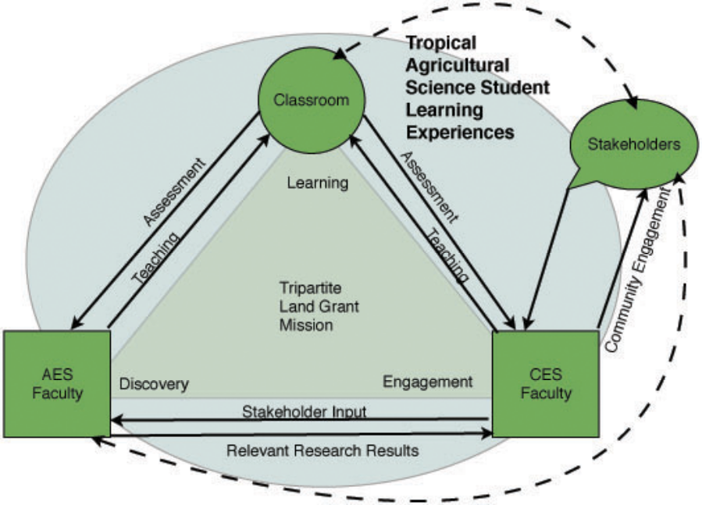

4. Supports for Strategic Initiatives

b. Student Success, Enrollment Growth and Institutional Visibility
The summary of employment of 26 TASP graduates during the years 2000-2006 based on alumni survey speaks well of the student success and supports the program fulfilling its mission to address community’s higher education needs.

Employed in AG-related jobs | 19
Entered Graduate school (includes 5 students also employed) | 7
Employed in non-AG-related jobs | 2
Unknown | 3

c. Land Grant Mission Engagement and Outreach
As shown above, the faculty of the TASP (AES & CES) are a model of how the Land Grant mission functions. An example of this in instruction was a USDA Challenge Grant, which involved many of the TASP (AES & CES) faculty. This grant funded a regional assessment of both the capacity and needs of the region in technology-mediated instruction, regional course development and evaluated alternate course delivery methods.

d. Community Engagement
Faculty with our program are actively involved throughout the community in various activities. This engagement of the CES & AES faculty with academic links to the TASP and CFS program was positively noted in the most recent WASC visit. Much of our community-based projects include partnerships with local government agencies and the frequency of hiring UOG students during the project period in various capacities (survey work, research assistants and extension associates) all add to the overall range of experiences that the student receives in addition to the coursework completed.

e. Institutional Efficiency and Effectiveness
Our program operates with between 1-2 total FTE a year making it a very efficient program. Most of the faculty members are full-time 12-month CES extension or AES research faculty who will remain with the university with or without the academic programs. Costs of adjuncts are covered by the tuition of the courses.

5. Meeting student and regional needs
TASP faculty obtained numerous grants that have related to meeting student and regional needs. Examples of such grants are:
AG Challenge Grant “Promoting Agriculture Education in The Western Pacific”. Included in this project was a Regional Student Pilot Group Feedback Survey, which assessed programs in Guam, Yap, Chuuk, Palau and Pohnpei.
USDA Scholarship Grant “Career Opportunity for Pacific Islanders in General Food and Agricultural Sciences”, 2002, $125,000.
USDA Scholarship Grant “Travel Grant for Pacific Islanders in General Food and Agricultural Sciences”, 2003, $18,750.
ADAP Summer Apprenticeship Program, which has introduced high school students to our TASP, CFS and other science programs. ADAP Capacity Building, which has funded staff pursuit of undergraduate degrees and faculty efforts towards Masters and Doctorate degrees.

6. Completed Program Review with recommendations acted upon

Years covered by Completed Program Review: 1994 to 2000; Date Completed: 2001

ACUP review and recommendations distributed back to faculty: 2003
Recommendation/Situation: “During the 5 academic years under review, the program produced 15 graduates. The program has successfully adapted to the low student numbers by developing a curriculum that is heavily based on conference courses and special project courses. As a result, faculty ends up being caught by conflicting demands. On the one hand, the institution is not providing adequate FTE allocations or financial enumerations.”
Actions Taken/Situation: In response to lack of dedicated FTE, the program has drawn on full time AES and CES faculty. We also utilize several adjunct faculty for teaching high demand GE courses where tuition pay the cost of salary. The number of graduates over the last six years was 26. This is an increase since the previous review (17 graduates). Students in AG 101, AG 109, and AG 136 were surveyed concerning the course content and interest in the TASP. According to the student surveys, there is a significant interest in getting a Minor degree in Agriculture. With this feedback, the faculty members are currently planning a Tropical Agriculture Science Minor and we will discuss this with faculty of the business and education schools.

Assessment of Student Learning and Program Outcomes
Recommendation/Situation: “The reviewers commend the program faculty for describing the program’s ‘Desirable Outcomes’ and ‘Criteria for Evaluating Outcomes’ (pages 4-7), what graduates of Agriculture will be able to do (page 15), and ‘outcomes anticipated from agriculture students’ (page 16). .., It is also important to note, that the absence of UOG-wide assessment of student learning in GE negatively affects student learning assessment efforts in academic degree programs. The self-study report of the Agriculture Program lucidly illustrates this campus wide problem.”
Actions Taken/Situation: Formal assessment has only recently been started. This was linked to the requirements for the preparation of the WASC Poster (Poster Presentation for WASC in Appendix). Methods for evaluating the achievement of goals have been identified and implementation initiated for targeted courses. A great deal of work remains to be done in this area, but the Program is working to meet the schedule in the 5-Year Assessment Plan for UOG. This plan calls for incorporation of intended student learning outcomes into syllabi to be completed during 2007.

Need for Assessment of Conference and Special Project Course
Recommendation/Situation: “the program has assumed functions of cultivating and socializing Agriculture students into productive research assistants for CALS research projects. As reported in the program’s self-study report, this provides many opportunities for students to gain research experience, develop relations with faculty, and to travel in the region. However, in the absence of a well developed monitoring and assessment system for conference courses and special project courses, there are great risks that the needs of research projects may be met on the expense of quality of academic instruction for students.”
Actions Taken/Situation: We have added structured courses in the form of seminar (AG491), practicum (AG492), Thesis (AG495) and Internship (AG498). Assessment is being incorporated into these new courses.

The Program's Institutional Location
Recommendation/Situation: “Historically, it appears that CALS gradually has developed a ‘monopoly’ regarding the implementation of the land-grant mandate of the University of Guam. Clearly, program faculty view the land grant mandate as their primary mission. As a result, the Agriculture Program has become land grant resource rich, relatively independent and less integrated into the overall UOG structures. This is reflected in the fact that the Agriculture Program has been teaching students without the required financial contributions from the University of Guam. According to the self-study, the University of Guam has been in violation with federal guidelines and regulations since 1993, when UOG almost completely ceased to pay for the ‘resident instruction’ workload allocations (which are in addition to the matching funds for land-grant projects). This forced CALS into subsidizing the Agriculture Program ‘under the table’.”
Actions Taken/Situation: The University has reorganized placing the sciences in one College (College of Natural and Applied Sciences). This has helped in developing more interdisciplinary research and expanded the opportunities for sciences faculty to participate in agricultural research proposal submissions. Land grant resources have become available to non-agricultural faculty on campus. However, UOG still does not provide RI funds to Tropical Agricultural Science Program. The situation described by ACUP in their recommendation as “the University of Guam has been in violation with federal guidelines and regulations since 1993, when UOG almost completely ceased to pay for the ‘resident instruction’ workload allocations” has NOT been corrected.

Clarify and simplify the program goals and objectives
Recommendation/Situation: “The members of ACUP recommend that the program faculty further clarify and simplify the program goals and objectives in order to develop a clear and realistic assessment plan for the program. It is important that the faculty make sure that program goals and objectives are connected with expected student learning outcomes in all courses, including conference and special project courses.”
Actions Taken/Situation: As proposed in the previous program self-study, the program was revised based on inputs of community stakeholders, graduates, and students. The program now offers a degree with two emphasis options, Applied or Research Emphasis. Two tracks were also linked to faculty interests and expertise.

Fulfill its mission in other ways
Recommendation/Situation: “ b) The members of ACUP recommend that the faculty explore how the program may fulfill its mission in other ways than through offering a degree program with such a low number of students. In particular, members of ACUP recommend exploring the further strengthening of the role Agriculture plays in the General Education at UOG.”
Actions Taken/Situation: The following courses are currently listed in the General Education Science courses: AG101, AG102, AG109, AG136. Plant Biology (AG102) was added last year to increase the number of courses available for GE Science. Biology majors are also taking AG upper division courses as their elective requirements. We also have cross-listed courses, AG/BI345, AG/BI430, AG/NS380, and AG/PA401 to increase students enrollments. Distance Education was explored through a Challenge Grant, however, it ended up a failure because the faculty were no longer involved in the DE program. AG teaching faculty members were not consulted during the next round of proposal writing to obtain further funding.

Recommendation/Situation: “The members of ACUP encourage the program faculty to assume a leadership role and educate UOG faculty about the land grant mandate to facilitate more collaborative academic work across disciplinary and college boundaries. It is reasonable to expect that a broader awareness of the land grant mandate across campus will aid the Agriculture Program in the long term.
Actions Taken/Situation: With the reorganization at the University, the sciences were placed into one College (College of Natural and Applied Sciences). Efforts have been made to encourage joint projects among Biology, Chemistry, Math and Agriculture. But a second part of this reorganization was a top down decision to remove Cooperative Extension Service from the college and place CES under the VPUCE. An unintended consequence was the breaking of the traditional linkages and faculty working groups between CES and AES. This has come very close to destroying the TASP degree program. This was compounded by 6 years of refusal to hire faculty in CES dropping the CES faculty in TASP from 15 to 6. This caused the Program to struggle to unify our efforts in our RI mission. It is amazing that we have increased our number of graduates (a testament to their employability) but it has not been without great stress and over-working by some faculty members without recognition by administrators. The reorganization also resulted in the loss of computer labs within the Tropical Agricultural Science Program. This will be discussed further in the section on Facilities. The current restoration of CES back into CNAS is very encouraging. The CNAS commitment to rebuilding the Extension faculty will be a great benefit to the TASP.

