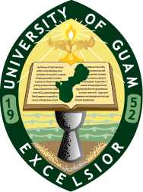  

**Announcement**

March 6, 2015

***Summer Internship Opportunity for Tropical Agricultural Science Majors***

The Tropical Agricultural Science Program is pleased to announce two internship programs to support two students for off-island study this summer.

**1. 2015 USDA/CariPac Summer Internship in American Samoa**

**American Samoa Community College will be hosting the summer internship program. We will provide support for one student with airfare and stipend.**

**Dates: June 1–19, 2015**

**2. 2015 STUDY TOUR of Asian Association of Agricultural Colleges and Universities (AAACU)**

**The Maejo University in Chiang-mai, Thailand is hosting the summer internship program. We will provide support for one student with airfare and stipend.**

**Dates: June 15-25, 2015.**

**Submission Procedures and Deadline**

The application form is available at the Dean’s office (2nd Floor) of the College of Natural and Applied Science in the Agricultural & Life Science building (Phone: 735-2000). The completed application must be submitted before **5:00 p.m.** on **March 16, 2015** to the Dean’s office. If you have any questions about the programs, please contact Dr. Mari Marutani (735-2131), Coordinator of the Tropical Agricultural Science Program and the USDA/CariPac program; or email to either marutani@uguam.uog.edu.

**Application deadline: March 16, 2015.**