**Guam Chamber of Commerce – Dave J. Santos Scholarship**

If you’re interested in a scholarship and internship, the Guam Chamber of Commerce is offering a great opportunity – Dave J. Santos Scholarship.

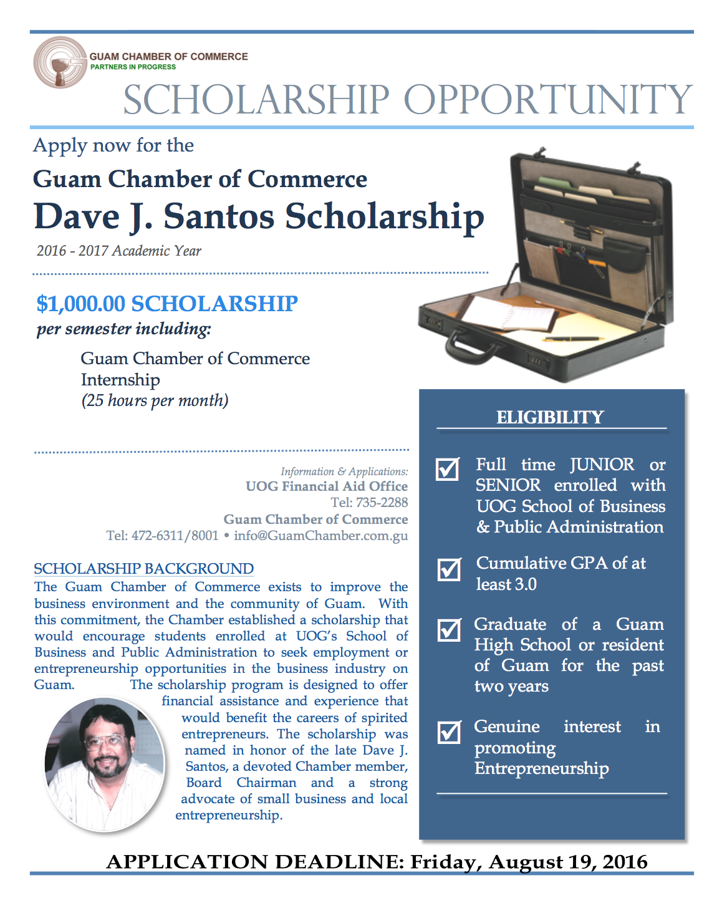

**Purpose**

This scholarship is sponsored and funded by the members of the Guam Chamber of Commerce in recognition of the achievements of the late Dave J. Santos, an entrepreneur, past Chairman of the Chamber of Commerce Board of Directors and the 1993 Small Business Person of the Year. The scholarship is made available to outstanding business majors of the University of Guam.

**Scholarship Benefit**

One scholarship award of $1000 per semester will be awarded per academic year and an internship at the Guam Chamber of Commerce. The scholarship will be awarded to one undergraduate business major in the name of the recipient and the University of Guam.

**Internship**

The scholarship recipient will be given an internship opportunity with the Guam Chamber of Commerce for the duration of the school year (September – May). It will require 25 hours each month and will pay $8.25 per hour.

**Eligibility Requirements**

1. The applicant must be a full time incoming Junior or Senior student enrolled in the UOG School of Business & Public Administration.
2. The applicant must have at least a cumulative GPA of 3.0 and should maintain a GPA of 3.0 each semester during the calendar year.
3. The applicant must be a graduate of a Guam High School and have resident on Guam for the last two years.
4. The applicant must present, before an interview committee, long term goals consistent with a genuine interest in promoting entrepreneurship, and the applicant should evidence knowledge and desire to excel as an entrepreneur on Guam. A history of entrepreneur experience or experience in the private sector is helpful.
5. Preference will be given to applicants as sole scholarship/loan recipients.

**Application Procedure**

Complete and file the Application Form with the UOG Financial Aid Office including evidence to support your eligibility by Friday, August, 19, 2016. Evidence shall include the following:

1. Official UOG transcript. If your transcript does not reflect that you are a Guam High school graduate, please provide a diploma.
2. Pre-registration form or a schedule of classes recommended by your advisor.