Car Gallery Website Project – AI vs Manual Analysis
Rayyan Masroor

1. Manual Website Description
The manual version of the website was created using basic HTML and CSS. It focuses on correct structure, semantic elements, and beginner-level styling. The layout is simple, readable, and fulfills assignment requirements without advanced effects.

2. AI-Generated Website Description
The AI-generated website introduces advanced styling, animations, gradients, and modern UI components. It includes card layouts, hover effects, responsive grids, and improved typography, giving a more professional and polished appearance.

3. AI Prompts Used
Prompt 1:
“make a premium car gallery website using HTML with sections for login, signup, gallery, about, and feedback u can go all out make the most heaviest and impressive website u can make, use images from mclaren, mustang, lambo and Bentley, all .jpg, make the website amazing”
Prompt 2:
“Separate the css part from the html one and give me both of them separately, css should be out of this world and it should be responsive”

4. Comparison: Manual vs AI Website
Manual Website:
- Simple layout
- Basic colors and fonts
- Beginner-friendly code
AI Website:
- Advanced UI/UX
- Animations and gradients
- Professional look and feel

5. Learning Outcomes
Through this project, I learned how to structure HTML using semantic elements, link external CSS files, apply responsive design using media queries, and understand how AI-generated code differs from manually written beginner-level code. I also learned that I would never be able to make something as good as the AI one

6. Git Submission Details
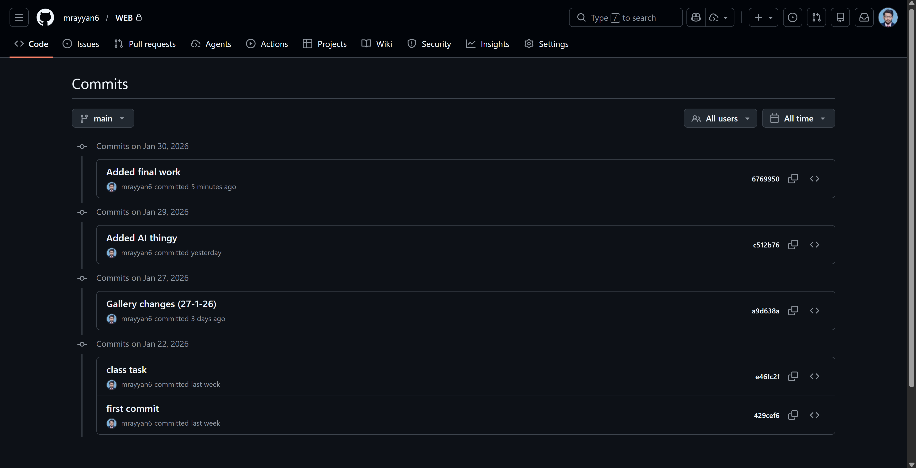

7. Conclusion
This assignment helped in understanding both manual and AI-assisted web development. While AI accelerates design and styling, manual coding strengthens foundational concepts. Both approaches together provide an effective learning experience.

