DFA Specifications

1️⃣ Identifier DFA
Rule:
• Start with uppercase letter
• Followed by lowercase / digit / underscore
• Max length 31 (checked separately)
States:
• q0 = Start
• q1 = Valid identifier
• qE = Error
Transition Table:
Current State | Input | Next State
q0 | A–Z | q1
q0 | other | qE
q1 | a–z | q1
q1 | 0–9 | q1
q1 | _ | q1
q1 | A–Z | qE
q1 | other | Accept
Accepting state: q1

2️⃣ Integer DFA
Rule:
• One or more digits
States:
• q0 = Start
• q1 = Digit seen
• qE = Error
Transition Table:
Current State | Input | Next State
q0 | 0–9 | q1
q0 | other | qE
q1 | 0–9 | q1
q1 | . | Float DFA
q1 | other | Accept
Accepting state: q1

3️⃣ Float DFA
Rule:
• digits '.' digits
• max 6 digits after decimal
• optional exponent
States:
• q0 = Start
• q1 = integer part
• q2 = dot seen
• q3 = decimal digits
• q4 = exponent symbol
• q5 = exponent sign
• q6 = exponent digits
• qE = Error
Transition Table:
State | Input | Next
q0 | 0–9 | q1
q1 | 0–9 | q1
q1 | . | q2
q2 | 0–9 | q3
q3 | 0–9 (≤6 digits) | q3
q3 | e/E | q4
q4 | +/− | q5
q4 | 0–9 | q6
q5 | 0–9 | q6
q6 | 0–9 | q6
q3/q6 | other | Accept
Accepting states: q3, q6

4️⃣ Boolean DFA
Recognizes: true, false

For "true"
State | Input | Next
q0 | t | q1
q1 | r | q2
q2 | u | q3
q3 | e | q4
q4 | other | Accept

For "false"
State | Input | Next
q0 | f | q1
q1 | a | q2
q2 | l | q3
q3 | s | q4
q4 | e | q5
q5 | other | Accept
Accepting states: q4 (true), q5 (false)

5️⃣ String DFA
Rule:
• Enclosed in double quotes
• Allows escape sequences
States:
• q0 = Start
• q1 = Inside string
• q2 = Escape
• q3 = Closing quote
• qE = Error
Transition Table:
State | Input | Next
q0 | " | q1
q1 | \ | q2
q1 | " | q3
q1 | other | q1
q2 | any char | q1
Accepting state: q3

6️⃣ Character DFA
Rule:
• Single quotes
• One char or valid escape
• Max 1 character inside
States:
• q0 = Start
• q1 = Opening '
• q2 = Character read
• q3 = Closing '
• qE = Error
Transition Table:
State | Input | Next
q0 | ' | q1
q1 | \ | q2
q1 | any single char | q2
q2 | ' | q3
q2 | other | qE
Accepting state: q3

7️⃣ Comment DFA

Single Line Comment: ##
State | Input | Next
q0 | # | q1
q1 | # | q2
q2 | not newline | q2
q2 | newline | Accept
Accepting state: q2 (on newline)

Multi-line Comment: #| |#
State | Input | Next
q0 | # | q1
q1 | | | q2
q2 | other | q2
q2 | | | q3
q3 | # | q4
q3 | other | q2
Accepting state: q4

DFA-Simple
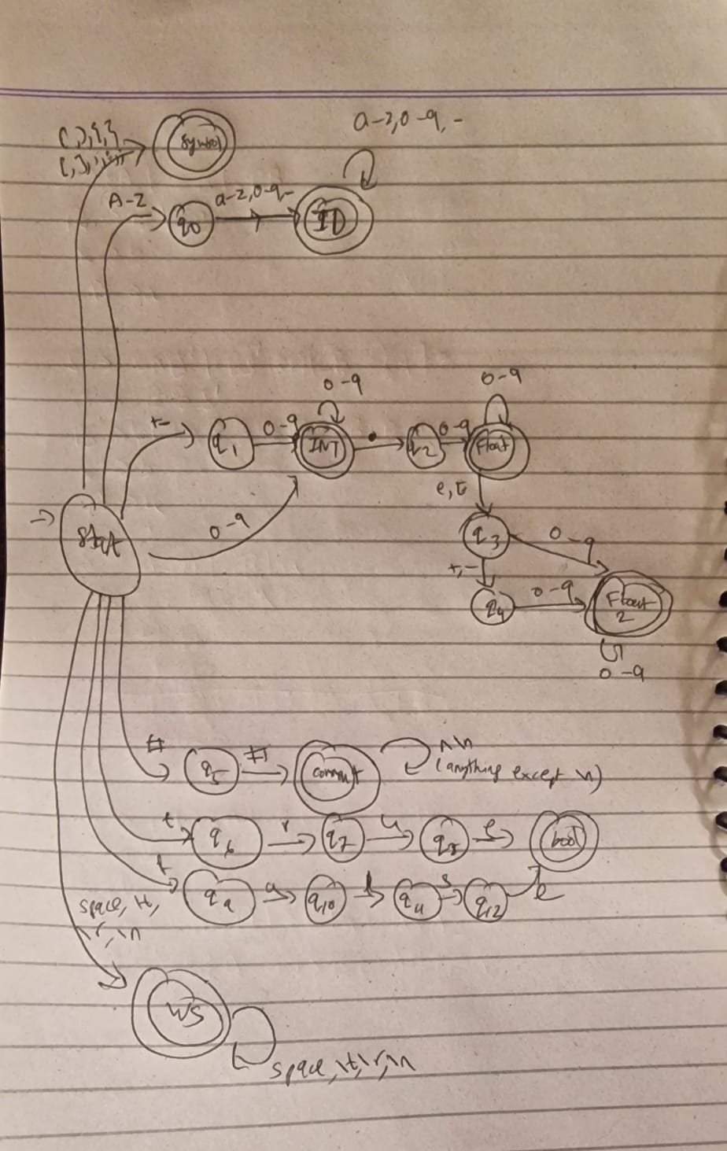
DFA-min states:
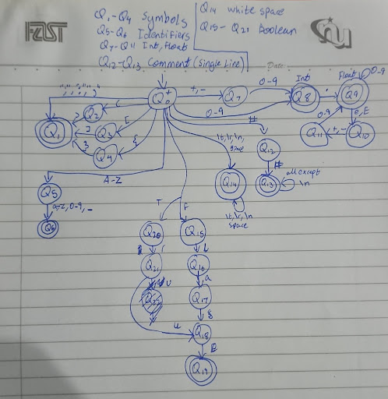

NFA:
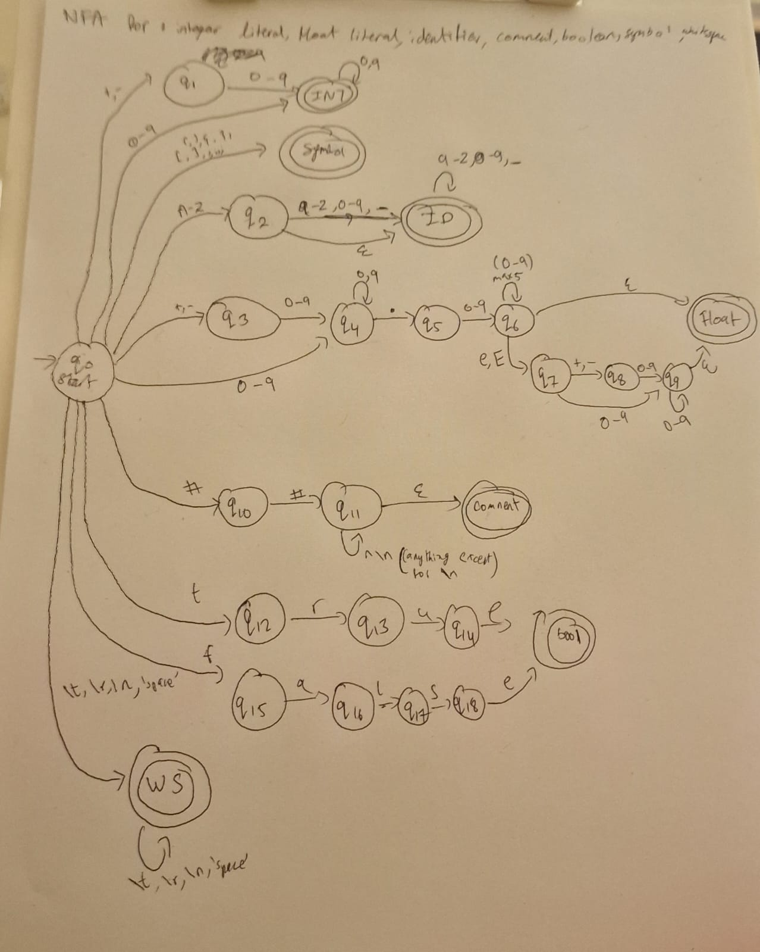

Regex:
1.
Keywords
- Regex: (start|finish|loop|condition|declare|output|input|function|return|break|continue|else)
- Note: Case-sensitive.
2.
Identifiers
- Regex: [A-Z][a-z0-9_]{0,30}
- Rule: Must start with an uppercase letter, followed by lowercase letters, digits, or underscores. Max length 31.
3.
Integer Literals
- Regex: [+-]?[0-9]+
- Examples: 42, +100, -567.
4.
Floating-Point Literals
- Regex: [+-]?[0-9]+\.[0-9]{1,6}([eE][+-]?[0-9]+)?
- Rule: Optional sign, required digits before dot, required digits (max 6) after dot, optional exponent.
5.
String Literals
- Regex: \$"([^"\\\n]|\\(["\\ntr]))*"\$
- Rule: Starts/ends with $". Supports escape sequences \", \\, \n, \t, \r.
- Note: Your implementation code used ", but the PDF explicitly specifies $". Use this regex for the design document to match the spec.
6.
Character Literals
- Regex: '([^'\\\n]|\\(['\\ntr]))'
- Rule: Enclosed in single quotes.
7.
Boolean Literals
- Regex: (true|false)
- Case-sensitive.
8.
Operators
- Arithmetic: (\+|\-|\*|/|%|\*\*)
- Relational: (==|!=|<=|>=|<|>)
- Logical: (&&|\|\||!)
- Assignment: (=|\+=|\-=|\*=|\/=)
- Inc/Dec: (\+\+|--)
- Combined Regex: (\*\*|==|!=|<=|>=|&&|\|\||\+=|\-=|\*=|\/=|\+\+|--|[+\-*/%<>=!])
9.
Punctuators
- Regex: [(){}\[\],;:]
10.
Comments
- Single-line: ##[^\n]*
- Multi-line: #\|(.|\s)*?\|#
- Rule: Single line starts with ##. Multi-line is enclosed in #| ... |#.
11.
Whitespace
+4
- Regex: [ \t\r\n]+

