**OTA Over HM10 Bluetooth**

# Required Hardware:

* 1. 2 HM10 BLE modules.
  2. 2 STM32 (NUCLEO 452RE-P)
  3. Jumper wires.

# Summary:

* 1. This document helps to get started with STM32 OTA using HM-10 modules.
  2. As part of the package, you will receive four firmware.
     1. Configuration Firmware – (Project Name: BLE_Configuration)
     2. Tx Bootloader – (Project Name: TxBLEBootloader)
     3. Tx Application – (Project Name: TxBLEApp)
     4. Rx Bootloader – (Project Name: RxBLEBootloader)
  3. The first step is to setup the hardware as described in **“Hardware Setup”** section.
  4. Then we need to configure one HM-10 as slave and other as master and make a connection. This can be done using the **“Configuring HM-10 modules”** section.
  5. Then we need to flash the bootloaders and applications into the Rx and Tx side STMs. This can be done using **“Flashing Process”** section.
  6. Finally, we need to initiate the OTA process using **“Initializing the OTA routine.”**

# Hardware Setup:

* 1. There are 2 boards, 1 for the reception side and 1 for transmission side.
  2. Make sure that while making the connections, the STM32 board is powered off.
  3. Both Rx and Tx have the same hardware setup.

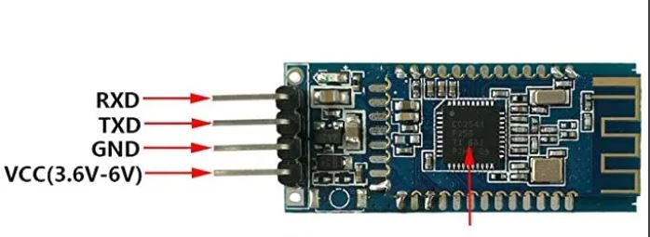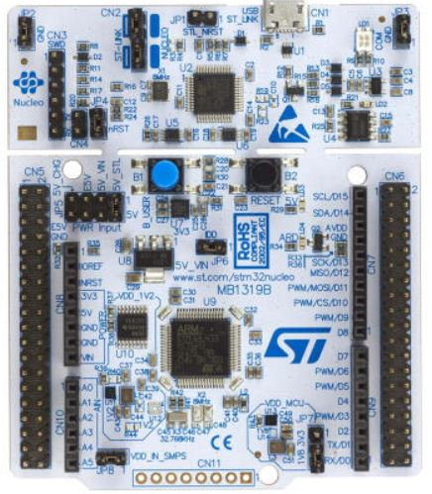

* 1. According to the connections above, connect “TXD” pin of HM10 to “A1” pin and “RXD” to pin “A0” on STM board.
  2. Next connect “GND” pin on HM10 to “GND” pin and VCC pin to “5V” pin on STM board.
  3. This is the complete hardware setup.
  4. Repeat the same process for the other STM32 and HM10 module.

# Configuring HM-10 modules

Flash the configuration firmware in both Reception and Transmission Setups

## Slave Configuration

* 1. The slave can be configured by pressing **“!”**.
  2. You will get the MAC Address of slave device(Example: 112233445566), copy this address, and save it in a notepad.

## Master Configuration

* 1. The master can be configured by pressing **“#”**.
  2. Make sure Slave STM is powered on
  3. Enter AT+CON[SLAVE MAC ADDRESS]
  4. Example: AT+CON112233445566

# Flashing process:

* 1. Connect the Transmission side STM.
  2. Flash the transmission side bootloader and then transmission side application on the transmission setup.
  3. Disconnect Transmission side STM and connect Reception side STM.
  4. Flash the reception side bootloader.
  5. Now connect the boards to your pc (if not already connected) and open their terminal consoles using baud rate of 115200.
  6. Give both the boards reset command via the reset button on the STM32 board.
  7. The TX side should show that it ran its bootloader and then jumped to its application.
  8. The RX side should show that bootloader is running.

# Initializing the OTA routine:

* 1. After the flashing process is completed, now you are ready to initiate the OTA process.
  2. On the transmission side terminal, enter command “AT” you should get “OK” as a response from your HM10 module.
  3. Now in order to connect the 2 BLE devices with each other on the transmission side terminal, enter the command “AT+START”.
  4. Upon giving this command you will notice that both the transmission and reception side hm10 modules blinking LEDS change their blinking frequency to lesser frequency.
  5. This shows that both your BLE devices are now connected with each other.
  6. After the connection has been made, type ‘!’ on the transmission console and you will notice that both your reception side and transmission side will both jump to their bootloader applications.
  7. After that the transmission side will start sending the OTA packets to the reception side and reception will keep acknowledging it.
  8. Once all the packets have been sent, both the boards will give “OTA COMPLETED” notification on their terminal consoles and they will jump to their applications.
  9. What basically happened is that the application that was running on the transmission side, its bootloader sends the exact same application to reception side.
  10. Upon OTA completion, the reception side starts running the same application as the transmission side.