# Bangladesh

To understand the housing crisis of Bangladesh it is important to understand the picture of urban living in Bangladesh. In major cities such as Dhaka and Chittagong, 28 percent of the population of Bangladesh reside. The total contribution to the GDP for these places are over 50 percent. Each year more and more people move into these financial hubs every year in the prospect of more income or a better life. The figure below provides a visualization of the growth compared to rural and urban areas of Bangladesh.

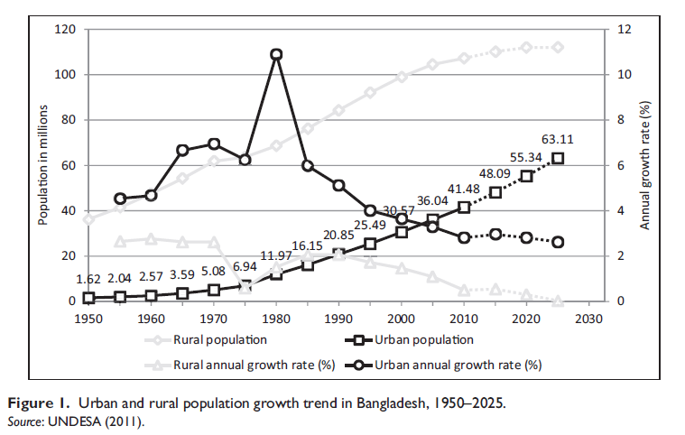

This mass influx of people inside cities like Dhaka has created a huge real estate market. Currently in cities the real estate market currently comprises of two different entities/property owners.

* Independent small property owners who own lodgings in the form of buildings, tin shed houses and multistoried apartments.
* Large scale real-state business enterprises that own areas of apartment complexes.

It is important to understand the business models of these individual entities to understand where the problem lies. Small independent property owners usually comprise people from the upper middle or wealthy class strata in Bangladesh. People purchase land in different areas in Bangladesh from money they have earned through their business, job, and government pension or from external sources such as remittance. These property owners construct either multistoried apartments or smaller tin shed housing prevalent throughout many slums or low income areas in major cities. The lodgings are usually rented or leased out to people and are not sold. The apartments owned by these people are mostly rented out to middle class and upper middle class peoples, whereas the tin-shed housing are commonly resided by the working class population of the city. It is often the case that in many scenarios the owner of the land may be an independent small time property owner who do not have the funds to construct an apartment building and since space in major cities is very expensive due to the sheer number of people living in it, a very lucrative revenue stream is being cut off for them.

Enter the real-state business enterprises. One of the many business operations of these businesses is to strike up deals with said property owners to construct the building in exchange for a certain percentage ownership of the number of flats and the power of attorney ownership. The apartment flats owned by the companies are in most cases sold off. Real-state companies also have their own apartment buildings outside these deals and also other commercial properties.

## The Problem:

The COVID-19 pandemic in cities have completely decimated economic and financial activities. This effect is especially prevalent in industries that Bangladesh excels in such as the RMG sector. Due to the public closure of many shopping malls and offices, small businesses and the private intra city transport sectors have taken a huge hit. Other important industries that have suffered include the travel and tourism industry. All of the industries mentioned above employ people from various walks of life and since the revenue streams have been cut off the individual corporations have taken measures to either reduce pay of staff or completely lay off employees, in the worst case they have gone out of business. Now due to this reduction in income of many, people are struggling to pay their monthly rent. For small-time independent property owners, whose tenants usually include people from the working class background i.e. garments workers, rickshaw pullers and such, have not been able to pay rent for consecutive months. Because landlords require a constant cash flow to pay off costs which come with owning a property such as utility bills and city corporation taxes. Tenants are being evicted from their homes to make room for other potential paying tenants. Which is leaving many tenants without homes at the same time many vacant homes as potentially paying tenants are on the decline.

Perhaps the most interesting part in all of this is, landlords in Bangladesh do not have as much of a bargaining power as they would like to have especially among working class people and bargaining power is absolutely essential when doing any business. The lack of this bargaining power chiefly has to do with Bangladesh still chiefly being an agrarian society at heart. There still exists within Bangladesh a large agricultural market that must be quenched and because of this many working class people still have an option to retreat to the countryside and work on land. As stated earlier, many small businesses closing down would also mean that a portion of the middle class demographic have also lost their income but even for them an alternative exists. Many people actually own land in the countryside which is primarily used for farming and can therefore derive income from there. Even though such alternatives exists they are not at all satisfactory for an individual living in today’s economy. Therefore it is imperative to resolve this.

Now the discussion will be regarding the investment sector of the housing industry and how COVID-19 has also to an extent disrupted the market. The investment are usually made by buying flats provided by real estate companies by the means discussed previously. The property buying for most people is done through a down payment with following yearly or monthly pay. Since property prices have hit an all-time low, corporate real estate investment have also plummeted either because some buyers are expecting the prices to drop even lower in the future or that they do not see much prospect in property investment right now. This has had a large impact on the real estate industry as a whole and their current revenue stream is being attenuated.

## The Solutions:

The solutions to such a problem will have to be implemented on multiple levels for complete resolution. The first level of solution discussed will be with a macroeconomic lens. Since the root cause of this entire domino effect is the decline of economic activity, the quickest way to get out of it would be to present conditions that facilitate businesses to resume operations. This may be through government stimulus packages to small businesses, tax cuts or through government investment in the IT sector and health sector so that businesses can evolve and ascend to a better platform and also to make conditions safe enough for the general consumers to interact with businesses. To keep the proverbial wheels of economy running in today’s day and age, where trade has become globalized to the point where one problem in some part of the world hundreds of miles away starts a chain reaction, it is not always possible to control everything. This case is especially true in the RMG industry in Bangladesh, one of the prime exports of the country. Large fast fashion brands in the West have seen a huge decline in sales as much as 26% during this pandemic, therefore in order to cut down on costs have cancelled large amounts of orders from RMG factories in Bangladesh, which in turn left many factories unable to pay wages to millions of workers and many have even had to shut down operations. To provide a safety net for such incidents the government should provide social security for workers of various industries.

Now we look at individualistic and business solutions. For small-time property owners, the primary way to get new tenants would be to lower the rent, but this cannot be done in a vacuum. This is where government intervention comes in. Since most running costs associated with owning a property come from utility bills, city corporation taxes and so on, these costs can either be reduced by the government or waived to a certain extent. This will allow landlords the financial freedom to charge less rent for a temporary amount of time. Since it is preferable for most to actually reside near their area of work, many might actually find a lower temporary lower rent feasible given the current context of things.

For real-estate businesses, the government has already paid 700 billion taka in stimulus packages to keep businesses afloat. As real-estate businesses have a very high barrier to entry due to the amount of money involved, only a select percent of the population can actually engage in the business. To currently rejuvenate the cash flow, companies should lower the barrier of entry so that a larger demographic can engage in the business. For instance, real estate businesses should consider smaller cheaper properties in their construction so that many small business owners can find it a worthwhile investment. Also to encourage more business more discounts should be introduced.