CGRPlotter Distance Correlation and Box Matching Program Workflow
Source code based engineering description

Purpose and execution boundary
This document describes the implemented processing paths in distance_correlation.py and cgr_box_matching.py. Distance correlation generates weld ties and correction files. Box matching separately reads a correction file, translates previous-run feature boxes into the recent-run distance frame, generates overlapping candidates and allocates one-to-one pairs by depth preference.
The supplied modules process two inspections at a time. They do not implement persistent tracking across three or more inspections. The workflow below documents current code, without adding probabilistic matching, nearest-distance selection or a multi-run tracking engine.

Module handoff
Stage | Implemented entry point | Artifact or result
Distance correlation | load_weld_records; correlate_welds | Monotonic weld ties and unmatched weld sets
Correlation export | export_correlation | Directional WCO text, DBF/CDX companions, audit and summary
Integration handoff | External to the two supplied modules | Select the previous-to-recent direction and stage it as Default.wco or Default.DBF
Box matching | run_box_matching | Feature correspondence, CGR tables, summary, counts and visualization data

Important implemented rules
Automatic weld-length tolerance defaults to 5% and cannot exceed 5%. Box tolerances fall back to ±100 mm axially and ±30 degrees circumferentially when not supplied through parameter data or overrides. These are implementation settings, not independently validated engineering acceptance criteria.
The current matcher tests complete rectangle overlap. Candidate allocation prefers greater reported wall loss on both sides. The reported distance diagnostic does not determine candidate eligibility or allocation. Unmatched CGR is calculated using a zero previous-depth baseline convention.
Source basis: supplied Python snapshots only. Function names and source line ranges below refer to these snapshots. The workflow is a source review; no full project or real inspection dataset was executed.

Distance correlation workflow
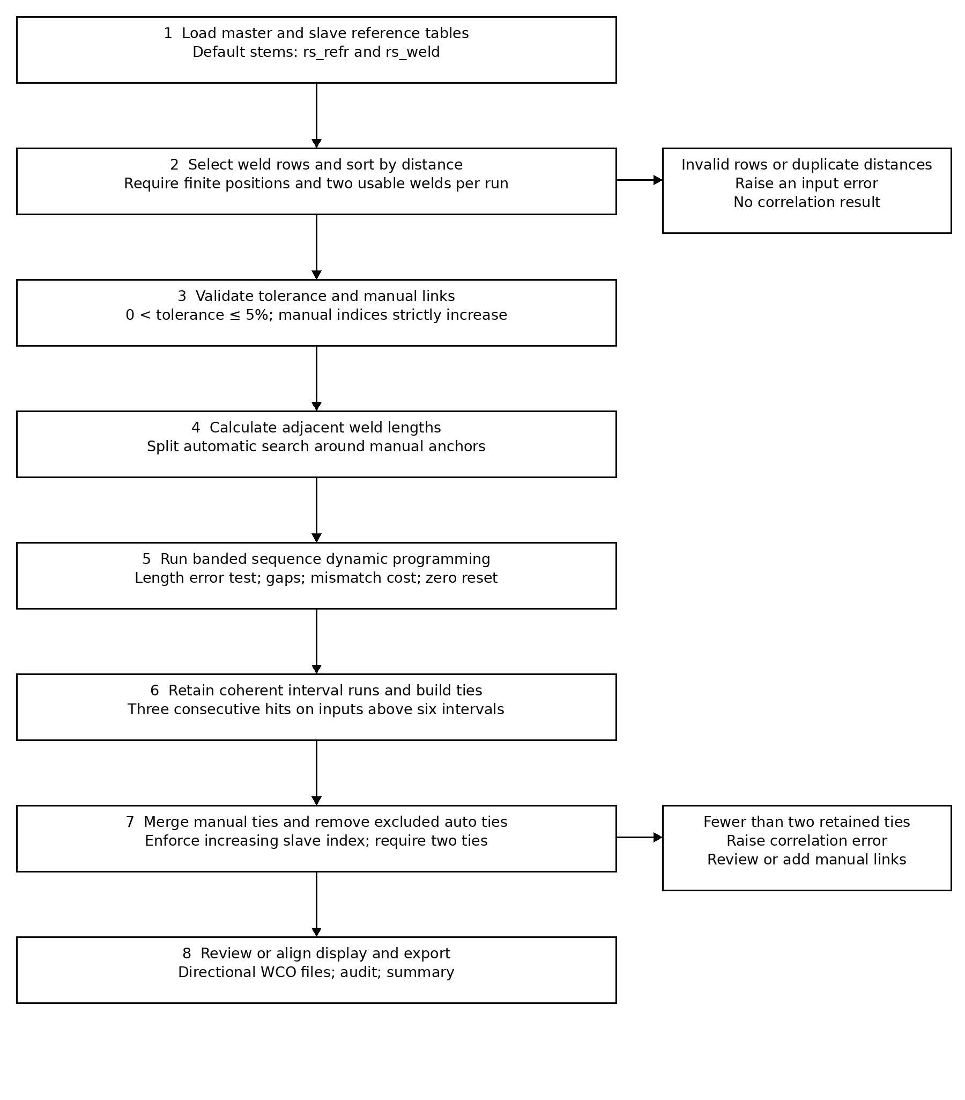

Box matching workflow
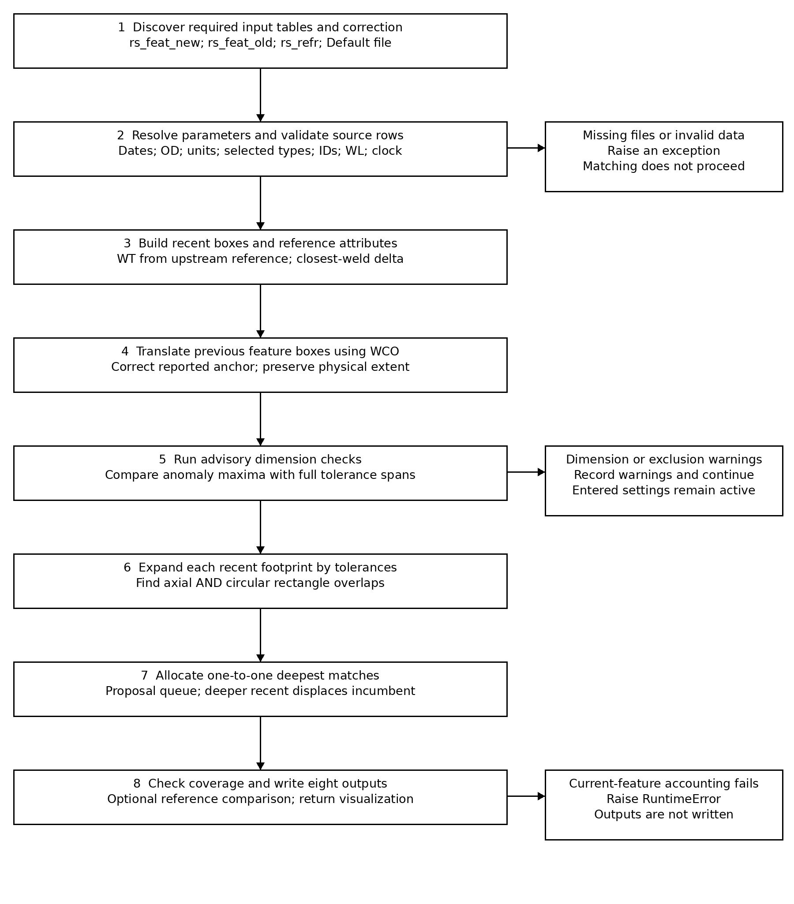

Distance correlation algorithm details

Input processing and manual controls
load_weld_records accepts DBF, CSV, XLSX, XLSM and XLS tables. TYPE and weld flags filter records only when recognized weld values occur; otherwise all rows are considered. DISTANCE is mandatory. Records sort by distance and source row. Invalid numeric data, fewer than two usable records and duplicate distances raise errors. Joint number and WT are retained but do not contribute to the automatic pattern score.
Manual links must be in range and strictly increase in both index sequences. They partition the automatic search into slices excluding the manual anchor rows. Automatic ties are combined with manual ties, with manual ties taking precedence for a master index. Excluded automatic pairs are skipped. Non-increasing automatic slave indices are discarded; a conflicting manual pair raises an error.
distance_correlation.py: load_weld_records 114–184; validate_manual_pairs 370–382; correlate_welds 385–478.

Sequence score and pattern retention
For master and slave adjacent lengths Lm and Ls, error = 100 × |Ls − Lm| / |Ls|. The denominator is the slave length. Let T be the selected percentage tolerance and E = ceil(1000 × T). An accepted diagonal receives 2E − min(E, round(1000 × error)); a mismatch costs E and a gap costs 3E.
The search band is min(max(nm, ns), max(256, |nm − ns| + 64)), where nm and ns are interval counts. Scores reset to zero and traceback starts at the highest-scoring cell, despite a source comment calling the method global alignment. Thus the implemented recurrence can retain a best-scoring subsequence rather than force end-to-end alignment.
Where max(nm, ns) > 6, only runs of at least three consecutive interval matches survive. Each accepted interval contributes its upstream weld as a tie. A terminal tie is added only when the final accepted interval is the final interval in both sequences.
distance_correlation.py: interval_error_percent 213–218; automatic_segment_pairs 221–367.

Reported confidence and display alignment
confidence_percent = 100 × intervals_within_tolerance / intervals_compared, or zero if the denominator is zero. The denominator accumulates the larger interval count per automatic slice. This is a pattern hit ratio, not a calibrated probability of correct correlation; counts are accumulated before later tie exclusion and ordering filters.
The Align Inspections display maps accepted ties exactly. Each unmatched slave weld receives the nearest accepted tie offset; it is not stretched by interpolation. This display behaviour differs from the piecewise-linear mapping consumed by box matching.
distance_correlation.py: CorrelationResult.confidence_percent 56–60; aligned_slave_distances 654–681.

Box geometry candidate generation and allocation

Population and geometry
The two runs discover recognized metal-loss types independently unless explicit type selections are supplied. Cluster rows are excluded by default. The requested pipeline range filters recent reported distance and previous adjusted reported distance. Matching uses the retained populations; it does not require equal TYPE labels or equal INTERNAL classifications between a candidate pair.
Reported location can be Center, Top left, Top right, Bottom left or Bottom right; the fallback is Top left. Explicit O_MINDIST, O_CENDIST and O_MAXDIST values take precedence where available, with an all-zero placeholder exception. Physical box dimensions otherwise come from LEN, WID and the chosen reporting point.
For a previous feature, the correction map evaluates its reported DISTANCE. The resulting offset translates its minimum, centre and maximum axial coordinates equally. LEN is preserved; the endpoints are not independently stretched through the correction map. The current feature WT comes from the upstream reference row.
cgr_box_matching.py: build_recent_features 1657–1730; build_previous_features 1733–1810; feature_box_distances 2755–2796; ReferenceLookup 321–354.

Candidate eligibility
Expand the complete recent footprint by ± axial tolerance and ± angular tolerance. A previous rectangle is eligible if both its closed axial interval and its clockwise angular interval overlap the expanded footprint. Angular overlap tests equivalent windows shifted by −360, 0 and +360 degrees. Comparisons include a numerical epsilon of 1e−12 in native station units and degrees respectively.
Previous features are indexed by minimum axial distance. A bisect search uses the maximum previous feature span to reduce the candidate set before exact overlap tests. Feature distance and candidate CGR are then calculated for every eligible pair.
cgr_box_matching.py: build_cga_box_analyses 1831–1913; overlap functions 1934–1974; tolerance_box_for_recent_feature 1990–2005.

One to one allocation
Each recent feature ranks previous candidates by descending WL, then ascending previous ID. Recent IDs initially enter a queue in ascending order. A proposal is held if the previous feature is free, or if the proposer has greater recent WL; equal recent WL favours the lower recent ID. A displaced recent feature retries its remaining choices. This is a stable proposal-and-retention process with depth preferences, not minimum-distance or Hungarian assignment.
Selected pairs are one-to-one. A recent feature exhausting its choices is an unused recent match; its first-ranked previous candidate is retained for diagnostic output. A recent feature with no candidate is unmatched. The supplied implementation does not classify physical splits or merges.
cgr_box_matching.py: select_deepest_box_matches 2026–2037; select_deepest_matches and recent_deepest_key 2066–2115.

Growth calculations settings and outputs

Implemented growth calculation
Δt = calendar-day difference / 365. Matched CGR = [(WLrecent − WLprevious) / 100] × WTrecent / Δt. Both percentage depths use the same recent WT in this calculation; the code does not separately convert previous WL using a previous WT. Unmatched CGR = (WLrecent / 100) × WTrecent / Δt, which embeds a zero previous-depth baseline convention and is not a measured matched growth rate.
Metric tables use metre stationing and mm dimensions, producing mm/year. Imperial tables use foot stationing and inch dimensions; CGR is multiplied by 1000 to report mils/year. OD and axial-tolerance inputs remain mm. Circumference uses 22/7 × OD for legacy compatibility. Negative matched CGR is retained and annotated for engineering review.
cgr_box_matching.py: Parameters 176–218; unit conversions 975–1012; calculate_matched_cgr 2643–2652; calculate_unmatched_cgr 2659–2667; deepest_matched_row 2330–2359.

Settings and checks
Setting or check | Actual behaviour
Parameter source | Optional parameters.mcw plus overrides; otherwise dates, OD and units must be entered.
Fallback tolerances | ±100 mm and ±30 degrees; axial ≥ 0; angular from 0 to 180 degrees.
Blocking validation | Required tables, correction rows, fields, selected unique positive integer IDs, WL 0–100%, nonnegative LEN/WID, valid clock and nonblank INTERNAL.
Advisory checks | Maximum LEN/WID meets or exceeds full tolerance span; excluded current metal-loss population. Matching continues.
settings.mcw | Read when present; return value is discarded in run_box_matching.

Eight box matching output files
All filenames include the run stamp. Output_All contains recent rows and eligible candidate rows. Output_Deepest contains selected pairs and no-candidate recent features. Output_Deepest_All_Features combines these with unused recent diagnostics and unused previous features.
Additional CSV stems: Output_Deepest_UnusedPreviousFeatures; Output_Deepest_UnusedRecentMatches; Output_Deepest_UnusedRecentMatchesWithPreviousMatches; Output_PrevDistAdj. Summary is a text file. Results are written in a tolerance-named output directory; optional reference-output comparison runs afterward.
cgr_box_matching.py: run_box_matching 438–690; write_outputs 2118–2234.

Integration boundary and review findings

Correction file direction and staging
The box matcher requires Default.wco or Default.DBF in its input folder. Text takes precedence over DBF. Text column 1 is treated as original previous-run distance and column 2 as corrected recent-run distance; DBF fields are ORGDIST and CORRDIST. At least two finite correction rows are required. Rows sort by their original distance.
Distance correlation exports files named from master and slave IDs, not Default files. Its forward text stores (master distance, slave distance); inverse rows generally swap that order. For a recent master and previous slave, the desired handoff is the previous-to-recent column order. No automatic invocation or copy/rename handoff between these modules appears in the supplied source.
distance_correlation.py: export_correlation 517–633; cgr_box_matching.py: read_correction_map 1395–1418.

Implemented behaviours requiring explicit review
Area | Source behaviour and implication
Boundary export | When extension is enabled, first boundary is (first_master, first_master − first_offset); last is (last_master + last_offset, last_master). The first inverse boundary is deliberately not swapped. These special rows require direction verification before staging a Default file.
Correction map validation | Importer sorts finite rows but does not reject duplicate original knots or nonmonotonic corrected knots. Mapping outside the range extrapolates the first or last segment; a duplicate x interval returns y0.
Pair compatibility | sides_are_compatible exists but is not called by the active candidate generation path. Nonblank INTERNAL validation does not prevent cross-surface candidates.
Distance diagnostic | feature_distance is a legacy output convention. It is not the allocation score and should not be described as the matching criterion.
Engineering confidence | No sizing-bias model, uncertainty propagation, calibrated match probability or physical split/merge classification is implemented in these paths.

Source identity and verification scope
distance_correlation.py | 1476 lines
SHA256 b4901e0ac6e41143e3dde9db916afde592875c345116908ce85cda9ad318b00b
cgr_box_matching.py | 3103 lines
SHA256 b07c202758ed4f2ddcc49c6c0195ad9b4dc0e6b435ba6f56cd072758ef5c1d4e
Review is based on the supplied source snapshots. The distance module imports cgr_plotter_core and distance_correlation_formats, which were not supplied. Their DBF/CDX serialization and the full GUI-to-project execution path were therefore not verified. No changes were made to either uploaded source file.

