Multi Run ILI Feature Tracking and Corrosion Growth Assessment
Engineering workflow and evidence basis

Purpose and scope
Track reported corrosion features across three or more in-line inspections and estimate interval-average depth growth with explicit correspondence and measurement uncertainty. The workflow excludes box matching and signal-to-signal matching.
The complete workflow is a proposed engineering integration. Published evidence supports probabilistic matching of reported features [1] and multi-inspection growth modelling with inspection error [2,3]. Graph-based track hypotheses, nonadjacent-run consistency checks and exception routing are proposed implementation elements requiring validation.

Evidence and implementation status
Element | Status
Probabilistic feature correspondence | Published framework using feature locations and girth welds; includes match probabilities and outliers [1].
Time-varying depth growth | Published dynamic linear model using multiple ILI datasets and measurement error [2].
Stochastic depth growth | Published nonhomogeneous gamma-process approach incorporating imperfect ILI evidence [3].
Integrated multi-run tracking | Proposed here; no validated performance is claimed for the combined workflow.

Evidence required before quantitative use
Obtain run dates, original feature IDs, axial and clock positions, weld and joint references, depth and WT basis, length, width and classification. Obtain tool performance definitions, reporting thresholds, coverage information, repair records and relevant field measurements. Record missing information explicitly.
No numerical registration tolerance, match acceptance threshold, sizing-error distribution, prior distribution or growth law is prescribed. These must be established from project evidence and validated for the intended use.

Workflow chart
Main path proceeds downward. Side branches identify conditions that prevent release of an individual feature growth result. Steps 5 and 6 are proposed tracking extensions; references identify published foundations.
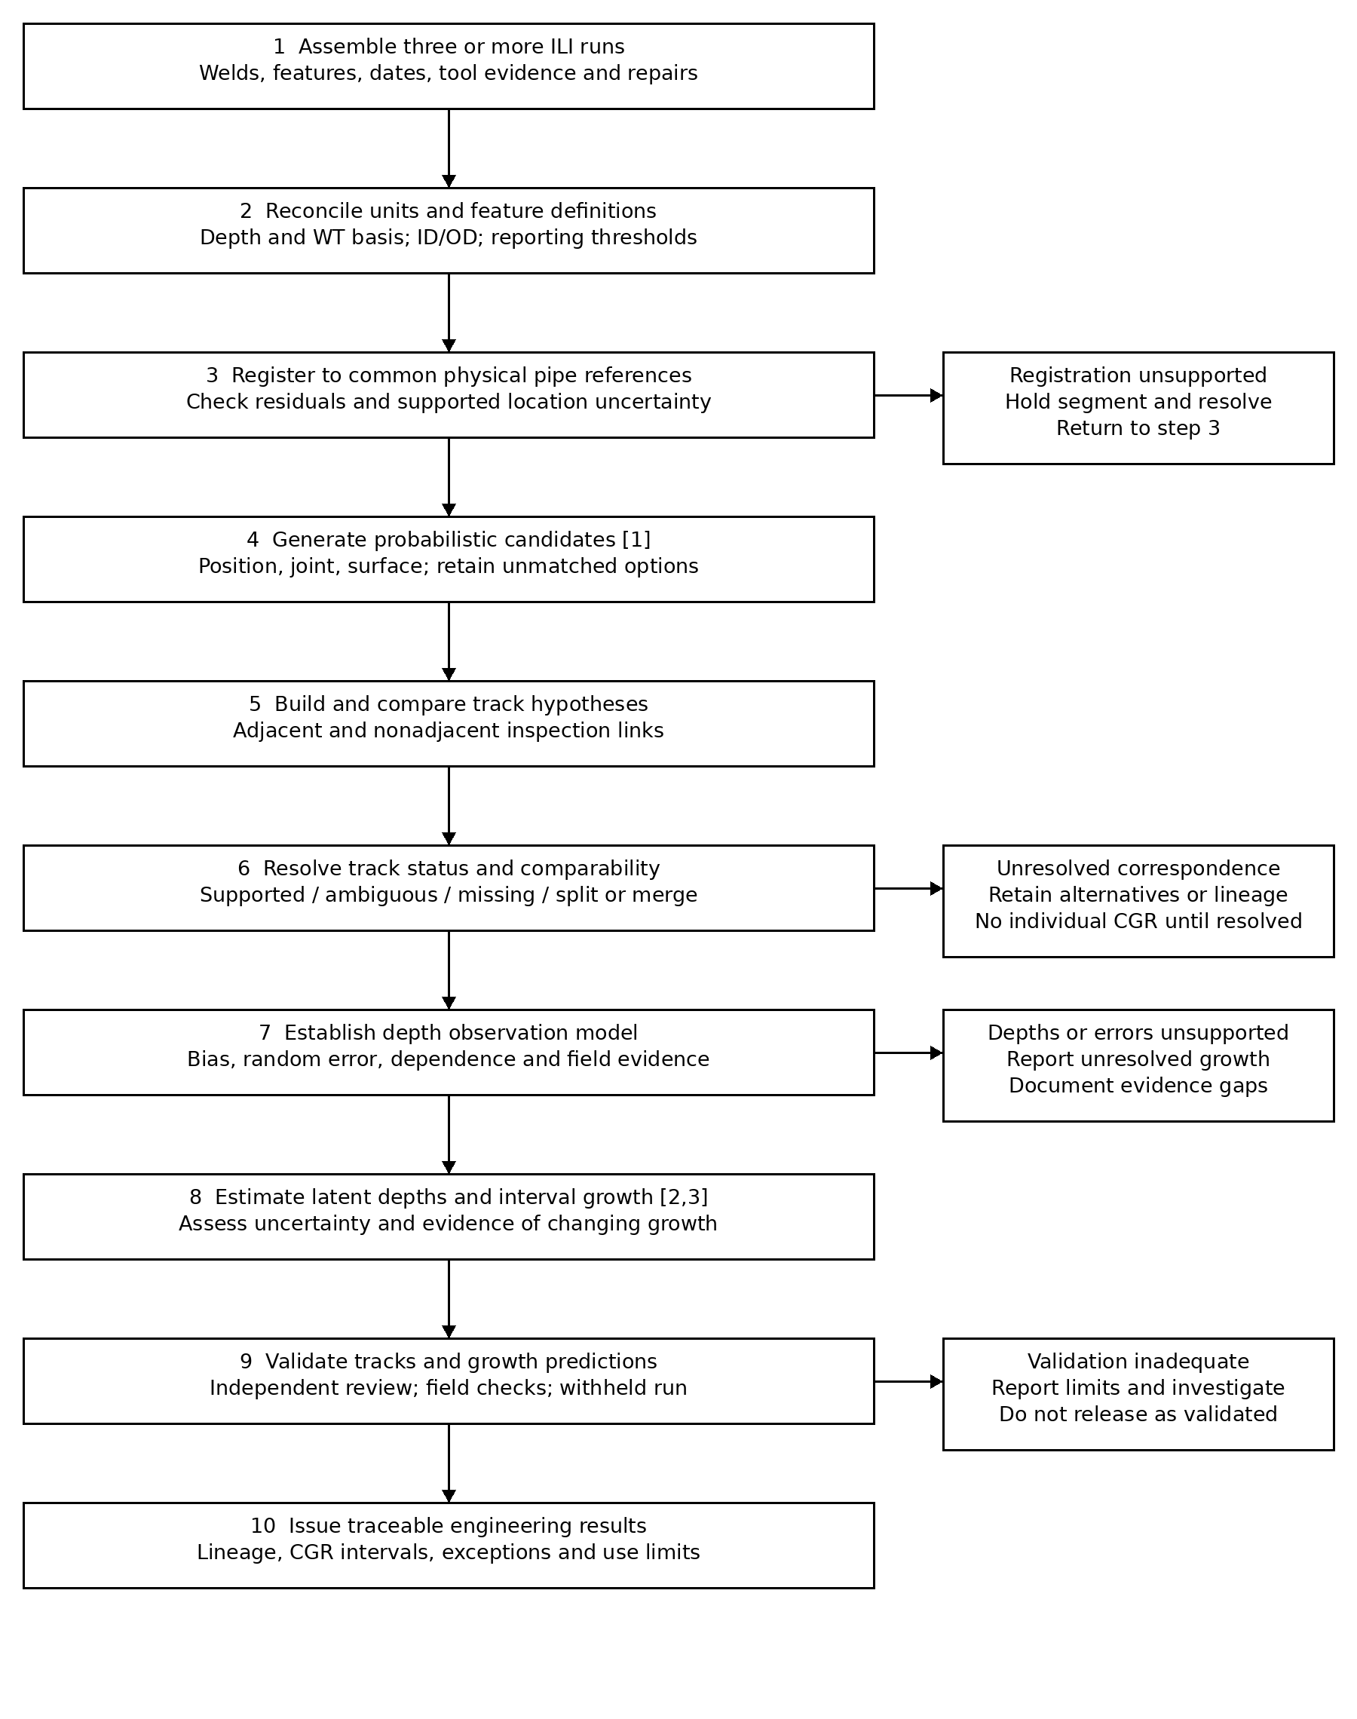

Engineering controls for correspondence

1 Reconcile data definitions
Preserve source records and original IDs. Confirm whether a position denotes the feature start, centre or another reference. Confirm inspection direction, clock convention, ID/OD meaning and parent-child reporting rules. Convert percentage depths to millimetres using the documented WT basis for each observation.

2 Register physical pipe references
Establish common joint identity from welds and stable fittings. Resolve weld renumbering, omitted references, reversed run direction and replaced pipe. Apply only transformations supported by reference evidence. Evaluate residual axial and circumferential discrepancies locally; retain the transformation and its uncertainty.

3 Generate and score candidates
Use registered position and supported location uncertainty to identify candidate correspondence. Handle circumferential wrap at 12 o’clock. Consider joint identity, surface classification, morphology and surrounding feature arrangement according to their reliability. Retain competing candidates and an unmatched option. Do not select matches primarily by depth similarity, which can favour artificially low growth.

4 Evaluate complete tracks
Represent each reported observation as a dated node and each candidate correspondence as a link. Compare complete track hypotheses, rather than committing independently to each pairwise match. For a proposed run 1 to run 2 to run 3 track, also examine the direct run 1 to run 3 correspondence. Agreement is supporting evidence, not independent proof: the comparisons reuse observations.
Enforce mutually consistent assignments for individual-feature tracks. Keep alternative hypotheses where evidence does not discriminate between them. A unique numerical optimum is not, by itself, evidence of a correct physical match.

5 Handle exceptions explicitly
Status | Required treatment
Missing observation | Investigate coverage, detection, reporting thresholds, repair and classification. Do not insert zero depth or assign an initiation date.
Ambiguous track | Retain alternative identities. Resolve with additional evidence or report individual growth as unresolved.
Split or merged report | Retain parent-child lineage. Establish a comparable physical depth quantity before calculating growth.
Repaired or replaced pipe | Review intervention type and date. Terminate or qualify the affected track according to physical continuity.

Depth growth and uncertainty

Observation relationship
A general measurement relationship separates physical depth from systematic and random sizing error. It does not prescribe a probability distribution.
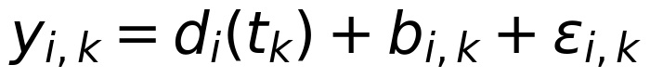
y is reported depth in mm; d is latent physical depth in mm; b is systematic sizing error in mm; ε is random measurement error in mm; i identifies the physical track and k the inspection. Bias may depend on tool, morphology and depth where supported by calibration evidence.
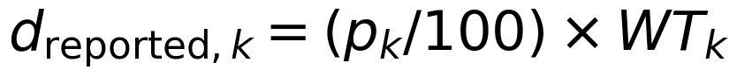
p is reported percentage wall loss and WT is its documented wall-thickness reference in mm. A change in assigned WT can change calculated depth without physical corrosion.

Interval average growth
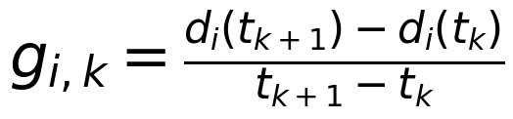
Use elapsed years to obtain mm/year. Estimate the distribution or supported uncertainty bounds of the interval growth, rather than reporting subtraction of measured depths as exact physical growth. Retain negative observed differences during error assessment; do not truncate measurements before calibration.

Changing growth across three inspections
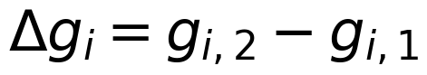
Evaluate uncertainty in the difference, including the shared middle inspection. Three depths provide two interval differences; this does not necessarily distinguish corrosion acceleration from sizing error. Report interval-average rates, rather than instantaneous rates, unless a justified model supports that interpretation.

Model selection and evidence limits
Published alternatives include a dynamic linear model allowing temporal growth variability [2] and a nonhomogeneous gamma-process model [3]. Select and validate a model using calibration evidence, residual behaviour, predictive performance and documented physical constraints. State every adopted distribution and prior explicitly.
Run-specific bias and true growth may be confounded. Additional inspections alone do not guarantee identifiability. If calibration is insufficient, report sensitivity to the unresolved error terms and the resulting limits on growth interpretation. Do not treat ambiguous match links as independent probabilities or multiply them without a justified joint model.

Validation records and references

Validation before engineering release
Validate physical correspondence independently of the estimated growth. Include sparse features, dense colonies, alternative matches, missing observations and split or merged reports. Record false matches and missed matches against an independently reviewed reference set. Define acceptance criteria for the intended engineering use before evaluating results.
Where sufficient observations exist, withhold an inspection and compare predicted depths with its reported observations through the observation model. Check systematic prediction error, interval coverage and performance by feature class. Withheld observations are inspection measurements, not exact physical ground truth.
Use field measurements only with their dates, spatial correspondence, measurement uncertainty and any intervening corrosion or repair accounted for. Release unresolved correspondence and inadequate calibration as explicit exceptions.

Required output record
Record group | Required contents
Identity and lineage | Physical track ID; original IDs and dates by run; parent-child relationships; repairs and missing-observation flags.
Correspondence evidence | Registered locations; registration residuals; alternative links; acceptance basis; probability only if calibrated.
Depth and growth | Reported depths; WT basis; bias and error evidence; estimated interval growth; uncertainty and model definition.
Validation and disposition | Reference review; prediction checks; unresolved issues; engineering reviewer; intended use and limitations.

References
[1] Dann MR and Dann C. Automated matching of pipeline corrosion features from in-line inspection data. Reliability Engineering and System Safety. 2017;162:40–50. https://doi.org/10.1016/j.ress.2017.01.008
[2] Zhang S and Zhou W. Bayesian dynamic linear model for growth of corrosion defects on energy pipelines. Reliability Engineering and System Safety. 2014;128:24–31. https://doi.org/10.1016/j.ress.2014.04.001
[3] Zhang S, Zhou W, Al-Amin M, Kariyawasam S and Wang H. Time-dependent corrosion growth modeling using multiple in-line inspection data. Journal of Pressure Vessel Technology. 2014;136(4):041202. https://doi.org/10.1115/1.4026798
Evidence boundary: these references support the component methods identified above. They do not establish the performance of the complete proposed tracking workflow or supply project-specific acceptance thresholds.

