rockconnect
Feature overview and project status
A white-label community platform for bands, venues and fans: gigs near you, who is going, private chat, and moderation built in.
Document | What has been built so far, how it works, and what is still open
Status | Working web application with a JSON API; pre-launch (not yet deployed)
Date | 6 October 2026
Author | mrbacco (mrbacco04@gmail.com)
Code | github.com/mrbacco/ROCKCONNECT_PY
Quality | 707 automated tests pass; 11 database migrations; every rule checked by breaking it on purpose

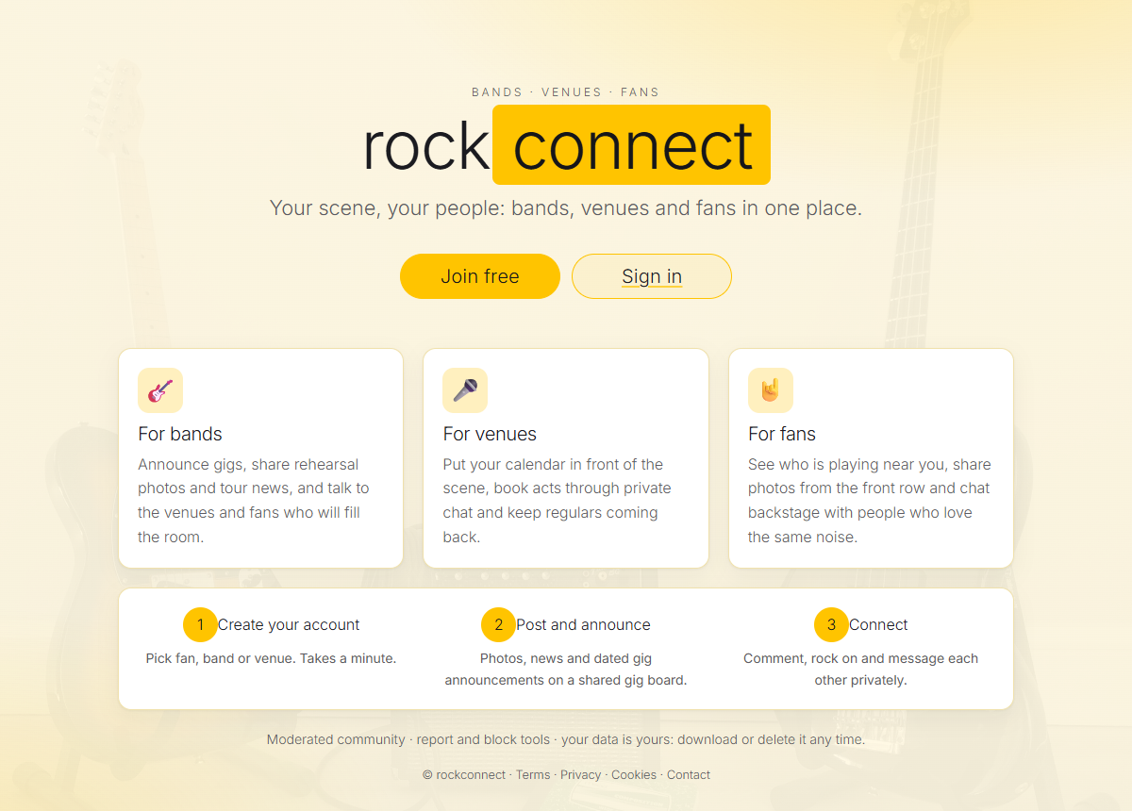

1. Summary
rockconnect started as a coursework rewrite (a Flask app with sign-in, posts and chat). It has been turned into a sellable community product for the live-music scene: members register as a fan, a band or a venue, announce and find gigs, see who else is going, and talk to each other safely. The same code serves many scenes: name, tagline and accent colour are set from configuration (white-label), and a versioned JSON API is ready for an Android app.

What makes it different from a generic social site
- Gigs are the centre. A gig can come from a band or venue on the site, or from worldwide event services, and every gig has a page with who is going, a discussion and an add-to-calendar button.
- Meet people through gigs. Say you are going, then find others going by what they play (with skill level), the music they like and what they are looking for (gig buddies, a lift, bandmates).
- Safe by design. Nobody can message a stranger without being accepted; posts can be checked before they appear, in 24 languages; members are 18+ with a date of birth check; members can export or erase all their data.
- Private about location. A position is rounded before it goes anywhere, and is never stored or logged.

At a glance
Area | What it does | State
Accounts and sessions | Sign up, 18+ date of birth, email confirmation, password reset, stay signed in for 30 days | Built
Feed and gigs | Posts and photos, likes, comments, gig announcements, gig board | Built
Gigs near you | Search by location or town; gigs imported for any city in the world | Built (Ticketmaster verified live)
Social | Going / interested, who is going, people search, follows, alerts, gig discussion, calendar export | Built
Messaging | Private chat, only after the other person accepts a request | Built
Moderation | Reports, blocks, admin and moderator roles, review queue, blocked words in 24 languages | Built
Privacy and legal | Data export, account deletion, legal pages, location privacy | Built (texts need legal review)
Private accounts | Be findable but share posts and plans only with people you accept | Built
Look and feel | Light yellow-and-white theme, Inter Light type, an always-visible icon menu, phone friendly, white-label | Built
JSON API v1 | Versioned API for the planned Android app | Built; app sign-in tokens still to do
Confirm-first sign-up | No account exists until the link mailed to the address is opened; throw-away mailboxes refused | Built (switches on with a mail server)
Landing = gigs near you | After sign-in, open on gigs near the member | Planned (next)

2. Accounts, sessions and trust
- Sign up: username, name, email, password (bcrypt hash, strength rules), kind (fan, band or venue), a short bio and acceptance of the terms. Location and website are optional.
- Minimum age 18. Sign-up asks for a date of birth; it is stored, never shown and cannot be changed by the member. Under 18 is refused. Members who joined before this existed are asked once on their next visit and cannot use the site until they answer (the API answers age_required). A date under the minimum closes the account. If an operator lowers the minimum below 18, adults and under-18s are kept apart in search, going lists, gig discussion and messages.
- Confirm-first sign-up. With email confirmation switched on (automatic once a mail server is configured), signing up does not create an account: the form is checked, the password hashed, and a link is mailed. The account is created only when that link is opened (a button, so mail scanners cannot use it up); the link works once and expires after 24 hours, then the waiting sign-up is deleted. Nobody can sign in or be seen before that, and usernames are not reserved, so fake addresses cannot squat names. Throw-away mailbox services are refused, and "send the link again" is rate-limited and gives the same answer whether or not an address is waiting.
- Existing members keep working; an unconfirmed older address only blocks posting, commenting and messaging. Forgotten-password reset uses single-use expiring links too. Without a mail server (development) the link is printed in the terminal.
- Sessions like Facebook: server-side sessions with hashed tokens, valid 30 days from the last visit and renewed on every visit; no countdown shown; "sign out on all devices"; an expired session sends you to sign in again.
- Abuse protection: database-backed rate limits on sign-in (per address and per username), sign-up, reset mails, posts, comments, messages, reports, exports, searches and new conversations.

3. Feed and gigs by members
- Posts: text and photos (JPG, PNG, GIF or WEBP up to 5 MB, stored under random names and shown only to signed-in members), likes ("Rock on"), comments, profile walls and paging.
- Feed tabs: Everyone, or People I follow.
- Gig announcements: bands and venues attach a date, a place, an optional genre and a map position to a post. The position comes from the location button or from looking up the place name (OpenStreetMap, cached). Announced gigs appear on the gig board, soonest first, and stay a few hours past their start.
- Three kinds of member are labelled on posts and filterable in the people directory.
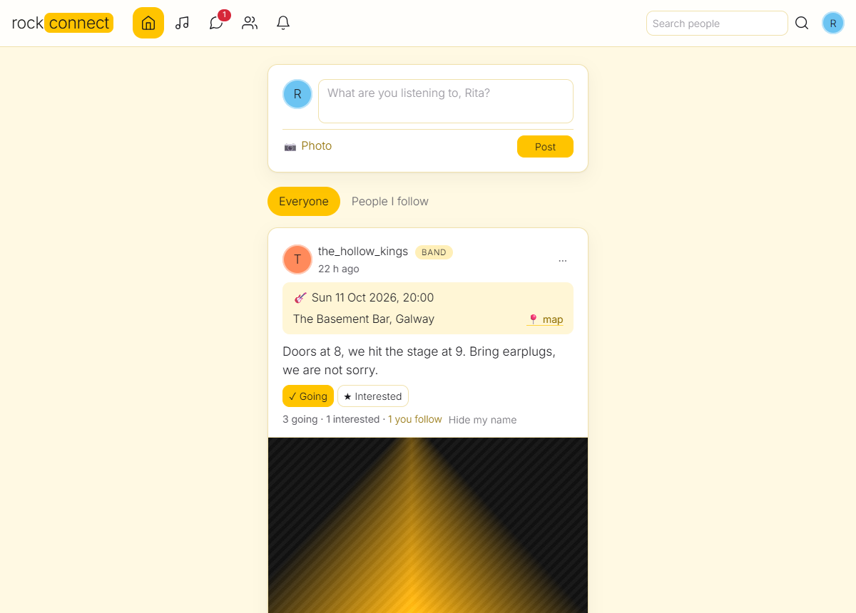
The feed: posts, gig announcements with Going / Interested buttons, and comments.

4. Gigs near you, anywhere in the world
A new community has no gigs yet, so the site fills itself from event services. Searching "near me" in a place nobody has searched before fetches that area on the spot and remembers it, so every city works as soon as a provider covers it.
- Search by the browser location (one click), a typed town, or the town in the member's profile; radius selectable.
- Privacy: only a rounded grid square of about 28 km goes to the event services, from the server and with the operator's key. The exact position and the member's identity never leave the site, and are not stored or logged.
- Limits that protect the quota: at most 60 new areas per hour for the whole site; one fetch even when many members search the same new city at once; failed areas retried after 10 minutes. A quick first page is shown at once while the rest loads in the background.
- One list: the same concert listed by several sources is shown once; members' own gigs win. An admin can hide an event whose provider data is wrong (it is not imported again). Events are deleted when over or not refreshed (providers only allow short storage); ticket links go to the provider's own page with "via ..." attribution.
- Tools: flask doctor --online checks every key and says why "gigs near me" is empty; import-events for scheduled imports; seed-demo for demos.
Provider | Covers | Key | Verified
Ticketmaster | Most of North America, UK and Ireland, much of Europe, Australia, NZ | Free, instant | Live: London, New York, Toronto, Dublin, Berlin, Sydney, Mexico City, Sao Paulo, Nairobi
Skiddle | UK and Ireland (clubs, small gigs) | Free, apply | Built from documentation, not run live
Songkick | Worldwide | By application only | Built from documentation, not run live
PredictHQ | Worldwide; events with a named venue, no ticket links | Paid, free trial | Built from documentation, tested with sample answers
Bandsintown | One band at a time | Each band's own app id | Built; band connects itself in Edit profile

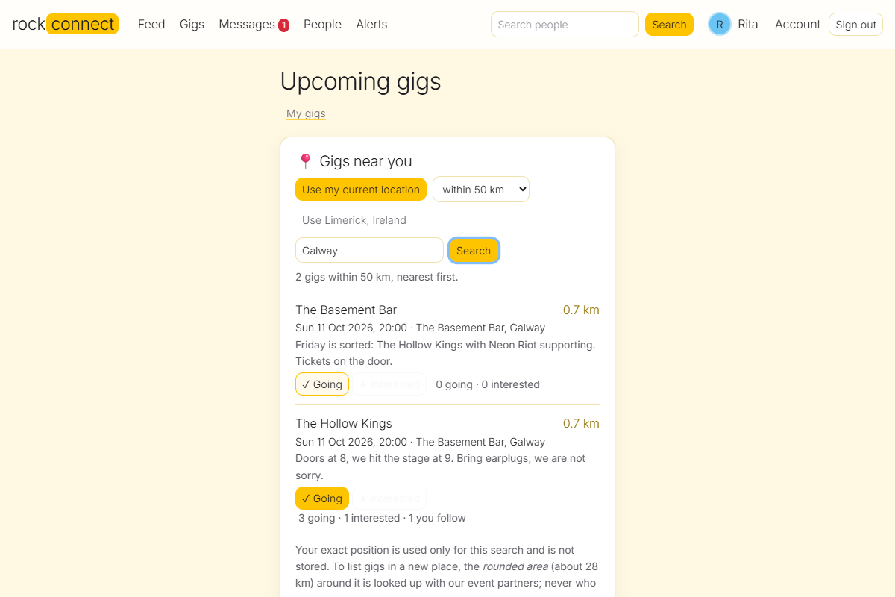
Gigs near you: a typed town, results nearest first, Going / Interested on every result.

5. The social side

Going to gigs and finding people
- Going or interested on any gig, on the card, the gig page and every nearby result. One RSVP can be private (counted, not named), or all plans can be hidden in Edit profile. Counts are per concert, even when two services list it.
- Who is going: a list with what each person plays (and how well), the genres they like and what they are looking for; filter it (for example "bass players, advanced or better"); people you follow come first.
- People page: search members by name, place, kind, instrument, level, genre and goal; or only people you follow or who follow you.
- Fixed lists so filters work: 22 instruments, 4 skill levels (beginner to professional), 16 genres and 5 goals (gig buddies, jam partners, bandmates, sharing a lift, new friends).
- My gigs: upcoming plans in one place, with an "add all to my calendar" button.
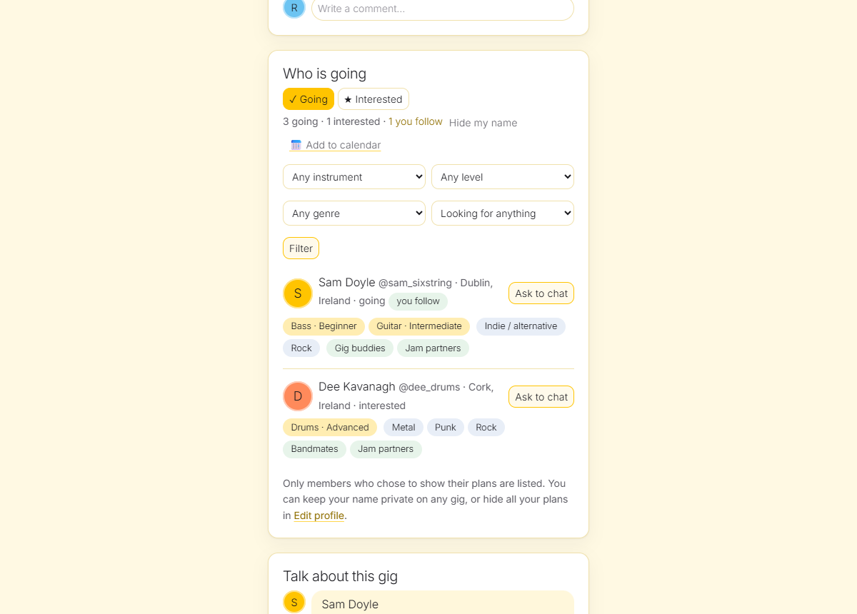
Who is going: filters, skill levels, follows and the Ask to chat button.

Follows and alerts
- Follow any member from their profile (no permission needed). Only you see your lists; others see counts.
- The Alerts bell shows a new follower, and "someone you follow is going to a gig" (switch off in Edit profile; not sent for private RSVPs or hidden plans; at most 200 followers notified per RSVP; read alerts deleted after 30 days, all after 90).

Private accounts
A member can switch on Private account in Edit profile. They stay visible on the platform (people search, who-is-going lists and a profile with name, picture, bio, what they play and follower counts), but their posts, photos, comments, gig comments, gig announcements and plans are only for the members they accept.
- Following becomes a request. The button reads "Request to follow", then "Requested" (press again to withdraw). The owner is told in Alerts and finds the waiting requests under their picture, in "Follow requests", where they accept (the requester is told) or decline (silent).
- Hidden everywhere, not just on the profile: the feed, the profile wall, a post's own page, the gig board, gigs near you, the discussion under a gig, who-is-going lists, and even the photo link itself, which stops working for strangers. A private RSVP is still counted ("12 going") but not named.
- People who already followed keep access when an account turns private; turning private off lets everyone who is waiting in. Blocking removes follows and requests both ways, and "is going" alerts only reach accepted followers.
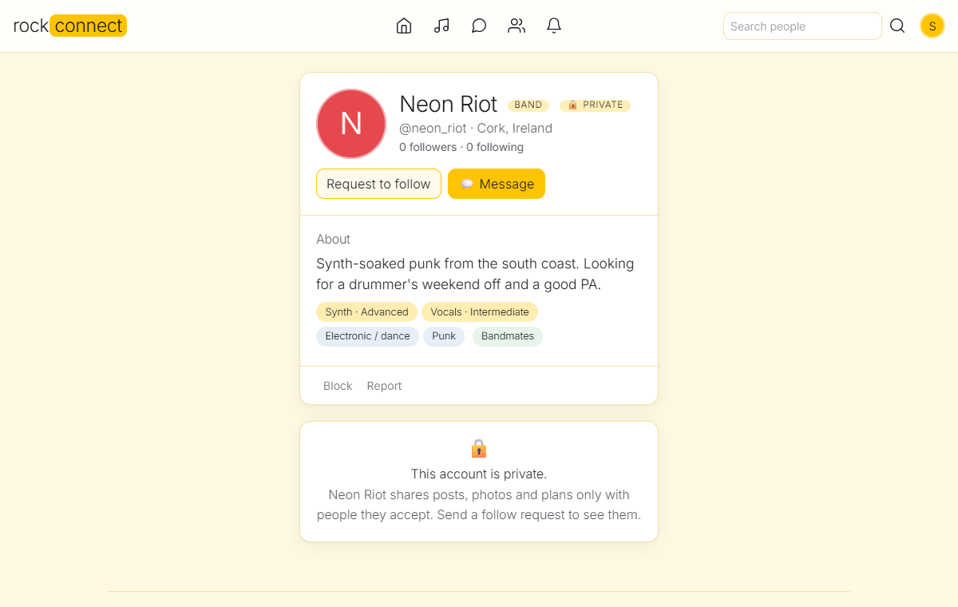
What a stranger sees on a private profile: the basics, and a request button instead of the posts.
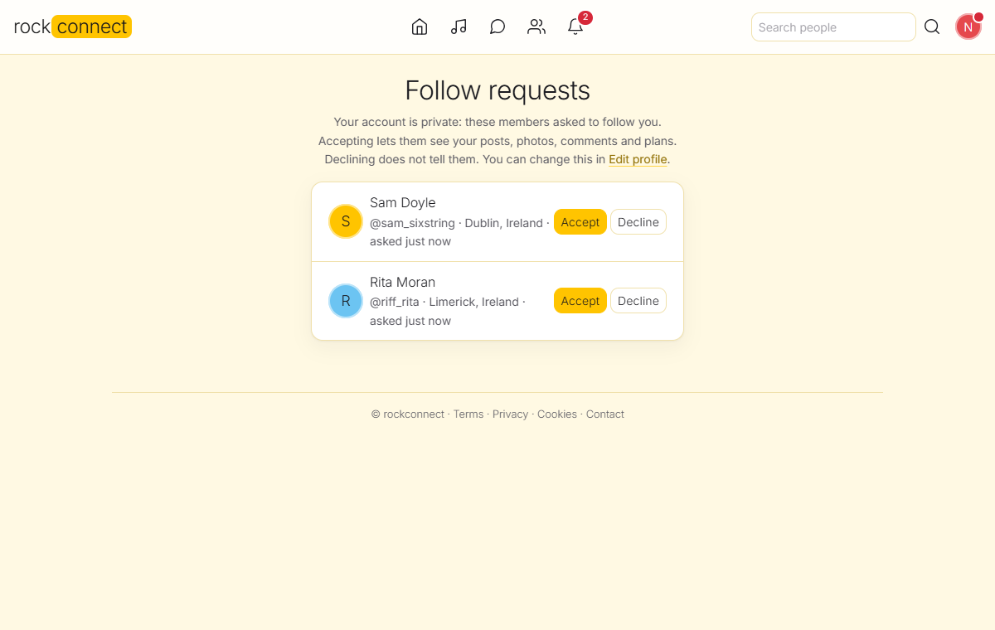
The owner's Follow requests page: accept or decline.

Talk about this gig
- One discussion per concert ("anyone driving from Dublin?"), shared across listings, up to 1,000 characters, open until a week after the gig. Authors delete their own; anyone can report; blocked and suspended authors are hidden.
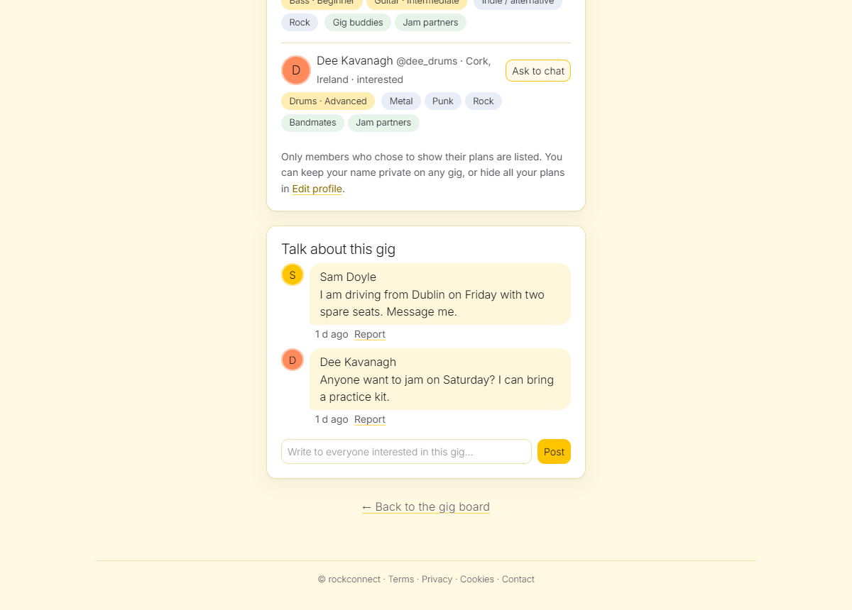
The discussion under a gig.

Add to calendar
- A standard .ics file (Google, Apple, Outlook) for one gig or for all your plans: going is a confirmed event, interested a tentative one; venue local time; date-only gigs become all-day events. There is no public subscription link, so nobody's plans can leak through an address.

6. Private chat and message requests
- Live one-to-one chat (new messages appear within seconds) with an unread badge in the menu.
- Nobody can write to a stranger. Pressing Message only sends a request with no text. The other person sees it under Requests and can accept, decline, block or report. Until they accept, neither side can send anything, and nothing from the asker is shown to them. A decline is silent. Requests from blocked or suspended members are not shown. At most 15 new requests per member per day.
- Blocking works both ways: no messages, posts or comments from each other, and any follow is removed.
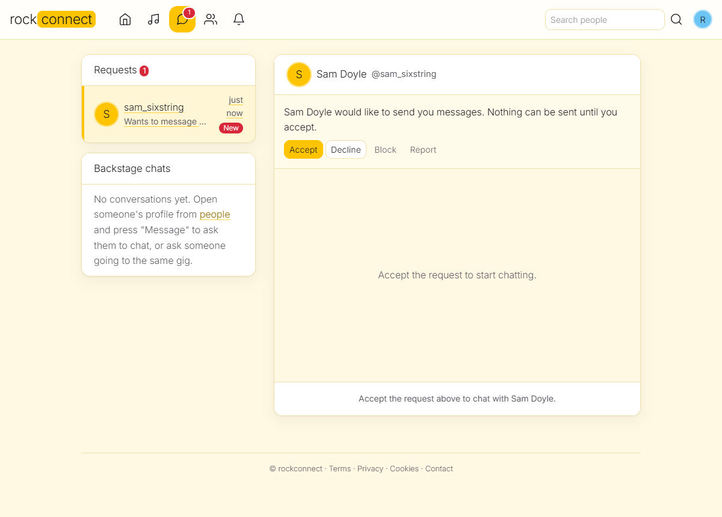
A message request: accept, decline, block or report. Nothing can be sent before accepting.

7. Moderation
Moderation has two halves: reacting to what members report, and catching problems before anyone sees them.

After the fact
- Report posts, comments, gig comments and profiles; each report keeps a copy of the text so it can be judged after edits.
- Block another member (both directions).
- Admin console: report queue (dismiss, remove, remove and suspend), members (suspend with a reason, unsuspend, erase), hidden events, and an audit log of every action.
- Roles: member, moderator (review queue and reports only; cannot suspend, erase or change settings) and admin. Roles can be granted only from the command line (make-admin, make-moderator), never from the website; the console returns a plain "not found" to everyone else.
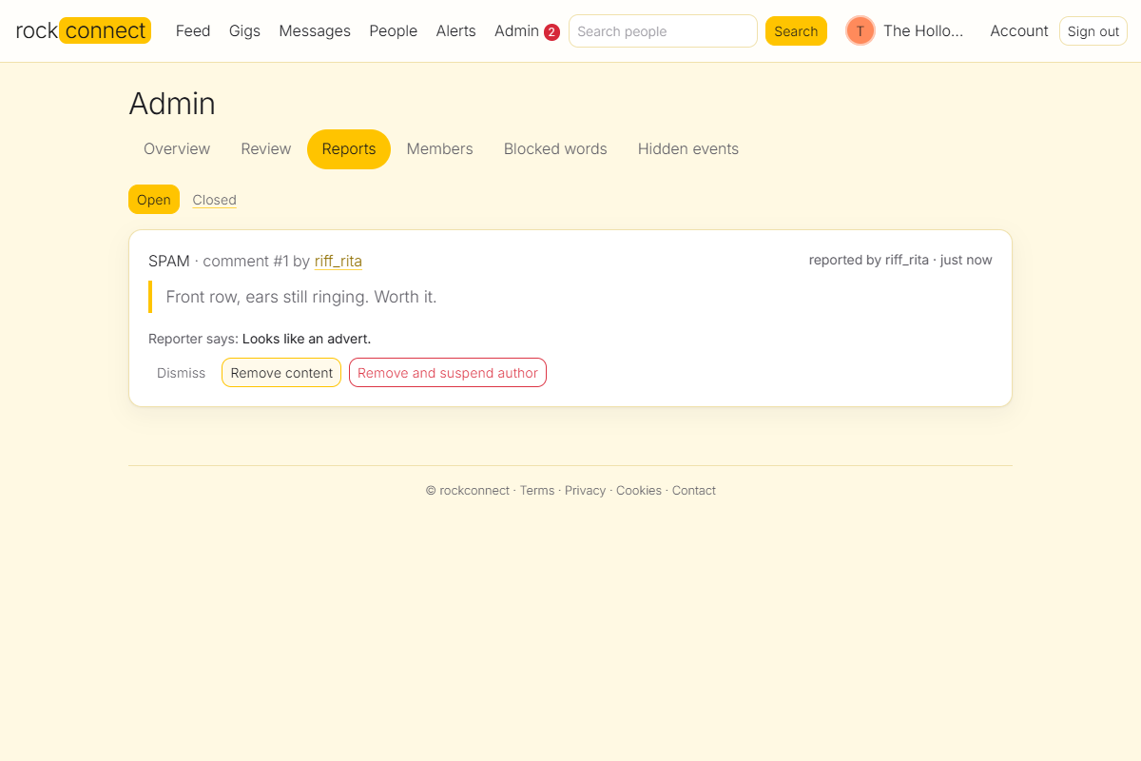
The admin report queue.

Before anyone sees it
Posts, comments and gig comments can be held until staff look. Only the author sees their own held item (with a notice); to everyone else it does not exist, including on the gig board and in nearby search. Staff approve, remove, or (admins) remove and suspend. Three things put an item in the review queue:
- Blocked words. A list the admin edits. It works in any language (it only compares text), ignores capitals and accents, matches whole words only ("ass" does not catch "class"), and sees through repeated letters ("porcaaa troia"), digits for letters ("p0rca tr0ia") and dashes between the words of a phrase. The author is told the post is waiting, not which word.
- New-member rules. A member's first 3 posts wait until approved; in the first 24 hours anything with a link or photo waits.
- Reports. Three different, established members reporting the same item hides it until staff decide (accounts under a day old do not count, so one person cannot hide things with many accounts).

24 languages
- Seven curated lists, on by default (written for this project): English, Italian (including blasphemy such as "porca troia"), Spanish, French, German, Portuguese and Russian (in Cyrillic).
- Seventeen broad lists, opt-in (open LDNOOBW project, licence CC BY 4.0): Arabic, Chinese, Czech, Danish, Dutch, Filipino, Finnish, Hindi, Hungarian, Japanese, Korean, Norwegian, Persian, Polish, Swedish, Thai and Turkish. They lean towards sexual vocabulary and are noisier; very short and everyday-word entries are dropped.
- Chinese, Japanese, Korean and Thai (no spaces between words) are matched anywhere in the text. Any other language: the admin adds words on the same page. Every list was checked against everyday gig chat in 22 languages for false matches.
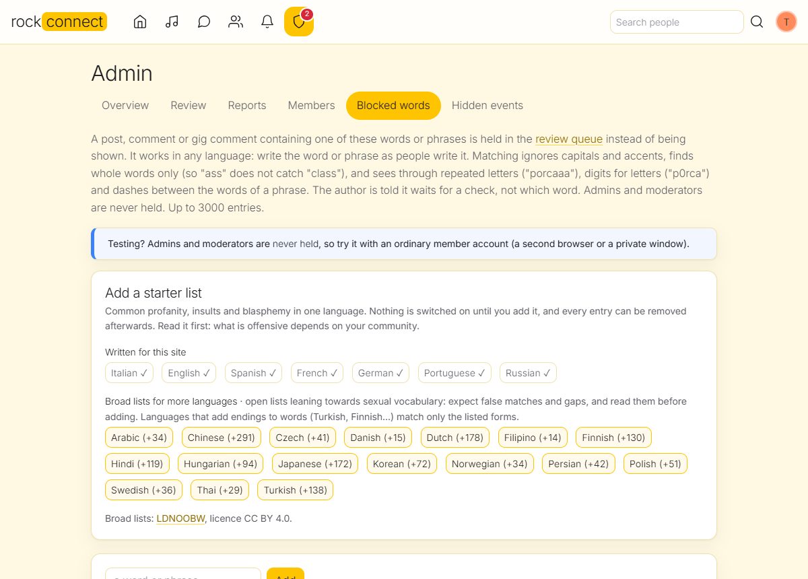
Admin: blocked words, with one-click starter lists for 24 languages.
Not covered: private chat messages and profile texts are not screened, and there is no image recognition (a photo from a trusted member is checked only if reported). A real classifier can be plugged into one function, review.screen().

8. Privacy, legal and security
- Their data, their control: members download everything as a zip (profile, posts, comments, likes, messages they sent, plans, follows, gig comments, interests) and can delete their account, which erases their content, conversations, plans, follows, alerts and review copies.
- Legal pages (terms, privacy policy, cookies) are generated from the operator's company details in configuration and describe what the software does, including the date of birth check, alerts, gig discussion and pre-publication checks. They are a starting point, not legal advice; have them reviewed for your country before launch.
- No trackers and no third-party loading: fonts, Bootstrap and jQuery are bundled, so the strict Content-Security-Policy holds and no visitor data leaves the site by accident.
- Security basics: CSRF protection on every state change, hashed session and reset tokens, security headers, a rate limiter, generic errors, the admin area hidden from non-staff, and API keys that never appear in logs or error messages.

9. Look and feel, and white-labelling
- Icon menu, always visible. The main menu is a row of icons (Feed, Gigs, Messages, People, Alerts, plus Admin or Moderate for staff), centred in the top bar between the logo and your picture, that never collapses into a hamburger button, on desktop or phone. The current page is highlighted, badges sit on the icons, every icon has a tooltip and a name for screen readers, and Account, My gigs and Sign out live in the menu under your picture. The search box shows on wide screens; on a phone the People icon opens search.
- Design: a light, minimal theme: white cards on a pale yellow page, one yellow accent, rounded corners, round avatars and Inter Light type everywhere. Page titles and the line under them are centred on every page, while cards, posts and forms keep left-aligned text so they stay easy to read. Works on phones.
- White-label: SITE_NAME, SITE_NAME_ACCENT, SITE_TAGLINE and ACCENT_COLOR rebrand the site. Whatever colour a customer picks, text on it and the accent used as text are adjusted to stay readable.
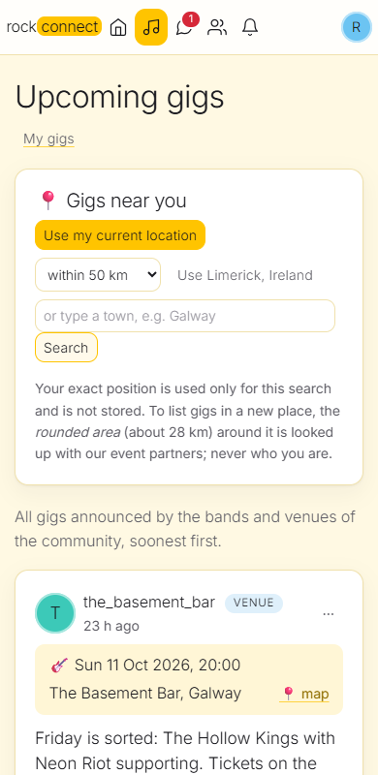
The gig board on a phone.

10. JSON API and the Android app
- Versioned /api/v1 that will not change in a breaking way for installed apps; GET /api/v1/meta returns the site name, accent colour and feature flags so one app build can carry a customer's branding.
- Endpoints: gigs nearby (one uniform shape for every source), going and attendees, people search, my gigs, lists, follows and follow requests, alerts, gig comments, plus the website cookie for sign-in today.
- Still to do for the app: token sign-in (access and refresh tokens instead of the website cookie), JSON versions of the feed, profile and chat, and push notifications. See docs/ANDROID.md.

11. Running it
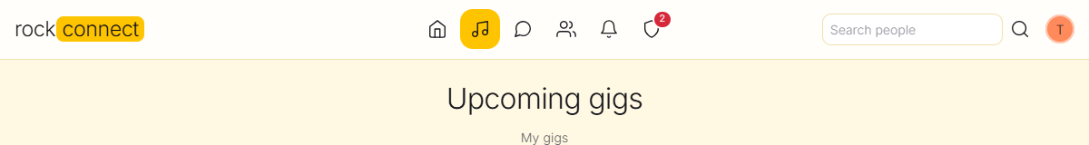
The menu on a desktop, for an admin (the shield icon and its badge are only for staff).
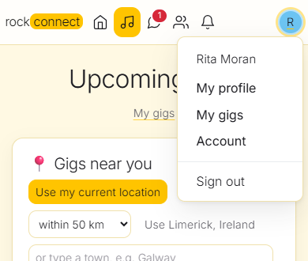
On a phone: all icons stay on one row, and the picture opens profile, My gigs, Account and Sign out.
Command | What it does
python run.py | Start the site (reads the .env file; creates and upgrades the database)
flask --app wsgi doctor [--online] | Show what is set up, test every event-service key, say why "gigs near me" is empty
flask --app wsgi make-admin NAME / make-moderator NAME | Give a member staff access (remove-admin, remove-moderator undo it)
flask --app wsgi seed-demo | Fill an empty site with demo bands, venues, fans, gigs, comments and chat
flask --app wsgi import-events | Scheduled import for chosen areas (from cron); prune-events removes stale ones
flask --app wsgi db-upgrade | Apply database migrations (also done at start-up)

- Configuration is all in environment variables / .env (see .env.example): secret key, database URL (SQLite by default; PostgreSQL and MySQL supported), SMTP mail, photo storage (local or S3), event-service keys, branding, limits and the moderation settings.
- Database: 28 tables, 11 Alembic migrations (0001-0011); a test fails if the code and the migrations drift apart.
- Health endpoint /health for monitors; Docker and deployment notes in docs/DEPLOY.md.

12. How it was tested
- 707 automated tests (pytest) covering sign-in, sessions, feed, chat, requests, moderation, privacy, imports, providers, social features, calendar export, word lists and migrations.
- Mutation checks: for each new rule a test run was repeated with that rule deliberately broken, to make sure a test fails. Gaps found this way (for example a held gig still joinable by its author) were fixed.
- Real browser checks in Chrome on desktop and phone widths for every new screen.
- Live service checks: Ticketmaster against the real service in ten cities, and OpenStreetMap place lookups.

13. Not done yet, and known limits
Item | Notes
Remove a follower | A private member can decline requests and block people, but there is no one-click "remove this follower" yet.
Real mail sending | The confirm-first sign-up is built and tested, but it needs an SMTP provider and SPF/DKIM records to run for real: not yet set up or tried with real mail.
Landing page = gigs near you | Planned: after sign-in open on nearby gigs, using the profile location by default (no location prompt on page load).
Android app | Needs token sign-in, more JSON endpoints and push; app itself not started.
Skiddle, Songkick, PredictHQ | Written from documentation, not yet run against the live services; run doctor --online once you have keys.
Other databases and storage | PostgreSQL, MySQL, real S3 and the Docker image have not been tried.
Image screening | No automatic image recognition. Optional classifier for text and photos could be added.
Word lists | Not complete dictionaries: no creative spellings or context; broad lists are noisy; languages with endings match listed forms only.
Site language | The interface is English only.
Legal | Terms, privacy and cookie texts are templates; provider terms (Ticketmaster, Bandsintown...) must be read before charging for the service.

14. Suggested next steps
- Set up a real mail sender (then the confirm-first sign-up is live) and try it with real addresses.
- Make gigs near the member the first screen after sign-in.
- Add token sign-in for the Android app and the remaining JSON endpoints.
- Get keys for Songkick and PredictHQ, run doctor --online, and fix whatever the live answers show.
- Deploy a small pilot (one town), with the moderation lists reviewed for that community.

Appendix A. Where things are in the code
File | Purpose
rockconnect/__init__.py, settings.py | App factory, security headers, configuration from the environment
auth.py, session_store.py, account.py, ages.py | Sign up/in, sessions, password reset, data export and erasure, date of birth
feed.py, views.py | Posts, comments, likes, gig board, people directory, profiles
api.py, geo.py, importer.py, providers.py, gigmatch.py, events.py | JSON API, map maths and place lookups, event import, provider parsers, duplicate detection, imported event page
social.py, taxonomy.py, follows.py, notifications.py, gigtalk.py, ical.py | Going and who is going, interest lists, follows, alerts, gig discussion, calendar files
conversations.py | Private chat and message requests
moderation.py, admin.py, modlog.py, review.py, wordlists.py | Reports and blocks, admin console, audit log, review queue and filter, starter lists
db.py, migrate.py, migrations/ | Schema (28 tables) and Alembic migrations
templates/, static/ | Pages, stylesheet, scripts, bundled Bootstrap, jQuery and Inter font
tests/ | The automated test suite

Appendix B. Documents in the repository
- README.md: overview, quick start, configuration.
- docs/SOCIAL.md: going, follows, alerts, discussion, calendar, age rules.
- docs/MODERATION.md: running the community, review queue, blocked words, privacy requests.
- docs/EVENT-IMPORT.md: event providers, how to get each key, limits and terms.
- docs/API.md and docs/ANDROID.md: the JSON API and the plan for the app.
- docs/DEPLOY.md: production deployment.

Appendix C. Third-party material
Bootstrap 4 and jQuery (MIT), Inter font (SIL Open Font License 1.1), and the LDNOOBW word lists (CC BY 4.0). Imported event data remains the property of its providers and is shown with attribution and a link to their ticket page.

