|  |
| --- |
| Bonimode  Online shop whith react  Team develop  Sahereh abbasi  Mohammad reaza khosravi  Erfan nagafi  Mohammad reza badri  **Git Hub** : https://github.com/mrbadri/banimode |

[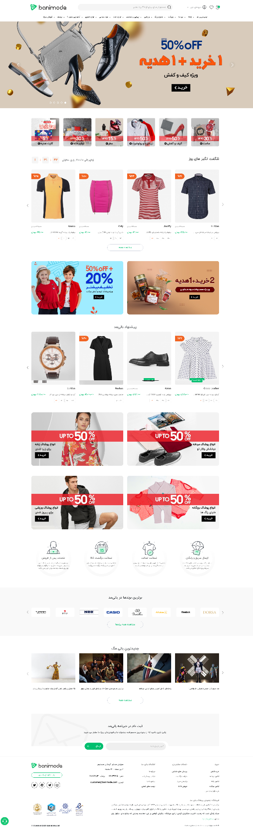](../Vision%20of%20the%20future/bonimodeFullScreen.png)

**Contents**

* Data list
* Flowchart
* User story
* Technologies used
* Developer team

**Data list**

**User** = {

Id: ,

fullName: ,

userName: ,

email: ,

password: ,

urlProfile: ,

dateBirth: ,

financial:{}

wallet:{} ,

addressList:[] ,

cart:[] ,

interestList:[] ,

commernts:[] ,

}

**Tip:**

The username is the same as the phone number

**product** = {

id: ,

title: ,

subTitle: ,

images:[] ,

price: ,

sizes: ,

colors: ,

comments:{} ,

}

**Financial** = {

cardNumber: ,

sabaNumber: ;

}

**cart** = [

{product} , …

]

**interestList** = [

{product}, …

]

**Wallet** = {

value: ,

history:[] ,

}

**Commernts** = [

}

titleComment: ,

textComment: ,

}

]

**addressList** = [

address: {

status: ,

title: ,

fullname: ,

phoneNumber: ,

landlinePhoneNumber : ,

district: ,

city : ,

country : ,

descrption: ,

locartion: ,

}

]

**Tip:**

phoneNumber = mobile phone number

location = position in google map

**category** = {

list : [

{id: , title: ,}

]

}

**barands** = [

{ title: , img: , } ,

]

**newsletters** = [

“email” ,

]

**discountCode** = [

{

code: ,

value: ,

date: ,

}

]

**specialOffer** = {

date: ,

listProduct: []

}

**order** = {

Id: ,

status: ,

dateBuy: ,

totalPrice : ,

description: ,

factor: ,

pay: ,

}

**orders** = [

{order} , …

]

**Ticket** = }

id: ,

title: ,

topic: ,

importance: ;

description: ,

{

**Tickets** = [

{tiket} , …

]

**referralRequest** = {

status: ,

numberOrder: ,

decription: ,

date: ,

}

**referralRequests** = [

{ referralRequest } , …

]

**Flowchart**

[Click here for show flowchart](../flowChart/flowChartBoniMode.drawio)

**User story**

**Technologies used**

React js

Scss

Material ui

React spring

Tailwind

**Developer Team**

* Sahereh abbasi linkden
* Mohammad reza khosravi linkden
* Erfan nagafi linkden
* Mohammad reza badri [linkden](https://www.linkedin.com/in/mohammad-reza-badri-906459204/)

**Thanks to Mr. Hosein Ashrafipour**