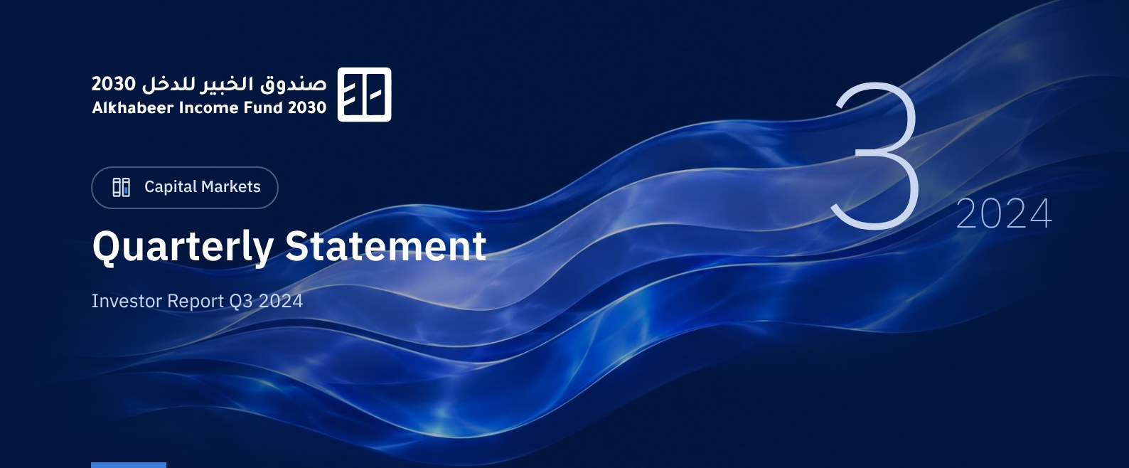

 FUND OVERVIEW
Alkhabeer Diversified Income Traded Fund 2030 (“the Fund”) is a public closed-ended Shari’a-compliant investment traded fund established in accordance with the Investment Funds Regulations and the applicable laws and regulations of the Kingdom of Saudi Arabia and regulated by the Capital Market Authority (CMA). The Fund’s investment objective is to generate periodic income to investors by investing in income generating assets using a Shari’a-compliant investment structure. The Fund Manager “Alkhabeer Capital” plans to invest in Sukuk, trade finance transactions, leasing transactions, structured income instruments, asset backed debts, income funds and Murabaha transactions, either directly or through investment funds.

 KEY FUND FACTS
TADAWUL SYMBOL | 4702
BLOOMBERG SYMBOL | AKDI2030:AB
FUND TYPE | Closed-ended Traded Public Fund
LISTING DATE | 17 July 2024
FUND TERM | 6 years, starting as from the Listing Date
NET ASSET VALUE PER UNIT | SAR 10.0857
FUND ASSETS SIZE* | SAR 308,970,652
FUND’S TOTAL CAPITAL AS AT THE LISTING DATE | SAR 305,456,350
FINANCING AMOUNT* | SAR -
RATIO OF LOANS TO FUND’S TOTAL ASSET VALUE* | 0.00%
RATIO OF LOANS TO FUND’S NET ASSET VALUE AS AT THE END OF THE REPORTING QUARTER | 0.00%
FUND MANAGER’S INVESTMENT VALUE AT THE END OF THE REPORTING QUARTER | SAR 50,428,718
RATIO OF FUND MANAGER'S INVESTMENT TO FUND'S NET ASSET VALUE AS AT THE END OF THE REPORTING QUARTER | 16.37%
RISK LEVEL | High
FUND CURRENCY | Saudi Arabian Riyal (SAR)
INVESTMENT ADVISOR AND FUND SUB-MANAGER | N/A
RATIO OF UNDERLYING FUNDS’ MANAGEMENT FEES | 0.00%
NUMBER OF DAYS WEIGHTED AVERAGE | 92 Days

* As of 30 September 2024 (Unaudited).

FUND PORTFOLIO INVESTMENT CONCENTRATION RATIOS *
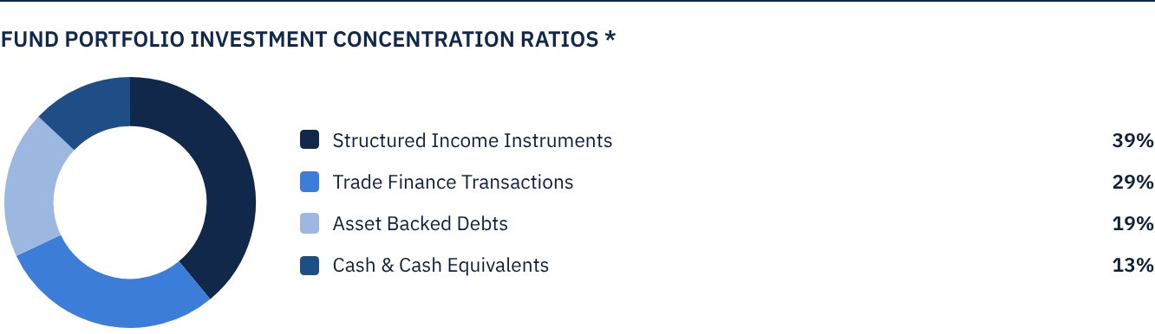
The average term of Fund investments is 1.6 years.

FINANCIAL INDICATORS*
VALUATION FREQUENCY | Semi-annually
FUND’S TOTAL ASSET VALUE | SAR 308,970,652
FUND UNITS’ NET ASSET VALUE | SAR 308,075,442
AMOUNT OF DEALING EXPENSES FOR THE REPORTING QUARTER TO FUND’S AVERAGE NET ASSET VALUE | N/A
RATIO OF DEALING EXPENSES FOR THE REPORTING QUARTER TO FUND’S AVERAGE NET ASSET VALUE | N/A
RATIO OF TRANSACTION EXPENSES FOR THE REPORTING QUARTER TO FUND'S AVERAGE NET ASSET VALUE | N/A
RATIO OF FUND'S EXPENSES AND FEES TO FUND’S TOTAL ASSET VALUE | 0.42%
RATIO OF FUND’S TOTAL COSTS TO FUND’S TOTAL ASSET VALUE | 0.42%
RATIO OF FUND’S TOTAL COSTS TO FUND’S AVERAGE NET ASSET VALUE | 0.42%
FUND'S TOTAL COSTS FOR THE REPORTING QUARTER | SAR 1,290,387

* As of 30 September 2024 (Unaudited).
** Fund expenses and fees are all Fund expenses during the reporting quarter, excluding financing costs.
*** Fund total costs are all Fund fees and expenses, including financing costs.
**** Fund average NAV for the reporting period = SAR 306,765,896

DISTRIBUTION OF INVESTMENTS BY GEOGRAPHY
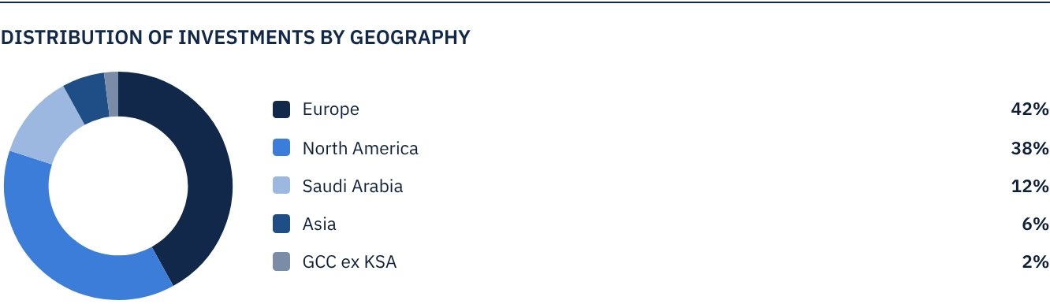

LARGEST TEN INVESTMENTS IN THE FUND
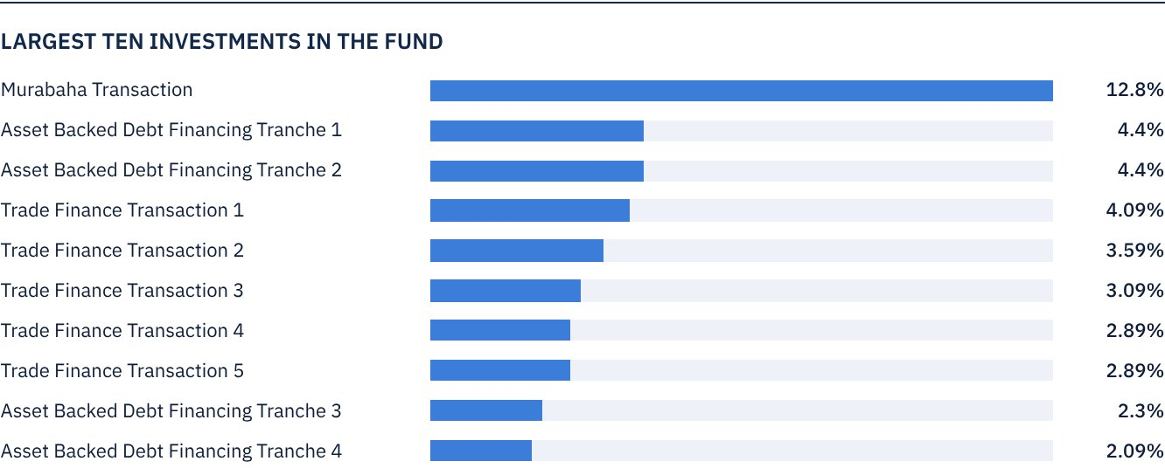

FUND ASSETS INFORMATION
ASSET BACKED DEBTS PORTFOLIO TOTAL VALUE | SAR 58,307,789
TRADE FINANCE PORTFOLIO TOTAL VALUE | SAR 88,954,789
STRUCTURED INCOME PORTFOLIO TOTAL VALUE | SAR 121,477,515
TOTAL CASH AND CASH EQUIVALENT | SAR 40,230,599

FUND MARKET VALUE INFORMATION*
AS AT THE LISTING DATE | SAR 305,456,350
AS AT 30 SEPTEMBER 2024 | SAR 227,564,981

* Based on the Unit Price.

 NET ASSET VALUE AND UNIT PRICE PERFORMANCE*
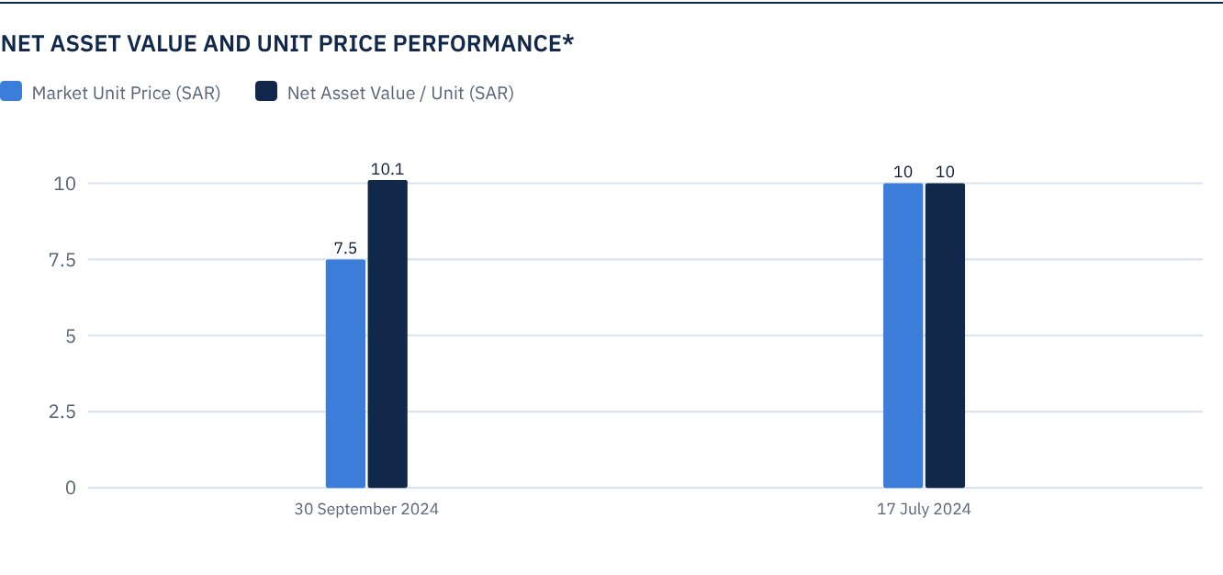

FUND UNITS INFORMATION
UNIT PRICE AS AT THE END OF Q3 (30 SEPTEMBER 2024) | SAR 7.45
CHANGE IN UNIT PRICE COMPARED TO THE PREVIOUS QUARTER* | -25.50%
UNIT PRICE PERFORMANCE SINCE THE LISTING DATE (FROM THE LISTING DATE TO END Q3 2024) | -25.50%
52-WEEK HIGH | SAR 10.00
52-WEEK LOW | SAR 7.01
NUMBER OF OUTSTANDING UNITS | 30,545,635 Units
P/E RATIO | N/A

* Unit Price as at the Listing Date 17 July 2024 = SAR 10.00.

 DIVIDEND DISTRIBUTION

DIVIDEND DISTRIBUTION POLICY
The Fund Manager will distribute dividends (if any) within 40 business days after the date of issue of the semi-annual and annual financial statements for each Gregorian year. Dividend distributions (if any) will be announced within ten business days after the date of issue of the semi-annual and annual financial statements. Details of cash distributions will be announced on Saudi Tadawul’s website, with the exception of capital gains resulting from the sale of underlying assets, which may be reinvested in other assets or distributed in whole or in part at the Fund Manager’s discretion. The Fund Manager may distribute the returns on the Fund’s investments, after deducting expenses and provisions, to Unitholders more than twice per year at the Fund Manager’s discretion.
TOTAL DIVIDENDS PAID IN THE REPORTING QUARTER* | SAR 0.00
TOTAL DIVIDENDS DISTRIBUTED FOR THE LAST SEMI-ANNUAL PERIOD | SAR -
DIVIDENDS DISTRIBUTED FOR THE LAST SEMI-ANNUAL PERIOD PER UNIT | SAR -
RATIO OF DIVIDENDS DISTRIBUTED IN THE REPORTING QUARTER TO THE INITIAL UNIT PRICE | -
DIVIDENDS DISTRIBUTED ON UNIT PRICE | -
TOTAL INCOME FOR THE REPORTING QUARTER* | SAR 3,909,480
RATIO OF TOTAL INCOME FOR THE REPORTING QUARTER TO THE UNIT PRICE (30 SEPTEMBER 2024) | 1.72%

* From the listing date of 17 July 2024 to 30 September 2024.

FUND PERFORMANCE CRITERIA AND INDICATORS
BENCHMARK | The Benchmark is a composite index comprised of 70% of the Yield of the Dow Jones Sukuk Index + 30% of the Secured Overnight Financing Rate for three months (SOFR 3M), which is a Shari’a compliant index.
INITIAL UNIT PRICE (AT THE INITIAL OFFERING*) | SAR 10
UNIT PRICE PERFORMANCE SINCE THE PREVIOUS PERIOD* | -25.50%
UNIT PRICE PERFORMANCE SINCE THE DATE OF INCEPTION* | -25.50%
TOTAL RETURN SINCE THE DATE OF INCEPTION* | -25.50%

* From the listing date of 17 July 2024 to 30 September 2024.

DESCRIPTION OF THE FUND’S BENCHMARK
The Fund’s Benchmark is a composite index comprised of 70% of the yield of the Dow Jones Sukuk Index + 30% of the Secured Overnight Financing Rate for three months (SOFR 3M) whish is a Shari’a compliant index.

PERFORMANCE ASSESSMENT CRITERIA AND INDICATORS
 | ALKHABEER INCOME FUND
NET ASSET VALUE PER UNIT AS AT THE BEGINNING OF THE PERIOD | 10.0000 | N/A
NET ASSET VALUE PER UNIT AS AT THE END OF THE PERIOD** | 10.0857 | N/A
UNIT PERFORMANCE | 0.86% | 1.03%

* As at the listing date of 17 July 2024.
** As at 30 September 2024.

OWNERSHIP OF FUND INVESTMENTS
OWNERSHIP | PERCENTAGE (%)
FREEHOLD | 100%
LEASEHOLD | 0%

RETURNS
ITEM | 3 MONTHS | YEAR TO DATE | ONE YEAR | 3 YEARS | 5 YEARS
TOTAL RETURN/NAV PER UNIT "FUND PERFORMANCE" | N/A* | N/A* | N/A* | N/A* | N/A*
BENCHMARK PERFORMANCE | N/A* | N/A* | N/A* | N/A* | N/A*
PERFORMANCE SPREAD | N/A* | N/A* | N/A* | N/A* | N/A*

* Not applicable as at the listing date of 17 July 2024.

 PERFORMANCE AND RISKS
PERFORMANCE AND RISKS CRITERIA | 3 MONTHS | YEAR TO DATE | ONE YEAR | 3 YEARS | 5 YEARS
STANDARD DEVIATION | N/A* | N/A* | N/A* | N/A* | N/A*
SHARPE RATIO | N/A* | N/A* | N/A* | N/A* | N/A*
TRACKING ERROR | N/A* | N/A* | N/A* | N/A* | N/A*
BETA | N/A* | N/A* | N/A* | N/A* | N/A*
ALPHA | N/A* | N/A* | N/A* | N/A* | N/A*
INFORMATION RATIO | N/A* | N/A* | N/A* | N/A* | N/A*

* Not applicable as at the listing date of 17 July 2024.

FUND HIGHLIGHTS AND ANY FUNDAMENTAL OR NON-FUNDAMENTAL CHANGES AFFECTING THE PERFORMANCE OF THE FUND
There were no fundamental or non-fundamental developments or changes affecting the performance of the Fund.

PERFORMANCE OF THE UNIT PRICE TRADED ON THE EXCHANGE SINCE THE INCEPTION OF THE FUND
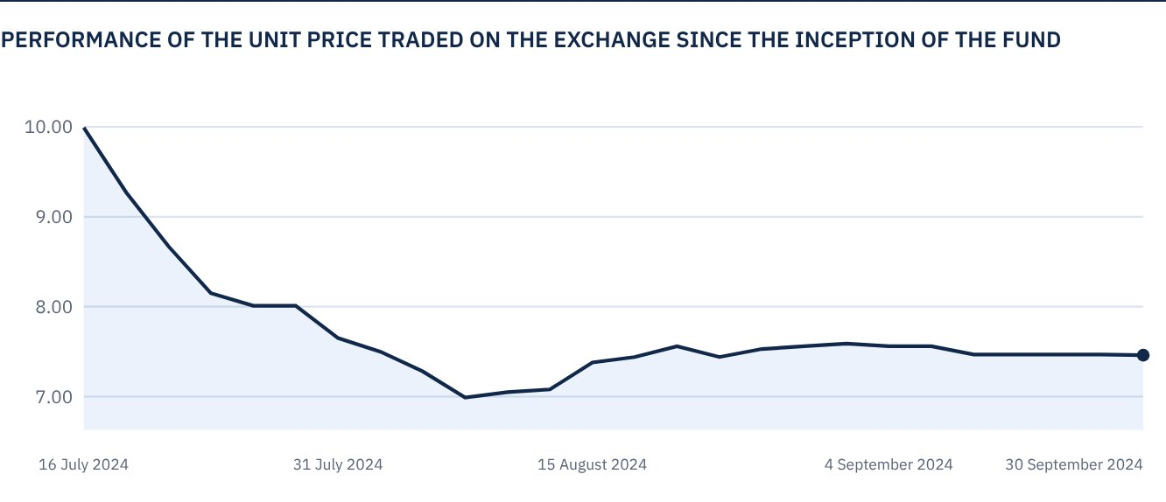

 FOR FURTHER INFORMATION
Alkhabeer Capital
PO Box 128289, Jeddah 21362
Kingdom of Saudi Arabia
Tel: +966 12 658 8888
Fax: +966 12 658 6663
Email: info@alkhabeer.com
CR No: 4030177445
CMA License No: 07074-37
www.alkhabeer.com

 DISCLAIMER
This document does not constitute an offer to buy, subscribe or participate in any way in Alkhabeer Diversified Income Traded Fund, nor shall it (or any part of it) form the basis of, or be relied on, in connection with, or act as inducement to enter into any contract whatsoever. Prospective investors should read carefully Alkhabeer Diversified Income Traded Fund’s Terms and Conditions, and their contents related to investment risks, as well as other Alkhabeer Diversified Income Traded Fund documents prior to making any investment decision. Alkhabeer Diversified Income Traded Fund documents are available on Alkhabeer Capital’s website www.alkhabeer.com. This investment is not a cash deposit with a local bank. The value of the amount invested and any other income which may arise therefrom may increase or decrease. All prospective investors are required to make their own determination with their own financial and legal advisors and to evaluate all risks involved. No assurance can be given that the targeted and projected results will be achieved. Moreover, past performance of Alkhabeer Diversified Income Traded Fund is not a guarantee of the Fund’s future results. By investing in the Fund, the investor acknowledges having read and accepted Alkhabeer Diversified Income Traded Fund’s Terms and Conditions, The Fund Manager or any of its affiliates shall not be liable for any financial loss which may be suffered by the Fund, unless such loss is deliberately caused by the Fund Manager.

