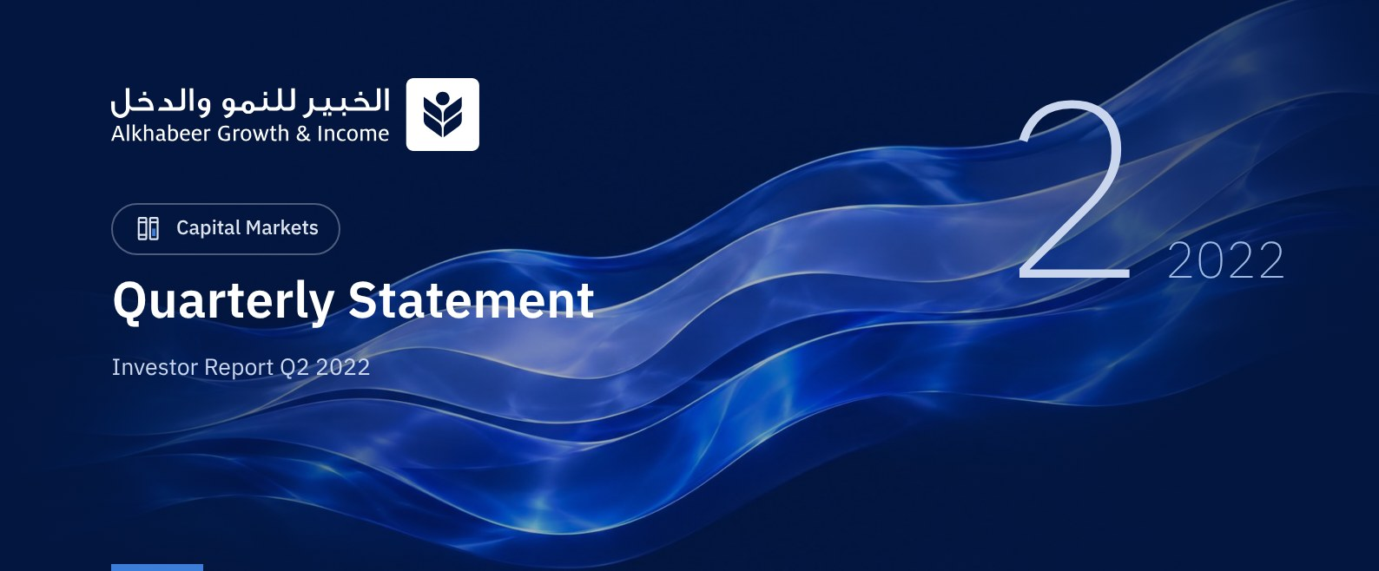

 FUND OVERVIEW
Alkhabeer Growth and Income Traded Fund (“the Fund”) is a closed-ended Shari’a-compliant investment traded public equity fund established in accordance with the applicable laws and regulations of the Kingdom of Saudi Arabia and regulated by the Capital Market Authority (CMA). The Fund’s investment objective is to increase the Fund’s Net Asset Value by boosting the performance of the Fund’s investments in the long term and generating current income to investors from the dividend distributions of the companies in which the Fund invests, in addition to part of the capital appreciation resulting from the growth of market value of the securities invested in. This is achieved by investing in a diversified portfolio of global equities, public and private equities, initial public offerings of companies, private placements, cash and cash equivalents.

 KEY FUND FACTS
TADAWUL SYMBOL | 4701
BLOOMBERG SYMBOL | AKGRINF AB EQUITY
LISTING DATE | 27 April 2022
FUND TYPE | closed-ended investment traded public equity fund
FUND TERM | 99 years, starting as from the Listing Date, renewable
NET ASSET VALUE PER UNIT | SAR 9.3614
FUND ASSETS SIZE* | SAR 937,798,714
FUND’S TOTAL CAPITAL | SAR 1 BILLION
BORROWING AMOUNT* | SAR 0.00
BORROWING PERCENTAGE TO FUND’S TOTAL ASSET VALUE* | 0.00%
RATIO OF LOANS TO FUND’S NET ASSET VALUE AS AT THE END OF THE REPORTING QUARTER | 0.00%
VALUE AND PERCENTAGE OF FUND MANAGER’S INVESTMENT TO FUND’S NET ASSET VALUE AS AT THE END OF THE REPORTING QUARTER | 0.00%
RISK LEVEL | High
FUND CURRENCY | Saudi Arabian Riyal (SAR)
INVESTMENT ADVISOR AND FUND SUB-MANAGER | -
PERCENTAGE OF FEES FOR THE MANAGEMENT OF THE INVESTED FUNDS | -

* Size of the fund as of 30 June 2022 (Unaudited).

FUND PORTFOLIO INVESTMENT CONCENTRATION RATIOS
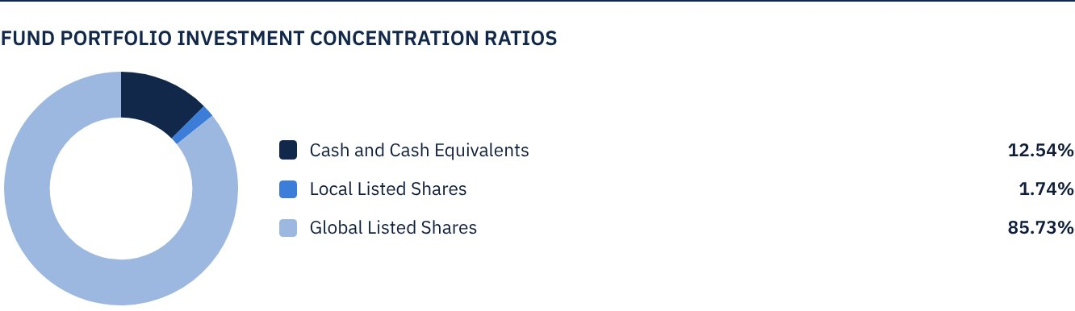
The chart shows the Fund's largest investments and sector allocation of investments.

FINANCIAL INDICATORS*
VALUATION FREQUENCY | Daily
FUND’S TOTAL ASSET VALUE* | SAR 937,798,714
FUND UNITS’ NET ASSET VALUE* | SAR 936,141,281
AMOUNT OF DEALING EXPENSES FOR THE REPORTING QUARTER | SAR 1,716,017
RATIO OF DEALING EXPENSES FOR THE REPORTING QUARTER TO FUND’S AVERAGE NET ASSET VALUE**** | 0.18%
RATIO OF TOTAL EXPENSES AND FEES TO FUND’S TOTAL ASSET VALUE** | 0.21%
RATIO OF FUND'S COSTS TO FUND'S TOTAL ASSET VALUE*** | 0.21%
RATIO OF FUND’S COSTS TO FUND’S AVERAGE NET ASSET VALUE*** | 0.20%
TOTAL EXPENSES AND FEES FOR THE REPORTING QUARTER | SAR 1,977,512
RATIO OF TOTAL EXPENSES AND FEES FOR THE REPORTING QUARTER TO FUND’S AVERAGE NET ASSET VALUE** | 0.20%

* As at 30 June 2022 (Unaudited).
** Fund's expenses and fees are total Fund expenses during the reporting quarter, excluding financing costs.
*** Fund's costs are all Fund's fees and expenses, including financing costs.
**** Fund's average net asset value during the reporting quarter = SAR 977,950,952.

DISTRIBUTION OF INVESTMENTS BY GEOGRAPHY
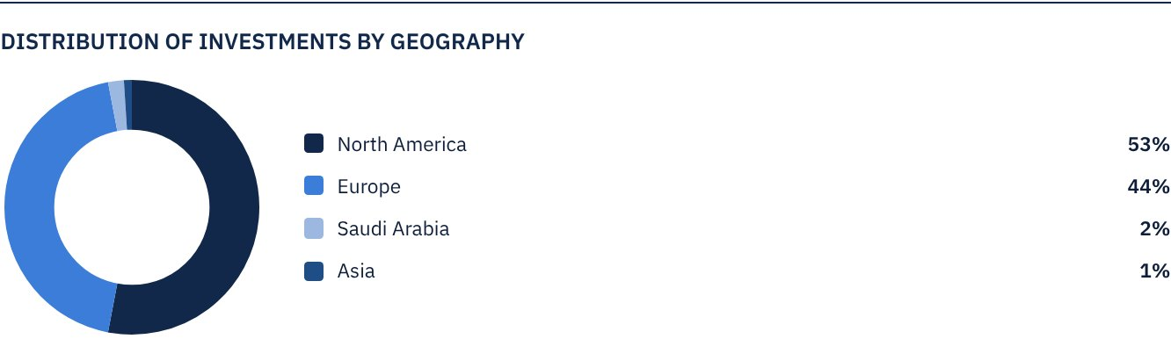

FUND ASSETS INFORMATION
LISTED SHARES | SAR 820,243,326
TOTAL CASH AND CASH EQUIVALENT | SAR 117,555,388

FUND MARKET VALUE INFORMATION
AS AT THE LISTING DATE | SAR 1,000,000,000
AS AT 30 JUNE 2022 | SAR 691,000,000

 NET ASSET VALUE AND UNIT PRICE PERFORMANCE*
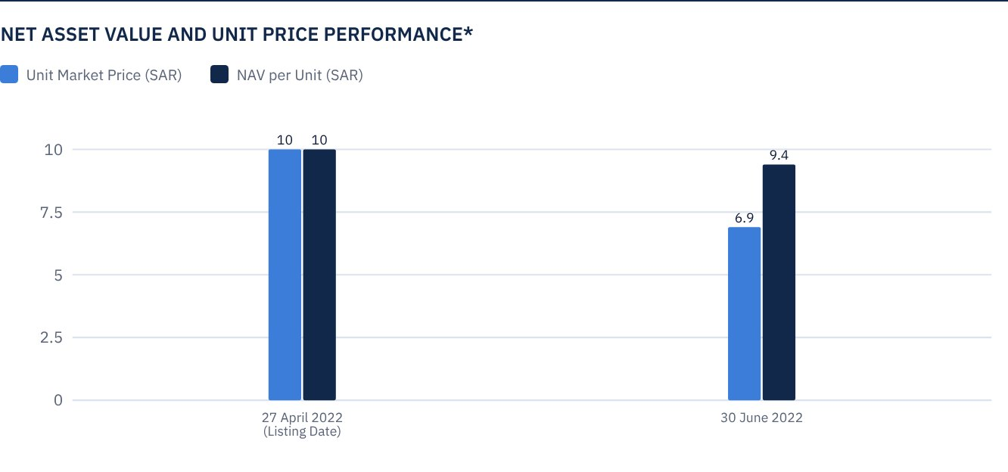
* Based on the Unit Price.

FUND UNITS INFORMATION
UNIT PRICE AS AT THE END OF Q2 (30 JUNE 2022) | SAR 6.91
CHANGE IN UNIT PRICE COMPARED TO THE PREVIOUS QUARTER (FROM THE LISTING DATE TO 30 JUNE 2022) | -30.90%
UNIT PRICE PERFORMANCE SINCE THE LISTING DATE (FROM THE LISTING DATE TO END Q2 2022) | -30.90%
52-WEEK HIGH | SAR 10.90
52-WEEK LOW | SAR 6.90
NUMBER OF OUTSTANDING UNITS | 100,000,000 Units

 DIVIDEND DISTRIBUTION
DIVIDEND DISTRIBUTION POLICY | The Fund Manager has the right, according to what it decides appropriate, to distribute 100% of the net investment returns of the Fund, which includes only the distributions of the listed shares in which the fund invests, and to distribute up to 50% of the realized and unrealized net capital gains twice annually, within (40) business days from the date of issuance of semi-annual and annual financial statements. The distributions (if any) will be announced within (10) business days from the date of issuance of the semi-annual and annual financial statements, and the details of cash dividends will be announced through the Saudi Tadawul website.
TOTAL DIVIDEND DISTRIBUTIONS FOR THE REPORTING QUARTER | SAR 0.00
TOTAL DIVIDEND DISTRIBUTIONS FOR THE LAST SEMI-ANNUAL PERIOD | SAR 0.00
DIVIDEND DISTRIBUTIONS FOR THE LAST SEMI-ANNUAL PERIOD PER UNIT | SAR 0.00
RATIO OF DISTRIBUTED DIVIDENDS TO INITIAL UNIT PRICE | 0.00%
RATIO OF DISTRIBUTED DIVIDENDS TO UNIT PRICE | 0.00%
DIVIDENDS FROM THE LISTED SHARES IN WHICH THE FUND INVESTS | SAR 804,909
UNREALIZED (LOSSES) FROM THE FUND'S INVESTMENTS | SAR (57,752,430)
UNREALIZED (LOSSES) FROM FOREIGN CURRENCY DIFFERENCES | SAR (4,933,686)
TOTAL INCOME FOR THE REPORTING QUARTER* | SAR (61,881,207)
TOTAL INCOME FOR THE REPORTING QUARTER TO UNIT PRICE AS AT 30 JUNE 2022 | -8.96%

FUND PERFORMANCE CRITERIA AND INDICATORS
BENCHMARK | Alkhabeer Global Equity Index
INITIAL UNIT PRICE (AT THE INITIAL OFFERING) | SAR 10
TOTAL RETURN TO NET ASSET VALUE PER UNIT SINCE THE DATE OF INCEPTION | -6.39%

DESCRIPTION OF THE FUND’S BENCHMARK
Alkhabeer Global Equity Index is an index especially created for the Fund in collaboration with the Index Service Provider, who will calculate the valuations of the companies that are included in the Index, and will manage the Index on behalf of the Fund. The Index includes companies which are diversified by sector and size in the largest global capital markets, as well as the largest leading companies in the Kingdom of Saudi Arabia. The companies will be filtered based on a market value exceeding US $ 100 million, and a trade value exceeding US $ 1 million per day. The Index includes 160 global companies representing the largest global capital markets, in addition to the largest 10 listed companies on the Saudi Stock Exchange, compliant with the guidelines of the Shari’a Supervisory Committee. The global companies included in the index are divided by market cap into three categories: the largest 70 in terms of market value of free float shares among large market cap companies, the largest 50 companies in terms of market value of free float shares among medium market cap companies, and the largest 40 companies in terms of market value of free float shares among small market cap companies.
Large market cap companies are defined as companies representing the largest market capitalization. It is the segment which represents up to 70% of the aggregate capitalization of the market combined, while the medium cap segment represents more than 70% up to 85% of the aggregate market capitalization, and the small cap represents more than 85% up to 100% of the aggregate market capitalization.

PERFORMANCE ASSESSMENT CRITERIA AND INDICATORS*
 | ALKHABEER GROWTH AND INCOME TRADED FUND | ALKHABEER GLOBAL EQUITY INDEX
NET ASSET VALUE PER UNIT AS AT THE BEGINNING OF THE PERIOD* | SAR 10.00 | 95.14684
NET ASSET VALUE PER UNIT AS AT THE END OF THE PERIOD** | SAR 9.3614 | 87.34397
UNIT PERFORMANCE | -6.39% | -8.20%

OWNERSHIP OF FUND INVESTMENTS
OWNERSHIP | PERCENTAGE (%)
FULL OWNERSHIP | 100%
UNSUFRUCT RIGHT | 0%

RETURNS
ITEM | REPORTING QUARTER
TOTAL RETURN TO NET ASSET VALUE PER UNIT | -6.39%
BENCHMARK PERFORMANCE | -8.20%
PERFORMANCE DIFFERENCE | 1.81%

 PERFORMANCE AND RISKS
PERFORMANCE AND RISKS CRITERIA | REPORTING QUARTER
STANDARD DEVIATION1 | 17.28
SHARPE RATIO2 | -1.91
TRACKING ERROR3 | 0.25
BETA4 | 0.45
ALPHA5 | 9.26
INFORMATION INDEX6 | 0.37

1. Standard Deviation is a measure of risk. It is calculated as any volatility in returns over a period of time. The lower the volatility, the more homogeneous the set of returns.
2. Sharpe Ratio is a risk-adjusted performance measure. It is calculated as the difference as the Fund Manager excess return over the risk-free rate, divided by the Standard Deviation. The greater a portfolio's Sharpe Ratio, the better its risk-adjusted performance.
3. Tracking Error is a measure of risks. It is calculated as the Standard Deviation between the Fund Manager's return and the Benchmark's return. The lower the Tracking Error, the lower the Fund Manager deviates from the Benchmark.
4. Beta is a measure of the average historical sensitivity of the Fund's returns compared to market returns. It is calculated by using the covariance of the Fund and the market on the variance of the market.
5. Alpha measures any excess return achieved by the Fund compared to the performance of the index.
6. Information Ratio is a risk-adjusted performance measure. It is calculated as the active return of the Fund Manager, divided by its tracking error. The higher the Information ratio, the higher the Fund Manager ability to generate excess returns per Unit of excess risk. Knowing that the performance and risk parameters were calculated based on the net asset value.

FUND HIGHLIGHTS AND ANY FUNDAMENTAL ORNON-FUNDAMENTAL CHANGES AFFECTING THE PERFORMANCE OF THE FUND
The Fund was listed and operated on 27 April 2022, and there are no fundamental, fundamental or important changes affecting the Fund's function.

OVERVIEW OF GLOBAL MARKETS
• The global markets in 2022 witnessed a slowdown economic growth driven by global geo-political crisis, supply chain disruptions and rising inflation. Consequently, equity markets across the world witnessed a contraction with major indices such as S&P500, NASDAQ 100, STOXX Europe 600, Nikkei 225 and FTSE 100 registering declines in Q2 2022.
• The major global markets index has declined by -21.21%, and the emerging global markets index has declined by -18.78%. Moreover, the market performance is considered the worst half-performance after the financial crisis in 2008, while the total return of the Fund's net unit value declined by -6.39% since its inclusion. Markets are accommodating changes in monetary policy with the peak of inflation rates, and thus the outlook for global markets is heading towards stability.
• According to IMF, global economy is forecasted to grow by 3.6% in 2022 and 2023 with Asian economies and commodities exporting countries registering above average growth rates such as Saudi Arabia achieving its highest level growth rates since 2011.

PERFORMANCE OF THE UNIT PRICE TRADED ON THE EXCHANGE SINCE ITS BEGINNING*
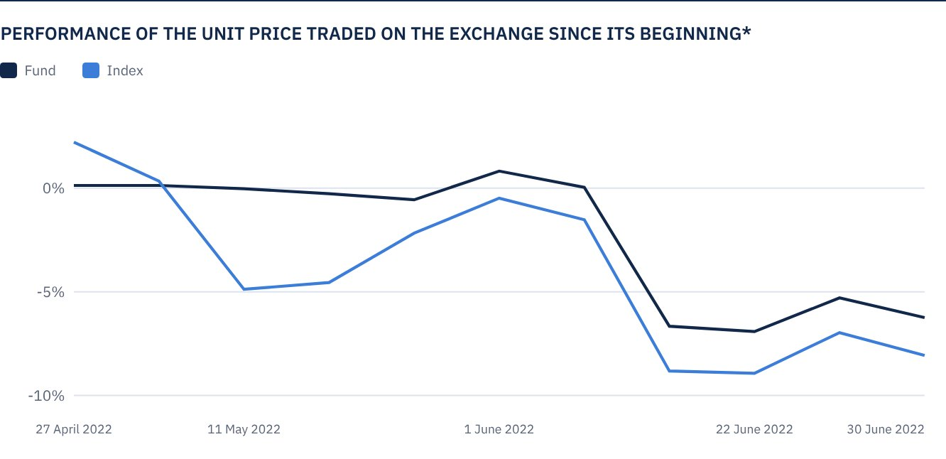
* Prices as of 30 June 2022

 FOR FURTHER INFORMATION
Alkhabeer Capital
PO Box 128289, Jeddah 21362
Kingdom of Saudi Arabia
Tel: +966 12 658 8888
Fax: +966 12 658 6663
Email: info@alkhabeer.com
CR No: 4030177445
CMA License No: 07074-37
www.alkhabeer.com

 DISCLAIMER
This document does not constitute an offer to buy, subscribe or participate in any way in Alkhabeer Growth and Income Traded Fund, nor shall it (or any part of it) form the basis of, or be relied on, in connection with, or act as inducement to enter into any contract whatsoever. Prospective investors should read carefully Alkhabeer Growth and Income Traded Fund’s Terms and Conditions and their contents related to investment risks, as well as other Alkhabeer Growth and Income Traded Fund documents prior to making any investment decision. Alkhabeer Growth and Income Traded Fund documents are available on Alkhabeer Capital’s website www.alkhabeer.com. This investment is not a cash deposit with a local bank. The value of the amount invested and any other income which may arise therefrom may increase or decrease. All prospective investors are required to make their own determination with their own financial and legal advisors and to evaluate all risks involved. No assurance can be given that the targeted and projected results will be achieved. Moreover, past performance of Alkhabeer Growth and Income Traded Fund is not a guarantee of the Fund’s future results. By investing in the Fund, the investor acknowledges having read and accepted Alkhabeer Growth and Income Traded Fund’s Terms and Conditions, The Fund Manager or any of its affiliates shall not be liable for any financial loss which may be suffered by the Fund, unless such loss is deliberately caused by the Fund Manager.

