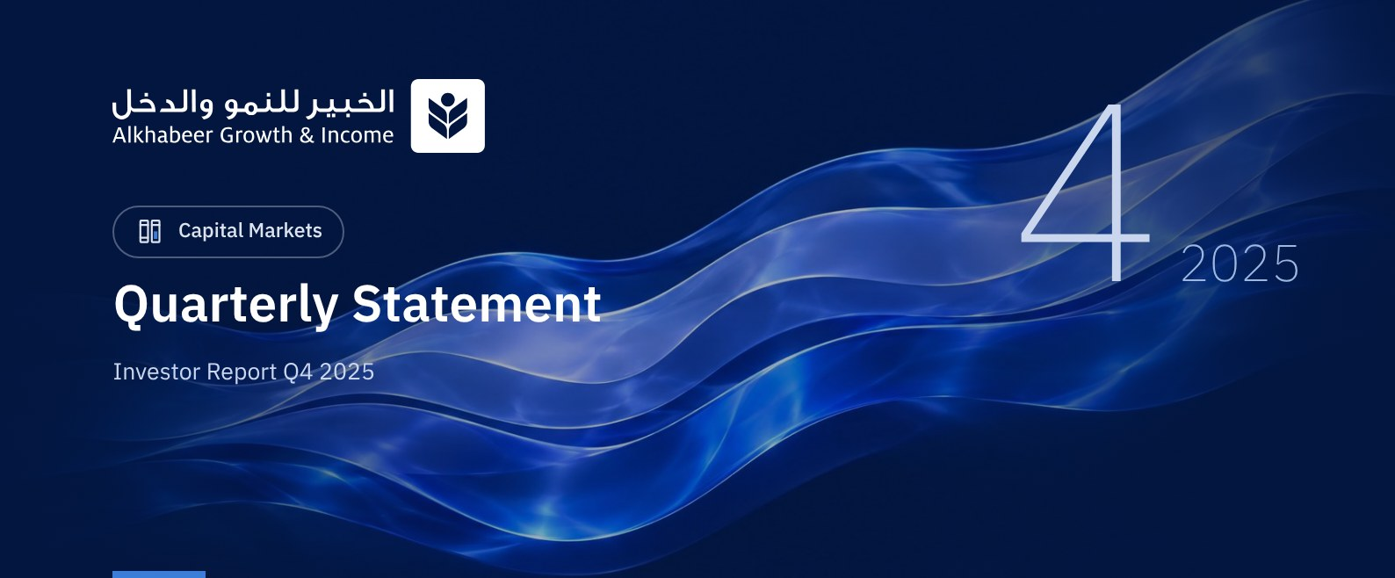

 a) Fund Objective:
The Fund Manager focuses on investing in a diversified portfolio of global equities. The Fund's investments include investing in shares of companies in all sectors, traded on global exchanges in countries such as Saudi Arabia, USA, China, Japan, Switzerland, UK, France, Germany and Canada. Investing on these exchanges will be in the currency of each country. In addition, the Fund Manager will invest in public and private equity funds managed by fund managers licensed by the Capital Market Authority (CMA) or a similar authority when investing abroad. These funds will include corporate shares of different market values in diverse geographies and sectors. The Fund Manager also intends to invest in intial public offerings (IPOs) listed on different stock exchanges, in addition to subscribing for capital increases of listed companies, as well as unlisted companies planning IPOs, by subscribing for planned IPOs, and investing in cash and cash equivalents in compliance with Shari'ah principles, to achieve long term growth and generate periodic income from the returns on equity shares and capital gain.

 b) Key Fund Facts:
Fund Inception Date | 27 April 2022
Initial Unit Price (at the Initial Offering) | SAR 10
Net Asset Value per Unit | SAR 10.9786
Fund Size * | SAR 706,228,090
Fund Type | Closed-ended Traded Public Equity Fund
Fund Currency | Saudi Riyal
Risk Level | High
Benchmark | Alkhabeer Global Equity Index
Frequency of Dividend Distribution (if any) | Semi Annual
Ratio of Management Fees of Underlying Funds | 0.06%
Investment Advisor and Fund Sub-Manager | N/A
Number of Days Weighted Average (if any) | 92 days

* Fund Total Assets as at 30 September 2025 (Unaudited).

c) Definitions:
Standard Deviation | Standard Deviation is a measure of risk. It is calculated as any volatility in returns over a period of time. The lower the volatility, the more homogeneous the set of returns.
Sharpe Ratio | Sharpe Ratio is a risk-adjusted performance measure. It is calculated as the difference of the Fund Manager excess return over the risk-free rate, divided by the Standard Deviation. The greater a portfolio's Sharpe Ratio, the better its risk-adjusted performance.
Tracking Error | Tracking Error is a measure of risks. It is calculated as the Standard Deviation between the Fund Manager's return and the Benchmark's return. The lower the Tracking Error, the lower the Fund Manager deviates from the Benchmark.
Beta | Beta is a measure of the average historical sensitivity of the Fund's returns compared to market returns. It is calculated by using the covariance of the Fund and the market on the variance of the market,
Alpha | Alpha measures any excess return achieved by the Fund compared to the performance of the index.
Information Ratio | Information Ratio is a risk-adjusted performance measure. It is calculated as the active return of the Fund Manager, divided by its tracking error. The higher the Information ratio, the higher the Fund Manager ability to generate excess returns per Unit of excess risk.

d) Fund Manager's Commentary:

Overview of Global Markets
Global equity markets closed Q4 2025 with positive performance, supported by resilient corporate earnings, easing inflationary pressures, and a shift toward looser monetary policy by major central banks. Despite ongoing geopolitical tensions and trade policy uncertainty, market sentiment remained generally positive during the quarter. Alkhabeer Capital index rose by +5.26% in Q4 2025, bringing its full-year 2025 performance to +20.62%, reflecting the strong momentum seen in global equity markets throughout the year.
The US economy continued to show signs of moderate slowing, with the unemployment rate rising to 4.6% while inflation stood at 2.7%, continuing its gradual path toward the long-term 2% target. In December, the US Federal Reserve cut interest rates by 25 basis point (bps), marking the third cut in 2025. In Europe, equity market performance was mixed amid relatively weak economic growth. Emerging markets benefited from attractive valuations and supportive policy measures, including fiscal support in China and continued strong domestic demand in India. Geopolitical developments and uncertainty related to trade-policy may continue to contribute to equity markets volatility. Conversely, further progress in containing inflation and monetary policy adjustments by central banks could provide additional market stability.
According to the IMF’s World Economic Outlook, global GDP growth is projected at 3.2% in 2025 and 3.1% in 2026, with advanced economies growing by 1.6% while emerging market growth exceeds 4%. Expected growth rates for fiscal year 2026 are approximately 2.1% for the United States, 1.3% for the United Kingdom, 4.0% for Saudi Arabia, 4.2% for China, and 6.2% for India.

Fund Highlights and Any Fundamental or Non-Fundamental Changes Affecting its Performance
During the quarter, the fund manager paid additional distributions totaling SAR 127.75 million, at SAR 2.00 per unit, for the period from 27 April 2022 to 31 December 2024. Since inception, the fund has distributed total cash dividends of SAR 4.715 per unit, equivalent to 47.15% of the IPO unit price.

 e) Contact Information:
Telephone Number | +966 12 658 8888
Website | www.alkhabeer.com
Email | info@alkhabeer.com

f) Price Information as at the End of the Reporting Quarter (December 2025):
Unit Price as at the end of Q4 (31 December 2025) | SAR 10.05
Change in Unit Price Compared to Previous Quarter | 9.48%
Dual Unit Price of Money Market Funds and Fixed Income Debt Funds | N/A
Total Fund Units | 63,876,285 Units
Fund's Net Asset Value | SAR 701,273,904
Price/Equity Ratio (P/E) | 21.7x

g) Fund Information as at the end of Q4 (December 2025):
Item | Saudi Riyal | %
Total Expense Ratio (TER) to Fund's Average Net Asset Value | SAR 2,968,586 | 0.37%
Ratio of Loans to Fund's Total Asset Value | N/A | N/A
Percentage of Dealing Expenses to Fund's Average Net Asset Value * | SAR 101,900 | 0.01%
Percentage of Fund Manager's Investment to Fund's Net Asset Value | N/A | N/A
Distributed Dividends | SAR 127,752,570 | 18.22%

* Fund's Average Net Asset Value for Q4 = SAR 797,860,384.

h) Information on Ownership of Fund Investments:
Freehold | 100%
Leasehold | 0%

 i) Disclaimer:
This document does not constitute an offer to buy, subscribe or participate in any way in Alkhabeer Growth and Income Traded Fund, nor shall it (or any part of it) form the basis of, or be relied on, in connection with, or act as inducement to enter into any contract whatsoever. Prospective investors should read carefully Alkhabeer Growth and Income Traded Fund’s Terms and Conditions and their contents related to investment risks, as well as other Alkhabeer Growth and Income Traded Fund documents prior to making any investment decision. Alkhabeer Growth and Income Traded Fund documents are available on Alkhabeer Capital’s website www.alkhabeer.com. This investment is not a cash deposit with a local bank. The value of the amount invested and any other income which may arise therefrom may increase or decrease. All prospective investors are required to make their own determination with their own financial and legal advisors and to evaluate all risks involved. No assurance can be given that the targeted and projected results will be achieved. Moreover, past performance of Alkhabeer Growth and Income Traded Fund is not a guarantee of the Fund’s future results. By investing in the Fund, the investor acknowledges having read and accepted Alkhabeer Growth and Income Traded Fund’s Terms and Conditions, The Fund Manager or any of its affiliates shall not be liable for any financial loss which may be suffered by the Fund, unless such loss is deliberately caused by the Fund Manager.

j) Graph Showing the Fund's Top Ten Investments:
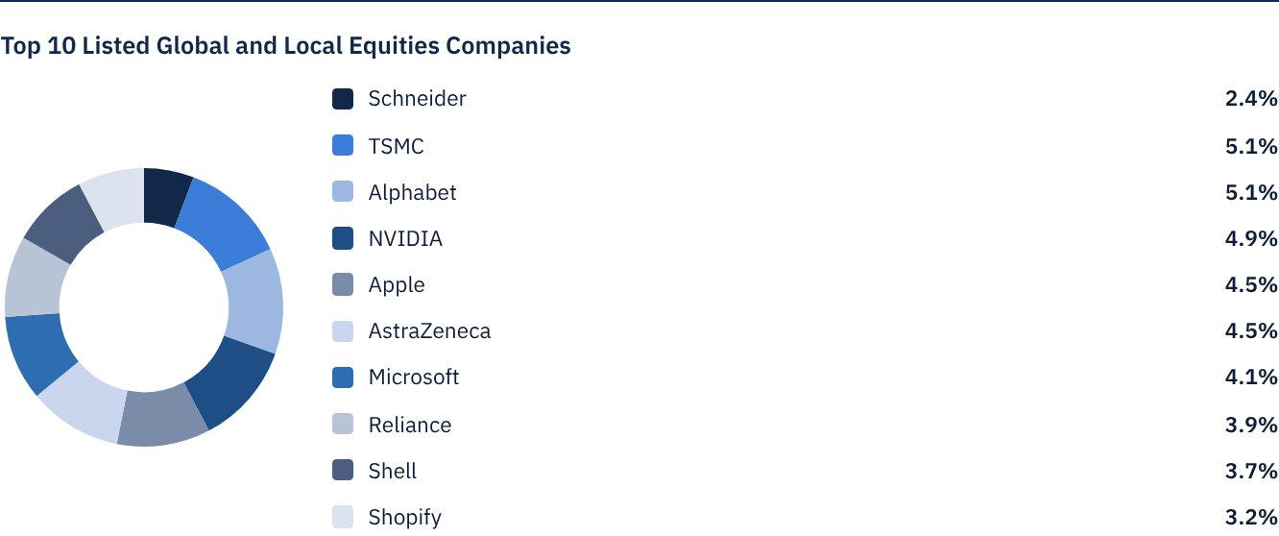

 k) Statement of Dividends Distributed to Unitholders (if any), as follows:
Total Dividend Distributions during Q4 | SAR 127,752,570
Number of Outstanding Units eligible for Dividends distribution during Q4 | 63,876,285 Units
Distributed Dividends per Unit during Q4 | SAR 2.00
Ratio of Distributions to Fund's Net Asset Value | 18.22%
Entitlement to Cash Distributions Paid during the Reporting Quarter | According to the Unitholders' Register as at Close of Business on Thursday, December 18, 2025

Distributions for the Period from 27 April 2022 to 31 December 2024.

l) Credit Rating of Underlying Debt Instruments of the Fund's Top Ten Investments, as follows:
Credit Rating of the Debt Instrument | N/A
Credit Rating of the Issuer of the Debt Instrument | N/A
Name of the Credit Rating Agency | N/A
Date of the Credit Rating | N/A

m) Graph Showing the Distribution of Fund Assets (by Sector/Geography):
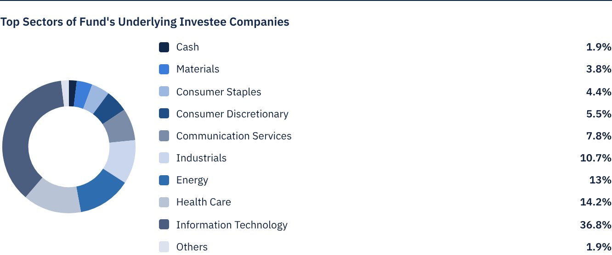
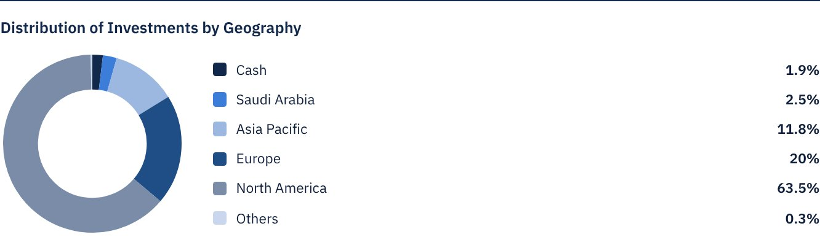

 n) Returns:
Item | 3 Months (End of Q4) | Year to Date (YTD) ** | One Year *** | 3 Years | 5 Years
Total Return to Net Asset Value per Unit (Fund Performance) * | 4.73% | 21.86% | 21.86% | 74.51% | N/A
Benchmark Performance | 5.26% | 20.62% | 20.62% | 61.43% | N/A
Performance Spread | -0.53% | 1.24% | 1.24% | 13.08% | N/A

* Total Return = NAV per Unit Price Performance plus Dividends.

 o) Performance and Risk:
Performance and Risk Criteria | 3 Months (End of Q4) | Year to Date (YTD) ** | One Year *** | 3 Years | 5 Years
Standard Deviation | 12.01 | 15.09 | 15.09 | 12.23 | N/A
Sharpe Ratio | 1.36 | 1.12 | 1.12 | 1.09 | N/A
Tracking Error | 1.55 | 3.30 | 3.30 | 6.28 | N/A
Beta | 0.94 | 0.95 | 0.95 | 0.87 | N/A
Alpha | -2.18% | 0.89% | 0.89% | 2.35% | N/A
Information Ratio | -1.41 | 0.27 | 0.27 | 0.37 | N/A

p) Equations Used to Calculate Performance and Risk:
Standard Deviation | σp = √[ 1/(N − 1) · Σ(Rp,i − Rp)² ] | where  Rp,i = Portfolio return in period i  Rp = Average portfolio return  N = Number of periods
Sharpe Ratio | [(Average Annualised Return − Risk Free Rate) ÷ Standard Deviation]
Tracking Error | TE = √[ 1/(N − 1) · Σ[(Rp,i − Rb,i) − (Rp − Rb)]² ] | Where  Rp,i = Portfolio return in period i  Rb,i = Portfolio return in period i  Rp = Average portfolio return  Rb = Average portfolio return
Beta | β = Cov(Rp, Rb) / Var (Rb) | Where  Cov(Rp, Rb)= covariance between portfolio and benchmark returns  Var (Rb)= variance of benchmark returns
Alpha | α = Rp − [ Rf + β ∗ (Rb − Rf)] | Where  (Rp)= average portfolio return  (Rb)= average benchmark return  (Rf)= risk free rate  β= portfolio beta

q) Graph Depicting Peformance as of the Inception of the Fund:
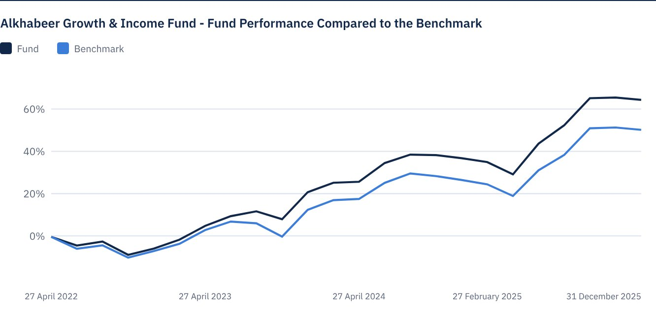
As of 31 December 2025

FOR FURTHER INFORMATION
Alkhabeer Capital
PO Box 128289, Jeddah 21362
Kingdom of Saudi Arabia
Tel: +966 12 658 8888
Fax: +966 12 658 6663
Email: info@alkhabeer.com
CR No: 4030177445
CMA License No: 07074-37
www.alkhabeer.com

DISCLAIMER
This document does not constitute an offer to buy, subscribe or participate in any way in Alkhabeer Growth and Income Traded Fund, nor shall it (or any part of it) form the basis of, or be relied on, in connection with, or act as inducement to enter into any contract whatsoever. Prospective investors should read carefully Alkhabeer Growth and Income Traded Fund’s Terms and Conditions and their contents related to investment risks, as well as other Alkhabeer Growth and Income Traded Fund documents prior to making any investment decision. Alkhabeer Growth and Income Traded Fund documents are available on Alkhabeer Capital’s website www.alkhabeer.com. This investment is not a cash deposit with a local bank. The value of the amount invested and any other income which may arise therefrom may increase or decrease. All prospective investors are required to make their own determination with their own financial and legal advisors and to evaluate all risks involved. No assurance can be given that the targeted and projected results will be achieved. Moreover, past performance of Alkhabeer Growth and Income Traded Fund is not a guarantee of the Fund’s future results. By investing in the Fund, the investor acknowledges having read and accepted Alkhabeer Growth and Income Traded Fund’s Terms and Conditions, The Fund Manager or any of its affiliates shall not be liable for any financial loss which may be suffered by the Fund, unless such loss is deliberately caused by the Fund Manager.

