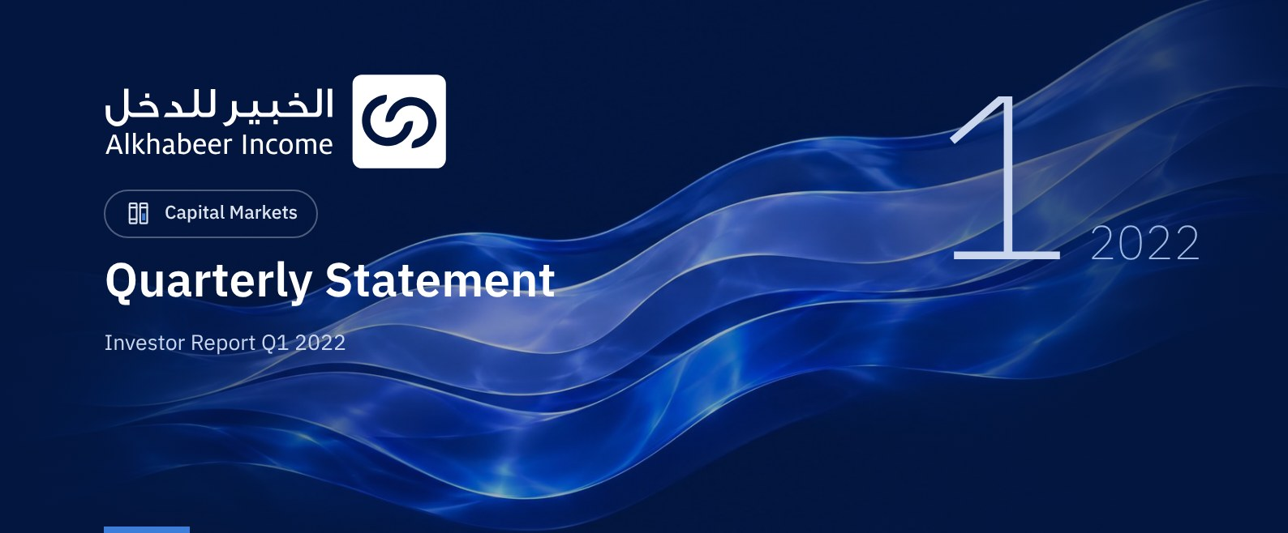

 FUND OVERVIEW
Alkhabeer Diversified Income Traded Fund (“the Fund”) is a closed-ended Shari’a-compliant investment traded fund established in accordance with the applicable laws and regulations of the Kingdom of Saudi Arabia and regulated by the Capital Market Authority (CMA). The Fund’s investment objective is to generate periodic income to investors by investing in Shari’a-compliant income generating assets. The Fund Manager “Alkhabeer Capital” plans to invest in Sukuk, trade finance transactions, leasing transactions, income funds and Murabaha transactions, either directly or through investment funds.

 KEY FUND FACTS
TADAWUL SYMBOL | 4700
BLOOMBERG SYMBOL | AKDICIF:AB
LISTING DATE | 19 January 2021
FUND TERM | 99 years, starting as from the Listing Date, renewable
NET ASSET VALUE PER UNIT | 9.9877
FUND ASSETS SIZE* | SAR 589,443,119
FUND’S TOTAL CAPITAL | SAR 472,814,700
FINANCING AMOUNT* | SAR 112,979,272
RATIO OF LOANS TO FUND’S TOTAL ASSET VALUE* | 19.17%
RATIO OF LOANS TO FUND’S NET ASSET VALUE AS AT THE END OF THE REPORTING QUARTER | 23.92%
VALUE AND PERCENTAGE OF FUND MANAGER’S INVESTMENT TO FUND’S NET ASSET VALUE AS AT THE END OF THE REPORTING QUARTER | 0.0%
RISK LEVEL | High
FUND CURRENCY | Saudi Arabian Riyal (SAR)
INVESTMENT ADVISOR AND FUND SUB-MANAGER | N/A
RATIO OF UNDERLYING FUNDS’ MANAGEMENT FEES | 0.42%

* As at 31 March 2022 (Unaudited).

FINANCIAL INDICATORS*
VALUATION FREQUENCY | Quarterly
FUND’S TOTAL ASSET VALUE* | SAR 589,443,119
FUND UNITS’ NET ASSET VALUE* | SAR 472,231,297
AMOUNT AND RATIO OF TRANSACTION EXPENSES FOR THE REPORTING QUARTER TO FUND’S AVERAGE NET ASSET VALUE | 0.00%
RATIO OF TOTAL EXPENSES AND FEES TO FUND’S TOTAL ASSET VALUE** | 0.38%
RATIO OF FUND’S COSTS TO FUND’S TOTAL ASSET VALUE*** | 0.47%
RATIO OF FUND’S COSTS TO FUND’S AVERAGE NET ASSET VALUE*** | 0.58%
TOTAL EXPENSES, COSTS AND FEES FOR THE REPORTING QUARTER | SAR 2,741,443
RATIO OF TOTAL EXPENSES AND FEES FOR THE REPORTING QUARTER TO FUND’S AVERAGE NET ASSET VALUE** | 0.48%

* As at 31 March 2022 (Unaudited).
** Fund expenses and fees are all Fund expenses during the reporting quarter, excluding financing costs.
*** Fund costs are all Fund fees and expenses, including financing costs.

FUND PORTFOLIO INVESTMENT CONCENTRATION RATIOS
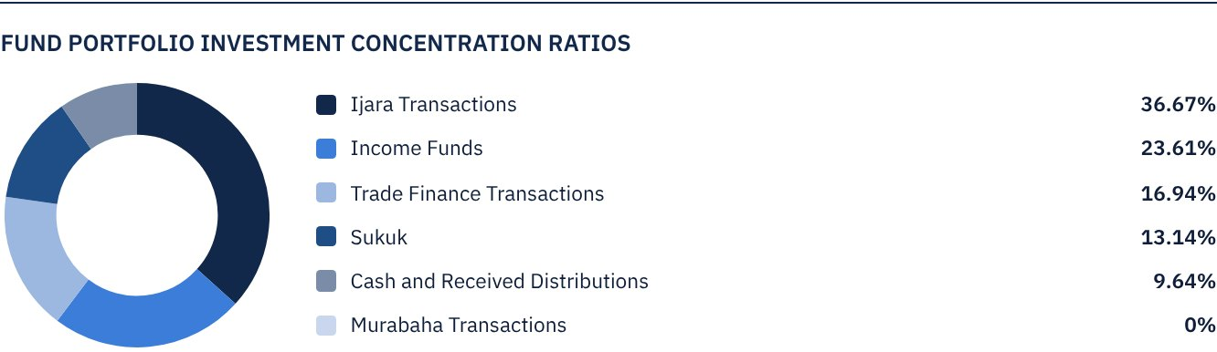
* The graph shows the largest investments in the Fund and the sectoral distribution of investments together.

DISTRIBUTION OF INVESTMENTS BY GEOGRAPHY
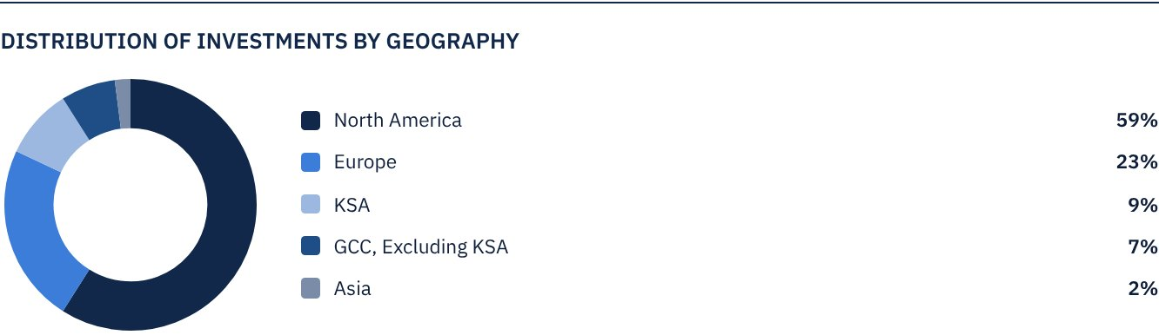

FUND ASSETS INFORMATION
TRADE FINANCE PORTFOLIO TOTAL VALUE | SAR 99,860,580
LEASING PORTFOLIO TOTAL VALUE | SAR 216,161,947
SUKUK PORTFOLIO TOTAL VALUE | SAR 77,423,435
INCOME FUNDS PORTFOLIO TOTAL VALUE | SAR 139,154,137
TOTAL CASH AND CASH EQUIVALENT | SAR 56,843,021

 NET ASSET VALUE AND UNIT PRICE PERFORMANCE*
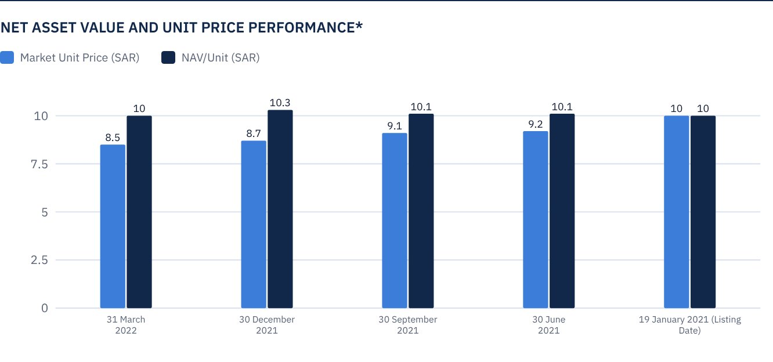
* Based on the Unit Price.

FUND MARKET VALUE INFORMATION*
AS AT THE LISTING DATE | SAR 472,814,700
AS AT 31 MARCH 2021 | SAR 428,370,118
AS AT 30 JUNE 2021 | SAR 433,098,265
AS AT 30 SEPTEMBER 2021 | SAR 427,897,304
AS AT 31 DECEMBER 2021 | SAR 409,930,345
AS AT 31 MARCH 2022 | SAR 402,838,124

* Based on the Unit Price.

FUND UNITS INFORMATION
UNIT PRICE AS AT THE END OF Q1 (31 MARCH 2022) | SAR 8.52
CHANGE IN UNIT PRICE DURING THE CURRENT QUARTER (FROM 31 DECEMBER 2021 TO 31 MARCH 2022)* | -1.73%
UNIT PRICE PERFORMANCE SINCE THE LISTING DATE (FROM THE LISTING DATE TO END Q1 2022) | -14.80%
52-WEEK HIGH | SAR 9.44
52-WEEK LOW | SAR 8.52
NUMBER OF OUTSTANDING UNITS | 47,281,470 Units

* Unit Price as at 31 December 2021 = SAR 8.67.

 DIVIDEND DISTRIBUTION
DIVIDEND DISTRIBUTION POLICY | The Fund Manager will distribute 100% of the semi-annual profits received from the returns on the Fund's investments after deducting the expenses from the Unitholders twice a year, provided distributions are made during the months of August and February annually.
TOTAL DIVIDENDS DISTRIBUTED IN THE REPORTING QUARTER* | SAR 0
TOTAL DIVIDENDS DISTRIBUTED FOR THE LAST SEMI-ANNUAL PERIOD** | SAR 11,820,368
DIVIDENDS DISTRIBUTED FOR THE LAST SEMI-ANNUAL PERIOD PER UNIT | SAR 0.25
RATIO OF DIVIDENDS DISTRIBUTED TO INITIAL UNIT PRICE | 2.50%
RATIO OF DIVIDENDS DISTRIBUTED ON UNIT PRICE*** | 2.93%
GROSS INCOME FOR THE REPORTING QUARTER* | SAR 2,323,405
INCOME FOR THE REPORTING QUARTER ON UNIT PRICE (31 MARCH 2022) | 0.58%

* For the period from 1 January 2022 to 31 March 2022
** For the period from 1 July 2021 to 31 December 2021
*** Unit Price as at 31 December 2021 = SAR 8.67.

FUND PERFORMANCE CRITERIA AND INDICATORS
BENCHMARK | 12M LIBOR + 300 bps
INITIAL UNIT PRICE (AT THE INITIAL OFFERING) | SAR 10
UNIT PRICE PERFORMANCE SINCE THE PREVIOUS PERIOD* | -1.73%
UNIT PRICE PERFORMANCE SINCE THE DATE OF INCEPTION** | -14.80%
TOTAL RETURN SINCE THE DATE OF INCEPTION*** | -10.50%

* From end Q4 2021 to end Q1 2022.
** From the Fund’s Date of Inception to end Q1 2022.
*** Total Return = Unit Price Performance + Total Dividend Distributions (if any).

DESCRIPTION OF THE FUND’S BENCHMARK
The Fund’s performance benchmark is “Alkhabeer Income Generating Asset Index”. a composite index comprised of Ideal Ratings Saudi REITs Index, which contributes a weight of 75%, and Ideal Ratings Global Sukuk Index, which contributes a weight of 25%. The Index is used for benchmarking the Fund’s performance to the performance of the Benchmark. The Benchmark data service is provided by Ideal Ratings.

PERFORMANCE ASSESSMENT CRITERIA AND INDICATORS*
 | ALKHABEER INCOME FUND | 12M LIBOR + 300 BPS
NET ASSET VALUE PER UNIT AS AT THE BEGINNING OF THE PERIOD* | 10.2465 | NOT APPLICABLE
NET ASSET VALUE PER UNIT AS AT THE END OF THE PERIOD** | 9.9877 | NOT APPLICABLE
UNIT PERFORMANCE | -2.53% | 1.05%***

* As at 31 December 2021.
** As at 31 March 2022.
*** Benchmark average return is 4.25% annually, which is equivalent to a return of 1.05% for the relevant quarter.

OWNERSHIP OF FUND INVESTMENTS
OWNERSHIP | PERCENTAGE (%)
FREEHOLD | 100%
LEASEHOLD | 0%

RETURNS
ITEM | 3 MONTHS | ONE YEAR UP TO 31 MARCH 2022 | ONE YEAR
TOTAL RETURN FOR NAV/UNIT | -0.09%* | -0.09%** | 4.67%***
BENCHMARK PERFORMANCE | 1.05% | 1.05% | 3.53%
PERFORMANCE SPREAD | -1.14% | -1.14% | 1.14%

* For the period from 1 January 2022 to 31 March 2022, including cash distributions of 2.50%.
** For the period from 1 January 2022 to 31 March 2022, including cash distributions of 2.50%.
*** For the period from 31 March 2021 to 31 March 2022, including cash distributions of 4.20% (Unit Price as at 31 March 2021 = SAR 9.9531).
It should be noted that the Unit Price on the Exchange may increase or decrease based on market factors.

 PERFORMANCE AND RISKS
PERFORMANCE AND RISKS CRITERIA | 3 MONTHS1 | ONE YEAR UP TO 31 MARCH 20222 | ONE YEAR
STANDARD DEVIATION3 | 9.18 | 9.18 | 6.70
SHARPE RATIO4 | -0.70 | -0.70 | -0.52
TRACKING ERROR5 | 9.19 | 9.19 | 6.70
BETA6 | -2.32 | -2.32 | -0.96
ALPHA7 | -9.77% | -9.77% | -6.60
INFORMATION RATIO8 | -1.06% | -1.06% | -0.99

1. For the period from 31 December 2021 to 31 March 2022.
2. For the period from 31 December 2021 to 31 March 2022.
3. For the period from 31 December 2021 to 31 March 2022.
4. Standard Deviation is a measure of risk. It is calculated as any volatility in returns over a period of time. The lower the volatility, the more homogeneous the set of returns.
5. Sharpe Ratio is a risk-adjusted performance measure. It is calculated as the difference as the Fund Manager excess return over the risk-free rate, divided by the Standard Deviation. The greater a portfolio's Sharpe Ratio, the better its risk-adjusted performance.
6. Tracking Error is a measure of risks. It is calculated as the Standard Deviation between the Fund Manager's return and the Benchmark's return. The lower the Tracking Error, the lower the Fund Manager deviates from the Benchmark.
7. Beta is a measure of the average historical sensitivity of the Fund's returns compared to market returns. It is calculated by using the covariance of the Fund and the market on the variance of the market.
8. Alpha measures any excess return achieved by the Fund compared to the performance of the index.
9. Information Ratio is a risk performance measure. It is calculated as the active return of the Fund Manager, divided by its tracking error. The higher the Information ratio, the higher the Fund Manager ability to generate excess returns per Unit of excess risk. Knowing that the performance and risk parameters were calculated based on the Unit's trading prices in the market.

FUND HIGHLIGHTS AND ANY FUNDAMENTAL, MATERIAL OR SIGNIFICANT CHANGES AFFECTING THE PERFORMANCE OF THE FUND
• The Fund Manager invested 36.7% of the Fund’s assets in leasing transactions across several types of equipment and companies. The leasing portfolio is mainly invested in the United States, and is expected to generate a total return of 6.00% - 6.50% annually over the next five-year term.
• To diversify the Fund’s investments, the Fund Manager invested 23.6% of the Fund’s assets in income funds, ranging between private financing, trade finance and securitization, with an expected average annual return of 6.0% to 7.0%.
• The Fund Manager invested 16.9% of the Fund’s assets in trade finance transactions with several counterparties and across various industries, mostly in the European continent. All executed transactions are of a short-term nature, with returns ranging between 6.0% to 7.0% annually.
• The Fund Manager invested 13.1% of the Fund’s assets in Sukuk of different credit ratings, including sovereign, semi-sovereign and corporate Sukuk. The Fund Manager has obtained credit facilities that support increasing the Portfolio’s returns to over 4.5% per annum, while maintaining a weighted average for classifying the Portfolio as an investment grade.

OVERVIEW OF THE LEASING, TRADE FINANCE AND SUKUK INDUSTRIES

LEASING INDUSTRY OVERVIEW
• The COVID-19 pandemic had a significant adverse effect on the leasing market, with the decline of consumer demand for many companies and the closure of commercial activities of some companies, due to the restrictive containment measures. The wide scale containment measures applied in many countries resulting in the closure of manufacturing and other industrial companies; thus, affecting demand on leased machinery and equipment throughout 2020 and well into 2021.
• In Q1 2022, supply chain challenges continued to adversely affect the availability of equipment in general. Furthermore, the conflict between Russia and Ukraine amplified overall market volatility and added to the instability of the market environment. As a result, the Monthly Leasing and Finance Index (MLFI-25), which tracks the economic activity of 25 companies representing the US$ 900 billion US equipment financing sector, declined from 61.8 in February 2022 to 58.2 in March 2022.
• Various industries, such as construction, mining and agriculture, have recently shown an increasing trend towards renting or leasing equipment, as opposed to buying, which reflects the increasing tendency of businesses exploring leasing options of new equipment, as well as the greater shift towards reducing cost, accompanied by smaller business increasing emphasis on expansion plans.
• The US Fed’s decision to increase interest rates in March 2022 is likely to instantly result in higher financing costs for many forms of borrowing and credit. Every interest rate increase is expected to yield more pressures on the leasing market.
• According to estimates published by the Business Research Company (TBRC), the global leasing market is expected to grow from US$ 1.35 trillion in 2021 to US$ 2.40 trillion in 2026, a CAGR of approximately 12.0%. The vehicle leasing market is projected to have the fastest growth, with a CAGR of 14.7% for the period from 2021 – 2026.

TRADE FINANCE INDUSTRY OVERVIEW
• According to UNCTAD, world trade in commodities remained strong, and services were restored to their pre-pandemic levels, to reach US$ 28.5 trillion in 2021, an increase of 25% compared to 2020, and 13% compared to 2019, with the bulk of the world trade taking place in the H1 2021, and further overall progress made in the H2 2021.
• After its relatively slow growth in Q3 2021, world trade in commodities increased by around US$ 200 billion in Q4 2021, to reach a total value of US$ 5.8 trillion. Similarly, world trade in services increase by US$ 50 billion to reach a total value of US$ 1.6 trillion, which is equal to its pre-pandemic levels.
• However, the increasing tensions caused by the Russian invasion of Ukraine are restricting world trade, according to a report published by Keil Institute, the German research center. Russian exports are expected to see the largest adverse effect in February 2022 (m-o-m), having declined by -11.8%, followed by the United States by -3.9% (m-o-m), EU shipments by -2.8% (m-o-m) and Germany by -0.3% (m-o-m), while China achieved growth by 0.3% (m-o-m). However, the accelerated fears over the spread of the Omicron variant may affect growth. Moreover, stricter customs regulation to ensure compliance with sanctions imposed on Russia may lead to delays in marine commerce.
• Given the fact that approximately 80% to 90% of the world trade relies on trade finance (trade credit / insurance / guarantees), the economic uncertainty of the world trade climate may adversely affect the trade finance industry in general.

SUKUK INDUSTRY OVERVIEW
• According to Fitch Ratings, global sukuk issues increased by 36% in 2021 to US$ 252.3 billion, and are expected to continue expanding in 2022 given the strong investor appetite. The majority of issues originated from Indonesia, Malaysia, GCC States, Turkey and Pakistan.
• Global sukuk issues neared US$ 40 billion in January/February 2022, an increase of over 7%, y-o-y, indicating the continued growth of market activity.
• The sustainability sukuk issues increased as well in 2021, with the growing importance of green projects and social projects amid efforts made by countries towards transforming to a more sustainable economy. The total sustainability sukuk jumped from US$ 1.6 billion in 2020 to US$ 3.7 billion in 2021.
• Growth of US Dollar denominated sukuk came to a halt in March with the start of the conflict between Russia and Ukraine, and amid higher oil prices (Fitch modified its expectations to US$ 100 per barrel in 2022 and US$ 80 per barrel in 2023), higher interest rates and inflationary pressures.
• The long term outlook of the sukuk market is strong considering the financing needs of the issuers, the diversification goals, and the investor appetite, particularly among Islamic bank in GCC States. Stable liquidity is likely to rise due to higher oil prices.
• The increased prices of oil and commodities is expected to have mixed effects on major Islamic finance markets. Oil exporters comprise the majority of main sukuk markets 70%, while oil importers comprise the remaining percentage. The pegging of GCC currencies to the United States Dollar is viewed as an advantage. Oil importing markets are expected to encounter increased financing requirements, part of which would be met through the issuance of sukuk.

PERFORMANCE OF THE UNIT PRICE TRADED ON THE EXCHANGE*
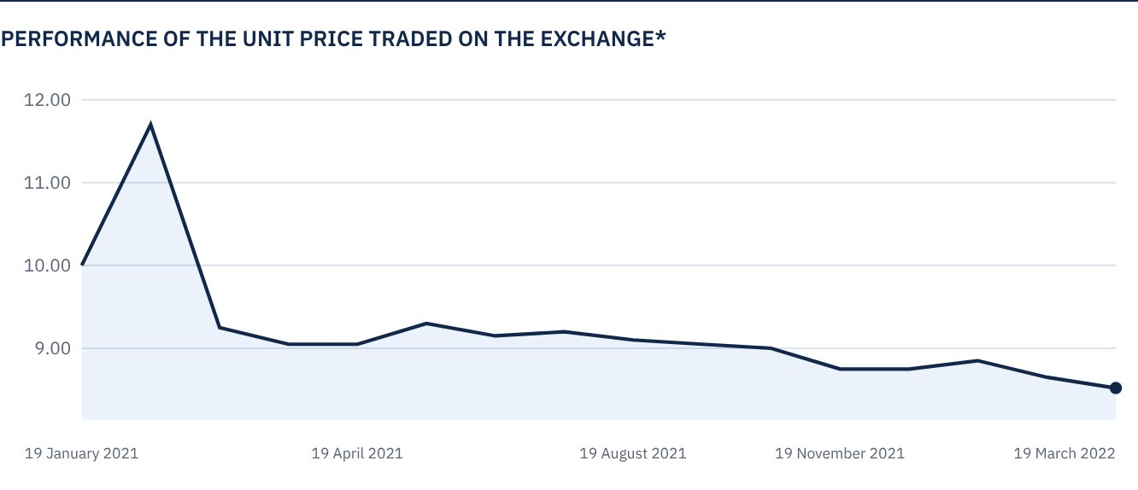
* Prices as at 31 March 2022

 FOR FURTHER INFORMATION
Alkhabeer Capital
PO Box 128289, Jeddah 21362
Kingdom of Saudi Arabia
Tel: +966 12 658 8888
Fax: +966 12 658 6663
Email: info@alkhabeer.com
CR No: 4030177445
CMA License No: 07074-37
www.alkhabeer.com

 DISCLAIMER
This document does not constitute an offer to buy, subscribe or participate in any way in Alkhabeer Diversified Income Traded Fund, nor shall it (or any part of it) form the basis of, or be relied on, in connection with, or act as inducement to enter into any contract whatsoever. Prospective investors should read carefully Alkhabeer Diversified Income Traded Fund’s Terms and Conditions and their contents related to investment risks, as well as other Alkhabeer Diversified Income Traded Fund documents prior to making any investment decision. Alkhabeer Diversified Income Traded Fund documents are available on Alkhabeer Capital’s website www.alkhabeer.com. This investment is not a cash deposit with a local bank. The value of the amount invested and any other income which may arise therefrom may increase or decrease. All prospective investors are required to make their own determination with their own financial and legal advisors and to evaluate all risks involved. No assurance can be given that the targeted and projected results will be achieved. Moreover, past performance of Alkhabeer Diversified Income Traded Fund is not a guarantee of the Fund’s future results. By investing in the Fund, the investor acknowledges having read and accepted Alkhabeer Diversified Income Traded Fund’s Terms and Conditions, The Fund Manager or any of its affiliates shall not be liable for any financial loss which may be suffered by the Fund, unless such loss is deliberately caused by the Fund Manager.

