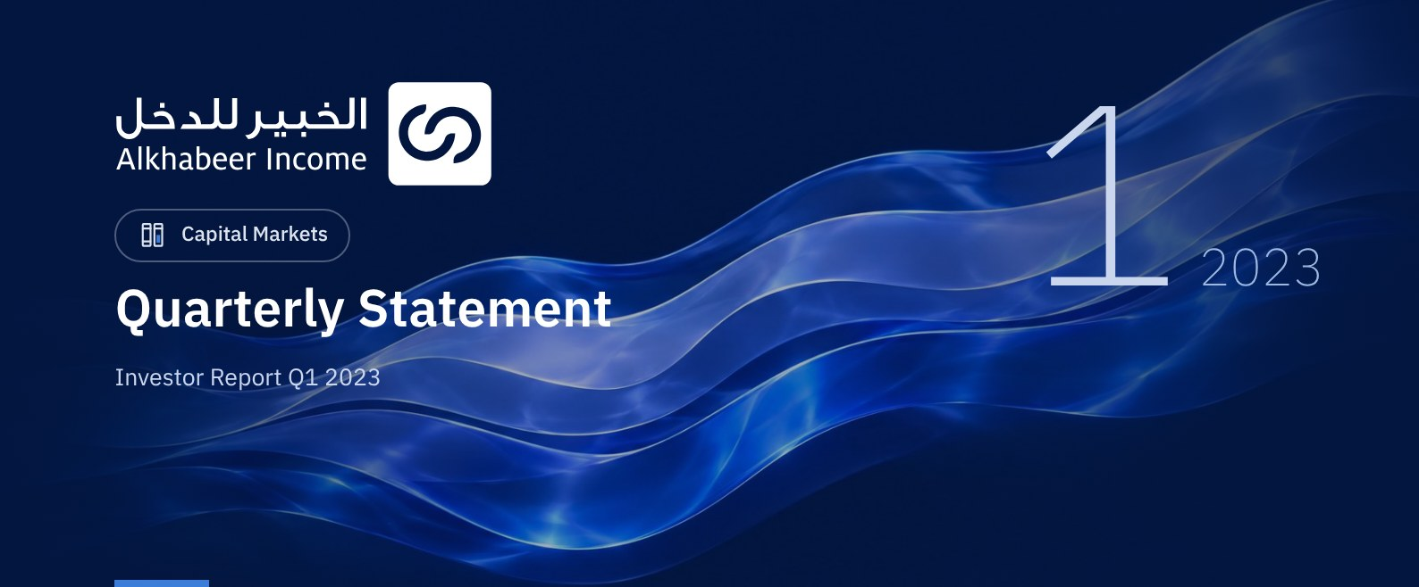

 FUND OVERVIEW
Alkhabeer Diversified Income Traded Fund (“the Fund”) is a closed-ended Shari’a-compliant investment traded fund established in accordance with the applicable laws and regulations of the Kingdom of Saudi Arabia and regulated by the Capital Market Authority (CMA). The Fund’s investment objective is to generate periodic income to investors by investing in Shari’a-compliant income generating assets. The Fund Manager “Alkhabeer Capital” plans to invest in Sukuk, trade finance transactions, leasing transactions, income funds and Murabaha transactions, either directly or through investment funds.

 KEY FUND FACTS
TADAWUL SYMBOL | 4700
BLOOMBERG SYMBOL | AKDICIF:AB
FUND TYPE | Closed-ended Traded Fund
LISTING DATE | 19 January 2021
FUND TERM | 99 years, starting as from the Listing Date, renewable
NET ASSET VALUE PER UNIT | SAR 9.7877
FUND ASSETS SIZE* | SAR 510,413,435
FUND’S TOTAL CAPITAL AS AT THE LISTING DATE | SAR 472,814,700
FINANCING AMOUNT* | SAR 45,716,577
RATIO OF LOANS TO FUND’S TOTAL ASSET VALUE* | 8.96%
RATIO OF LOANS TO FUND’S NET ASSET VALUE AS AT THE END OF THE REPORTING QUARTER | 9.88%
VALUE AND PERCENTAGE OF FUND MANAGER’S INVESTMENT TO FUND’S NET ASSET VALUE AS AT THE END OF THE REPORTING QUARTER | 0.0%
RISK LEVEL | High
FUND CURRENCY | Saudi Arabian Riyal (SAR)
INVESTMENT ADVISOR AND FUND SUB-MANAGER | N/A
RATIO OF UNDERLYING FUNDS’ MANAGEMENT FEES | 0.38%
NUMBER OF DAYS WEIGHTED AVERAGE | 90 Days

* As of 31 March 2023 (Unaudited).

FUND PORTFOLIO INVESTMENT CONCENTRATION RATIOS *
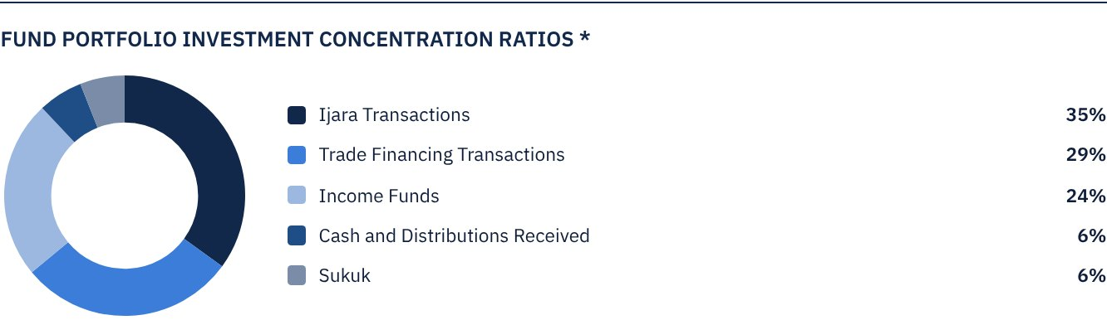
* The graph shows the largest investments in the Fund and the sectoral distribution of investments together.

FINANCIAL INDICATORS*
VALUATION FREQUENCY | Quarterly
FUND’S TOTAL ASSET VALUE* | SAR 510,413,435
FUND UNITS’ NET ASSET VALUE* | SAR 462,776,898
AMOUNT AND RATIO OF TRANSACTION EXPENSES FOR THE REPORTING QUARTER TO FUND’S AVERAGE NET ASSET VALUE | 0.00%
RATIO OF TOTAL EXPENSES AND FEES TO FUND’S TOTAL ASSET VALUE**
RATIO OF FUND’S COSTS TO FUND’S TOTAL ASSET VALUE*** | 0.68%
RATIO OF TOTAL EXPENSES AND FEES FOR THE REPORTING QUARTER TO FUND’S AVERAGE NET ASSET VALUE** | 0.58%
RATIO OF FUND’S COSTS TO FUND’S AVERAGE NET ASSET VALUE**** | 0.74%
TOTAL EXPENSES, COSTS AND FEES FOR THE REPORTING QUARTER | SAR 3,464,888

* As of 31 March 2023 (Unaudited).
** Fund expenses and fees are all Fund expenses during the reporting quarter, excluding financing costs.
*** Fund costs are all Fund fees and expenses, including financing costs.
**** Fund average NAV = SAR 466,507,341

DISTRIBUTION OF INVESTMENTS BY GEOGRAPHY
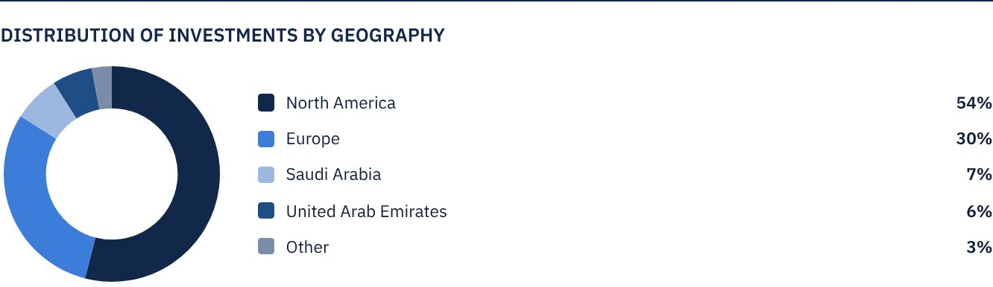

FUND ASSETS INFORMATION
TRADE FINANCE PORTFOLIO TOTAL VALUE | SAR 148,210,653
LEASING PORTFOLIO TOTAL VALUE | SAR 178,684,868
SUKUK PORTFOLIO TOTAL VALUE | SAR 32,592,278
INCOME FUNDS PORTFOLIO TOTAL VALUE | SAR 121,010,436
TOTAL CASH AND CASH EQUIVALENT | SAR 29,915,201

 NET ASSET VALUE AND UNIT PRICE PERFORMANCE
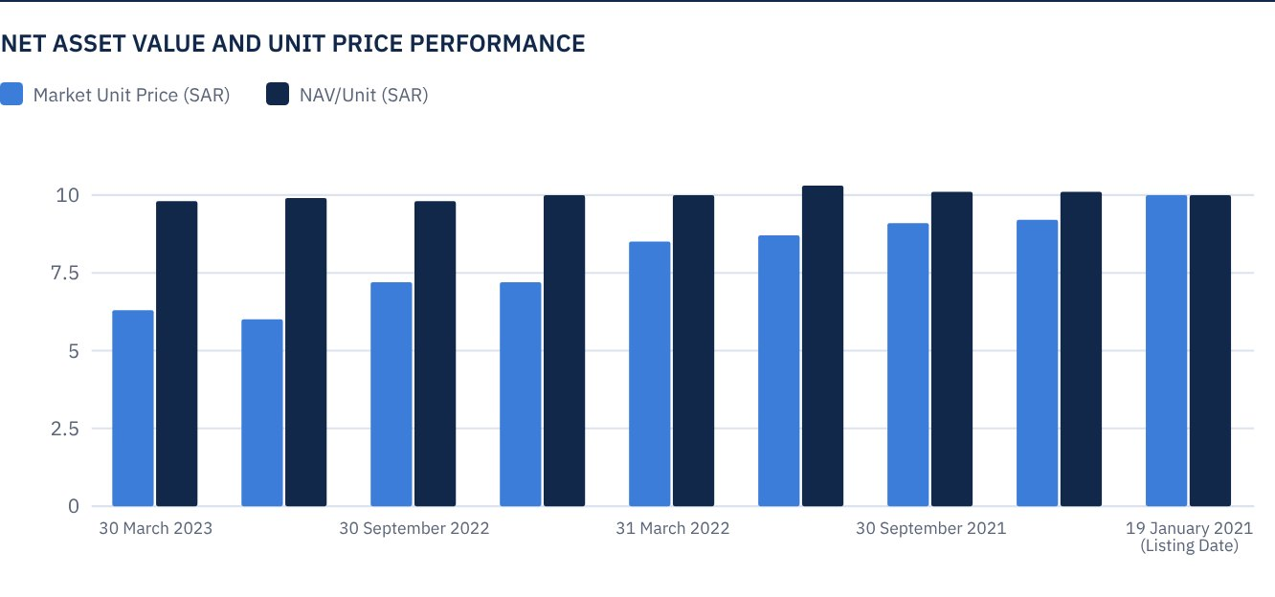

FUND MARKET VALUE INFORMATION*
AS AT THE LISTING DATE | SAR 472,814,700
AS AT 31 MARCH 2021 | SAR 428,370,118
AS AT 30 JUNE 2021 | SAR 433,098,265
AS AT 30 SEPTEMBER 2021 | SAR 427,897,304
AS AT 31 DECEMBER 2021 | SAR 409,930,345
AS AT 31 MARCH 2022 | SAR 402,838,124
AS AT 30 JUNE 2022 | SAR 342,317,843
AS AT 30 SEPTEMBER 2022 | SAR 339,480,955
AS AT 31 DECEMBER 2022 | SAR 281,324,747
AS AT 30 MARCH 2023 | SAR 297,873,261

* Based on the Unit Price.

FUND UNITS INFORMATION
UNIT PRICE AS AT THE END OF Q1 (30 MARCH 2023) | SAR 6.30
CHANGE IN UNIT PRICE COMPARED TO THE PREVIOUS QUARTER (FROM 29 DECEMBER 2022 TO 30 MARCH 2023)* | 5.88%
UNIT PRICE PERFORMANCE SINCE THE LISTING DATE (FROM THE LISTING DATE TO END Q1 2023) | -37.00%
52-WEEK HIGH | SAR 8.54
52-WEEK LOW | SAR 5.91
NUMBER OF OUTSTANDING UNITS | 47,281,470 Units

* Unit Price as at 29 December 2022 = SAR 5.95.

 DIVIDEND DISTRIBUTION
DIVIDEND DISTRIBUTION POLICY | The Fund Manager will distribute 100% of the semi-annual profits received from the returns on the Fund's investments after deducting the expenses from the Unitholders twice a year, provided distributions are made during the months of August and February annually.
TOTAL DIVIDENDS DISTRIBUTED IN THE REPORTING QUARTER* | SAR 0.00
TOTAL DIVIDENDS DISTRIBUTED FOR THE LAST SEMI-ANNUAL PERIOD** | SAR 13,238,812
DIVIDENDS DISTRIBUTED FOR THE LAST SEMI-ANNUAL PERIOD PER UNIT | SAR 0.28
RATIO OF DIVIDENDS DISTRIBUTED IN THE REPORTING QUARTER TO THE INITIAL UNIT PRICE | 2.80%
DIVIDENDS DISTRIBUTED ON UNIT PRICE*** | 4.42%
TOTAL INCOME FOR THE REPORTING QUARTER* | SAR 9,242,815
RATIO OF TOTAL INCOME FOR THE REPORTING QUARTER TO THE UNIT PRICE (30 MARCH 2023) | 3.10%

* From 1 January 2023 to 31 March 2023.
** From 1 July 2022 to 31 December 2022.
*** Unit Price as at the distribution date on 19 February 2023 = SAR 6.34.

FUND PERFORMANCE CRITERIA AND INDICATORS
BENCHMARK | 12M LIBOR + 300 bps
INITIAL UNIT PRICE (AT THE INITIAL OFFERING) | SAR 10
UNIT PRICE PERFORMANCE SINCE THE PREVIOUS PERIOD* | 5.88%
UNIT PRICE PERFORMANCE SINCE THE DATE OF INCEPTION** | -37.00%
TOTAL RETURN SINCE THE DATE OF INCEPTION*** | -28.42%

* Unit Price as of 31 December 2022 = SAR 5.95.
** From the Fund’s Date of Inception to end Q4 2022.
*** Total Return = Unit Price Performance + Total Dividend Distributions (if any).
It should be noted that the Unit Price on the Exchange may increase or decrease based on market factors.

DESCRIPTION OF THE FUND’S BENCHMARK
The Fund’s Benchmark is 12-month LIBOR plus 300 bps.

PERFORMANCE ASSESSMENT CRITERIA AND INDICATORS*
 | ALKHABEER INCOME FUND | 12M LIBOR + 300 BPS
NET ASSET VALUE PER UNIT AS AT THE BEGINNING OF THE PERIOD* | 9.9455 | N/A
NET ASSET VALUE PER UNIT AS AT THE END OF THE PERIOD** | 9.7877 | N/A
UNIT PERFORMANCE | -1.59% | 2.11%***

* As of 31 December 2022.
** As of 30 March 2023.
*** Benchmark average return is 8.39% per annum, or a return of 2.11% for the reporting quarter.

OWNERSHIP OF FUND INVESTMENTS
OWNERSHIP | PERCENTAGE (%)
FREEHOLD | 100%
LEASEHOLD | 0%

RETURNS
ITEM | 3 MONTHS | YEAR TO DATE UP TO 30 MARCH 2023 | ONE YEAR | 3 YEARS | 5 YEARS
TOTAL RETURN/NAV PER UNIT | 1.23%* | 1.23%** | 3.48%*** | N/A | N/A
BENCHMARK PERFORMANCE | 2.11% | 2.11% | 7.58% | N/A | N/A
PERFORMANCE SPREAD | -0.88% | -0.88% | -4.10% | N/A | N/A

* For the period from 31 December 2022 to 30 March 2023, including cash distributions of 2.8%.
** For the period from 31 December 2022 to 30 March 2023, including cash distributions of 2.8%.
*** For the period from 30 March 2202 to 30 March 2023, including cash distributions of 5.4%.

 PERFORMANCE AND RISKS
PERFORMANCE AND RISKS CRITERIA | 3 MONTHS1 | YEAR TO DATE UP TO 30 MARCH 20232 | ONE YEAR3 | 3 YEARS | 5 YEARS
STANDARD DEVIATION4 | 28.87 | 28.87 | 19.85 | N/A | N/A
SHARPE RATIO5 | 1.61 | 1.61 | -1.22 | N/A | N/A
TRACKING ERROR6 | 28.86 | 28.86 | 19.84 | N/A | N/A
BETA7 | 2.41 | 2.41 | 2.65 | N/A | N/A
ALPHA8 | 0.33 | 0.33 | -0.29 | N/A | N/A
INFORMATION RATIO9 | 1.16 | 1.16 | -1.49 | N/A | N/A

1. For the period from 31 December 2022 to 30 March 2023.
2. For the period from 31 December 2022 to 30 March 2023.
3. For the period from 30 March 2022 to 30 March 2023.
4. Standard Deviation is a measure of risk. It is calculated as any volatility in returns over a period of time. The lower the volatility, the more homogeneous the set of returns.
5. Sharpe Ratio is a risk-adjusted performance measure. It is calculated as the difference as the Fund Manager excess return over the risk-free rate, divided by the Standard Deviation. The greater a portfolio's Sharpe Ratio, the better its risk-adjusted performance.
6. Tracking Error is a measure of risks. It is calculated as the Standard Deviation between the Fund Manager's return and the Benchmark's return. The lower the Tracking Error, the lower the Fund Manager deviates from the Benchmark.
7. Beta is a measure of the average historical sensitivity of the Fund's returns compared to market returns. It is calculated by using the covariance of the Fund and the market on the variance of the market.
8. Alpha measures any excess return achieved by the Fund compared to the performance of the index.
9. Information Ratio is a risk-adjusted performance measure. It is calculated as the active return of the Fund Manager, divided by its tracking error. The higher the Information ratio, the higher the Fund Manager ability to generate excess returns per Unit of excess risk. Knowing that the performance and risk parameters were calculated based on the Unit's trading prices in the market.

FUND HIGHLIGHTS AND ANY FUNDAMENTAL OR NON-FUNDAMENTAL CHANGES AFFECTING THE PERFORMANCE OF THE FUND
There were no fundamental or non-fundamental developments or changes affecting the performance of the Fund.

OVERVIEW OF THE LEASING, TRADE FINANCE AND SUKUK INDUSTRIES

LEASING INDUSTRY OVERVIEW
• The steady rise in short-term interest rates and stubborn inflationary pressures do not seem to have suppressed demand for productive equipment by US businesses.
• According to the 2023 equipment outlook from US Equipment Leasing and Finance Association (ELFA), the top five hottest equipment sectors in 2023 include: construction, machine tools, medical equipment, trucks/trailers, and hi-tech/computers. Notably, construction equipment was the big winner of the survey, ranking first for the 10th consecutive year. The outlook for construction remains good based on pent-up demand for highway, commercial and civil projects.
• The Equipment Leasing and Finance Association’s (ELFA) Monthly Leasing and Finance Index (MLFI-25), which reports economic activity from twenty-five companies representing a cross section of the USD 1 trillion equipment finance sector, showed their overall new business volume for February 2023 was USD 7.9 billion, up 11% compared to new business volume in February 2022.

TRADE FINANCE INDUSTRY OVERVIEW
• According to United Nations Conference on Trade and Development (UNCTAD), the global trade reached a record USD 32 trillion in 2022 - trade in goods was about USD 25 trillion (an increase of about 10% from 2021) and trade in services totaled ~USD 7 trillion (an increase of ~15% YoY).
• The record levels were largely due to robust growth in the first half of 2022; however, due to deteriorating economic conditions and rising uncertainties, growth turned negative in H2 2022 and is expected to stagnate in the first half of 2023.
• Meanwhile, the World Bank links the global trade finance gap to the pool of available liquidity compared to the optimal amount required by companies, which stood at USD 1.5 trillion in 2020 for developing countries. The shortfall worsened with the spread of the pandemic, and the Asian Development Bank expects the gap in trade finance transactions to increase to at least USD 2 trillion in 2022.

SUKUK INDUSTRY OVERVIEW
• As per Fitch Ratings, global outstanding Sukuk reached USD 765.3 billion in 2022, 7.6% higher than a year ago. The main issuers remain the sovereigns and multilaterals.
• According to Refinitiv, global Sukuk issuance exceeded market expectations, reaching USD 193.9 billion in 2022 (USD 144.4 billion of new issuances and the remainder being new issuances), despite a record number of consecutive rate hikes during 2022. 2022 was the second highest year after issuance reached USD 196.5 billion in 2021.
• In terms of performance, further to the worst year in decades in global Sukuk markets in 2022, the Sukuk market has slightly recovered until March 2023. The Dow Jones Sukuk Index (ex-reinvestment) gained about 2.1% YTD, while the Dow Jones index gained 1.2%, and the S&P GCC Sukuk Index was up 1.2% YTD.

PERFORMANCE OF THE UNIT PRICE TRADED ON THE EXCHANGE SINCE THE INCEPTION OF THE FUND *
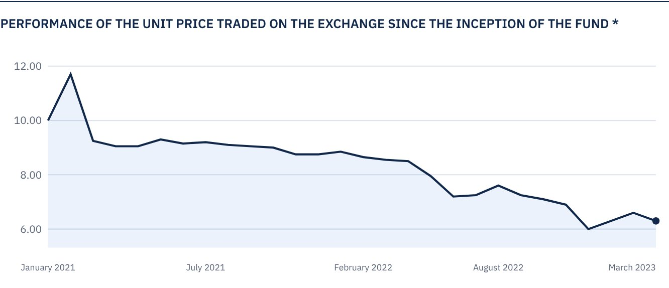
* Prices as of 30 March 2023.

 FOR FURTHER INFORMATION
Alkhabeer Capital
PO Box 128289, Jeddah 21362
Kingdom of Saudi Arabia
Tel: +966 12 658 8888
Fax: +966 12 658 6663
Email: info@alkhabeer.com
CR No: 4030177445
CMA License No: 07074-37
www.alkhabeer.com

 DISCLAIMER
This document does not constitute an offer to buy, subscribe or participate in any way in Alkhabeer Diversified Income Traded Fund, nor shall it (or any part of it) form the basis of, or be relied on, in connection with, or act as inducement to enter into any contract whatsoever. Prospective investors should read carefully Alkhabeer Diversified Income Traded Fund’s Terms and Conditions and their contents related to investment risks, as well as other Alkhabeer Diversified Income Traded Fund documents prior to making any investment decision. Alkhabeer Diversified Income Traded Fund documents are available on Alkhabeer Capital’s website www.alkhabeer.com. This investment is not a cash deposit with a local bank. The value of the amount invested and any other income which may arise therefrom may increase or decrease. All prospective investors are required to make their own determination with their own financial and legal advisors and to evaluate all risks involved. No assurance can be given that the targeted and projected results will be achieved. Moreover, past performance of Alkhabeer Diversified Income Traded Fund is not a guarantee of the Fund’s future results. By investing in the Fund, the investor acknowledges having read and accepted Alkhabeer Diversified Income Traded Fund’s Terms and Conditions, The Fund Manager or any of its affiliates shall not be liable for any financial loss which may be suffered by the Fund, unless such loss is deliberately caused by the Fund Manager. Investment in the Fund is subject to fees as stated in the Terms and Conditions.

