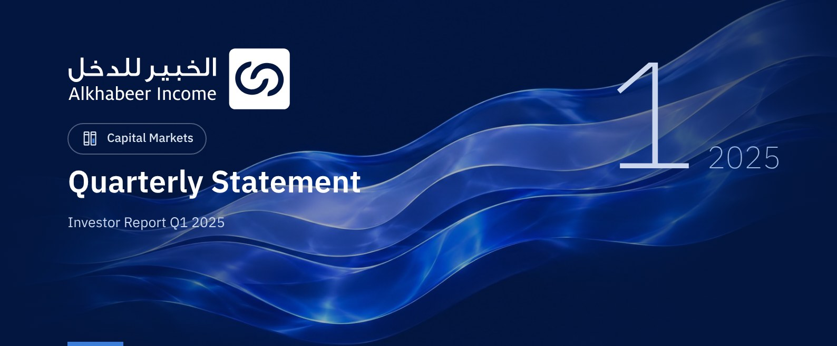

 FUND OVERVIEW
Alkhabeer Diversified Income Traded Fund (“the Fund”) is a closed-ended Shari’a-compliant investment traded fund established in accordance with the applicable laws and regulations of the Kingdom of Saudi Arabia and regulated by the Capital Market Authority (CMA). The Fund’s investment objective is to generate periodic income to investors by investing in Shari’a-compliant income generating assets. The Fund Manager “Alkhabeer Capital” plans to invest in Sukuk, trade finance transactions, leasing transactions, income funds and Murabaha transactions, either directly or through investment funds.

 KEY FUND FACTS
TADAWUL SYMBOL | 4700
BLOOMBERG SYMBOL | AKDICIF: AB
FUND TYPE | Closed-ended Traded Public Fund
LISTING DATE | 19 January 2021
FUND TERM | 99 years, starting as from the Listing Date, renewable
NET ASSET VALUE PER UNIT | SAR 9.5605
FUND ASSETS SIZE* | SAR 481,444,971
FUND’S TOTAL CAPITAL AS AT THE LISTING DATE | SAR 472,814,700
FINANCING AMOUNT* | SAR 26,828,616
RATIO OF LOANS TO FUND’S TOTAL ASSET VALUE* | 5.587%
RATIO OF LOANS TO FUND’S NET ASSET VALUE AS AT THE END OF THE REPORTING QUARTER | 5.94%
VALUE OF FUND MANAGER'S INVESTMENT TO FUND'S NET ASSET VALUE AS AT THE END OF THE REPORTING QUARTER | 0.00
RATIO OF FUND MANAGER'S INVESTMENT TO FUND'S NET ASSET VALUE AS AT THE END OF THE REPORTING QUARTER | 0.0%
RISK LEVEL | High
FUND CURRENCY | Saudi Arabian Riyal (SAR)
INVESTMENT ADVISOR AND FUND SUB-MANAGER | N/A
RATIO OF UNDERLYING FUNDS’ MANAGEMENT FEES | 0.33%
NUMBER OF DAYS WEIGHTED AVERAGE | 90 Days

* As of 31 March 2025 (Unaudited).

FUND PORTFOLIO INVESTMENT CONCENTRATION RATIOS *
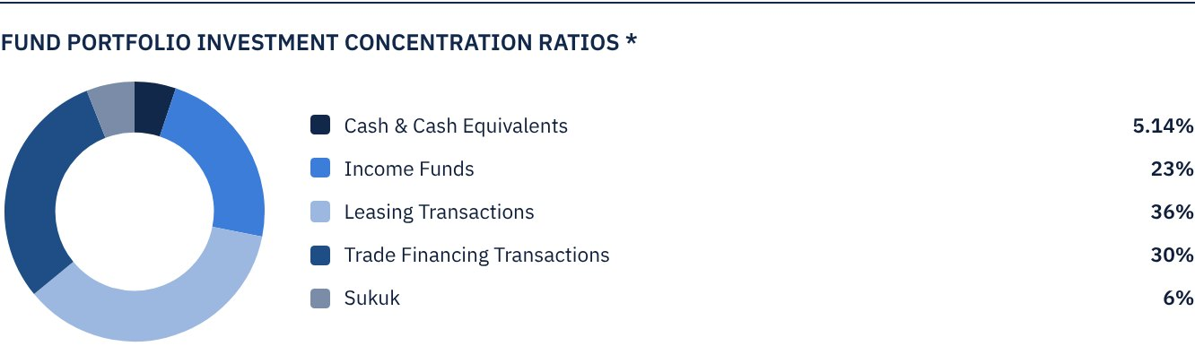
The average term of Fund investments is 2.6 years. *

FINANCIAL INDICATORS*
VALUATION FREQUENCY | Quarterly
FUND’S TOTAL ASSET VALUE* | SAR 481,444,971
FUND UNITS’ NET ASSET VALUE* | SAR 452,033,044
AMOUNT OF DEALING EXPENSES FOR THE REPORTING QUARTER TO FUND’S AVERAGE NET ASSET VALUE | N/A
RATIO OF DEALING EXPENSES FOR THE REPORTING QUARTER TO FUND’S AVERAGE NET ASSET VALUE | 0.00%
RATIO OF TRANSACTION EXPENSES FOR THE REPORTING QUARTER TO FUND'S AVERAGE NET ASSET VALUE | 0.00%
RATIO OF FUND'S EXPENSES AND FEES TO FUND’S TOTAL ASSET VALUE ** | 0.40%
RATIO OF FUND’S TOTAL COSTS TO FUND’S TOTAL ASSET VALUE*** | 0.48%
RATIO OF FUND’S TOTAL COSTS TO FUND’S AVERAGE NET ASSET VALUE**** | 0.51%
FUND'S TOTAL COSTS FOR THE REPORTING QUARTER | SAR 2,300,660

* As of 31 March 2025 (Unaudited).``
** Fund expenses and fees are all Fund expenses during the reporting quarter, excluding financing costs.
*** Fund total costs are all Fund fees and expenses, including financing costs.
**** Fund average NAV for the reporting period = SAR 453,203,166

DISTRIBUTION OF INVESTMENTS BY GEOGRAPHY
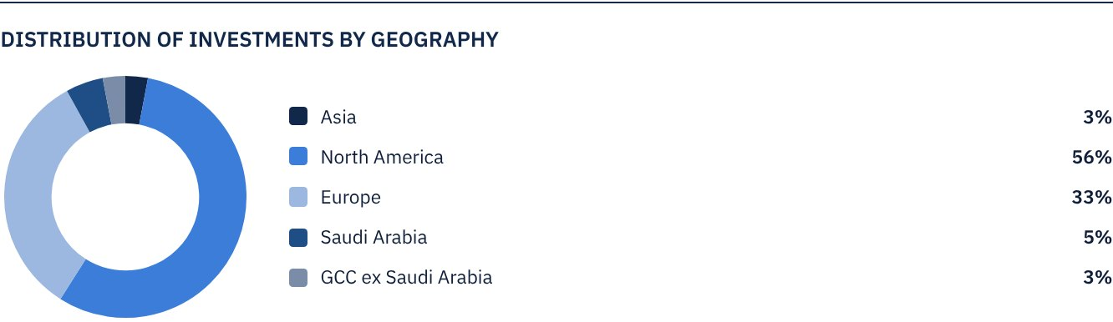

LARGEST TEN INVESTMENTS IN THE FUND
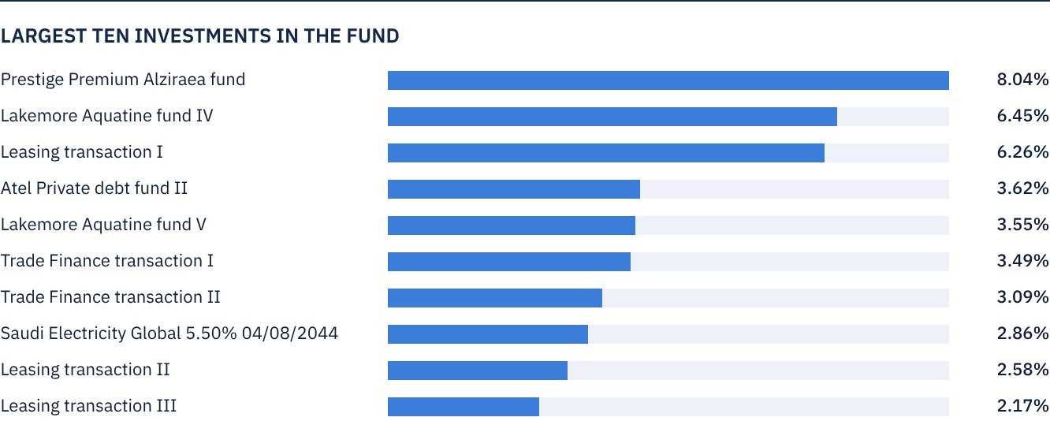

FUND ASSETS INFORMATION
TRADE FINANCE PORTFOLIO TOTAL VALUE | SAR 142,944,818
LEASING PORTFOLIO TOTAL VALUE | SAR 172,152,213
SUKUK PORTFOLIO TOTAL VALUE | SAR 31,386,813
INCOME FUNDS PORTFOLIO TOTAL VALUE | SAR 110,234,803
TOTAL CASH AND CASH EQUIVALENT | SAR 24,726,323

 NET ASSET VALUE AND UNIT PRICE PERFORMANCE*
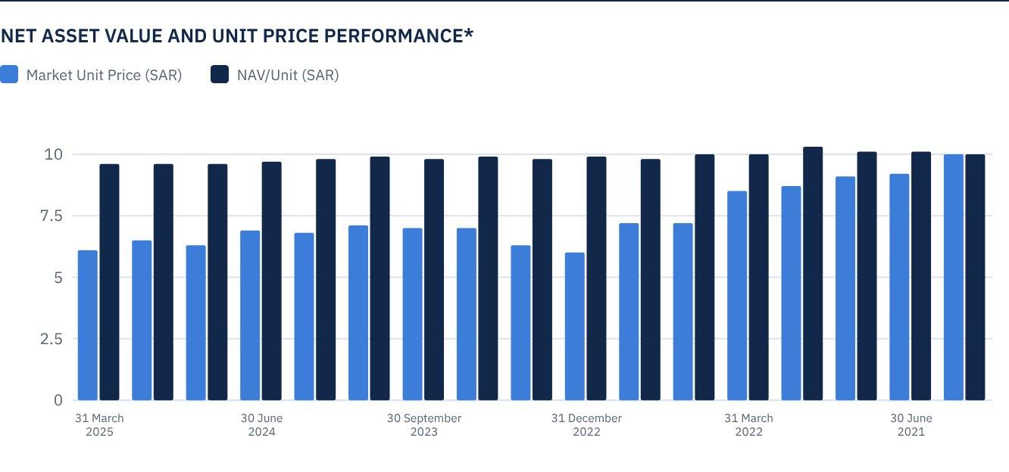

FUND MARKET VALUE INFORMATION*
AS AT THE LISTING DATE | SAR 472,814,700
AS AT 31 MARCH 2021 | SAR 428,370,118
AS AT 30 JUNE 2021 | SAR 433,098,265
AS AT 30 SEPTEMBER 2021 | SAR 427,897,304
AS AT 31 DECEMBER 2021 | SAR 409,930,345
AS AT 31 MARCH 2022 | SAR 402,838,124
AS AT 30 JUNE 2022 | SAR 342,317,843
AS AT 30 SEPTEMBER 2022 | SAR 339,480,955
AS AT 31 DECEMBER 2022 | SAR 281,324,747
AS AT 31 MARCH 2023 | SAR 297,873,261
AS AT 30 JUNE 2023 | SAR 329,079,031
AS AT 30 SEPTEMBER 2023 | SAR 329,551,846
AS AT 31 DECEMBER 2023 | SAR 335,698,437
AS AT 31 MARCH 2024 | SAR 320,568,367
AS AT 30 JUNE 2024 | SAR 326,714,958
AS AT 30 SEPTEMBER 2024 | SAR 296,927,632
AS AT 31 DECEMBER 2024 | SAR 305,438,296
AS AT 31 MARCH 2025 | SAR 286,525,708

*Based on the Unit Price.

FUND UNITS INFORMATION
UNIT PRICE AS AT THE END OF Q1 (31 MARCH 2025) | SAR 6.06
CHANGE IN UNIT PRICE COMPARED TO THE PREVIOUS QUARTER (FROM 31 DECEMBER 2024 TO 27 MARCH 2025) | -6.19%
UNIT PRICE PERFORMANCE SINCE THE LISTING DATE (FROM THE LISTING DATE TO END Q1 2025) | -39.40%
52-WEEK HIGH | SAR 6.95
52-WEEK LOW | SAR 6.02
NUMBER OF OUTSTANDING UNITS | 47,281,470 Units
P/E RATIO | N/A
DUAL UNIT PRICE OF MONEY MARKET FUNDS AND FIXED INCOME DEBT FUNDS | N/A

 DIVIDEND DISTRIBUTION
DIVIDEND DISTRIBUTION POLICY | The Fund Manager will distribute 100% of the semi-annual profits received from the returns on the Fund's investments after deducting the expenses from the Unitholders twice a year, provided distributions are made during the months of August and February annually.
TOTAL DIVIDENDS PAID IN THE REPORTING QUARTER* | SAR 10,874,738.10
TOTAL DIVIDENDS DISTRIBUTED FOR THE LAST SEMI-ANNUAL PERIOD** | SAR 10,874,738.10
DIVIDENDS DISTRIBUTED FOR THE LAST SEMI-ANNUAL PERIOD PER UNIT | SAR 0.23
RATIO OF DIVIDENDS DISTRIBUTED IN THE REPORTING QUARTER TO THE INITIAL UNIT PRICE | 2.30%
DIVIDENDS DISTRIBUTED ON UNIT PRICE | 3.80%
TOTAL INCOME FOR THE REPORTING QUARTER* | SAR 8,202,213
RATIO OF TOTAL INCOME FOR THE REPORTING QUARTER TO THE UNIT PRICE (27 MARCH 2025) | 2.86%

* From 1 January 2025 to 31 March 2025.
** From 1 July 2024 to 31 December 2024 (Distributed Dividends paid on 19 February 2025).

FUND PERFORMANCE CRITERIA AND INDICATORS
BENCHMARK | 12 months Term SOFR + 300 bps*
INITIAL UNIT PRICE (AT THE INITIAL OFFERING) | SAR 10
UNIT PRICE PERFORMANCE SINCE THE PREVIOUS PERIOD** | -6.19%
UNIT PRICE PERFORMANCE SINCE THE DATE OF INCEPTION*** | -39.40%
TOTAL RETURN SINCE THE DATE OF INCEPTION**** | -19.03%

* On 16 May 2023, the Fund has changed Its benchmark from the London Interbank Offered Rate (LIBOR) 12 months + 300 basis points to the Secured Overnight Financing Rate (Term
SOFR) 12 months + 300 basis points.
** Unit Price as at 31 December 2024 = SAR 6.46.
*** From the Fund’s Date of Inception to end Q1 2025.
**** Total Return = Unit Price Performance + Total Dividend Distributions (if any).
Note: It should be noted that the Unit Price on the Exchange may increase or decrease based on market factors.

DESCRIPTION OF THE FUND’S BENCHMARK
The Fund’s Benchmark is 12 months Term SOFR plus 300 bps.

PERFORMANCE ASSESSMENT CRITERIA AND INDICATORS*
 | ALKHABEER INCOME FUND | 12M TERM SOFR + 300 BPS*
NET ASSET VALUE PER UNIT AS AT THE BEGINNING OF THE PERIOD | 9.6100 | N/A
NET ASSET VALUE PER UNIT AS AT THE END OF THE PERIOD | 9.5605 | N/A
UNIT PERFORMANCE | -0.52% | 1.71%***

* As at 31 December 2024.
** As at 31 March 2025.
*** Benchmark average return is 7.47% per annum, or a return of 1.71% for the reporting quarter.

OWNERSHIP OF FUND INVESTMENTS
OWNERSHIP | PERCENTAGE (%)
FREEHOLD | 100%
LEASEHOLD | 0%

RETURNS
ITEM | 3 MONTHS * | YEAR TO DATE** | ONE YEAR*** | 3 YEARS | 5 YEARS
TOTAL RETURN/NAV PER UNIT "FUND PERFORMANCE" | 1.88% | 1.88% | 2.99% | 12.83% | N/A
BENCHMARK PERFORMANCE | 1.751% | 1.71% | 7.47% | 30.37% | N/A
PERFORMANCE SPREAD | 0.17% | 0.17% | -4.48% | -17.54% | N/A

* For the period from 1 January 2025 to 31 March 2025.
** For the period from 1 January 2025 to 31 March 2025, including cash distributions of 2.30%.
*** For the period from 1 January 2025 to 31 March 2025, including cash distributions of 2.30%.

 PERFORMANCE AND RISKS
PERFORMANCE AND RISKS CRITERIA | 3 MONTHS1 | YEAR TO DATE2 | ONE YEAR3 | 3 YEARS | 5 YEARS
STANDARD DEVIATION4 | 11.96 | 11.96 | 15.19 | 15.97 | N/A
SHARPE RATIO5 | -2.76 | -2.76 | -0.74 | -0.53 | N/A
TRACKING ERROR6 | 12.11 | 12.11 | 15.21 | 16.01 | N/A
BETA7 | -0.15 | -0.15 | -0.02 | -0.02 | N/A
ALPHA8 | -0.42 | -0.42 | -0.15 | -0.12 | N/A
INFORMATION RATIO9 | -3.34% | -3.34% | -1.00% | -0.78% | N/A

1. For the period from 1 January 2025 to 31 March 2025.
2. For the period from 1 January 2025 to 31 March 2025.
3. For the period from 1 April 2024 to 31 March 2025.
4. Standard Deviation is a measure of risk. It is calculated as any volatility in returns over a period of time. The lower the volatility, the more homogeneous the set of returns.
5. Sharpe Ratio is a risk-adjusted performance measure. It is calculated as the difference as the Fund Manager excess return over the risk-free rate, divided by the Standard Deviation. The greater a portfolio's Sharpe
Ratio, the better its risk-adjusted performance.
6. Tracking Error is a measure of risks. It is calculated as the Standard Deviation between the Fund Manager's return and the Benchmark's return. The lower the Tracking Error, the lower the Fund Manager deviates
from the Benchmark.
7. Beta is a measure of the average historical sensitivity of the Fund's returns compared to market returns. It is calculated by using the covariance of the Fund and the market on the variance of the market.
8. Alpha measures any excess return achieved by the Fund compared to the performance of the index.
9. Information Ratio is a risk-adjusted performance measure. It is calculated as the active return of the Fund Manager, divided by its tracking error. The higher the Information ratio, the higher the Fund Manager ability
to generate excess returns per Unit of excess risk. Knowing that the performance and risk parameters were calculated based on the Unit's trading prices in the market.

FUND HIGHLIGHTS AND ANY FUNDAMENTAL OR NON-FUNDAMENTAL CHANGES AFFECTING THE PERFORMANCE OF THE FUND
The Fund Manager would like to highlight that the Fund’s investment in “Prestige Premium Alziraea Fund” which represented 8.6% of the Fund’s Net Asset Value as of the end of March 2025 is currently undergoing a managed sell down process.
This is based on information received on October 7, 2024, from the income fund manager of “Prestige Premium Alziraea Fund”, who informed us of the income fund management’s decision to liquidate the fund.
Accordingly, and as stated by the income fund manager of “Prestige Premium Alziraea Fund”, no dividend will be distributed during the exit period, which may negatively impact the Fund’s ability to distribute profits to unit holders during this period and until the managed sell down process is completed.
The Fund Manager also notes that the exit process carries several risks, including:
• The possibility of delays in the exit timeline or returns being lower than expected
• A decrease in the investment’s value if the assets are liquidated at prices below their book value
• The potential inability to recover the full invested capital if the liquidated fund encounters any unexpected liabilities or additional expenses. The Fund Manager will continue to closely monitor the developments of the exit process and will inform unit holders of any si gnificant updates in due course.

OVERVIEW OF THE LEASING, TRADE FINANCE AND SUKUK INDUSTRIES

LEASING INDUSTRY OVERVIEW
• The Equipment Leasing and Finance Association’s (ELFA) Monthly Confidence Index (MCI-EFI) declined to 58.81 in February, reflecting persistent strong demand on investment equipment. The Index shows the assessments of top executives in the equipment leasing industry - the size of which is estimated at around USD 1.3 trillion equipment leasing industry – of prevailing business conditions and their future outlook.
• The Equipment Leasing and Finance Association’s (ELFA) projects that the industry is in well positioned for growth, even if the Fed slows the pace of rate decreases.

TRADE FINANCE INDUSTRY OVERVIEW
• According to the most recent Global Trade Update published by the United Nations Conference on Trade and Development (UNCTAD), global trade has reached a record level of USD 33 trillion, an increase of 3.7% compared to 2023, driven by the growth of developing economies and the strength of the service sector.
• In spite of the geopolitical and economic challenges, the International Chamber of Commerce (ICC) Trade Register 2024 reaffirms the resilience of trade finance instruments, with default rates remaining low across all regions and asset classes. The report confirms that trade, supply chain and export finance continue to be classified as low risk.

SUKUK INDUSTRY OVERVIEW
• S&P Global Ratings forecasts Islamic Sukuk issuances in 2025 to range between USD 190 billion and USD 200 billion, supported by robust market performance in the previous year. Total issuances in 2024 reached around USD 193.4 billion, with a slight decline compared to US$ 197.8 billion in 2023.
• In terms of performance, the US Dow Jones Sukuk Index (ex-reinvestment) recorded gains by 2.30% in Q1 2025, while the S&P GCC Bond and Sukuk Index gained 2.78% during the same period.

PERFORMANCE OF THE UNIT PRICE TRADED ON THE EXCHANGE SINCE THE INCEPTION OF THE FUND *
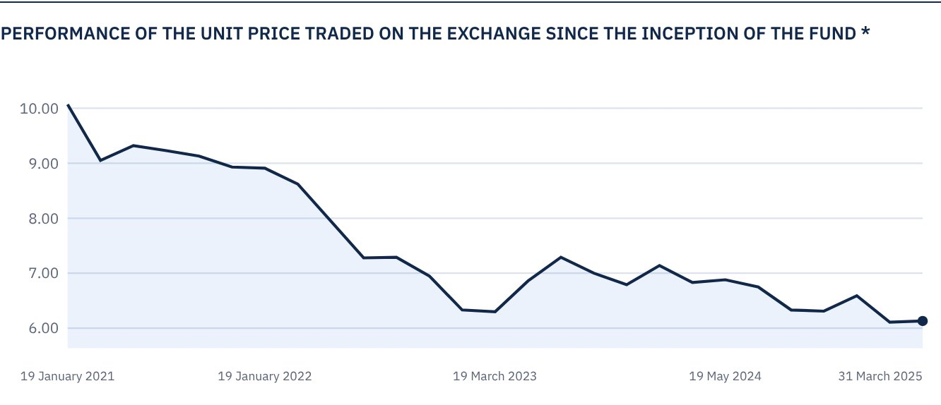

 FOR FURTHER INFORMATION
Alkhabeer Capital
PO Box 128289, Jeddah 21362
Kingdom of Saudi Arabia
Tel: +966 12 658 8888
Fax: +966 12 658 6663
Email: info@alkhabeer.com
CR No: 4030177445
CMA License No: 07074-37
www.alkhabeer.com

 DISCLAIMER
This document does not constitute an offer to buy, subscribe or participate in any way in Alkhabeer Diversified Income Traded Fund, nor shall it (or any part of it) form the basis of, or be relied on, in connection with, or act as inducement to enter into any contract whatsoever. Prospective investors should read carefully Alkhabeer Diversified Income Traded Fund’s Terms and Conditions and their contents related to investment risks, as well as other Alkhabeer Diversified Income Traded Fund documents prior to making any investment decision. Alkhabeer Diversified Income Traded Fund documents are available on Alkhabeer Capital’s website www.alkhabeer.com. This investment is not a cash deposit with a local bank. The value of the amount invested and any other income which may arise therefrom may increase or decrease. All prospective investors are required to make their own determination with their own financial and legal advisors and to evaluate all risks involved. No assurance can be given that the targeted and projected results will be achieved. Moreover, past performance of Alkhabeer Diversified Income Traded Fund is not a guarantee of the Fund’s future results. By investing in the Fund, the investor acknowledges having read and accepted Alkhabeer Diversified Income Traded Fund’s Terms and Conditions, The Fund Manager or any of its affiliates shall not be liable for any financial loss which may be suffered by the Fund, unless such loss is deliberately caused by the Fund Manager.

