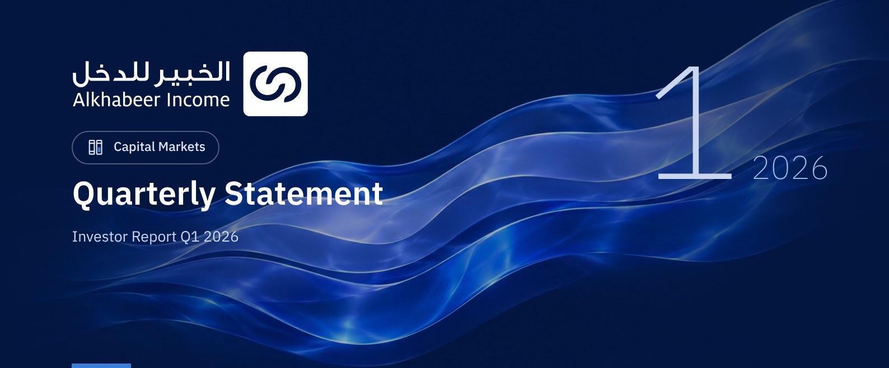

 a) Fund Objective:
The Fund investment objective is to generate periodic income to investors by investing in income generating assets, Trade Financing Transactions, Leasing Transactions, Income Funds and Murabaha transactions, either directly or by way of Shari'a compliant investment funds.

 b) Key Fund Facts:
Fund Inception Date | 19 January 2021
Initial Unit Price (at the Initial Offering) | SAR 10
Net Asset Value per Unit (NAV per Unit) | SAR 8.9501
Fund Size * | SAR 425,563,392
Fund Type | Closed-ended Traded Public Fund
Fund Currency | SAR
Risk Level | High
Benchmark | 12 months Term SOFR + 300 bps
Frequency of Dividend Distribution (if any) | Semi Annually, in February and August of each Year
Ratio of Management Fees of Underlying Funds | 0.25%
Investment Advisor and Fund Sub-Manager | N/A
Number of Days Weighted Average (if any) | 90 days

* Total Asset Value as at 31 March 2026 (Unaudited).

c) Definitions:
Standard Deviation | Standard Deviation is a measure of risk. It is calculated as any volatility in returns over a period of time. The lower the volatility, the more homogeneous the set of returns.
Sharpe Ratio | Sharpe Ratio is a risk-adjusted performance measure. It is calculated as the difference of the Fund Manager excess return over the risk-free rate, divided by the Standard Deviation. The greater a portfolio's Sharpe Ratio, the better its risk-adjusted performance.
Tracking Error | Tracking Error is a measure of risks. It is calculated as the Standard Deviation between the Fund Manager's return and the Benchmark's return. The lower the Tracking Error, the lower the Fund Manager deviates from the Benchmark.
Beta | Beta is a measure of the average historical sensitivity of the Fund's returns compared to market returns. It is calculated by using the covariance of the Fund and the market on the variance of the market,
Alpha | Alpha measures any excess return achieved by the Fund compared to the performance of the index.
Information Ratio | Information Ratio is a risk-adjusted performance measure. It is calculated as the active return of the Fund Manager, divided by its tracking error. The higher the Information ratio, the higher the Fund Manager ability to generate excess returns per Unit of excess risk.

d) Fund Manager's Commentary:
The Fund Manager continues to closely monitor the exit process from its "Prestige Premium Agricultural" income fund with KPMG LLP, which is overseeing the optional exit. The most recent valuation of Prestige Premium Agricultural Income Fund (US $25.87 per Unit) received by the Fund Manager was applied to the most recent valuation of Alkhabeer Diversified Income Traded Fund. Unitholders will be kept informed of any material developments as and when they occur.
The Fund Manager also acknowledges that the exit process currently in progress by the Fund Manager, involves a number of risks, including:
• Potential delay in the exit time line or generating less than expected returns.
• Decrease of the investment value if underlying assets are sold at less than their book value.
• Risk of inability to recover the full value of the invested capital in the event the Fund faces unforeseen additional obligations or expenses after its liquidation.

 e) Contact Information:
Telephone Number | +966 12 658 8888
Website | www.alkhabeer.com
Email | info@alkhabeer.com

f) Price Information as at the End of the Reporting Quarter (March 2026):
Unit Price as at the end of Q1 (March 2026) | SAR 4.89
Change in Unit Price Compared to Previous Quarter | -8.08%
Dual Unit Price of Money Market Funds and Fixed Income Debt Funds | N/A
Total Fund Units | 47,281,470 Units
Fund's Net Asset Value | SAR 423,175,560
Price/Equity Ratio (P/E) | N/A

g) Fund Information as at the End of Q1 (March 2026):
Item | Saudi Riyal | %
Total Expense Ratio (TER) to Fund's Average Net Asset Value | SAR 1,755,903 | 0.41%
Ratio of Loans to Fund's Total Asset Value | N/A | N/A
Percentage of Dealing Expenses to Fund's Average Net Asset Value | N/A | N/A
Percentage of Fund Manager's Investment to Fund's Net Asset Value | N/A | N/A
Distributed Dividends from Fund's Asset Value | SAR 7,565,035 | N/A

h) Information on Ownership of Fund Investments:
Freehold | 100%
Leasehold | 0%

 i) Disclaimer:
This document does not constitute an offer to buy, subscribe or participate in any way in Alkhabeer Diversified Income Traded Fund, nor shall it (or any part of it) form the basis of, or be relied on, in connection with, or act as inducement to enter into any contract whatsoever. Prospective investors should read carefully Alkhabeer Diversified Income Traded Fund’s Terms and Conditions and their contents related to investment risks, as well as other Alkhabeer Diversified Income Traded Fund documents prior to making any investment decision. Alkhabeer Diversified Income Traded Fund documents are available on Alkhabeer Capital’s website www.alkhabeer.com. This investment is not a cash deposit with a local bank. The value of the amount invested and any other income which may arise therefrom may increase or decrease. All prospective investors are required to make their own determination with their own financial and legal advisors and to evaluate all risks involved. No assurance can be given that the targeted and projected results will be achieved. Moreover, past performance of Alkhabeer Diversified Income Traded Fund is not a guarantee of the Fund’s future results. By investing in the Fund, the investor acknowledges having read and accepted Alkhabeer Diversified Income Traded Fund’s Terms and Conditions, The Fund Manager or any of its affiliates shall not be liable for any financial loss which may be suffered by the Fund, unless such loss is deliberately caused by the Fund Manager.

j) Graph Showing the Fund's Top Ten Investments:
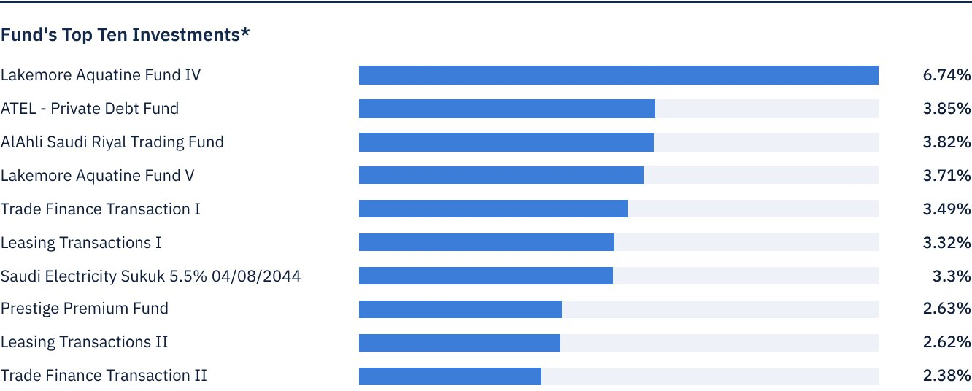
* As at the beginning of the relevant quarter

 k) Statement of Dividends Distributed to Unitholders (if any), as follows:
Total Dividend Distributions for Q1 | SAR 7,565,035.20
Number of Outstanding Units Receiving Dividends in Q1 | 47,281,470 Units
Distributed Dividends per Unit in Q1 | SAR 0.16
Ratio of Distributions to Fund's Net Asset Value | 1.8%
Entitlement to Cash Distributions Paid during the Reporting Quarter | According to the Unitholders' Register as at Close of Business on Monday, 16 February 2026 (end of trading on Thursday, 12 February 2026).

l) Credit Rating of Underlying Debt Instruments of the Fund's Top Ten Investments, as follows:
Credit Rating of the Debt Instrument | Aa3
Credit Rating of the Issuer of the Debt Instrument | Aa3
Name of the Credit Rating Agency | Moody’s
Date of the Credit Rating | 27 November 2024

m) Graph Showing the Distribution of Fund Assets (by Sector/Geography):
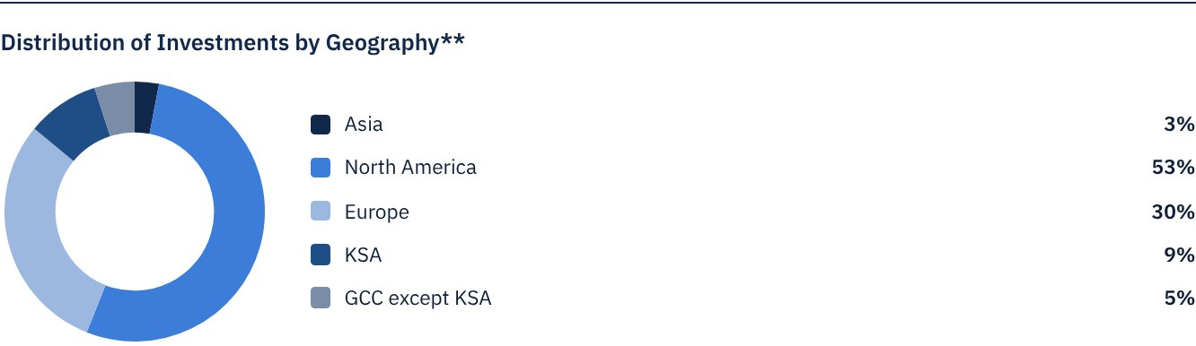
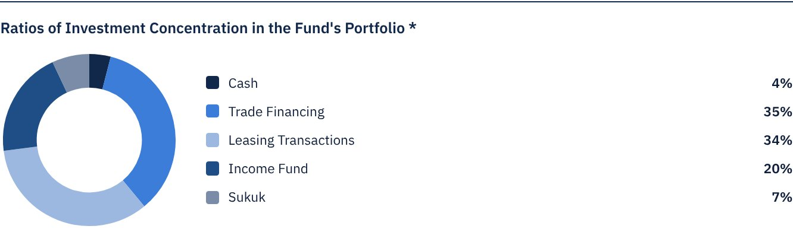
* Average investment term of the Fund is 3-4 years.
** As at the beginning of the relevant quarter.

 n) Returns:
Item | 3 Months (End of Q4) | Year to Date (YTD) ** | One Year *** | 3 Years **** | 5 Years
Total Return to Net Asset Value per Unit (Fund Performance) * | 0.71% | 0.71% | -2.59% | 6.21% | N/A
Benchmark Performance | 1.57% | 1.57% | 6.74% | 24.00% | N/A
Performance Spread | -0.85% | -0.85% | -9.33% | -17.79% | N/A

* Total Return = NAV/Unit plus dividend distributions.
** For the period from 1 January 2026 to 31 March 2026.
*** For the period from 31 March 2025 to 31 March 2026.
**** For the period from 31 March 2023 to 31 March 2026.

 o) Performance and Risk:
Performance and Risk Criteria | 3 Months (End of Q4) | Year to Date (YTD) * | One Year ** | 3 Years *** | 5 Years
Standard Deviation | 0.14 | 0.14 | 0.10 | 0.13 | N/A
Sharpe Ratio | -2.35 | -2.35 | -2.28 | -0.92 | N/A
Tracking Error | 0.14 | 0.14 | 0.10 | 0.13 | N/A
Beta | -11.46 | -11.46 | -2.53 | 0.92 | N/A
Alpha | 0.57 | 0.57 | -0.02 | -0.14 | N/A
Information Ratio | -2.45 | -2.45 | -2.43 | -1.12 | N/A

* For the period from 1 January 2026 to 31 March 2026.
** For the period from 31 March 2025 to 31 March 2026.
*** For the period from 31 March 2023 to 31 March 2026.

p) Equations Used to Calculate Performance and Risk:
Standard Deviation | σp = √[ 1/(N − 1) · Σ(Rp,i − Rp)² ] | where  Rp,i = Portfolio return in period i  Rp = Average portfolio return  N = Number of periods
Sharpe Ratio | [(Average Annualised Return − Risk Free Rate) ÷ Standard Deviation]
Tracking Error | TE = √[ 1/(N − 1) · Σ[(Rp,i − Rb,i) − (Rp − Rb)]² ] | where  Rp,i = Portfolio return in period i  Rb,i = Portfolio return in period i  Rp = Average portfolio return  Rb = Average portfolio return  N = Number of periods
Beta | β = Cov(Rp, Rb) / Var (Rb) | where  Cov(Rp, Rb)= covariance between portfolio and benchmark returns  Var (Rb)= variance of benchmark returns
Alpha | α = Rp − [ Rf + β ∗ (Rb − Rf)] | where  (Rp)= average portfolio return  (Rb)= average benchmark return  (Rf)= risk free rate  β= portfolio beta
Information Ratio | IR = (Rp − Rb) / σ (Rp − Rb) | where  Rp = Return of the portfolio  Rb = Return of the benchmark  Rp-Rb = Active return (the difference between portfolio and benchmark returns  σ(Rp−Rb) = Tracking error (standard deviation of the active return)

q) Graph Depicting Performance Since the Inception of the Fund:
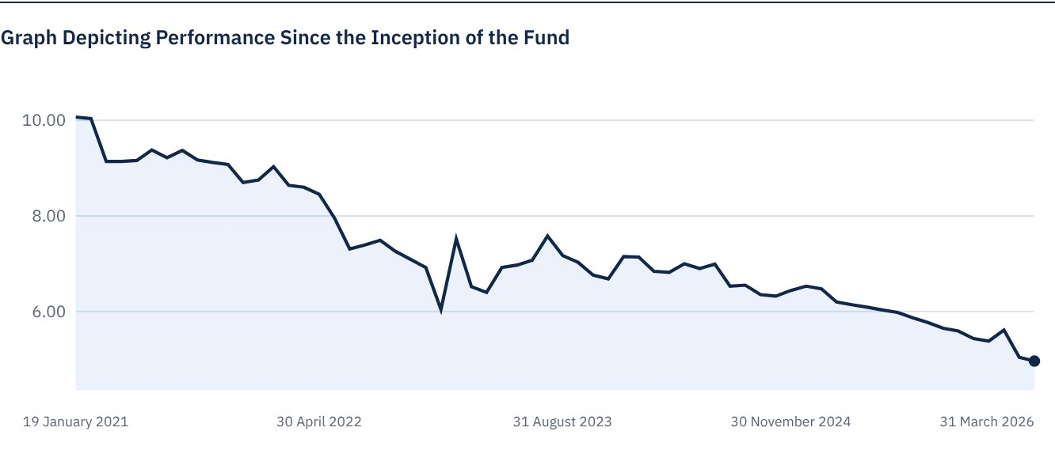
As at 31 March 2026.

FOR FURTHER INFORMATION
Alkhabeer Capital
PO Box 128289, Jeddah 21362
Kingdom of Saudi Arabia
Tel: +966 12 658 8888
Fax: +966 12 658 6663
Email: info@alkhabeer.com
CR No: 4030177445
CMA License No: 07074-37
www.alkhabeer.com

DISCLAIMER
This document does not constitute an offer to buy, subscribe or participate in any way in Alkhabeer Diversified Income Traded Fund, nor shall it (or any part of it) form the basis of, or be relied on, in connection with, or act as inducement to enter into any contract whatsoever. Prospective investors should read carefully Alkhabeer Diversified Income Traded Fund’s Terms and Conditions and their contents related to investment risks, as well as other Alkhabeer Diversified Income Traded Fund documents prior to making any investment decision. Alkhabeer Diversified Income Traded Fund documents are available on Alkhabeer Capital’s website www.alkhabeer.com. This investment is not a cash deposit with a local bank. The value of the amount invested and any other income which may arise therefrom may increase or decrease. All prospective investors are required to make their own determination with their own financial and legal advisors and to evaluate all risks involved. No assurance can be given that the targeted and projected results will be achieved. Moreover, past performance of Alkhabeer Diversified Income Traded Fund is not a guarantee of the Fund’s future results. By investing in the Fund, the investor acknowledges having read and accepted Alkhabeer Diversified Income Traded Fund’s Terms and Conditions, The Fund Manager or any of its affiliates shall not be liable for any financial loss which may be suffered by the Fund, unless such loss is deliberately caused by the Fund Manager.

