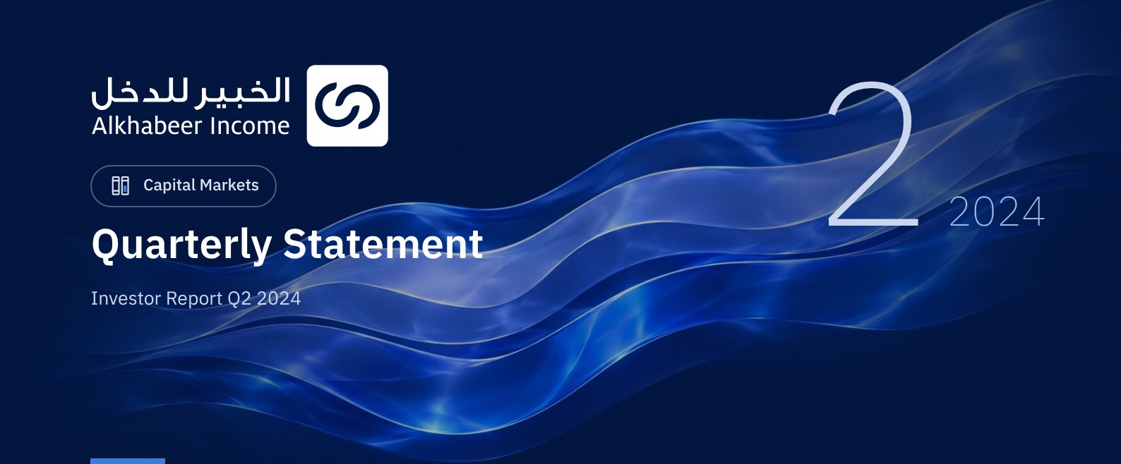

 FUND OVERVIEW
Alkhabeer Diversified Income Traded Fund (“the Fund”) is a closed-ended Shari’a-compliant investment traded fund established in accordance with the applicable laws and regulations of the Kingdom of Saudi Arabia and regulated by the Capital Market Authority (CMA). The Fund’s investment objective is to generate periodic income to investors by investing in Shari’a-compliant income generating assets. The Fund Manager “Alkhabeer Capital” plans to invest in Sukuk, trade finance transactions, leasing transactions, income funds and Murabaha transactions, either directly or through investment funds.

 KEY FUND FACTS
TADAWUL SYMBOL | 4700
BLOOMBERG SYMBOL | AKDICIF:AB
FUND TYPE | Closed-ended Traded Public Fund
LISTING DATE | 19 January 2021
FUND TERM | 99 years, starting as from the Listing Date, renewable
NET ASSET VALUE PER UNIT | SAR 9.7123
FUND ASSETS SIZE* | SAR 491,619,706
FUND’S TOTAL CAPITAL AS AT THE LISTING DATE | SAR 472,814,700
FINANCING AMOUNT* | SAR 27,958,418
RATIO OF LOANS TO FUND’S TOTAL ASSET VALUE* | 5.69%
RATIO OF LOANS TO FUND’S NET ASSET VALUE AS AT THE END OF THE REPORTING QUARTER | 6.09%
RATIO OF LOANS TO FUND’S NET ASSET VALUE AS AT THE END OF THE REPORTING QUARTER | 0.00%
RATIO OF FUND MANAGER'S INVESTMENT TO FUND'S NET ASSET VALUE AS AT THE END OF THE REPORTING QUARTER | 0.00%
RISK LEVEL | High
FUND CURRENCY | Saudi Arabian Riyal (SAR)
INVESTMENT ADVISOR AND FUND SUB-MANAGER | N/A
RATIO OF UNDERLYING FUNDS’ MANAGEMENT FEES | 0.34%
NUMBER OF DAYS WEIGHTED AVERAGE | 91 Days

* As of 30 June 2024 (Unaudited).

FUND PORTFOLIO INVESTMENT CONCENTRATION RATIOS *
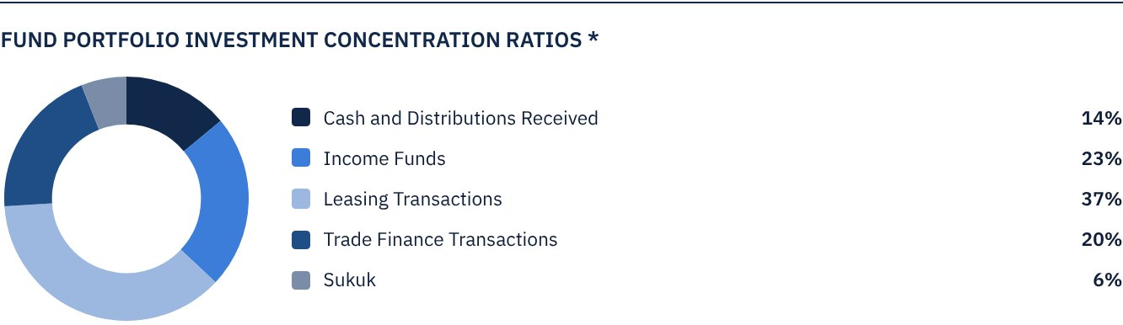
* The average term of Fund investments are 3.0 years.

FINANCIAL INDICATORS*
VALUATION FREQUENCY | Quarterly
FUND’S TOTAL ASSET VALUE* | SAR 491,619,706
FUND UNITS’ NET ASSET VALUE* | SAR 459,213,920
AMOUNT OF DEALING EXPENSES FOR THE REPORTING QUARTER TO FUND’S AVERAGE NET ASSET VALUE | N/A
RATIO OF DEALING EXPENSES FOR THE REPORTING QUARTER TO FUND’S AVERAGE NET ASSET VALUE | 0.00%
RATIO OF TRANSACTION EXPENSES FOR THE REPORTING QUARTER TO FUND'S AVERAGE NET ASSET VALUE | 0.00%
RATIO OF FUND'S EXPENSES AND FEES TO FUND’S TOTAL ASSET VALUE ** | 0.55%
RATIO OF FUND’S TOTAL COSTS TO FUND’S TOTAL ASSET VALUE*** | 0.65%
RATIO OF FUND’S TOTAL COSTS TO FUND’S AVERAGE NET ASSET VALUE**** | 0.69%
FUND'S TOTAL COSTS FOR THE REPORTING QUARTER | SAR 3,195,897

* As of 30 June 2024 (Unaudited).
** Fund expenses and fees are all Fund expenses during the reporting quarter, excluding financing costs.
*** Fund total costs are all Fund fees and expenses, including financing costs.
**** Fund average NAV for the reporting period = SAR 460,889,953

DISTRIBUTION OF INVESTMENTS BY GEOGRAPHY
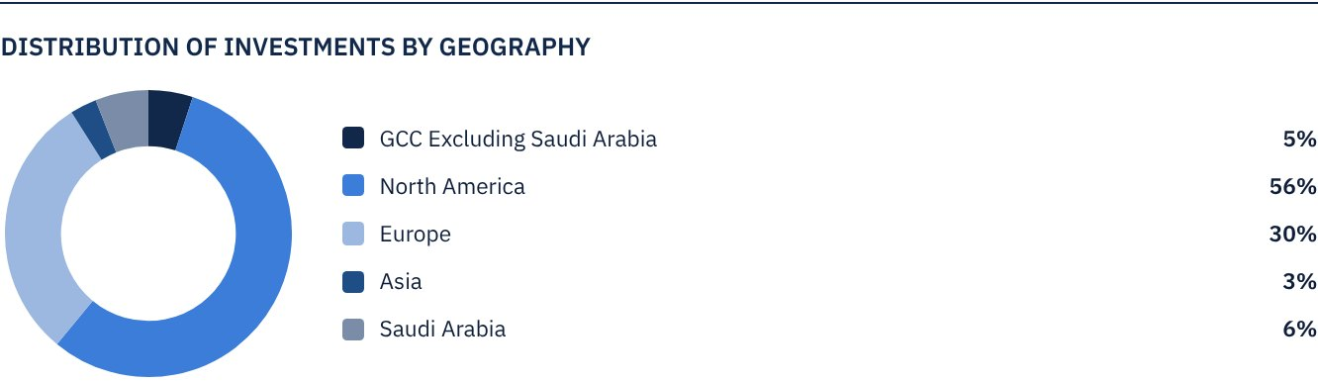

TOP 10 INVESTMENTS OF THE FUND
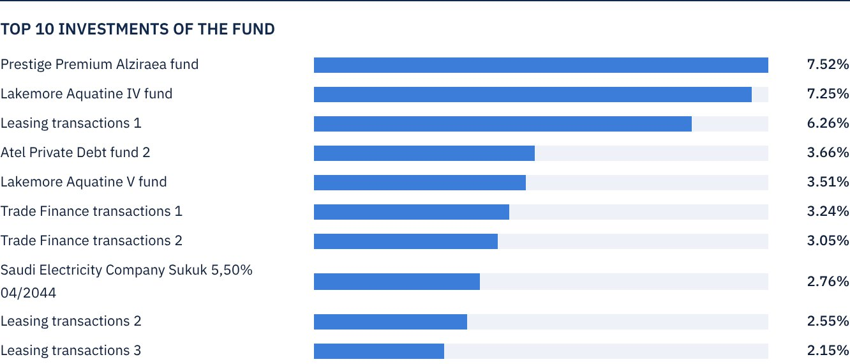

FUND ASSETS INFORMATION
TRADE FINANCE PORTFOLIO TOTAL VALUE | SAR 99,617,014
LEASING PORTFOLIO TOTAL VALUE | SAR 182,484,409
SUKUK PORTFOLIO TOTAL VALUE | SAR 31,188,430
INCOME FUNDS PORTFOLIO TOTAL VALUE | SAR 111,487,809
TOTAL CASH AND CASH EQUIVALENT | SAR 66,842,043

 NET ASSET VALUE AND UNIT PRICE PERFORMANCE
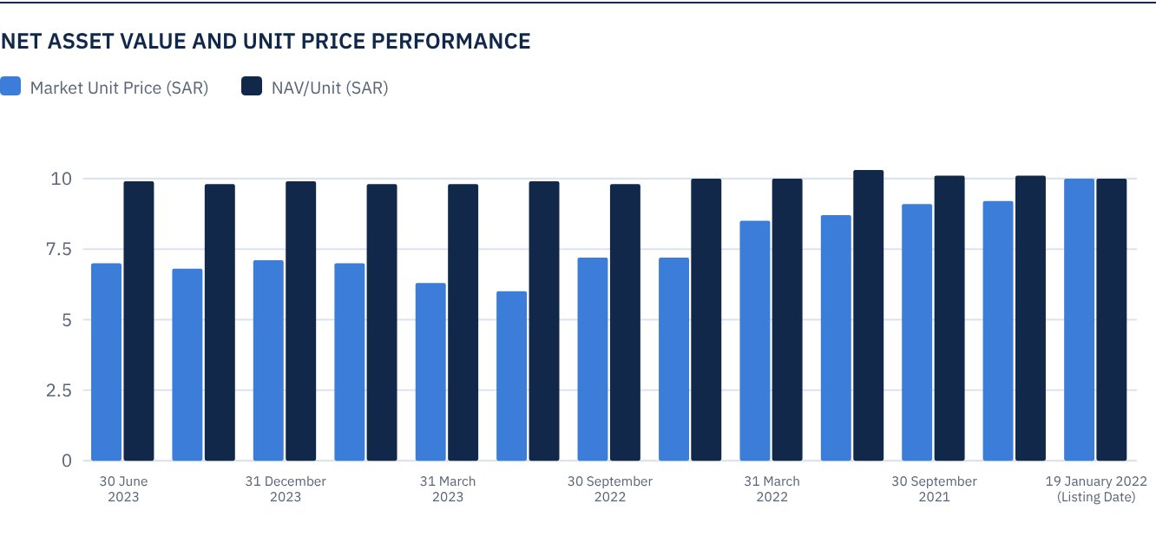

FUND MARKET VALUE INFORMATION*
AS AT THE LISTING DATE | SAR 472,814,700
AS AT 31 MARCH 2021 | SAR 428,370,118
AS AT 30 JUNE 2021 | SAR 433,098,265
AS AT 30 SEPTEMBER 2021 | SAR 427,897,304
AS AT 31 DECEMBER 2021 | SAR 409,930,345
AS AT 31 MARCH 2022 | SAR 402,838,124
AS AT 30 JUNE 2022 | SAR 342,317,843
AS AT 30 SEPTEMBER 2022 | SAR 339,480,955
AS AT 31 DECEMBER 2022 | SAR 281,324,747
AS AT 31 MARCH 2023 | SAR 297,873,261
AS AT 30 JUNE 2023 | SAR 329,079,031
AS AT 30 SEPTEMBER 2023 | SAR 329,551,846
AS AT 31 DECEMBER 2023 | SAR 335,698,437
AS AT 31 MARCH 2024 | SAR 320,568,367
AS AT 30 JUNE 2024 | SAR 326,714,958

*Based on the Unit Price.

FUND UNITS INFORMATION
UNIT PRICE AS AT THE END OF Q2 (30 JUNE 2024) | SAR 6.91
CHANGE IN UNIT PRICE COMPARED TO THE PREVIOUS QUARTER (FROM 31 MARCH 2024 TO 30 JUNE 2024)* | 1.92%
UNIT PRICE PERFORMANCE SINCE THE LISTING DATE (FROM THE LISTING DATE TO END Q2 2024) | -30.90%
52-WEEK HIGH | SAR 7.54
52-WEEK LOW | SAR 6.52
NUMBER OF OUTSTANDING UNITS | 47,281,470 Units
P/E RATIO | N/A

* Unit Price as at 30 June 2024 = SAR 6.78.

 DIVIDEND DISTRIBUTION
DIVIDEND DISTRIBUTION POLICY | The Fund Manager will distribute 100% of the semi-annual profits received from the returns on the Fund's investments after deducting the expenses from the Unitholders twice a year, provided distributions are made during the months of August and February annually.
TOTAL DIVIDENDS PAID IN THE REPORTING QUARTER* | SAR 0
TOTAL DIVIDENDS DISTRIBUTED FOR THE LAST SEMI-ANNUAL PERIOD** | SAR 13,711,626
DIVIDENDS DISTRIBUTED FOR THE LAST SEMI-ANNUAL PERIOD PER UNIT | SAR 0.29
RATIO OF DIVIDENDS DISTRIBUTED IN THE REPORTING QUARTER TO THE INITIAL UNIT PRICE | -
DIVIDENDS DISTRIBUTED ON UNIT PRICE | -
TOTAL INCOME FOR THE REPORTING QUARTER* | SAR 169,078
RATIO OF TOTAL INCOME FOR THE REPORTING QUARTER TO THE UNIT PRICE (30 JUNE 2024) | 0.05%

* From 1 April 2024 to 30 June 2024.
** From 1 January 2024 to 30 June 2024 (Distributed Dividends paid on 25 February 2024).

FUND PERFORMANCE CRITERIA AND INDICATORS
BENCHMARK | 12 months Term SOFR + 300 bps*
INITIAL UNIT PRICE (AT THE INITIAL OFFERING) | SAR 10
UNIT PRICE PERFORMANCE SINCE THE PREVIOUS PERIOD** | 1.92%
UNIT PRICE PERFORMANCE SINCE THE DATE OF INCEPTION*** | -30.90%
TOTAL RETURN SINCE THE DATE OF INCEPTION**** | -14.84%

* On 16 May 2023, the Fund has changed Its benchmark from the London Interbank Offered Rate (LIBOR) 12 months + 300 basis points to the Secured Overnight Financing Rate (Term
SOFR) 12 months + 300 basis points.
** Unit Price as at 31 March 2024 = SAR 6.78.
*** From the Fund’s Date of Inception to end Q2 2024.
**** Total Return = Unit Price Performance + Total Dividend Distributions (if any).
Note: It should be noted that the Unit Price on the Exchange may increase or decrease based on market factors.

DESCRIPTION OF THE FUND’S BENCHMARK
The Fund’s Benchmark is 12 months Term SOFR plus 300 bps.

PERFORMANCE ASSESSMENT CRITERIA AND INDICATORS*
 | ALKHABEER INCOME FUND | 12M TERM SOFR + 300 BPS
NET ASSET VALUE PER UNIT AS AT THE BEGINNING OF THE PERIOD* | 9.7832 | N/A
NET ASSET VALUE PER UNIT AS AT THE END OF THE PERIOD** | 9.7123 | N/A
UNIT PERFORMANCE | -0.72% | 2.01%***

* As at 31 March 2024.
** As at 30 June 2024.
*** Benchmark average return is 8.22% per annum, or a return of 2.01% for the reporting quarter.

OWNERSHIP OF FUND INVESTMENTS
OWNERSHIP | PERCENTAGE (%)
FREEHOLD | 100%
LEASEHOLD | 0%

RETURNS
ITEM | 3 MONTHS * | YEAR TO DATE** | ONE YEAR*** | 3 YEARS | 5 YEARS
TOTAL RETURN/NAV PER UNIT "FUND PERFORMANCE" | -0.72% | 0.82% | 3.40% | 11.74% | N/A
BENCHMARK PERFORMANCE | 2.01% | 3.95% | 8.22% | 21.92% | N/A
PERFORMANCE SPREAD | -2.73% | -3.13% | -4.82% | -10.18% | N/A

* For the period from 31 March 2024 to 30 June 2024.
** For the period from 31 December 2023 to 30 June 2024, including cash distributions of 2.90%.
*** For the period from 30 June 2023 to 30 June 2024, including cash distributions of 5.70%.

 PERFORMANCE AND RISKS
PERFORMANCE AND RISKS CRITERIA | 3 MONTHS1 | YEAR TO DATE2 | ONE YEAR3 | 3 YEARS | 5 YEARS
STANDARD DEVIATION4 | 5.91 | 7.06 | 9.19 | 13.76 | N/A
SHARPE RATIO5 | -0.45 | 0.17 | -0.02 | -0.52 | N/A
TRACKING ERROR6 | 6.00 | 7.10 | 9.36 | 13.81 | N/A
BETA7 | -5.67 | -6.45 | -1.98 | -1.67 | N/A
ALPHA8 | -5.94 | -1.70 | -3.31 | -8.69 | N/A
INFORMATION RATIO9 | -0.99 | -0.24 | -0.35 | -0.63 | N/A

1. For the period from 31 March 2024 to 30 June 2024.
2. For the period from 31 December 2023 to 30 June 2024.
3. For the period from 30 June 2023 to 30 June 2024.
4. Standard Deviation is a measure of risk. It is calculated as any volatility in returns over a period of time. The lower the volatility, the more homogeneous the set of returns.
5. Sharpe Ratio is a risk-adjusted performance measure. It is calculated as the difference as the Fund Manager excess return over the risk-free rate, divided by the Standard Deviation. The greater a portfolio's Sharpe
Ratio, the better its risk-adjusted performance.
6. Tracking Error is a measure of risks. It is calculated as the Standard Deviation between the Fund Manager's return and the Benchmark's return. The lower the Tracking Error, the lower the Fund Manager deviates
from the Benchmark.
7. Beta is a measure of the average historical sensitivity of the Fund's returns compared to market returns. It is calculated by using the covariance of the Fund and the market on the variance of the market.
8. Alpha measures any excess return achieved by the Fund compared to the performance of the index.
9. Information Ratio is a risk-adjusted performance measure. It is calculated as the active return of the Fund Manager, divided by its tracking error. The higher the Information ratio, the higher the Fund Manager ability
to generate excess returns per Unit of excess risk. Knowing that the performance and risk parameters were calculated based on the Unit's trading prices in the market.

FUND HIGHLIGHTS AND ANY FUNDAMENTAL OR NON-FUNDAMENTAL CHANGES AFFECTING THE PERFORMANCE OF THE FUND
There were no fundamental or non-fundamental developments or changes affecting the performance of the Fund.

OVERVIEW OF THE LEASING, TRADE FINANCE AND SUKUK INDUSTRIES

LEASING INDUSTRY OVERVIEW
• Banks and other lenders maintained a positive outlook of the asset-based lending market in the first quarter of 2024, driven by forecasts of slow decline of the US economy. Notwithstanding, lenders remain wary of the forthcoming regulatory changes and continue to monitor investment portfolios for post-pandemic pressures.
• The Equipment Leasing and Finance Association’s (ELFA) Monthly Leasing and Finance Index (MLFI-25), which reports economic activity from twenty-five companies representing a cross section of the USD 1 trillion equipment finance sector, showed their overall new business volume for May 2024 was USD 10.2 billion, or an annualized increase of 11%. Cumulative new business volume was up by 6.0% year-to-date, compared to 2023.
• On a separate note, the Equipment Leasing and Finance Foundation’s (ELFF) Monthly Confidence Index (MCI-EFI) which reports a qualitative assessment of both the prevailing business conditions and expectations for the future of the equipment finance sector, declined slightly to 50.2 in June from 50.7 in May.

TRADE FINANCE INDUSTRY OVERVIEW
• According to the IMF World Economic Outlook for June 2024, world trade is expected to grow by 2.5% in 2024, recovering from an almost flat growth in 2023, however remaining lower than the pre-pandemic averages. Trade in commodities is expected to increase driven by increased global demand, particularly in the US, the Eurozone and China. Trade in services is expected to stabilize near the pre-pandemic averages.
• World trade expanded in May 2024, for the second time since March 2022. According to S&P’s Global Purchasing Managers Index (PMI), the Global PMI Index for new export orders remained at 50.6 in May (stable compared to April), recording the second month of increased exports and improved trade conditions for manufacturing and services.
• The global trade finance gap has widened to USD 2.5 trillion (per recent ADB survey of September 2023), registering a 47% increase from its previous survey which had estimated the 2020 trade finance gap at USD 1.7 trillion. The gap currently represents 10% of global trade in goods. It continues to adversely affect small and medium enterprises worldwide.

SUKUK INDUSTRY OVERVIEW
• According to Fitch, outstanding global sukuk value rose to over US$ 867 billion as at the end of the first quarter of 2024, an annualized increase of 10.3%. Total sukuk issuances in primary markets reached US$ 56.8 billion in the first quarter of 2024, maintaining the status of sukuk as a vital financing instrument with a 33% share of the capital market issuances.
• Fitch expects global sukuk issuances will continue to grow during the remaining part of 2024, driven by financing needs, diversification, refinancing requirements and lower interest rates. However, Fitch forecasts growth to be slower compared to the first quarter of 2024.
• In the first half of 2024, the US Dow Jones Sukuk Index (ex-reinvestment) gained 0.65% while S&P GCC Bond and Sukuk Index declined by 0.29%.

PERFORMANCE OF THE UNIT PRICE TRADED ON THE EXCHANGE SINCE THE INCEPTION OF THE FUND *
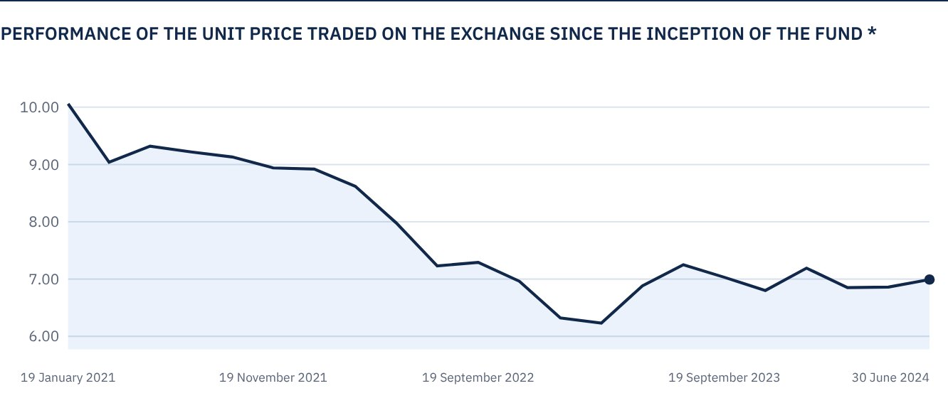

 FOR FURTHER INFORMATION
Alkhabeer Capital
PO Box 128289, Jeddah 21362
Kingdom of Saudi Arabia
Tel: +966 12 658 8888
Fax: +966 12 658 6663
Email: info@alkhabeer.com
CR No: 4030177445
CMA License No: 07074-37
www.alkhabeer.com

 DISCLAIMER
This document does not constitute an offer to buy, subscribe or participate in any way in Alkhabeer Diversified Income Traded Fund, nor shall it (or any part of it) form the basis of, or be relied on, in connection with, or act as inducement to enter into any contract whatsoever. Prospective investors should read carefully Alkhabeer Diversified Income Traded Fund’s Terms and Conditions and their contents related to investment risks, as well as other Alkhabeer Diversified Income Traded Fund documents prior to making any investment decision. Alkhabeer Diversified Income Traded Fund documents are available on Alkhabeer Capital’s website www.alkhabeer.com. This investment is not a cash deposit with a local bank. The value of the amount invested and any other income which may arise therefrom may increase or decrease. All prospective investors are required to make their own determination with their own financial and legal advisors and to evaluate all risks involved. No assurance can be given that the targeted and projected results will be achieved. Moreover, past performance of Alkhabeer Diversified Income Traded Fund is not a guarantee of the Fund’s future results. By investing in the Fund, the investor acknowledges having read and accepted Alkhabeer Diversified Income Traded Fund’s Terms and Conditions, The Fund Manager or any of its affiliates shall not be liable for any financial loss which may be suffered by the Fund, unless such loss is deliberately caused by the Fund Manager.

