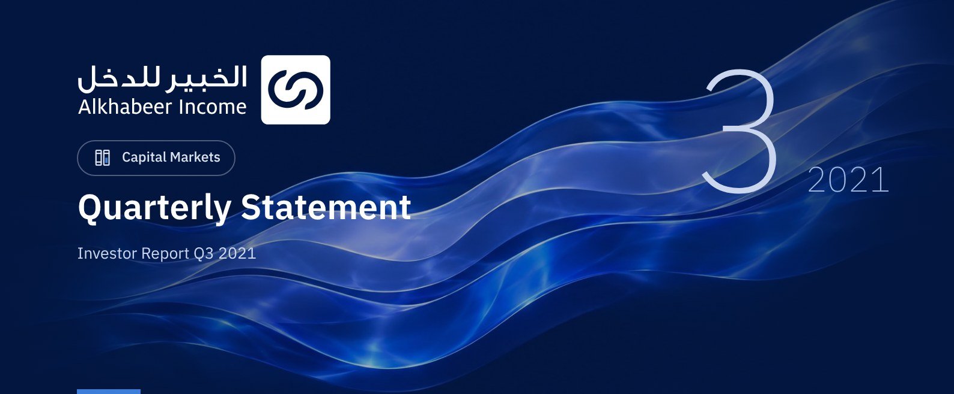

 FUND OVERVIEW
Alkhabeer Diversified Income Traded Fund (“the Fund”) is a closed-ended Shari’a-compliant investment traded fund, established in accordance with the applicable laws and regulations of the Kingdom of Saudi Arabia and regulated by the Capital Market Authority (CMA). The Fund’s investment objective is to generate periodic income to investors by investing in Shari’a-compliant income generating assets. The Fund Manager “Alkhabeer Capital” plans to invest in Sukuk, trade finance transactions, leasing transactions, income funds and Murabaha transactions, either directly or through investment funds.

 KEY FUND FACTS
TADAWUL SYMBOL | 4700
BLOOMBERG SYMBOL | AKDICIF:AB
LISTING DATE | 19 January 2021
FUND TERM | 99 years, starting as from the Listing Date, renewable
NET ASSET VALUE PER UNIT | 10.1022
FUND ASSETS SIZE* | SAR 516,604,888
FUND’S TOTAL CAPITAL | SAR 472,814,700
FINANCING AMOUNT* | SAR 37,463,850
RATIO OF LOANS TO FUND’S TOTAL ASSET VALUE* | 7.25%
RATIO OF LOANS TO FUND’S NET ASSET VALUE AS AT THE END OF THE REPORTING QUARTER | 7.84%
VALUE AND PERCENTAGE OF FUND MANAGER’S INVESTMNET TO FUND’S NET ASSET VALUE AS AT THE END OF THE REPORTING QUARTER | 0.0%
RISK LEVEL | High
FUND CURRENCY | Saudi Arabian Riyal (SAR)
INVESTMENT ADVISOR AND FUND SUB-MANAGER | N/A
RATIO OF UNDERLYING FUNDS’ MANAGEMENT FEES | 0.22%

* As at 30 September 2021 (Unaudited).

FUND PORTFOLIO INVESTMENT CONCENTRATION RATIOS
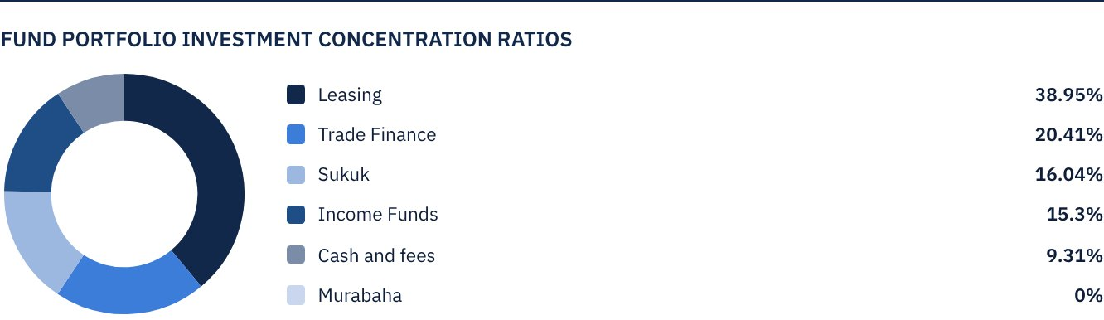

FINANCIAL INDICATORS*
VALUATION FREQUENCY | Quarterly
FUND’S TOTAL ASSET VALUE* | SAR 516,604,888
FUND UNITS’ NET ASSET VALUE* | SAR 477,647,954
AMOUNT AND RATIO OF TRANSACTION EXPENSES FOR THE REPORTING QUARTER TO FUND’S AVERAGE NET ASSET VALUE | 0.00%
RATIO OF TOTAL EXPENSES AND FEES TO FUND’S TOTAL ASSET VALUE* | 0.41%
RATIO OF FUND’S COSTS TO FUND’S TOTAL ASSET VALUE* | 0.41%
RATIO OF FUND’S COSTS TO FUND’S AVERAGE NET ASSET VALUE* | 0.44%
TOTAL EXPENSES AND FEES FOR THE CURRENT QUARTER | SAR 2,119,712
RATIO OF TOTAL EXPENSES AND FEES FOR THE REPORTING QUARTER TO FUND’S AVERAGE NET ASSET VALUE | 0.44%

* As at 30 September 2021 (Unaudited).

DISTRIBUTION OF INVESTMENTS BY GEOGRAPHY
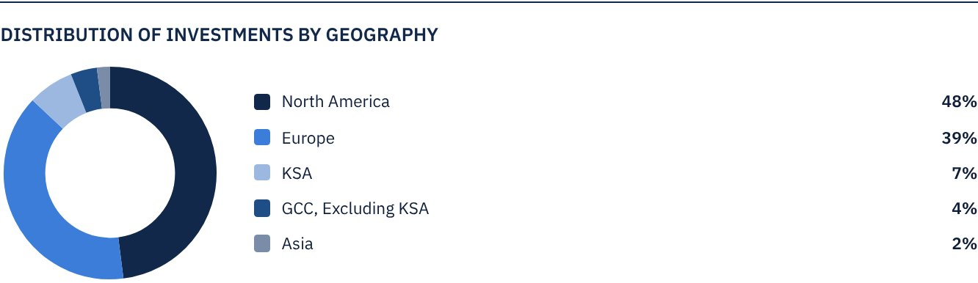

FUND ASSETS INFORMATION
TRADE FINANCE PORTFOLIO TOTAL VALUE | SAR 105,419,985
LEASING PORTFOLIO TOTAL VALUE | SAR 201,208,756
SUKUK PORTFOLIO TOTAL VALUE | SAR 82,881,472
INCOME FUNDS PORTFOLIO TOTAL VALUE | SAR 79,024,530
TOTAL CASH AND CASH EQUIVALENT | SAR 48,070,146

 NET ASSET VALUE AND UNIT PRICE PERFORMANCE*
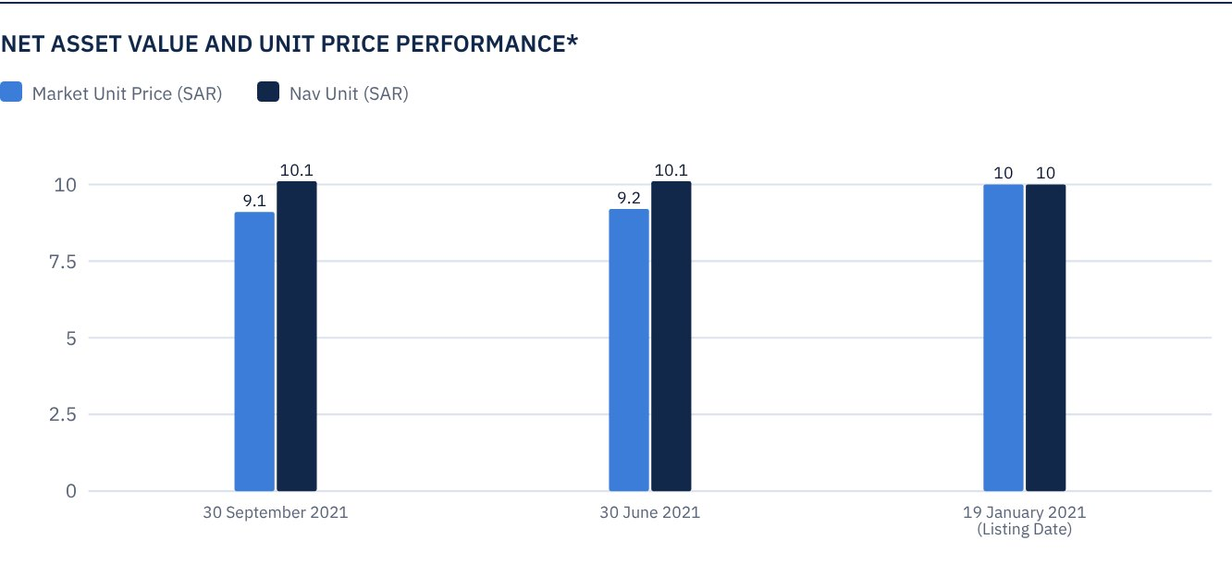
* Based on the Unit Price.

FUND MARKET VALUE INFORMATION*
AS AT THE LISTING DATE | SAR 472,814,700
AS AT 31 MARCH 2021 | SAR 428,370,118
AS AT 30 JUNE 2021 | SAR 433,098,265
AS AT 30 SEPTEMBER 2021 | SAR 427,897,304

* Based on the Unit Price.

FUND UNITS INFORMATION
UNIT PRICE AS AT THE END OF Q3 (30 SEPTEMBER 2021) | SAR 9.05
CHANGE IN UNIT PRICE DURING THE CURRENT QUARTER (FROM 30 JUNE 2021 TO 30 SEPTEMBER 2021) * | -1.2%
UNIT PRICE PERFORMANCE SINCE THE LISTING DATE (FROM THE LISTING DATE TO END Q3 2021) | -9.5%
52-WEEK HIGH | SAR 12.00
52-WEEK LOW | SAR 8.98
NUMBER OF OUTSTANDING UNITS | 47,281,470 Units

*Unit Price as at 30 June = SAR 9.16

 DIVIDEND DISTRIBUTION FOR THE QUARTER
DIVIDEND DISTRIBUTION POLICY | The Fund Manager will distribute 100% of the semi-annual profits received from the Fund's investment returns after deducting expenses from the Unitholders twice a year, given that the distributions are during the months of August and February annually.
GROSS INCOME FOR THE PERIOD (30 SEPTEMBER 2021) | SAR 8,552,102
INCOME FOR THE PERIOD ON UNIT PRICE (30 SEPTEMBER 2021) | 2.00%
TOTAL DIVIDENDS DISTRIBUTED IN THE REPORTING QUARTER (ANY DIVIDEND PAID SUBSEQUENT TO THE LATEST DISCLOSED REPORT) | SAR 8,510,665
DIVIDENDS DISTRIBUTED PER UNIT | SAR 0.18
DIVIDENDS DISTRIBUTED ON UNIT PRICE* | 1.97%
ELIGIBILITY TO CASH DIVIDENDS DISTRIBUTED DURING THE REPORTING QUARTER | According to the Unitholders register at the end of 19 August 2021 (end of trading day 17 August 2021)
TOTAL DIVIDENDS DISTRIBUTED IN THE REPORTING QUARTER | SAR 8,510,665
RATIO OF DIVIDENDS DISTRIBUTED IN THE REPORTING QUARTER TO INITIAL UNIT PRICE | 1.8%

*Unit Price as at 30 June = SAR 9.16

FUND PERFORMANCE CRITERIA AND INDICATORS
BENCHMARK | 12M LIBOR + 300 bps
INITIAL UNIT PRICE (AT THE INITIAL OFFERING) | SAR 10
UNIT PRICE PERFORMANCE SINCE THE PREVIOUS PERIOD* | -1.20%
UNIT PRICE PERFORMANCE SINCE THE DATE OF INCEPTION** | -9.50%
TOTAL RETURN SINCE THE DATE OF INCEPTION*** | -7.70%

* From end Q2 to end Q3 2021.
** From the Fund’s Date of Inception to end Q3 2021.
*** Total Return = Unit Price Performance + Total Dividend Distributions (if any).

PERFORMANCE ASSESSMENT CRITERIA AND INDICATORS*
 | ALKHABEER INCOME FUND | 12M LIBOR + 300 BPS
NET ASSET VALUE PER UNIT AS AT THE BEGINNING OF THE PERIOD* | 10.15 | NOT APPLICABLE
NET ASSET VALUE PER UNIT AS AT THE END OF THE PERIOD** | 10.10 | NOT APPLICABLE
UNIT PERFORMANCE | -0.43% | 0.80%***

* As at 1 July 2021.
** As at 30 September 2021.
*** Benchmark return is 3.23%.

OWNERSHIP OF FUND INVESTMENTS
OWNERSHIP | PERCENTAGE* (%)
FREEHOLD | 100%
LEASEHOLD | 0%

RETURNS
ITEM | 3 MONTHS* | SINCE INCEPTION OF THE FUND UP TO 30 SEPTEMBER 2021**
FUND’S NET ASSET VALUE PERFORMANCE* | 1.37% | 2.82%
BENCHMARK PERFORMANCE | 0.80% | 2.28%
PERFORMANCE SPREAD | 0.57% | 0.54%

* For the period from 1 July 2021 to 30 September 2021, Including dividend distribution of 1.80%
** For the period from 19 January 2021 to 30 September 2021
Knowing that the Unit Price in the Exchange may increase or decrease based on market factors.

 PERFORMANCE AND RISKS
PERFORMANCE AND RISKS CRITERIA | 3 MONTHS1 | SINCE INCEPTION OF THE FUND UP TO 30 SEPTEMBER 20212
STANDARD DEVIATION3 | 8.19 | 11.43
SHARPE RATIO4 | -0.17 | -1.20
TRACKING ERROR5 | 8.18 | 11.43
BETA6 | -7.59 | -4.72
ALPHA7 | -9.44% | -17.88%
INFORMATION RATIO8 | -1.15% | -1.56%

1. For the period from 1 July 2021 to 30 September 2021
2. For the period from 19 January 2021 to 30 September 2021
3. Standard Deviation is a measure of the dispersion of Fund's prices relative to its mean over a period of time. The lower the volatility, the more homogeneous the set of returns.
4. Sharpe ratio is a risk adjusted performance measure and is calculated as the difference as the Fund Manager excess return over the risk-free rate, divided by Its standard deviation. The greater a portfolio's sharpe. ratio, the better its risk-adjusted performance.
5. Tracking error is a measure of risk and is calculated as the standard deviation between the Fund Manager return and the benchmark return. The lower the tracking error, the lower the Fund Manager deviates from the Benchmark.
6. Beta is a measure of the average historical sensitivity of a Fund's returns compared to market returns, and is calculated by using the covariance of the Fund and the market on the variance of the market.
7. Alpha measures any excess return achieved by the Fund compared to the performance of the index.
8. Information ratio is a risk adjusted performance measure and is calculated as the active return of the Fund Manager divided by Its tracking error. The higher the Information ratio, the higher the Fund Manager ability to generate excess returns per unit of excess risk. Knowing that the performance and risk parameters were calculated based on the unit's trading prices in the market.

FUND HIGHLIGHTS AND ANY FUNDAMENTAL, MATERIAL OR SIGNIFICANT CHANGES AFFECTING THE PERFORMANCE OF THE FUND
• The Fund Manager invested 38.9% of the Fund’s assets in leasing transactions across several types of equipment and companies. The leasing portfolio is mainly invested in the United States and expected to generate a total return of 6.5% annually over the next five-year term.
• The Fund Manager invested 20.4% of the Fund’s assets in trade finance transactions with several counterparties and across various industries, mostly in the European continent. All executed transactions are of a short-term nature, with returns ranging between 6.5% to 7.0% annually.
• The Fund Manager invested 16% of the Fund’s assets in Sukuk of different credit ratings, including sovereign, semi-sovereign and corporate Sukuk. The Fund Manager has obtained credit facilities that support increasing the portfolio’s returns to over 5% per annum, while maintaining a weighted average for classifying the portfolio as an investment grade.
• To diversify the Fund’s investments, the Fund Manager invested 15.3% of the Fund’s assets in income funds, ranging from private financing and leasing to trade finance and securitization, with an expected average annual return of 6% to 7%.
• The Fund Manager plans to distribute the profits earned as per the targeted timeframe specified in the Terms and Conditions.

OVERVIEW OF THE LEASING, TRADE FINANCE AND SUKUK INDUSTRY

LEASING INDUSTRY OVERVIEW
Overall, the U.S. economy has rebounded well from the COVID-19 pandemic, with GDP growth projected to hit 7% in 2021, higher than the Euro Area, Japan, and other advanced global economies.
In addition, the U.S. unemployment rate continues to decline, lowering to 5.2% as at 31 August 2021 from 5.9% as at 30 June 2021.
Investment in equipment jumped in the first quarter of 2021 and is currently above pre-pandemic levels. Businesses across the country are continuing to invest, which should support growth for the remainder of the year.
According to the Equipment Leasing Financing Foundation, investment in equipment is projected to expand by approximately 13% in 2021, signaling a strong rebound from 2020. Over the next six months, the Foundation anticipates solid growth in the industries the Fund targets including agriculture, railroad, construction, and materials handling.
Overall, the +$900 billion equipment finance marketplace is projected to remain stable.
The Equipment Leasing and Finance Association’s (ELFA) Monthly Leasing and Finance Index (MLFI-25), which reports economic activity from 25 companies representing a cross section of the $900 billion equipment finance sector, showed their overall new business volume for July 2021 was $9.9 billion, up 9 percent year-over-year from new business volume in July 2020. Year-to-date, cumulative new business volume was up nearly 9 percent compared to 2020, signaling a strong recovery.
Separately, the Equipment Leasing & Finance Foundation’s Monthly Confidence Index (MCI-EFI) in August 2021 is 66.6, a decrease from the July 2021 index of 72.9, but still substantially above 2020 and the historical average of 59.4.
Despite supply chain disruptions in some sectors of the economy, signs of inflation and emergence of the Delta coronavirus, July new business volume in the equipment finance industry is strong. Consumer spending is picking up, equity markets continue to advance and unemployment is slowing—reasons to be optimistic about equipment investment and industry performance for the second half of the year.

TRADE FINANCE INDUSTRY OVERVIEW
According to Coalition, the research arm of S&P Global, the global pool of trade finance is expected to rebound to USD 52 billion in 2021 and to around USD 54 billion by 2022, surpassing the pre-pandemic level of USD 53 billion reported in 2019.
As over 80% to 90% of the world trade relies on trade finance, a 7.2% rise in the global trade volumes in 2021, as reported by the World Trade Organization (WTO), would largely support an increase in the trade finance transactions.
Notably, as per the International Chamber of Commerce’s September 2021 report, no asset class in the trade finance industry recorded default rates above the peak historic rates in 2020, thereby affirming the relative stability of the sector, even during the times of economic stress.
It is also expected an improvement in margins on trade finance transactions on account of lower funding costs due to low interest rates, would drive the growth of revenues of trade finance transactions.
Moreover, the recent implementation of stringent lending criteria (Basel III norms) has created an opportunity for private debt funds and investors to participate in the trade finance industry, which was once restricted only to traditional banks.
In addition to that, small and medium sized enterprises (SMEs) present a substantial opportunity for trade finance industry, as traditional banks generally focus on large transactions.

SUKUK INDUSTRY OVERVIEW
As per S&P Global Ratings, Sukuk issuances rose to USD 90.6 billion in H1 2021, up from USD 86.4 billion in the same period last year.
As corporate activities were muted in 2020 due to the COVID-19 related restrictions, it is expected that a portion of these investments would be executed in 2021.
It is further expected that bank and corporate issuances would drive the overall performance of the Sukuk market in the second half of 2021.
Also, the expected refinancing of USD 20 billion maturing Sukuk in the second half of 2021, shall drive the overall level of issuances in the Sukuk market.
As per Fitch Ratings, Sukuk supply is expected to rise in the second half of 2021, after it showed strong growth during Q2 2021. Sukuk issuances will be supported by strong investor appetite and issuers’ refinancing and funding diversification needs.
On a regional basis, the GCC Sukuk issuance is expected to further decline in the second half of the year, as higher oil prices have lowered sovereign funding needs in the GCC relative to 2020. However, new corporate issuers are expected to partially offset the lower volumes from the sovereign side.
As per Moody’s rating agency, the total gross short term and long-term sukuk issuance in 2021 shall reach an amount between $190 billion and $200 billion after a record $205 billion in 2020.
Improved market conditions led to a strong rebound in corporate issuances, but sovereigns remained the largest issuers by value as reported by the agency.
Besides, green Sukuk issuance is also expected to increase in the second half of 2021 as governments promote sustainable policy agendas and as demand for sustainable investments encourages new issuers to consider green sukuk as an alternative financing tool.

PERFORMANCE OF THE UNIT PRICE TRADED ON THE EXCHANGE*
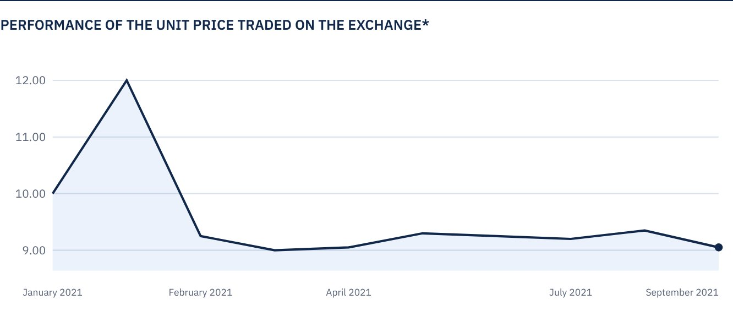
* Prices as at the close of 30 September 2021.

 FOR FURTHER INFORMATION
Alkhabeer Capital
PO Box 128289, Jeddah 21362
Kingdom of Saudi Arabia
Tel: +966 12 658 8888
Fax: +966 12 658 6663
Email: info@alkhabeer.com
CR No: 4030177445
CMA License No: 07074-37
www.alkhabeer.com

 DISCLAIMER
This document does not constitute an offer to buy, subscribe or participate in any way in Alkhabeer Diversified Income Traded Fund, nor shall it (or any part of it) form the basis of, or be relied on, in connection with, or act as inducement to enter into any contract whatsoever. Prospective investors should read carefully Alkhabeer Diversified Income Traded Fund’s Terms and Conditions and their contents related to investment risks as well as other Alkhabeer Diversified Income Traded Fund documents prior to making any investment decision. Alkhabeer Diversified Income Traded Fund documents are available on Alkhabeer Capital’s website www.alkhabeer.com. This investment is not a cash deposit with a local bank. The value of the amount invested and any other income which may arise therefrom, may increase or decrease. All prospective investors are required to make their own determination with their own financial and legal advisors, and evaluate all risks involved. No assurance can be given that the targeted and projected results will be achieved. Moreover, past performance of Alkhabeer Diversified Income Traded Fund is not a guarantee of the Fund’s future results. By investing in the Fund, the investor acknowledges having read and accepted the Alkhabeer Diversified Income Traded Fund’s Terms and Conditions.

