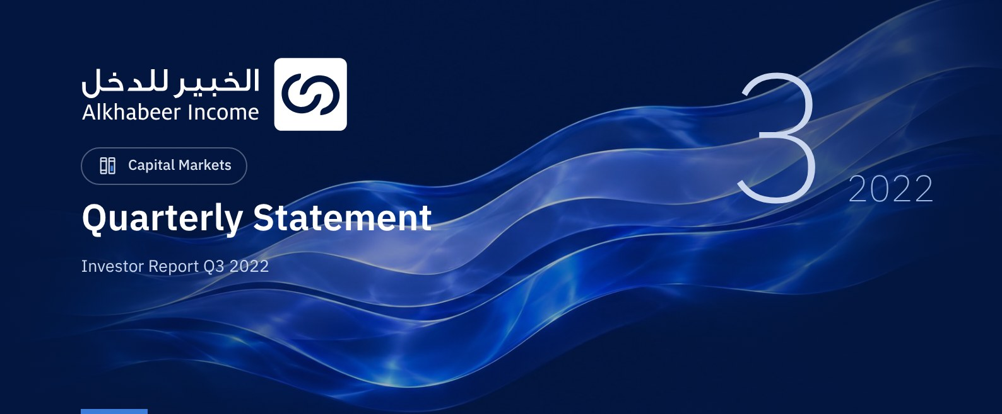

 FUND OVERVIEW
Alkhabeer Diversified Income Traded Fund (“the Fund”) is a closed-ended Shari’a-compliant investment traded fund established in accordance with the applicable laws and regulations of the Kingdom of Saudi Arabia and regulated by the Capital Market Authority (CMA). The Fund’s investment objective is to generate periodic income to investors by investing in Shari’a-compliant income generating assets. The Fund Manager “Alkhabeer Capital” plans to invest in Sukuk, trade finance transactions, leasing transactions, income funds and Murabaha transactions, either directly or through investment funds.

 KEY FUND FACTS
TADAWUL SYMBOL | 4700
BLOOMBERG SYMBOL | AKDICIF:AB
FUND TYPE | Closed-ended Traded Fund
LISTING DATE | 19 January 2021
FUND TERM | 99 years, starting as from the Listing Date, renewable
NET ASSET VALUE PER UNIT | 9.7756
FUND ASSETS SIZE* | SAR 555,514,335
FUND’S TOTAL CAPITAL AS AT THE LISTING DATE | SAR 472,814,700
FINANCING AMOUNT* | SAR 91,686,496
RATIO OF LOANS TO FUND’S TOTAL ASSET VALUE* | 16.50%
RATIO OF LOANS TO FUND’S NET ASSET VALUE AS AT THE END OF THE REPORTING QUARTER | 19.84%
VALUE AND PERCENTAGE OF FUND MANAGER’S INVESTMENT TO FUND’S NET ASSET VALUE AS AT THE END OF THE REPORTING QUARTER | 0.0%
RISK LEVEL | High
FUND CURRENCY | Saudi Arabian Riyal (SAR)
INVESTMENT ADVISOR AND FUND SUB-MANAGER | N/A
RATIO OF UNDERLYING FUNDS’ MANAGEMENT FEES | 0.34%

* As at 30 September 2022 (Unaudited).

FUND PORTFOLIO INVESTMENT CONCENTRATION RATIOS
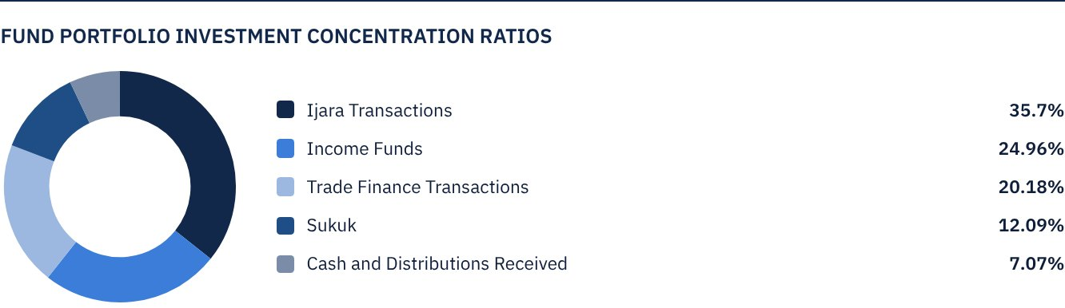
* The graph shows the largest Fund investments and the distribution of investments by sector.

FINANCIAL INDICATORS*
VALUATION FREQUENCY | Quarterly
FUND’S TOTAL ASSET VALUE* | SAR 555,514,335
FUND UNITS’ NET ASSET VALUE* | SAR 462,205,513
AMOUNT AND RATIO OF TRANSACTION EXPENSES FOR THE REPORTING QUARTER TO FUND’S AVERAGE NET ASSET VALUE | 0.00%
RATIO OF TOTAL EXPENSES AND FEES TO FUND’S TOTAL ASSET VALUE** | 0.37%
RATIO OF FUND’S COSTS TO FUND’S TOTAL ASSET VALUE*** | 0.52%
RATIO OF FUND’S COSTS TO FUND’S AVERAGE NET ASSET VALUE*** | 0.62%
TOTAL EXPENSES, COSTS AND FEES FOR THE REPORTING QUARTER | SAR 2,890,637
RATIO OF TOTAL EXPENSES AND FEES FOR THE REPORTING QUARTER TO FUND’S AVERAGE NET ASSET VALUE** | 0.43%

* As at 30 September 2022 (Unaudited).
** Fund expenses and fees are all Fund expenses during the reporting quarter, excluding financing costs.
***Fund costs are all Fund fees and expenses, including financing costs.

DISTRIBUTION OF INVESTMENTS BY GEOGRAPHY
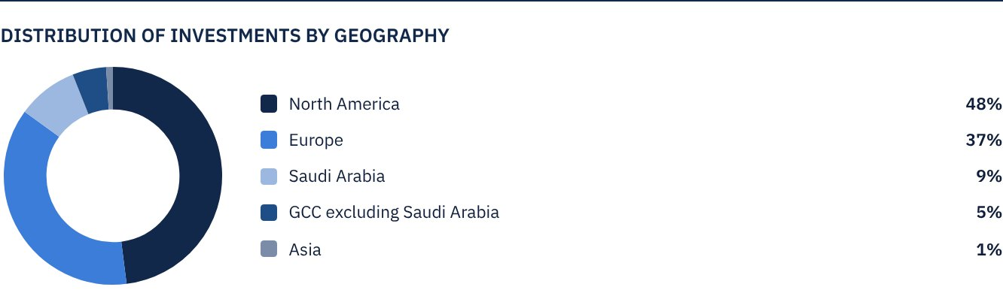

FUND ASSETS INFORMATION
TRADE FINANCE PORTFOLIO TOTAL VALUE | SAR 112,093,705
LEASING PORTFOLIO TOTAL VALUE | SAR 198,294,542
SUKUK PORTFOLIO TOTAL VALUE | SAR 67,155,550
INCOME FUNDS PORTFOLIO TOTAL VALUE | SAR 138,679,206
TOTAL CASH AND CASH EQUIVALENT | SAR 39,291,332

 NET ASSET VALUE AND UNIT PRICE PERFORMANCE*
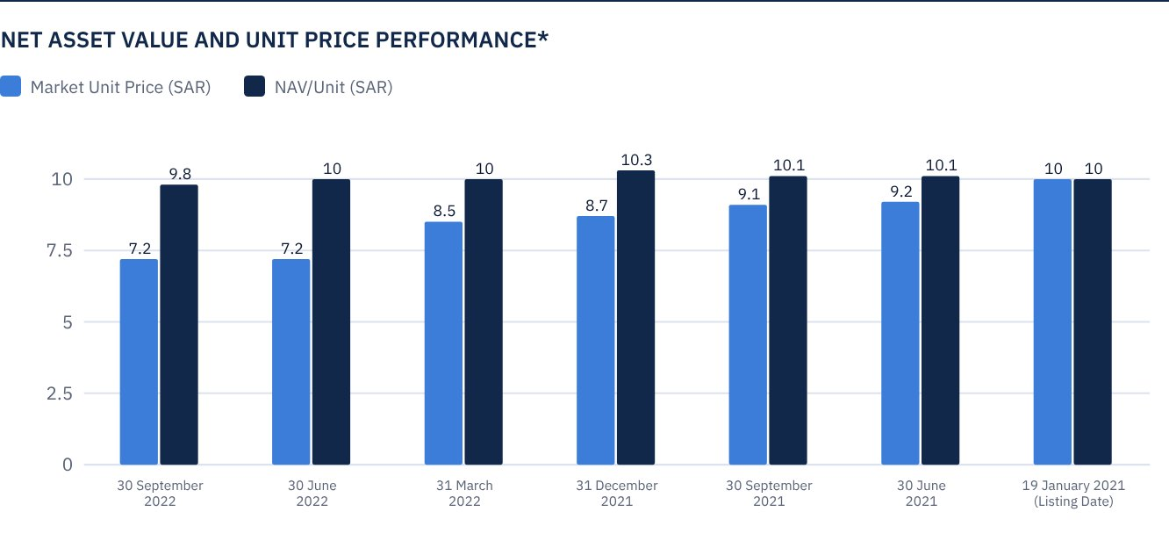
* Based on the Unit Price.

FUND MARKET VALUE INFORMATION*
AS AT THE LISTING DATE | SAR 472,814,700
AS AT 31 MARCH 2021 | SAR 428,370,118
AS AT 30 JUNE 2021 | SAR 433,098,265
AS AT 30 SEPTEMBER 2021 | SAR 427,897,304
AS AT 31 DECEMBER 2021 | SAR 409,930,345
AS AT 31 MARCH 2022 | SAR 402,838,124
AS AT 30 JUNE 2022 | SAR 342,317,843
AS AT 30 SEPTEMBER 2022 | SAR 339,480,955

* Based on the Unit Price.

FUND UNITS INFORMATION
UNIT PRICE AS AT THE END OF Q3 (30 SEPTEMBER 2022) | SAR 7.18
CHANGE IN UNIT PRICE COMPARED TO THE PREVIOUS QUARTER (FROM 30 JUNE 2022 TO 30 SEPTEMBER 2022)* | -0.83%
UNIT PRICE PERFORMANCE SINCE THE LISTING DATE (FROM THE LISTING DATE TO END Q3 2022) | -28.20%
52-WEEK HIGH | SAR 9.05
52-WEEK LOW | SAR 7.11
NUMBER OF OUTSTANDING UNITS | 47,281,470 Units

* Unit Price as at 30 June 2022 = SAR 7.24.

 DIVIDEND DISTRIBUTION FOR THE QUARTER
DIVIDEND DISTRIBUTION POLICY | The Fund Manager will distribute 100% of the semi-annual profits received from the returns on the Fund's investments after deducting the expenses from the Unitholders twice a year, provided distributions are made during the months of August and February annually.
TOTAL DIVIDENDS DISTRIBUTED IN THE REPORTING QUARTER* | SAR 0.00
TOTAL DIVIDENDS DISTRIBUTED FOR THE LAST SEMI-ANNUAL PERIOD** | SAR 12,293,182
DIVIDENDS DISTRIBUTED FOR THE LAST SEMI-ANNUAL PERIOD PER UNIT | SAR 0.26
RATIO OF DIVIDENDS DISTRIBUTED IN THE REPORTING QUARTER TO THE INTIAL UNIT PRICE | 2.60%
DIVIDENDS DISTRIBUTED ON UNIT PRICE*** | 3.59%
TOTAL INCOME FOR THE REPORTING QUARTER* | SAR 4,441,823
RATIO OF TOTAL INCOME FOR THE REPORTING QUARTER TO THE UNIT PRICE (30 SEPTEMBER 2022) | 1.31%

* From 1 July 2022 to 30 September 2022.
** From 1 January 2022 to 30 June 2022.
*** Unit Price as at 30 June 2022 = SAR 7.24.

FUND PERFORMANCE CRITERIA AND INDICATORS
BENCHMARK | 12M LIBOR + 300 bps
INITIAL UNIT PRICE (AT THE INITIAL OFFERING) | SAR 10
UNIT PRICE PERFORMANCE SINCE THE PREVIOUS PERIOD* | -0.83%
UNIT PRICE PERFORMANCE SINCE THE DATE OF INCEPTION** | -28.20%
TOTAL RETURN SINCE THE DATE OF INCEPTION*** | -21.30%

* Unit Price as at 30 June 2022 = SAR 7.24.
** From the Fund’s Date of Inception to end Q3 2022.
*** Total Return = Unit Price Performance + Total Dividend Distributions (if any).
It should be noted that the Unit Price on the Exchange may increase or decrease based on market factors.

DESCRIPTION OF THE FUND’S BENCHMARK
The Fund’s Benchmark is 12-month LIBOR plus 300 bps.

PERFORMANCE ASSESSMENT CRITERIA AND INDICATORS*
 | ALKHABEER INCOME FUND | 12M LIBOR + 300 BPS
NET ASSET VALUE PER UNIT AS AT THE BEGINNING OF THE PERIOD* | 10.0028 | NOT APPLICABLE
NET ASSET VALUE PER UNIT AS AT THE END OF THE PERIOD** | 9.7756 | NOT APPLICABLE
UNIT PERFORMANCE | -2.27% | 1.76%***

* As at 30 June 2022.
** As at 30 September 2022.
*** Benchmark average return is 7.08% per annum, or a return of 1.76% for the reporting quarter.

OWNERSHIP OF FUND INVESTMENTS
OWNERSHIP | PERCENTAGE (%)
FREEHOLD | 100%
LEASEHOLD | 0%

RETURNS
ITEM | 3 MONTHS* | ONE YEAR UP TO 30 SEPTEMBER 2022** | ONE YEAR***
NAV/UNIT PERFORMANCE | 0.33% | 0.40%** | 1.83%***
BENCHMARK PERFORMANCE | 1.76% | 4.25% | 5.15%
PERFORMANCE SPREAD | -1.43% | -3.85% | -3.32%

* For the period from 1 July 2022 to 30 September 2022, including cash distributions of 2.6%.
** For the period from 1 January 2022 to 30 September 2022, including cash distributions of 5.1%.
** For the period from 1 October 2021 to 30 September 2022, including cash distributions of 5.1% (Unit Price as at 30 September 2021 = SAR 10.1022).

 PERFORMANCE AND RISKS
PERFORMANCE AND RISKS CRITERIA | 3 MONTHS1 | ONE YEAR UP TO 30 SEPTEMBER 20222 | ONE YEAR
STANDARD DEVIATION3 | 11.57 | 10.50 | 9.57
SHARPE RATIO4 | 0.59 | -1.72 | -1.81
TRACKING ERROR5 | 11.59 | 10.52 | 9.59
BETA6 | (1.87) | (3.17) | (2.58)
ALPHA7 | -0.02 | -0.23 | -0.22
INFORMATION RATIO8 | 0.16 | -2.23 | -2.34

1. For the period from 1 July 2022 to 30 September 2022.
2. For the period from 1 January 2022 to 30 September 2022.
3. For the period from 1 October 2021 to 30 September 2022.
4. Standard Deviation is a measure of risk. It is calculated as any volatility in returns over a period of time. The lower the volatility, the more homogeneous the set of returns.
5. Sharpe Ratio is a risk-adjusted performance measure. It is calculated as the difference as the Fund Manager excess return over the risk-free rate, divided by the Standard Deviation. The greater a portfolio's Sharpe Ratio, the better its risk-adjusted performance.
6. Tracking Error is a measure of risks. It is calculated as the Standard Deviation between the Fund Manager's return and the Benchmark's return. The lower the Tracking Error, the lower the Fund Manager deviates from the Benchmark.
7. Beta is a measure of the average historical sensitivity of the Fund's returns compared to market returns. It is calculated by using the covariance of the Fund and the market on the variance of the market.
8. Alpha measures any excess return achieved by the Fund compared to the performance of the index.
9. Information Ratio is a risk-adjusted performance measure. It is calculated as the active return of the Fund Manager, divided by its tracking error. The higher the Information ratio, the higher the Fund Manager ability to generate excess returns per Unit of excess risk. Knowing that the performance and risk parameters were calculated based on the Unit's trading prices in the market.

FUND HIGHLIGHTS AND ANY FUNDAMENTAL OR NON FUNDAMENTAL CHANGES AFFECTING THE PERFORMANCE OF THE FUND
There were no fundamental or non-fundamental developments or changes affecting the performance of the Fund.

OVERVIEW OF THE LEASING, TRADE FINANCE AND SUKUK INDUSTRIES

LEASING INDUSTRY OVERVIEW
• During Q3 of 2022, higher inflation in global economies has led to the slowdown of growth. However, strong labor market information has somewhat offset the effect on the leasing sector. As a result, the Monthly Leasing and Finance Index (MLFI-25) which reports the economic activity from 25 companies representing a cross section of the US$ 900 billion US leasing sector, has shown that their overall new business volume for July 2021 was US$ 10.1 billion, up 2% annually compared to the overall new business volume for July 2021. The cumulative new business volume was up 5% year-to-date, compared to 2021.
• Meanwhile, the Monthly Confidence Index for the Equipment Finance Industry released by the Equipment Leasing and Finance Foundation (MCI-EFI) has improved to 50 in August 2022 from 46.1 in July 2022 in spite of higher interest rates, continued supply chain disruptions and higher inflation, the leasing sector continues to provide value to companies who rely on it in the procurement of capital equipment necessary for their operations.
• ELFA continues to note strong interest from business and agricultural companies and producers, while they look to expand their operations and secure low rates in the long term. Demand exceeds supply as the industry continues to face delays in equipment delivery due to persisting supply chain challenges.

TRADE FINANCE INDUSTRY OVERVIEW
• According to the latest estimate released by the UNCTAD, the value of world trade increased by approximately 15% to US$ 7.7 trillion in the first quarter of 2022. The most recent data for the second quarter of 2022 released by S&P Global Market Intelligence points to the positive growth of exports and imports on an annualized basis in all of the top ten countries tracked by UNCTAD.
• Globally, banks are ratcheting up funds for the global commodities, according to an article recently published by Bloomberg, considering that trade finance is the lifeblood of the commodities industry, and with prices surging amid the war in Ukraine, and with the supply routes disrupted by the conflict, traders are clamoring for additional funds to pay for shipments of grains, metals and fuels.
• The latest report by Trade Finance Global (TFG) focused on the viability of SME trade finance from a European outlook, pointing out that despite high inflation, record high energy prices and geopolitical uncertainty, demand for trade finance by SME’s is on the rise.

SUKUK INDUSTRY OVERVIEW
• Global Sukuk issuance slowed down in the first half of 2022 in spite of the strong activity of the issuers during the first quarter, amid high demand from foreign investors. Global Sukuk raised US$ 22 billion in the first half of 2022, down by 10% from US$ 33.2 billion in the first half of 2021.
• According to Moody’s Credit Ratings, global Sukuk issuance is expected to decrease from US$ 181 billion in 2021 to between US$ 160 billion and US$ 170 billion in 2022. According to Refinitiv, global Sukuk issuance is expected to slightly decrease to US$ 185 billion in 2022. Subsequently, issuance is expected to grow by 6.4% per annum over the next five years, to reach US$ 257 billion in 2027.
• In terms of performance, the huge losses in the global bonds market in 2022 will mark the worst year on record since decades. The Sukuk market has declined significantly year-to-date, with the Dow Jones Sukuk Index losing 9.63% year-to-date.

PERFORMANCE OF THE UNIT PRICE TRADED ON THE EXCHANGE SINCE THE INCEPTION OF THE FUND *
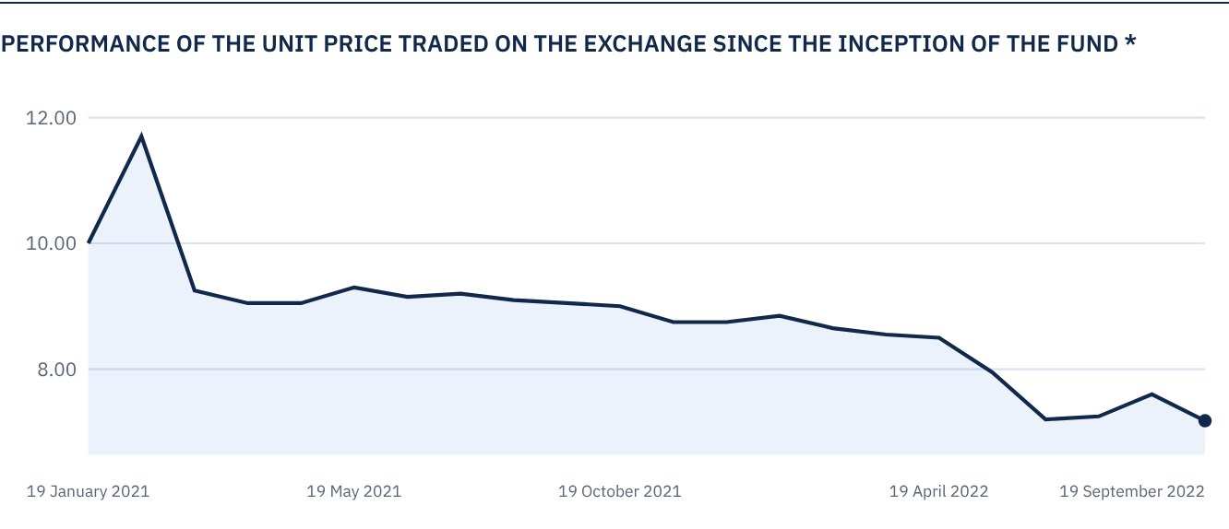
* Prices as at 30 September 2022

 FOR FURTHER INFORMATION
Alkhabeer Capital
PO Box 128289, Jeddah 21362
Kingdom of Saudi Arabia
Tel: +966 12 658 8888
Fax: +966 12 658 6663
Email: info@alkhabeer.com
CR No: 4030177445
CMA License No: 07074-37
www.alkhabeer.com

 DISCLAIMER
This document does not constitute an offer to buy, subscribe or participate in any way in Alkhabeer Diversified Income Traded Fund, nor shall it (or any part of it) form the basis of, or be relied on, in connection with, or act as inducement to enter into any contract whatsoever. Prospective investors should read carefully Alkhabeer Diversified Income Traded Fund’s Terms and Conditions and their contents related to investment risks, as well as other Alkhabeer Diversified Income Traded Fund documents prior to making any investment decision. Alkhabeer Diversified Income Traded Fund documents are available on Alkhabeer Capital’s website www.alkhabeer.com. This investment is not a cash deposit with a local bank. The value of the amount invested and any other income which may arise therefrom may increase or decrease. All prospective investors are required to make their own determination with their own financial and legal advisors and to evaluate all risks involved. No assurance can be given that the targeted and projected results will be achieved. Moreover, past performance of Alkhabeer Diversified Income Traded Fund is not a guarantee of the Fund’s future results. By investing in the Fund, the investor acknowledges having read and accepted Alkhabeer Diversified Income Traded Fund’s Terms and Conditions, The Fund Manager or any of its affiliates shall not be liable for any financial loss which may be suffered by the Fund, unless such loss is deliberately caused by the Fund Manager.

