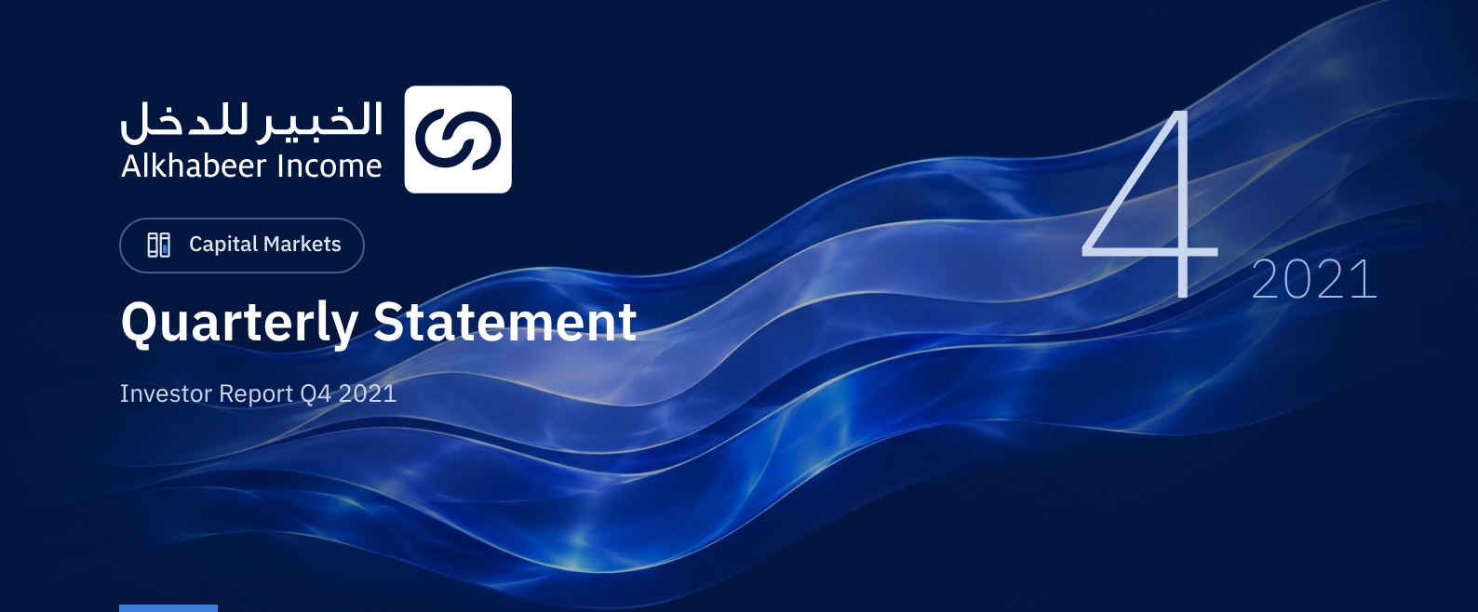

 FUND OVERVIEW
Alkhabeer Diversified Income Traded Fund (“the Fund”) is a closed-ended Shari’a-compliant investment traded fund established in accordance with the applicable laws and regulations of the Kingdom of Saudi Arabia and regulated by the Capital Market Authority (CMA). The Fund’s investment objective is to generate periodic income to investors by investing in Shari’a-compliant income generating assets. The Fund Manager “Alkhabeer Capital” plans to invest in Sukuk, trade finance transactions, leasing transactions, income funds and Murabaha transactions, either directly or through investment funds.

 KEY FUND FACTS
TADAWUL SYMBOL | 4700
BLOOMBERG SYMBOL | AKDICIF:AB
LISTING DATE | 19 January 2021
FUND TERM | 99 years, starting as from the Listing Date, renewable
NET ASSET VALUE PER UNIT | 10.2462
FUND ASSETS SIZE* | SAR 600,803,847
FUND’S TOTAL CAPITAL | SAR 472,814,700
FINANCING AMOUNT* | SAR 113,306,286
RATIO OF LOANS TO FUND’S TOTAL ASSET VALUE* | 18.86%
RATIO OF LOANS TO FUND’S NET ASSET VALUE AS AT THE END OF THE REPORTING QUARTER | 23.39%
VALUE AND PERCENTAGE OF FUND MANAGER’S INVESTMENT TO FUND’S NET ASSET VALUE AS AT THE END OF THE REPORTING QUARTER | 0.0%
RISK LEVEL | High
FUND CURRENCY | Saudi Arabian Riyal (SAR)
INVESTMENT ADVISOR AND FUND SUB-MANAGER | N/A
RATIO OF UNDERLYING FUNDS’ MANAGEMENT FEES | 0.21%

* As at 31 December 2021 (Unaudited).

FUND PORTFOLIO INVESTMENT CONCENTRATION RATIOS
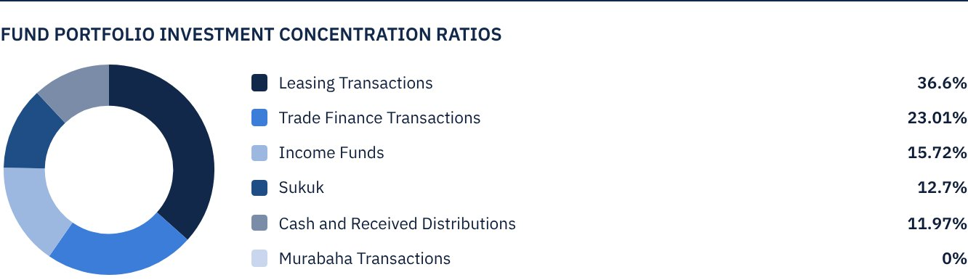

FINANCIAL INDICATORS*
VALUATION FREQUENCY | Quarterly
FUND’S TOTAL ASSET VALUE* | SAR 600,803,847
FUND UNITS’ NET ASSET VALUE* | SAR 484,454,364
AMOUNT AND RATIO OF TRANSACTION EXPENSES FOR THE REPORTING QUARTER TO FUND’S AVERAGE NET ASSET VALUE | 0.00%
RATIO OF TOTAL EXPENSES AND FEES TO FUND’S TOTAL ASSET VALUE* | 0.20%
RATIO OF FUND’S COSTS TO FUND’S TOTAL ASSET VALUE* | 0.24%
RATIO OF FUND’S COSTS TO FUND’S AVERAGE NET ASSET VALUE* | 0.30%
TOTAL EXPENSES AND FEES FOR THE REPORTING QUARTER | SAR 1,466,711
RATIO OF TOTAL EXPENSES AND FEES FOR THE REPORTING QUARTER TO FUND’S AVERAGE NET ASSET VALUE | 0.30%

* As at 31 December 2021 (Unaudited).

DISTRIBUTION OF INVESTMENTS BY GEOGRAPHY
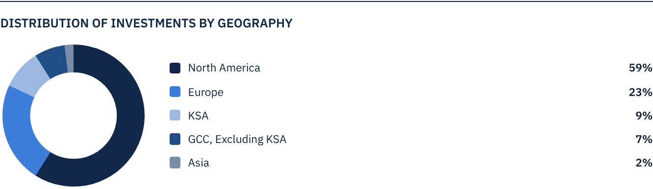

FUND ASSETS INFORMATION
TRADE FINANCE PORTFOLIO TOTAL VALUE | SAR 138,235,898
LEASING PORTFOLIO TOTAL VALUE | SAR 219,888,478
SUKUK PORTFOLIO TOTAL VALUE | SAR 76,301,845
INCOME FUNDS PORTFOLIO TOTAL VALUE | SAR 94,447,247
TOTAL CASH AND CASH EQUIVALENT | SAR 71,930,379

 NET ASSET VALUE AND UNIT PRICE PERFORMANCE*
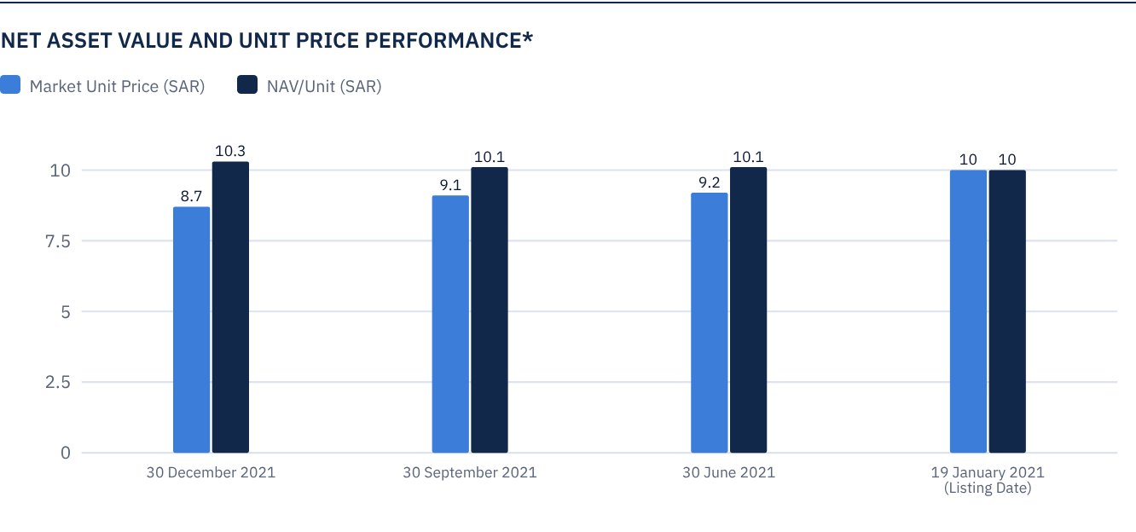
* Based on the Unit Price.

FUND MARKET VALUE INFORMATION*
AS AT THE LISTING DATE | SAR 472,814,700
AS AT 31 MARCH 2021 | SAR 428,370,118
AS AT 30 JUNE 2021 | SAR 433,098,265
AS AT 30 SEPTEMBER 2021 | SAR 427,897,304
AS AT 31 DECEMBER 2021 | SAR 409,930,345

* Based on the Unit Price.

FUND UNITS INFORMATION
UNIT PRICE AS AT THE END OF Q4 (31 DECEMBER 2021) | SAR 8.67
CHANGE IN UNIT PRICE DURING THE CURRENT QUARTER (FROM 30 SEPTEMBER 2021 TO 31 DECEMBER 2021)* | -4.20%
UNIT PRICE PERFORMANCE SINCE THE LISTING DATE (FROM THE LISTING DATE TO END Q4 2021) | -13.30%
52-WEEK HIGH | SAR 12.00
52-WEEK LOW | SAR 8.59
NUMBER OF OUTSTANDING UNITS | 47,281,470 Units

* Unit Price as at 30 September 2021 = SAR 9.05.

 DIVIDEND DISTRIBUTION FOR THE QUARTER
DIVIDEND DISTRIBUTION POLICY | The Fund Manager will distribute 100% of the semi-annual profits received from the returns on the Fund's investments after deducting the expenses from the Unitholders twice a year, provided distributions are made during the months of August and February annually.
GROSS INCOME FOR THE PERIOD (1 OCTOBER 2021 - 31 DECEMBER 2021) | SAR 8,273,117
INCOME FOR THE PERIOD ON UNIT PRICE (31 DECEMBER 2021) | 2.02 %
TOTAL DIVIDENDS DISTRIBUTED IN THE REPORTING QUARTER (ANY DIVIDEND PAID SUBSEQUENT TO THE LATEST DISCLOSED REPORT) | SAR 0.00
DIVIDENDS DISTRIBUTED PER UNIT | SAR 0.00
DIVIDENDS DISTRIBUTED ON UNIT PRICE* | 0.00%
ELIGIBILITY TO CASH DIVIDENDS DISTRIBUTED DURING THE REPORTING QUARTER | SAR 0.00
TOTAL DIVIDENDS DISTRIBUTED IN THE REPORTING QUARTER | SAR 0.00
RATIO OF DIVIDENDS DISTRIBUTED IN THE REPORTING QUARTER TO INITIAL UNIT PRICE | 0.00%

FUND PERFORMANCE CRITERIA AND INDICATORS
BENCHMARK | 12M LIBOR + 300 bps
INITIAL UNIT PRICE (AT THE INITIAL OFFERING) | SAR 10
UNIT PRICE PERFORMANCE SINCE THE PREVIOUS PERIOD* | -4.20%
UNIT PRICE PERFORMANCE SINCE THE DATE OF INCEPTION** | -13.30%
TOTAL RETURN SINCE THE DATE OF INCEPTION*** | -11.50%

* From end Q3 to end Q4 2021
** From the Fund’s Date of Inception to end Q4 2021
*** Total Return = Unit Price Performance + Total Dividend Distributions (if any).

PERFORMANCE ASSESSMENT CRITERIA AND INDICATORS*
 | ALKHABEER INCOME FUND | 12M LIBOR + 300 BPS
NET ASSET VALUE PER UNIT AS AT THE BEGINNING OF THE PERIOD* | 10.10 | NOT APPLICABLE
NET ASSET VALUE PER UNIT AS AT THE END OF THE PERIOD** | 10.25 | NOT APPLICABLE
UNIT PERFORMANCE | 1.43% | 0.80%***

* As at 30 September 2021
** As at 31 December 2021
*** Benchmark return is 3.40%

OWNERSHIP OF FUND INVESTMENTS
OWNERSHIP | PERCENTAGE (%)
FREEHOLD | 100%
LEASEHOLD | 0%

RETURNS
ITEM | 3 MONTHS* | SINCE INCEPTION OF THE FUND UP TO 31 DECEMBER 2021**
NAV/UNIT PERFORMANCE | 1.43% | 4.26%
BENCHMARK PERFORMANCE | 0.85% | 3.24%
PERFORMANCE SPREAD | 0.58% | 1.02%

* For the period from 1 October 2021 to 31 December 2021
** For the period from 19 January 2021 to 31 December 2021, including cash distributions of 1.80%.
Knowing that the Unit Price in the Exchange may increase or decrease based on market factors.

 PERFORMANCE AND RISKS
PERFORMANCE AND RISKS CRITERIA | 3 MONTHS1 | SINCE INCEPTION OF THE FUND UP TO 31 DECEMBER 20212
STANDARD DEVIATION3 | 6.42 | 9.83
SHARPE RATIO4 | -2.33 | -1.25
TRACKING ERROR5 | 6.43 | 9.84
BETA6 | -38.31 | -6.67
ALPHA7 | -19.40% | -16.28%
INFORMATION RATIO8 | -3.02% | -1.65%

1. For the period from 1 July 2021 to 31 December 2021
2. For the period from 19 January 2021 to 31 December 2021
3. Standard Deviation is a measure of risk. It is calculated as any volatility in returns over a period of time. The lower the volatility, the more homogeneous the set of returns.
4. Sharpe Ratio is a risk-adjusted performance measure. It is calculated as the difference as the Fund Manager excess return over the risk-free rate, divided by the Standard Deviation. The greater a portfolio's Sharpe Ratio, the better its risk-adjusted performance.
5. Tracking Error is a measure of risks. It is calculated as the Standard Deviation between the Fund Manager's return and the Benchmark's return. The lower the Tracking Error, the lower the Fund Manager deviates from the Benchmark.
6. Beta is a measure of the average historical sensitivity of the Fund's returns compared to market returns. It is calculated by using the covariance of the Fund and the market on the variance of the market.
7. Alpha measures any excess return achieved by the Fund compared to the performance of the index.
8. Information Ratio is a risk-adjusted performance measure. It is calculated as the active return of the Fund Manager, divided by its tracking error. The higher the Information ratio, the higher the Fund Manager ability to generate excess returns per Unit of excess risk. Knowing that the performance and risk parameters were calculated based on the Unit's trading prices in the market.

FUND HIGHLIGHTS AND ANY FUNDAMENTAL, MATERIAL OR SIGNIFICANT CHANGES AFFECTING THE PERFORMANCE OF THE FUND
• The Fund Manager invested 36.6% of the Fund’s assets in leasing transactions across several types of equipment and companies. The leasing portfolio is mainly invested in the United States and is expected to generate a total return of 6.5% annually over the next five-year term.
• The Fund Manager invested 23.0% of the Fund’s assets in trade finance transactions with several counterparties and across various industries, mostly in the European continent. All executed transactions are of a short-term nature, with returns ranging between 6.0% to 7.0% annually.
• The Fund Manager invested 12.7% of the Fund’s assets in Sukuk of different credit ratings, including sovereign, semi-sovereign and corporate Sukuk. The Fund Manager has obtained credit facilities that support increasing the Portfolio’s returns to over 5% per annum, while maintaining a weighted average for classifying the Portfolio as an investment grade.
• To diversify the Fund’s investments, the Fund Manager invested 15.7% of the Fund’s assets in income funds, ranging from private financing and leasing to trade finance and securitization, with an expected average annual return of 6% to 7%.
• The Fund Manager succeeded in obtaining Shari’a compliant financing during December 2021 amounting to SAR 75,796,490. The financing amount was placed in Ijara transactions and income funds. The Fund Manager intends to use the financing to improve the Fund’s returns in the short to medium term.
• The Fund Manager plans to distribute the profits earned as per the targeted timeframe specified in the Terms and Conditions.

OVERVIEW OF THE LEASING, TRADE FINANCE AND SUKUK INDUSTRIES

LEASING INDUSTRY OVERVIEW
While the global economies faced significant operational challenges in 2020 on account of the restrictive containment measures and the closure of the commercial activities, the gradual normalization of economic activities in 2021 driven by the availability of vaccines and higher vaccination rates have supported recovery in equipment leasing.
The Monthly Confidence Index for the Equipment Finance Industry (MCI-EFI) rebounded to 64.6 in November from 61.1 in October, indicating a positive business outlook.
The Equipment Leasing and Finance Association’s Monthly Leasing and Finance Index (MLFI-25) that tracks the economic activity of 25 prominent companies representing a cross section of the equipment finance sector, showed that YTD (through October) new business volume growth rose 10.5% as compared to 2020 levels.
According to a recent report issued by the US Equipment Leasing and Finance Association (ELFA), investment in most equipment verticals is showing signs of peaking or slowing over the next six months. However, ELFA expects volume of investment in equipment in the US to expand by 4.6% Year-on-Year in 2022, with a pickup in the pace of investment during the second half of the year.
As per estimates from ‘The Business Research Company’, the global machinery and equipment leasing market size is expected to grow from $316.2 billion in 2020 to $454.78 billion in 2025, at a strong CAGR of 7%. The Business Research Company sees the heavy construction machinery and equipment leasing segment as the segment with the most attractive opportunities.

TRADE FINANCE INDUSTRY OVERVIEW
While the global trade volumes bounced back in 2021 following a sharp drop in the initial stages of the spread of the COVID-19 pandemic in 2020, several supply chain bottlenecks continue to threaten the pace of recovery. Global trade volume is expected to reach about $28 trillion in 2021, an increase of 23% as compared to 2020.
Boston Consulting Group (BCG) estimates the global revenue pool of the trade finance industry to reach $68 billion in 2030, leaving an extra $23 billion of revenues up for the trade finance players as compared to 2020 levels of $45 billion.
The rise of digitalized platforms has been a notable trend in the trade finance space. According to the Asian Development Bank’s 2021 Trade Finance Survey, lockdown conditions on account of the spread of the pandemic accelerated the need for digital processes in the trade finance sector. This also propelled various fintech players to offer digital platforms to enable trade finance. S&P Global suggests that the banks will have to speed up their digitalization efforts and innovate their products to capture the increasing competition from the non-traditional digitalized service providers. As per BCG’s estimates, around 10% to 25% of the total trade finance volume and 20% to 25% of the volume of the small and medium-sized enterprises’ trade finance will be conducted through digital platforms through 2025.
Notably, companies, such as Amazon, Alibaba and PayPal Holdings, have already established lending arms to offer working capital to their own vendors, by using the sales data to assess performance and manage risks.
A recent report from the World Trade Organization (WTO) notes that the supply chain issues in critical sectors and the gridlock in the shipping sector are worsening prospects for global trade. UN notes that the outlook for 2022 “remains very uncertain”. The pessimistic outlook is exacerbated by the fact that many global economies, including those in Europe, continue to face COVID-19-related disruption, which affects consumer demand in 2022.

SUKUK INDUSTRY OVERVIEW
According to Refinitiv, the global Sukuk issuance volume reached $147 billion at the end of the first nine months of 2021 and is expected to continue its momentum to reach $180 billion by the end of 2021.
Over 90% of the Sukuk issuances for the first nine months of 2021 came from five countries, namely Malaysia ($58 billion), Saudi Arabia ($32 billion), Indonesia ($22 billion), Turkey ($11 billion) and Kuwait ($9 billion).
In terms of issuer type, issuances from sovereign issuers accounted for 58% of the total Sukuk issuances (for the first nine months of 2021), amounting to $85 billion, while corporate Sukuk issuances totaled $34.7 billion, registering an increase of 9% as compared to the first nine months of 2020.
Sukuk issuances were lower in some GCC countries on account of higher oil prices.
Sukuk issuances from the GCC, Malaysia and Indonesia declined in the third quarter of 2021, mainly due to the challenges associated with the provision of additional documentation to prove compliance with the Shari’a guidelines and standards, as required by the Accounting and Auditing Organization for Islamic Financial Institutions (AAOIFI).
Saudi Arabia has become a leading contender in the Sukuk market. The Kingdom’s overall annual issuance volume has increased more than seven folds since 2016, to reach $36.3 billion in 2020 and $32 billion by the end of the first nine months of 2021.
Refinitiv expects global Sukuk issuances to grow at a 10% CAGR over the next five years, from $178 billion in 2021 to $290 billion in 2026.

PERFORMANCE OF THE UNIT PRICE TRADED ON THE EXCHANGE
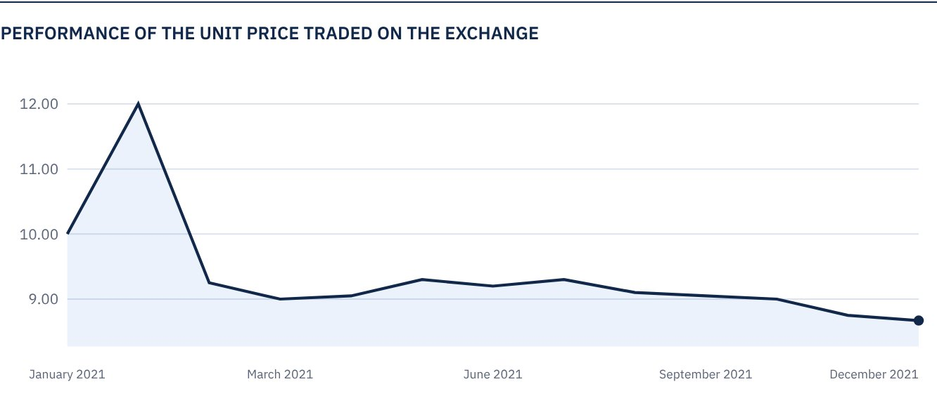

 FOR FURTHER INFORMATION
Alkhabeer Capital
PO Box 128289, Jeddah 21362
Kingdom of Saudi Arabia
Tel: +966 12 658 8888
Fax: +966 12 658 6663
Email: info@alkhabeer.com
CR No: 4030177445
CMA License No: 07074-37
www.alkhabeer.com

 DISCLAIMER
This document does not constitute an offer to buy, subscribe or participate in any way in Alkhabeer Diversified Income Traded Fund, nor shall it (or any part of it) form the basis of, or be relied on, in connection with, or act as inducement to enter into any contract whatsoever. Prospective investors should read carefully Alkhabeer Diversified Income Traded Fund’s Terms and Conditions and their contents related to investment risks as well as other Alkhabeer Diversified Income Traded Fund documents prior to making any investment decision. Alkhabeer Diversified Income Traded Fund documents are available on Alkhabeer Capital’s website www.alkhabeer.com. This investment is not a cash deposit with a local bank. The value of the amount invested and any other income which may arise therefrom may increase or decrease. All prospective investors are required to make their own determination with their own financial and legal advisors and to evaluate all risks involved. No assurance can be given that the targeted and projected results will be achieved. Moreover, past performance of Alkhabeer Diversified Income Traded Fund is not a guarantee of the Fund’s future results. By investing in the Fund, the investor acknowledges having read and accepted Alkhabeer Diversified Income Traded Fund’s Terms and Conditions, The Fund Manager or any of its affiliates shall not be liable for any financial loss which may be suffered by the Fund, unless such loss is deliberately caused by the Fund Manager.

