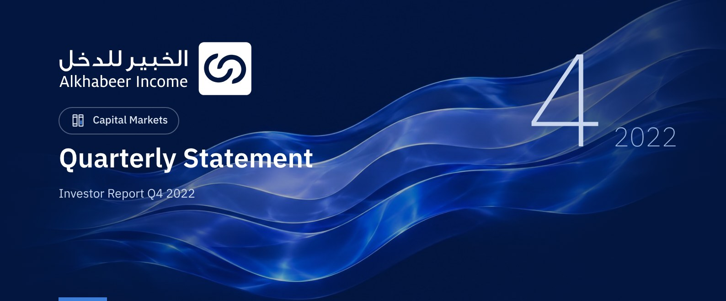

 FUND OVERVIEW
Alkhabeer Diversified Income Traded Fund (“the Fund”) is a closed-ended Shari’a-compliant investment traded fund established in accordance with the applicable laws and regulations of the Kingdom of Saudi Arabia and regulated by the Capital Market Authority (CMA). The Fund’s investment objective is to generate periodic income to investors by investing in Shari’a-compliant income generating assets. The Fund Manager “Alkhabeer Capital” plans to invest in Sukuk, trade finance transactions, leasing transactions, income funds and Murabaha transactions, either directly or through investment funds.

 KEY FUND FACTS
TADAWUL SYMBOL | 4700
BLOOMBERG SYMBOL | AKDICIF:AB
FUND TYPE | Closed-ended Traded Fund
LISTING DATE | 19 January 2021
FUND TERM | 99 years, starting as from the Listing Date, renewable
NET ASSET VALUE PER UNIT | 9.9264
FUND ASSETS SIZE* | SAR 521,400,605
FUND’S TOTAL CAPITAL AS AT THE LISTING DATE | SAR 472,814,700
BORROWING AMOUNT* | SAR 48,754,009
RATIO OF LOANS TO FUND’S TOTAL ASSET VALUE* | 9.35%
RATIO OF LOANS TO FUND’S NET ASSET VALUE AS AT THE END OF THE REPORTING QUARTER | 10.39%
VALUE OF FUND MANAGER’S INVESTMENT TO FUND’S NET ASSET VALUE AS AT THE END OF THE REPORTING QUARTER | N/A
PERCENTAGE OF FUND MANAGER’S INVESTMENT TO FUND’S NET ASSET VALUE AS AT THE END OF THE REPORTING QUARTER | 0.0%
RISK LEVEL | High
FUND CURRENCY | Saudi Arabian Riyal (SAR)
INVESTMENT ADVISOR AND FUND SUB-MANAGER | N/A
RATIO OF UNDERLYING FUNDS’ MANAGEMENT FEES | 0.34%
NUMBER OF DAYS WEIGHTED AVERAGE | 92

* As of 31 December 2022 (Unaudited).

FUND PORTFOLIO INVESTMENT CONCENTRATION RATIOS
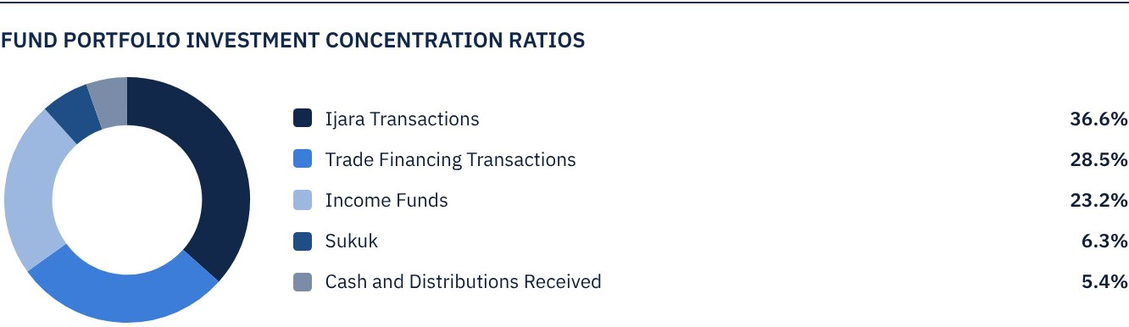
*The chart shows the fund's 10 largest investments.
The average term of Fund investments are 3.4 years.

FINANCIAL INDICATORS*
VALUATION FREQUENCY | Quarterly
FUND’S TOTAL ASSET VALUE* | SAR 521,400,605
FUND UNITS’ NET ASSET VALUE* | SAR 469,334,101
AMOUNT OF TRANSACTION EXPENSES FOR THE REPORTING QUARTER TO FUND’S AVERAGE NET ASSET VALUE | N/A
RATIO OF TRANSACTION EXPENSES FOR THE REPORTING QUARTER TO FUND’S AVERAGE NET ASSET VALUE | 0.00%
RATIO OF TOTAL EXPENSES AND FEES TO FUND’S TOTAL ASSET VALUE** | 0.47%
RATIO OF FUND’S COSTS TO FUND’S TOTAL ASSET VALUE*** | 0.64%
RATIO OF FUND’S COSTS TO FUND’S AVERAGE NET ASSET VALUE*** | 0.72%
TOTAL EXPENSES, COSTS AND FEES FOR THE REPORTING QUARTER | SAR 3,361,765
RATIO OF TOTAL EXPENSES AND FEES FOR THE REPORTING QUARTER TO FUND’S AVERAGE NET ASSET VALUE** | 0.52%

* As of 31 December 2022 (Unaudited).
** Fund expenses and fees are all Fund expenses during the reporting quarter, excluding financing costs.
*** Fund costs are all Fund fees and expenses, including financing costs.

DISTRIBUTION OF INVESTMENTS BY GEOGRAPHY
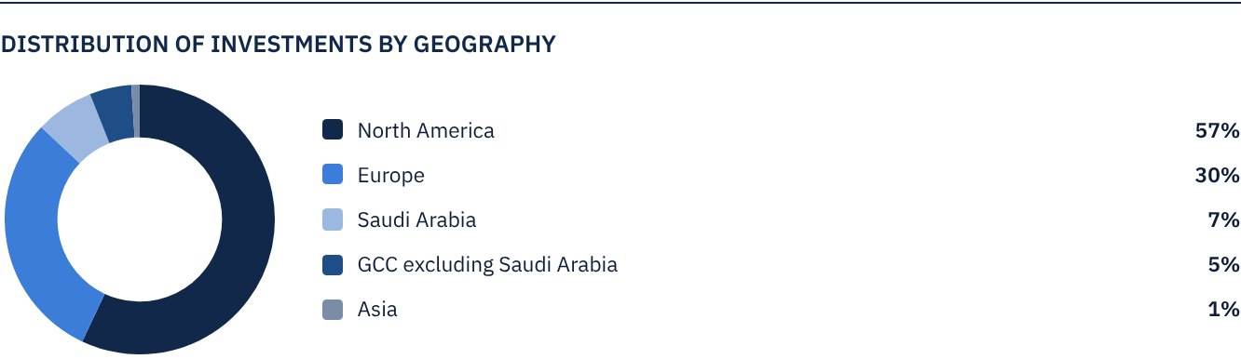

FUND ASSETS INFORMATION
TRADE FINANCE PORTFOLIO TOTAL VALUE | SAR 148,454,361
LEASING PORTFOLIO TOTAL VALUE | SAR 190,889,334
SUKUK PORTFOLIO TOTAL VALUE | SAR 32,766,996
INCOME FUNDS PORTFOLIO TOTAL VALUE | SAR 121,115,423
TOTAL CASH AND CASH EQUIVALENT | SAR 28,174,491

 NET ASSET VALUE AND UNIT PRICE PERFORMANCE*
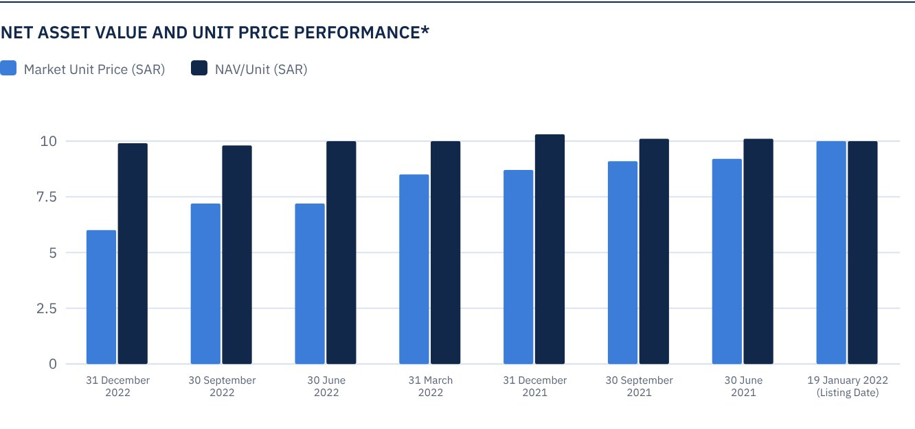
* Based on the Unit Price.

FUND MARKET VALUE INFORMATION*
AS AT THE LISTING DATE | SAR 472,814,700
AS AT 31 MARCH 2021 | SAR 428,370,118
AS AT 30 JUNE 2021 | SAR 433,098,265
AS AT 30 SEPTEMBER 2021 | SAR 427,897,304
AS AT 31 DECEMBER 2021 | SAR 409,930,345
AS AT 31 MARCH 2022 | SAR 402,838,124
AS AT 30 JUNE 2022 | SAR 342,317,843
AS AT 30 SEPTEMBER 2022 | SAR 339,480,955
AS AT 31 DECEMBER 2022 | SAR 281,324,747

* Based on the Unit Price.

FUND UNITS INFORMATION
UNIT PRICE AS AT THE END OF Q4 (31 DECEMBER 2022) | SAR 5.95
CHANGE IN UNIT PRICE COMPARED TO THE PREVIOUS QUARTER (FROM 30 SEPTEMBER 2022 TO 31 DECEMBER 2022)* | -17.13%
UNIT PRICE PERFORMANCE SINCE THE LISTING DATE (FROM THE LISTING DATE TO END Q4 2022) | -40.50%
52-WEEK HIGH | SAR 8.99
52-WEEK LOW | SAR 5.91
NUMBER OF OUTSTANDING UNITS | 47,281,470 Units
DUAL UNIT PRICE OF MONEY MARKET FUNDS AND FIXED INCOME DEBT INSTRUMENTS FUNDS | N/A

* Unit Price as at 30 September 2022 = SAR 7.18.

 DIVIDEND DISTRIBUTION
DIVIDEND DISTRIBUTION POLICY | The Fund Manager will distribute 100% of the semi-annual profits received from the returns on the Fund's investments after deducting the expenses from the Unitholders twice a year, provided distributions are made during the months of August and February annually.
TOTAL DIVIDENDS DISTRIBUTED IN THE REPORTING QUARTER* | SAR 0.00
TOTAL DIVIDENDS DISTRIBUTED FOR THE LAST SEMI-ANNUAL PERIOD** | SAR 12,293,182
DIVIDENDS DISTRIBUTED FOR THE LAST SEMI-ANNUAL PERIOD PER UNIT | SAR 0.26
RATIO OF DIVIDENDS DISTRIBUTED IN THE REPORTING QUARTER TO THE INTIAL UNIT PRICE | 0.0%
DIVIDENDS DISTRIBUTED ON UNIT PRICE*** | 3.59%
TOTAL INCOME FOR THE REPORTING QUARTER* | SAR 10,475,325
RATIO OF TOTAL INCOME FOR THE REPORTING QUARTER TO THE UNIT PRICE (31 DECEMBER 2022) | 3.72%
P/E RATIO | N/A

* From 1 October 2022 to 31 December 2022.
** From 1 January 2022 to 30 June 2022.
*** Unit Price as at the distribution date of 30 June 2022 = SAR 7.24.

FUND PERFORMANCE CRITERIA AND INDICATORS
BENCHMARK | 12M LIBOR + 300 bps
INITIAL UNIT PRICE (AT THE INITIAL OFFERING) | SAR 10
UNIT PRICE PERFORMANCE SINCE THE PREVIOUS PERIOD* | -17.13%
UNIT PRICE PERFORMANCE SINCE THE DATE OF INCEPTION** | -40.50%
TOTAL RETURN SINCE THE DATE OF INCEPTION*** | -33.60%

* Unit Price as of 30 September 2022 = SAR 7.18.
** From the Fund’s Date of Inception to end Q4 2022.
*** Total Return = Unit Price Performance + Total Dividend Distributions (if any).
Note: It should be noted that the Unit Price on the Exchange may increase or decrease based on market factors.

DESCRIPTION OF THE FUND’S BENCHMARK
The Fund’s Benchmark is 12-month LIBOR plus 300 bps.

PERFORMANCE ASSESSMENT CRITERIA AND INDICATORS*
 | ALKHABEER INCOME FUND | 12M LIBOR + 300 BPS
NET ASSET VALUE PER UNIT AS AT THE BEGINNING OF THE PERIOD* | 9.7756 | N/A
NET ASSET VALUE PER UNIT AS AT THE END OF THE PERIOD** | 9.9264 | N/A
UNIT PERFORMANCE | 1.54% | 2.05%***

* As of 30 September 2022.
** As of 31 December 2022.
*** Benchmark average return is 8.41% per annum, or a return of 2.05% for the reporting quarter.

OWNERSHIP OF FUND INVESTMENTS
OWNERSHIP | PERCENTAGE (%)
FREEHOLD | 100%
LEASEHOLD | 0%

RETURNS
ITEM | 3 MONTHS | ONE YEAR UP TO 30 SEPTEMBER 2022 | ONE YEAR
TOTAL RETURN/NAV PER UNIT "FUND PERFORMANCE" | 1.54%* | 1.86%** | 1.86%***
BENCHMARK PERFORMANCE | 2.05% | 6.42% | 6.42%
PERFORMANCE SPREAD | -0.51% | -4.56% | -4.56%

* For the period from 1 October 2022 to 31 December 2022.
** For the period from 1 January 2022 to 31 December 2022, including cash distributions of 5.1%.
*** For the period from 1 January 2022 to 31 December 2022, including cash distributions of 5.1% (NAV/Unit as at 31 December 2021 = SAR 10.2462).

 PERFORMANCE AND RISKS
PERFORMANCE AND RISKS CRITERIA | 3 MONTHS1 | ONE YEAR UP TO 30 SEPTEMBER 20222 | ONE YEAR3
STANDARD DEVIATION4 | 2.51 | 9.22 | 9.22
SHARPE RATIO5 | -13.25 | -2.41 | -2.41
TRACKING ERROR6 | 2.52 | 9.27 | 9.27
BETA7 | (24.32) | (4.92) | (4.92)
ALPHA8 | -42.05% | -28.49% | -28.49
INFORMATION RATIO9 | -16.71% | -3.07% | -3.07

1. For the period from 1 October 2022 to 31 December 2022.
2. For the period from 1 January 2022 to 31 December 2022.
3. For the period from 1 January 2022 to 31 December 2022.
4. Standard Deviation is a measure of risk. It is calculated as any volatility in returns over a period of time. The lower the volatility, the more homogeneous the set of returns.
5. Sharpe Ratio is a risk-adjusted performance measure. It is calculated as the difference as the Fund Manager excess return over the risk-free rate, divided by the Standard Deviation. The greater a portfolio's Sharpe Ratio, the better its risk-adjusted performance.
6. Tracking Error is a measure of risks. It is calculated as the Standard Deviation between the Fund Manager's return and the Benchmark's return. The lower the Tracking Error, the lower the Fund Manager deviates from the Benchmark.
7. Beta is a measure of the average historical sensitivity of the Fund's returns compared to market returns. It is calculated by using the covariance of the Fund and the market on the variance of the market.
8. Alpha measures any excess return achieved by the Fund compared to the performance of the index.
9. Information Ratio is a risk-adjusted performance measure. It is calculated as the active return of the Fund Manager, divided by its tracking error. The higher the Information ratio, the higher the Fund Manager ability to generate excess returns per Unit of excess risk. Knowing that the performance and risk parameters were calculated based on the Unit's trading prices in the market.

FUND HIGHLIGHTS AND ANY FUNDAMENTAL OR NON-FUNDAMENTAL CHANGES AFFECTING THE PERFORMANCE OF THE FUND
There were no fundamental or non-fundamental developments or changes affecting the performance of the Fund.

OVERVIEW OF THE LEASING, TRADE FINANCE AND SUKUK INDUSTRIES

LEASING INDUSTRY OVERVIEW
• According to the December 2022 Monthly Confidence Index for the Equipment Finance Industry released by the Equipment Leasing and Finance Foundation (MCI-EFI), the overall confidence index in the equipment finance industry increased to 45.9, compared to 43.7 in November. Survey results show that 55.6% of respondents believe that business conditions will remain unchanged in the coming four months, compared to 46.4% in the previous month, while 40.7% believe that business conditions will worsen, a decrease from 53.6% in November.
• The Monthly Leasing and Finance Index (MLFI-25) released by the Equipment Leasing and Finance Association (ELFA), which tracks the economic activity of 25 companies across the equipment finance sector, with a value of US$ 1 trillion, revealed that the volume of new business in November totaled US$ 8.6 billion, an increase of 9% on an annualized basis, compared to the volume of new business in November 2021. The cumulative volume of new business increased to date by 6% compared to 2021.
• According to ELFA, the expansion of investments in hardware and software boomed in the second half of 2022, forming a strong launch pad into 2023, which is expected to be a year of greater difficulty for the economy and industry. In the meantime, investment in hardware and software increased by 12% (on an annualized basis) in Q3 of 2022, a significant recovery following its weak growth in Q2.

TRADE FINANCE INDUSTRY OVERVIEW
• The United Nations Conference on Trade and Development (UNCTAD) stated that the volume of trade has increased in 2022, which is a sign of strong global demand.
• According to the Asian Development Bank (ADB), the gap in the global trade finance transactions has continued to be wide for at least ten years. It is estimated to have grown to US$ 1.7 trillion in 2020, compared to US$ 1.5 trillion in 2018. The ADB forecasts that the gap in trade finance transactions will increase to at least US$ 2 trillion in 2022.
• The significant growth in trade finance transactions is mainly attributed to the greater demand on energy products trade finance transactions. World trade is expected to reach a new high of US$ 32 million in 2022, an increase of 12% on an annualized basis, amid elastic demand on commodities and services.

SUKUK INDUSTRY OVERVIEW
• According to Fitch Credit Ratings, total Sukuk issues in major markets decreased by 14.4% in Q3 of 2022. Nevertheless, outstanding global Sukuk increased by 2.1% on a quarterly basis, to reach US$ 749.6 billion.
• Fitch Credit Ratings expects the activity in the Sukuk market to be slow in the short term in the key markets of the GCC, Malaysia and Indonesia due to continued volatility, higher interest rates, higher global energy prices, geopolitical events and lower demand on emerging market debts.
• In spite of higher profitability, domestic issuers are expected to continue to give priority to their liquidity needs for the coming year by focusing on increasing equity through debt issuance, particularly Sukuk. According to KPMG, domestic issues in the first nine months of 2022 totaled US$ 3.8 billion. This figure is expected to increase in the coming months with banks catering to the increasing demand in the public and private sectors.
• In terms of performance, losses in global Sukuk markets in 2022 are expected to mark the worst year in decades. The Sukuk market declined significantly in 2022, with Dow Jones Sukuk Index registering a decrease of 7.81%.

PERFORMANCE OF THE UNIT PRICE TRADED ON THE EXCHANGE SINCE THE INCEPTION OF THE FUND *
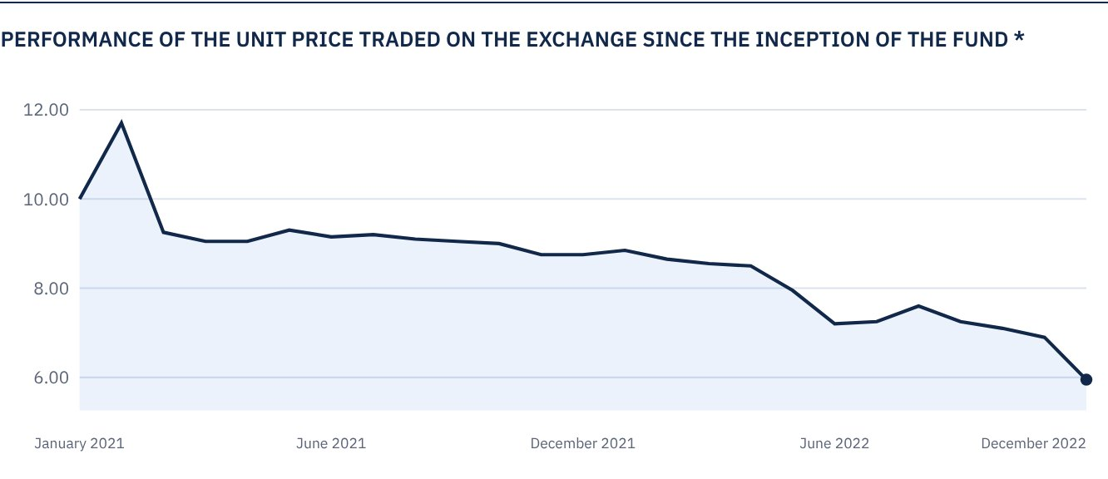
* Prices as of 31 December 2022

 FOR FURTHER INFORMATION
Alkhabeer Capital
PO Box 128289, Jeddah 21362
Kingdom of Saudi Arabia
Tel: +966 12 658 8888
Fax: +966 12 658 6663
Email: info@alkhabeer.com
CR No: 4030177445
CMA License No: 07074-37
www.alkhabeer.com

 DISCLAIMER
This document does not constitute an offer to buy, subscribe or participate in any way in Alkhabeer Diversified Income Traded Fund, nor shall it (or any part of it) form the basis of, or be relied on, in connection with, or act as inducement to enter into any contract whatsoever. Prospective investors should read carefully Alkhabeer Diversified Income Traded Fund’s Terms and Conditions and their contents related to investment risks, as well as other Alkhabeer Diversified Income Traded Fund documents prior to making any investment decision. Alkhabeer Diversified Income Traded Fund documents are available on Alkhabeer Capital’s website www.alkhabeer.com. This investment is not a cash deposit with a local bank. The value of the amount invested and any other income which may arise therefrom may increase or decrease. All prospective investors are required to make their own determination with their own financial and legal advisors and to evaluate all risks involved. No assurance can be given that the targeted and projected results will be achieved. Moreover, past performance of Alkhabeer Diversified Income Traded Fund is not a guarantee of the Fund’s future results. By investing in the Fund, the investor acknowledges having read and accepted Alkhabeer Diversified Income Traded Fund’s Terms and Conditions, The Fund Manager or any of its affiliates shall not be liable for any financial loss which may be suffered by the Fund, unless such loss is deliberately caused by the Fund Manager.

