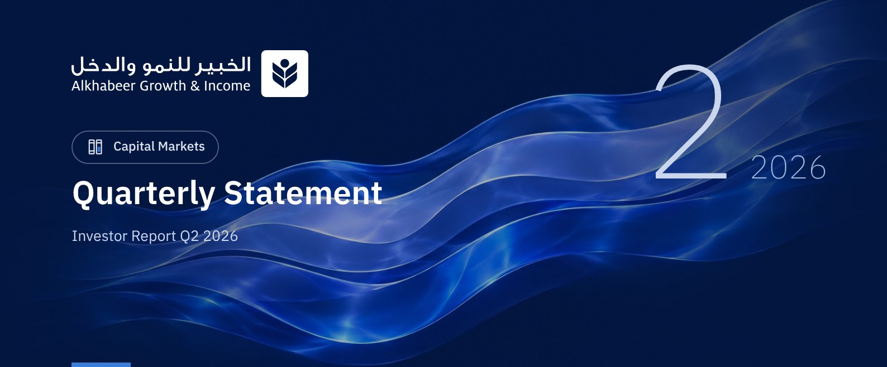

 a) Fund Objective:
The Fund Manager focuses on investing in a diversified portfolio of global equities. The Fund's investments include investing in shares of companies in all sectors, traded on global exchanges in countries such as Saudi Arabia, USA, China, Japan, Switzerland, UK, France, Germany and Canada. Investing on these exchanges will be in the currency of each country. In addition, the Fund Manager will invest in public and private equity funds managed by fund managers licensed by the Capital Market Authority (CMA) or a similar authority when investing abroad. These funds will include corporate shares of different market values in diverse geographies and sectors. The Fund Manager also intends to invest in intial public offerings (IPOs) listed on different stock exchanges, in addition to subscribing for capital increases of listed companies, as well as unlisted companies planning IPOs, by subscribing for planned IPOs, and investing in cash and cash equivalents in compliance with Shari'ah principles, to achieve long term growth and generate periodic income from the returns on equity shares and capital gain.

 b) Key Fund Facts:
Fund Inception Date | 27 April 2022
Initial Unit Price (at the Initial Offering) | SAR 10
Net Asset Value per Unit | SAR 11.7366
Fund Size* | SAR 753,788,228
Fund Type | Open-Ended Public Equity Investment Fund
Fund Currency | Saudi Riyal
Risk Level | High
Benchmark | Alkhabeer Global Equity Index
Frequency of Dividend Distribution (if any) | Semi Annual
Ratio of Management Fees of Underlying Funds | 0.05%
Investment Advisor and Fund Sub-Manager | N/A
Number of Days Weighted Average (if any) | N/A

* Fund Total Assets as at 29 June 2026 (Unaudited).
June 29, 2026 is used as the cut-off date, being the last NAV date after the Fund's conversion into an open-ended fund.

c) Definitions:
Standard Deviation | Standard Deviation is a measure of risk. It is calculated as any volatility in returns over a period of time. The lower the volatility, the more homogeneous the set of returns.
Sharpe Ratio | Sharpe Ratio is a risk-adjusted performance measure. It is calculated as the difference of the Fund Manager excess return over the risk-free rate, divided by the Standard Deviation. The greater a portfolio's Sharpe Ratio, the better its risk-adjusted performance.
Tracking Error | Tracking Error is a measure of risks. It is calculated as the Standard Deviation between the Fund Manager's return and the Benchmark's return. The lower the tracking error, the less the fund's performance deviates from the performance of the index
Beta | Beta is a measure of the average historical sensitivity of the Fund's returns compared to market returns. It is calculated by using the covariance of the Fund’s unit price and the market index by the variance of the market,
Alpha | Alpha measures any excess return achieved by the Fund compared to the performance of the index.
Information Ratio | Information Ratio is a risk-adjusted performance measure. It is calculated as the active return of the Fund Manager, divided by its tracking error. The higher the Information ratio, the higher the Fund Manager ability to generate excess returns per Unit of excess risk.

d) Fund Manager's Commentary:

Overview of Global Markets
Global equity markets delivered a strong recovery during the second quarter of 2026, supported by improved investor sentiment, resilient corporate earnings, and more measured central bank policy guidance. The Alkhabeer Global Equities Index (AGEI) was up 12.22% during the second quarter. Despite the positive market performance, volatility remained elevated due to geopolitical developments and uncertainty around energy prices.
The U.S. economy continued to expand at a solid pace, with unemployment little changed at around 4.3% and headline inflation rising to 4.2% year-on-year in May, driven largely by higher energy prices. The U.S. Federal Reserve maintained interest rates at 3.50% to 3.75%, signaling a cautious stance in response to elevated inflation. European equity markets advanced as energy prices stabilized, although the region’s growth outlook remained subdued. Emerging markets benefited from attractive valuations and robust earnings growth, despite lingering geopolitical uncertainty.
According to the IMF April 2026 World Economic Outlook, global GDP growth is projected at 3.1% in 2026, revised lower amid the geopolitical conflict, while advanced economies are projected to grow at 1.8% and emerging markets at 3.9%. Saudi Arabia is projected to grow by 3.1%, China by 4.4%, and India by 6.5% in 2026.
Looking ahead, geopolitical developments, commodity price movements, and central bank policy decisions may continue to influence equity market volatility. Nevertheless, should inflationary pressures gradually ease, energy prices stabilize, and corporate earnings sustain their current resilience, global equity markets could find meaningful support over the coming periods.

Fund Performance
Alkhabeer Growth & Income Fund follows a core-satellite investing approach, where at least 75% of assets are benchmark-aligned core allocation and the remaining allocation is actively managed through funds, IPOs, pre-IPOs, and money market instruments.
During the second quarter of 2026, the Fund achieved a total net return of 12.72%, outperforming the benchmark index (AGEI), which recorded 12.22%. Based on Fund performance attribution, the main sources of outperformance were the Fund’s active allocation to funds and supportive positioning in the Energy, Consumer Staples, and Healthcare sectors. These positive effects were partly offset by underperformance in the Information Technology sector.
The Fund’s positive alpha during the second quarter reflects the impact of these factors and confirms that performance was supported by effective investment allocation decisions and active portfolio management.

Key Fund Events and Any Fundamental or Non-Fundamental Changes Affecting Performance

Material Fund Developments
After reviewing the Fund Manager's recommendations, and taking into account the interests of all unitholders and the preservation of their rights, including compliance with the relevant statutory timelines, the Fund Board approved, on 18 December 2025, the Fund Manager’s recommendation to delist the Fund as a closed-ended traded fund and convert it into an open-ended public fund.
Following the approval of the Capital Market Authority on 20 May 2026, unitholders approved the delisting of the Fund and its conversion into an open-ended public fund on 14 June 2026.
Upon completion of all statutory procedures, trading of the Fund’s units on the Saudi Exchange (Tadawul) was suspended on 18 June 2026, and the Fund began operating as an open-ended public investment fund effective 29 June 2026.

 e) Contact Information:
Telephone Number | +966 12 658 8888
Website | www.alkhabeer.com
Email | info@alkhabeer.com

f) Price Information as at the End of the Reporting Quarter (June 2026):
Unit Price as at the end of Q2 (29 June 2026) | SAR 11.7366
Change in Unit Price Compared to Previous Quarter* | 12.72%
Dual Unit Price of Money Market Funds and Fixed Income Debt Funds | N/A
Total Fund Units | 63,876,285 Units
Fund's Net Asset Value | SAR 749,688,586
Price/Equity Ratio (P/E) | 21.1x

* Net asset value per unit in the previous quarter = 10.4120 SAR / unit

g) Fund Information as at the end of Q2 (June 2026):
Item | Saudi Riyal | %
Total Expense Ratio (TER) to Fund's Average Net Asset Value for the quarter | SAR 2,501,336 | 0.34%
Ratio of Loans to Fund's Total Asset Value | N/A | N/A
Percentage of Dealing Expenses to Fund's Average Net Asset Value* | SAR 30,695 | 0.004%
Percentage of Fund Manager's Investment to Fund's Net Asset Value | N/A | N/A
Distributed Dividends | SAR 0 | 0.00%

* Fund's Average Net Asset Value for Q2 = SAR 729,039,528.

h) Information on Ownership of Fund Investments:
Freehold | 100%
Leasehold | 0%

 i) Disclaimer:
This document does not constitute an offer to purchase, subscribe, or participate in any way in Alkhabeer Growth and Income Fund, nor does this document, or any part thereof, constitute a basis for, nor should it be relied upon for undertaking any of the foregoing, or an inducement to enter into any contract of whatever nature. Potential investors must read the Terms and Conditions of Alkhabeer Growth and Income Fund, including the investment risks stated therein, and its other documents carefully and accurately before making a decision, through the website of Alkhabeer Capital: www.alkhabeer.com This investment is not a cash deposit with a local bank. The value of the investment and any other income derived from it may rise or fall. All investors wishing to invest must also reach their decision in consultation with their financial and legal advisors and evaluate all the risks involved in the investment. No assurance can be given that the targeted and expected results will be achieved; moreover, past performance does not guarantee the fund’s future results. An investor's investment in the fund constitutes an acknowledgment that they have reviewed and accepted the fund’s Terms and Conditions. Neither the Fund Manager nor any of its affiliates shall be liable in the event of any financial loss to the fund, unless this results from deliberate acts by the Fund Manager.

j) Graph Showing the Fund's Top Ten Investments:
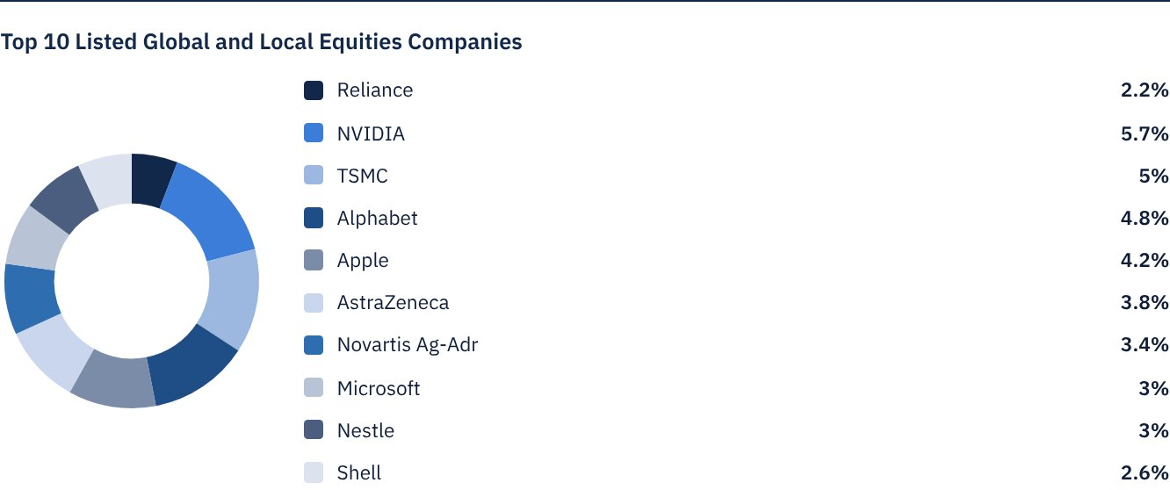

 k) Statement of Dividends Distributed to Unitholders (if any), as follows:
Total Dividend Distributions during Q2 | -
Number of Outstanding Units eligible for Dividends distribution during Q2 | -
Distributed Dividends per Unit during Q2 | -
Ratio of Distributions to Fund's Net Asset Value | -
Entitlement to Cash Distributions Paid during the Reporting Quarter | -

l) Credit Rating of Underlying Debt Instruments of the Fund's Top Ten Investments, as follows:
Credit Rating of the Debt Instrument | N/A
Credit Rating of the Issuer of the Debt Instrument | N/A
Name of the Credit Rating Agency | N/A
Date of the Credit Rating | N/A

m) Graph Showing the Distribution of Fund Assets (by Sector/Geography):
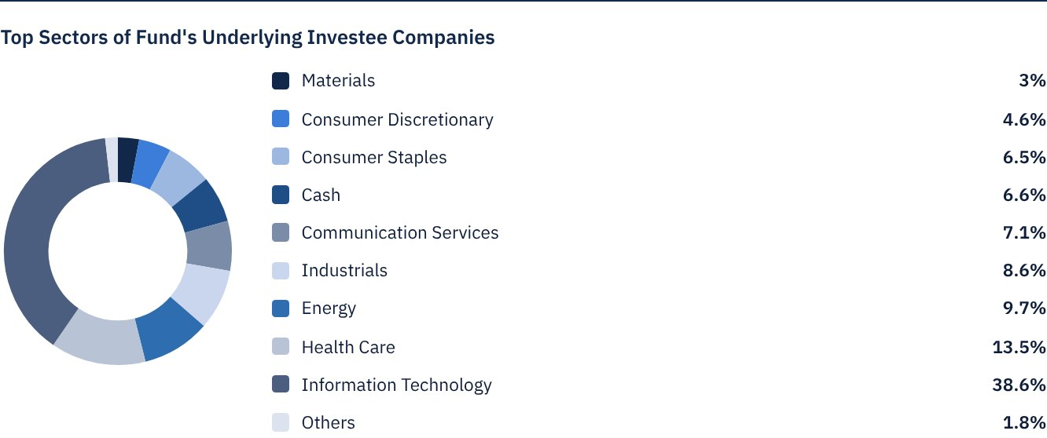
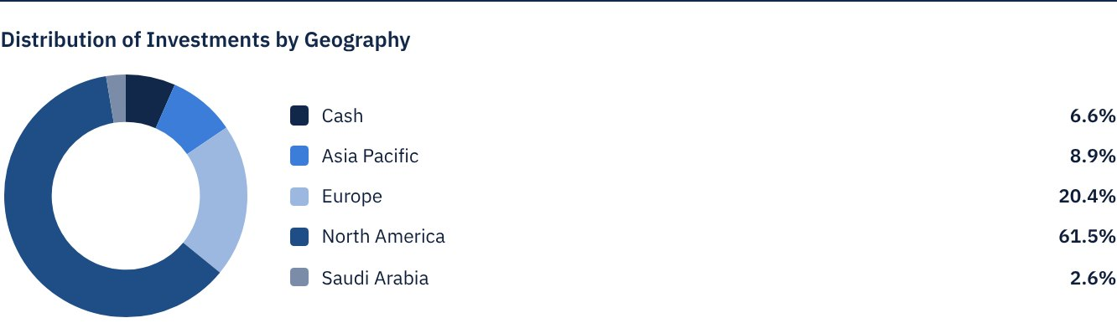

 n) Returns:
Item | 3 Months (End of Q2) | Year to Date (YTD) | One Year | 3 Years | 5 Years | Since Inception
Total Return to Net Asset Value per Unit (Fund Performance) * | 12.72% | 9.88% | 24.75% | 63.29% | N/A | 81.03%
Benchmark Performance | 12.22% | 10.83% | 26.12% | 53.66% | N/A | 66.91%
Performance Spread | 0.50% | -0.95% | -1.37% | 9.63% | N/A | 14.12%

* Total Return = NAV per Unit Price Performance plus Dividends.

 o) Performance and Risk:
Performance and Risk Criteria | 3 Months (End of Q2) | Year to Date (YTD) | One Year | 3 Years | 5 Years | Since Inception
Standard Deviation | 14.44 | 14.24 | 12.54 | 13.44 | N/A | 14.11
Sharpe Ratio | 3.99 | 1.13 | 1.57 | 0.91 | N/A | 0.70
Tracking Error | 1.87 | 2.15 | 1.86 | 5.61 | N/A | 9.23
Beta | 0.99 | 1.00 | 0.98 | 0.93 | N/A | 0.76
Alpha | 2.27% | -1.95% | -0.97% | 3.89% | N/A | 5.33%
Information Ratio | 1.55 | -0.99 | -0.73 | 0.42 | N/A | 0.24

All performance and risk measures calculations are based on daily time series data.

p) Equations Used to Calculate Performance and Risk:
Standard Deviation | σp = √[ 1/(N − 1) · Σ(Rp,i − Rp)² ] | where  Rp,i = Portfolio return in period i  Rp = Average portfolio return  N = Number of periods
Sharpe Ratio | [(Average Annualised Return − Risk Free Rate) ÷ Standard Deviation]
Tracking Error | TE = √[ 1/(N − 1) · Σ[(Rp,i − Rb,i) − (Rp − Rb)]² ] | Where  Rp,i = Portfolio return in period i  Rb,i = Benchmark return in period i  Rp = Average portfolio return  Rb = Average Benchmark return  N = Number of periods
Beta | β = Cov(Rp, Rb) / Var (Rb) | Where  Cov(Rp, Rb)= covariance between portfolio and benchmark returns  Var (Rb)= variance of benchmark returns
Alpha | α = Rp − [ Rf + β ∗ (Rb − Rf)] | Where  (Rp)= average portfolio return  (Rb)= average benchmark return  (Rf)= risk free rate  β= portfolio beta

q) Graph Depicting Peformance as of the Inception of the Fund:
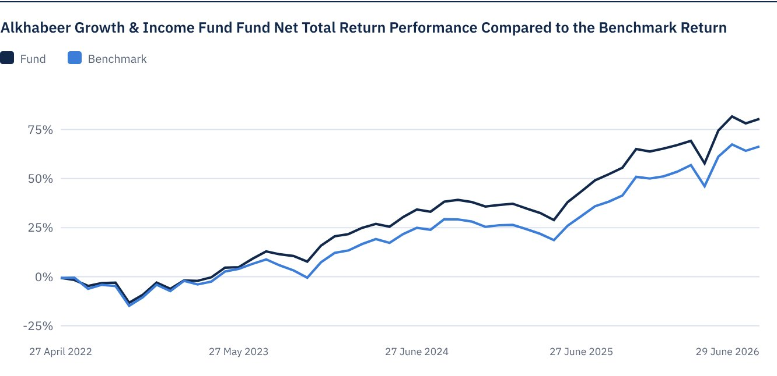
As of 29 June 2026.

FOR FURTHER INFORMATION
Alkhabeer Capital
PO Box 128289, Jeddah 21362
Kingdom of Saudi Arabia
Tel: +966 12 658 8888
Fax: +966 12 658 6663
Email: info@alkhabeer.com
CR No: 4030177445
CMA License No: 07074-37
www.alkhabeer.com

DISCLAIMER
This document does not constitute an offer to buy, subscribe or participate in any way in Alkhabeer Growth and Income Traded Fund, nor shall it (or any part of it) form the basis of, or be relied on, in connection with, or act as inducement to enter into any contract whatsoever. Prospective investors should read carefully Alkhabeer Growth and Income Traded Fund’s Terms and Conditions and their contents related to investment risks, as well as other Alkhabeer Growth and Income Traded Fund documents prior to making any investment decision. Alkhabeer Growth and Income Traded Fund documents are available on Alkhabeer Capital’s website www.alkhabeer.com. This investment is not a cash deposit with a local bank. The value of the amount invested and any other income which may arise therefrom may increase or decrease. All prospective investors are required to make their own determination with their own financial and legal advisors and to evaluate all risks involved. No assurance can be given that the targeted and projected results will be achieved. Moreover, past performance of Alkhabeer Growth and Income Traded Fund is not a guarantee of the Fund’s future results. By investing in the Fund, the investor acknowledges having read and accepted Alkhabeer Growth and Income Traded Fund’s Terms and Conditions, The Fund Manager or any of its affiliates shall not be liable for any financial loss which may be suffered by the Fund, unless such loss is deliberately caused by the Fund Manager.

