Task 1: E-commerce Demand Forecasting System (60 marks)
Submited by: Mayur Bhawsar [C0958076]
- Workflow diagram
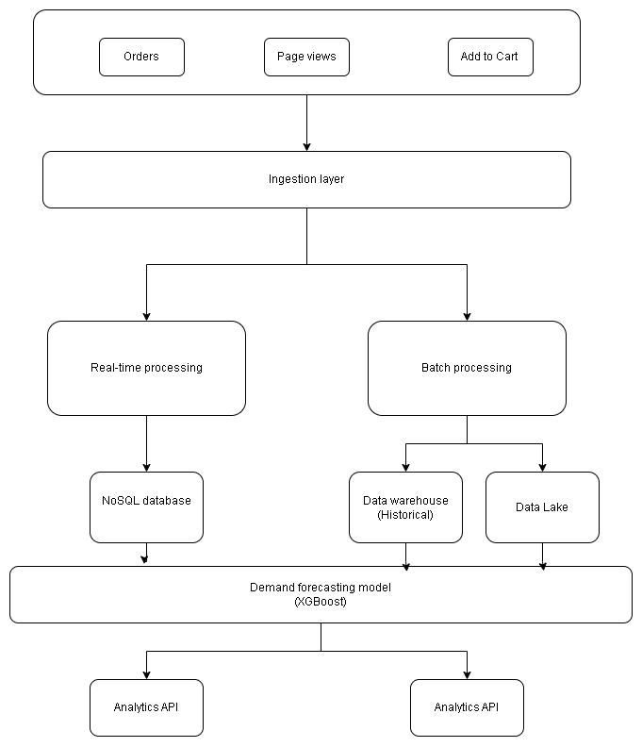

2. System Design Description
a. Data Sources
- What events are generated? (orders, product views, etc.)
Order event
Product view event
Cart event
b. Processing Pipelines
- Real-time pipeline
Gets inputs from the ingestion layer
Applies aggregation, maintaining sessions and anomaly detection
- Batch pipeline
Runs jobs periodically and fetches data
Produce aggregated results and sends further to analytics data warehouse
c. Prediction Component
- What are you predicting?
Weekly product demand
- What data is used for training?
Both data from real-time processing (noSql) data and the batch processing data (data warehouse).
- How often is the model updated?
Weekly
d. Storage / Database Choices
- Database for real-time data
Redis
- Database/data warehouse for analytics
Amazon S3 for data warehouse
Snowflake for analytics data warehouse
- Storage for ML features/models
S3 + a noSQL db
MLflow for model registry
e. Serving Layer
- APIs for product teams (e.g., demand predictions)
REST API
- Dashboard for business users
Internal React dashboard

Database schema

Tables:
Order event
order_id
user_id UUID
product_ids
total_amount
status
timestamp

Product event
event_id
user_id UUID
product_id
category
source
timestamp

Cart event

Demand prediction

Product id
predicted_units
ci_lower
ci_upper
model_version
generated_at

