

HomePage

Pakistan biggest share accommodation website

1- I Need A RoomMate(روم میٹ)
Create a listing so potential roommates can find you.

2- I Need A Room(کمرہ)
Make a listing so people seeking a room can find you.
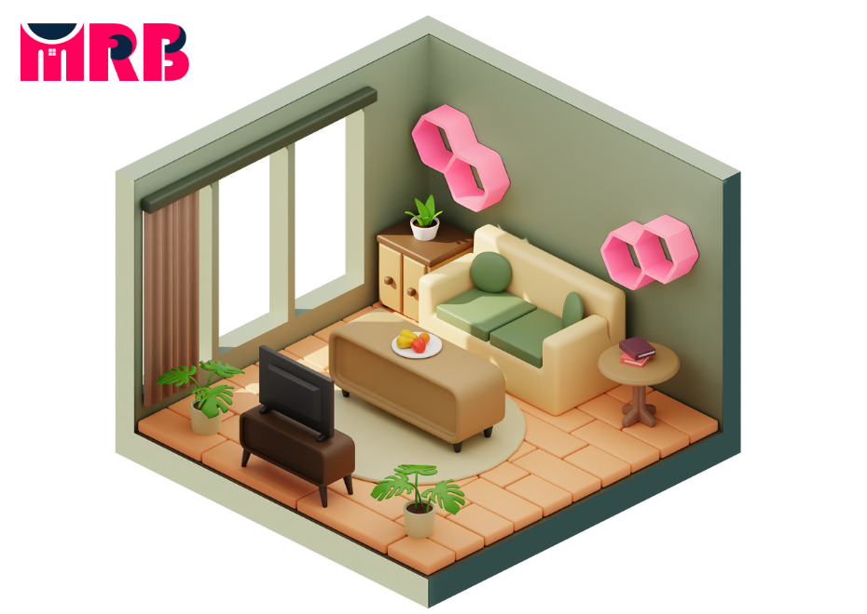

Footer:
Sharehouse.pk is a peer-to-peer listing site for those looking for shared homes or those looking for a tenant. Simply create a listing, search and connect.

About Us Page:
Welcome to sharehouse.pk! We're here to help you find or offer shared living spaces hassle-free. Whether you need a room or want to rent one out, we've got you covered.

Our goal is to make finding or offering shared accommodations easy and straightforward. With our simple platform, you can create listings, search for rooms, and connect with potential roommates or tenants in no time.

(Link to last section of this document file)
Video Play Button

 | Our Mission:  We offer our services throughout Pakistan, along with helpful tools and real estate experts, to assist you in finding the perfect shared house accommodation.  1- Room Listings: Easily advertise available rooms for rent.  2- Roommate Matching: Connect with compatible roommates.  3- Tenant Search: Find suitable tenants for your space.  4- Messaging Platform: Communicate securely with potential roommates or tenants.

How It Works Page:

List Your Space:  Create a listing for your available room, providing details such as location, amenities, and rental terms.  Search for Rooms:  Browse through listings to find rooms that match your preferences and budget. Filter results based on location, price, and other criteria.  Connect with Potential Roommates or Tenants:  Communicate with interested parties via our messaging platform. Ask questions, arrange viewings, and discuss rental agreements.  Finalize Agreement:  Once you've found the right match, finalize the rental agreement, including terms and move-in details.  Enjoy Shared Living:  Move in and enjoy your shared living experience! Benefit from cost savings, companionship, and a comfortable living environment. | 

Privacy policy Page:
We take your privacy seriously at sharehouse.pk. Here's how we handle your information:
- Personal Information: We collect basic details like your name, email, and contact information to provide our services and communicate with you.
- Usage Data: We may collect information about how you use our platform to improve user experience and troubleshoot issues.
- Cookies: We use cookies to personalize your experience and analyze site traffic. You can manage cookie preferences in your browser settings.
- Third-party Sharing: We don't sell or share your personal information with third parties without your consent, except as required by law.
- Security: We implement security measures to protect your information from unauthorized access or disclosure.
- Updates: We may update our privacy policy occasionally, and we'll notify you of any significant changes.
By using sharehouse.pk, you agree to our privacy policy terms. If you have any questions, feel free to contact us.

Terms and Conditions Page:
Welcome to sharehouse.pk! Here are the terms you agree to by using our platform:
- Acceptance: By accessing or using our services, you agree to these terms and conditions.
- User Responsibilities: You are responsible for the accuracy of the information you provide and your actions on our platform.
- Listing Guidelines: When listing a room, ensure that the information is truthful and accurate.
- Communications: We may contact you regarding your account, listings, or important updates.
- Intellectual Property: Content on sharehouse.pk is protected by copyright. You may not use it without permission.
- Liability: We are not liable for any damages resulting from your use of our platform.
- Changes: We reserve the right to update these terms at any time. You'll be notified of any significant changes.
By using sharehouse.pk, you agree to abide by these terms and conditions. If you have any questions, feel free to reach out to us.
FAQs and Contact Page:
FAQ (Frequently Asked Questions):
- What is sharehouse.pk? Sharehouse.pk is a platform where you can find shared living spaces or list your available rooms for rent.
- How do I list my room for rent? To list your room, simply create an account, fill in the details about your space, and publish your listing.
- How can I search for available rooms? You can search for rooms by using our search filters to find listings that match your preferences.
- How do I communicate with potential roommates or tenants? You can message them directly through our platform once you've found a listing you're interested in.
- Is there a fee for using sharehouse.pk? It's free to create an account, list your room, and search for available rooms.
Contact Us:
If you have any questions, concerns, or feedback, please don't hesitate to contact us. You can reach us via email at info@sharehouse.pk or by filling out the contact form on our website. We're here to help!

(Info Page)
Latest Articles:
1- "Maximizing Shared Living: The Impact of sharehouse.pk"
This article explores how sharehouse.pk is revolutionizing shared living arrangements, providing insights into its features and benefits for both landlords and tenants.

2- "The Benefits of Shared Living: Insights from sharehouse.pk Community"
Discover the numerous benefits of shared living through the experiences of sharehouse.pk users. From cost savings to companionship, explore the advantages of sharing living spaces and how sharehouse.pk is enabling individuals to unlock these benefits.

3- "Navigating Rental Agreements: A Guide for sharehouse.pk Users"
Get practical advice on understanding and navigating rental agreements for shared accommodations. Learn about key terms to look out for, your rights and responsibilities as a tenant or landlord, and how sharehouse.pk can assist you in ensuring a fair and transparent rental process.

4- "The Future of Shared Accommodations: Trends and Innovations on sharehouse.pk"
Delve into the future of shared accommodations and the role of technology in shaping this sector. Learn about emerging trends, such as co-living communities and smart home integration, and how sharehouse.pk is adapting to meet the evolving needs of its users.

5- "5 Ways to Deal with Higher Living Costs"
When living expenses go up, it's important to know how to manage your money smartly.
Article 1:
"Maximizing Shared Living: The Impact of sharehouse.pk"
This article delves into how sharehouse.pk revolutionizes shared living experiences. It explores the platform's role in simplifying the process of finding shared accommodations, connecting individuals seeking rooms with compatible roommates or tenants. sharehouse.pk's user-friendly interface and robust features streamline the search process, offering detailed listings, secure messaging options, and helpful filters to refine search results. By facilitating connections and fostering transparency, sharehouse.pk enhances the shared living experience, promoting harmonious relationships and cost-effective arrangements for users. Ultimately, sharehouse.pk's impact extends beyond convenience, shaping the way people approach shared living and maximizing the benefits of communal housing arrangements.
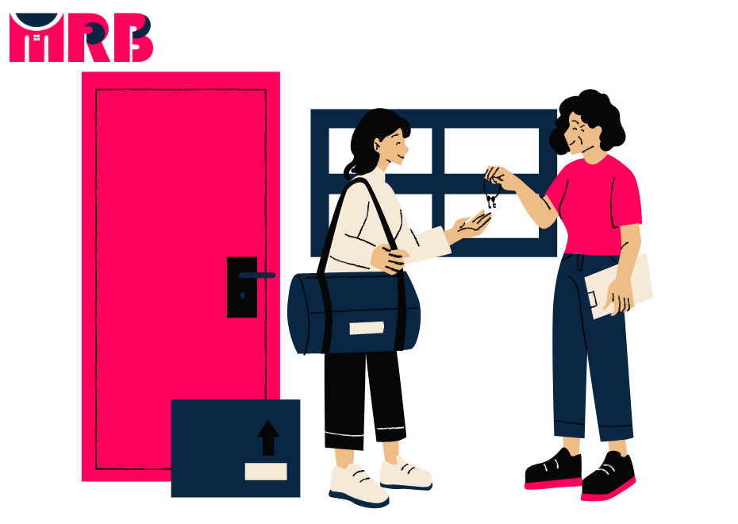

Article 2:
"The Benefits of Shared Living: Insights from sharehouse.pk Community"
This article explores the numerous advantages of shared living, as shared by members of the sharehouse.pk community. It delves into the benefits experienced by individuals who choose to live together, including cost savings, companionship, and a sense of community. Through firsthand accounts and experiences shared by users of sharehouse.pk, readers gain insights into the positive impact of shared living arrangements on their daily lives. From splitting expenses to forming meaningful connections with roommates, the article highlights how shared living enhances quality of life and fosters a supportive and collaborative environment. Overall, it provides valuable insights into the advantages of shared living and the role of sharehouse.pk in facilitating these experiences.


Article 3:
"Navigating Rental Agreements: A Guide for sharehouse.pk Users"
This guide helps sharehouse.pk users understand and manage rental agreements. It breaks things down in simple terms so you can handle your rental smoothly.
- Know the Basics: Learn the important terms in rental agreements like security deposits, lease length, rent due dates, and who handles repairs. Knowing these terms will help you understand what you’re agreeing to.
- Read Everything: Make sure to read the entire rental agreement before you sign it. Pay close attention to rules about things like subletting, pets, and how to renew your lease.
- Negotiate if Needed: Don’t be afraid to ask for changes if something doesn’t work for you. This might be about the rent amount, asking for repairs, or needing flexible lease terms.
- Know Your Rights and Duties: Understand what you and your landlord are responsible for. You have the right to a safe place to live, and you need to pay your rent on time and take care of the property.
- Solve Problems: If problems come up, know how to handle them. Document the issue, talk to your landlord, and if necessary, seek help from a mediator or lawyer.
- Keep Records: After signing, keep a copy of the rental agreement and all related documents like receipts and emails. This helps if you need to refer back to them later.
- Ending the Lease: Understand how to properly end your rental agreement. Know the notice period, how to move out, and how to get your security deposit back.
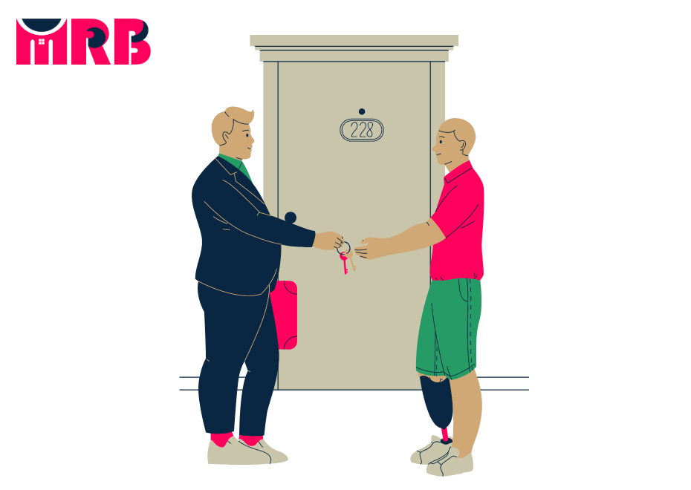
By using this guide, sharehouse.pk users can feel confident about their rental agreements. It makes the renting process easier and ensures you know your rights and responsibilities.

Article 4:
"The Future of Shared Accommodations: Trends and Innovations on sharehouse.pk"
The Future of Shared Accommodations: Trends and Innovations on sharehouse.pk"
This article talks about the future of shared living and how sharehouse.pk is leading the way with new trends and cool ideas.
Co-Living Spaces: More people are choosing co-living spaces where they have their own rooms but share common areas. sharehouse.pk helps you find these modern, stylish places that suit different lifestyles.
Tech Solutions: Technology is making shared living easier. sharehouse.pk uses smart tech like matching algorithms to find the best roommates, virtual tours to see homes online, and secure payment systems to handle rent.
Eco-Friendly Living: Living green is a big deal now. sharehouse.pk supports eco-friendly homes with energy-saving appliances and sustainable practices. You can find listings that help you live a greener life.
Flexible Leases: Flexibility is important. sharehouse.pk offers various lease options, from short-term to long-term, so you can find something that fits your needs, whether you’re a student, a professional, or a traveler.
Personalized Living: Everyone has different needs. sharehouse.pk lets you search for homes based on your preferences, like pet-friendly places or specific amenities, to ensure you find the perfect fit.
Safety and Security: Safety is always important. sharehouse.pk highlights homes with good security features to make sure you feel safe and secure in your new place.


Article 5:
"5 Ways to Deal with Higher Living Costs"
Living costs are going up, but you can still manage your money smartly. Here are five easy tips to help:
- Make a Budget: Write down how much you earn and spend each month. This helps you see where your money goes and find ways to save.
- Share Your Home: Consider living with roommates to split rent and bills. It's cheaper and can be fun too!
- Cut Back on Spending: Look for ways to spend less, like cooking at home instead of eating out or buying second-hand items.
- Earn Extra Cash: Think about ways to make more money, like getting a part-time job or selling stuff you don't need anymore.
- Use Discounts: Look for discounts and coupons when you shop. They can help you save money on things you need.

With these tips, you can handle higher living costs without stressing out. It's all about being smart with your money and finding ways to save.

How to Guide(page)
Introduction:
Welcome to our How-To Guide for sharehouse.pk ! This guide will help you use our platform to find the perfect roommate or list your room for rent.
1. Getting Started:
- Create an Account: Sign up and fill out your profile.
- Explore the Platform: Learn how to search for listings and message other users.
2. Finding a Roommate:
- Search for Listings: Use filters to find the right listing.
- Communicate: Message potential roommates to ask questions and set up viewings.
3. Listing a Room for Rent:
- Create a Listing: Step-by-step instructions to create a listing.
- Responding to Inquiries: Tips for answering messages and scheduling viewings.
4. Negotiating Terms:
- Rent Negotiation: How to talk about rent and lease terms.
- Setting Expectations: Discuss house rules and shared expenses upfront.
5. Finalizing the Agreement:
- Signing the Lease: Understanding and signing rental agreements.
- Payment and Move-In: Handling payments and moving in smoothly.
6. Managing Your Listing:
- Keeping Your Listing Updated: Updating your listing with any changes.
- Responding to Feedback: Handling feedback from users.
Conclusion:

Congrats! You now know how to use sharehouse.pk like a pro. Keep exploring and enjoy your shared living experience!

Local Guide(page)
Introduction:
Welcome to sharehouse.pk's Local Guide! Explore our comprehensive resource for valuable insights and information about neighborhoods and communities in your area.
1. Neighborhood Profiles:
- Overview: Discover detailed profiles of popular neighborhoods in your city, including information on demographics, amenities, transportation options, and nearby attractions.
- Housing Market: Get insights into the local housing market, including average rent prices, property types, and trends in housing availability.
2. Community Highlights:
- Events and Activities: Stay updated on upcoming events, festivals, and community gatherings happening in your neighborhood.
- Local Businesses: Explore nearby shops, restaurants, cafes, and other businesses that contribute to the vibrancy of your community.
3. Transportation and Accessibility:
- Public Transit: Learn about public transportation options available in your neighborhood, including bus routes, subway stations, and bike-sharing programs.
- Walkability: Assess the walkability of your neighborhood, including access to sidewalks, pedestrian-friendly amenities, and proximity to essential services.
4. Safety and Security:
- Crime Rates: Access information about crime rates and safety measures in your neighborhood, including data on reported incidents and crime prevention initiatives.
- Emergency Services: Locate nearby police stations, fire departments, hospitals, and other emergency services for peace of mind.
5. Schools and Education:
- School Districts: Explore local school districts, including information on school rankings, enrollment policies, and extracurricular activities.
- Educational Resources: Find resources for parents and students, such as tutoring services, libraries, and after-school programs.
6. Parks and Recreation:
- Green Spaces: Discover parks, playgrounds, and recreational areas in your neighborhood where you can enjoy outdoor activities and relaxation.
- Fitness Facilities: Locate gyms, sports clubs, and fitness centers offering workout classes and exercise equipment for residents.
7. Local Tips and Recommendations:
- Insider Tips: Access insider tips and recommendations from residents and community members about the best places to eat, shop, and explore in your neighborhood.
- User Reviews: Read user reviews and ratings of local businesses and services to help you make informed decisions about where to visit or shop.
Conclusion:

Explore sharehouse.pk's Local Guide to gain valuable insights and make informed decisions about your neighborhood. Whether you're a long-time resident or new to the area, our guide is your trusted companion for discovering everything your community has to offer.

About Us(page)
What is ShareHousepk?
Welcome to ShareHousepk! We're a leading online platform dedicated to simplifying the process of finding and listing shared accommodations.
Our Mission:
At ShareHousepk, our mission is to make shared living arrangements more accessible and convenient for everyone. Whether you're a student, a young professional, or a property owner, we're here to help you find the perfect match for your shared living needs.
How It Works:
Using ShareHousepk is straightforward and hassle-free. Here's how it works:
- Sign Up: Create an account on ShareHousepk to get started. It's quick, easy, and free!
- Browse Listings: Explore our extensive database of listings for shared accommodations, including rooms for rent, shared apartments, co-living spaces, and more.
- Connect with Others: Once you find a listing that interests you, use our secure messaging system to communicate directly with potential roommates or tenants.
- Finalize Arrangements: Once you've found the right match, finalize the details of your shared living arrangement and get ready to move in!
Why Choose ShareHousepk?
Here are some reasons why ShareHousepk stands out:
- Wide Selection: We offer a diverse range of listings to suit every preference and budget.
- Convenient Communication: Our secure messaging system makes it easy to connect with potential roommates or tenants directly.
- Trusted Platform: Your safety and security are our top priorities. We verify all users and ensure that transactions are conducted safely and securely.
- Supportive Community: Join our community of like-minded individuals who are all seeking positive shared living experiences. Share advice, tips, and stories with others who understand the joys and challenges of shared living.
Get Started Today:
Ready to find your perfect shared accommodation or list your available space? Sign up for a ShareHousepk account today and start your shared living journey!


Info (page)
Welcome to ShareHouse.pk
About Us:
ShareHouse.pk is your trusted platform for finding and listing shared accommodations. Whether you're a student, a young professional, or a property owner, we're here to help you navigate the world of shared living with ease.

Our Services:
- Finding Roommates: Explore our database of listings to find the perfect roommate or tenant for your shared space.
- Listing Rooms: List your available room or property on ShareHouse.pk and connect with potential tenants effortlessly.
- Local Guide: Discover valuable insights and information about neighborhoods and communities in your area through our comprehensive local guide.
How It Works:
Using ShareHouse.pk is simple:
- Sign up for an account.
- Browse listings or create your own.
- Connect with potential roommates or tenants.
- Finalize your arrangements and move in!
Articles:
- "Maximizing Shared Living: The Impact of ShareHouse.pk"
  - Learn how ShareHouse.pk is revolutionizing shared living experiences.
- "The Benefits of Shared Living: Insights from ShareHouse.pk Community"
  - Discover the advantages of shared living, as shared by our community members.
- "Navigating Rental Agreements: A Guide for ShareHouse.pk Users"
  - Get expert tips on navigating rental agreements and making informed decisions.
- "The Future of Shared Accommodations: Trends and Innovations on ShareHouse.pk"
  - Explore upcoming trends and innovations in shared accommodations.
- "5 Ways to Deal with Higher Living Costs"
  - Learn practical tips for managing higher living costs and staying financially savvy.

Get Started Today:

Ready to find your perfect shared accommodation or list your available space? Sign up for a ShareHouse.pk account and start your shared living journey today!

- Facebook Link: (Sharehouse.pk)
https://www.facebook.com/profile.php?id=61558962586427
- Instagram Link: (Sharehouse.pk)
https://www.instagram.com/sharehousepk/

- Youtube Link: (Sharehouse.pk)
https://youtube.com/channel/UCqsYfCHrgn2B33ePA_vLrtg

Address: Office no#8, 3rd Floor, Plaza#11, Sector C Enclave Ave, Bahria Enclave Islamabad.
Phone No: +92-309-8419000
Email: info@sharehouse.pk

……………………………………………………………

