CSE422 Lab Project Report Template

Group No-04
Team Member1 : SHAJEDUL AREFIN (24241267)
Team Member2 : SHAFIUL AZAM(22201551)

Submitted to
Asif Hasan sir and Rafeed Rahman sir

Table of contents
Content | Page no.
Introduction | 3
Dataset description | 4
EDA | 7
Dataset preprocessing | 7
Datasplitting | 8
Model training & testing (Supervised) | 8
Unsupervised(Clusters) | 9
Model selection/Comparison analysis | 10
Conclusion | 13

Introduction
Employee attrition is a major challenge for organizations, as high turnover leads to increased hiring costs, productivity loss, and disruption in workflow. The goal of this project is to build a machine learning model that can predict whether an employee is likely to leave the company (attrition = 1) or stay (attrition = 0) based on various employee features such as age, department, job role, salary, work-life balance, and more.
This is a binary classification problem, where the target variable represents attrition. The project explores and compares multiple machine learning algorithms — Logistic Regression, K-Nearest Neighbors (KNN), Decision Trees (DT), and Neural Networks (NN) — to identify the most effective model.
Because the dataset is highly imbalanced (most employees do not leave), special care is taken to handle class imbalance using stratified splitting, class weighting, and proper evaluation metrics such as precision, recall, and ROC-AUC, rather than just accuracy. At last, it was treated as an unsupervised learning problem using K Means Clustering.
The final objective is to provide HR teams with a reliable predictive tool that can help them take proactive measures to retain valuable employees.

Dataset Description

How many features?

- There are 35 features.(including the target one)

Classification or regression problem? Why do you think so?

- It is a binary Classification problem because the target column has only 2 outcome 0/1(True/False).

How many data points?

- 58695

What kind of features are in your dataset? (Quantitative / Categorical)
- There are 27 quantitative features and 8 Categorical features.
Do you need to encode the categorical variables, why or why not?

-Yes, because the models I am going to use they performs various types of operation such as matrix multiplication(Linear Regression, Neural Net) and distance calculation(KNN). so, it was necessary encode the categorical variables.

Correlation of all the features (input and output features) (apply heatmap using the seaborn library)

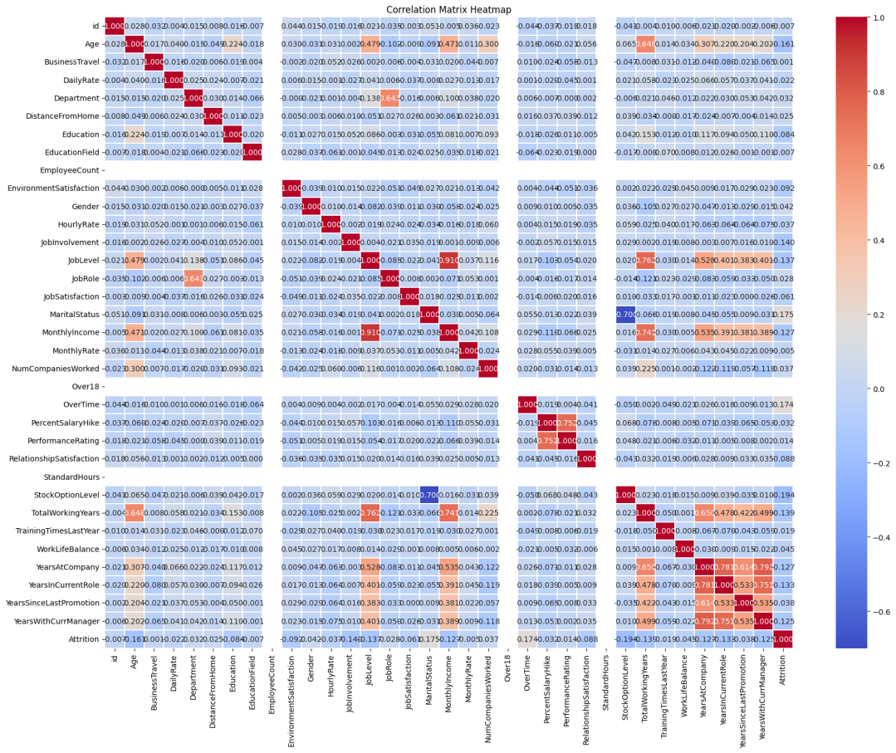

What do you understand after the correlation test?

- After the correlation test I’ve seen multiple features have correlation between each other such as YearsAtCompany-Yearsatcurrentrole(.78), yearswithcompany-yearswithcurrentmanager(.79). But with 0.8 threshold the one that extended it was joblevel-monthlyincome(.92).

Imbalanced Dataset

For the output feature, do all unique classes have an equal number of instances or not?
- No, all unique classes don’t have an equal number of instances.(no. of 0: 1477, no. Of 1-200).

Represent using a bar chart of N classes (N=number of classes you have in your dataset).

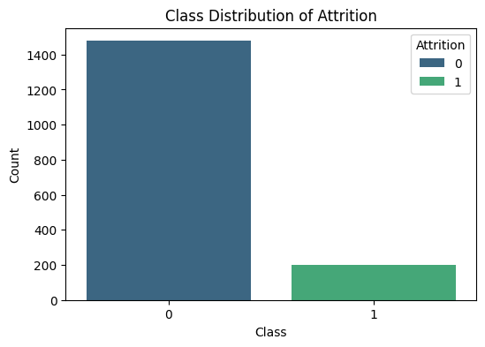

Perform exploratory data analysis to extract some important relationships from your data. [Reference: EDA Lab CSE422]
https://colab.research.google.com/drive/1qrXCFJ78hQFlwVEAxbnp5N5LzlSVEOIn?usp=sharing
This link contains all the EDA data of my dataset
Dataset pre-processing
While prepossessing the data at first I checked if there is any null value but the data-set didn’t contain any null value.
Then the column “Id” wasn’t a useful data to my data-set that is why I dropped that column
There were 2 of the column which contains just one unique value. Which didn’t add any value in my calculation. “EmployeeCount”, “Over18” I dropped them as well.
Then I handled the categorical columns
Firstly there was one columned that needed to be mapped which is "BusinessTravel” because it contains data that were hierarchical.
Then there was a column named “overtime” which needed to be ladled as binary classified.
Some columns needed to be one hot encoded 'Department', 'EducationField','Gender', 'JobRole', 'MaritalStatus' becasuse all of their value was within the same hierarchical.
And lastly I calculated their correlation using the seaborn library. Which showed some of the correlation that were crossing my threshold 0.8. A this much high correlation will affect my models prediction and that is what led me to dropping one of them(“Department_Human_Resources”, “MonthlyIncome”, “JobRole_Sales_Executive”).
And lastly in my numerical columns the variance was quite different from one another. So, I scaled them with the Standard scaler except the Boolean ones(0/1).

Dataset splitting

I split-ted the data in a 80/20 manner and it was stratified. Because of my highly imbalance target column. Which ensured the test and train portion have the same amount of (0s and 1s).
I also used K-fold cross validation which helped me ensuring a great amount of accuracy. And got maximum amount of insights from the data.

Model training & testing (Supervised)

As my problem was a classification problem. That is why I used these 3 models for training and tesing

KNN (for classification problem)

Logistic Regression (for classification problem)

Neural Network (for classification/regression problem) [This was applied using SKlearn]

Unsupervised Learning(K means Clusters)
Result:-

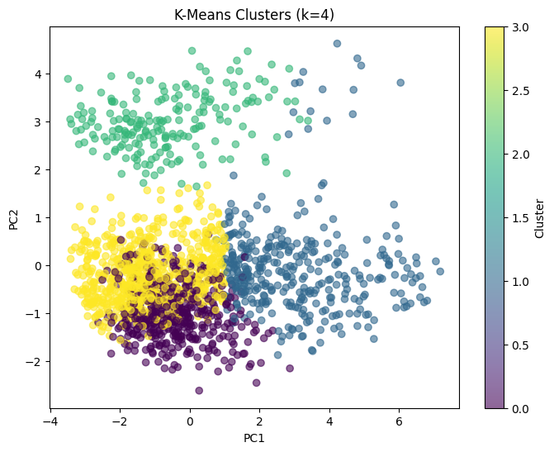

Model selection/Comparison analysis
While comparing the accuracy was the average accuracy of the 5 folds of the data. And the Confusion_matrix, Precision, Recall, ROC_AUC was the data from the best ROC_AUC fold.

Bar chart showcasing prediction accuracy of all models (for classification)
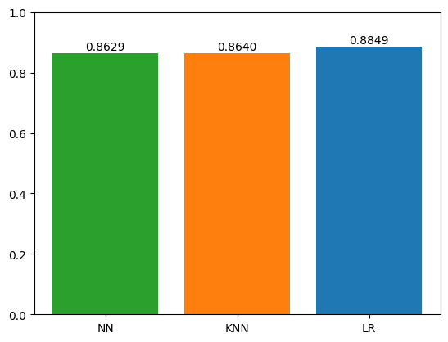
Precision, recall comparison of each model. (for classification)
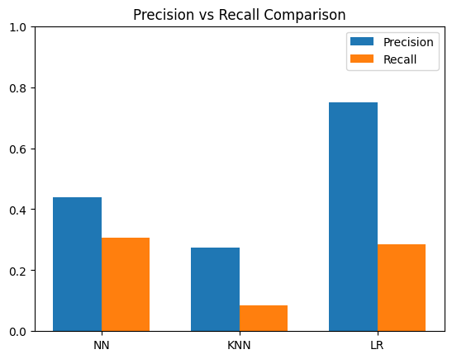
Confusion Matrix (for classification)
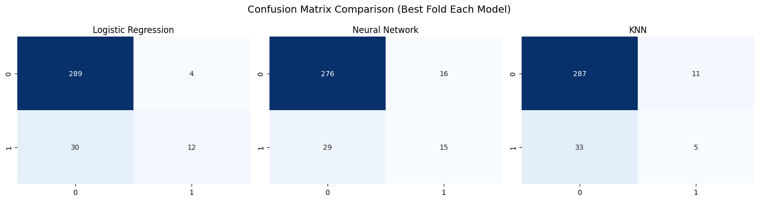
AUC score, ROC curve for each model (for classification)
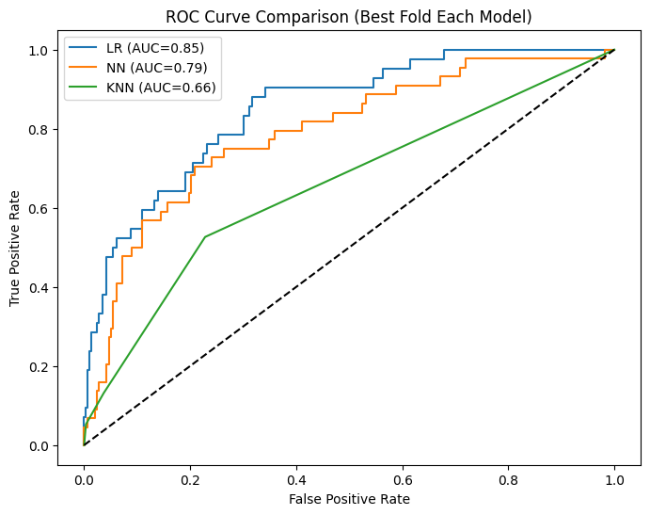
From the above data we can see that though the accuracy wise Neural Network came at last but it is onw with highest recall as it performed well in the negative class compared to the Linear Regression Model and the Linear Regression is the one with highest Precision score and the highest AUC. It shows that it can perform well in this kind of dataset. And though KNN went second in terms of accuracy but It has the lowest Precision, recall and AUC score.

Conclusion

What do you understand from the results

From the above data we can see that though the accuracy wise Neural Network came at last but it is onw with highest recall as it performed well in the negative class compared to the Linear Regression Model and the Linear Regression is the one with highest Precision score and the highest AUC. It shows that it can perform well in this kind of dataset. And though KNN went second in terms of accuracy but It has the lowest Precision, recall and AUC score.

Make useful comments regarding the performance of your model
The Logistic Regression model performed very well on this dataset, achieving the highest accuracy among the models. This result is expected because Logistic Regression works effectively when the decision boundary between classes is approximately linear, which seems to be the case here. However, it was slightly sensitive to class imbalance and tended to favor the majority class.
The KNN model also performed competitively, achieving similar accuracy to Logistic Regression. KNN benefits from well-scaled features and can capture some non-linear patterns, but it can be computationally expensive on larger datasets and is sensitive to noisy data. Its performance slightly dropped compared to LR when the class imbalance was considered.

Neural Network didn’t have good accuracy compared to the other 2 because the data-set wasn’t that much complex rather a simple one. But it handled the imbalance portion better than the LR and KNN.

Why do you think you are getting such results
The performance of the models could be influenced by the complexity of the dataset. For instance, simple models like Logistic Regression (LR) might perform well if the data has clear linear separability, whereas Neural Networks (NN) may not show a significant advantage on simple datasets.
Imbalanced classes can affect metrics like accuracy. Some models might handle imbalance better than others (e.g., NN can adjust weights, whereas KNN and LR may need preprocessing like oversampling).
Feature scaling and variance: Large differences in feature ranges can impact models differently. Models like KNN are sensitive to scale, so normalization is important.
Hyperparameter tuning: If hyperparameters are not optimally chosen, some models may underperform.
What are some of the challenges that you have faced
In the supervised learning portion I didn’t faced that much of a challenge except the data preprocessing part. But In the unsupervised portion. I had to apply PCA(Principle component analysis) firstly for getting how many components got the 95% of the variance then I converted 46 component to 19 and then I had to calculate the knee point and then used that 4 clusters. Lastly in graph I had to convert it to 2 component and then graph the clusters. It was challenging yet a great experience.

Reference:
- Pedregosa et al., "Scikit-learn: Machine Learning in Python," Scikit-learn Documentation, 2011. [Online]. Available: https://scikit-learn.org/stable/ . [Accessed: Sep. 5, 2025].
CampusX, "CampusX – YouTube channel," YouTube, 2025. [Online]. Available: https://www.youtube.com/@campusx-official. [Accessed: Sep. 7, 2025].

