CHAPTER THREE
METHODOLOGY AND SYSTEM DESIGN

3.1 Research Methodology

3.1.1 Research Approach
This study adopts a Design Science Research (DSR) approach, in which the primary research output is a purposeful IT artefact, in this case the Smart Campus Parking Management System, built and evaluated to address a defined organisational problem (Hevner et al., 2004). DSR was chosen over a purely experimental, survey, or case-study approach because the objective of the study, stated in Chapter One, is to design, build, and evaluate a working system rather than to test a hypothesis about an existing population or to describe a phenomenon without intervention. The study follows the general activities of the Design Science Research Methodology (DSRM) process model of Peffers et al. (2007): problem identification and motivation (Chapter One), definition of objectives for a solution (Chapter One), design and development (this chapter and Chapter Four), demonstration and evaluation (Chapter Four), and communication of the results (this report as a whole).

3.1.2 Data Collection Methods
Because the study is systems-oriented rather than survey-oriented, no questionnaire or interview instrument was administered to a sample of respondents. Instead, requirements were gathered through three complementary, non-human-subject sources: a review of the smart-parking and campus-parking literature discussed in Chapter Two, an informal review of how parking is currently managed on the KsTU campus and in the Kumasi central business district more broadly (corroborated by the governance study of Ntim et al., 2023), and an analysis of the parking roles and constraints that already exist in a typical Ghanaian tertiary institution (distinct categories of student, lecturer, staff, and visitor, each with different parking privileges). These sources were triangulated to arrive at the functional and non-functional requirements presented in Section 3.2. Because no personal or institutional data was collected from human participants for this purpose, no questionnaire or interview transcript accompanies this report as an appendix.

3.1.3 System Development Methodology
The system itself was developed using an Agile, iterative approach (Beck et al., 2001), in which functionality was built and tested in small, independently usable increments rather than as a single, fully specified build. In practice, this meant the system was developed roughly in the following increments: (1) authentication and user profiles, (2) zone and slot management, (3) vehicle registration, (4) the reservation workflow and role-based allocation engine, (5) QR-code generation and verification, and (6) the administrative reporting dashboard. Each increment was runnable and testable on its own before the next was added, which allowed earlier design decisions, such as the shape of the Appwrite collections, to be revisited as later increments exposed new requirements, a flexibility that a strictly sequential, Waterfall-style process would not have accommodated within the timeframe of an undergraduate project.

3.2 Requirements Analysis

3.2.1 Functional Requirements
The functional requirements below were derived directly from the modules implemented in the system and describe what the system must do.
1. The system shall allow a prospective user to register an account by supplying a name, email address, password, role (student, lecturer, staff, or visitor), department, and phone number.
2. The system shall allow a registered user to log in and log out, and to request and complete a password reset via an emailed recovery link.
3. The system shall allow a logged-in user to view and update their profile information.
4. The system shall allow a logged-in user to add, edit, and delete their own vehicles, each recorded with a plate number, vehicle type, colour, brand, and model.
5. The system shall display a live parking map showing all zones and the current status (available, reserved, occupied, or under maintenance) of every slot within them.
6. The system shall allow a logged-in user to reserve a parking slot by selecting a destination zone and one of their registered vehicles, and shall allocate a slot automatically according to the user's role and the destination-then-fallback rule described in Section 3.5.
7. The system shall prevent a user from holding more than one active reservation at a time, and shall automatically expire a reservation, releasing its slot, once a fixed holding period (30 minutes) has elapsed without verification.
8. The system shall generate a unique, scannable QR code for each active reservation and allow the user to view or cancel their reservation.
9. The system shall send an email notification to the user when a reservation is confirmed, cancelled, or expired, and shall log each notification attempt.
10. The system shall allow an administrator to scan a reservation's QR code with a device camera, verify the reservation against the stored token, expiry, and status, and, if valid, mark the reservation as completed and its slot as occupied.
11. The system shall allow an administrator to create, edit, and delete parking zones and slots, including toggling a slot into and out of maintenance status.
12. The system shall allow an administrator to view all registered users and vehicles, and to change a user's role.
13. The system shall allow an administrator to view all reservations across all users, and a reporting dashboard summarising user counts by role, slot occupancy by status, the most-used zones, and daily reservation volume over the past seven days.

3.2.2 Non-Functional Requirements
1. Usability: the interface shall be responsive across desktop and mobile screen sizes, built from an accessible component library (Radix UI/shadcn), and shall support both light and dark themes.
2. Performance: the allocation algorithm shall return a result in a single pass over the retrieved zones and slots, so that a reservation request completes without a perceptible delay under normal campus-scale data volumes (tens of zones, hundreds of slots).
3. Security: every state-changing operation shall run as a server action or API route that independently re-checks the caller's authenticated session and, where relevant, their role, rather than trusting client-supplied role information; session identifiers shall be stored in an HTTP-only cookie.
4. Availability and reliability: the system shall depend only on Appwrite's managed authentication, database, and messaging services rather than on self-hosted infrastructure that the development team would otherwise need to keep available.
5. Maintainability: the codebase shall separate concerns by domain (auth, vehicles, zones, slots, reservations, reports, notifications) into individually testable server-action modules, so that a change to one domain's logic does not require touching unrelated modules.
6. Data integrity: role eligibility, slot availability, and reservation-uniqueness rules shall be enforced on the server before any database write, not only in the client interface.
7. Auditability: every outbound notification email shall be recorded in an EmailLogs collection with its outcome (sent or failed), so that delivery issues can be investigated after the fact.

3.2.3 User Requirements / User Stories
1. As a student, I want to see which parking zones have space near my next class before I leave home, so that I do not waste time circling the campus looking for a slot.
2. As a lecturer, I want my reservation to be eligible for staff slots as well as general slots, so that my role is respected when the system allocates a space.
3. As a visitor, I want to be able to register a single-use account and reserve a slot without needing a long-term university affiliation.
4. As a registered user, I want a QR code I can show at the gate, so that I do not need to carry a physical permit or explain my reservation to security staff verbally.
5. As a registered user, I want to be notified by email if my reservation is about to be cancelled or has expired, so that I am not caught by surprise.
6. As an administrator, I want to scan a QR code at the entrance and immediately know whether the reservation is genuine, so that I can admit or turn away a vehicle with confidence.
7. As an administrator, I want a dashboard showing which zones are busiest and how occupancy is trending, so that I can advise the university on where to add capacity.
8. As an administrator, I want to take a slot out of service for maintenance without deleting it, so that it is not offered to drivers while it is unusable but its history is preserved.

3.3 Tools and Technologies Used
This section lists the concrete tools and technologies used to build the Smart Campus Parking Management System, corresponding to the technology categories discussed conceptually in Chapter Two.

3.3.1 Programming Language
JavaScript (in JSX form for React components) is used throughout the codebase, on both the client and the server, since Next.js allows a single language to express the user interface, the server actions, and the API route handlers.

3.3.2 Frameworks and Libraries
• Next.js 16 (App Router) — provides file-based routing, React Server Components, Server Actions, and API routes in a single framework.
• React 19 — the underlying UI library for building interactive components (e.g., ParkingMapClient, ReserveForm, ScanClient).
• Tailwind CSS 4 with shadcn and Radix UI — utility-first styling and accessible, unstyled component primitives used to build the buttons, cards, dialogs, and form controls seen throughout the interface.
• next-themes — implements the light/dark theme toggle.
• lucide-react — the icon set used across the interface.
• recharts — renders the bar/line charts on the administrative reports page.
• qrcode — generates the QR code image (as a data URL) for a reservation on the client.
• html5-qrcode — decodes a QR code from the device camera on the admin scanning page.

3.3.3 Database and Backend Services
• Appwrite — the backend-as-a-service platform providing account/session authentication, the NoSQL document database (collections for users, vehicles, zones, slots, reservations, and email logs), and transactional email messaging.
• appwrite (client SDK) and node-appwrite (server SDK) — the JavaScript libraries through which the Next.js application calls Appwrite's Auth, Databases, and Messaging APIs.

3.3.4 Development Tools
• pnpm — the package manager used to install and manage project dependencies.
• ESLint 9 with eslint-config-next — enforces code-quality and framework-specific linting rules.
• Git — used for version control of the source code.
• Environment variables (.env.local, with .env.example as a template) — used to keep the Appwrite endpoint, project ID, database ID, and API key out of source control.
• A code editor such as Visual Studio Code, and Node.js as the JavaScript runtime for local development and the seed script (scripts/seed.js).

3.4 System Design

3.4.1 System Architecture Diagram
Figure 3.1 shows the three-tier architecture of the system: a browser-based client that renders the Next.js user interface and hosts the QR-generation and QR-scanning libraries; a Next.js application server that enforces route protection through middleware, serves pages, exposes API routes, and executes the domain-specific server actions and the allocation engine; and Appwrite, which supplies authentication, the document database, and email messaging as managed backend-as-a-service capabilities. All data reads and writes pass through the server-action layer, so that the client never talks to Appwrite directly with elevated privileges.

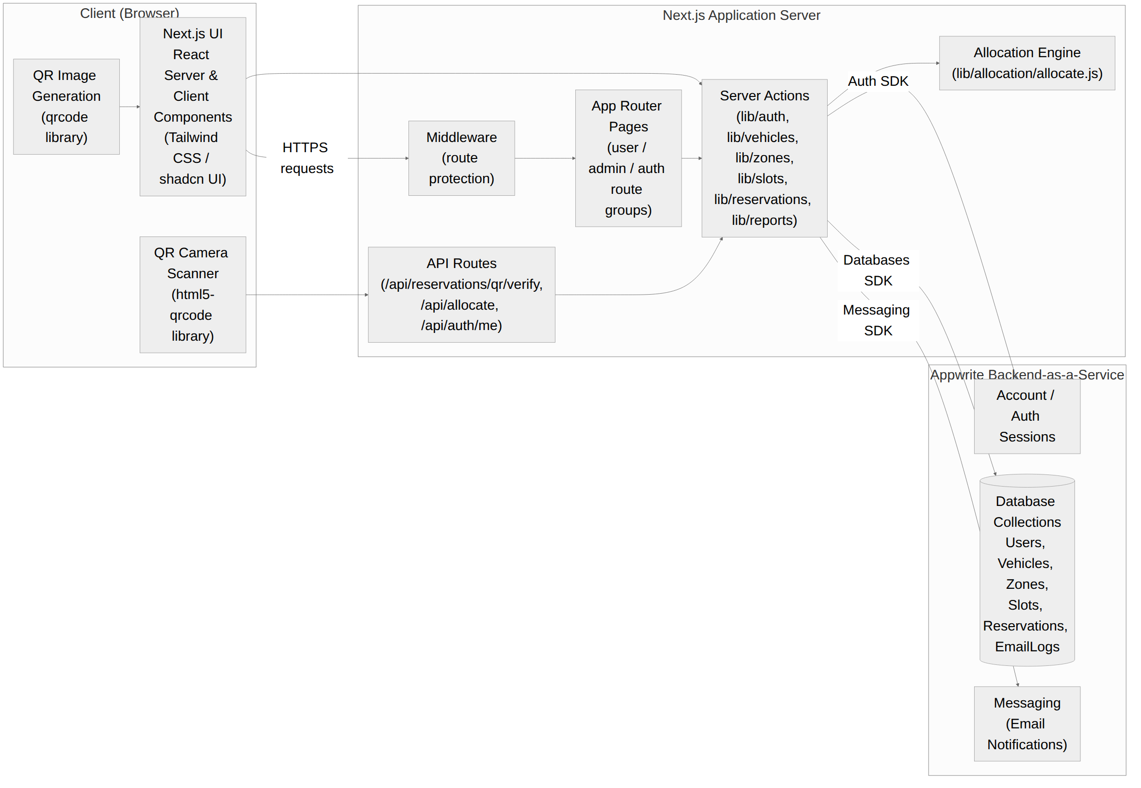
Figure 3.1: System Architecture Diagram

3.4.2 Use Case Diagram
Figures 3.2a and 3.2b summarise the system's functionality from the perspective of its two categories of actor. A Registered User, whether a student, lecturer, staff member, or visitor, can register and log in, manage a profile and vehicles, view the live parking map, reserve a slot (which internally invokes role- and destination-based allocation), and view, cancel, and receive notifications about a reservation. An Administrator, a role which in the current system also covers campus security or gate staff who are simply issued an administrator account, can manage zones and slots, manage users and their roles, view all reservations, view analytical reports, and scan a QR code to verify and admit a vehicle, which in turn updates the corresponding slot to occupied.

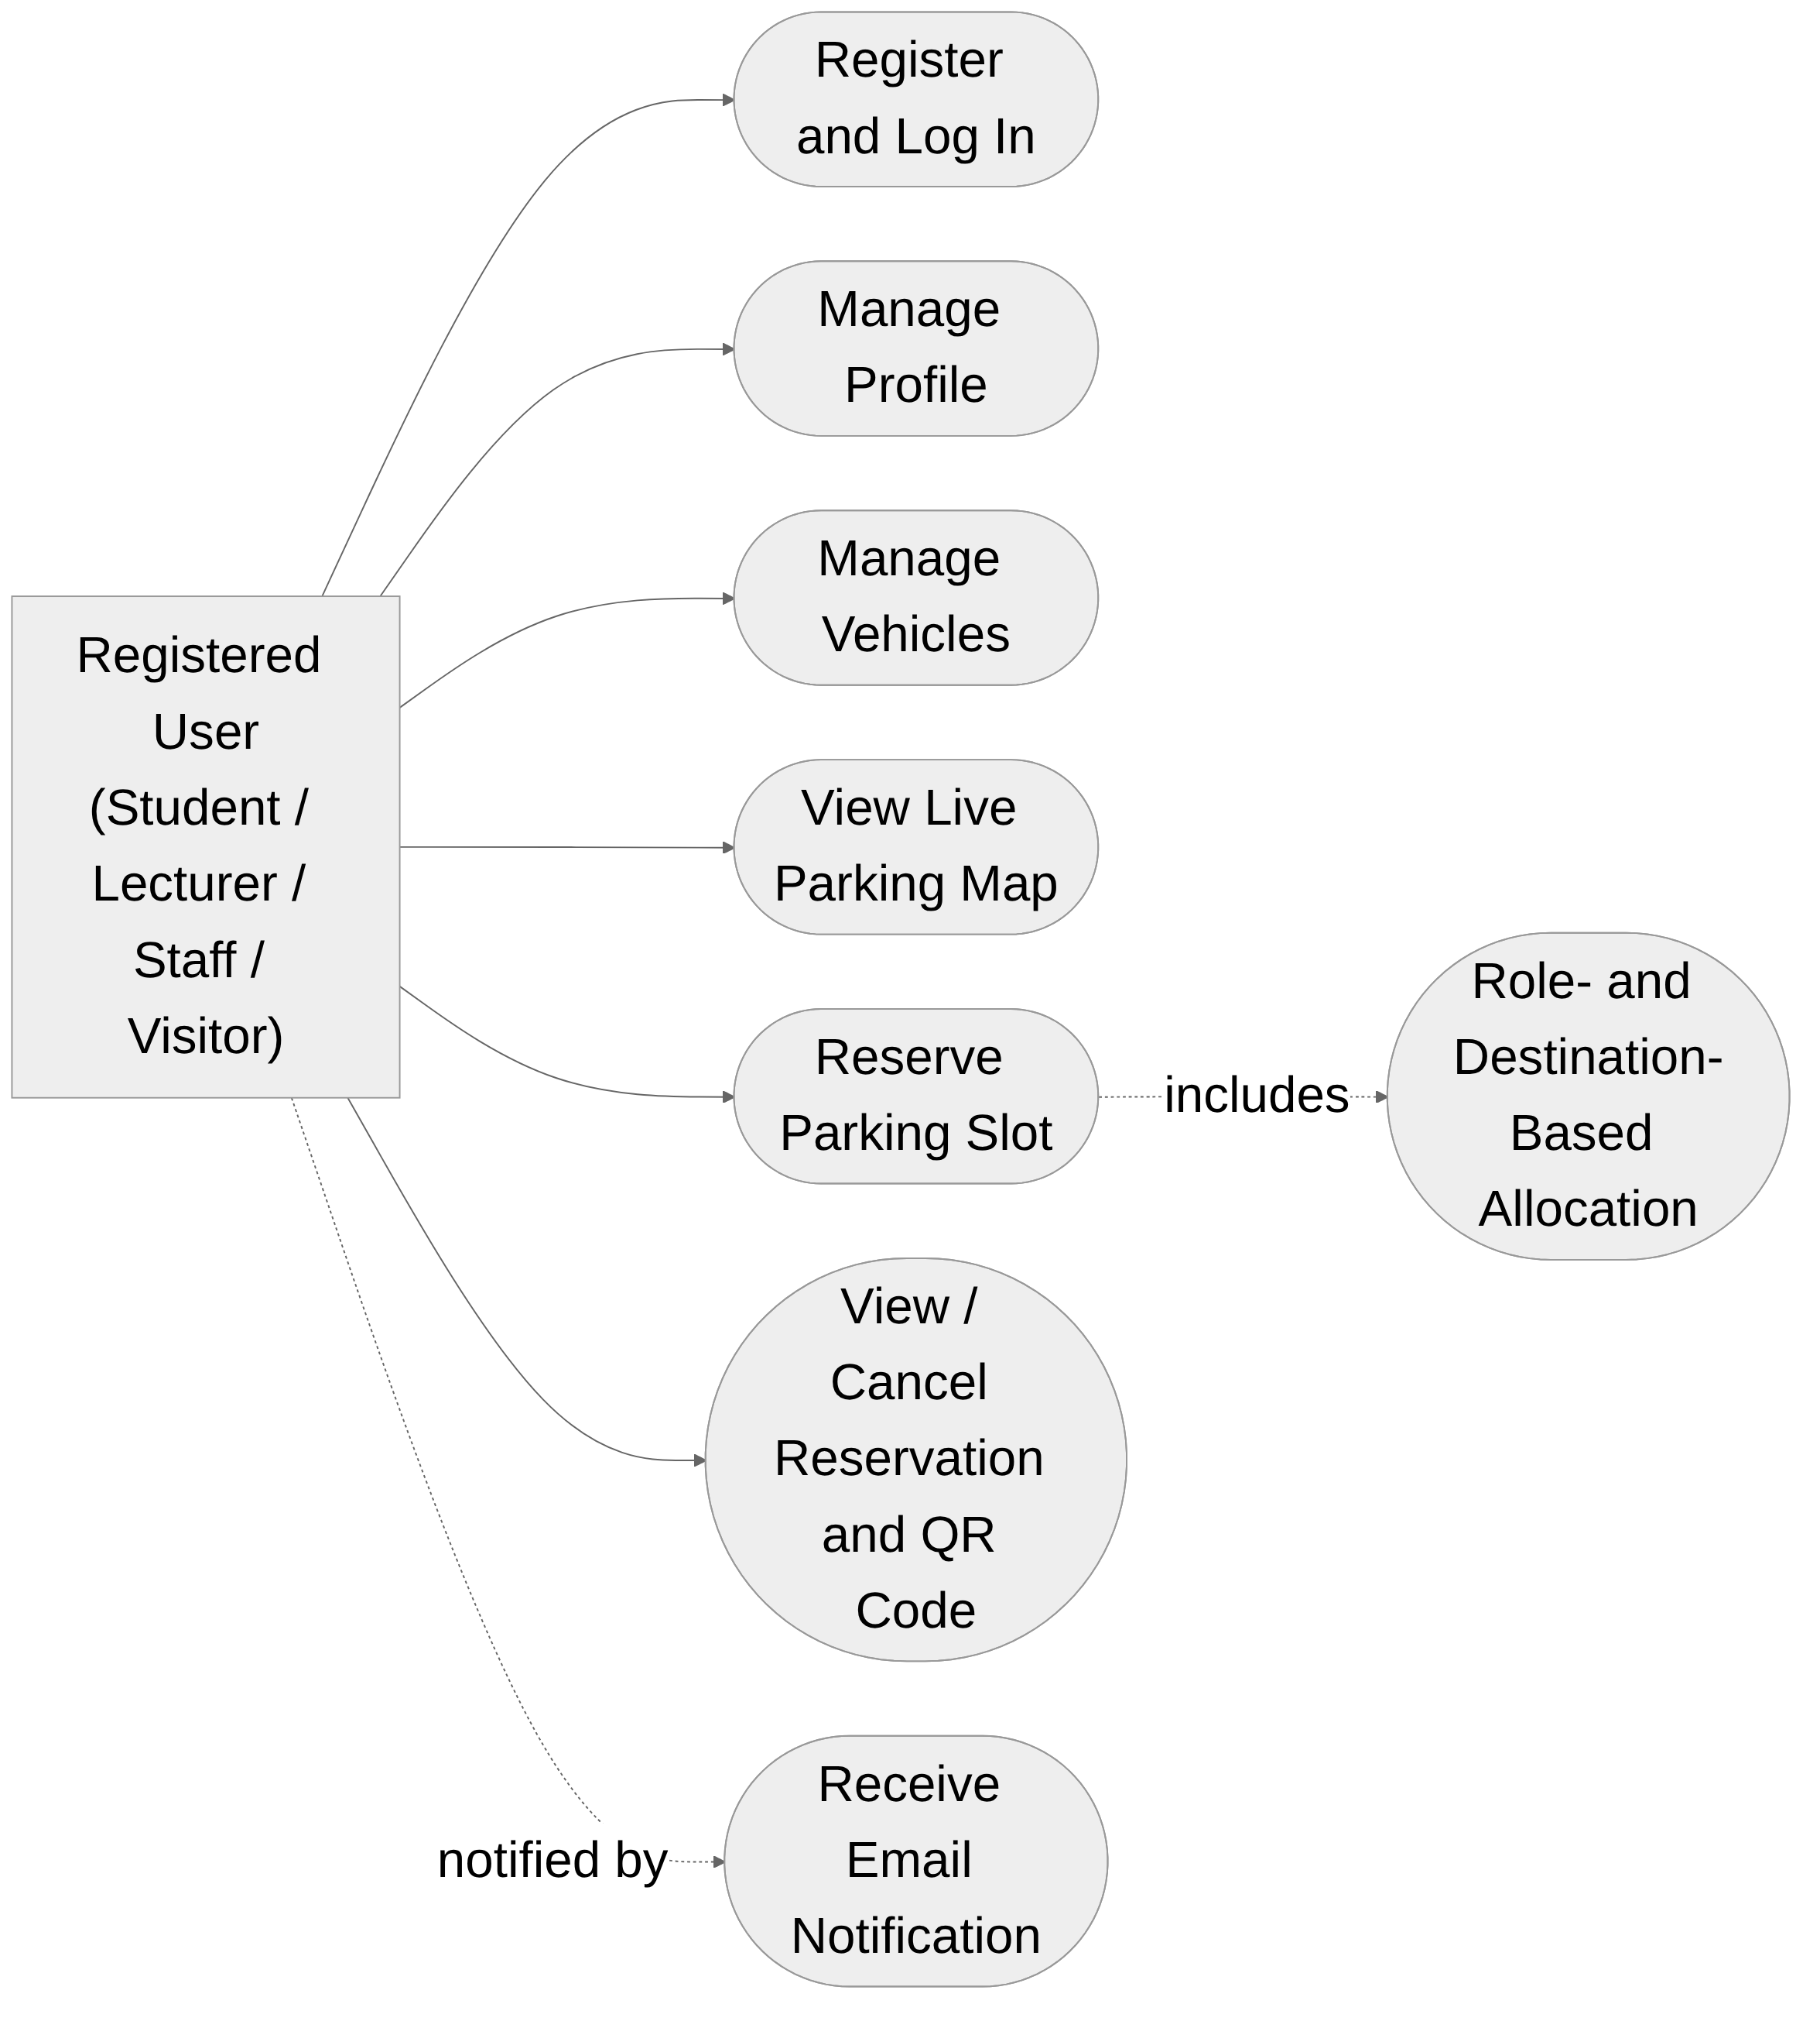
Figure 3.2a: Use Case Diagram — Registered User
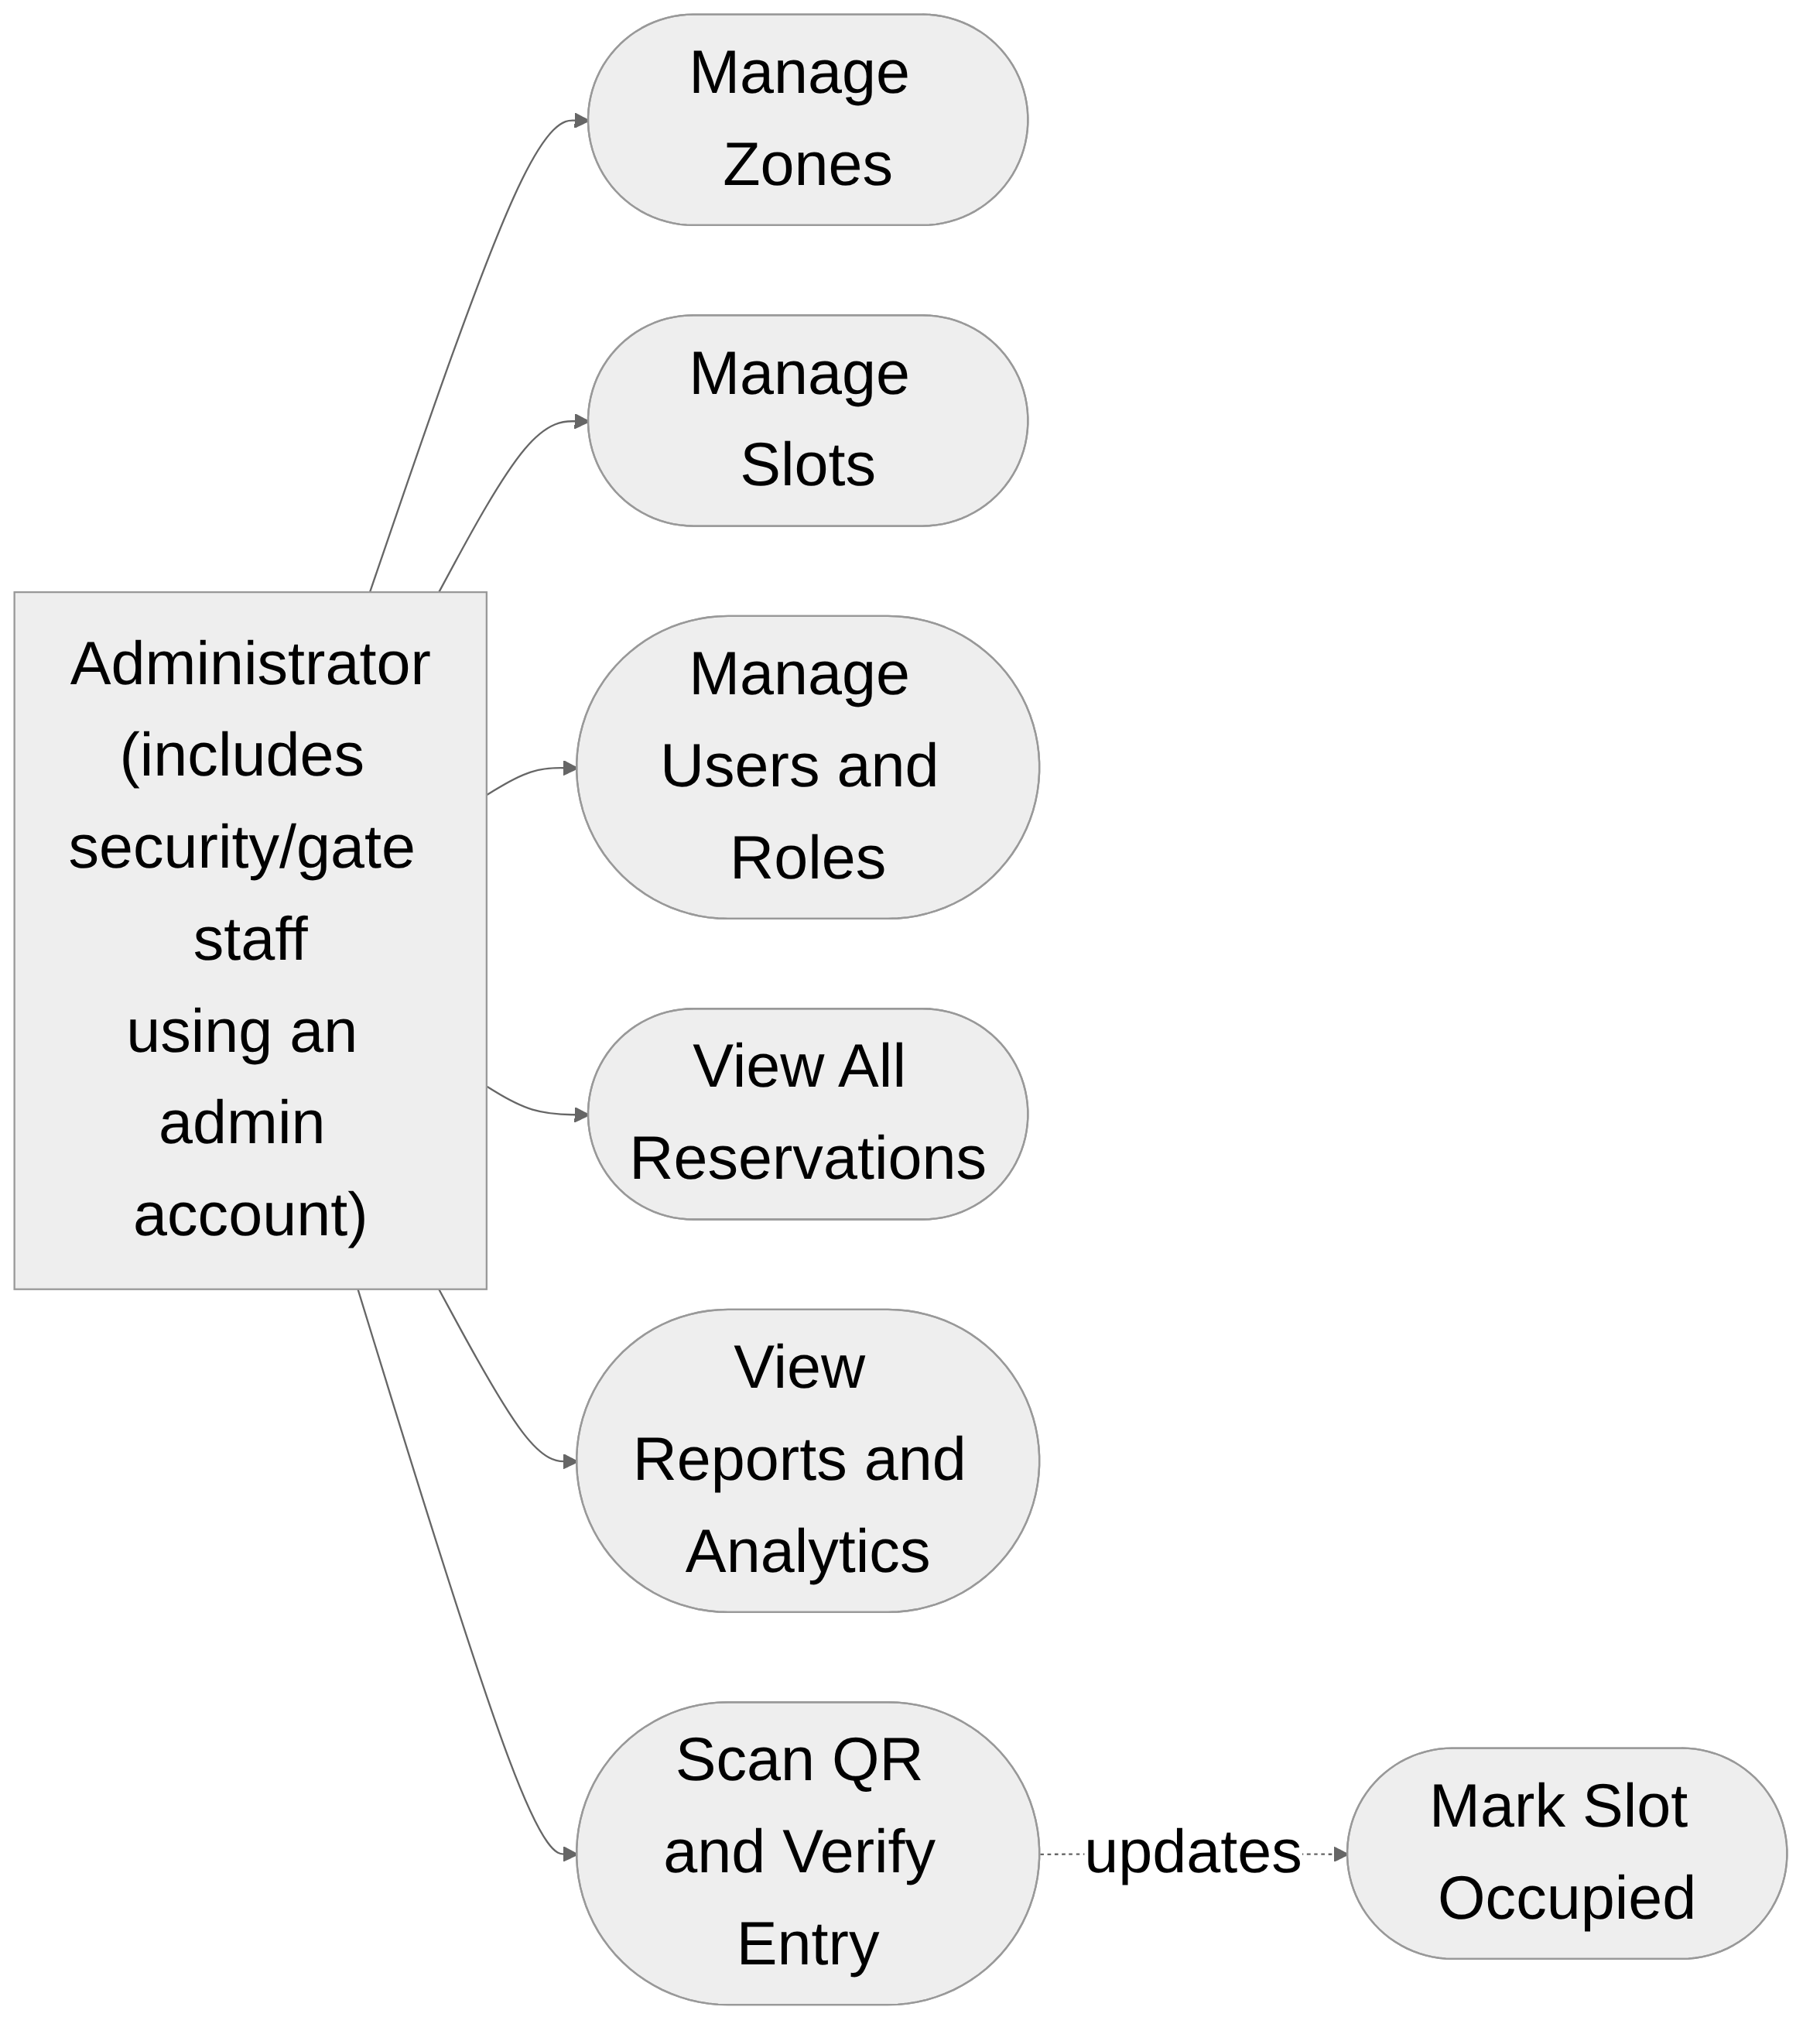
Figure 3.2b: Use Case Diagram — Administrator

3.4.3 Database Design (Entity-Relationship Diagram)
Figure 3.3 shows the entity-relationship structure implemented across Appwrite's six document collections. A Users document (keyed by the Appwrite account's userId) owns zero or more Vehicles and makes zero or more Reservations, and receives zero or more EmailLogs entries. A Zones document contains one or more Slots. A Reservation document references exactly one User, one Vehicle, and one Slot, and carries its own status (active, completed, cancelled, or expired), creation and expiry timestamps, and the random QR token issued for verification. Because Appwrite is a document database rather than a relational one, these relationships are implemented as string foreign-key fields (for example, ownerId on Vehicles, zoneId on Slots, and userId, vehicleId, and slotId on Reservations) resolved in application code, rather than as database-enforced foreign keys.

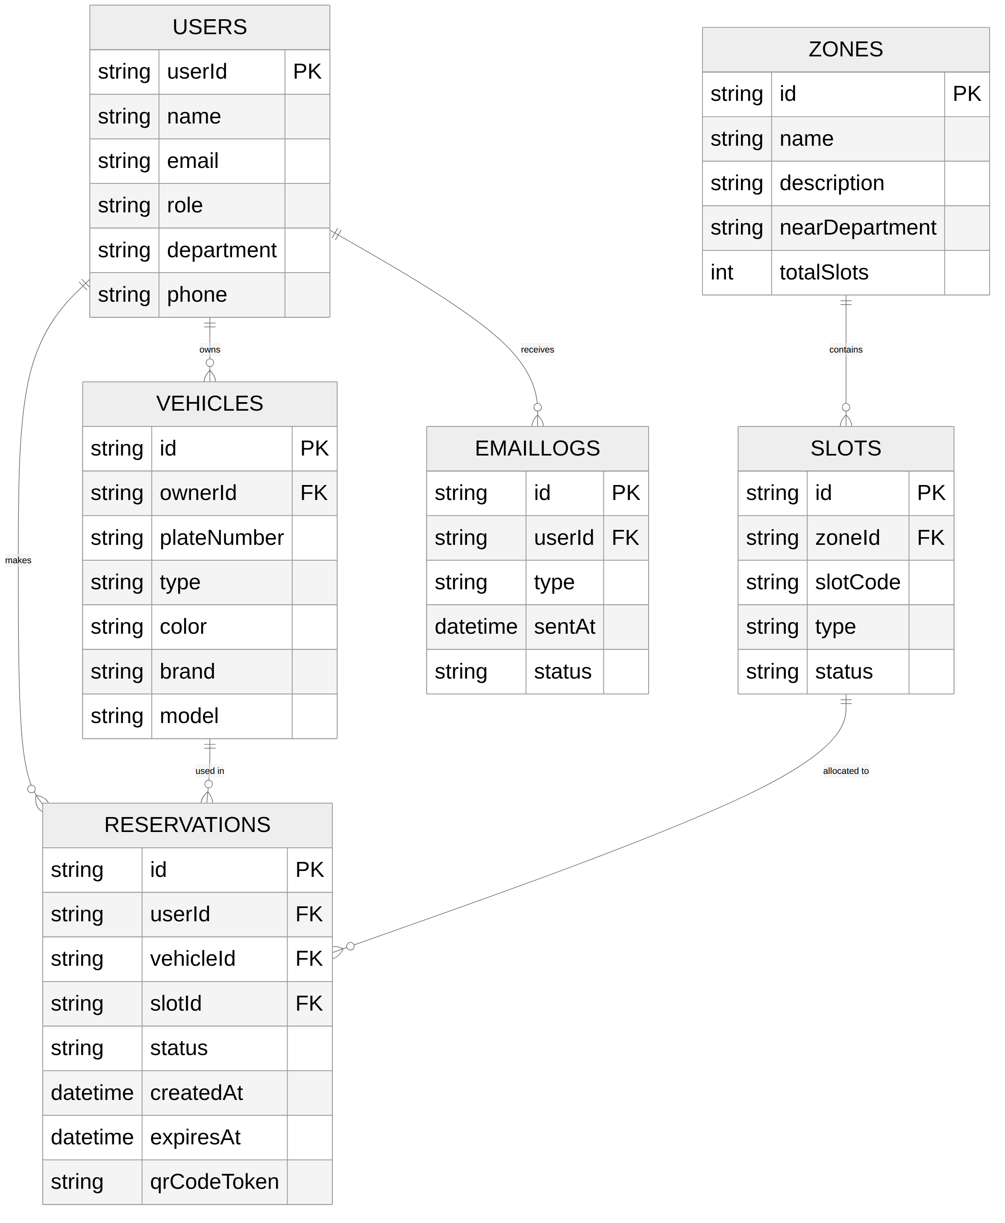
Figure 3.3: Entity-Relationship Diagram

3.4.4 Sequence Diagram
Figure 3.4 traces the two events at the centre of the system's core workflow: creating a reservation and verifying it at the point of entry. When a user submits a reservation, the server action first checks for an existing active reservation, then retrieves all zones and slots and passes them, together with the user's role and chosen destination, to the allocation engine. Once a slot is allocated, the reservation is written with an active status and a freshly generated QR token, the slot is marked reserved, a confirmation email is queued, and the client displays the reservation and its QR code. Later, when an administrator scans that QR code, the token is matched against the stored reservation, its expiry and status are checked, and, if valid, the reservation is marked completed and the slot marked occupied, admitting the vehicle.

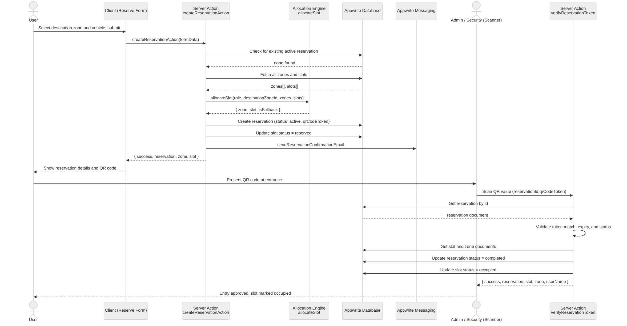
Figure 3.4: Sequence Diagram — Reservation Creation and QR Verification

3.4.5 Activity Diagram
Figure 3.5 presents the same reservation-creation logic as an activity diagram, emphasising the decision points a request passes through: whether the user is authenticated, whether they already hold an active reservation, whether their destination zone has an eligible available slot, and, if not, whether any other zone does. Each negative outcome terminates the activity with a specific, user-facing error message, while a successful allocation proceeds to record creation, slot update, notification, and display of the QR code to the user.

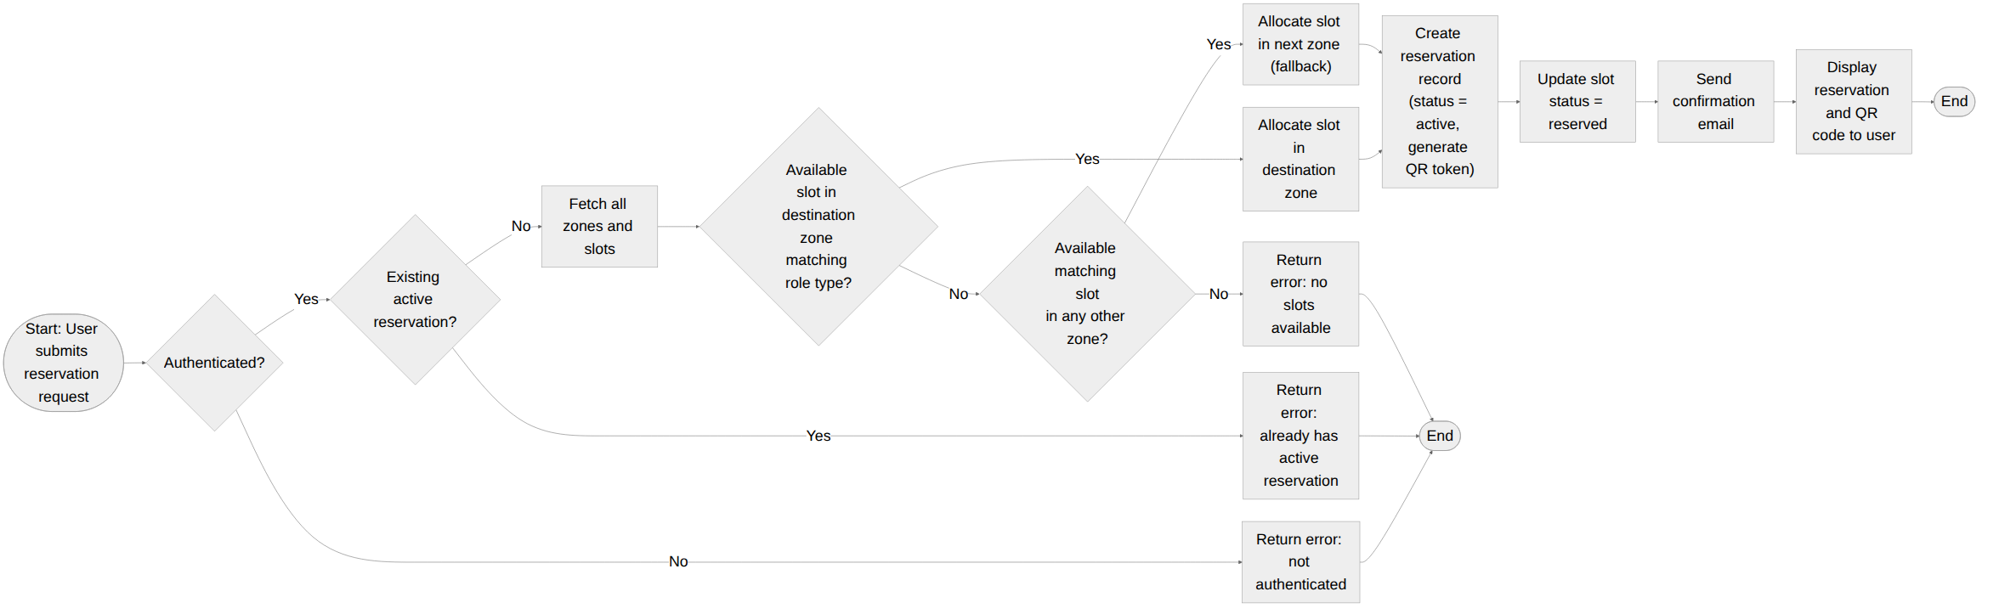
Figure 3.5: Activity Diagram — Reservation Creation

3.5 Algorithm / Model Description
The allocation engine (lib/allocation/allocate.js) implements a deterministic, rule-based algorithm rather than a probabilistic or learning-based model, consistent with the design choice discussed and justified against the literature in Chapter Two. Its logic can be expressed as the following pseudocode:
FUNCTION allocateSlot(role, destinationZoneId, zones, slots):
// e.g. role "lecturer" -> ["general", "staff"]
allowedTypes := ROLE_ALLOWED_TYPES[role]

destinationZone := FIND zone IN zones
WHERE zone.id == destinationZoneId
IF destinationZone IS NULL: RETURN NULL

// search destination zone first, then all
// remaining zones, in order, as a fallback
orderedZones := [destinationZone]
+ (zones - destinationZone)

FOR EACH zone IN orderedZones:
candidate := FIND slot IN slots
WHERE slot.zoneId == zone.id
AND slot.status == "available"
AND slot.type IN allowedTypes

IF candidate IS FOUND:
isFallback := (zone.id != destinationZoneId)
RETURN { zone, slot: candidate, isFallback }

RETURN NULL // no eligible slot in any zone
The algorithm first narrows the search space by role, using a fixed lookup table (a student may occupy only a general slot; a lecturer or staff member may occupy a general or staff slot; a visitor may occupy a general or visitor slot; an administrator may occupy any type), then searches the user's destination zone before falling back, in list order, to every other zone. This gives the algorithm a worst-case time complexity of O(Z × S), where Z is the number of zones and S is the number of slots, since in the worst case every zone must be scanned against every slot before an eligible one is found; in practice the search terminates as soon as the first eligible, available slot is located, and typically resolves within the destination zone itself. The trade-off, discussed in Chapter Two, is that the algorithm optimises for a fast, explainable, single-user decision rather than a global assignment across all users and zones simultaneously.

3.6 Data Description / Dataset
This project does not use an externally sourced dataset; its data model consists entirely of operational records generated through normal use of the system, stored as documents in six Appwrite collections: Users, Vehicles, Zones, Slots, Reservations, and EmailLogs (detailed in Section 3.4.3). For development and testing, the database is populated using a seed script (scripts/seed.js) that creates three campus zones (Zone A, near the Computer Science department; Zone B, near the Engineering department; and Zone C, near the Sports Complex), each pre-populated with a fixed number of slots (eight, eight, and six respectively) of type general, with the final slot in each zone marked disabled to test that pathway. Because each document is a small, structured JSON object with a handful of string, numeric, and datetime fields, no data-cleaning or preprocessing pipeline, of the kind required for an external or tabular dataset, is necessary; the only transformation applied is the JSON-serialisation step (JSON.parse(JSON.stringify(...))) used to strip Appwrite SDK response objects down to plain data before they are passed from server actions to client components.

3.7 Validation or Testing Plan
The system will be validated using a combination of the following testing types, aligned to the modules described in Sections 3.3 and 3.4.
1. Unit testing: the allocation engine (allocateSlot) is a pure function of its inputs and outputs, with no side effects, making it straightforward to unit test in isolation against constructed lists of zones and slots covering role eligibility, destination-zone success, fallback to a second zone, and the no-slots-available case.
2. Integration testing: each server action (for example, createReservationAction, verifyReservationToken, and the vehicle, zone, and slot management actions) will be exercised against a development Appwrite project to confirm that documents are created, read, and updated with the correct field values and status transitions, and that role checks (requireRole) correctly reject unauthorised callers.
3. System and user-acceptance testing: complete end-to-end journeys will be walked through manually, including registration through to login, adding a vehicle, making a reservation, viewing the generated QR code, and having that code scanned and verified by an administrator account, to confirm that the modules work together as intended from a user's perspective.
4. Role and security testing: attempts to reach an administrator-only route (for example, /admin or /scan) or to call an administrator-only server action while authenticated as a non-admin role will be made to confirm that middleware redirection and the requireRole checks inside each action reject the attempt.
5. Edge-case testing: scenarios specific to this system's business rules will be tested directly, including attempting a second active reservation while one already exists, presenting an expired reservation's QR code, presenting a QR code whose token does not match its reservation, and requesting a reservation when every eligible slot across every zone is unavailable.
The detailed test cases, test data, and recorded results for each of these testing types are presented in Chapter Four.

3.8 Ethical Considerations

3.8.1 Data Privacy
The system collects only the personal data needed to operate a campus parking service: a user's name, email address, phone number, department, and role, and, for each vehicle, its plate number, type, colour, brand, and model. No financial, biometric, or precise location data is collected. Access to this data is restricted by role: a regular user can read and modify only their own profile, vehicles, and reservations, while only an administrator account can list all users, all vehicles, or all reservations.

3.8.2 Consent
Consent is obtained implicitly at the point of registration, since a user must voluntarily create an account and supply their details before any data is stored, and no data is collected from a person who does not use the system. The present implementation does not yet display an explicit terms-of-use or privacy-notice screen during registration; adding one is noted as an improvement for future work in Chapter Five.

3.8.3 Security Considerations
Passwords are never handled or stored by the application itself; they are passed directly to Appwrite's Account service, which is responsible for hashing and verifying credentials. Session identifiers are stored in an HTTP-only cookie, which is inaccessible to client-side JavaScript and therefore not directly exposed to cross-site-scripting attacks. Authorisation is enforced twice, once by Next.js middleware, which redirects an unauthenticated request to protected routes such as /dashboard or /admin, and again inside every sensitive server action through requireRole, so that a user cannot bypass the interface and call an administrator-only action directly. Each reservation's QR code encodes only a reservation ID and a randomly generated token, neither of which reveals personal information on its own, and a token is checked for an exact match, correct status, and non-expiry before a reservation is treated as valid. Finally, all credentials needed to connect to Appwrite (the endpoint, project ID, database ID, and API key) are kept in an untracked .env.local file, with only a placeholder .env.example committed to version control.

References (Chapter 3 sources)
Beck, K., Beedle, M., van Bennekum, A., Cockburn, A., Cunningham, W., Fowler, M., Grenning, J., Highsmith, J., Hunt, A., Jeffries, R., Kern, J., Marick, B., Martin, R. C., Mellor, S., Schwaber, K., Sutherland, J., & Thomas, D. (2001). Manifesto for agile software development. https://agilemanifesto.org/
Hevner, A. R., March, S. T., Park, J., & Ram, S. (2004). Design science in information systems research. MIS Quarterly, 28(1), 75–105. https://doi.org/10.2307/25148625
Ntim, J. A., Anokye, P., & Asibey, M. O. (2023). City challenge: User perception on the governance and quality of parking spaces in central business district of Kumasi, Ghana. Transportation in Developing Economies. https://doi.org/10.1007/s40890-022-00174-3
Peffers, K., Tuunanen, T., Rothenberger, M. A., & Chatterjee, S. (2007). A design science research methodology for information systems research. Journal of Management Information Systems, 24(3), 45–77. https://doi.org/10.2753/MIS0742-1222240302

