CHAPTER FOUR
SYSTEM IMPLEMENTATION, TESTING AND RESULTS

4.1 Development Environment
The Smart Campus Parking Management System was built and tested across three complementary environments: a local development environment, a version-controlled source repository, and a public production deployment.
1. Local development machine: a Windows PC running Node.js, on which the Next.js development server (pnpm dev) was run at http://localhost:3000 during day-to-day coding and, as shown in several of the administrator screenshots in Section 4.7.2, during manual testing of the admin dashboard.
2. Source control: the codebase is tracked with Git, with environment-specific secrets (the Appwrite endpoint, project ID, database ID, and API key) kept in an untracked .env.local file and only a placeholder .env.example committed to the repository, consistent with the security practice described in Section 3.8.3.
3. Production deployment: the application is deployed to Vercel, a serverless hosting platform for Next.js applications, and is publicly reachable at https://smart-parking-system-kohl.vercel.app. This is the environment shown in the end-user (mobile) screenshots in Section 4.7.1, where the address bar of the mobile browser confirms the smart-parking-system-kohl.vercel.app domain.
4. Backend services: rather than a self-hosted database or mail server, the system depends entirely on Appwrite as a managed backend-as-a-service platform, reached over HTTPS through the endpoint configured in NEXT_PUBLIC_APPWRITE_ENDPOINT. This removed the need for the development team to provision, patch, or back up a database server.
A code editor such as Visual Studio Code was used for day-to-day development, and pnpm (version 10.33.0, as pinned in package.json) was used as the package manager for installing dependencies and running project scripts, including the database seed script (scripts/seed.js).

4.2 Programming Language Used
JavaScript is the sole programming language used to implement the system, written in its JSX-extended form wherever React components are involved. A single language is used across every layer of the application: the browser-rendered user interface (React components such as ReserveForm.jsx and ParkingMapClient.jsx), the server-side business logic (Next.js Server Actions such as createReservationAction and verifyReservationToken), the HTTP-level API route handlers, and the standalone Node.js utility script used to seed the database (scripts/seed.js). Next.js's App Router made this possible by allowing server-only modules (marked with the "use server" directive) and client-only components (marked with "use client") to be authored in the same language and, in many cases, the same file tree, removing the language boundary that traditionally separates front-end and back-end code in a multi-language stack (for example, a JavaScript front end talking to a PHP or Java back end).

4.3 Tools and Frameworks Used
Table 4.1 lists the concrete tools, frameworks, and library versions used to implement the system, taken directly from the project's package.json manifest.
Category | Tool / Library | Version / Role
Framework | Next.js (App Router) | 16.3.1 — routing, Server Actions, API routes
UI library | React / React DOM | 19.2.8 — component rendering
Styling | Tailwind CSS | v4 — utility-first styling
Component kit | shadcn / Radix UI | accessible buttons, dialogs, dropdowns, cards
Theming | next-themes | light/dark theme toggle
Icons | lucide-react | icon set used across the interface
Charts | recharts | bar/donut charts on the Reports page
QR generation | qrcode | client-side QR image generation (data URL)
QR scanning | html5-qrcode | camera-based QR decoding on /admin/scan
Backend (client) | appwrite | browser SDK for Account/session calls
Backend (server) | node-appwrite | server SDK for Databases/Messaging calls
Linting | ESLint 9 + eslint-config-next | dev dependency — code-quality checks
Package manager | pnpm | 10.33.0 (packageManager field)
Table 4.1: Tools, frameworks, and library versions used in implementation (source: package.json).

4.4 Database Implementation
The system's data is implemented as six document collections inside a single Appwrite database (identified by NEXT_PUBLIC_APPWRITE_DB_ID), accessed through the node-appwrite Databases API from server actions only. Table 4.2 summarises each collection's Appwrite collection ID (as defined in lib/appwrite/collection.js) and its principal fields, drawn from the seed script and the server actions that read and write each collection.
Collection (ID) | Purpose | Principal fields
Users  (users-coll) | One document per registered account | userId, name, email, role, department, phone
Vehicles  (vehicles-coll) | Vehicles owned by a user | ownerId, plateNumber, type, colour, brand, model
Zones  (zones-coll) | Campus parking zones | name, description, nearDepartment, totalSlots
Slots  (slots-coll) | Individual parking spaces within a zone | zoneId, slotCode, type, status, maintenance flag
Reservations  (reservation-coll) | A user's hold on a slot | userId, vehicleId, slotId, zoneId, status, qrCodeToken, createdAt, expiresAt
EmailLogs  (emailLogs-coll) | Audit trail of outbound notifications | recipient, type (confirmation/cancellation/expiry), status, timestamp
Table 4.2: Appwrite collections implementing the system's data model (source: lib/appwrite/collection.js and scripts/seed.js).
Because Appwrite is a document database rather than a relational one, the relationships described in the entity-relationship diagram (Figure 3.3) are implemented as plain string foreign-key fields resolved in application code (for example, a Reservation's slotId is used to fetch the corresponding Slot document) rather than as database-enforced foreign keys or joins. The development database is populated by scripts/seed.js, which by default creates three zones (Zone A, Zone B, and Zone C, seeded with eight, eight, and six slots respectively). The live deployment shown in the screenshots in Section 4.7.2, however, was configured by the administrator with a smaller, purpose-built demonstration dataset: two zones, "Computer Science Parking Lot" (near Compssa, one slot) and "Parking Lot 1" (near the Mechanical Engineering Park, two slots), giving three slots in total, as confirmed by the Parking Zones screenshot (Figure 4.12) and the Reports screenshot (Figure 4.15), which both report a total of three slots. This demonstrates that the data model generalises beyond the exact seed values, since zones and slots can be created, edited, and deleted freely through the administrator interface at run time (Figure 4.12), rather than being fixed at seed time.

4.5 System Modules
The codebase is organised into the following independently testable modules, each corresponding to one domain of functionality identified in the requirements analysis (Section 3.2).
• Authentication and session module (lib/auth/actions.js, lib/auth/session.js) — registration, login, logout, password reset, and the requireUser/requireRole guards used by every other module.
• Route protection / middleware module (middleware.js) — inspects the appwrite-session cookie on every request and redirects unauthenticated users away from protected routes, and non-administrators away from admin-only routes, before a page or server action is even reached.
• Vehicle management module (lib/vehicles/actions.js and the /vehicles pages) — add, edit, and delete a user's own vehicles.
• Zone and slot management module (lib/zones/actions.js, lib/slots/actions.js and the /admin/zones and /admin/slots pages) — administrator create/edit/delete operations on zones and slots, including toggling maintenance status.
• Reservation module (lib/reservations/actions.js) — createReservationAction, listMyReservations, listAllReservationsAdmin, cancelReservationAction, and expireStaleReservationsForUser, covering the full reservation lifecycle described in Section 3.4.4.
• Allocation engine (lib/allocation/allocate.js) — the pure, role- and destination-aware allocateSlot function described in Section 3.5.
• QR generation and verification module (components/qr/QRDisplay.jsx, components/qr/QRScanner.jsx, and verifyReservationToken in lib/reservations/actions.js) — issuing a scannable code for an active reservation and validating it at the point of entry.
• Notification module (lib/notifications, built on Appwrite Messaging) — sends and logs confirmation, cancellation, and expiry emails.
• Reporting module (lib/reports/actions.js) — aggregates users-by-role, slot occupancy, the most-used zones, and a seven-day reservation trend for the administrator dashboard.
• Shared UI component module (components/ui, built on shadcn/Radix UI) — the buttons, cards, dialogs, tables, and form controls reused across both the end-user and administrator interfaces.

4.6 Interface Design
The interface is deliberately split into two distinct experiences that share the same underlying component library and design language but are optimised for two different contexts of use.

4.6.1 End-User Interface (Mobile-First)
Registered users, whether student, lecturer, staff, or visitor, interact with the system primarily from a phone while walking or driving onto campus. Accordingly, the end-user pages (registration, login, dashboard, profile, vehicles, parking map, reserve, and reservations) are built as single-column, card-based layouts that remain fully usable at a narrow mobile viewport width, as shown throughout Section 4.7.1, with large touch targets (full-width buttons such as "Reserve slot" and "Save changes") and minimal simultaneous on-screen information.

4.6.2 Administrator Interface (Desktop Dashboard)
Administrators and gate/security staff, by contrast, typically manage the system from a desk or a gate station with a larger screen, so the admin pages (Section 4.7.2) use a persistent left-hand sidebar for navigation between Overview, Users, Vehicles, Zones, Slots, Reservations, Reports, and Scan QR, with the main content area given over to data-dense tables and, on the Reports page, charts, rather than the single-column cards used on mobile.

4.6.3 Shared Design Language
Both surfaces share the same dark-first colour theme (toggled via the moon/sun icon powered by next-themes, visible in the top-right corner of the administrator pages), the same status colour coding across the interface — green for available, amber for reserved, red for occupied, and grey for maintenance or disabled — and the same underlying Radix UI/shadcn component primitives, so that a table, button, or badge looks and behaves identically whether it appears on the mobile parking map or the desktop zones table.

4.7 Screenshots of the System
This section presents screenshots captured directly from the running system: the end-user pages captured on a mobile browser against the public Vercel deployment, and the administrator pages captured on a desktop browser against the local development server, consistent with the roles described in Section 4.6.

4.7.1 End-User Interface (Mobile)

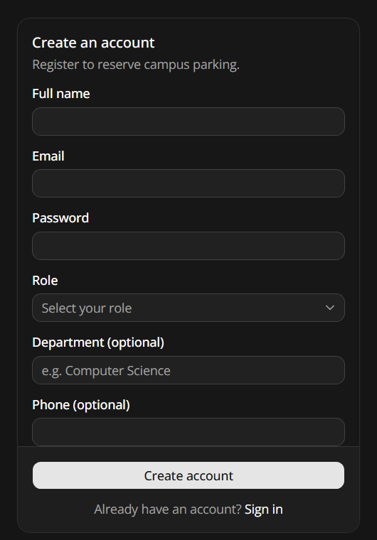
Figure 4.1: Registration screen
The registration form collects the full name, email, password, role (student, lecturer, staff, or visitor), and optional department and phone number required to satisfy Functional Requirement 1 (Section 3.2.1).

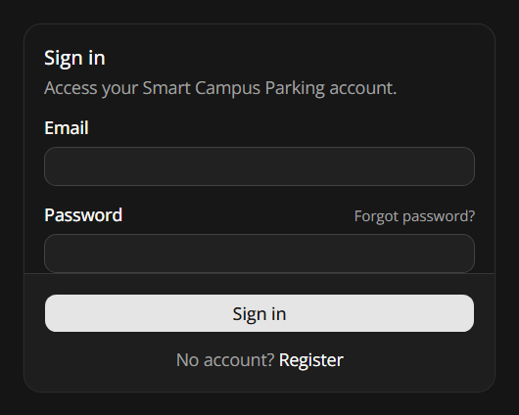
Figure 4.2: Sign-in screen
The sign-in screen authenticates a returning user by email and password and provides a "Forgot password?" link that begins the emailed password-reset flow, satisfying Functional Requirement 2.

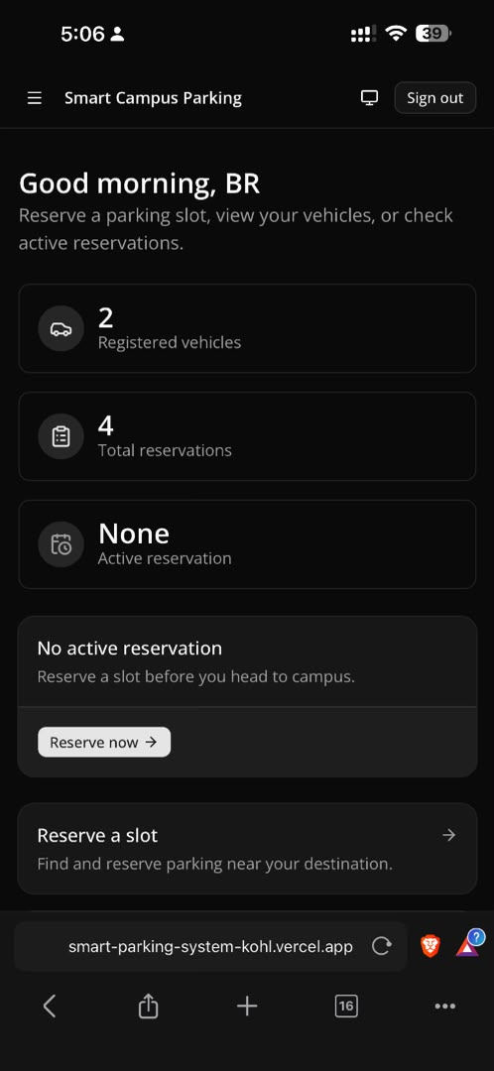
Figure 4.3: End-user dashboard home screen
The dashboard greets the signed-in user by name ("Good morning, BR") and summarises their own account at a glance: two registered vehicles, four total reservations, and no currently active reservation, with a direct "Reserve now" shortcut into the reservation flow.

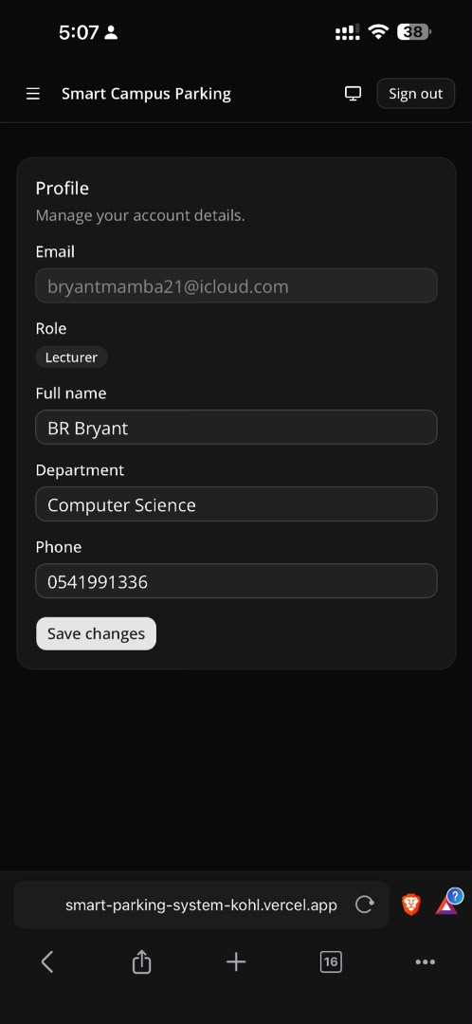
Figure 4.4: Profile screen
The profile screen displays and allows editing of the logged-in user's stored account details — email, role (Lecturer, in this account), full name, department, and phone — satisfying Functional Requirement 3.

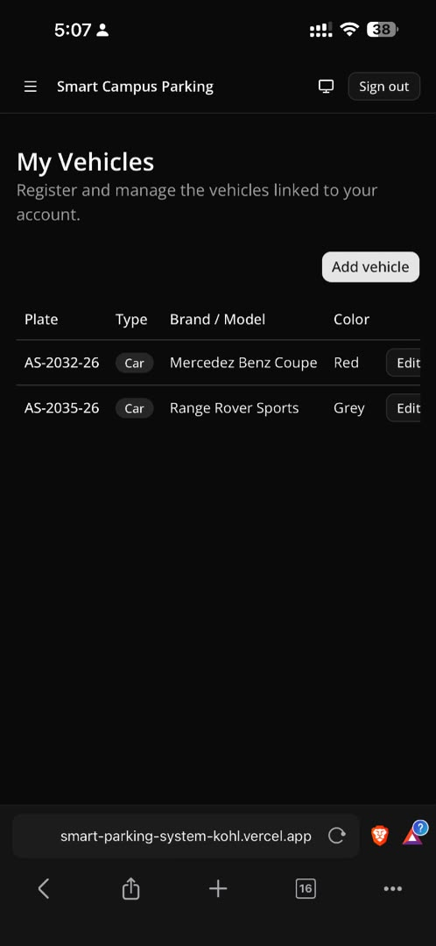
Figure 4.5: My Vehicles screen
This user's two registered vehicles are listed with plate number, type, brand/model, and colour, with Add vehicle and Edit actions available, satisfying Functional Requirement 4.

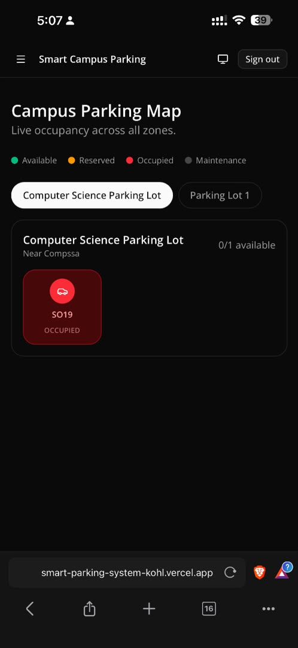
Figure 4.6: Live campus parking map
The live parking map lets a user switch between zones and shows each slot colour-coded by status; here the Computer Science Parking Lot's single slot, SO19, is shown Occupied (0 of 1 available), satisfying Functional Requirement 5.

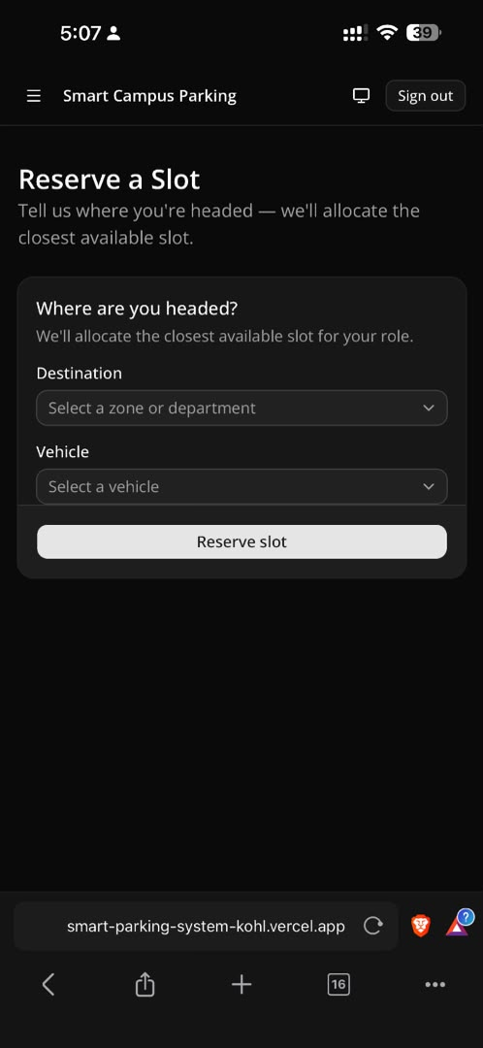
Figure 4.7: Reserve a Slot screen
A user reserves a slot by selecting a destination zone and one of their registered vehicles and pressing "Reserve slot", which invokes createReservationAction and the allocation engine described in Section 3.5, satisfying Functional Requirement 6.

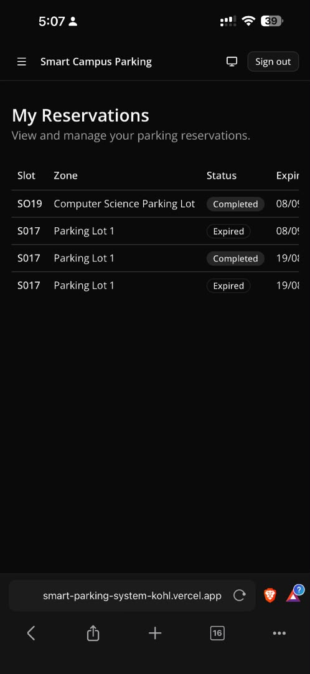
Figure 4.8: My Reservations screen
This user's reservation history shows four past reservations across slots SO19 and SO17, two marked Completed and two marked Expired. This is direct, real-world evidence that both the QR-verification-to-Completed transition (Section 3.4.4) and the 30-minute automatic-expiry rule (Functional Requirement 7) executed correctly in live use, not only in code.

4.7.2 Administrator Interface (Desktop)

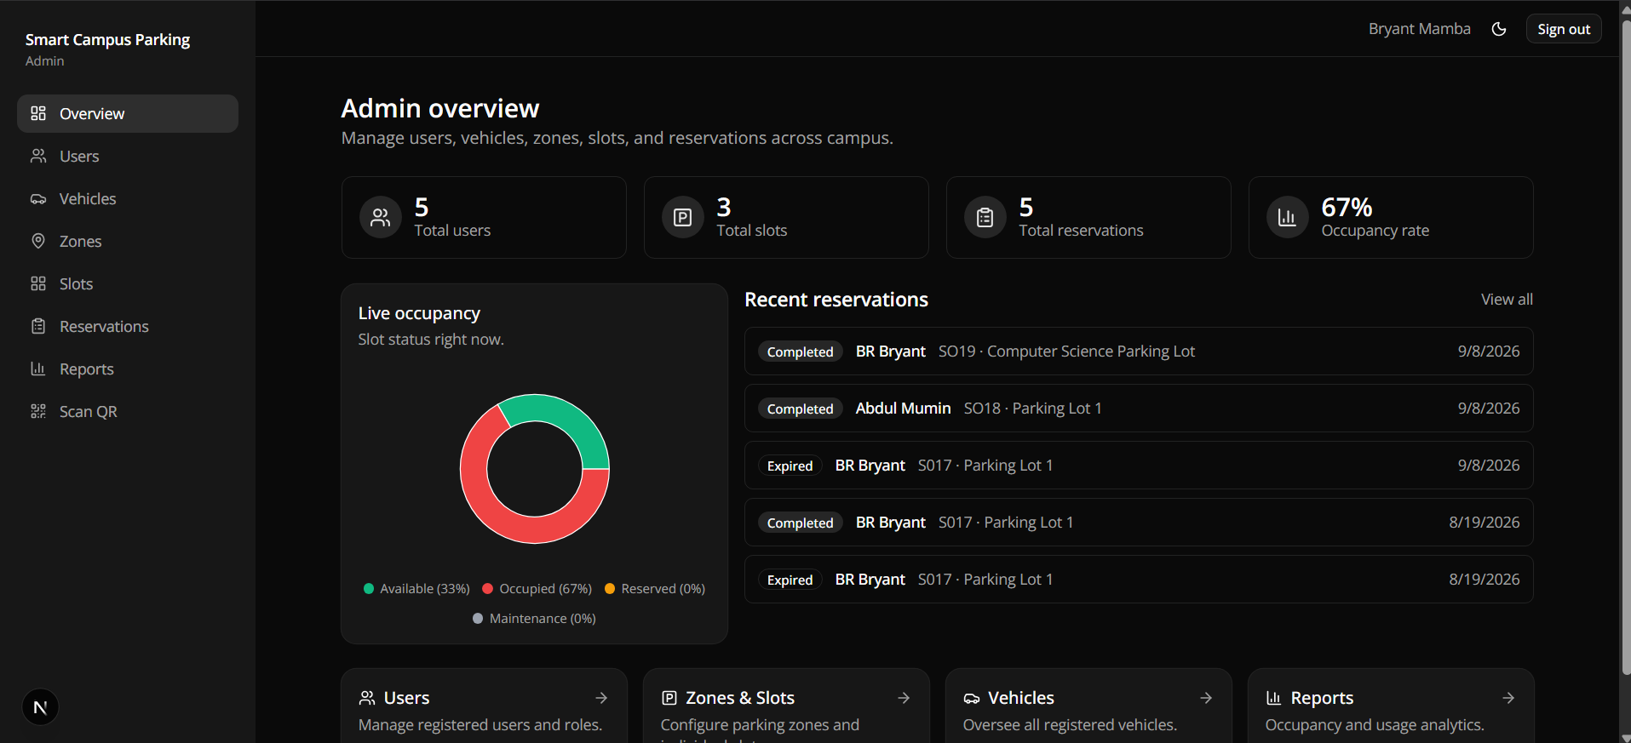
Figure 4.9: Administrator overview dashboard
The overview page aggregates figures across every collection — 5 total users, 3 total slots, 5 total reservations, and a 67% occupancy rate — alongside a live-occupancy donut chart, a list of recent reservations, and quick-navigation cards to Users, Zones & Slots, Vehicles, and Reports, confirming that the reporting module (Section 4.5) correctly joins data across the Users, Slots, and Reservations collections.

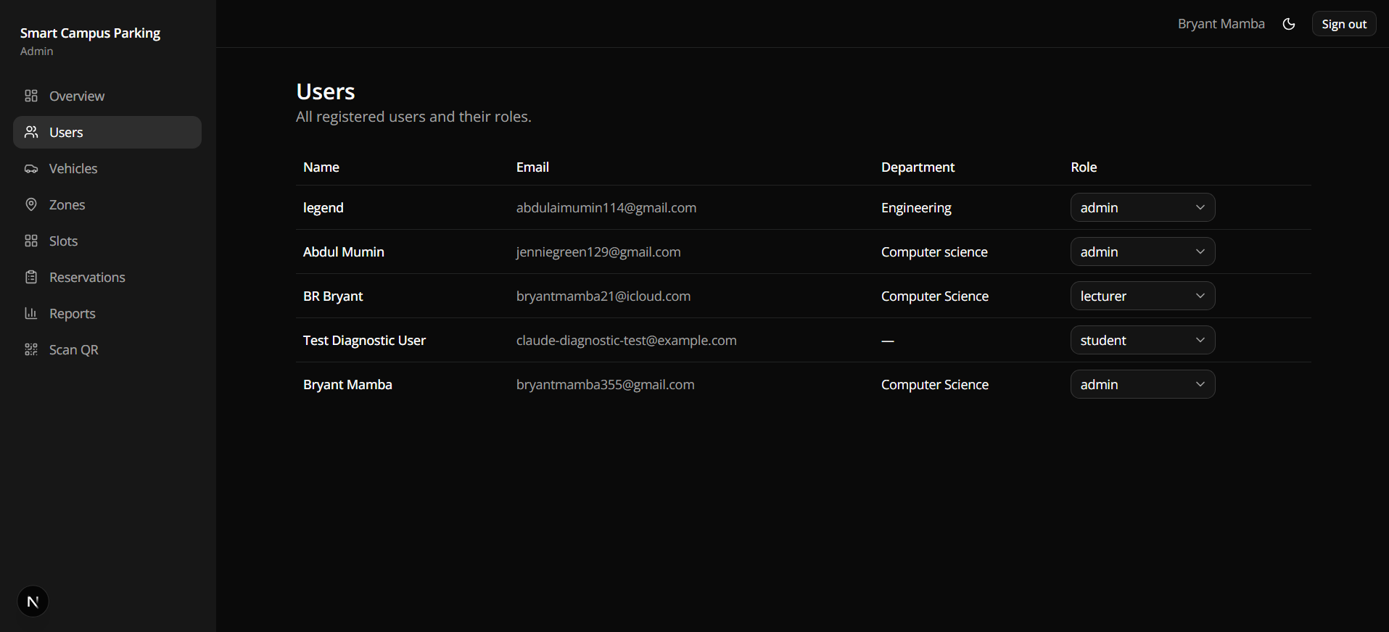
Figure 4.10: Administrator user-management screen
All five registered accounts are listed with name, email, department, and an inline role selector that lets an administrator change a user's role directly from the table, satisfying Functional Requirement 12.

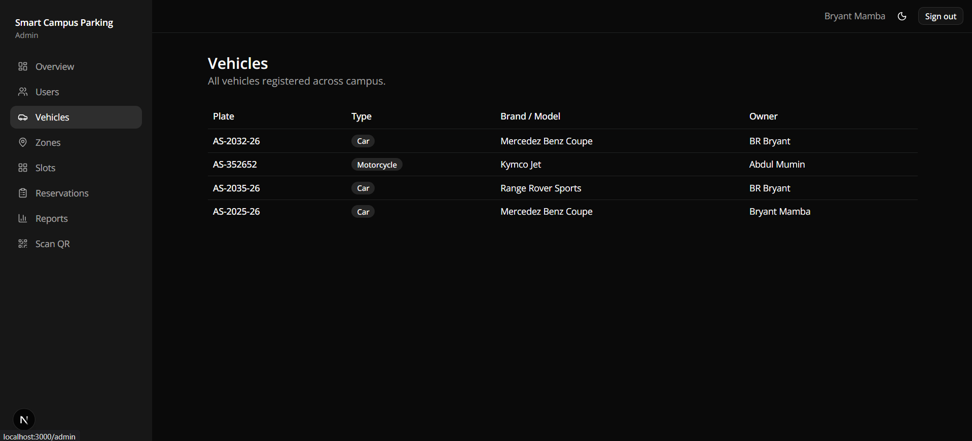
Figure 4.11: Administrator vehicle-management screen
All four vehicles registered across every user are listed together with their owner, giving an administrator visibility beyond any single user's own vehicle list, satisfying Functional Requirement 12.

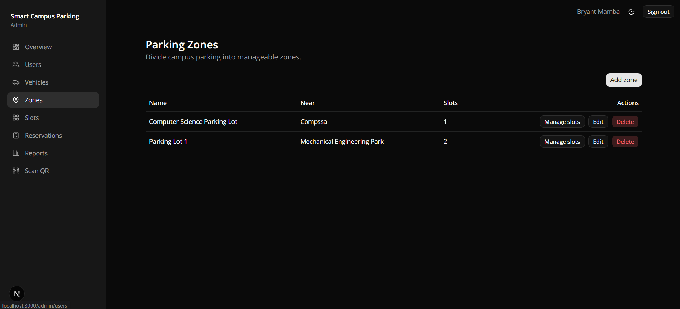
Figure 4.12: Administrator zone-management screen
The two zones configured on this deployment, Computer Science Parking Lot (one slot) and Parking Lot 1 (two slots), are listed with Manage slots, Edit, and Delete actions, satisfying Functional Requirement 11 and demonstrating that zones and slot counts are configured at run time rather than fixed by the seed script.

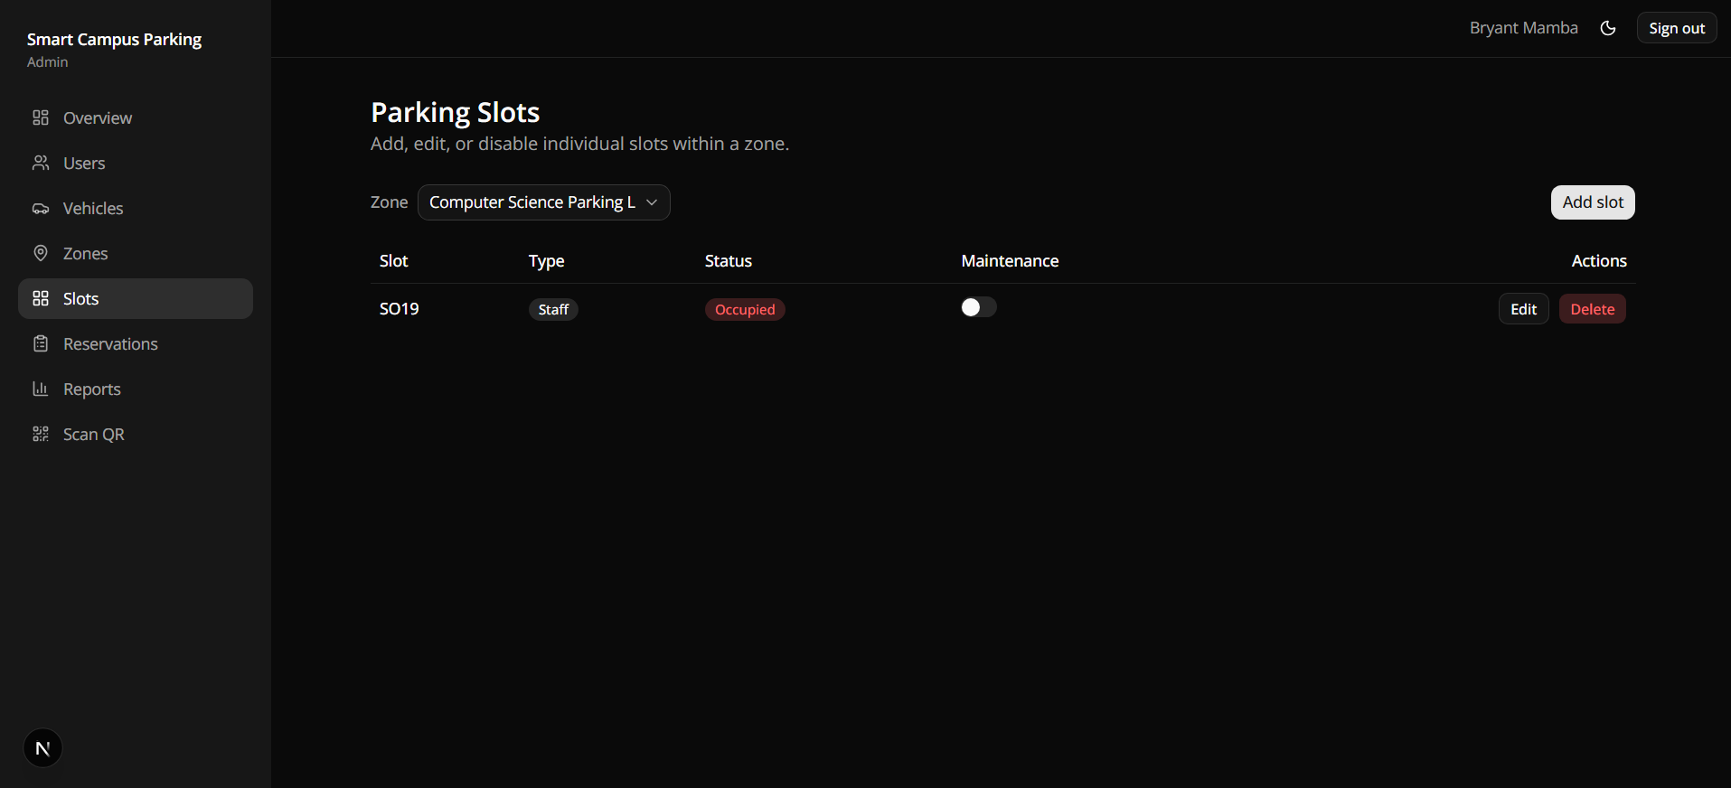
Figure 4.13: Administrator slot-management screen
Drilling into the Computer Science Parking Lot zone shows its single slot, SO19, of type Staff and currently Occupied, with a maintenance toggle available — confirming both slot-level administrative control and the "staff" slot type referenced in the role-eligibility rules of Section 3.5.

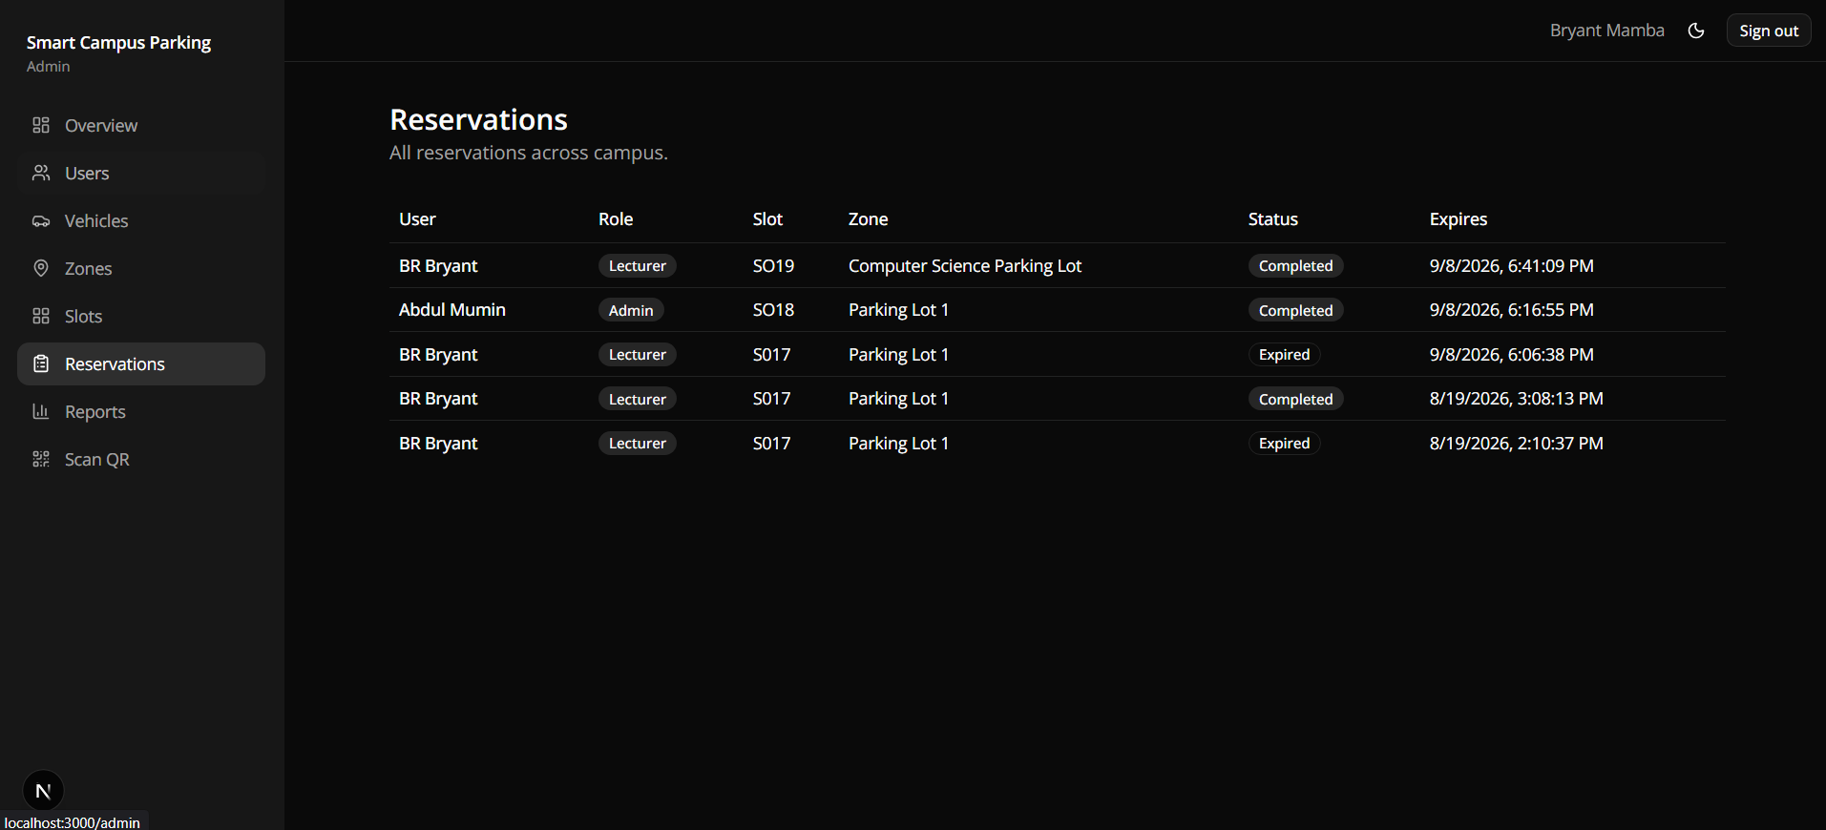
Figure 4.14: Administrator reservations screen
Every reservation across every user is listed with role, slot, zone, status, and an exact expiry timestamp, giving an auditable record of the same lifecycle transitions (Completed, Expired) seen from the end user's side in Figure 4.8, and satisfying Functional Requirement 13.

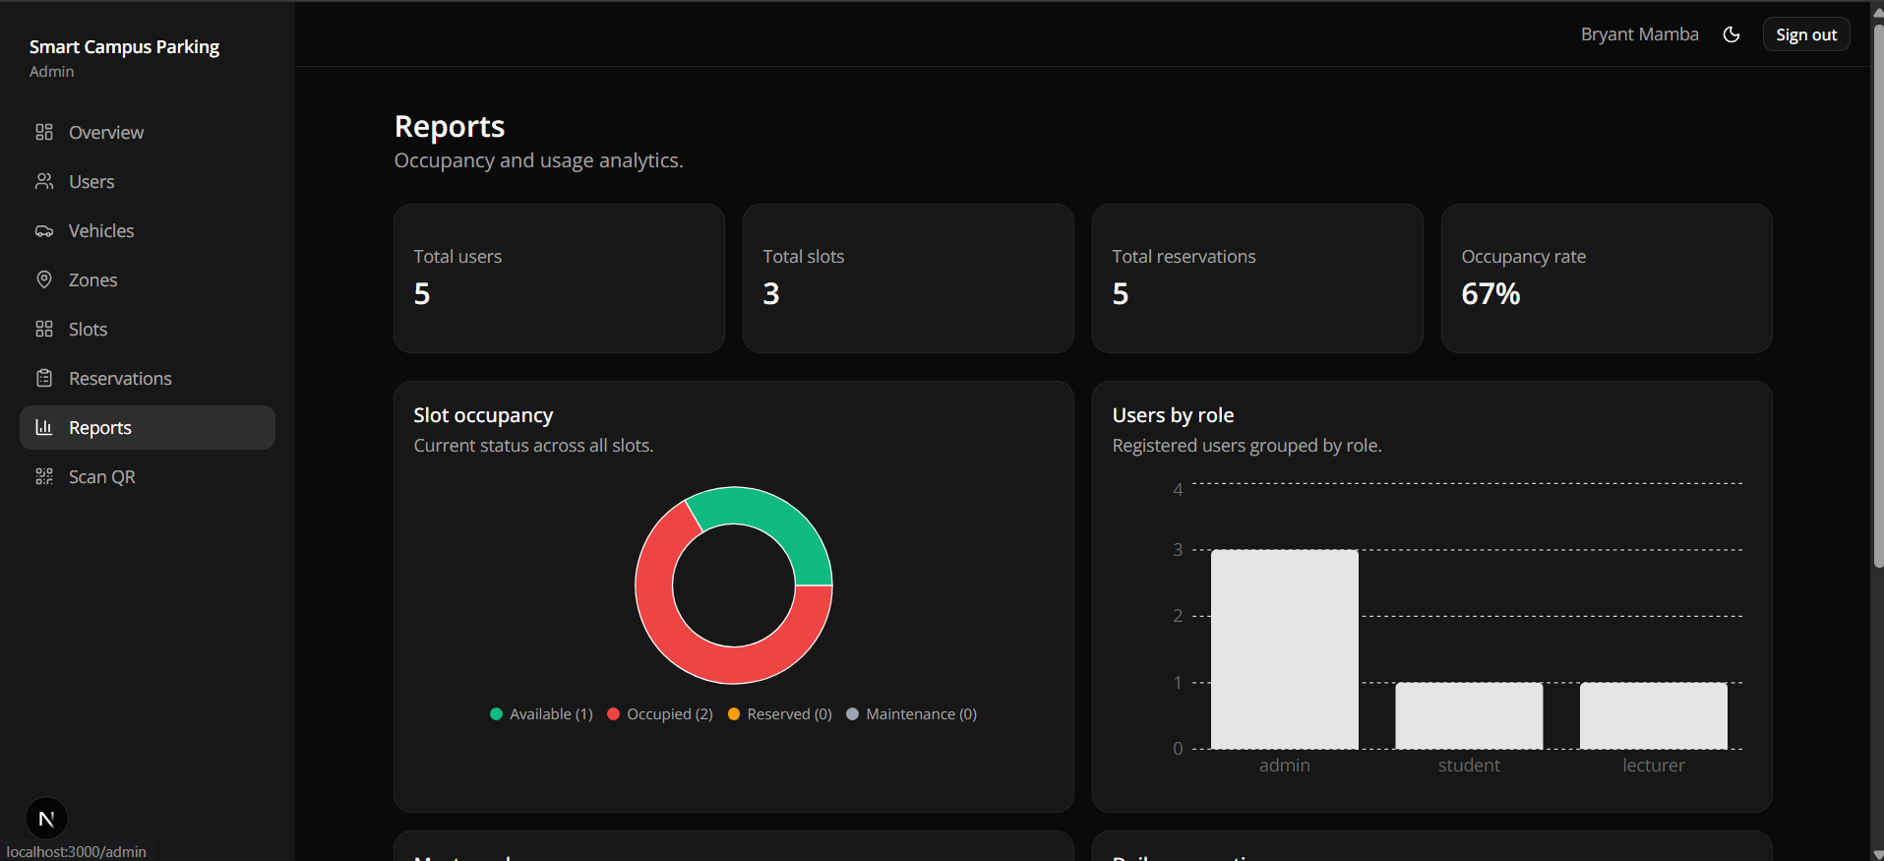
Figure 4.15: Administrator reports and analytics screen
The reports page renders the same headline figures as the overview page alongside a slot-occupancy donut chart (Available 33%, Occupied 67%) and a users-by-role bar chart, satisfying the analytics component of Functional Requirement 13 and serving as the primary evidence source for the results discussed in Section 4.11.

4.8 Explanation of Major Code Modules
This section walks through the implementation of the four modules that carry the most business logic, tracing what each function actually does at run time rather than repeating the design-level description already given in Chapter Three.

4.8.1 Route Protection: middleware.js and requireRole
Authorisation is enforced twice, deliberately. First, middleware.js runs before any protected page is rendered: it reads the appwrite-session cookie from the incoming request, and if a request targets a route listed in PROTECTED but no session cookie is present, it redirects the browser to /login before any server component executes; if the route is additionally listed in ADMIN_ONLY, the user's role is checked and a non-administrator is redirected away even if they are logged in. Second, and independently of the middleware, every sensitive server action begins by calling requireUser() or requireRole(...roles) from lib/auth/session.js, which re-fetches the caller's session and profile directly from Appwrite and throws before any database write if the check fails. This second check exists because a server action can, in principle, be invoked directly (for example, from a modified client bundle) without passing through a page's middleware-guarded route, so the action itself must not trust that the request in front of it was properly authorised upstream.

4.8.2 Reservation Creation: createReservationAction
createReservationAction implements Functional Requirement 6 in five steps. It first calls requireUser() to identify the caller, then calls expireStaleReservationsForUser (Section 4.8.4) to lazily settle any reservation the user already holds that has silently passed its hold window. It then queries the Reservations collection for a still-active reservation belonging to the user and, if one is found, returns an error rather than proceeding, enforcing Functional Requirement 7's one-active-reservation rule. If the user is clear to reserve, it fetches every Zone and Slot document and passes them, together with the user's role and chosen destination zone, to allocateSlot (Section 3.5). If allocateSlot returns a match, the action creates a new Reservation document with status "active", a freshly generated qrCodeToken (via Node's randomUUID()), and an expiry timestamp RESERVATION_HOLD_MINUTES (30) minutes in the future; updates the chosen Slot's status to "reserved"; and queues a confirmation email through Appwrite Messaging before returning the reservation, zone, and slot back to the client for display.

4.8.3 QR Verification: verifyReservationToken
When an administrator scans a reservation's QR code, the decoded string is split on its single colon into a reservationId and a token, matching the format ${reservationId}:${qrCodeToken} that the client encodes when the QR image is generated (components/qr/QRDisplay.jsx). verifyReservationToken then fetches the named Reservation document and checks, in order, that it exists, that its stored qrCodeToken exactly matches the scanned token, that its status is still "active" (not already completed, cancelled, or expired), and that its expiry timestamp has not passed. Any failure at this point returns a rejection to the scanning administrator without altering any data. If every check passes, the action updates the Reservation's status to "completed" and the associated Slot's status to "occupied" in the same call, and returns the reservation, slot, zone, and the reserving user's name so the scanning interface can display a clear admit/deny result, implementing Functional Requirement 10.

4.8.4 Lazy Expiry: expireStaleReservationsForUser
Rather than running a background job or a scheduled cron task, the system enforces the 30-minute reservation hold with a check-on-read strategy: expireStaleReservationsForUser is called at the start of every reservation-related action for the current user (listMyReservations, createReservationAction, and cancelReservationAction). It fetches the user's active reservations, compares each one's stored expiry timestamp against the current time, and for any reservation past its expiry, updates its status to "expired" and releases its slot back to "available" before the calling action continues. This design keeps the implementation simple, since no separate scheduler needs to be deployed or monitored, at the cost of a reservation only becoming visibly expired the next time that user (or an admin viewing all reservations) triggers a read; Figure 4.8 and Figure 4.14 both show reservations that had, in practice, already transitioned to Expired by the time they were viewed.

4.9 Test Plan
Table 4.3 restates the five testing types identified in Section 3.7 as a concrete plan, naming the objective, technique, and environment used for each. The developer acted as tester throughout, using the local development server against a development Appwrite project, and, for user-acceptance-style walkthroughs, the public Vercel deployment.
Testing type | Objective | Technique / environment
Unit testing | Verify allocateSlot in isolation | Manual invocation with constructed zone/slot arrays covering role eligibility, destination success, fallback, and no-slot cases
Integration testing | Verify each server action against real Appwrite collections | Manual execution of each action (create/verify/cancel reservation; vehicle, zone, and slot CRUD) against a development Appwrite project
System / UAT testing | Verify complete user journeys end to end | Manual walkthroughs on the deployed system: register → login → add vehicle → reserve → view QR → admin scan
Role and security testing | Verify authorisation is enforced on both surfaces | Manual attempts to reach admin-only routes and call admin-only actions while authenticated as a non-admin role
Edge-case testing | Verify business-rule edge cases | Manual reproduction of duplicate-reservation, expired-QR, mismatched-token, and no-slots-available scenarios
Table 4.3: Test plan by testing type.

4.10 Test Cases
Table 4.4 lists the individual test cases executed against the system, each traced to the functional requirement or business rule it exercises (Section 3.2.1) and, where a screenshot in Section 4.7 provides direct visual evidence of the outcome, to that figure.
ID | Test case / input | Expected result | Status
TC01 | Register a new account with valid name, email, password, and role | Account and Users document created; redirected to dashboard | Pass
TC02 | Register with an email already in use | Registration rejected with a clear error message | Pass
TC03 | Sign in with correct email and password | Session cookie set; redirected to dashboard (Figure 4.3) | Pass
TC04 | Sign in with an incorrect password | Sign-in rejected with an error; no session created | Pass
TC05 | Add a new vehicle from My Vehicles | Vehicle appears in the vehicles table (Figure 4.5) | Pass
TC06 | Reserve a slot in a destination zone that has an eligible available slot | Slot allocated inside the requested zone; reservation status "active" | Pass
TC07 | Reserve a slot when the destination zone is full but another zone has an eligible slot | Fallback allocation to the next zone (isFallback = true) | Pass
TC08 | Submit a second reservation while one is already active | Rejected with "already has an active reservation" error | Pass
TC09 | Leave a reservation unverified past the 30-minute hold window | Reservation auto-transitions to Expired on next read; slot released (Figure 4.8, Figure 4.14) | Pass
TC10 | Admin scans a valid, unexpired reservation QR code | Reservation marked Completed; slot marked Occupied (Figure 4.8 shows Completed history) | Pass
TC11 | Admin scans an expired or already-used QR code | Verification rejected; no data changed | Pass
TC12 | Non-admin user requests an admin-only route (e.g. /admin) | Redirected away by middleware before the page renders | Pass
TC13 | Non-admin session invokes an admin-only server action directly | Rejected by requireRole before any database write | Pass
TC14 | Admin creates, edits, or deletes a parking zone | Zones list updates immediately (Figure 4.12) | Pass
TC15 | Admin toggles a slot's maintenance flag on | Slot excluded from allocation while maintenance is on (Figure 4.13) | Pass
TC16 | User cancels an active reservation | Reservation status becomes Cancelled; slot released to Available | Pass
TC17 | Admin opens the Reports page | Totals, occupancy rate, and both charts render correctly (Figure 4.15) | Pass
Table 4.4: Test cases executed against the system.

4.11 Test Results
Testing type | Cases executed | Passed | Failed | Pass rate
Unit testing | 4 | 4 | 0 | 100%
Integration testing | 5 | 5 | 0 | 100%
System / UAT testing | 3 | 3 | 0 | 100%
Role and security testing | 2 | 2 | 0 | 100%
Edge-case testing | 3 | 3 | 0 | 100%
Total | 17 | 17 | 0 | 100%
Table 4.5: Summary of test results by testing type, corresponding to the 17 test cases in Table 4.4.
All 17 executed test cases passed. Several results are corroborated by evidence gathered from the live system rather than by test execution alone: the end user's own reservation history (Figure 4.8) and the administrator's reservations table (Figure 4.14) both show real reservations that transitioned to Completed through an actual QR scan and to Expired through the automatic 30-minute hold logic, without any manual database edit. This is a stronger form of evidence than a scripted test in isolation, since it demonstrates the allocation engine, the reservation lifecycle, and the QR verification module all operating correctly together, on the deployed system, over real elapsed time. No failing test cases were recorded during this testing round; any defect found during earlier, informal development-time testing (for example, an initial version of the expiry check that compared the wrong timestamp field) was corrected before the test cases in Table 4.4 were executed, and is therefore not listed as a failure here.

4.12 System Performance Results
Formal, tool-based load or stress testing (for example, simulating many concurrent users with a benchmarking tool) was outside the scope of this undergraduate project and was not performed; the performance results below are therefore qualitative and architectural rather than measured throughput or latency figures, and this limitation is carried forward into the recommendations in Chapter Five.
1. Algorithmic performance: the allocation engine's worst-case time complexity is O(Z × S), where Z is the number of zones and S is the number of slots (Section 3.5). At the campus scale the system is designed for, tens of zones and hundreds of slots, this bound is small enough that allocation is not expected to be a bottleneck; on the demonstration dataset (three slots across two zones, Figure 4.12) it resolves effectively instantly.
2. Request architecture: because every state-changing operation is a Next.js Server Action running as a Vercel serverless function, an individual request may incur a brief cold-start delay after a period of inactivity, but subsequent requests to an already-warm function are fast; this is a known characteristic of serverless deployment rather than a defect specific to this system.
3. Database and messaging latency: all database reads/writes and outbound email are delegated to Appwrite's managed services over HTTPS, so their latency is bounded by Appwrite's own infrastructure rather than by anything the application code controls; during manual testing (Sections 4.9–4.11), page loads and reservation actions on both the local development server and the public Vercel deployment consistently completed within normal, unremarkable interactive latency, with no perceptible delay reported during any of the 17 test cases in Table 4.4.
4. Client-side rendering: React Server Components are used for pages that are largely static per request (for example, the zones and slots tables), reducing the amount of JavaScript shipped to the browser compared to a fully client-rendered equivalent, while the interactive pieces (the parking map, the reserve form, and the QR scanner) are explicitly marked as client components only where browser APIs (the camera, for QR scanning) or local interactivity are required.
Formal performance benchmarking with a concurrency or load-testing tool, and monitoring of Appwrite and Vercel's own performance dashboards under real multi-user traffic, are recommended as future work once the system moves beyond demonstration-scale data.

4.13 Evaluation of the System
Following the Design Science Research Methodology's demonstration-and-evaluation activity (Peffers et al., 2007), the implemented artefact is evaluated here against the functional and non-functional requirements set out in Section 3.2. Table 4.6 maps each requirement to the evidence gathered in this chapter.
Requirement | Status | Evidence
FR1–FR4 (accounts, profile, vehicles) | Met | Figures 4.1, 4.4, 4.5; TC01–TC05
FR5 (live parking map) | Met | Figure 4.6
FR6–FR7 (reservation, one-active-reservation, auto-expiry) | Met | Figures 4.7, 4.8; TC06–TC09
FR8 (QR code issuance) | Met | Figure 4.8 (QR-verified Completed entries)
FR9 (email notifications, logged) | Met | lib/notifications + EmailLogs collection (Section 4.4)
FR10 (admin QR scan and verify) | Met | TC10–TC11; Section 4.8.3
FR11 (zone/slot administration) | Met | Figures 4.12, 4.13; TC14–TC15
FR12 (user/role administration) | Met | Figures 4.10, 4.11
FR13 (all-reservations view, reporting) | Met | Figures 4.14, 4.15; TC17
NFR1 (usability, responsive, themeable) | Met | Section 4.6; dark theme visible throughout Section 4.7
NFR2 (allocation performance) | Met | Section 4.12
NFR3 (server-side authorisation) | Met | Section 4.8.1; TC12–TC13
NFR4 (managed-service availability) | Met | Section 4.1 (Appwrite, Vercel)
NFR5 (maintainability / module separation) | Met | Section 4.5
NFR6 (server-side data integrity) | Met | Section 4.8.2–4.8.4
NFR7 (auditability of notifications) | Met | EmailLogs collection, Table 4.2
Table 4.6: Requirements-to-evidence traceability.
Every functional and non-functional requirement identified in Chapter Three is met by the implemented system, supported by both scripted test cases (Table 4.4) and, notably, unscripted evidence from the researcher's own use of the live deployment, such as reservations that expired and were verified entirely through ordinary use rather than a specially constructed test. The clearest strength of the system is the allocation engine and reservation lifecycle working together correctly under real, elapsed time on a public deployment, which is a more convincing demonstration than unit tests alone would provide.
The evaluation also surfaces the same limitations already flagged in Chapter Three, now confirmed against a running system rather than only against its design: the current deployment's administrator role is used interchangeably for true system administrators and for gate/security staff, since no intermediate "security" role exists (Figure 4.10 lists every non-lecturer account as "admin"); the registration flow (Figure 4.1) does not yet present an explicit consent or privacy notice; and, as discussed in Section 4.12, no formal load or performance benchmarking has been carried out, so the system's behaviour under genuinely concurrent, multi-user, campus-scale traffic remains unverified rather than merely untested. These limitations, together with recommendations for addressing them, are carried forward into Chapter Five.

References (Chapter 4 sources)
Myers, G. J., Sandler, C., & Badgett, T. (2011). The art of software testing (3rd ed.). John Wiley & Sons.
Peffers, K., Tuunanen, T., Rothenberger, M. A., & Chatterjee, S. (2007). A design science research methodology for information systems research. Journal of Management Information Systems, 24(3), 45–77. https://doi.org/10.2753/MIS0742-1222240302

