

MBA in International Business
XXXVI edition

FINAL REPORT
[write your title]

By
[write your name]

DISCUSSANT:
[write the name of your discussant]

[leave a Blank page]
INDEX
Create the index by using the INSERT; REFERENCE; INDEX & TABLES and TABLE OF CONTENTS commands.
Set up the TABLE OF CONTENTS box.

Paragraph:
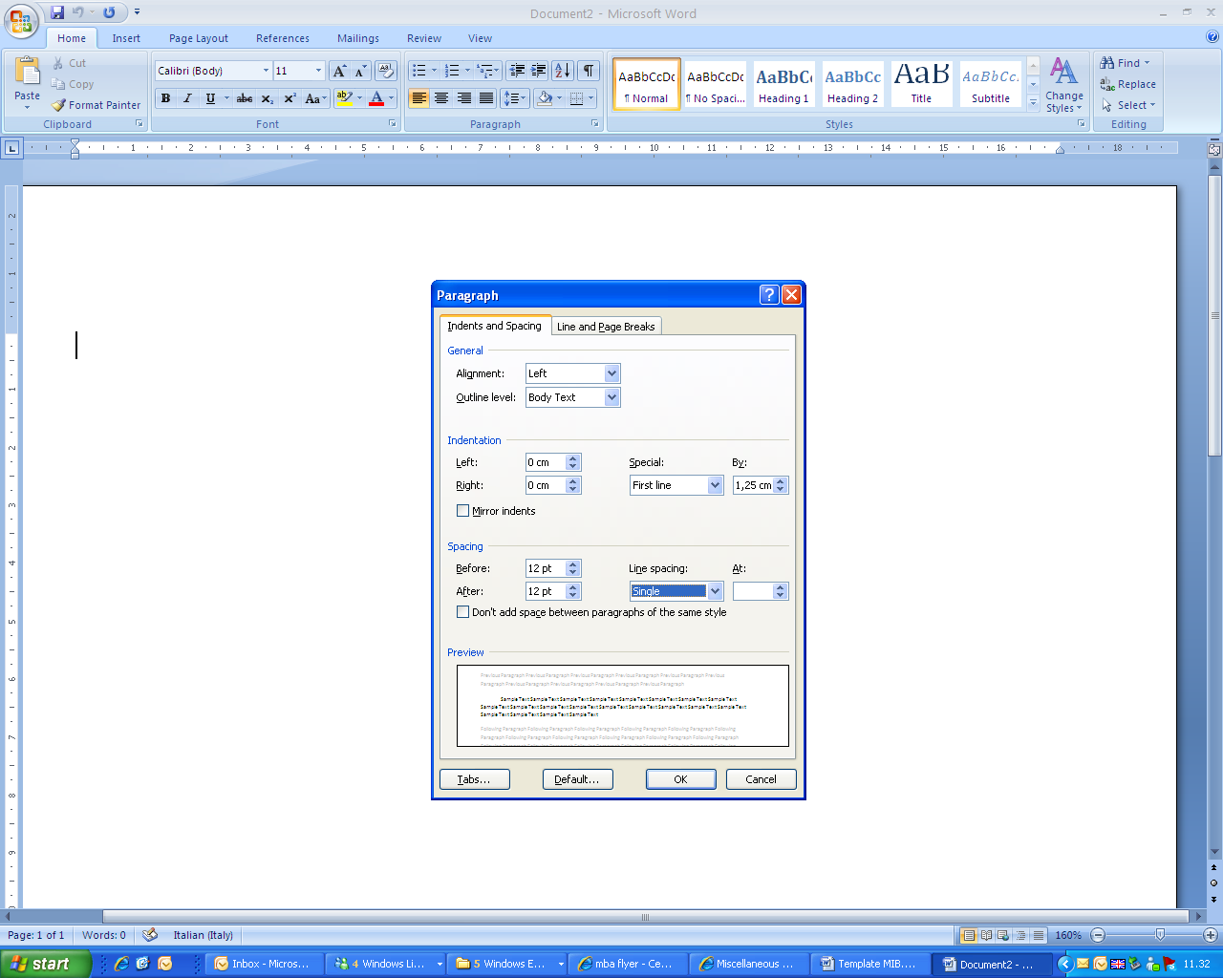

FONTS

Heading 1 (Calibri 20 - colour)

heading 2 (Calibri MS 16 - colour)

heading 3 (Calibri MS 12 - colour)
Body: (Calibri, regular, 11 – Automatic black)

The text should be written using NORMAL style
- To insert bullets and numbering use the FORMAT menu or click on the bullets and numbering icons

Graphs should be inserted as follows (only for Office style graphs):
- For Excel graphs, use the paste special command from the menu and choose the Enhanced Metafile option;
- To insert Word graphs, use INSERT; OBJECT; MICROSOFT WORD DOCUMENT
Use the FIGURE style for the paragraphs which contain graphs

To insert tables, use the TABLE style
Descrizione raggruppamento | Tasso di crescita indebitamento | Tasso di crescita capitale netto
Imprese con risultati economici non costanti | 49,77% | 80,08%
Imprese con risultati economici negativi | 673,00% | 1364,33%

To insert captions and cross-references use the Word commands (from the INSERT menu)
Figure 1 (use command INSERT….REFERENCE…CROSS REFERENCES)
Figure 1 (use command INSERT…REFERENCE…CROSS REFERENCES)
Insert footnotes with the automatic command in Word

Footnote

