

MBA in International Business
XXXVI edition

FINAL REPORT
AI Washing or Credible Disclosure? Patterns and Clusters in Corporate AI Disclosures

By
Germán Oviedo

DISCUSSANT:
Francesco Venier

Table of contents

Executive Summary
Mentions of artificial intelligence became nearly universal across the S&P 500 by the end of 2025. What separates firms is no longer whether they discuss AI, but how: in which register they write, which operations they claim, and how much of that claim they document. This thesis measures how far those three things diverge within a firm, how the resulting patterns sort across sectors and venues, and which of the differences carry information about firm risk and performance.
The study analyzes a corpus of 9.7 million paragraphs from 59,820 SEC filings and earnings calls, distinguishing narrative volume, communication posture, reported operational activities, and their documentary grounding. From it the study catalogs 46,855 operational AI activities in 471 firms.
Three communication postures recur across the index: Vocal Substantives, who emphasize customer-facing AI applications; Governance-Led firms, who emphasize governance and oversight; and Defensive Disclosers, who emphasize risks and caveats. At comparable disclosure intensity, communication postures distinguish firms’ reported activity portfolios and customer-facing integration. Firms commonly present AI initiatives under their own brands, while providing much less detail about the external models, platforms, and infrastructure supporting them.
Narrative grew faster than the evidence behind it: the 2023–2025 surge added activity volume without improving average grounding. The gap between volume and substance has a persistent within-firm component, whether that reflects a stable disclosure practice or reused language. Inside the same firm and fiscal year, earnings calls are more promotional, and carry more quantified claims, than the statutory filings, so the two venues are not interchangeable.
The study also tests whether disclosure patterns are associated with subsequent market and accounting outcomes, finding selective relationships. Accumulated decoupling between communication and documentary evidence and sustained disclosure volume are associated with a more positive change in beta around earnings calls, while single-call decoupling shows no association that survives multiple-testing correction. Relative to Defensive disclosure, a governance-oriented composition is associated with a lower beta shift, higher subsequent abnormal returns, and slower revenue growth. No associations survive multiple-testing correction for announcement-window returns or weekly crash risk.
These findings provide the basis for a practical framework for reading and writing corporate AI communication. It identifies communication posture, checks documentary grounding, and compares operational claims across channels, then prioritizes material claims and specifies the verification each requires. An issuer can check its own communication against what it can document; an investor or board can decide which external claims deserve verification before committing capital. What the routine diagnoses is documentary distance, not fraud and not technological maturity, and an adaptation to early-stage ventures is proposed rather than estimated.

1. Introduction

1.1 Problem and practical relevance
As the use of artificial intelligence proliferated after ChatGPT’s release in November 2022, corporate AI disclosure has become harder and harder to read. Investors and analysts need to separate firms with real AI adoption from firms that are mostly making promotional claims, because real adoption can move productivity and firm value (Basnet et al. 2025; Eisfeldt et al. 2023). Managers and boards have the same problem seen from the inside: they have to communicate technical initiatives without overstating how mature they are, because the distance between what a firm says and what it can show is now a legal and reputational exposure. Regulators have made that exposure concrete and have named overstated AI capability as a form of misstatement (Gensler 2024; U.S. Securities and Exchange Commission 2024), and SEC comment letters show that an inconsistency between a promotional earnings call and the formal filings can attract direct scrutiny (U.S. Securities and Exchange Commission 2025).
AI rapidly became a standard topic of corporate communication after ChatGPT’s release (Anantharaman, Parker, and Rozario 2026). In the S&P 500, the share of firms mentioning AI in SEC filings went from 34% in 2021 to 93% in 2025. Over the same period, narrative intensity across the panel increased 7.3-fold and, when annualizing 2026 observations, reaches approximately 12 times its 2021 level.
The usual textual methods in finance work with keyword frequencies or dictionary-based sentiment (Loughran and McDonald 2011), and such methods give the same weight to a routine risk disclaimer and to a detailed account of an AI deployment or a commercial partnership. To judge the substance and the credibility of corporate AI disclosure one has to move past how often a firm mentions AI and look instead at how it frames the claim, what operational activity it reports, and how concretely that activity is backed by disclosed evidence.

1.2 Main research question
These tensions lead to one central question:
To what extent do public firms exhibit strategic heterogeneity in their corporate AI disclosures, and does distinguishing disclosure volume, communication posture, and grounded operational substance carry incremental economic information?

1.3 Objectives and contributions
This thesis studies how S&P 500 firms communicate about artificial intelligence across 59,820 SEC filings and earnings-call transcripts, and reads that communication in four places: the text itself, the choice of disclosure channel, regulatory comment letters, and market prices.
The thesis makes three contributions:
- Evidence on how firms communicate about AI: three recurring communication postures; activity portfolios that differ between them at the same disclosure volume; a narrative that grew faster than the documentary evidence behind it; a within-firm gap between what is said on a call and what is filed; and selective associations between these measures and market and operating outcomes.
- A textual measurement architecture with several dimensions: instead of counting words, it combines a gradient-boosted filter with zero-shot LLM frame extraction to build six constructs ($D,P,A,G,S,W$) that put informal earnings calls and statutory filings on the same scale.
- A credibility framework built from that evidence: a review routine with which an issuer can compare its own disclosure against what it can document, and with which an investor can rank external claims by the verification each one needs.

1.4 Theoretical foundations and state of the art
Corporate narratives carry informative signals beyond standard accounting data: Li (2008) links readability to earnings persistence, Loughran and McDonald (2011) identify financial vocabulary misclassified by general dictionaries, and Gentzkow, Kelly, and Taddy (2019) formalize text as economic data. Following the post-2022 surge in AI disclosure (Anantharaman, Parker, and Rozario 2026), studies distinguish actionable plans from boilerplate (Basnet et al. 2025), compare disclosure with AI hiring and patents (Song et al. 2026; Babina et al. 2024; Barrios et al. 2025), and examine promotional language and valuations unsupported by fundamentals (Cheng et al. 2019; Huang, Teoh, and Zhang 2014). Regulatory scrutiny of AI-related misstatements (Gensler 2024; U.S. Securities and Exchange Commission 2024, 2025) mirrors the greenwashing literature’s account of selective disclosure sustained by scrutiny (Delmas and Burbano 2011; Marquis, Toffel, and Zhou 2016; Seele and Schultz 2022).
Instead of relying only on external hiring or patent proxies, this study asks whether the disclosure itself is internally consistent and factually grounded. Four theoretical mechanisms support that measurement:
- Costly signalling and verification: in classical signalling theory (Spence 1973; Crawford and Sobel 1982), an ungrounded narrative claim is costless “cheap talk,” while a disclosure that names an operational system, a commercial partner, a deployment stage or a quantitative metric carries verification and reputational cost (Rogers, Van Buskirk, and Zechman 2011). This is the reasoning behind the evidentiary grounding construct ($G$).
- Institutional isomorphism: institutional theory (DiMaggio and Powell 1983; Meyer and Rowan 1977) predicts that firms exposed to the same regulator and to the same peers will write in the same way, whether or not their operations have changed. Raw AI mention volume ($D$) is the measure of that mimetic pressure.
- Organizational decoupling: following Westphal and Zajac (1994), Crilly, Zollo, and Hansen (2012) and Bromley and Powell (2012), organizations often decouple their formal policy statements from what they do every day. The gap between narrative volume and documented operational activity ($W$) measures that decoupling directly.
- Channel liability differential: statutory filings (Form 10-K) carry strict liability under Sections 11 and 18 of the Exchange Act, while earnings calls enjoy a wider safe harbor for forward-looking statements (Frankel, Johnson, and Skinner 1999; Matsumoto, Pronk, and Roelofsen 2011). Comparing the same firm across the two venues shows how far regulatory discipline holds promotional language back.

1.5 Hypotheses and research questions
Main hypothesis. Beyond raw narrative volume alone, corporate disclosure posture and grounded operational substance carry incremental information about firm operating characteristics (H-operational) and market risk (H-market).
Four research questions guide the empirical tests:
Table 1: Research questions, theoretical mechanisms, and expected outcomes.
RQ | Theoretical mechanism | Expected outcome
RQ1: Evolution and composition | Institutional isomorphism (DiMaggio and Powell 1983) | AI narrative volume diffuses rapidly across all sectors, whereas concrete, verifiable activities expand at a substantially slower rate.
RQ2: Strategic heterogeneity | Signalling theory (Spence 1973) & organizational configurations | Stable communication archetypes emerge, where disclosure posture predicts verified operational activity and firm fundamentals beyond raw volume.
RQ3: Decoupling and venue divergence | Organizational decoupling (Crilly, Zollo, and Hansen 2012) & channel liability (Frankel, Johnson, and Skinner 1999) | Unbacked promotional claims appear more heavily in voluntary earnings calls than in statutory filings, with regulatory scrutiny compressing this gap.
RQ4: Capital market pricing | Costly signalling (Crawford and Sobel 1982; Rogers, Van Buskirk, and Zechman 2011) | Markets price accumulated decoupling, cumulative disclosure intensity, and a governance-weighted posture into systematic risk (beta) rather than reacting to unverified single-quarter narrative volume.

1.6 Methodology overview
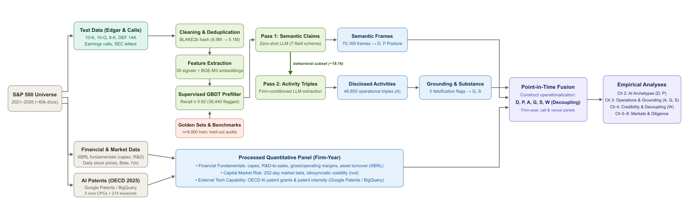
Figure 1: End-to-end data acquisition, inference, and multi-source fusion pipeline.
The pipeline transforms corporate disclosures into six constructs ($D,P,A,G,S,W$) using deduplication, supervised screening and zero-shot LLM extraction (Figure 1). They support four analyses: disclosure strategies and activity portfolios; narrative–substance gaps and within-firm channel differences; changes around regulatory and technological events; and associations with subsequent market and accounting outcomes, controlling for prior outcomes, firm characteristics, and sector and year fixed effects. Appendix A details acquisition, extraction and aggregation.
Code and data availability. Code and extraction prompts are available on GitHub (Oviedo 2026c); derived datasets and fitted models are on Hugging Face Datasets (Oviedo 2026a) and Models (Oviedo 2026b), respectively. Releases and revisions are pinned to this thesis version; licensed transcripts are excluded. Appendix A.6 documents extraction, and the README provides reproduction instructions.
The subsequent chapters follow this architecture: Chapters 2 through 5 present the empirical progression from disclosure postures and operational activities to cross-venue credibility and capital-market pricing; Chapter 6 translates these empirical constructs into an operational due-diligence framework for issuers and allocators; Chapter 7 concludes.

2. Corporate AI Disclosure Strategies
How did corporate communication about artificial intelligence change as the technology went mainstream, and do firms write in the same way or in different ways? This chapter lays the empirical foundation for the thesis. It fixes the S&P 500 study universe, presents the multi-source disclosure corpus, sets out the measurement architecture that turns narrative text into six analytical constructs, traces diffusion across the market from 2021 to 2026, and identifies the communication postures that recur among large-cap firms.

2.1 Study universe and data
The study universe is the S&P 500 as it stood on January 1, 2021 (499 unique issuers), followed over six annual reporting cycles (2021–2026). Fixing the cohort before generative AI was commercially available gives a clean baseline of large-cap U.S. firms and avoids look-ahead selection: a universe taken from a later roster would over-sample the technology winners that entered the index on post-2022 market capitalization. Against survivorship bias, the 39 firms later acquired or delisted stay in the panel up to their exit date. In total 498 firms have processed narrative records, 471 disclose concrete operational AI activities, and 465 firms form a balanced panel observed in all six years.
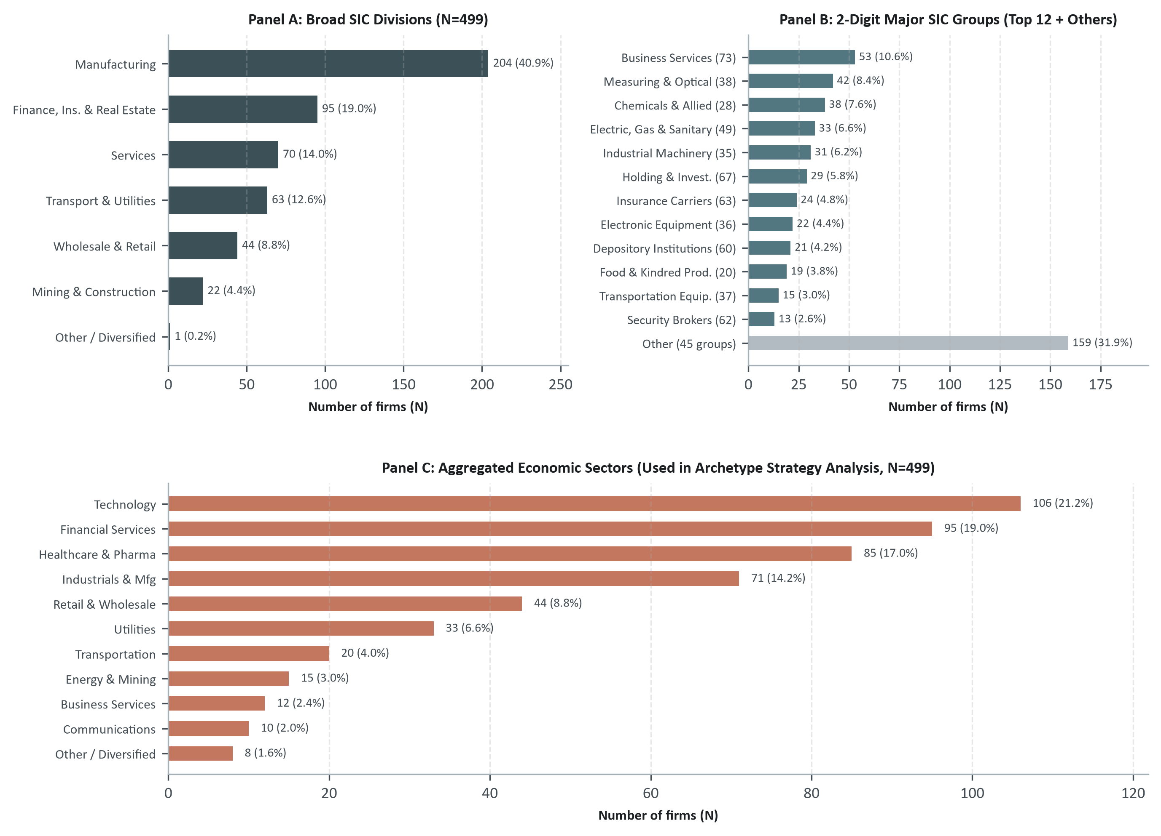
Figure 2: Industrial distribution of the S&P 500 study universe (fixed at 2021-01-01, $N=499$) across three classification tiers. Panel A: broad SIC divisions. Panel B: two-digit SIC major groups (top 12 plus remaining). Panel C: 11 aggregated economic sectors.
The spread across divisions and 2-digit groups in Figure 2 means that AI adoption here is observed under very different cost structures and capital intensities, not inside one technology cohort. Technology, financial services and healthcare account for more than half the sample and 45 smaller SIC groups cover the rest, so sectoral controls can separate economy-wide diffusion pressure from industry-specific workflow integration (Appendix A.3).
The analysis draws on five data sources, textual, financial and technological: statutory SEC filings (Forms 10-K, 10-Q, DEF 14A, 8-K, 20-F) taken from EDGAR; earnings-call transcripts covering both the management presentation and the analyst Q&A; daily market prices and returns; standardized accounting fundamentals from FactSet (FactSet Research Systems, n.d.); and OECD-classified AI patent records from Google Patents.
For statutory filings the coverage is complete: every mandated report filed while the firm was in the index. For voluntary earnings calls, three transcript sources are combined (Hugging Face community repository, a commercial transcript feed [EQ], and a financial portal archive [SA]), each record verified on ticker, host company and event type; a quarter with no transcript (16% of firm-quarters) is treated as unobserved and not as silence. Filing records run to 2026-09-03, and the 2026 observations are year-to-date (covering 423 firms with 10-Ks, 463 firms with 10-Qs, and 453 firms with calls), so trend comparisons are scaled by a same-calendar-window seasonal adjustment (Appendix A.3). Table 2 summarizes the document corpus by form.
Table 2: Current processed U.S. corpus by form.
Form | Documents
10-K | 2,839
10-Q | 8,163
DEF 14A | 2,846
8-K | 35,322
Earnings call | 10,650
Total | 59,820

2.2 Core disclosure constructs
To keep rhetoric apart from operational initiative, the framework separates corporate claims from concrete activities:
- From text to claims: a zero-shot language model identifies statements about AI along seven communicative dimensions (subject, technology type, temporal stance, functional concepts, specificity signals, promotional tone and sentence anchors). Because every classification carries a sentence-level anchor, an analyst can always go back to the source text.
- From claims to concrete activities: when a claim describes an operational action by the firm itself, a second pass extracts an action triple (verb, technological object, business function) together with the deployment stage, the origin of the technology and the evidence offered. With this inventory, initiatives can be compared by maturity and evidence instead of by vocabulary.
Claims and activities then aggregate into six analytical constructs (Table 3):
Table 3: The six core disclosure constructs. Constructs $D$ and $P$ capture corporate communication; $A$, $G$, and $S$ evaluate disclosed operational activity and documentary grounding; and $W$ identifies narrative-substance discrepancies.
Construct | Symbol | Core Definition and Formula | Managerial and Empirical Interpretation
AI Disclosure Intensity | $D$ | $D_{it}=\frac{{\text{AI frames}}_{it}}{{\text{words}}_{it}/1,000}$ | Narrative volume: frequency of AI claims normalized by scorable document length
Communication Posture | $P$ | 7-dimensional profile: promotional, hedging, risk, governance, realization, customer-facing, specificity | Communicative register: how management frames AI rather than how much it speaks
Disclosed AI Activity | $A$ | Count of discrete operational action triples ($n_{\text{activities}}$) across 6 business domains | Breadth of reported execution: volume of distinct operational initiatives
AI Activity Grounding | $G$ | Mean share of 5 evidentiary attributes (function, production stage, product, metric, vendor) $∈\left[0,1\right]$ | Factual verifiability: documentary backing anchoring reported initiatives
Disclosed Substance | $S$ | $S_{it}=log\left(1+n_{\text{activities},it}\right)×G_{it}$ | Grounded operational volume: activity count weighted by evidentiary strength
Decoupling | $W$ | $W_{it}=\text{rank}\left(D_{it}\right)−\text{rank}\left(S_{it}\right)∈\left[−1,1\right]$ | Disclosure gap: narrative volume rank minus substance rank (“AI washing”)

$D$ and $P$ describe the communication, $A$, $G$ and $S$ the disclosed activity and its documentary evidence, and $W$ ranks the discrepancies that deserve review. All measures aggregate to the firm-year through median document rates (Appendix A.6).
Measurement validation. Held-out samples labelled by an independent language model give the screen a weighted precision of 0.67 and a recall of 0.97 on forms it was not trained on, and the measures line up with OECD AI patent portfolios (Appendix A.10). Systematic human verification is still to be run: the atomic validator built for it is described in the appendix.
With the measurement in place, what follows is the diffusion of AI disclosure across the market and the communication postures that appear inside the S&P 500.

2.3 The expansion and diffusion of AI disclosures
Between 2021 and 2025 AI moved from being an emerging topic to being a standard reporting item (Figure 3): the share of S&P 500 firms mentioning AI rose from 34.3% to 93.5%. A balanced cohort of the 465 firms observed continuously from 2021 to 2026 follows the same path (35% to 94%), so the growth reflects adoption across the whole market rather than survivorship or index rebalancing.
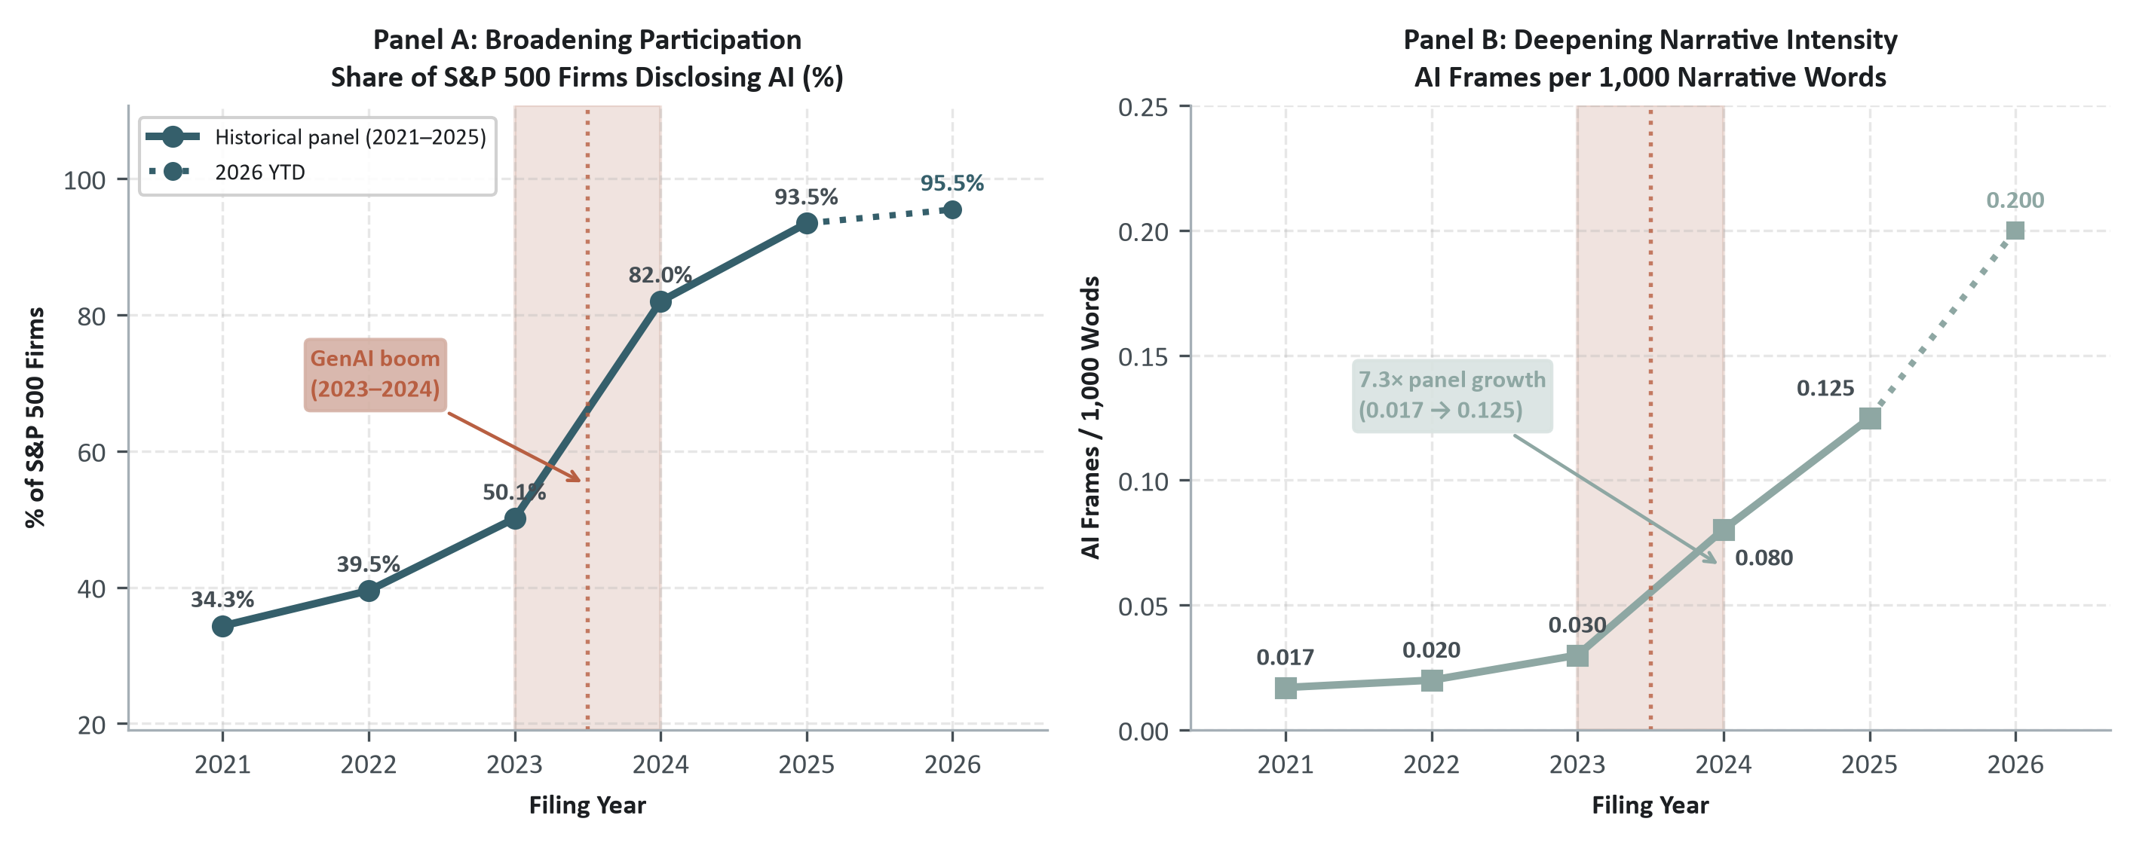
Figure 3: The diffusion of corporate AI disclosure across the S&P 500, 2021–2025 (2026 shown as year-to-date). Panel A: participation, % of disclosing firms. Panel B: narrative intensity, AI frames per 1,000 words. Generative AI commercialization inflection marked.
Once almost every large firm talks about AI, presence alone says little. At 93.5% participation, whether a firm discloses AI no longer separates firms. What separates them is how they communicate: the framing, emphasis, risk perception, and specificity that make up their disclosure posture.

2.4 The dimensions of AI disclosure strategy
Communication Posture ($P$) is described by seven frame-level dimensions. Disclosure intensity ($D$) adds narrative volume, which makes eight dimensions in total. The archetypes are fitted on the seven posture dimensions only: how much a firm discloses is a different question from how it discloses, and if the two are mixed, volume dominates the result. Table 4 defines each dimension and Figure 4 shows how they are distributed across the S&P 500.
Table 4: Operational definitions of the eight AI disclosure strategy dimensions.
Dimension | Operational Definition | Range | Managerial Meaning
Promotional posture | Average of promotional tone and strategic-importance framing | $\left[0,1\right]$ | Extent to which AI is communicated as a transformative strategic asset
Hedging posture | Share of statements framed with cautious or conditional language | $\left[0,1\right]$ | Degree to which AI claims are qualified rather than asserted outright
Risk orientation | Share of statements containing risk, uncertainty, or dependency concepts | $\left[0,1\right]$ | Degree to which AI is treated as an operational vulnerability or hazard
Governance orientation | Share of statements containing oversight, ethics, or compliance policies | $\left[0,1\right]$ | Formal institutionalization of model oversight and responsible AI guardrails
Claim realization | Share of statements describing current, realized usage rather than planned/future intentions | $\left[0,1\right]$ | Operational maturity: active/realized deployment vs. future roadmap or intent
Customer-facing | Share of statements oriented toward external clients and commercial offerings | $\left[0,1\right]$ | Commercial orientation: external client products vs. internal operating workflows
Claim specificity | Mean of 5 binary grounding flags (process, product, vendor, metric, timeline) | $\left[0,1\right]$ | Falsifiability and informational granularity of corporate statements
Disclosure intensity | Percentile rank of AI semantic frames per 1,000 narrative words | $\left[0,1\right]$ | Overall narrative volume dedicated to artificial intelligence

The eight dimensions behave very differently from each other across the S&P 500: some cover almost the full range across firms, while others stay compressed near the lower bound for the typical firm (Figure 4). Disclosure strategy is therefore not simply a matter of talking more or talking less; firms differ in which themes they emphasize, how concrete their evidence is, how far into the future they commit, and which function they point at, and only a multidimensional profile lets promotional framing be read against the concreteness of the underlying evidence in the same text. Earlier work on tone shows that these choices are managed and not mechanical: Huang, Teoh, and Zhang (2014) find that abnormally positive tone is not explained by fundamentals and predicts worse future performance, and Cheng et al. (2019) that speculative talk grows during technology booms.
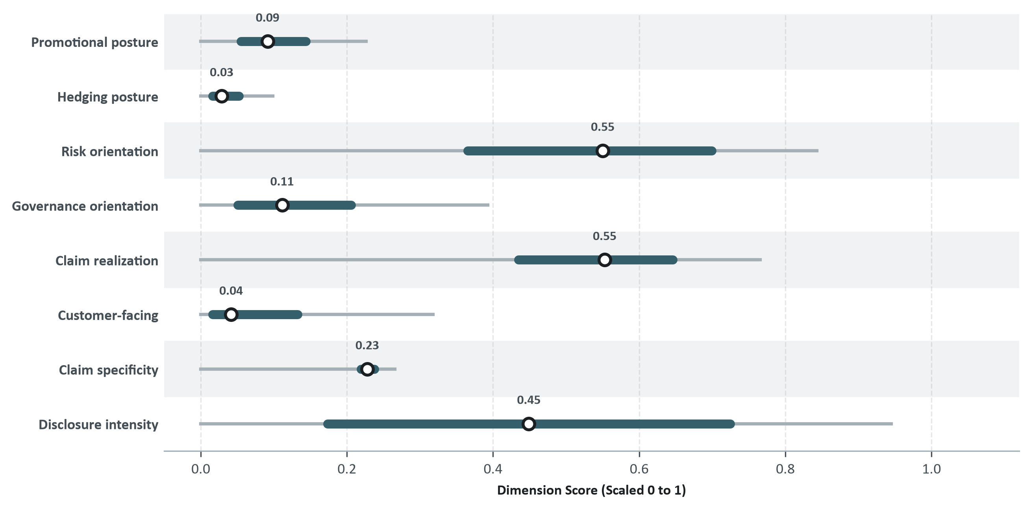
Figure 4: Distribution of Seven AI Disclosure Posture Dimensions and Disclosure Intensity Across the S&P 500, pooled 2021–2026 YTD. White circles denote medians; petrol bars interquartile ranges; grey whiskers the 5th–95th percentile. All measures are scaled from 0 to 1.
The correlations among the seven posture dimensions and disclosure intensity show two things (Table 38, Appendix B.3):
- Governance framing stands on its own. Governance orientation barely correlates with promotional posture ($r=$ 0.13), risk framing ($r=$ -0.02), or disclosure intensity ($r=$ -0.15). It is a dimension in its own right and not a proxy for general verbosity or for risk aversion.
- Risk orientation runs against operational execution. Risk framing correlates negatively with realized temporal posture ($r=$ -0.58), specificity ($r=$ -0.54), customer positioning ($r=$ -0.47), and intensity ($r=$ -0.31).
Keeping governance, specificity and operational maturity separate is therefore what stops a reader from taking narrative intensity as an undifferentiated signal of technical capability.

2.5 Disclosure archetypes
The posture dimensions are computed for all 498 firms. A firm with fewer than five AI frames in its 2021–2025 SEC filings gets the rule-based label No AI ($n=$ 47). That leaves 90.6% of the panel with enough AI commentary to carry an active posture.
For those active firms ($n=$ 451), disclosure strategies mix several communication registers instead of falling into clean separate bins, so the method used here is Archetypal Analysis (Cutler and Breiman 1994), applied to the seven posture dimensions. It picks $k$ extreme profiles from the edge of the data and writes every firm as a blend of them. A firm is therefore not assigned to one style; it receives a share of each, for example 60% of one and 40% of another, and the shares sum to one. Those shares are what the rest of the chapter works with (formal specification in Appendix B.1).

2.5.1 Archetypal profiles and the disclosure simplex
With $k=3$ the three shares of every disclosing firm sum to one, so each firm can be drawn as a point inside a triangle whose corners are the three extreme profiles. A firm sitting in a corner is entirely that style; a firm in the middle is an even blend of all three. Figure 5 places all 451 disclosing constituents on this simplex, together with consolidated industry centroids and both boundary and central examples:
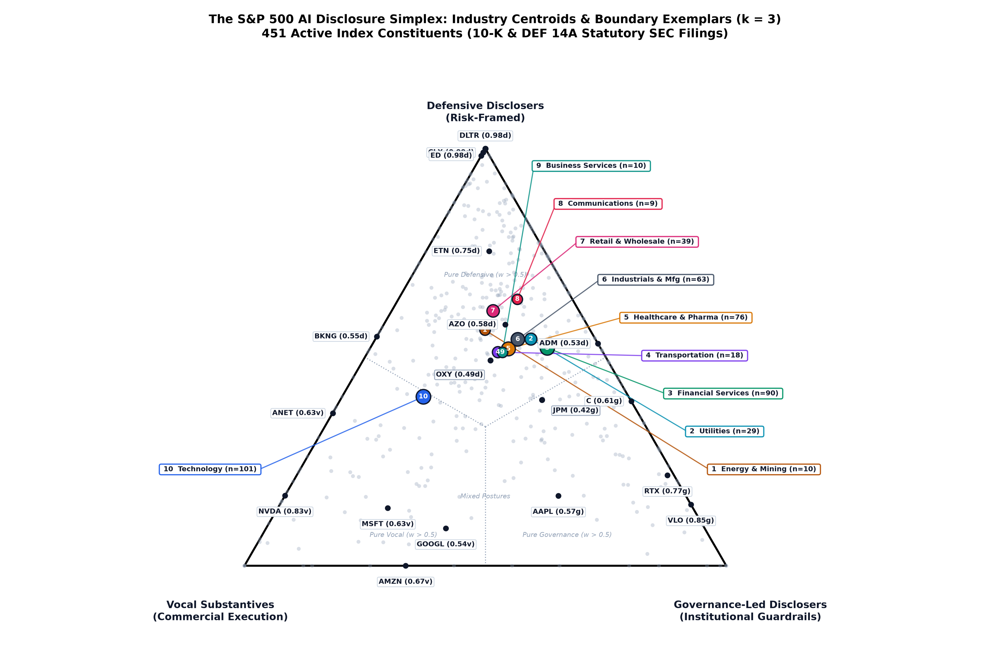
Figure 5: The S&P 500 AI Disclosure Simplex: Industry Centroids and Boundary Exemplars, 2021–2026 (year to date). k = 3; active index constituents, 10-K and DEF 14A filings. Ten consolidated industry centroids with radial non-crossing leader lines. Boundary exemplars: simplex boundary clipping. Central exemplars (OXY, JPM): balanced tripartite postures.
The analysis returns three stable disclosure strategies plus the non-disclosing baseline (Table 5):
Table 5: AI corporate disclosure archetypes at a glance.
Archetype | Firms ($n$) | Share (%) | Archetypal disclosure profile | Stability (Jaccard)
Vocal Substantives | 78 | 15.7% | High customer-facing (+1.63 SD), specificity (+1.56 SD), promotional (+1.23 SD), intensity (+0.99 SD), realized (+0.85 SD); low risk (-1.19 SD) | 0.77
Governance-Led Disclosers | 91 | 18.3% | High governance (+1.40 SD), realized (+0.87 SD) | 0.67
Defensive Disclosers | 282 | 56.6% | low realized (-0.52 SD) | 0.83
No AI | 47 | 9.4% | Fewer than 5 pooled AI frames across 2021–2025 SEC filings (rule-based filter) | 1
Notes: Archetypal disclosure profile: standardized coordinate score (SD from pooled mean) on the defining dimensions. Stability: mean bootstrap Jaccard reproducibility, frame-level resampling.
Each vertex is an extreme configuration that can still be read in plain terms (Figure 6). The vertices come from posture alone: disclosure volume is measured separately and plays no part in the fit, so the fact that Vocal Substantives also disclose the most is a property of those firms and not something the method was told.
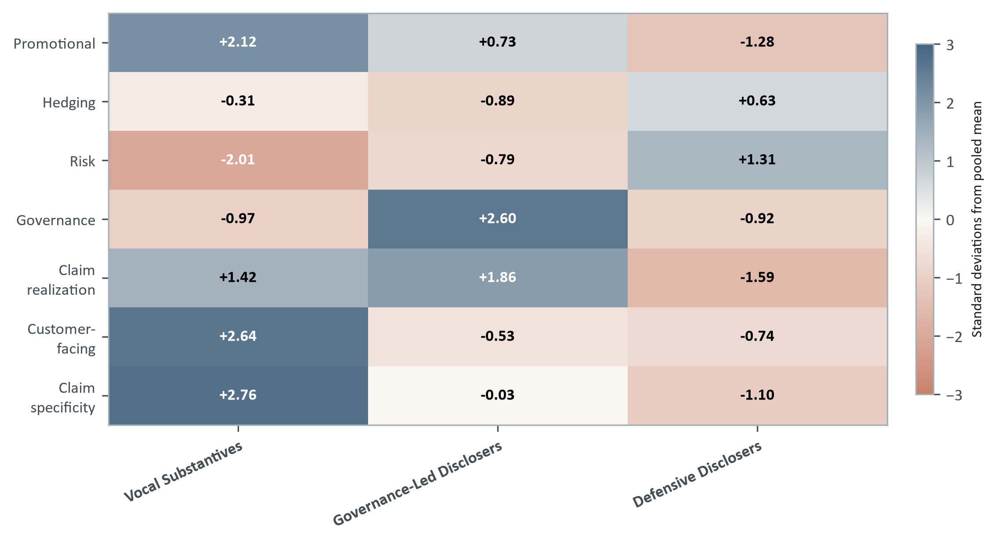
Figure 6: Disclosure archetypes: standardized coordinates (matrix A, z-scores) of the three archetypal vertices (k = 3), 2021–2026 (year to date).
Named firms make the distinction concrete (Table 6):
Table 6: Representative corporations and disclosure registers across AI disclosure archetypes.
Archetype | Prominent Constituents | Centroid-Closest Exemplars | Primary SEC Disclosure Focus
Vocal Substantives | Microsoft (MSFT), NVIDIA (NVDA), Alphabet (GOOGL), Meta (META), Amazon (AMZN) | Nasdaq (NDAQ), Cadence Design Systems (CDNS), MICROSOFT CORP (MSFT), Johnson Controls (JCI) | Customer-facing tools, commercial roadmaps, high technical specificity, realized deployments
Governance-Led Disclosers | Citigroup (C), BlackRock (BLK), Apple (AAPL), UnitedHealth (UNH), Walmart (WMT) | ALASKA AIR GROUP, INC. (ALK), Delta Air Lines (DAL), General Mills (GIS), RTX (RTX) | Board oversight, model risk management, responsible AI frameworks, data privacy
Defensive Disclosers | Goldman Sachs (GS), Morgan Stanley (MS), Johnson & Johnson (JNJ), American Express (AXP), Eli Lilly (LLY) | STARBUCKS CORP (SBUX), Microchip Technology (MCHP), Danaher (DHR), Labcorp (LH) | Item 1A risk factors, cybersecurity, third-party vendor dependencies, minimal operational claims
No AI | Costco (COST), Texas Instruments (TXN), O’Reilly Automotive (ORLY), NVR (NVR) | Rule-based filter (< 5 frames) | Physical operations, heavy capital assets, retail/real estate; negligible AI mentions in SEC filings
Notes: Prominent constituents: widely recognized S&P 500 members per cluster. Centroid-closest exemplars: firms nearest each archetype’s mean posture vector. Primary SEC disclosure focus: dominant narrative register in statutory filings.
Two cases show how far SEC disclosure posture can sit from commercial reputation:
- Apple falls into Governance-Led. The firm ships proprietary AI in its consumer devices, but in its SEC filings the AI mentions are about board oversight and responsible-use proposals. The product marketing happens at keynotes, outside EDGAR.
- Goldman Sachs falls into Defensive. More than 60% of its AI-bearing text is in Item 1A risk factors (model risk, cybersecurity, vendor dependencies), and there is very little operational disclosure.
Placing a firm next to its peers therefore tells a reader which filings deserve a closer look. It says something about communication strategy and nothing directly about technological capability.
The No AI group also contains 20 firms that left the S&P 500 through acquisition or delisting before the generative AI boom, so part of the group is explained by the timing of the exit rather than by an active disclosure policy. They are kept in order to preserve the panel.

2.5.2 Sectoral sorting and institutional channels
Industry economics and regulatory exposure shape the archetypes a great deal, although peers inside the same sector still differ from each other. Comparing each sector’s share of an archetype with the sample baseline shows the sorting clearly (Figure 7):
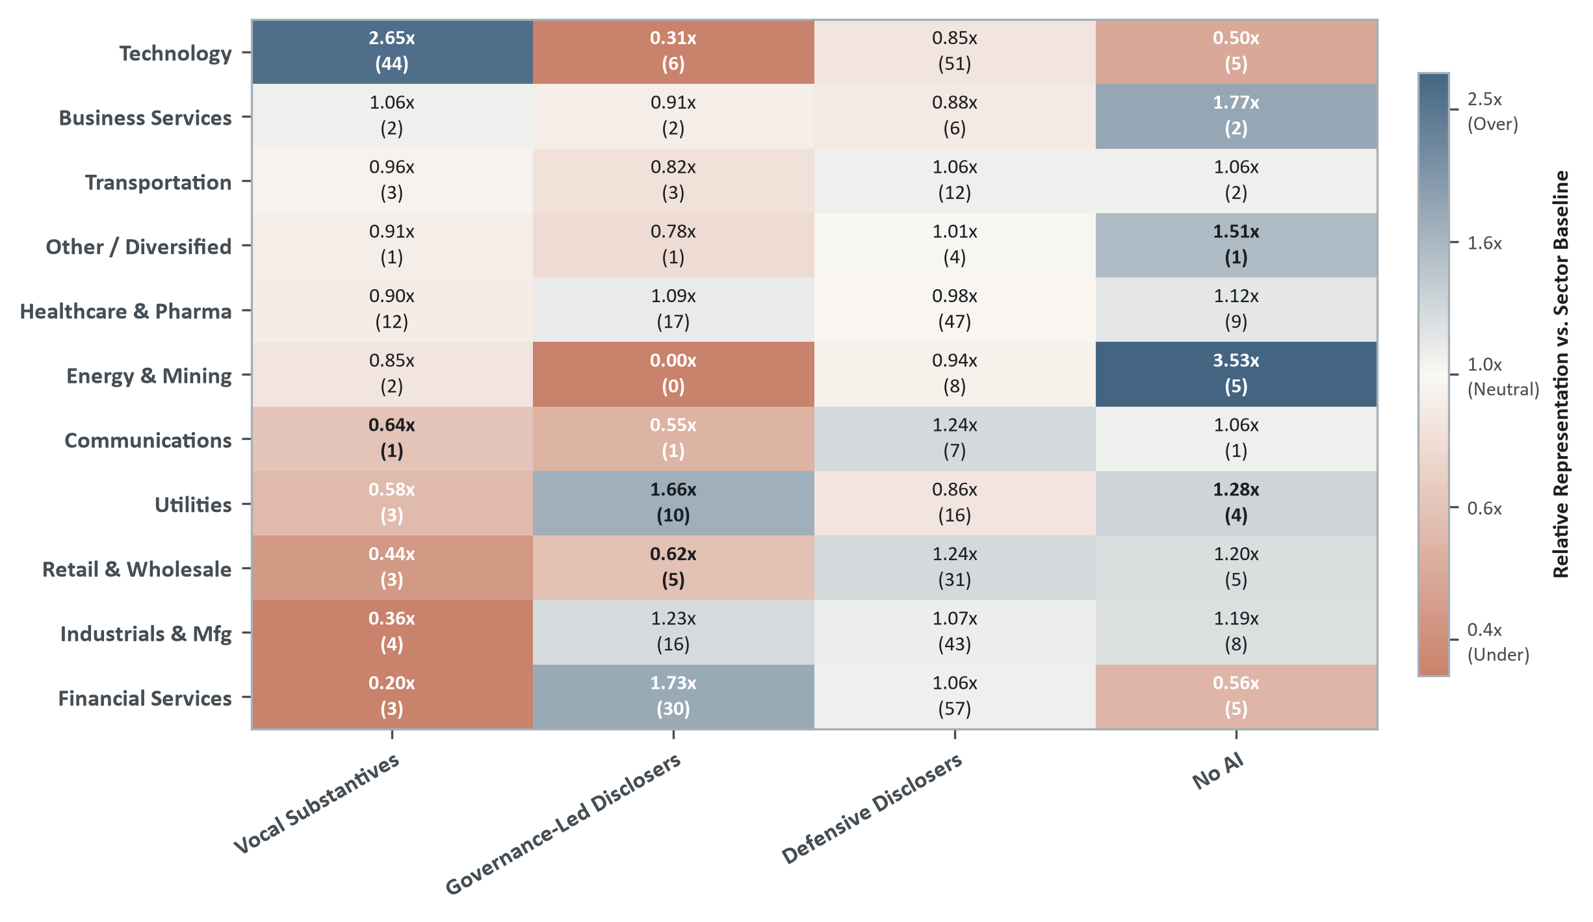
Figure 7: Sector representation by disclosure archetype, 2021–2026 (year to date). Ratio of archetype share to sector baseline (observed / expected ratio, firm counts in parentheses). Cells with fewer than five firms show high ratios on small constituent counts and should be read with caution.
Two contrasts illustrate the sorting. Technology concentrates heavily in Vocal Substantives: enterprise software and infrastructure providers have both the capability and the commercial reason to market client-facing AI products. Financial Services and Utilities, by contrast, dominate Governance-Led Disclosers (1.73$×$ and 1.66$×$ the baseline, against 1.09$×$ for Healthcare & Pharma), a pattern compatible with compliance-heavy environments where model-risk management, board oversight and responsible-AI guardrails are emphasized first. The largest ratios in Figure 7 rest on a handful of firms and should not be read as a sectoral pattern.
Firms that answer to the same regulator end up writing about AI in similar terms. This reading is compatible with institutional isomorphism (DiMaggio and Powell 1983; Suchman 1995): a shared institutional pressure toward a sector-level disclosure convention. Both for corporate benchmarking and for investment screening, a firm has to be judged against its sector peers before any posture can be called exceptional.

2.5.2.1 Institutional channels: where vs. how firms disclose
Where a firm discloses and how it discloses cannot be separated in the data. Across the $N=$ 451 disclosing firms, the archetypal weights correlate strongly with particular statutory channels:
- Defensive Disclosers ($w_{\text{Def}}$) go with Form 10-K Item 1A Risk Factors ($r=$ +0.773, $R^{2}=$ 59.8%), where the claims stay on liabilities, regulatory hazards and vendor dependencies and never become promotional.
- Governance-Led Disclosers ($w_{\text{Gov}}$) go with Form DEF 14A proxy statements ($r=$ +0.719, $R^{2}=$ 51.7%), on board committee charters, supervisory accountability and executive oversight.
- Vocal Substantives ($w_{\text{Vocal}}$) go with Form 10-K Item 1 (Business Description) and Item 7 (MD&A) ($r=$ +0.515, $R^{2}=$ 26.5%), the parts of the filing where commercial strategy and product milestones are stated.
The choice of channel is itself a strategic decision: Campbell et al. (2014) show that mandatory risk-factor disclosure carries information that investors price, so what a firm decides to put in a filing rather than in a call already says something. DEF 14A coverage reaches 100% of the disclosing firms (393 mention AI, 58 do not), which means that a low $w_{\text{Gov}}$ weight comes from the firm leaving the topic out, not from a missing filing.
A refit of the archetypes on Form 10-K frames alone reproduces Vocal Substantives and Defensive Disclosers closely ($r=$ 0.912 and 0.727) but not Governance-Led ($r=$ 0.335, because the board-oversight language lives in the DEF 14A proxy statement). A review that looks only at the Form 10-K can therefore miss a large part of the governance and oversight evidence (full correlations in Appendix C.1).

2.5.3 The evolving composition of disclosure postures, 2021-2026
For each year $t$, the archetype label of a firm comes from a fit on that firm’s own text accumulated from 2021 up to $t$, one vector per firm, so that no firm enters a single fit twice; the fit is then used to classify the cross-section of year $t$ itself. A label for one year never uses information from a later year.
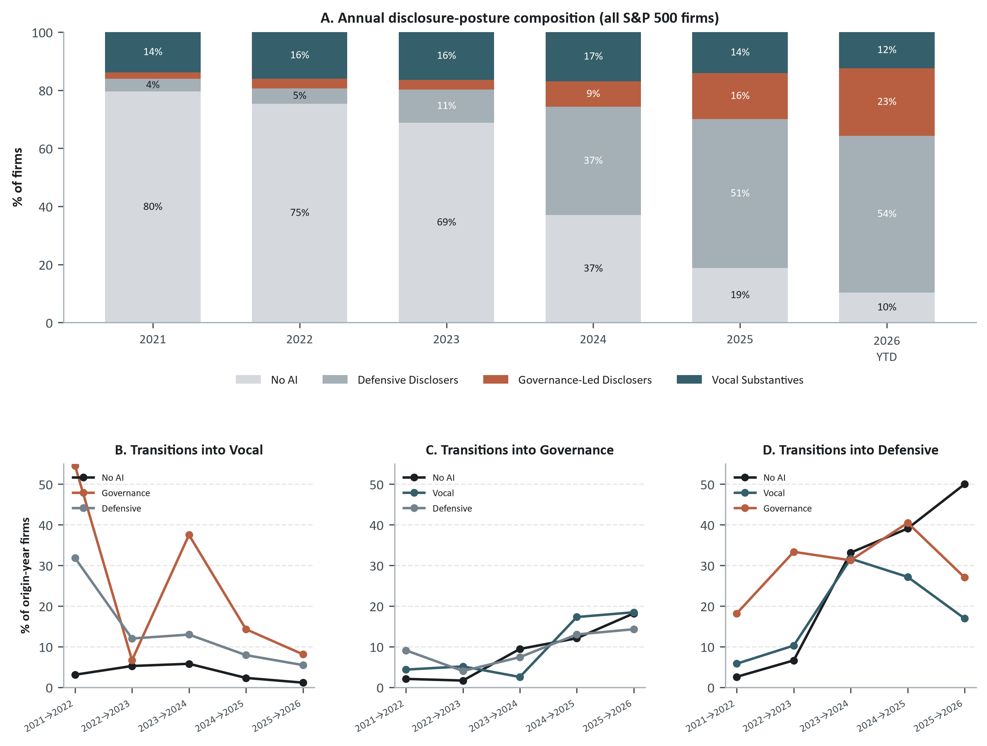
Figure 8: AI disclosure diffuses primarily through defensive reporting: annual composition and firm-level transitions, 2021–2026 YTD. Each firm-year’s archetype label comes from a fit on that firm’s own text accumulated up to that year. Panels B-D show, for each year-to-year transition, the share of an origin archetype’s firms classified into the named destination the following year, on a shared 0-60% axis.
The firms that started to disclose went almost entirely into defensive compliance, not into commercial claims. The share of Defensive Disclosers rises more than tenfold (4.4% $→$ 54.0% of the index) while Vocal Substantives stays roughly flat (13.9% $→$ 12.5%), so the space left by No AI (79.5% $→$ 10.3%) was taken by the defensive register.
Panels B-D show the entry channel behind this asymmetry: new entrants rarely go straight into Vocal Substantives (the flow from No AI never exceeds 5.8% in any year), and instead split between Governance-Led and Defensive, whose inflows both climb over the panel (2.6% to 50.0% and 2.1% to 18.2%, respectively). Firm-level persistence falls from 86.8% in 2021–2022 to a low of 55.0% at the 2023–2024 break and then recovers to between 58.4% and 61.7% (full transition matrices in the supplementary analytics). For monitoring purposes, a shift in posture is a reason to read the newly filed disclosures; by itself it does not prove that anything changed in the operations.

2.5.4 Model validation
The number of archetypes $k$ is chosen on reproducibility. Each $k∈\{2,3,4,5\}$ is tested under two non-parametric bootstrap regimes (Hennig 2007) with 50 independent replicates (Figure 9): frame-level resampling within firms, which speaks to measurement error, and firm-level resampling, which speaks to the sensitivity of the sample composition. Every archetype has to clear a mean Jaccard overlap of $≥0.60$ in both regimes.
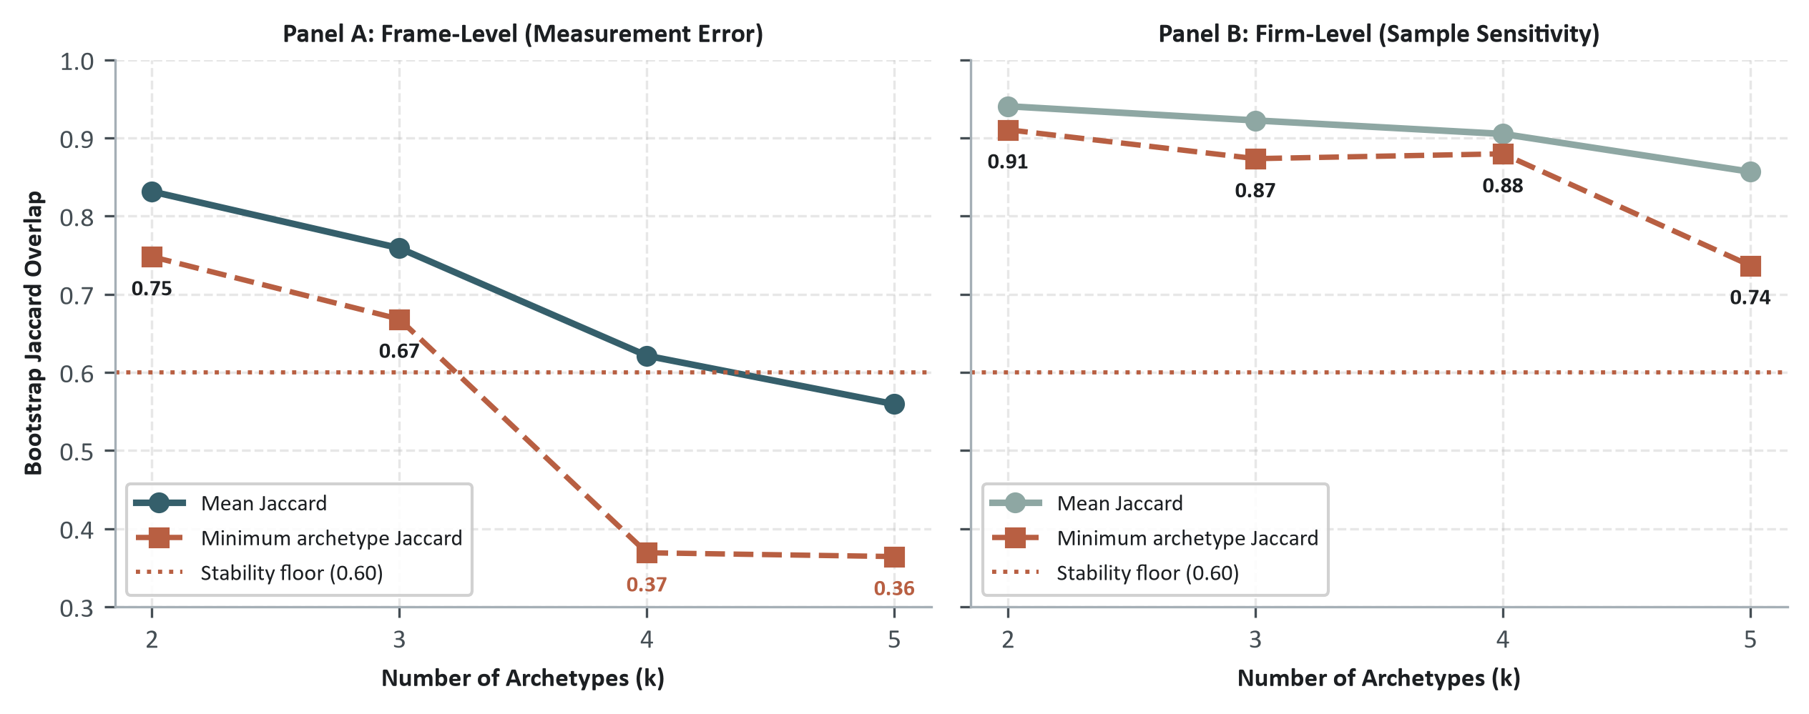
Figure 9: Choosing k by bootstrap stability across candidate values, 50 replicates per k. Panel A: frame-level resampling within firms (measurement error). Panel B: firm-level resampling (sample sensitivity). Only k = 3 keeps every archetype above the 0.60 Jaccard floor in both regimes.
Only $k=3$ clears the 0.60 Jaccard threshold in both bootstrap regimes. At $k=4$ the whole partition becomes unstable, because the candidate fourth cluster picks up too few firms, and very unstable ones, to be a real archetype. The three-archetype solution also holds when it is projected onto cohorts it was not fitted on (Appendix B.2 has the complete diagnostics, the $k=2$ comparison and the K-means cross-checks).

2.6 Conclusions
Read through signalling theory (Spence 1973; Verrecchia 1983), the three archetypes sit at different points on a curve of proprietary and litigation cost. The sectoral sorting follows that logic: Technology sorts Vocal, the regulated sectors sort Governance-Led, and the rest sort Defensive or No AI, treating AI as an exposure to manage and not as a claim worth proving.
The composition over time in Figure 8 works the same way. Institutional pressure pushes firms to mention AI (Meyer and Rowan 1977; DiMaggio and Powell 1983), and non-disclosers land in Defensive rather than in Vocal Substantives, since boilerplate is cheap to produce on short notice and a Vocal claim is not. The same pattern appears in the drift from Vocal to Defensive inside firms, against 58.5% persistence in 2025–2026.
The failure of the $k=4$ split fits here too. Promotional language without technical specificity does not form a stable cluster of its own, which means that AI washing is not a separate communication style. It is a gap inside the firm between narrative volume and grounded substance, and that gap is what $W$ measures.

3. AI Activity and Business Models
Does a communication posture correspond to real technological execution, or is it talk with nothing behind it? This chapter looks at the operational substance behind corporate AI claims, sorting the disclosed activities into functional business roles and checking how well each one is grounded. Keeping activity separate from posture follows Enholm et al. (2022), who separate the process-level effects of AI from what those effects later mean for firm performance, and who point to the technological, organizational and environmental conditions that decide whether value is created at all. What follows is an inventory of what firms say they do with AI, in which business function, and with what evidence; it describes disclosed activity and is not in itself proof of an economic benefit.

3.1 What corporate AI activity consists of
This section tests whether the four disclosure archetypes line up with disclosed AI activity, which was extracted separately. Across 471 S&P 500 firms, the extraction finds 46,855 unique AI activity claims. For each one it records the action, the object, the business domain, the operational stage, the evidence strength, and where the technology comes from.
Table 7: Business purpose: what the disclosed AI activity is for.
Business purpose | Definition
Sell | AI built into the products themselves, such as AI features, generative tools, and predictive analytics inside customer-facing software.
Operate | AI that runs the business better, from supply chains and process automation to forecasting, logistics, and back-office finance.
Build | The AI plumbing, such as company data platforms, cloud infrastructure, and training the firm’s own foundation models.
Enable | AI that helps employees work, such as developer copilots, code generation, enterprise search, and internal tools.
Control | AI that protects the firm, such as fraud detection, cybersecurity anomaly detection, compliance monitoring, and model risk oversight.
Serve | AI that talks to customers, such as service chatbots, client chat interfaces, recommendation engines, and targeted marketing.

So that a manager can read the inventory, every activity is classified on two independent dimensions: the business purpose it serves (Table 7) and the operational action taken (Table 8). Each activity has exactly one purpose and one action. A firm can, for example, develop (action) a feature that it then sells (purpose), or deploy (action) a system that it uses to control (purpose) fraud risk.
Table 8: Operational action: how the disclosed AI activity is carried out.
Operational action | Definition
Deploy / Integrate | Putting an AI capability into live systems, products, or workflows.
Develop / Build | Building or investing in the underlying AI capability in-house, rather than buying it.
Partner / Buy | Acquiring AI capability through a vendor, partnership, or procurement rather than building it.
Pilot / Explore | Testing or evaluating an AI capability before full deployment.
Analyze / Measure | Measuring or analyzing the performance or outcomes of an AI system.
Automate | Deploying AI specifically to automate an existing process.
Govern / Control | Governing, restricting, or overseeing AI use through policy or compliance action.

Keeping business purpose apart from operational action separates where AI is supposed to add value from what the firm is actually doing to put it in place.

3.2 How AI applications differ across industries
The purpose and action taxonomies pool every sector together. Crossing them with the 10 aggregated economic sectors (Table 24, Appendix A), excluding “Other / Diversified,” shows which sectors concentrate their AI activity in one purpose or one action and which simply look like the pooled average.
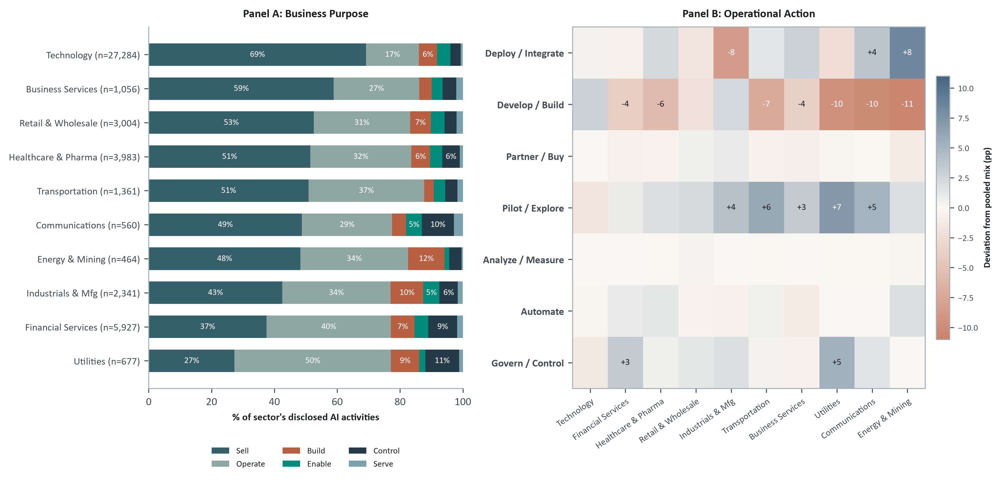
Figure 10: Sectoral business purpose and operational action of disclosed AI activity, pooled 2021–2026 YTD. Panel A: each sector’s row sums to 100%, ordered by Sell share descending. Panel B: each cell is a sector’s share of that action type minus the pooled share across sectors (red = above, blue = below); labeled only where the gap is at least 3 points.
On business purpose (Panel A), Technology and Business Services lean most toward Sell and Utilities and Financial Services most toward Operate. Panel B shows that operational action varies far less by sector: most action types barely deviate from the pooled mix. The clearest exception is Utilities, where Pilot / Explore and Govern / Control both peak (+7.1 and +5.3), consistent with AI still reading as experimental and tightly governed rather than as settled infrastructure there. A firm’s portfolio of initiatives should therefore be judged against its own operating model and its industry peers, not against Technology-sector disclosure as a universal benchmark.

3.3 Disclosure strategy meets disclosed AI activity
The activity inventory was never an input to the fit; the archetypes come from frame-level posture only. Crossing the archetypes with the activity features shows that posture does map onto operational disclosure (Figure 11):
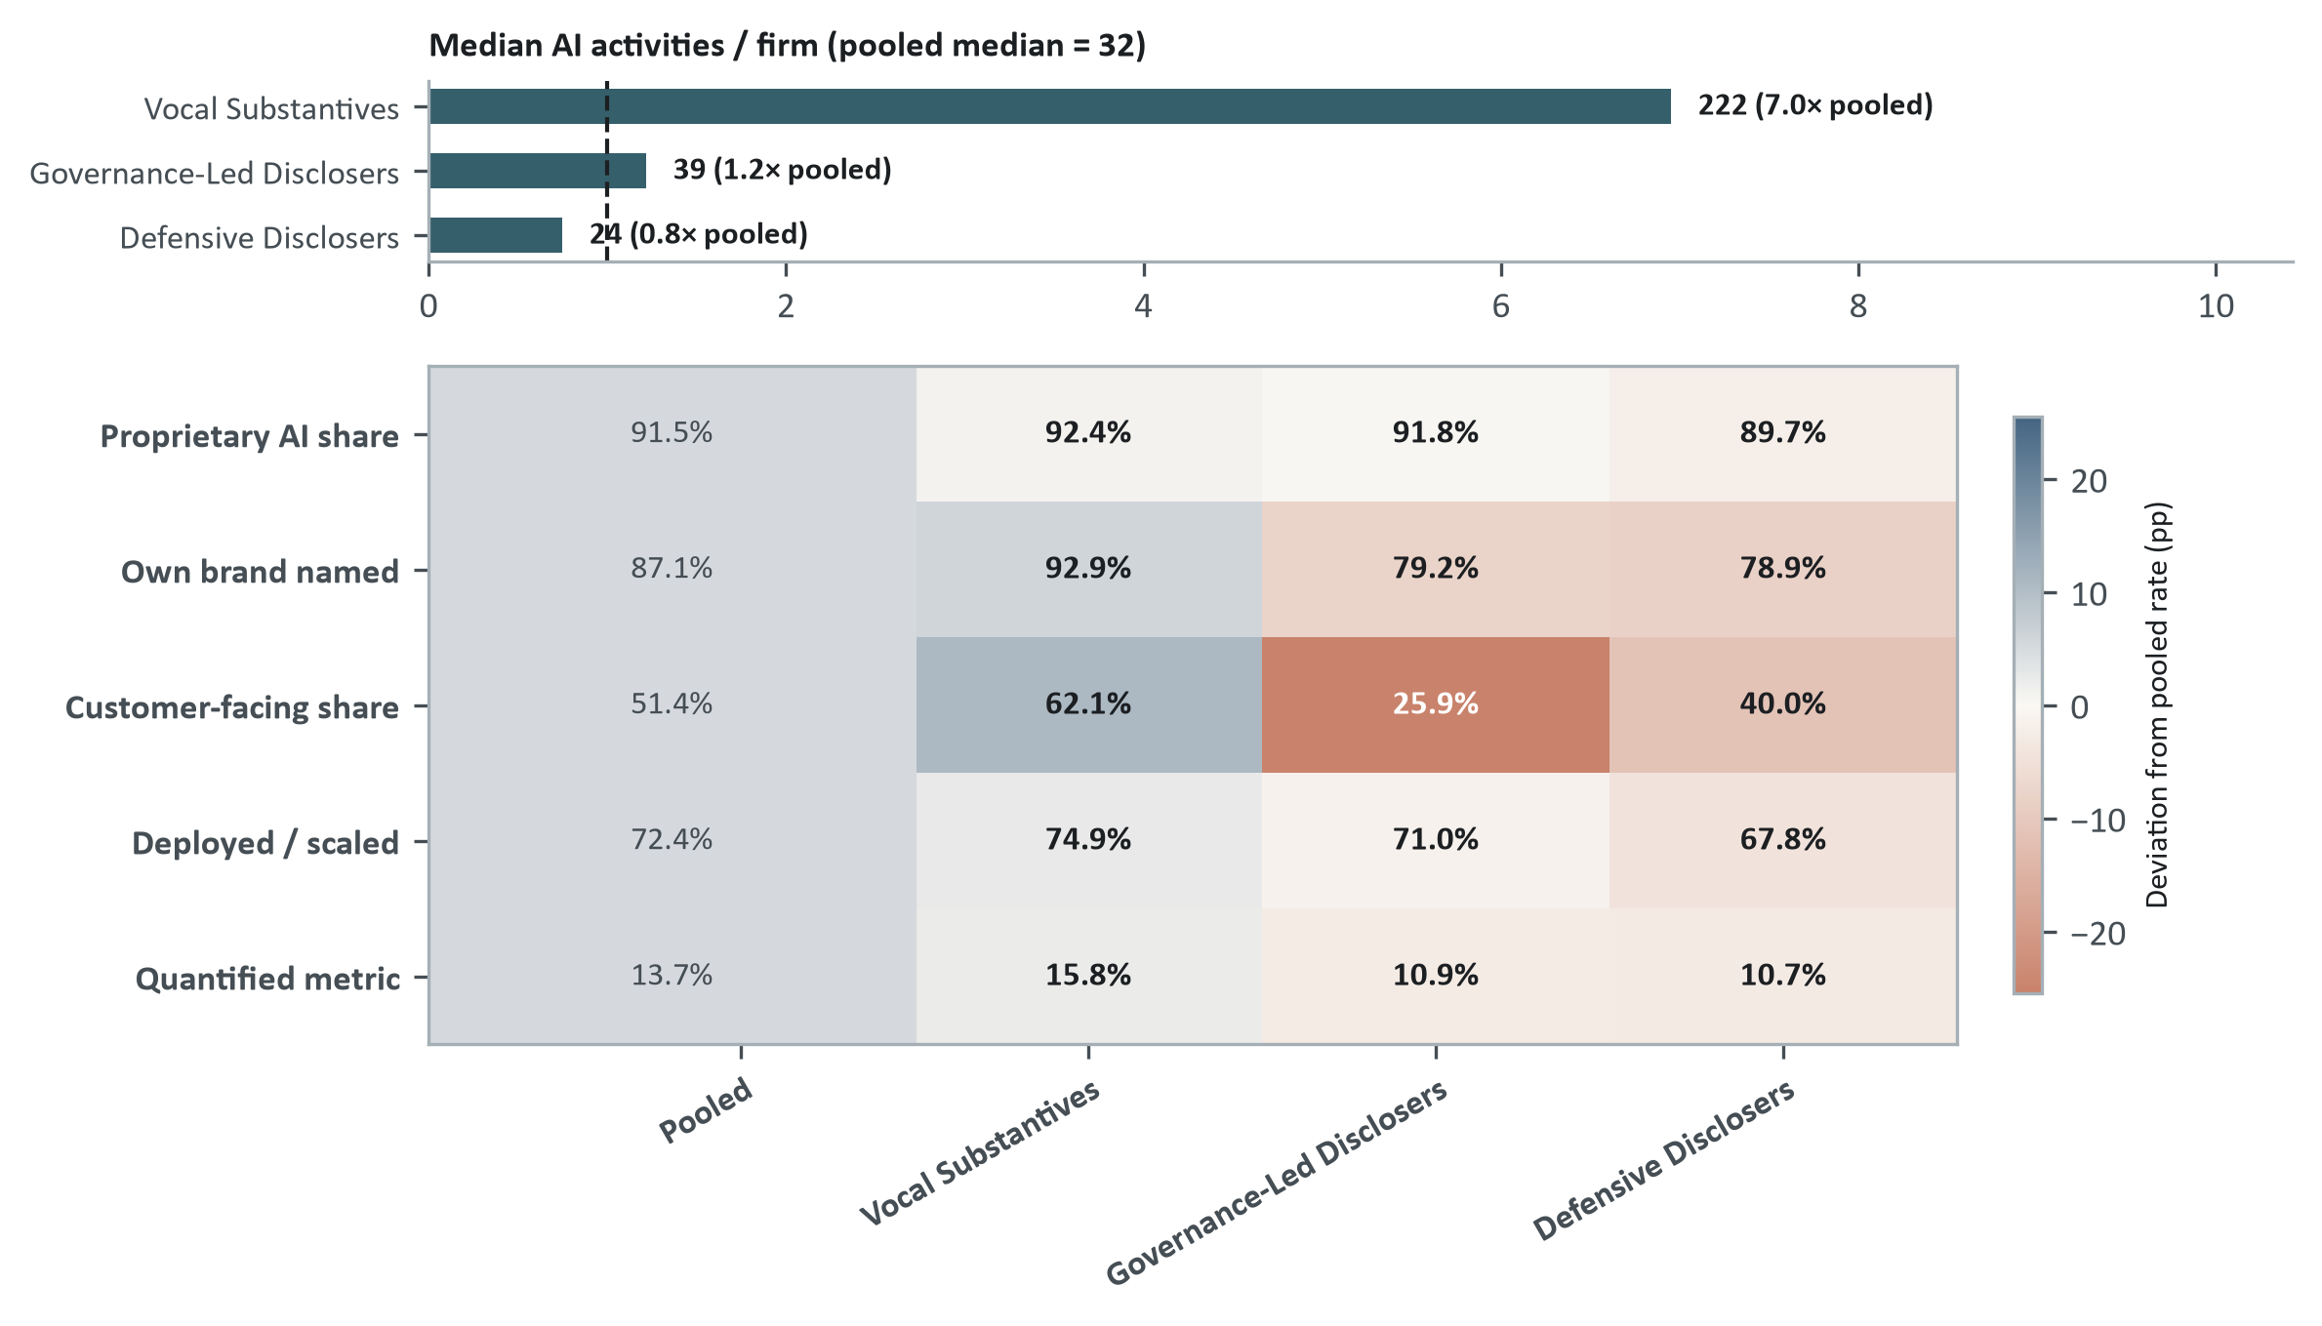
Figure 11: Archetypes differ most in activity volume and customer orientation: profile by archetype, pooled 2021–2026 YTD. Top panel: median disclosed AI activities per firm relative to the full universe. Bottom panel: raw rates by archetype, with shading indicating percentage-point deviation from the pooled benchmark.
Where the archetypes really differ is in volume and in customer orientation. Vocal Substantives report a median of 222 AI activities per firm, 7.0 times the pooled median, and their customer-facing share (62.1%) sits 11 points above the pooled rate. Governance-Led and Defensive Disclosers go the other way: both are well under the pooled customer-facing rate (25.9% and 40.0%) and also under it on own-brand naming, which fits communication built around internal process and oversight rather than around products sold to customers. Outcome metrics, by contrast, are scarce in every group: quantified outcomes stay close to a low pooled rate regardless of archetype.
The difference is not simply that some firms write more. At identical narrative volume, Vocal Substantives still report 2.02 times as many operational AI activities as Defensive Disclosers and Governance-Led Disclosers 1.52 times as many (both $p<0.001$; the negative binomial conditioning on total AI disclosure volume is in Appendix B.5). Posture is therefore useful for deciding where to start a review, but since outcome metrics are scarce in every group, an analyst still has to check the factual backing of each initiative one by one.

3.4 What firms disclose doing differently
What those activities are for also differs across the archetypes (Figure 12):
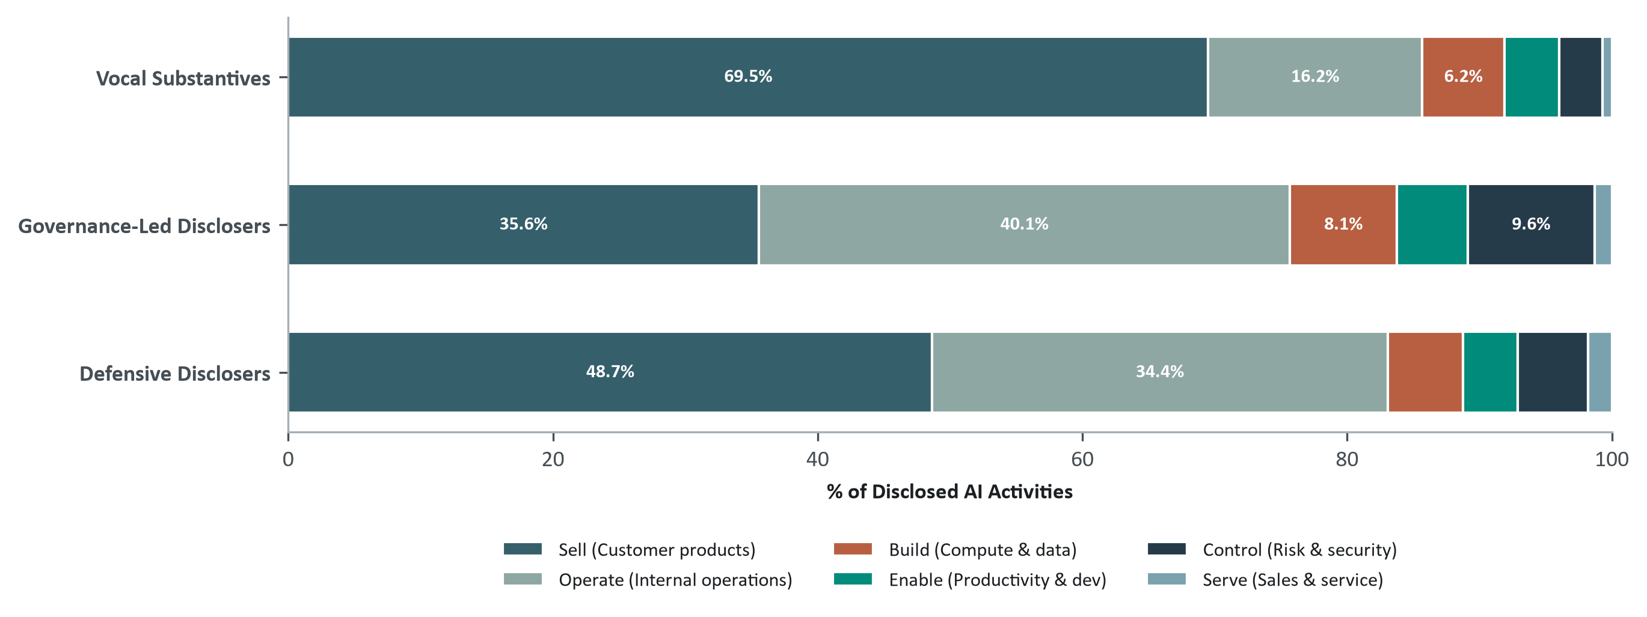
Figure 12: Mix of disclosed corporate AI activities by disclosure archetype, pooled 2021–2026 YTD. 100% stacked horizontal bars: share of each archetype’s disclosed AI activities across six business roles (Sell, Operate, Build, Enable, Control, Serve).
Selling, meaning AI placed inside the products and services that customers buy, dominates all three archetypes, but its weight shifts against internal operations: Vocal Substantives lean on it hardest (70% of their AI activities are Sell), while Governance-Led Disclosers split more evenly between selling and internal operations. A governance posture does not, however, imply a control-dominated portfolio: even inside the Governance-Led group, risk and compliance work is only a small part of the reported deployments, and a firm can write at length about supervisory oversight while still putting its actual AI into commercial and operational tools. Three filings show how this looks on the page (Table 9).
Table 9: Illustrative statutory filing excerpts across disclosure archetypes and activity orientations.
Archetype | Firm | Primary Focus | Filing Excerpt | Diagnostic Interpretation
Vocal Substantives | AMD | Sell | “On March 31, 2025 (the Acquisition Date), we completed the acquisition of ZT Group Int’l, Inc. (ZT Systems), which is expected to enable AMD to deliver end-to-end AI solutions and…” | Specific and verifiable: names the acquisition, product line, and deployment targets.
Governance-Led Disclosers | AIG | Control | “Based on these discussions, we have expanded our disclosure regarding governance matters, including adding new disclosure regarding the Board’s oversight of AI and the leadership t…” | Institutional oversight language rather than technical or operational deployment.
Defensive Disclosers | Eli Lilly | Generic (Sell / Operate) | “This proxy statement contains forward-looking statements, including those regarding our strategies and financial performance; our development of new products, indications and techn…” | Vague and defensive: no named products, operational stages, or concrete metrics.

3.5 Decomposing AI activity grounding
Firms disclose thousands of AI activities, and the question that matters is how concretely each one is grounded in the text. To measure AI activity grounding ($G$), every disclosed activity is put through a ladder of requirements that become stricter at each step:
$$\text{AI Activity Claim} → \text{Specific Business Function} → \text{Deployed Stage} → \text{Named Product/Process} → \text{Quantified Outcome Metric}$$
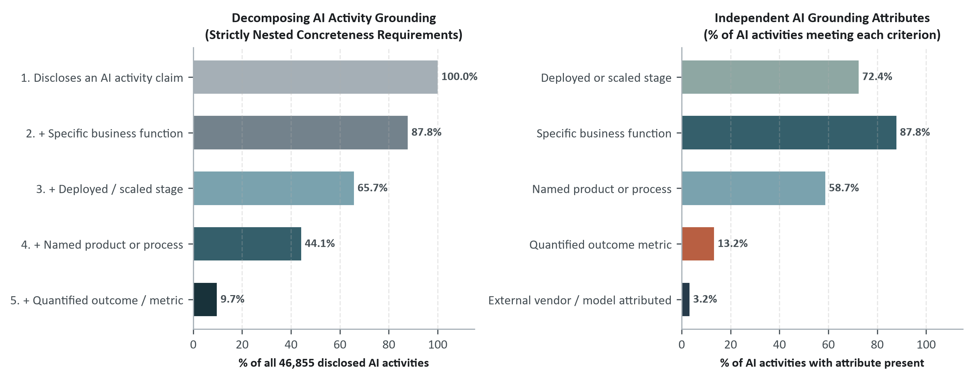
Figure 13: Decomposing AI activity grounding across all disclosed AI activities, pooled 2021–2026 YTD. Left: cumulative nested progression of evidence requirements. Right: independent grounding attribute frequencies.
Only 9.7% of disclosed AI activities reach the top of the ladder, where an operational deployment comes together with a quantified performance metric (Figure 13). Each step of the ladder is an audit point in practice: a company can see exactly which piece of factual backing is missing from its own claim, whether a named business function, a deployed or scaled stage, a named product or process, or a quantified metric, and an investor can ask for that specific piece, without requiring every initiative to satisfy all five attributes at once.

3.6 More activities but with thinner grounding
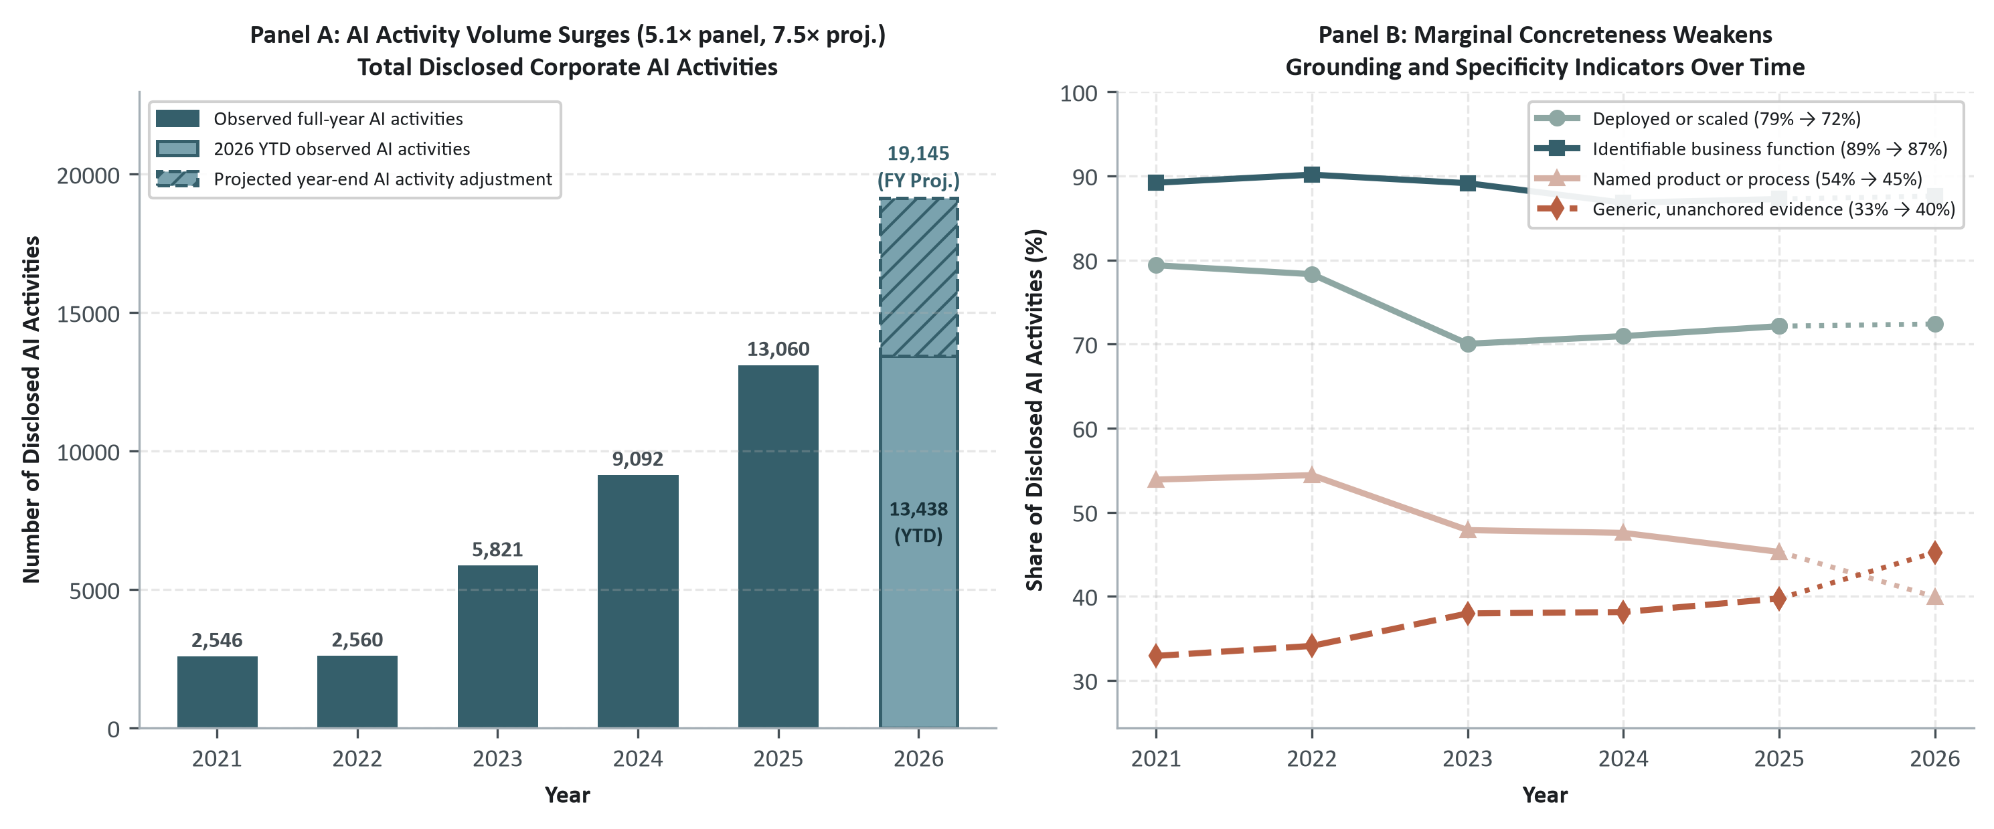
Figure 14: Disclosed AI activity expands while average grounding declines: activity volume and grounding, 2021–2026 YTD.
The generative AI boom multiplied the number of disclosed activities while diluting their average grounding (Figure 14). Disclosed activities in 2025 were 5.1 times the 2021 count (projected to 7.5 times in 2026), while the share of initiatives at a deployed or scaled stage fell from 79% to 72% (72% in 2026 YTD) and those naming a specific product or process dropped from 54% to 45% (40% in 2026). This is what institutional theory expects (Meyer and Rowan 1977): once AI vocabulary became an external market expectation, rhetorical adoption spread much faster than organizational execution. The same widening connects two earlier findings. Anantharaman, Parker, and Rozario (2026) document the post-ChatGPT surge in corporate AI talk but do not separate what firms claim to be running from what they claim to be planning, and Basnet et al. (2025) show that separating actionable from speculative AI text is what makes a disclosure informative. The measurement used here supplies the missing half of the first and turns the second from a binary split into a graded account of what an activity actually names. What declines here is the documentary detail carried per activity, that is, named products, deployment stage, concrete metrics, and not necessarily the real execution behind it; growth in the number of projects has to be read together with the grounding, because a larger volume of initiatives on its own says nothing about operational progress.
Panel A: disclosed AI activity volume surged several-fold. Panel B: marginal concreteness and grounding indicators deteriorated.

3.7 Corporate branding versus external-vendor attribution
An investor reading an AI claim also wants to know where the technology comes from. The named entity roles across the 46,855 disclosed AI activity statements show a clear imbalance (Figure 15): 87.7% attach the firm’s own brand or in-house product name to the deployment, against 27.2% that name or declare an external source. Attribution is incomplete rather than substitutive: external credit almost never displaces the firm’s own brand, it is layered alongside it.
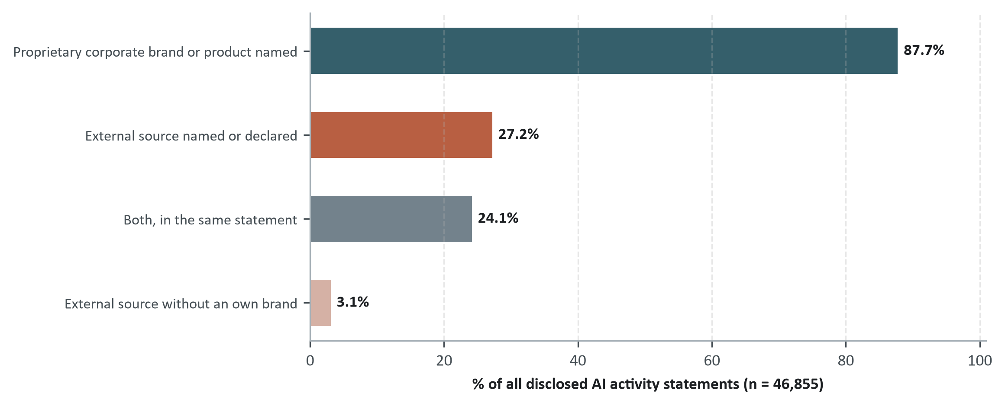
Figure 15: Corporate branding versus external-vendor attribution in disclosed AI activities, pooled 2021–2026 YTD. Indicator shares overlap across statements and do not sum to 100. External sources combine named vendors/foundation models, commercial partners, or declared third-party origin, identified via entity tagging and vendor lexicon matching.
Issuers consistently put their own brand ahead of external attribution, and an investor reading such a disclosure has to ask directly about model provenance, vendor reliance and architectural dependency.

3.7.1 Technology ecosystems named in AI disclosure
When S&P 500 corporations discuss artificial intelligence, which suppliers do they name? Only commercial names count here: a company, a cloud platform, an accelerator, a model family, read inside paragraphs that already carry an AI disclosure frame, and only when the supplier is somebody else’s. Country words are not names: “China” locates a market, not a technology. The AI technology stack (model developers, cloud infrastructure, semiconductors) is kept apart from enterprise software (applied AI inside business platforms), since a blended number would hide which of the two is moving. Appendix B.6 gives the lexicon and the disambiguation rules.
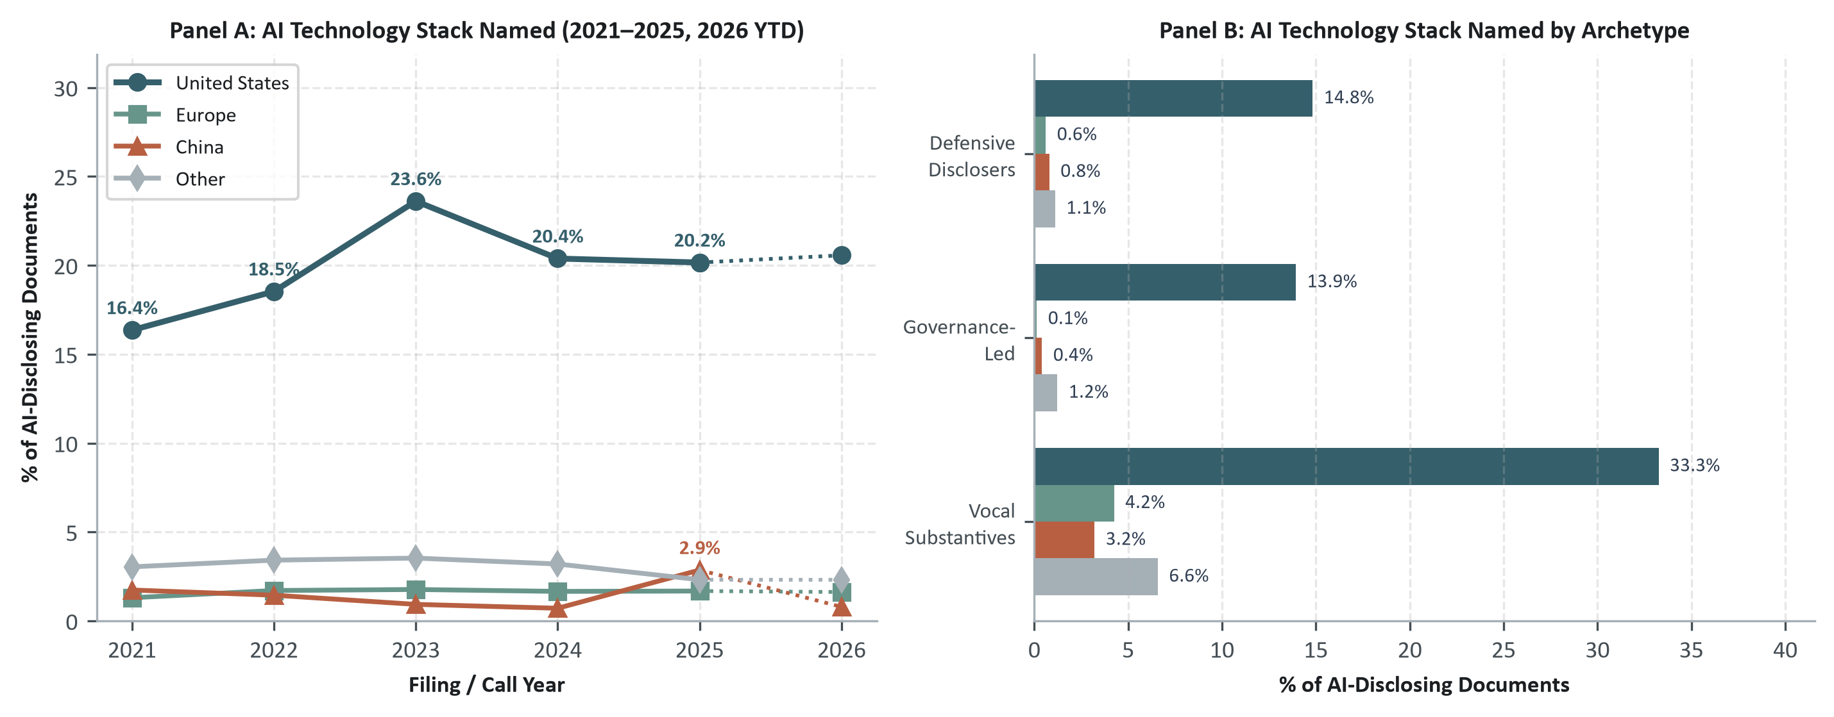
Figure 16: Named technology ecosystems in AI disclosure across S&P 500 firms, 2021–2026 YTD. Panel A tracks the share of AI-disclosing documents naming each ecosystem’s stack, with 2026 as a dotted, year-to-date segment; Panel B breaks the same rate down by archetype. The denominator is the 8,452 documents with an AI frame; rates are independent presence indicators, so the four series do not sum to 100.
Two findings stand out (Figure 16, Figure 17).
- Naming a supplier is now the majority practice, and the supplier is American. 66.3% of the 483 firms with AI disclosure name any external provider, and 59.8% name a U.S. technology stack against 12.0% for China; no non-U.S. provider reaches a tenth of firms.
- Chinese providers appear in one year and then recede. Chinese stack mentions stay below 2% of documents in every year except 2025, when they reach 2.9%, and fall to 0.8% in the 2026 year-to-date sample. DeepSeek alone accounts for the movement, which makes it an episode in who gets named rather than a durable Chinese presence in the disclosed stack.
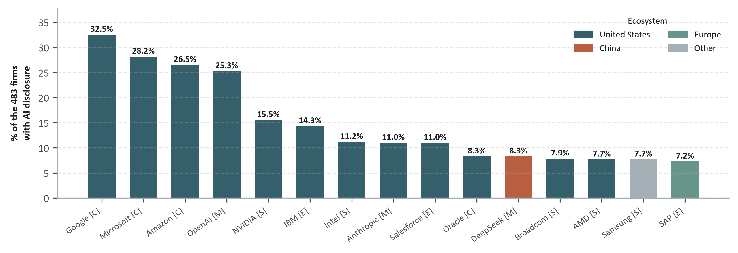
Figure 17: Provider families most cited in AI disclosure, by ecosystem and stack role, pooled 2021–2026 YTD. Bars: share of AI-disclosing firms naming each family, colored by ecosystem, with its stack role beside the name (M model, C cloud, S semiconductor, E enterprise software). The 15 most-named of 49 families in the corpus (full list, Appendix B.6); a firm’s own products are excluded. Only disclosures containing sections identified as AI-related are included.
Enterprise software reverses part of the picture without changing its center: Europe reaches 10.4% here, against 7.5% in the technology stack, entering these disclosures as a software vendor rather than as a source of models or compute.

3.8 Exogenous shocks: regulatory warnings and technology surprises
Two dated events fall inside the sample: the SEC’s December 2023 warning on AI claims, and DeepSeek’s release in January 2025. Each is examined as an interrupted time series on the aggregate, that is, a break in the level and in the slope of a monthly series with reporting seasonality and the composition of firms filing that month held constant, rather than as a difference between exposed and unexposed firms. A shock that moves every firm alike leaves no differential to detect, which is what a difference design would look for and miss.

3.8.1 SEC scrutiny, December 2023
In December 2023 the SEC warned public companies against overstating what their AI can do, with the agency’s chair naming “AI washing” as securities fraud in the same terms as any other misstatement (Gensler 2024), followed by enforcement against advisers who had claimed capability they did not have (U.S. Securities and Exchange Commission 2024): risk and governance framing accelerate over the sample, but neither turns at that date, and both fit a break in early 2023 better than the warning itself (Appendix C.3).
Direct scrutiny is also rare. Across SEC staff comment letters from 2022 to mid-2026, 8 threads match AI terms within the panel and 1 questioned a firm’s operational AI claims: the Welltower inquiry of 2025-04-28, which contrasted a boilerplate sentence in the 10-K with an “industry-leading” platform claimed on the earnings call. The response was not defensive retreat (Figure 18).
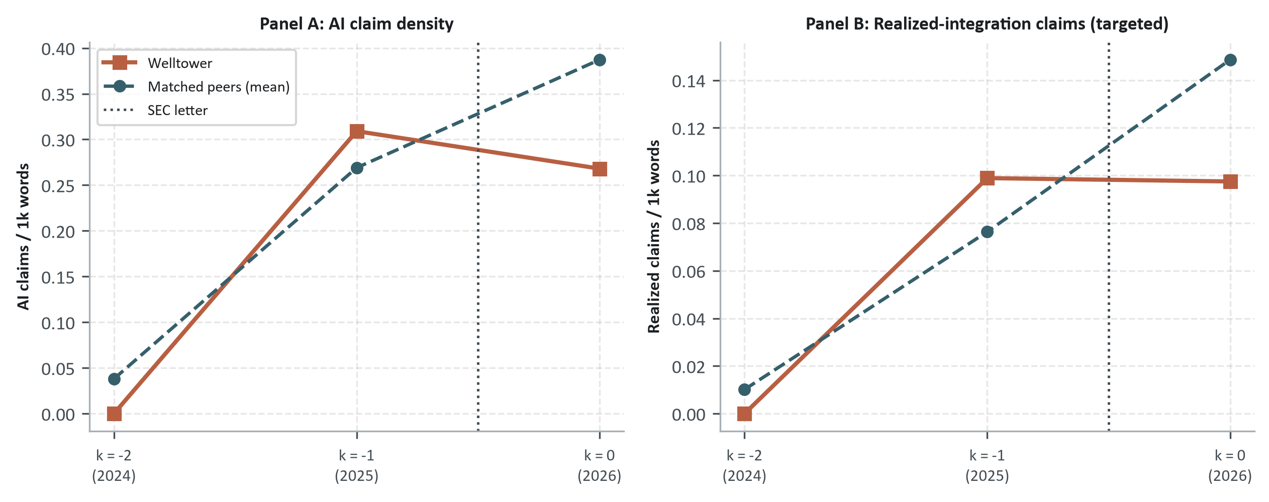
Figure 18: Welltower’s annual-report AI disclosure around the SEC comment letter of 2025-04-28, against the mean of three matched real-estate peers. k = −1 is the FY2024 10-K the letter reviewed; k = 0 is the first 10-K filed after the letter. Panel A: AI claim density; Panel B: realized-integration claims, the dimension the staff asked about.
In the first annual report filed after the inquiry, Welltower’s AI claim density fell from 0.309 to 0.268 claims per thousand words, and in the dimension the letter targeted, realized integration, density fell to 0.097. Decoupling narrowed from 0.142 to -0.126. One firm cannot establish a regulatory effect, and read alongside the aggregate series, where no break dates to the intervention, the evidence supports a narrow claim: scrutiny is rare, and where it occurred the firm added evidence rather than withdrawing claims (case details in Table 49, Appendix C.2).

3.8.2 DeepSeek, January 2025
DeepSeek produced a two-month burst of open-source vocabulary on earnings calls and left no lasting change in level (Figure 19).
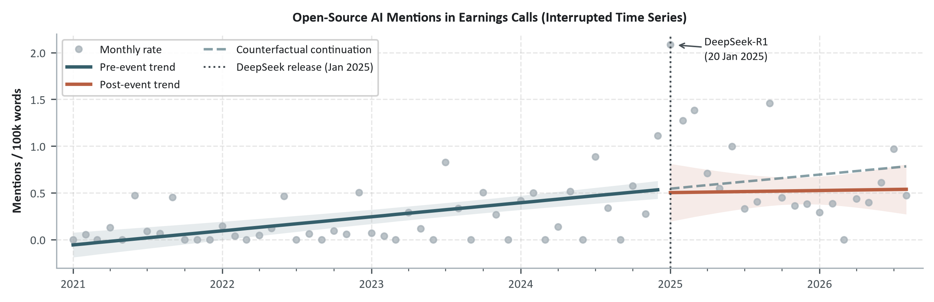
Figure 19: Open-source vocabulary in earnings calls around the January 2025 DeepSeek release. Monthly open-source mentions in earnings calls (Jan 2021–Aug 2026). Shaded band: 95% confidence interval; dashed line: counterfactual pre-event trend. The interrupted-time-series specification, including the seasonal, weighting and pulse-term controls, is in Appendix C.3.
Over 68 months of calls, January 2025 alone stands +1.65 mentions per 100,000 words above the path around it (95% CI [+1.36, +1.93], $p$ < 0.001) and February a further +0.75 (95% CI [+0.50, +0.99], $p$ < 0.001). January itself reaches 208.59, roughly ten times the earlier monthly mean of 0.21. Once those two months are held in their own terms, the level change that outlasts them is -0.04 (95% CI [-0.33, +0.25], $p$ = 0.775), which is nothing distinguishable from none.
The trend itself flattens rather than falls. The series had been rising at +0.013 mentions per 100,000 words per month ($p$ < 0.001) before the event; afterwards it runs at +0.002 (95% CI [-0.024, +0.028], $p$ = 0.889), and the change in slope itself, -0.011 ($p$ = 0.431), is not distinguishable from zero. A conversation that had grown for four years stopped growing; the estimate gives no basis for saying it reversed.
What ties the series to the event is the text rather than the timing: analysts name the model, AT&T’s call on 2025-01-27 opening “you’ve seen DeepSeek has created a much lower cost, large language model” and Corning’s two days later on “market dislocation over the last week from DeepSeek”. The series is earnings calls alone, since a call can respond within weeks while a 10-K published in a given month was written earlier; the pooled series shows no break, consistent with that dilution without establishing it. January is not entirely after the 20th, so what is located here is a change around the turn of the year, not on a particular day. An analyst therefore has to keep temporary market attention to a new technology apart from a durable change in what firms actually disclose doing.

3.9 What disclosed AI activity adds to disclosure posture
Disclosed activity carries information that posture alone does not. At equal disclosure volume, Vocal Substantives report 2.02 times as many AI activities as Defensive Disclosers, demonstrating that the archetypes do not simply reflect verbosity. Yet firms retain wide discretion over what they emphasize inside any single document, leaving open whether these operational claims survive when legal and regulatory commitments increase.

4. Credibility Under Increasing Disclosure Commitment
How credible are corporate AI claims once the legal and regulatory commitment behind them rises? There is no audited census of enterprise AI adoption, so credibility is assessed here by watching what survives as the cost of misrepresentation goes up (Crawford and Sobel 1982; Rogers, Van Buskirk, and Zechman 2011). What a firm leaves out is as much a decision as what it puts in: Dye (1985) shows that when investors cannot even tell whether a manager holds the information, withholding an unfavorable detail costs nothing. That is why the absence of a named system or a figure is treated here as evidence about the claim and not as missing data. Three designs test credibility: decoupling between disclosure intensity and disclosed substance inside the same document; a comparison of activity composition and grounding between voluntary earnings calls and statutory filings; and the disclosure response to SEC comment-letter scrutiny. The three move from what can be checked inside the text to settings where the disclosure has external consequences (Table 10).
Table 10: Empirical designs for assessing the credibility of corporate AI claims.
Credibility test | Evidence and unit of analysis | Empirical comparison | Credibility inference
1. Within-document substantiation | AI disclosure frames and extracted AI activity claims within the same firm-year document set | Disclosure Intensity (D) versus Disclosed Substance (S); their gap is summarized by Decoupling (W) | Claims are more credible when extensive AI communication is matched by specific activities, deployed systems, named artifacts, and quantified outcomes. Large positive W identifies disclosure running ahead of disclosed substance.
2. Cross-venue comparison | AI disclosures across voluntary earnings calls and statutory 10-K/10-Q filings within the same firm-year | Firm × fiscal-year fixed-effects comparison of activity composition and evidentiary grounding across communication venues | Evidentiary filtering under statutory exposure: claims carrying operational grounding in calls appear with less verifiable detail in formal filings.
3. Regulatory-scrutiny response | Firm disclosures before and after SEC AI-related comment letters, compared with control firms | Event-study tracking of changes in disclosure, substance, and grounding following direct regulatory inquiry | A credible response should increase specificity, substantiation, or governance rather than merely expand generic AI language after scrutiny.

4.1 Where disclosure runs ahead of substance
Does a firm’s disclosure volume keep pace with its concrete operational substance? Volume is Disclosure Intensity ($D$: AI frames per thousand words); substance is Disclosed Substance ($S$: log activity count weighted by AI Activity Grounding). The sample is 1,884 disclosing firm-years (475 S&P 500 firms, 2021–2026, 2026 shown as year-to-date).
Decoupling ($W_{it}$), the percentile-rank gap between Disclosure Intensity and Disclosed Substance, answers that question directly: $W=0$ means talk and substance rank the same, $W>0$ means narrative runs ahead of grounded substance (“decoupling”), and $W<0$ means “quiet substance.”
The construct turns the ideas of organizational decoupling (Meyer and Rowan 1977; Westphal and Zajac 1994; Bromley and Powell 2012) and symbolic disclosure (Delmas and Burbano 2011; Lyon and Montgomery 2015; Elhajjar and Itani 2025) into something observable inside public filings: how much a firm talks about AI compared with the grounded operational activity it is willing to put on the record. Most firms land close to the diagonal where the two ranks are equal (Figure 20).
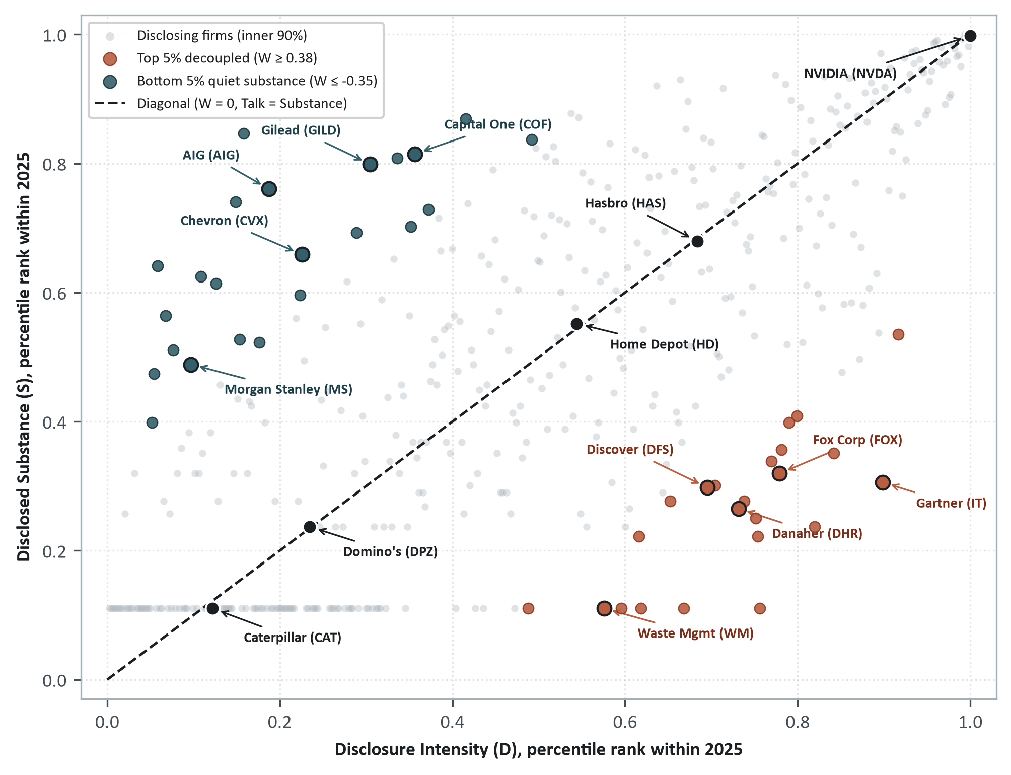
Figure 20: Talk against substance: where firms rank on each, and where the two come apart, end of 2025. One point per firm in 2025, ranked that year on talk ($D$) and grounded activity ($S$) (Appendix A.6). Colored points mark the top and bottom 5% decoupling ($W$) tails of that year’s cross-section and the diagonal, each with five firms labeled; the cut shown in the legend is therefore the single-year percentile, slightly below the pooled-panel one. The flat band along the bottom is a tie: firms with no extracted AI activity all score zero substance.
They rank about as high on talk as on grounded activity, which is what you would hope to see. The firms that talk most are not the ones the measure flags: Vocal Substantives crowd the top-right corner, high on both, and sit near the line. What $W$ reads is the distance from it. Below the line, the narrative has run ahead of anything the filings can show; above it, the activity is there and the firm has barely mentioned it.
One caution about how $W$ should be read: the ranks are renormalized every cycle, so the cross-sectional mean sits near zero in every year by construction. Averaging $W$ over the years therefore cannot say whether the market as a whole became more decoupled or less, and comparing relative percentiles across years does not answer that question either. Figure 20 is about sorting: which firms sit where against their peers inside one reporting cycle. The market-wide question is answered by the widening distance between expanding activity volume and diluted grounding over the 2021–2026 panel (Figure 14).
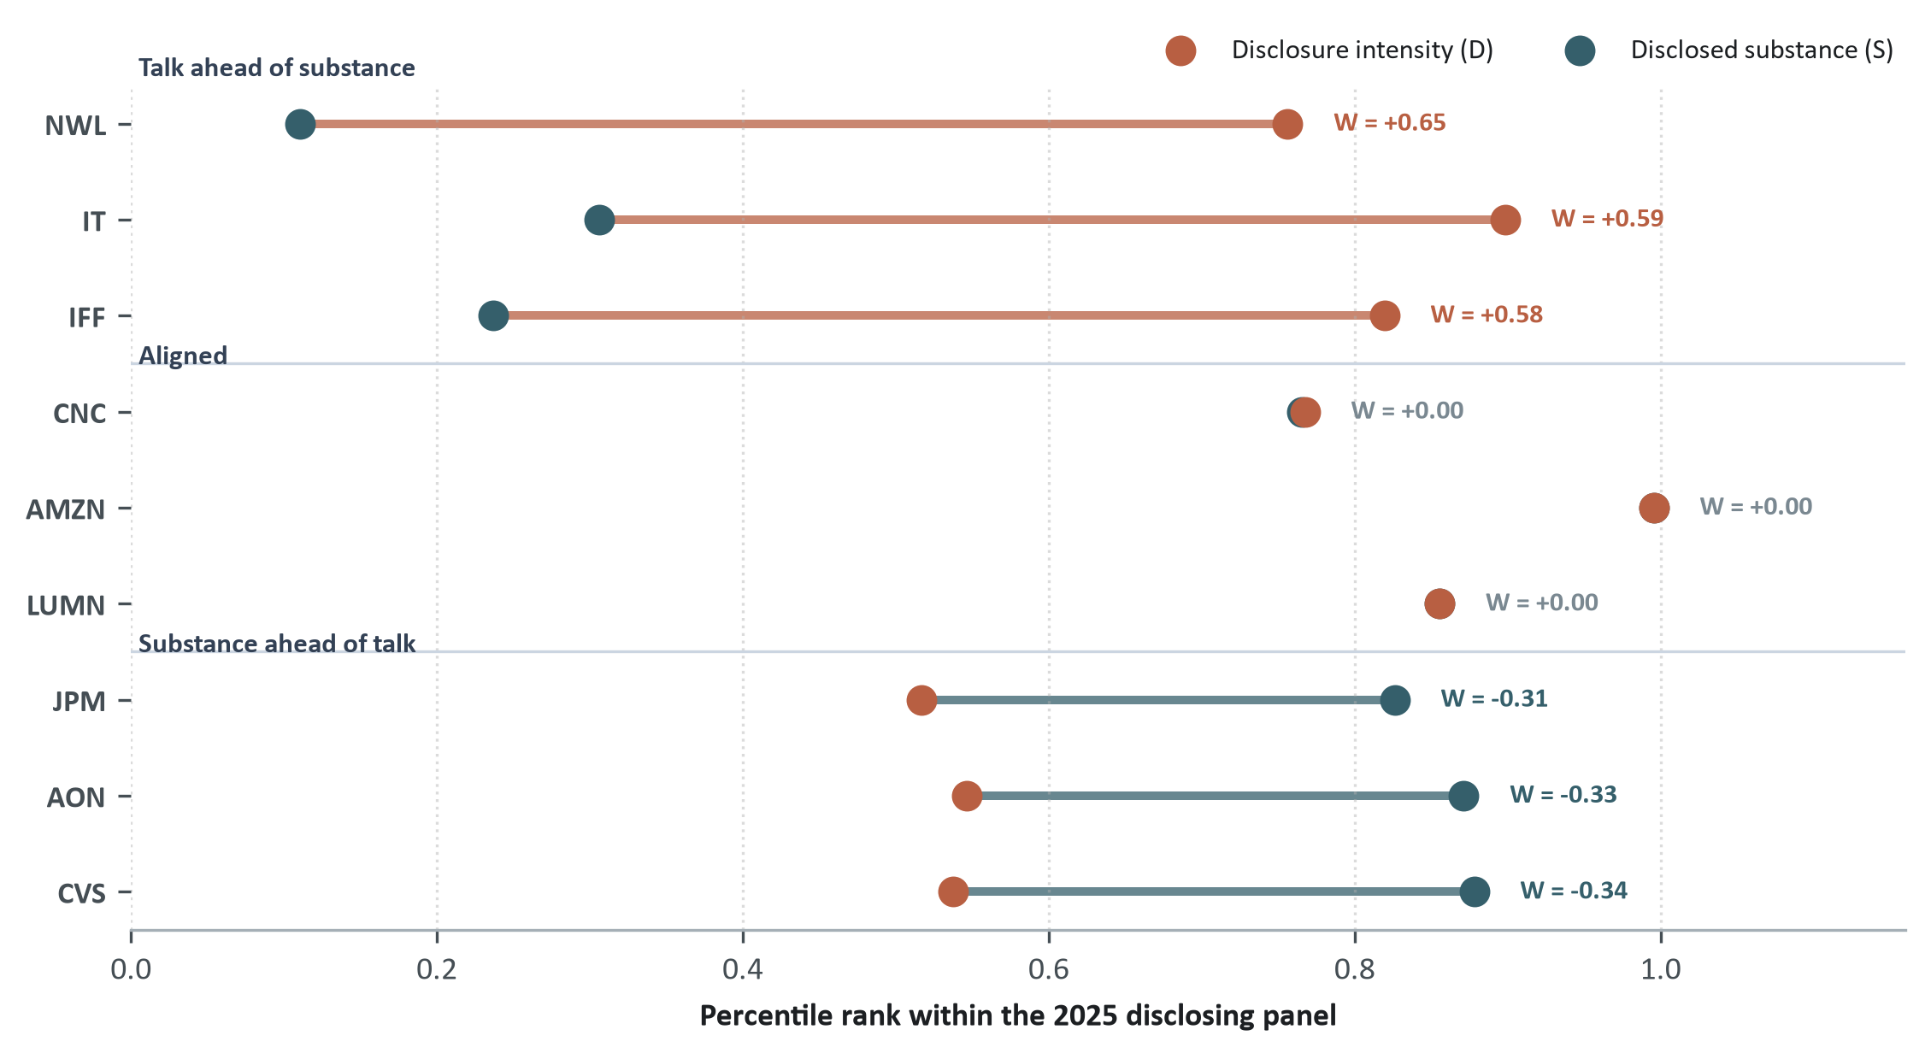
Figure 21: Disclosure intensity and disclosed substance for selected firms, with the gap between them, end of 2025. Each line joins a firm’s percentile ranks of disclosure intensity ($D$) and disclosed substance ($S$); the gap between the two endpoints is $W$. Cases show the three largest positive, negative, and near-zero gaps among firms in the upper half of $D$ in 2025.
Table 11: What the two extremes read like: one firm from each end of the gap.
Pole | Firm | Source | Excerpt | What the extraction reads
Talk ahead of substance | NWL | 10-K, 2025 | “The Company may use artificial intelligence in its business, and challenges with properly managing its use could result in reputational harm, competitive harm, and legal liability.” | No activity: a stated possibility, no system, stage or result
Aligned | CNC | DEF 14A, 2025 | “We are deploying AI within our provider contracting operations to reduce the manual labor associated with configuring and maintaining contracts.” | Activity in a named operation, deployed, no result reported
Substance ahead of talk | AON | DEF 14A, 2026 | “Deploy AI and advanced analytics to transform data into real-time, actionable insights and provide clients with digitally-enabled, consistently excellent service through our global Aon Business Services platform.” | Named platform, deployed stage, customer-facing
Notes: Representative excerpts illustrating the poles of decoupling ($W$) from Figure 21 among high-intensity disclosers, contrasting boilerplate possibilities against grounded deployments.
Firms that talk about AI at comparable intensity end up far apart on substance (Figure 21). Pooled over the 2021–2026 panel, $W$ is widely dispersed ($\text{standard deviation}=$ 0.23), with 95 firm-years in the decoupled tail at the pooled 95th percentile ($W≥$ 0.39). These firms dedicate substantial narrative volume to AI while disclosing minimal verifiable operational substance, combining top-quintile disclosure intensity with bottom-quintile substantive grounding. This divergence represents a durable reporting posture rather than idiosyncratic annual noise, persisting year-over-year at a Spearman $ρ=$ +0.599 (Appendix C.2).

4.2 What changes from filing to call
A lasting decoupling raises a further question: what happens when the same firm discusses AI in two venues carrying very different legal liability.
Holding the firm and the year fixed isolates that comparison. The design is a firm × fiscal-year fixed effect ($α_{i,t}$) over 790 balanced cells (285 firms) with at least three disclosed AI activities in each channel:
$$Y_{i,t,\text{venue}}=α_{i,t}+β 1\left[\text{venue}=\text{Call}\right]+ε_{i,t,\text{venue}}$$
Each cell holds exactly two observations: all earnings calls of the fiscal year pooled into one call record, and all statutory filings of that year (the 10-K and the 10-Qs) as the filing benchmark. The metrics are per thousand words or shares of the disclosed activities. Standard errors are clustered at the firm level, and the fixed effects absorb whatever is constant about the firm as well as macroeconomic shocks. A call mixes management remarks with analyst Q&A, so the estimate is the net institutional difference between two venues with different legal exposure (Frankel, Johnson, and Skinner 1999; Matsumoto, Pronk, and Roelofsen 2011), read as a shift in the composition of disclosed activity and evidence.
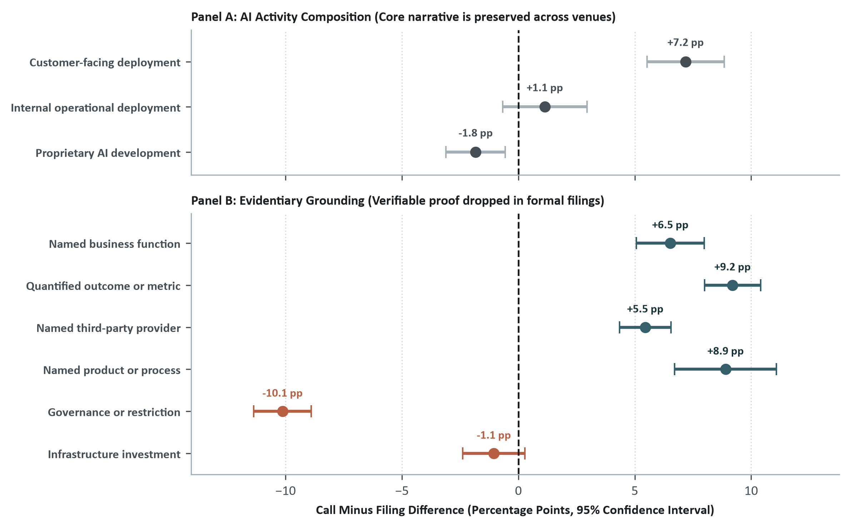
Figure 22: Calls provide more evidentiary detail within the same firm-year: differences in AI activity composition and grounding, pooled 2021–2026 YTD. 95% CI. Both panels: firm × fiscal-year fixed-effects estimates; pooled call/filing ratios reported elsewhere are descriptive means without fixed effects.
What firms claim to do stays largely consistent across venues, but the evidence attached to those claims diverges sharply (Figure 22). Internal operational deployment (+1.1 pp, $p$ = 0.22) and proprietary development (-1.8 pp, $p$ = 0.0049) line up closely between calls and filings; customer-facing deployment is the exception, appearing somewhat more often on calls (+7.2 pp, $p$ < 0.001), which fits managers speaking to analysts about commercial applications.
The evidence behind those activities does not travel the same way: the share carrying a quantified outcome is ↑ 9.2 percentage points higher in calls ($p$ < 0.001), named products (↑ 8.9 percentage points higher in calls ($p$ < 0.001)) and third-party providers (↑ 5.5 percentage points higher in calls ($p$ < 0.001)) are both lower in the filings, and governance caveats run the other way (↓ 10.1 percentage points lower in calls ($p$ < 0.001)).
The pattern looks like filtering under higher statutory exposure, evidentiary detail trimmed as a claim moves from the call into the filing, rather than an explicit retraction. The design compares composition at the venue level, so it does not track whether any specific claim made on a call reappears, unchanged or softened, in the filing that follows.
The pooled model gives the average gap over the whole panel, which leaves one question open: did this divergence already exist before generative AI, or did it appear together with it? Estimating the same within-firm-year gap (${\text{Call}}_{i,t}−{\text{Filing}}_{i,t}$) year by year, on the three dimensions that carry the evidence, separates the two cases (Figure 23).
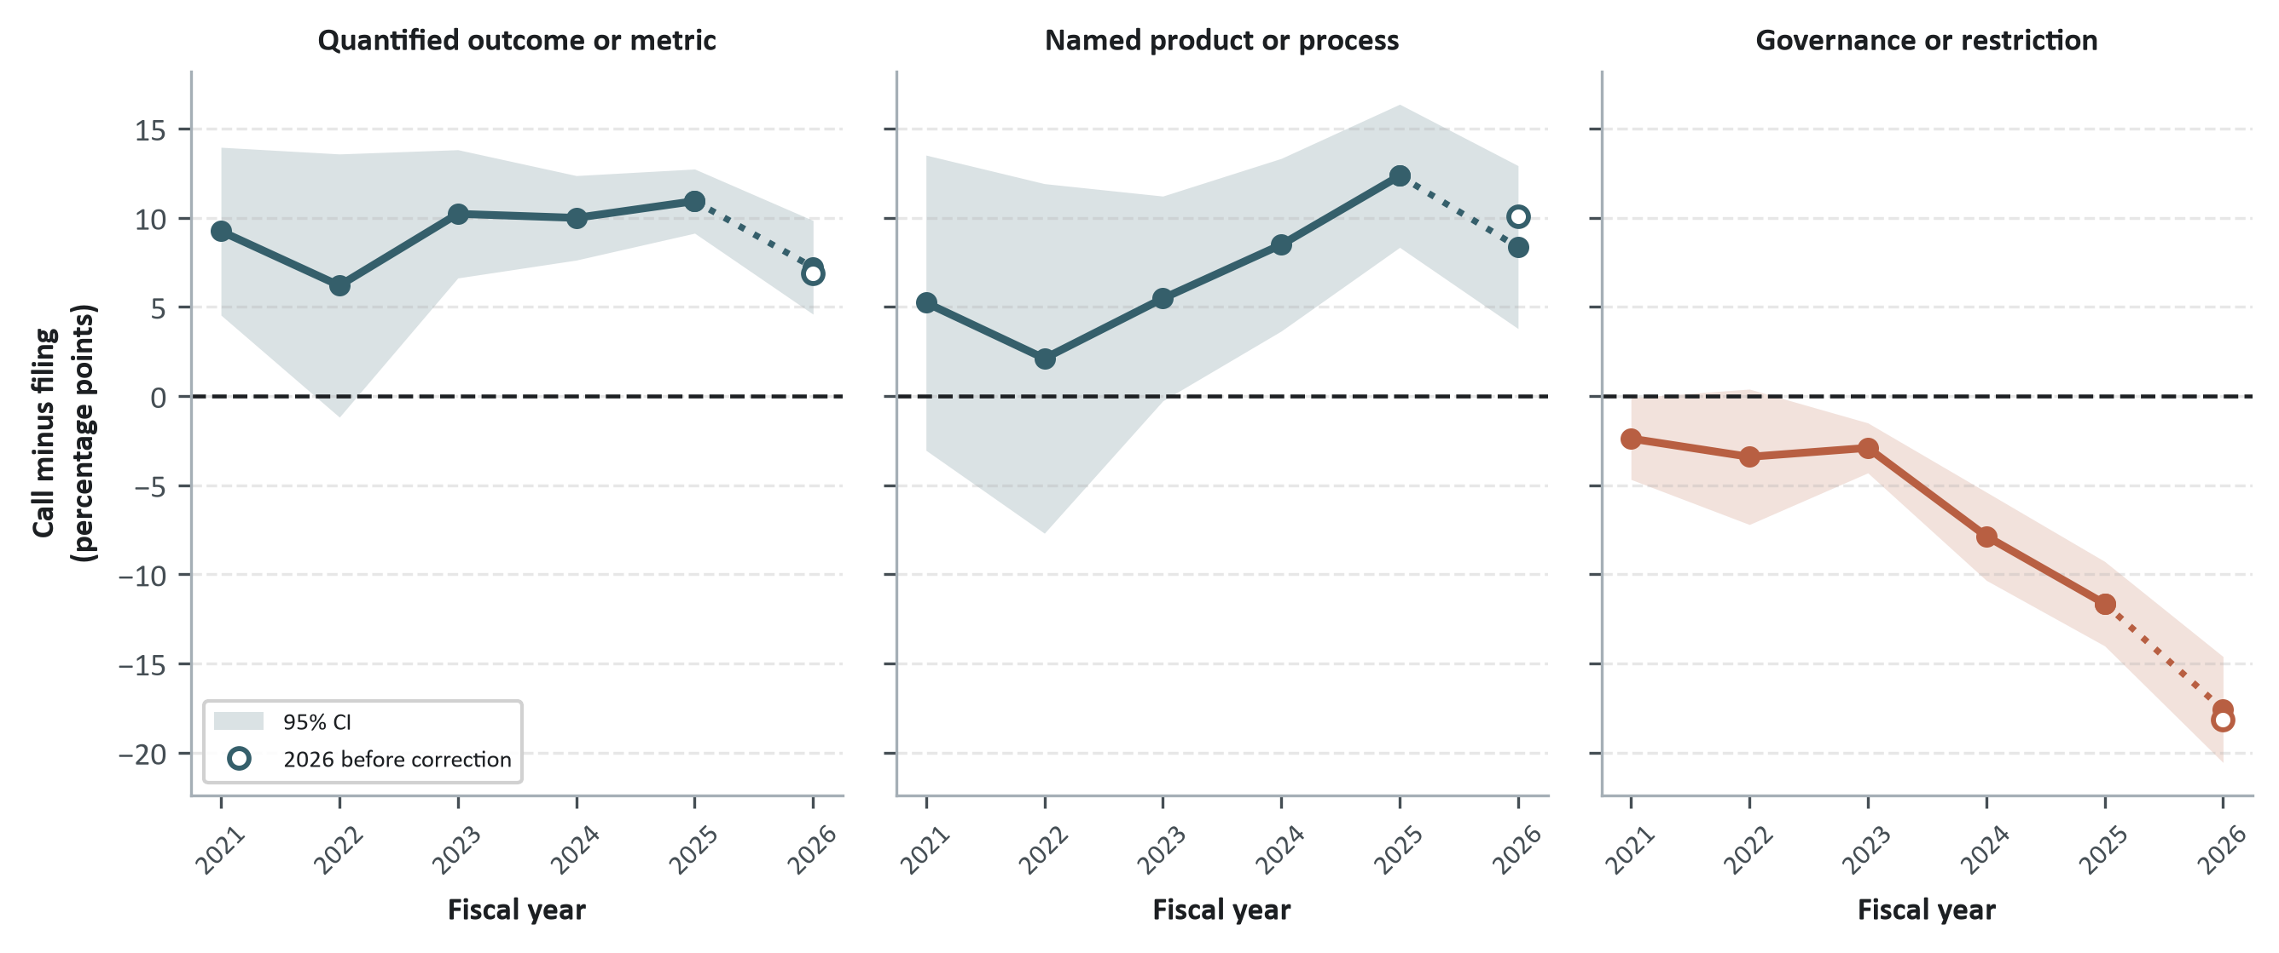
Figure 23: Call-minus-filing gap by fiscal year on three evidentiary dimensions, 2021–2026 YTD. Each point: mean call-minus-filing gap across that year’s firm × fiscal-year cells, with the 95% CI from a one-sample $t$-test. 2026 is still open at the 2026-09-03 cut-off and is seasonally corrected (Appendix A.3); the hollow marker is the uncorrected value. Cells per year: 2021: 57, 2022: 56, 2023: 103, 2024: 152, 2025: 228, 2026: 194.
The three dimensions do not share a history (Figure 23). The call premium on quantified outcomes is already there in 2021 (+9.2 pp, 95% CI [+4.5, +13.9]) and stays roughly flat for the rest of the panel (+10.9 pp, 95% CI [+9.1, +12.7] in 2025), so putting more figures into the oral discussion than into the filing is an old managerial habit and not something generative AI produced. Naming a product or a process behaves differently: in 2021 and 2022 the interval still covers zero (+2.1 pp, 95% CI [-7.7, +11.9] in 2022), and by 2025 it clearly does not (+12.3 pp, 95% CI [+8.3, +16.4]). Governance and restriction language moves in the opposite direction and keeps widening, from -2.4 pp, 95% CI [-4.7, -0.1] in 2021 to -17.6 pp, 95% CI [-20.6, -14.6] (observed -18.2) in 2026, as the filings absorb the caveats the calls do not carry.
Two caveats attach to the last point of each panel. 2026 is a partial year: the two channels report on different calendars, so the seasonal correction (Appendix A.3) matters in both directions, and the plotted value is the corrected one rather than the raw year-to-date count. Each year is also estimated on its own cells, so these intervals are wider than the pooled ones and the first two cycles are the thinnest in the panel.
An investor should therefore read both venues and not rely on one of them alone, and an issuer should check that the claims are substantively consistent between the oral and the statutory disclosure, without expecting the same wording or the same level of detail in both. A difference in detail between the two is a question to resolve, not proof of inconsistency: the venues carry different liability and address different audiences, and only a difference in the scope actually claimed points to a problem.

4.3 Promotion is not the opposite of evidence
Do earnings calls amplify promotional language at the expense of disclosed evidence, trading one for the other?
The cross-venue data reject this trade-off. Per 1,000 words, earnings calls contain 16.8× more promotional statements than statutory filings, and they amplify quantification even more: 18.7× more quantified outcome claims (Figure 24). These are pooled per-1,000-word rates without firm-year fixed effects, and part of each ratio reflects the longer, boilerplate-heavy denominator of statutory filings rather than a pure difference in claim density.
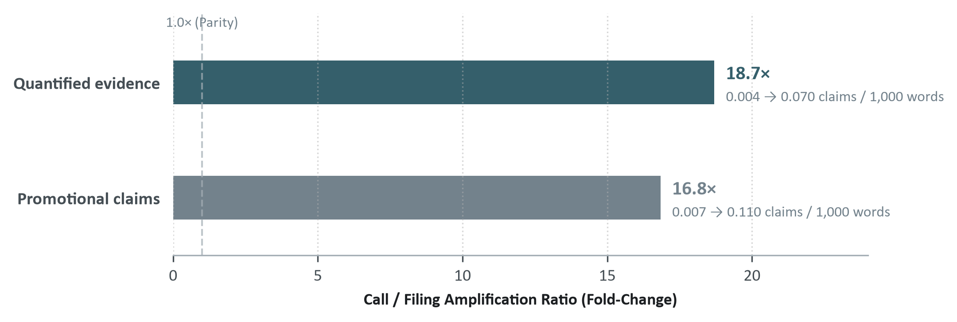
Figure 24: Calls amplify both promotion and quantified evidence: call-to-filing amplification ratios per 1,000 words, pooled 2021–2026 YTD. Relative amplification in quantified evidence exceeds that of promotional claims.
This co-movement aligns with Jia et al. (2025), who find that corporate discussions of generative AI frequently join positive sentiment with concrete initiatives; while their metric includes planned initiatives, the framework here separates grounding from realized operational outcomes. Tone and disclosed evidence constitute two distinct dimensions of corporate communication rather than opposing poles of a single axis.

4.4 What credibility means in this thesis
Three conclusions come out of the credibility ladder:
- Decoupling persists. The gap between narrative intensity and grounded substance is a lasting characteristic of the firm-year (year over year, $ρ=$ 0.60).
- What differs between venues is the evidence. The cross-venue gap comes from grounding that is missing in the statutory filings, not from a different mix of operational activity.
- Direct scrutiny is rare. In the one case observed, the issuer reacted by reducing narrative volume and narrowing its decoupling, not by adding boilerplate.
AI washing in this thesis is therefore an observable and persistent decoupling ($W$) between narrative volume and grounded operational substance. It is not legal proof of fraud, nor proof that nothing was implemented.

5. Market Relevance of Disclosure Signals
Do the disclosure measures built here carry information that equity markets price? The unit of observation is an earnings call held by an S&P 500 constituent between 2021 and 2026, and the test is whether disclosure signals known before the call are associated with market and fundamental outcomes after it. Following Gelman and Loken (2014), the regressions are exploratory diagnostics rather than confirmatory tests, and three channels motivate them: narrative volume priced as exposure to a theme (Eisfeldt et al. 2023), disclosed substance acting as a costly signal (Spence 1973; Verrecchia 1983), and decoupling accumulating as opacity that eventually shows up in tail risk (Jin and Myers 2006; Fu, Wu, and Zhang 2021).

5.1 The disclosure construct and the estimating equation
The history-based regressors are predetermined with respect to the call, through a backward as-of join on the call date, so that none of them carries information published after it. $W_{\text{call}}$ is the exception by construction: it is measured on the transcript of the call itself, so it is known once the call ends and before any outcome window opens. Table 12 lists the regressors and the controls.
Table 12: Regressors and controls predetermined at call date $t$. Continuous regressors and lagged outcomes are standardized to unit variance. The Kim, Li and Zhang (2011) controls are added only to the two weekly crash-risk outcomes (Kim, Li, and Zhang 2011).
Term | Symbol | What it measures | Scale
Call decoupling | $W_{\text{call}}$ | Disclosure percentile minus substance percentile of this call’s own transcript | Standardized
Historical decoupling | $W_{\text{exp}}$ | Expanding average of past call decoupling | Standardized
Cumulative disclosure intensity | $D$ | AI frames per 1k words across statutory filings through prior quarter | Standardized
Discloses AI in filings | $\text{has}$ | Indicator for filing any AI frame in trailing year | Binary {0, 1}
Posture weights | $w_{\text{voc}},w_{\text{gov}}$ | Trailing 12-month archetype mixture relative to Defensive reference | [0, 1]
Lagged outcome | $Y_{t−1}$ | Pre-call level of the same construct, where one exists | Standardized
Controls | n/a | Log market cap, 60-day pre-call return, ROA | Standardized
Crash-risk controls (KLZ) | $\text{DTURN},\text{SIGMA},\text{RET},\text{MB},\text{LEV}$ | Share-turnover change, pre-call return volatility and mean, market-to-book, leverage | Standardized

The estimating equation is an analysis of covariance (ANCOVA) regressing post-call outcomes on predetermined disclosure quantities, the lagged outcome $Y_{i,t^{−}}$ where the outcome has a pre-call level of the same construct, predetermined controls (log market capitalization, 60-day return momentum, and ROA, plus the KLZ controls for the two crash-risk outcomes), additive sector and year fixed effects, and standard errors clustered at the firm level:
$$Y_{i,t}=α+β {\text{Disclosure}}_{i,t^{−}}+γ Y_{i,t^{−}}+δ {\text{Controls}}_{i,t^{−}}+{\text{Sector}}_{i}+{\text{Year}}_{t}+ε_{i,t}$$
The archetype weights sum to one, so the Defensive posture is kept as the reference vertex. The coefficients on $w_{\text{voc}}$ and $w_{\text{gov}}$ are therefore reallocations of weight away from Defensive, and a shift of 10 percentage points corresponds to $0.10×β$. The indicator $\text{has}$ covers the extensive margin, that is, whether the firm discloses any AI activity at all, which keeps the decision to speak apart from the way the posture is distributed.

5.2 Outcomes and their measurement windows
Table 13 lists the eight outcomes. Each is drawn from a design already established in the event-study and crash-risk literatures, applied here to the firm’s own earnings call rather than to an earnings announcement or a macro shock.
Table 13: Outcomes and their measurement windows. The beta shift is a single pooled regression over the trading days on both sides of the call, with a 21-trading-day gap left on each side of the call date; the two CAR outcomes and the two weekly crash-risk measures are estimated from the residuals of a separate market model fit before the call; the three accounting outcomes are measured over the four fiscal quarters that follow the call’s own quarter, against the four that precede it, with ratio changes winsorized at 1% to limit denominator distortion. Appendix A.8 gives the estimating equations.
Outcome | Window | Form
Beta shift (Brenner 1979) | Trading days $[−63,−21)$ and $[+21,+63)$ around the call, pooled | Change in slope (POST $×$ MKT interaction)
Cumulative abnormal return, CAR[-1,+1] | Trading days $\left[−1,+1\right]$ around the call | Announcement-window abnormal return
Post-announcement drift, CAR[+2,+63] | Trading days $\left[+2,+63\right]$ after the call | Cumulative abnormal return
Negative return skewness (NCSKEW), weekly | 26 trading weeks after the call | Post-call level
Down-to-up volatility (DUVOL), weekly | 26 trading weeks after the call | Post-call level
Gross margin expansion | Four fiscal quarters after the call’s own quarter | Change from the trailing four quarters, pp, winsorized at 1%
Change in ROIC-WACC spread | Four fiscal quarters after the call’s own quarter | Change from the trailing four quarters, pp, winsorized at 1%
Revenue growth | Four fiscal quarters after the call’s own quarter | Growth over the trailing four quarters

Eight outcomes are estimated over six disclosure variables, so the hypothesis tests use a Benjamini-Hochberg false discovery rate correction (Benjamini and Hochberg 1995) over the whole family of 48 coefficients, not outcome by outcome.

5.3 Results
The eight regressions share one specification and appear together in Table 14, one row per outcome. The table should be read down a column and not across a row: a disclosure measure behaves consistently across the outcomes, and the finding belongs to the measure rather than to any single outcome.
Table 14: The disclosure coefficients, standardized, with p-values in parentheses; stars at *** p<0.01, ** p<0.05, * p<0.10 and bold below 5%. Posture terms are reallocations away from the Defensive vertex. Controls, the lagged outcome and the fixed effects are estimated but omitted here; Table 46 and Table 47 report every term.
Outcome | $W_{\text{call}}$ | $W_{\text{exp}}$ | Intensity | $β_{\text{has}}$ | $β_{\text{voc}}$ | $β_{\text{gov}}$ | $β_{\text{gov}}−β_{\text{voc}}$ | Calls | $R^{2}$ | Composition, joint $F$
Beta shift (Brenner 1979 Delta-beta) | +0.019* (0.084) | +0.092*** (0.000) | +0.073*** (0.000) | +0.052 (0.269) | -0.042 (0.636) | -0.223*** (0.000) | -0.180* (0.076) | 9,350 | 0.291 | 6.45*** (0.002)
Cumulative abnormal return [-1,+1] | -0.002 (0.807) | +0.008 (0.501) | -0.001 (0.931) | +0.006 (0.906) | -0.004 (0.956) | -0.014 (0.829) | -0.010 (0.891) | 9,717 | 0.012 | 0.02 (0.975)
Post-announcement drift, CAR[+2,+63] | -0.003 (0.758) | +0.027** (0.018) | +0.035*** (0.004) | -0.093** (0.047) | +0.110* (0.095) | +0.220*** (0.000) | +0.111* (0.088) | 9,446 | 0.061 | 6.87*** (0.001)
Negative return skewness (NCSKEW, weekly) | +0.000 (0.988) | -0.023* (0.094) | +0.001 (0.975) | +0.048 (0.407) | -0.056 (0.590) | -0.039 (0.612) | +0.017 (0.877) | 8,178 | 0.031 | 0.21 (0.813)
Down-to-up volatility (DUVOL, weekly) | -0.002 (0.850) | -0.028** (0.048) | -0.001 (0.953) | +0.043 (0.456) | -0.021 (0.836) | -0.032 (0.674) | -0.011 (0.919) | 8,178 | 0.030 | 0.09 (0.913)
Gross margin expansion (pp, TTM) | +0.011 (0.473) | +0.025 (0.328) | -0.007 (0.743) | -0.058 (0.357) | +0.102 (0.334) | +0.058 (0.432) | -0.045 (0.688) | 6,239 | 0.227 | 0.62 (0.540)
Change in ROIC-WACC spread (pp, TTM) | +0.014 (0.356) | -0.028 (0.237) | +0.023 (0.442) | -0.015 (0.827) | +0.035 (0.772) | -0.057 (0.566) | -0.092 (0.515) | 6,214 | 0.151 | 0.25 (0.780)
Revenue growth (%, TTM) | -0.005 (0.723) | -0.005 (0.805) | +0.123** (0.028) | +0.084 (0.118) | -0.086 (0.404) | -0.196*** (0.005) | -0.110 (0.335) | 6,427 | 0.235 | 4.02** (0.019)

Accumulated disclosure, not a single call’s decoupling, is associated with a more positive shift in beta around the earnings call. Historical decoupling ($W_{\text{exp}}$) and cumulative disclosure intensity ($D$) both associate with a more positive beta shift ($W_{\text{exp}}$: $β=$ +0.092, $p$ < 0.001; $D$: $β=$ +0.073, $p$ < 0.001), and both clear the 5% Benjamini-Hochberg false discovery rate (BH-FDR) correction over all 48 disclosure coefficients. The decoupling of an individual call ($W_{\text{call}}$) carries none of this: across all eight outcomes its coefficient never separates from zero ($β∈[$ -0.005, +0.019 $]$). Persistent decoupling behaves as a firm characteristic rather than an episode, consistent with accumulated opacity being priced into systematic risk (Jin and Myers 2006; Fu, Wu, and Zhang 2021), though the design cannot separate that channel from a market-theme exposure reading of the same intensity effect (Eisfeldt et al. 2023).
Relative to Defensive disclosure, a governance-weighted composition is associated with a more negative beta shift, higher subsequent abnormal returns, and slower revenue growth. A composition weighted toward Governance rather than Defensive goes with a more negative beta shift ($β=$ -0.223, $p$ < 0.001), more positive post-announcement drift ($β=$ +0.220, $p$ < 0.001), and slower revenue growth over the following four quarters ($β=$ -0.196, $p$ = 0.005); all three survive BH-FDR control, and the joint test on the full posture composition rejects only for these three outcomes (Table 14). Cumulative disclosure intensity also adds to the post-announcement drift ($β=$ +0.035, $p$ = 0.004, surviving). Together, these associations link governance-oriented disclosure to a more negative change in systematic exposure, stronger subsequent abnormal returns, and slower revenue growth, without identifying a common mechanism.
No disclosure variable survives the correction on the announcement-window reaction or on the weekly crash-risk measures. The three-day cumulative abnormal return around the call, $\text{CAR}\left[−1,+1\right]$, returns no coefficient that clears even the 10% nominal threshold. On the weekly measures, historical decoupling is nominally significant on DUVOL ($β=$ -0.028, $p$ = 0.048) and marginal on NCSKEW ($β=$ -0.023, $p$ = 0.094), both in the direction of less downside asymmetry, and neither survives the Benjamini-Hochberg correction over the grid. The analysis detects no association with announcement-window returns, and the evidence on the shape of the return distribution over the following 26 weeks is too weak to carry a claim. Two robustness checks confirm this for the weekly measures: excluding each sector in turn, and restricting to calls where the firm’s dominant posture had already changed by the call, leave every disclosure coefficient on NCSKEW and DUVOL statistically indistinguishable from zero.
The accounting outcomes carry the least of the disclosure signal. Gross margin expansion and the change in the ROIC-WACC spread show no association with any of the six disclosure variables, nominal or corrected. Revenue growth’s one surviving coefficient is the Governance composition effect above; cumulative disclosure intensity is nominally significant on it ($β=$ +0.123, $p$ = 0.028) but does not survive the correction.
The analysis stops at association. These estimates capture cross-sectional differences across 9,350 calls (484 firms) rather than causal policy interventions: modifying disclosure language does not mechanically alter capital costs or tail-risk exposure. The lowest joint-composition $p$-value across outcomes (0.001) still describes an association, not an effect estimate. The disclosure coefficients under the post-call beta level specification, alongside the beta shift used here, are reported as a robustness check against alternative windows and market-model specifications in Appendix C.4 (Table 45).

6. From Disclosure Evidence to Strategic Decisions
Six constructs measured what a firm says about AI and what it can show for it. What follows turns them into a procedure for reading one firm at a time: what to check first, what would settle the question, and who is accountable for the answer.

6.1 Developing the AI disclosure credibility framework
The six constructs were built to be read together, and read together they answer a diagnostic question: where does what a firm says stop matching what it can show? None of this settles whether a claim is true. It orders where to look first, which is the scarce decision in both disclosure review and due diligence.

6.1.1 From findings to design
Each design choice answers something the evidence showed (Table 15). The findings motivate the choices; the effectiveness of the assembled procedure has still to be evaluated. The market and operating results play a different role here. They show that some of the distinctions the diagnosis draws are also economically informative: a firm’s accumulated distance between narrative and substance, and the posture it writes in, show up later in its systematic risk, its abnormal returns and its revenue growth. Had those outcomes all been null, the cross-venue divergence and the documentary gaps would still leave the reading worth doing for governance and due diligence. That is a reason to read disclosure closely, not a step in the procedure, which ends at the verification and leaves the valuation or the budget to the analysis that follows it.
Table 15: Empirical findings and the design choice each one motivates.
What the evidence shows | What the framework does with it
Postures separate communication patterns without certifying substance. | Use posture to set context and to choose the peer set, whether a firm is reading itself or reading another.
Activity volume and documentary grounding can diverge. | Read reported activities and their grounding separately, then against narrative volume.
Channels differ in emphasis and in detail. | Compare the scope and the support of operational claims across channels.
A disclosure gap has several possible explanations. | Verify the material claims before choosing a response.

6.1.2 Framework stages and outputs
A review runs in four stages, and runs the same way whether the reader sits inside the firm or outside it. Define: fix the firm, the reporting period, the channels to be read and the decision at stake, which may be a filing about to be signed, a claim about to be published, a position about to be taken or a supplier about to be chosen. Diagnose: establish posture, the alignment between narrative and substance, and the consistency of claims across channels. Prioritize and verify: rank the material claims, name the support each one lacks and the evidence that would settle it. Act and monitor: record the finding, assign a response and an owner, and set the date of the next review.
The output is a claim register, one row per material claim with its diagnosis, the verification it needs and its owner: a function inside the firm when the review is the firm’s own, an analyst or a committee when it is external. Ownership and the reporting cycle around it are set out later in this chapter.

6.1.3 Diagnosis in three steps
The diagnosis itself asks three questions in order. Step 1, Posture: which communication archetype does the firm’s register resemble? Step 2, Documentary grounding: does that posture correspond to grounded operational substance, or only to narrative volume? Step 3, Venue: are the operational claims consistent between the voluntary earnings call and the statutory Form 10-K?

6.1.4 Application: screening the S&P 500
The disclosure intensity and substance heuristic.
Once the posture is known from Step 1, Step 2 asks whether documented substance stands behind it. The tool is a 2×2 heuristic built on Disclosure Intensity ($D$) and Disclosed Substance ($S$) (Table 16). $D$ and $S$ fix the quadrant, and $W$ only orders priority inside it; $W$ is not a fraud classifier. The matrix is a first screen on public disclosure and does not replace technical due diligence (Simonian 2025). Placing a firm in a quadrant needs $D$ and $S$ for a comparison group, which the published extraction pipeline produces for any corpus it is pointed at, including a firm’s own filings, its calls, its competitors’ documents or the internal reporting an issuer already holds, at whatever level of automation its processes support. A reader without that machinery keeps the logic and loses the ranking: read a handful of sector peers and count, claim by claim, how many name a product, a provider and a measured outcome. The median split fills every one of the four cells by construction, so the screen allocates attention across the index; it does not measure how much washing exists.
Table 16: AI Disclosure Decision Heuristic: portfolio screening by disclosure intensity ($D$) and substance ($S$) across the S&P 500 in the 2026 reporting season All four cells are shares of the same 465 index firms, so they add to the whole index; Deprioritize also absorbs the 21 firms that disclose no AI at all. The median cut-offs that place a firm in a cell are taken among the 444 disclosing issuers, which is a property of the cut and not of the base these shares are read against. The Reconcile screen further down has its own base, the issuers with both a call and a filing that year. $D$ and $S$ set the quadrant; $W=\text{rank}\left(D\right)−\text{rank}\left(S\right)$ only ranks priority within it.
 | Low Disclosed Substance ($S$) | High Disclosed Substance ($S$)
High Disclosure Intensity ($D$) | INVESTIGATE (56 firms, 12.0%)Audit claims and verify whether oral conference-call claims are reflected in statutory Form 10-Ks; within this quadrant, prioritize by persistent decoupling, highest first (Step 3). | VALIDATE (166 firms, 35.7%)Confirm documented evidence remains cross-venue consistent and operational grounding is sustained.
Low Disclosure Intensity ($D$) | DEPRIORITIZE (187 firms, 40.2% of index)Low narrative exposure with minimal reported activity; lowers priority for dedicated AI disclosure review (not general corporate diligence) unless posture shifts. | EXPLORE (56 firms, 12.0%)Investigate quiet execution: concrete, grounded operational capability deployed under minimal promotional fanfare; within this quadrant, prioritize by persistent decoupling, lowest first.

Ordering the triage.
$W$ is built from the same two ranks that fix the quadrant, $\text{rank}\left(D\right)$ and $\text{rank}\left(S\right)$, so it refines the cut rather than adding an independent signal; a firm’s 2026 value of $W$ still carries no association with what happens to it afterward, while the mean of $W$ over the cycles a ticker has disclosed through 2026 does (Market Relevance chapter). The triage inside each quadrant of Table 16 is therefore ordered on that expanding mean rather than on 2026 alone, together with a persistence flag for firms whose annual $W$ sits above the year’s median in at least two consecutive cycles: 82% of the 56 Investigate-quadrant firms carry that flag. In the Investigate quadrant, 14 FY2026 firm-years sit above the 95th percentile of this persistent measure among 2026 disclosers; for those firms the immediate task is to read the ungrounded claims that drive the narrative volume and to look for factual backing in technical documentation or product releases.
At the other end, 225 disclosers have a negative persistent $W$, with the substance rank staying above the volume rank across cycles rather than in one year alone. A negative $W$ is a ranking, not a cell: these firms sit across the matrix, and only those that are also above the median on $S$ and below it on $D$ fall in Explore. What the rank flags is activity that the firm documents more than it advertises, and the work is to catalogue it. Why it is not advertised the measure cannot say: competitive reasons, an editorial choice and simple omission all look the same from outside.
Step 3, Venue. A cross-cutting screen, Reconcile, orders the cross-venue verification among the 447 issuers that have both a 2026 earnings call and a 2026 filing. Of these, 32 show an oral-minus-filing promotional gap more than 1.5 standard deviations above the 2026 mean ($Z_{\text{gap}}>1.5$). Those are the claims to audit across channels first: the analyst checks whether differences in promotional emphasis coincide with differences in the scope or the documentary support of the operational claims once statutory liability applies. The 1.5 standard deviation cut is an operating convention rather than a calibrated threshold, and a larger promotional gap does not by itself mean weaker support, since a call carries both more promotion and more grounding than the matching filing.
Archetype composition within the quadrants.
Step 1 does not predict Step 2’s quadrant; it sets what the rest of the review does with the firm. It fixes the peer set: 84% of Vocal Substantives land in VALIDATE (Table 17), so a Vocal Substantive is read against other Vocal Substantives, holding register and volume constant while $D$ and $S$ do the discriminating. It sets what the register is evidence of: at equal disclosure volume, Vocal Substantives report several times as many operational activities as Governance-Led or Defensive Disclosers, so a governance-led firm writing about oversight is not itself evidence of substance, and a vocal register is not itself evidence of exaggeration. And it sets which claims to sample first: Vocal Substantives concentrate their activity in customer-facing, named deployments, which is where Step 2 should start, while Governance-Led and Defensive registers concentrate in internal process and oversight claims that Step 2 has to seek out rather than expect at the top of the narrative.
Table 17: Screening quadrant by disclosure archetype, 2026 disclosing issuers (row percentages).
Archetype | Investigate | Validate | Deprioritize | Explore
Vocal Substantives (n=58) | 3% | 84% | 5% | 7%
Governance-Led Disclosers (n=108) | 6% | 44% | 30% | 20%
Defensive Disclosers (n=251) | 19% | 28% | 43% | 11%
No AI (n=27) | 0% | 0% | 89% | 11%
Notes: Rows sum to 100%; quadrants are defined by the 2026 median split on $D$ and $S$ (Table 16). Archetype uses the expanding-window label, classified from cumulative disclosure through the prior year; the small “No AI” row reflects that one-year lag for firms that started disclosing only in 2026.
From firm to claim.
The screen ranks firms; the register needs one row per claim. Inside a flagged firm, the reader sorts the claims by what each one names, the same three anchors the grounding ladder is built on: an activity with no named product or process, no named provider and no quantified outcome is the one to list and verify first, and an activity that already carries all three is the one that can be checked cheaply, since the filing or the call already states what to confirm. This ordering is a property of the activity, not of the firm’s quadrant, so it applies the same way to a firm in Investigate and to one in Explore.

6.2 Turn the diagnosis into a strategic response
The screen says where to look. It does not say what to do, and the same position on the matrix can call for opposite responses depending on two things the measures do not carry.
The first is how much the claim matters. A firm-wide capability that the value proposition rests on and a scheduling tool in a back office can occupy the same cell, and giving them the same scrutiny wastes the effort on the second while under-spending it on the first. Materiality has to come from outside the framework: from the business, or from the investment thesis. It can also reverse the screen’s order: a central claim in a Deprioritize firm outranks a peripheral one in Investigate.
The second is what kind of gap it is, which only becomes visible after the verification. Table 18 sorts the answers that verification can return.
Table 18: What the diagnosis implies once the claim has been verified.
What verification finds | Manager’s response | Investor’s response
Execution exists, the evidence is not organised. | Fix measurement, documentation and ownership. | Ask for the backing before crediting the benefit.
Evidence exists, the communication does not carry it. | Decide what is worth disclosing and what stays confidential. | Look into the capability, without assuming it is mispriced.
The claim runs ahead of the execution. | Narrow the claim and separate expectation from result. | Make the assessment conditional on verifiable milestones.
Execution exists, its economic value is unproven. | Review cost, adoption and contribution before scaling. | Keep technical capability apart from economic attractiveness.
The evidence supports a material activity. | Decide continuity or expansion on the economic case. | Take it into the thesis and test it against the valuation.

What this buys is specific: before committing capital or approving a claim, a reader knows which uncertainty has to be resolved and what would resolve it. The framework does not choose the initiative to fund. Deciding what to verify first is the step that was missing.
Materiality and this sorting of responses extend how the framework is applied. Neither is an estimated result, and neither changes the six constructs. One row does rest on an estimate: over this sample and window, neither gross margin expansion nor the change in the ROIC-WACC spread moves with any of the disclosure measures, so documented activity is not by itself evidence of economic value.

6.3 Worked decisions: corporate examples
The three steps are applied below to contrasting firm-years from the S&P 500 (Table 19). Each case shows the firm’s posture (Step 1), whether the reported activities and their documentary grounding match that posture (Step 2), and whether the operational claims stay consistent across venues (Step 3).
Table 19: Illustrative peer comparisons across firm-years within Financials, Technology, and Real Estate.
Dimension | JPMorgan Chase (JPM, 2024) | Goldman Sachs (GS, 2024) | Microsoft (MSFT, 2024) | Apple (AAPL, 2024) | Welltower (WELL, 2025)
Disclosure Archetype | Governance-Led Disclosers | Defensive Disclosers | Vocal Substantives | Governance-Led Disclosers | Defensive Disclosers
Disclosure Intensity ($D$) | 29th pct (0.02/1k) | 59th pct (0.05/1k) | 100th pct (1.86/1k) | 94th pct (0.30/1k) | 59th pct (0.08/1k)
Disclosed AI Activities ($A$) | 99 total (53 in 10-K) | 87 total (40 in 10-K) | 1376 total (695 in 10-K) | 236 total (43 in 10-K) | 42 total (14 in 10-K)
AI Activity Grounding ($G$) | 0.297 | 0.437 | 0.457 | 0.397 | 0.228
Disclosed Substance ($S$) | 0.62 (64th pct) | 0.70 (68th pct) | 2.43 (99th pct) | 0.95 (79th pct) | 0.41 (44th pct)
Decoupling ($W$) | -0.344 | -0.084 | +0.005 | +0.145 | +0.142
Next review action | Examine whether modest narrative visibility reflects deliberate IP protection or uncommunicated internal deployment. | Verify whether deep technical grounding in risk factors translates into deployed production systems across business units. | Validate cross-venue alignment, then verify the material initiatives against adoption and contribution evidence. | Review whether governance-framed privacy claims are anchored by concrete system architecture before treating them as documented. | Reconcile oral conference-call claims against statutory 10-K disclosures to resolve cross-venue divergence.
Notes: 2024 filing year (Welltower: 2025, covering its FY2024 10-K and the cited call). Percentiles: within-year ranks across S&P 500 constituents. Activity counts include both statutory 10-K filings and voluntary earnings conference calls.
Microsoft (MSFT). The highest narrative volume in the sample sits with one of the largest disclosed activity inventories and the densest documentary grounding in the corpus (Table 19), so the gap between talk and substance is close to zero; a volume-only screen would flag Microsoft as a washing risk that the substance does not support. Dense grounding confirms documentary detail, not audited implementation or economic return, so the dilemma is which of the initiatives already carry the expectations built into the price: if the material ones come with adoption and contribution evidence, the case can proceed on them, and if the detail turns out to be descriptive only, that growth has to be reconsidered even though nothing here looks inflated.
JPMorgan Chase (JPM) and Goldman Sachs (GS). Both rank higher on grounded activity than on narrative volume, giving a negative $W$, and both frame AI through controls rather than through products. A negative $W$ only places them relative to peers; it does not establish that either firm holds capability it is hiding, and the measure cannot tell whether the quiet disclosure is a competitive choice, a regulatory habit in their sector, or simply unmanaged. The dilemma for an investor comparing them against a louder peer is to ask what is being built that the disclosure does not describe, and treat the answer, not the rank, as the evidence; for a board, it is whether the silence is deliberate, and if it is not, whether it costs anything.
Apple (AAPL). A governance-oriented posture combines 94th-percentile narrative presence with a positive gap: the privacy framing carries the AI discussion further than the disclosed activity behind it, since a governance commitment and a deployed capability are different claims. The dilemma is whether the capabilities that reach users are described anywhere in the filings, and at what maturity; if the review finds commitments without deployment detail, the disclosure needs the scope and maturity of its strategic claims made explicit, while the alternative, that the capability exists but is simply not filed, needs evidence from outside the filings that cannot be settled here.
Welltower (WELL). The clearest cross-venue divergence in the sample: the earnings call ran well ahead of the statutory 10-K, and the firm received a direct SEC comment letter (Appendix D.1). A difference in detail between two venues is not by itself an inconsistency, since the venues carry different liability and different audiences; what has to be resolved is whether the scope claimed on the call is supported in the filing. The practical answer is to reconcile the prepared remarks against the filing language before the call, which is where the discrepancy was available to anyone reading both, and for a reviewer who finds scope in one venue and not the other to raise it with management rather than draw a conclusion from the gap alone.

6.4 Embed the framework in a management and investment process
For an issuer, disclosure governance means keeping the external communication in line with the role AI really plays inside the business. Where AI is a core differentiator, that means keeping the evidence dense and reporting milestones that can be falsified. Where it is peripheral, it means resisting promotional inflation, which costs credibility with investors long before it attracts a comment letter. Whatever the posture, the draft remarks for a call are worth reconciling with the signed Form 10-K before they are delivered.
Table 20 turns these rules into five due-diligence standards, for issuers drafting disclosure and for investors reading it. Each dimension already has an institutional or technical antecedent, most directly the named owners, risk-based prioritization and continuous evaluation that AI risk-management guidance sets out (National Institute of Standards and Technology 2023); assembling them into one framework tied to the disclosure posture measured here is this thesis’s own contribution.
Table 20: The AI Disclosure Credibility Checklist: operational guidance for corporate issuers and investment due diligence.
Dimension | Issuer Implementation Guidance | Investor / Due Diligence Read
0. Communication Posture | Identify which of the three archetypes (Vocal Substantive, Governance-Led, Defensive Discloser) the firm’s register resembles, and calibrate the rest of this checklist to it. | Posture is a prior on style, not on grounding: a Vocal register raises the number of claims to check, it does not certify any of them.
1. Activity & Maturity | Distinguish exploratory pilots from deployed or scaled production workflows; specify the operational function. | Discount unanchored “exploring” statements; verify whether deployment has reached production scale.
2. Evidentiary Grounding | Anchor claims with named products, proprietary tools, and quantified operational metrics (costs, latency, revenue). | Look for falsifiable metrics; generic buzzwords warrant additional verification rather than being taken as execution.
3. Technology Provenance | Disclose solution origin: in-house proprietary, commercial vendor licensed, or co-developed partnership. | Check vendor dependence; unstated provenance concentrates in the least grounded corporate claims.
4. Cross-Venue Consistency | Reconcile voluntary conference-call remarks against signed Form 10-K filings under statutory legal liability. | Scrutinize promotional claims that carry less evidence in the 10-K than on the call; the divergence is a diligence flag worth raising with management.
5. Supervision & Governance | Institutionalize board and audit committee oversight of AI risk in proxy statements (DEF 14A) and Item 10; define accountable owners and supervisory scope. | Are accountable owners, supervisory controls, and governance scope clearly identified?

Each line of the checklist puts a diagnostic question next to the action it implies. Behind it sits the artefact that makes the review repeatable: a register of the material claims, close in spirit to a supplier’s declaration of conformity for an AI service (Arnold et al. 2019), holding for each one the claim, its source and date, the initiative it refers to, the maturity of that initiative, the evidence available, the limitations of that evidence akin to a model card’s declared intended use and evaluation limits (Mitchell et al. 2019), an accountable owner and the date of the next review. That register is what makes the review repeatable.
The two sides run the same register differently (Table 21).
Table 21: The same register, from either side of the market.
 | Input | Work | Output
Management and board | Internal inventory of initiatives; drafts of what is about to be communicated. | Test each claim against execution, evidence and business priority. | Corrections, measurement gaps to close, and the decisions that need review before the claim goes out.
Investor and analyst | Public filings and calls, plus whatever access the relationship allows. | Rank the claims by materiality, put the questions, verify the answers. | Assumptions confirmed, still open, or dropped from the thesis.

The register needs owners, or it is written once. In a listed issuer, communications or investor relations coordinates it, the owner of each initiative confirms the facts, and finance validates any economic metric that appears in a claim; it is reviewed before a significant publication and whenever something material changes. In a startup those roles collapse onto the founders, which is workable as long as the confirming step stays separate from the drafting one.
Two rules keep the register honest. First, $W$ is a relative position and not a performance target: a firm can improve its rank because peers got noisier, so internal progress has to be tracked against evidence and stated commitments rather than against the ranking. Second, the framework organises documentary uncertainty and stops there. The decision itself still needs the economic, technical and strategic analysis that this framework does not perform.

6.5 Adapt the framework to private companies and early-stage ventures
Everything estimated here comes from the S&P 500, where filings are mandatory, standardised and comparable. None of that holds for a private company, and less of it holds for a startup. What transfers is the logic of separating a claim from its evidence and reading one channel against another. What does not transfer is the calibration: the percentiles, the archetypes and the financial associations were fitted on a large-cap public universe and do not carry over.
Table 22 sets out what changes.
Table 22: What transfers to private and early-stage settings, and what has to be replaced.
 | Established private company | Early-stage venture
Sources | Partner and board reporting, commercial proposals, the website, the data room. | Pitch deck, demo, pilots, contracts, investor updates.
Reading across channels | External promises against internal reporting and contractual commitments. | Commercial promise against demonstrated capability and the conditions of the trial.
Relevant evidence | Deployment, usage, results, cost, controls. | Evidence appropriate to the stage: hypothesis, prototype, pilot, commercial use.
Benchmark | Comparable peers, where enough of them exist. | Track milestones instead; a ranking over a small heterogeneous universe means little.
The decision | Scale, document, correct, or review the initiative. | What has to be demonstrated before widening the promise, the deployment or the investment.

Four things are worth stating for this setting, because the public-market intuitions mislead here. A startup can communicate credibly without profitability or deployment at scale, and holding it to a large-cap evidence standard is a category error. A demo is not production and a pilot is not sustained adoption. Building on someone else’s model does not remove a competitive advantage, so the question is what the firm itself contributes on top. And confidential evidence that has actually been verified belongs in a separate record from public grounding.
A short hypothetical shows the shape of it. A seed-stage company says its product “uses AI to automate claims processing end to end”. The register asks what is deployed: one pilot with one insurer, covering the intake step, with a human reviewing every output. The claim is then narrowed to what the evidence supports, an intake automation in pilot with a named partner. The next milestone is a second pilot with the criteria stated in advance, the same discipline a randomized trial of Italian startups found improves entrepreneurial decisions (Camuffo et al. 2020): what quality threshold the output has to meet, what it costs to run, and how much human review it still takes.
Across the S&P 500, private companies and early-stage ventures alike, the same six constructs and four stages change specific decisions on both sides of the market.

6.6 What the findings change for decision-makers
What the measurements describe is how firms communicate about AI, how far that communication runs ahead of what they document, and which of those differences show up later in market and operating outcomes. The six constructs and the four-stage procedure turn that into a way of reading a single firm: where to look first, what to verify, and what the answer changes. Attention is the scarce input in both disclosure review and due diligence, and redirecting it is what the evidence can do. Table 23 sets out each finding next to the decision it changes on either side of the market.
Table 23: What the findings change for the two sides of the market.
What the evidence establishes | What changes for an investor | What changes for a manager
Mentioning AI became ordinary. | Presence separates almost nobody; a mention is not a screen. | “We do AI too” needs a function and a backing to carry any weight.
Posture and volume are different dimensions. | Compare firms on register and context together with volume, never on frequency alone. | Pick a register that fits the business; no archetype is the winning one.
Disclosed activity grew while its average grounding thinned. | Check the evidence behind the material initiatives before reading breadth as maturity. | Track progress and outcomes, not the count of announced initiatives.
Promotion and evidence coexist. | An ambitious story is not by itself a reason to walk away. | You can be ambitious and still bound the scope, the maturity and the evidence.
The two venues carry different information. | Read them together and check the discrepancies that matter. | Keep the facts consistent even when detail and emphasis differ.
Accumulated decoupling and disclosure volume are associated with the beta shift around the call; a single call’s decoupling is not. | Put the communication record into the risk view, without turning the score into a rule. | Follow accumulated commitments and how they resolve, not only the next release.
Against the Defensive reference, a governance-weighted posture goes with a more negative beta shift, higher abnormal returns over the 61 trading days after the call and slower revenue growth; margins and the ROIC-WACC spread show no association. | Consider the smaller beta shift alongside slower revenue growth, without treating posture as a general measure of risk. | Justify AI spending on your own operating evidence, not on posture alone.

7. Conclusions

7.1 Answer to the research question
There is strategic heterogeneity, and separating volume from posture from evidence is what makes it visible. Corporate AI disclosure spread across almost the whole market, from one third of S&P 500 firms in 2021 to more than nine in ten by 2025–2026, while the concrete evidence behind each disclosed activity thinned over the same years: companies talk about AI more than before, and each mention carries less proof. Firms sort into three stable ways of communicating, shaped by their industry, and the style tracks what they report doing rather than only how much they say, since at equal disclosure volume some styles report several times as many concrete activities as others. Earnings calls carry more promotional language and more documentary detail than statutory filings, not at each other’s expense, the gap between talk and evidence is a stable trait of the firm rather than an accident of one year, and the one company observed under direct SEC scrutiny narrowed the gap instead of disputing it.
On the market side the answer is narrower and has to be stated with its correction attached. Six associations survive multiple-testing control, and they concentrate in how a firm’s systematic risk shifts around its own call and in what happens to its price afterward, not in the announcement itself. Accumulated decoupling and cumulative disclosure volume both go with a more positive shift in beta around the call; a posture weighted toward Governance goes with a more negative beta shift, more post-announcement drift over the following quarter, and slower revenue growth over the following year; cumulative disclosure volume also adds to that drift. Disclosed substance separates firms that differ operationally, but that separation is not what these market measures pick up, which is a statement about these specifications and this sample rather than a finding that substance does not matter to value.

7.2 Interpreting potential AI washing
The evidence here identifies decouplings and documentary asymmetries. It does not establish that any claim was false, and it does not reach intent.
What it does show is the shape of the phenomenon. It is continuous rather than categorical: decoupling varies in degree across firms and persists across reporting cycles, so firms sit at different points on one spectrum instead of falling into a separate class of offenders, which fits institutional pressure to adopt a shared vocabulary at least as well as it fits a group of bad actors. It is a fact about information rather than about capability, since firms disclosed proportionally less concrete evidence per activity as AI became a market-wide topic, and that says nothing about whether the underlying programs improved or worsened. And it filters by venue: earnings calls carry more quantified metrics and more named providers per thousand words, while the statutory filing keeps standardised hazard warnings and high-level strategy.
A gap of this kind is compatible with several explanations. Competitive sensitivity, editorial conventions governing statutory filings, genuine overstatement, and internal disorganisation can each produce identical measured divergence. Disentangling these mechanisms requires internal evidentiary access beyond public disclosures; the framework therefore specifies targeted verification steps rather than imputing intent.

7.3 Contributions to knowledge and practice
Three contributions, and they were not established in the same way. The first is empirical: the diffusion and thinning of grounding, the three postures and their sectoral sorting, the cross-venue asymmetry in evidence, and the market associations with the correction applied. The second is the measurement architecture behind it: six constructs that hold narrative volume, communication posture, disclosed activity and documentary grounding apart, extracted at a scale no manual reading reaches and checked against held-out labels and an external patent benchmark. Both of these were estimated.
The third is a proposed application. The process set out in Chapter 6 turns a documentary diagnosis into an order of verification and a conditional decision, and its components rest on the estimated results, but it has not yet been tested against decisions people actually took. What it offers is a way to make the review repeatable and to state, for any claim, what would settle it. Evaluating whether it improves practical decisions is the natural next study.

7.4 Implications for governance and capital allocation
For allocators and analysts, the practical shift is from tracking mention frequency to measuring the persistent distance between narrative intensity and verifiable operational substance, and to reading that distance together with the market’s own risk framework rather than as a rule on its own; keyword screens provide negligible cross-sectional sorting once AI vocabulary is ubiquitous.
For corporate managers and directors, ambitious claims demand explicit scope, operational maturity, and verifiable backing, since promotional communication and dense evidentiary grounding can coexist.

7.5 Limits and open questions
Five limits bound this evidence, and each one has a consequence for how it should be used.
- Disclosure is not verified deployment. Disclosed activity is what companies choose to say, not an audit of what they built, so dense grounding confirms documentary detail and not implementation. AI patents give one external check (Appendix A.10), but patents track capacity rather than operational use, and the grounding criteria were fixed before the generative-AI boom, so they may undercount patterns specific to it, such as naming a third-party vendor without a proprietary product or metric.
- The measurement has not been audited by hand. Accuracy at every automated tier is measured against held-out labels produced by an independent language model, supported by targeted manual reading of selected paragraphs and firms during development. That reading was purposive rather than sampled, so it can show that the constructs behave as intended on chosen cases but cannot bound the error rate. An atomic validator was built for the systematic review, which presents one factual question at a time with its evidence sentences, and running it on the stratified samples already drawn is an outstanding task (Appendix A.9).
- Association is not intervention. The market results are cross-sectional, so nothing here says that changing how a firm writes would change its beta or its valuation, and the single instance of direct regulatory scrutiny is one case rather than a test.
- A relative rank is not an absolute improvement. $W$ is a within-year percentile gap, so a firm’s position can improve because its peers changed. Internal progress has to be tracked against evidence and stated commitments.
- The S&P 500 is not the whole economy. These patterns describe large, closely watched, mandatorily reporting U.S. firms. The percentiles, the archetypes and the financial associations do not transfer to private companies or early-stage ventures, whatever the reading logic does.
These boundaries suggest four specific open questions. The first is whether these cross-sectional associations remain stable across longer historical panels, broader equity universes, and less noisy financial metrics. The second is empirical validation in private markets: constructing hand-collected panels of investor updates, pilot contracts, and commercial proposals to test the proposed venture adaptation. The third is behavioral: evaluating whether investment analysts and corporate allocators equipped with structured claim registers reach measurably different or better-calibrated judgments than those reviewing raw filings alone. The fourth is methodological: expanding company-specific event studies to isolate idiosyncratic disclosure responses to regulatory scrutiny from market-wide technological shocks.

References
Anantharaman, Divya, Chanyuan Parker, and Andrea M. Rozario. 2026. “AI Disclosure in Annual Reports: Evolution, Determinants, and Capital Market Participants’ Perceptions.” Journal of Information Systems. https://doi.org/10.2308/ISYS-2025-056.
Arnold, Matthew, Rachel K. E. Bellamy, Michael Hind, Stephanie Houde, Sameep Mehta, Aleksandra Mojsilović, Ravi Nair, et al. 2019. “FactSheets: Increasing Trust in AI Services Through Supplier’s Declarations of Conformity.” IBM Journal of Research and Development 63 (4/5): 6:1–13. https://doi.org/10.1147/JRD.2019.2942288.
Babina, Tania, Anastassia Fedyk, Alex He, and James Hodson. 2024. “Artificial Intelligence, Firm Growth, and Product Innovation.” Journal of Financial Economics 151: 103745. https://doi.org/10.1016/j.jfineco.2023.103745.
Barrios, John Manuel, John L. Campbell, Ryan G. Johnson, and Christine Liu. 2025. “Signals or Smoke? The Determinants and Informativeness of Corporate Artificial Intelligence (AI) Disclosures.” Working Paper 5133107. Social Science Research Network (SSRN). https://doi.org/10.2139/ssrn.5133107.
Basnet, Anup, Maxim Elias, Galla Salganik-Shoshan, Thomas Walker, and Yunfei Zhao. 2025. “Analyzing the Market’s Reaction to AI Narratives in Corporate Filings.” International Review of Financial Analysis 105: 104378. https://doi.org/10.1016/j.irfa.2025.104378.
Benjamini, Yoav, and Yosef Hochberg. 1995. “Controlling the False Discovery Rate: A Practical and Powerful Approach to Multiple Testing.” Journal of the Royal Statistical Society: Series B (Methodological) 57 (1): 289–300. https://doi.org/10.1111/j.2517-6161.1995.tb02031.x.
Brenner, Menachem. 1979. “The Sensitivity of the Efficient Market Hypothesis to Alternative Specifications of the Market Model.” The Journal of Finance 34 (4): 915–29. https://doi.org/10.2307/2327056.
Bromley, Patricia, and Walter W. Powell. 2012. “From Smoke and Mirrors to Walking the Talk: Decoupling in the Contemporary World.” Academy of Management Annals 6 (1): 483–530. https://doi.org/10.1080/19416520.2012.684462.
Brown, Stephen J., and Jerold B. Warner. 1985. “Using Daily Stock Returns: The Case of Event Studies.” Journal of Financial Economics 14 (1): 3–31. https://doi.org/10.1016/0304-405X(85)90042-X.
Campbell, John L., Hsinchun Chen, Dan S. Dhaliwal, Hsiou-Wei Lu, and Logan B. Steele. 2014. “The Information Content of Mandatory Risk Factor Disclosures in Corporate Filings.” The Review of Financial Studies 27 (2): 396–455. https://doi.org/10.1093/rfs/hht060.
Camuffo, Arnaldo, Alessandro Cordova, Alfonso Gambardella, and Chiara Spina. 2020. “A Scientific Approach to Entrepreneurial Decision Making: Evidence from a Randomized Control Trial.” Management Science 66 (2): 564–86. https://doi.org/10.1287/mnsc.2018.3249.
Chen, Jianlv, Shitao Xiao, Peitian Zhang, Kun Luo, Defu Lian, and Zheng Liu. 2024. “M3-Embedding: Multi-Linguality, Multi-Functionality, Multi-Granularity Text Embeddings Through Self-Knowledge Distillation.” In Findings of the Association for Computational Linguistics: ACL 2024. https://doi.org/10.18653/v1/2024.findings-acl.137.
Chen, Joseph, Harrison Hong, and Jeremy C. Stein. 2001. “Forecasting Crashes: Trading Volume, Past Returns, and Conditional Skewness in Stock Prices.” Journal of Financial Economics 61 (3): 345–81. https://doi.org/10.1016/S0304-405X(01)00066-6.
Cheng, Si Fang, Gus De Franco, Hai Jiang, and Pengkai Lin. 2019. “Riding the Blockchain Mania: Public Firms’ Speculative 8-k Disclosures.” Management Science 65 (12): 5901–13. https://doi.org/10.1287/mnsc.2018.3220.
Crawford, Vincent P., and Joel Sobel. 1982. “Strategic Information Transmission.” Econometrica 50 (6): 1431–51. https://doi.org/10.2307/1913390.
Crilly, Donal, Maurizio Zollo, and Morten T. Hansen. 2012. “Faking It or Muddling Through? Understanding Decoupling in Response to Stakeholder Pressures.” Academy of Management Journal 55 (6): 1429–48. https://doi.org/10.5465/amj.2010.0697.
Cutler, Adele, and Leo Breiman. 1994. “Archetypal Analysis.” Technometrics 36 (4): 338–47. https://doi.org/10.1080/00401706.1994.10485840.
Delmas, Magali A., and Vanessa Cuerel Burbano. 2011. “The Drivers of Greenwashing.” California Management Review 54 (1): 64–87. https://doi.org/10.1525/cmr.2011.54.1.64.
DiMaggio, Paul J., and Walter W. Powell. 1983. “The Iron Cage Revisited: Institutional Isomorphism and Collective Rationality in Organizational Fields.” American Sociological Review 48 (2): 147–60. https://doi.org/10.2307/2095101.
Dye, Ronald A. 1985. “Disclosure of Nonproprietary Information.” Journal of Accounting Research 23 (1): 123–45. https://doi.org/10.2307/2490910.
Efron, Bradley, and Carl N. Morris. 1973. “Stein’s Estimation Rule and Its Competitors—an Empirical Bayes Approach.” Journal of the American Statistical Association 68 (341): 117–30. https://doi.org/10.1080/01621459.1973.10481350.
Eisfeldt, Andrea L., Gregor Schubert, Bledi Taska, and Miao Ben Zhang. 2023. “Generative AI and Firm Values.” 31222. National Bureau of Economic Research (NBER). https://doi.org/10.3386/w31222.
Elhajjar, Samer, and Omar S. Itani. 2025. “AI Washing: A Conceptual Exploration.” AMS Review 15 (3–4): 519–38. https://doi.org/10.1007/s13162-025-00323-y.
Enholm, Ida Merete, Emmanouil Papagiannidis, Patrick Mikalef, and John Krogstie. 2022. “Artificial Intelligence and Business Value: A Literature Review.” Information Systems Frontiers 24 (5): 1709–34. https://doi.org/10.1007/s10796-021-10186-w.
FactSet Research Systems. n.d. “FactSet Fundamentals and Market Data.” factset.com. https://www.factset.com.
Financial Market Archive (SA). n.d. “Earnings Call Transcripts Directory.” Financial web portal.
Financial Transcript Feed (EQ). n.d. “Earnings Call Transcripts API.” Commercial transcript API provider.
Frankel, Richard, Marilyn Johnson, and Douglas J. Skinner. 1999. “An Empirical Examination of Conference Calls as a Voluntary Disclosure Medium.” Journal of Accounting Research 37 (1): 133–50. https://doi.org/10.2307/2491400.
Friedman, Jerome H. 2001. “Greedy Function Approximation: A Gradient Boosting Machine.” The Annals of Statistics 29 (5): 1189–1232. https://doi.org/10.1214/aos/1013203451.
Fu, Xi, Xiaoxi Wu, and Zhifang Zhang. 2021. “The Information Role of Earnings Conference Call Tone: Evidence from Stock Price Crash Risk.” Journal of Business Ethics 173 (3): 643–60. https://doi.org/10.1007/s10551-019-04326-1.
Gelman, Andrew, and Eric Loken. 2014. “The Statistical Crisis in Science: Data-Dependent Analysis—a ‘Garden of Forking Paths’—Explains Why Many Statistically Significant Comparisons Don’t Hold Up.” American Scientist 102 (6): 460–65. https://doi.org/10.1511/2014.111.460.
Gensler, Gary. 2024. “AI, Finance, Movies, and the Law.” Remarks before the Yale Law School, 13 February.
Gentzkow, Matthew, Bryan Kelly, and Matt Taddy. 2019. “Text as Data.” Journal of Economic Literature 57 (3): 535–74. https://doi.org/10.1257/jel.20181020.
Hennig, Christian. 2007. “Cluster-Wise Assessment of Cluster Stability.” Computational Statistics & Data Analysis 52 (1): 258–71. https://doi.org/10.1016/j.csda.2006.11.025.
Huang, Xuan, Siew Hong Teoh, and Yinglei Zhang. 2014. “Tone Management.” The Accounting Review 89 (3): 1083–113. https://doi.org/10.2308/accr-50684.
Jia, Ning, Ningzhong Li, Guang Ma, and Da Xu. 2025. “Corporate Responses to Generative AI: Early Evidence from Conference Calls.” Review of Accounting Studies 31 (2): 649–703. https://doi.org/10.1007/s11142-025-09916-1.
Jin, Li, and Stewart C. Myers. 2006. “$R^{2}$ Around the World: New Theory and New Tests.” Journal of Financial Economics 79 (2): 257–92. https://doi.org/10.1016/j.jfineco.2004.11.003.
Jones, Jennifer J. 1991. “Earnings Management During Import Relief Investigations.” Journal of Accounting Research 29 (2): 193–228. https://doi.org/10.2307/2491047.
Kim, Jeong-Bon, Yinghua Li, and Liandong Zhang. 2011. “Corporate Tax Avoidance and Stock Price Crash Risk: Firm-Level Analysis.” Journal of Financial Economics 100 (3): 639–62. https://doi.org/10.1016/j.jfineco.2010.07.007.
Kurry. 2024. “S&P 500 Earnings Call Transcripts.” Hugging Face Datasets. https://huggingface.co/datasets/kurry/sp500_earnings_transcripts.
Li, Feng. 2008. “Annual Report Readability, Current Earnings, and Earnings Persistence.” Journal of Accounting and Economics 45: 221–47. https://doi.org/10.1016/j.jacceco.2008.02.003.
Loughran, Tim, and Bill McDonald. 2011. “When Is a Liability Not a Liability? Textual Analysis, Dictionaries, and 10-Ks.” Journal of Finance 66 (1): 35–65. https://doi.org/10.1111/j.1540-6261.2010.01625.x.
Lyon, Thomas P., and A. Wren Montgomery. 2015. “The Means and End of Greenwash.” Organization & Environment 28 (2): 223–49. https://doi.org/10.1177/1086026615575332.
MacKinlay, A. Craig. 1997. “Event Studies in Economics and Finance.” Journal of Economic Literature 35 (1): 13–39.
Marquis, Christopher, Michael W. Toffel, and Yanhua Zhou. 2016. “Scrutiny, Norms, and Selective Disclosure: A Global Study of Greenwashing.” Organization Science 27 (2): 483–504. https://doi.org/10.1287/orsc.2015.1039.
Matsumoto, Dawn, Maarten Pronk, and Erik Roelofsen. 2011. “What Makes Conference Calls Useful? The Information Content of Managers’ Presentations and Analysts’ Discussion Sessions.” The Accounting Review 86 (4): 1383–1414. https://doi.org/10.2308/accr-10034.
Meyer, John W., and Brian Rowan. 1977. “Institutionalized Organizations: Formal Structure as Myth and Ceremony.” American Journal of Sociology 83 (2): 340–63. https://doi.org/10.1086/226550.
Mitchell, Margaret, Simone Wu, Andrew Zaldivar, Parker Barnes, Lucy Vasserman, Ben Hutchinson, Elena Spitzer, Inioluwa Deborah Raji, and Timnit Gebru. 2019. “Model Cards for Model Reporting.” In Proceedings of the Conference on Fairness, Accountability, and Transparency (FAT* ’19), 220–29. New York, NY, USA: Association for Computing Machinery. https://doi.org/10.1145/3287560.3287596.
National Institute of Standards and Technology. 2023. “Artificial Intelligence Risk Management Framework (AI RMF 1.0).” NIST SP 100-1. U.S. Department of Commerce, National Institute of Standards; Technology. https://doi.org/10.6028/NIST.AI.100-1.
Oviedo, Germán. 2026a. “AI Disclosure Analysis: Derived Datasets.” Hugging Face Datasets. https://huggingface.co/datasets/mrbungie/ai-disclosure-analysis.
———. 2026b. “AI Disclosure Analysis: Fitted Models.” Hugging Face Models. https://huggingface.co/mrbungie/ai-disclosure-analysis.
———. 2026c. “AI Disclosure Analysis: Pipeline, Extraction Prompts and Analytics.” GitHub repository. https://github.com/mrbungie/ai_disclosure_analysis.
Rogers, Jonathan L., Andrew Van Buskirk, and Sarah L. C. Zechman. 2011. “Disclosure Tone and Shareholder Litigation.” The Accounting Review 86 (6): 2155–83. https://doi.org/10.2308/accr-10137.
Seele, Peter, and Mario D. Schultz. 2022. “From Greenwashing to Machinewashing: A Model and Future Directions Derived from Reasoning by Analogy.” Journal of Business Ethics 178 (4): 1063–89. https://doi.org/10.1007/s10551-022-05054-9.
Simonian, Joseph. 2025. “AI Washing: Signs, Symptoms, and Suggested Solutions for Investment Stakeholders.” Research Report. CFA Institute. https://doi.org/10.56227/25.1.20.
Song, Xiapeng, Wenxuan Hou, Zizhou Ouyang, and Fangmin Hao. 2026. “AI Washing: Strategic Disclosure and Backlash.” Finance Research Letters 95: 109684. https://doi.org/10.1016/j.frl.2026.109684.
Spence, Michael. 1973. “Job Market Signaling.” Quarterly Journal of Economics 87 (3): 355–74. https://doi.org/10.2307/1882010.
Suchman, Mark C. 1995. “Managing Legitimacy: Strategic and Institutional Approaches.” Academy of Management Review 20 (3): 571–610. https://doi.org/10.5465/amr.1995.9508080331.
U.S. Securities and Exchange Commission. 2024. “SEC Charges Two Investment Advisers with Making False and Misleading Statements about Their Use of Artificial Intelligence.” Press Release 2024-36, 18 March.
———. 2025. “Comment Letter to Welltower Inc., Form 10-k for the Fiscal Year Ended December 31, 2024.” Division of Corporation Finance, 28 April.
Verrecchia, Robert E. 1983. “Discretionary Disclosure.” Journal of Accounting and Economics 5: 179–94. https://doi.org/10.1016/0165-4101(83)90011-3.
Westphal, James D., and Edward J. Zajac. 1994. “Substance and Symbolism in CEOs’ Long-Term Incentive Plans.” Administrative Science Quarterly 39 (3): 367–90. https://doi.org/10.2307/2393295.

Appendices

Appendix A: Data Acquisition and Measurement Methodology

A.1 Computational environment and analytical stack
The pipeline, the feature engineering and the statistical analysis are written entirely in Python 3.12, inside an isolated and deterministic environment managed with uv. The stack is:
- Data engineering: polars for ingestion, text hashing and the multi-million-row Bronze and Silver Parquet transformations, and pandas with NumPy for the Gold analytical panels and the tabular aggregations.
- NLP and embeddings: dense representations from the Hugging Face model BAAI/bge-m3 (Jianlv Chen et al. 2024), which handles several languages and an 8,192-token context window, used for the semantic anchor scores.
- Machine learning and inference: supervised classification with lightgbm and scikit-learn; LLM extraction with openai/gpt-5.6-luna through Amazon Bedrock and OpenRouter, with the JSON output enforced by pydantic-ai.
- Econometrics: cross-sectional and panel regressions, fixed-effects specifications and survival diagnostics, estimated with statsmodels and SciPy.
- Reproducibility: all code and pipeline artifacts under Git, with deterministic seeds on every stochastic step.

A.2 Study universe and analysis panel
The sample is a fixed cohort of S&P 500 constituents as of January 1, 2021 ($N=$ 499 unique issuers, with dual-class structures unified under the primary equity ticker). Fixing index membership at the start of the period removes survivorship and look-ahead bias: the panel keeps the 39 firms later acquired, restructured or delisted and follows their disclosure over their active listing window instead of conditioning on membership through 2026. Daily equity prices, dividend-inclusive total returns, daily market capitalization and the S&P 500 total-return benchmark run from FactSet (FactSet Research Systems, n.d.), starting September 17, 2015 and truncated to null after a constituent’s delisting date rather than carried forward; the analysis panel uses this series from 2021 onward, the same window as the disclosure corpus.
Table 24 defines the structural correspondence between the 57 two-digit Standard Industrial Classification (SIC) major groups observed in the S&P 500 universe ($N=$ 499) and the 11 aggregated economic sectors used throughout this study. Collapsing the 2-digit groups into these 11 sectors avoids very sparse cells in the cross-sectional models and still keeps the economic distinctions that matter here: how technology is generated, capital intensity, regulatory exposure and the operating model.
Table 24: Structural correspondence between two-digit SIC major groups and aggregated economic sectors ($N=499$ S&P 500 study universe).
Aggregated Economic Sector | Firms (%) | SIC-2 Codes
Technology | 106 (21.2%) | 35, 36, 73
Financial Services | 95 (19.0%) | 60, 61, 62, 63, 64, 65, 67
Healthcare & Pharma | 85 (17.0%) | 28, 38, 80
Industrials & Mfg | 71 (14.2%) | 20, 21, 22, 23, 24, 25, 26, 27, 29, 30, 31, 33, 34, 37, 39
Retail & Wholesale | 44 (8.8%) | 50, 51, 52, 53, 54, 55, 56, 57, 58, 59
Utilities | 33 (6.6%) | 49
Transportation | 20 (4.0%) | 40, 42, 44, 45, 47
Energy & Mining | 15 (3.0%) | 10, 13, 14
Business Services | 12 (2.4%) | 70, 78, 79, 87
Communications | 10 (2.0%) | 48
Other / Diversified | 8 (1.6%) | 00, 01, 15, 16, 17
Notes: Petroleum refining (SIC 29) sits in Manufacturing and is grouped into Industrials & Mfg, while oil/gas extraction (SIC 13) and mining (SIC 10, 14) form Energy & Mining. Software and data processing (SIC 737x) sit in Business Services (SIC 73), grouped here with hardware and electronics into Technology.

A.3 Data sources and acquisition protocol
Table 25 lists the external origins the pipeline reads and what each one supplies. Only the transcript feeds are third-party redistributions; everything else is pulled from a primary source.
Table 25: External data origins and what each supplies.
Origin | What it supplies | Access
SEC EDGAR | Forms 10-K, 10-Q, DEF 14A, 8-K, 20-F, and the staff comment letters of Appendix C.1, parsed into item sections on the SEC’s own taxonomy | Public, via edgartools, under 10 requests per second with a declared institutional user-agent
FactSet (FactSet Research Systems, n.d.) | Standardized annual and quarterly accounting fundamentals; daily prices, dividend-inclusive total returns, market capitalization, and the S&P 500 total-return benchmark | Commercial provider
Hugging Face, kurry/sp500_earnings_transcripts (Kurry 2024) | Earnings-call transcripts, first source in the union | Third-party dataset
Commercial feed (EQ) (Financial Transcript Feed (EQ), n.d.) | Earnings-call transcripts, gap fill | Commercial provider
Financial portal (SA) (Financial Market Archive (SA), n.d.) | Earnings-call transcripts, residual gap fill | Web portal archive
Ken French data library | Daily risk-free rate | Public
Google Patents via BigQuery | Patent publications 2021-2023, matched to issuers on curated assignee aliases and classified with the OECD (2025) AI taxonomy | Public dataset, paid query
Hugging Face, BAAI/bge-m3 (Jianlv Chen et al. 2024) | Embedding model behind the prefilter’s semantic anchors | Open weights
OpenRouter, openai/gpt-5.6-luna | Zero-shot extraction in both passes | Paid API

Earnings call union and coverage audit. Voluntary disclosure is followed through quarterly earnings-call transcripts taken from a deduplicated union of three sources: a Hugging Face community dataset (Kurry 2024), a commercial transcript feed (EQ) (Financial Transcript Feed (EQ), n.d.), and a financial portal archive (SA) (Financial Market Archive (SA), n.d.), taken in that order of priority. Vendor feeds omit transcripts in ways that are not random, so every transcript is cross-verified automatically against the SEC filing dates, matching the ticker, the company name and the fiscal period marker. A firm-quarter with no vendor coverage at all (16% of all panel firm-quarters) is marked as unmonitored (cov_call_gap = 1) and stored as null, not as zero. The distinction matters: otherwise an unobserved call would be analyzed as a quarter with no disclosure.
Observation window and 2026 adjustment. Filing and call dates run from January 1, 2021 through 2026-09-03. The 2026 observations are year-to-date up to the cut-off (423 firms with Form 10-Ks, 463 with Form 10-Qs and 453 with earnings calls). For multi-year comparisons and projected annual volumes, the 2026 measures are scaled by a same-calendar-window seasonal factor (hd_act_factor), the ratio of full-year 2025 activity to the activity recorded in 2025 over the same calendar span. The call-versus-filing gap by year (Figure 23) applies the same logic at the level of each evidentiary family and each venue: the numerator (activities of that family) and the denominator (all disclosed activities in that venue) are each scaled by their own same-window growth factor before the shares are formed and differenced.
Table 26 counts, for every year of the panel, the derived artifacts the pipeline produces from the source filings and calls (analysis universe, S&P 500 as of 2021-01-01), and the number of firms with at least one such artifact.
Table 26: Derived artifacts by year: number of items and, in parentheses, number of firms with at least one item (analysis universe, S&P 500 at 2021-01-01).
Artifact | 2021 | 2022 | 2023 | 2024 | 2025 | 2026
10-K documents with ≥1 AI frame | 133 (133) | 155 (155) | 183 (183) | 347 (347) | 413 (413) | 399 (399)
10-Q documents with ≥1 AI frame | 96 (40) | 123 (47) | 141 (58) | 291 (116) | 385 (142) | 344 (179)
DEF 14A documents with ≥1 AI frame | 94 (94) | 117 (117) | 140 (140) | 233 (232) | 308 (308) | 347 (347)
8-K documents with ≥1 AI frame | 7 (6) | 4 (3) | 11 (10) | 53 (23) | 88 (37) | 77 (46)
Call transcripts with ≥1 AI frame | 361 (184) | 362 (190) | 601 (266) | 764 (296) | 1,009 (366) | 866 (377)
AI semantic frames in statutory filings | 1,453 (171) | 1,691 (194) | 2,516 (241) | 6,745 (392) | 10,457 (443) | 12,710 (444)
AI semantic frames in earnings calls | 1,477 (184) | 1,564 (190) | 5,438 (266) | 7,343 (296) | 10,364 (366) | 11,168 (377)
Disclosed AI activities in statutory filings | 1,071 (134) | 1,120 (153) | 1,548 (172) | 3,456 (278) | 5,011 (335) | 6,472 (389)
Disclosed AI activities in earnings calls | 1,333 (162) | 1,361 (170) | 4,238 (237) | 5,386 (263) | 7,583 (343) | 8,073 (353)
Firm-years with Decoupling ($W$) (disclosing firms) | 170 (170) | 194 (194) | 241 (241) | 392 (392) | 443 (443) | 444 (444)
Earnings-call events with post-call beta | 1,817 (480) | 1,877 (476) | 1,875 (472) | 1,855 (466) | 1,821 (461) | 771 (452)
Notes: Frames are unique semantic frames per document (a frame shared by identical paragraphs in several documents counts once per document). Activities are counted once per firm × text × activity index and dated by the document that contains them. Post-call beta requires 63 trading days after the call, roughly one reporting quarter.

A.4 Corpus preparation, deduplication, and prefiltering
Segmentation splits the ingested HTML and plain-text files into separate paragraph instances. Parsing drops XML tags, financial tables, ASCII graphics and exhibits that contain no prose. A text block longer than 3 characters and containing alphanumeric tokens is kept as a scorable instance.
Cryptographic deduplication. In statutory reporting, legal boilerplate, risk-factor language and accounting notes repeat verbatim from one quarter to the next and across exhibits. So that a duplicated paragraph neither distorts the downstream measures nor is paid for twice in LLM inference, each scorable paragraph is hashed with a 64-bit BLAKE2b hash (text_hash). The LLM extraction runs over unique hashes only, and the extracted frame and activity metadata are then mapped back to every document instance that shares the hash.
Supervised GBDT prefilter. Before the language model sees anything, unique passages pass a supervised Gradient Boosted Decision Tree (GBDT) classifier (Friedman 2001) that removes non-AI corporate text. The model scores 39 lexical, positional and syntactic features: dense semantic anchor similarities (from BAAI/bge-m3), exact keyword stems, named entity frequencies and document section tags. The threshold is deliberately low ($τ=0.17$), which gives more than 98% recall on held-out gold annotations (Appendix A.9), so candidate AI disclosures survive while most of the non-technological narrative is dropped. A document with no candidate paragraph after this step enters the panels as a true zero, not as a missing record.
Table 27: Summary of the multi-stage corpus prefiltering and inference funnel.
Stage | Unit of Observation | Operational Filter | Retained Volume | Share of Raw
1. Raw Corpus | Paragraph instances | Raw segmentation across 59,820 filings & calls | 9,714,405 | 100.00%
2. Scorable Filter | Scorable instances | Length (>3 chars) & alphanumeric content | 8,891,944 | 91.53%
3. Deduplication | Unique scorable texts | BLAKE2b content hash | 5,122,492 | 52.73%
4. Machine Learning Gate | Candidate unique texts | Supervised GBDT (tau=0.17, 39 signals) | 38,440 | 0.40%
5. Semantic Frames | Texts with >=1 frame | Zero-shot LLM extractor (yields 70,169 claims) | 31,550 | 0.32%
6. Disclosed AI Activities | Texts with firm action | Firm-conditioned LLM (yields 46,855 activities) | 28,229 | 0.29%
Notes: Multi-stage inference funnel identifying corporate AI disclosures across 59,820 filings and calls. Stages 1-2 track raw and scorable paragraph instances; stages 3-6 track unique text passages through deduplication, GBDT prefiltering and zero-shot LLM evaluation.

A.5 Structured extraction and schema taxonomies
Extraction model selection. The production extraction model, openai/gpt-5.6-luna (hosted on Amazon Bedrock in us-east-1, operating with zero reasoning effort), was chosen after an adversarial benchmark of seven candidate models on real 10-K disclosure excerpts (Table 28). The comparison looked at internal field consistency, call latency, output fragmentation and the cost of processing the whole corpus. gpt-5.6-luna produced no logical contradictions between fields, ran at a predictable speed of about 3 seconds per paragraph, and was competitive on cost.
Table 28: Judge model, provider, and reasoning-effort comparison on challenging benchmark paragraphs, with estimated full-corpus classification costs.
Model | Provider | Reasoning | Latency/call | Inconsistency | Recall / stability note | Est. cost (42,359 pars)
google/gemini-3.8-flash | (default) | (default) | ~22s | – | runaway output (up to 7,473 tok/call, unbounded reasoning) | n/a
qwen/qwen3.8-flash | makora | none | ~2s | 25-33% | 1 transient failure (did not reproduce isolated) | $23
openai/gpt-5.4-nano | openai/flex | (default) | ~3s | 9% | activity fragmentation (fixed post-hoc) | $10
minimax/minimax-m3 | coreweave/fp4 | (default) | 30-183s | – | 4/6 calls failed outright | n/a
deepseek/deepseek-v4.1-flash | siliconflow/fp8 | low | 11-67s | – | poor recall vs. other candidates on the same paragraphs | $67
openai/gpt-5.6-luna | amazon-bedrock/us-east-1 | none | ~3s | 0% | no failures, no pathological fragmentation | $20
z-ai/glm-5.3-flash | baseten/fp8 | low | 8-250s | – | poor recall, worst latency of the comparison | $66
anthropic/claude-haiku-4.5 | (not tested) | n/a | not tested | not tested | excluded a priori: $1.00/$5.00 per 1M, 3-10x every tested candidate’s price | n/a

Pass 1: Semantic frame extraction. Candidate texts passing the GBDT prefilter (42,358 unique paragraphs) are submitted to the extraction model using constrained JSON schemas enforced via pydantic-ai. The prompt instructs the model to extract all discrete semantic frames (claims) describing AI, scoring each frame across seven structured dimensions (Table 29). Paragraphs where AI is only mentioned tangentially (e.g., general macro risk language without specific AI context) yield zero frames and are filtered out.
Table 29: Semantic frame schema: operational definitions, categorical levels, and observed corpus distributions.
Dimension | Operational Scope | Schema Classes | Observed Prevalence (n=69,804)
Subject | Identifies the focal entity of the corporate claim | Firm, partners, customers, industry, regulators | Firm: 78.9%; Customers: 8.4%; Industry: 8.4%; Partners: 2.6%; Regulators: 1.6%
AI Category | Distinguishes generative AI from classical/predictive ML | Generative, predictive ML, unspecified general AI | Unspecified: 61.9%; Generative: 27.8%; Predictive Ml: 10.3%
Temporal Stance | Operational tense, developmental timing, and certainty | Realized (today), forward-looking (planned or expected), hypothetical | Realized: 65.0%; Forward: 23.0%; Hypothetical: 11.9%
Functional Concepts | Fixed multi-label vocabulary of operational and oversight stances | Adoption, capability, commercial offering, risk, governance | Adoption/deploy: 46.1%; Governance/control: 18.2%; Risk: 22.4%
Specificity Signals | Verifiable objective anchors present in narrative text | Up to 5 tags: product/system, process, timeline, metric, vendor | Product: 47.4%; Process: 66.4%; Timeline: 14.0%; Metric: 11.2%; Vendor: 4.9%
Promotional Register | Rhetorical framing: promotional, strategic, or hedged/cautious | Promotional, strategic importance, hedged (non-exclusive tags) | Strategic importance: 35.2%; Promotional tone: 18.3%; Hedged: 5.2%
Sentence Anchors | Sentence-level citation indices for auditability and verification | List of 0-indexed sentence IDs supporting the frame | 100% anchored (mean 1.8 sentences per claim)

Pass 2: Disclosed AI activity extraction. Passages where Pass 1 identifies a firm-subject action (25,960 unique paragraphs) are re-evaluated in Pass 2 to extract structured corporate AI activities. Pass 2 decomposes unstructured assertions into discrete operational action triples (action_verb, operational_object, business_function), while classifying lifecycle stage, technology sourcing provenance, target beneficiary, and evidentiary verification signals (Table 30).
Table 30: Disclosed AI activity schema: operational definitions, taxonomic families, and observed activity volumes.
Attribute | Operational Scope | Schema Classes & Taxonomies | Observed Distribution (n=46,865)
Action Verb | Discrete operational action taken by the disclosing firm | Deploy, invest, scale, develop, procure, staff | Deploy: 38.6%; Develop: 30.6%; Invest: 10.0%; Scale: 6.8%
Operational Object | Target system, model family, algorithm, or enterprise asset | Free-text extraction mapped into 21 standardized object families | Copilots/LLMs, predictive models, cloud platforms, vision, robotics
Business Domain | Functional enterprise division where AI is implemented | Operate, Sell, Build, Control, Serve, Enable (6 domains) | Other: 35.4%; Operations And Supply Chain: 12.9%; Product Feature: 5.9%
Maturity Stage | Operational lifecycle stage of the disclosed initiative | Deployed in production, scaled firmwide, piloting, exploring | Deployed: 68.2%; Unspecified: 17.8%; Exploring: 7.7%; Scaled: 4.1%
Technology Sourcing | Intellectual property ownership and technology provenance | Own proprietary, third-party vendor, acquired, co-developed, open source | Own: 89.1%; Third Party: 3.2%; Co Developed: 3.1%; Mixed: 2.8%
Target Beneficiary | Primary constituency receiving or utilizing the system | Customers, internal workflows, employees, suppliers/partners | Customers: 51.4%; Internal Process: 34.3%; Employees: 7.1%; Unspecified: 3.2%
Evidence Attributes | Verifiable grounding strength anchoring the operational claim | Generic narrative, named product/process, metric, vendor named | Named: 45.5%; Generic: 40.0%; Metric: 13.2%; Vendor: 1.2%
Named Entities | External commercial partners, cloud providers, and foundation models | 8 entity roles (brands, hyperscalers, partners, acquisitions) | 66,640 entity citations (Microsoft, AWS, NVIDIA, OpenAI, etc.)

Inference configuration. The prompt alone does not reproduce the procedure, so the settings are fixed and recorded with every extracted row. Both passes call openai/gpt-5.6-luna through OpenRouter, routed to amazon-bedrock/us-east-1 with reasoning effort set to none and provider fallback allowed, so a full-corpus run degrades to another provider rather than stalling. Output is constrained to the Pydantic schema by pydantic-ai, which retries twice on its own when the model returns something the schema rejects. On top of that there is one semantic retry the schema cannot perform: sentence_ids are checked against the actual sentence count of the paragraph, and an out-of-range citation is sent back to the model with the error quoted. A paragraph that still fails is written as an error row rather than dropped, and the next run picks it up again, so a failure never silently removes a paragraph from the corpus. Every row carries the model name, the prompt version and the session id.
The Pass 1 prompt. The classification prompt is reproduced below.
You extract structured "frames" about AI from one paragraph of a corporate
filing (10-K/10-Q), for research on AI disclosure. You are told which firm
files the document (ticker and name): that firm, its subsidiaries and its
products ('our X', or the firm named in third person, e.g. a quoted press
release) are subject=firm. Sentences are numbered [0], [1], ... Cite them by
index; never reproduce sentence text.
A frame is one coherent proposition about AI: who (subject), what kind of AI
(ai_type), when (temporal), and which concepts it asserts. Create the minimum
number of frames that keeps pairings correct: one sentence asserting several
concepts about the same subject and time is ONE frame. Split only when merging
would pair information from different propositions (e.g. a realized use and a
planned use). Zero frames is a valid and common answer.
Rules:
- subject is whoever performs the action. "We face evolving AI regulation" is
subject=firm with risk_regulatory; "the EU AI Act requires providers to..."
is subject=regulators; customer or market demand for the firm's products is
subject=customers. partners = a named supplier, vendor, or joint-venture
partner acting on its own (e.g. "NVIDIA's CUDA platform").
- A frame captures only what the text affirms; a negated statement ("we do not
use generative AI") earns no frame.
- temporal tracks the state of the fact, for whichever subject: realized =
already exists, done, or ongoing (a competitor's or the industry's current
capability counts, even mentioned briefly or in a list); forward = a stated
future intent ("plans to", "will", "expects to"); hypothetical = conditional
possibility or risk ("could", "may result in", "if... then").
- valence: every frame states one. positive for gains or savings, negative for
losses or cost increases, mixed for both -- whenever a *_outcome concept is
present. not_applicable otherwise.
- specificity lists the concrete evidence given: process (a named business
process), product (a named product or system), vendor (a named vendor or
partner), metric (a quantified figure), timeline (a date or period).
- rhetoric: promotional = superlatives or self-praise; strategic = AI framed as
central to strategy; hedged = non-committal wording about the firm's own
realized or forward activity ("may", "could", "seek to") -- reserved for that
case, since risk-factor conditionals already carry temporal=hypothetical.
- ai_type follows whatever the text names, for whichever entity: assign
predictive_ml/generative the moment the proposition says machine learning,
deep learning, an LLM, or generative AI, even for a competitor or the
industry.
- sentence_ids cites the full set of sentences behind subject, ai_type,
temporal and every concept -- both sentences when a frame's evidence spans
two.
Output schema. The model answers a ParagraphExtraction, which is a list of frames and may legitimately be empty. Each frame is:
class AIFrame(BaseModel):
subject: Subject # firm | competitors | customers |
# partners | regulators | industry
ai_type: AIType # generative | predictive_ml | ...
temporal: Temporal # realized | forward | hypothetical
concepts: list[Concept] # >= 1
specificity: list[Specificity] # process | product | vendor |
# metric | timeline
rhetoric: list[Rhetoric] # promotional | strategic | hedged
valence: Valence # required; never defaulted to null
sentence_ids: list[int] # >= 1, validated against the paragraph
Two validators run after parsing. One de-duplicates repeated values inside a list, a real failure mode that would otherwise inflate any downstream count of list membership. The other enforces that a valence other than not_applicable appears only when an outcome concept is present, so the field cannot drift into a free-floating sentiment score.
The Pass 2 prompt. The second pass sees only the sentences the frames point at, plus a one-line description of each frame, and turns them into activities. It never revisits the classification.
You extract the concrete AI activities a firm discloses, for research on AI
disclosure. You receive: the filing firm (ticker and name); selected numbered
sentences from one paragraph (indices are the original ones and may be
non-contiguous); and the frames already identified in that paragraph, each
with a frame_id and its supporting sentence indices. Cite sentences by index;
never reproduce sentence text.
An activity is: the firm performs ACTION on OBJECT for FUNCTION. Produce one
activity per distinct (action, object, function); merge only exact
repetitions. Every activity sets frame_id to the frame it realizes and cites
at least one sentence. Zero activities is valid when the frames are too
generic to name an object ("AI is important to our strategy").
Rules:
- Report only what the firm itself does, did or plans. Never customers, the
market or competitors.
- The object must be AI/ML or something the text explicitly calls AI-enabled.
Generic technology, digital or data investment without AI is not an activity.
- The filing firm, its subsidiaries and its "our X" products are own_brand
with source=own. Only a clearly different company or its product is
provider, model or partner.
- object: 1-3 lowercase generic words ("copilot", "fraud model"). Brand names,
companies and model names go in entities with their role, every one of them.
- function: snake_case verb_noun; "unspecified" if the text gives none. Do not
invent an object or function.
- stage is the maturity of the asset as stated (exploring, piloting, deployed,
scaled), not the tense of the sentence. "We plan to deploy" is action=deploy;
stage is whatever the text states, otherwise unspecified.
- metrics: one entry per number the text attaches to the activity. raw is the
verbatim span (max 6 words). value is the normalized number: USD as a full
float ($10M -> 10000000.0), percentages as decimals (15% -> 0.15), counts
and headcounts as integers. Leave value null for vague quantities
("hundreds", "significant"). For a range set value to the minimum and
value_max to the maximum. Never invent a number.
- evidence_type: named if a product or process is named, metric if a figure is
given, vendor if a provider is named, generic otherwise. If several apply,
pick the strongest in the order metric > named > vendor > generic.
Pass 2 output schema. The answer is a ParagraphActivities, a list that may again be empty. Each activity is:
class AIActivity(BaseModel):
frame_id: int # the Pass 1 frame this realizes
action: Action # deploy | develop | partner | pilot | ...
object: str # 1-3 lowercase generic words
function: str # snake_case verb_noun, or "unspecified"
target: Target # customers | internal_process | ...
stage: Stage # exploring | piloting | deployed | scaled
source: Source # own | vendor | partner | acquired
entities: list[Entity] # {name, role}: own_brand | provider |
# model | partner
metrics: list[Metric] # {raw, value, value_max, unit, measures}
evidence_type: Evidence # metric > named > vendor > generic
sentence_ids: list[int] # >= 1, validated against the window
Three validators run after parsing. Entities are de-duplicated on the (name, role) pair, the same failure mode the frame schema guards against. A reversed metric range is normalized rather than rejected. And frame_id and sentence_ids are checked against the frames and the sentence window the prompt actually offered, so an activity cannot cite something it was never shown.
A worked extraction. One paragraph from Accenture’s FY2024 Form 10-K carries the whole chain. The source sentence reads: “With our digital learning platform, we delivered approximately 44 million training hours, an increase of 10% compared with fiscal 2023, predominantly due to generative AI training.”
Pass 1 returns a single frame: subject=firm, ai_type=generative, temporal=realized, with a productivity outcome concept, specificity=[process, metric], valence=positive, citing the one sentence. Because the subject is the firm and the temporal state is realized, the paragraph goes to Pass 2, which extracts one activity: the action triple is deploy / generative AI training / train_employees, the stage is deployed, the technology is own-sourced, the beneficiary is an internal process, the evidence type is metric, and the quantity captured is 44 million training hours.
That single row then moves four measures. It adds one AI frame to the numerator of disclosure intensity ($D$) for that firm-year. Its specificity flags feed the specificity dimension of posture ($P$). It adds one unit to disclosed activity ($A$). And it clears three rungs of the grounding ladder, since it names a business function, reports a deployed stage and carries a quantified figure, while failing the two that would require a named product and a named external provider, so it contributes 0.6 to that firm’s grounding ($G$) before the empirical-Bayes shrinkage. The same anchor works backwards: the sentence index stored on the row returns the reader to this exact sentence in EDGAR.
Traceability and audit anchors. So that the chain can be audited end to end, every extracted frame and every disclosed activity is bound to a zero-indexed list of sentence citations inside its source paragraph (sentence_ids). Any aggregate index, regression coefficient or quoted case in this study can be traced back to the exact sentence published in EDGAR or spoken on the call.

A.6 Construction of disclosure measures
Extracted semantic frames and operational activities are aggregated into six core construct measures:
$$\underset{\text{Pass 1}}{\underset{⏟}{\text{Semantic frames}}}⇒D,P \underset{\text{Pass 2}}{\underset{⏟}{\text{Disclosed AI activities}}}⇒A,G \left(D,A,G\right)⇒S⇒W$$
1. AI Disclosure Intensity ($D_{it}$): Captures the relative narrative volume of corporate AI discussion, scaled by total document length to avoid bias from verbosity:
$$D_{it}=\frac{{\text{AI frames}}_{it}}{{\text{words}}_{it}/1,000}$$
2. Communication Posture ($P_{it}$): A seven-dimensional vector summarizing rhetorical emphasis across firm-subject claims: promotional tone ($P_{\text{prom}}$), hedging ($P_{\text{hedge}}$), risk exposure ($P_{\text{risk}}$), governance and oversight ($P_{\text{gov}}$), claim realization ($P_{\text{real}}$), customer focus ($P_{\text{cust}}$), and technical specificity ($P_{\text{spec}}$). Each dimension is measured as the proportion of the firm’s AI claims exhibiting that feature.
3. Disclosed AI Activity ($A_{it}$): The total count of discrete operational action triples ($n_{\text{activities},it}$) across the six enterprise business domains (Operate, Sell, Build, Control, Serve, Enable).
4. AI Activity Grounding ($G_{it}$): An index in $\left[0,1\right]$ measuring the proportion of five concrete evidentiary criteria met across disclosed activities: (i) identified operational business function, (ii) deployed or scaled maturity stage, (iii) named product or process, (iv) quantified performance or financial metric, and (v) named third-party technology provider.
5. Disclosed Substance ($S_{it}$): Grounded operational activity volume, scaling the log-transformed count of concrete activities by their average evidentiary verifiability:
$$S_{it}=log\left(1+n_{\text{activities},it}\right)×G_{it}$$
6. Decoupling ($W_{it}$): Measures the divergence between narrative volume and verifiable operational backing:
$$W_{it}=\text{rank}\left(D_{it}\right)−\text{rank}\left(S_{it}\right)∈\left[−1,1\right]$$
where $\text{rank}\left(⋅\right)∈\left[0,1\right]$ is the empirical percentile rank computed within a reporting year among AI-disclosing firms. A large positive value is a firm making strong narrative claims with little verifiable backing (“AI washing”); a negative value is a firm with substantial grounded implementation and very little promotion around it.
Aggregation across documents. The firm-year indicator is the median document rate across everything the firm published in that fiscal period. The median limits the influence of boilerplate legal exhibits, short press releases and outlier filings, which would pull an arithmetic mean around. A firm-year holds the documents filed in that calendar year, not the accounting periods they describe. $D$ and $S$ are percentile-ranked within the year among disclosing firms, so ranks from different years are not comparable.
Treatment of zeros and low-volume text. A firm with no AI claims has $D_{it}=0$, $A_{it}=0$, $G_{it}=0$ and $S_{it}=0$. Decoupling ($W_{it}$) is defined only over disclosing firms ($D_{it}>0$), since a rank gap means nothing when there is no narrative at all. For firms with only one or two claims, empirical-Bayes shrinkage toward the sector-year prior is evaluated in Appendix A.11 and the ranking does not depend on low-denominator artifacts.

A.7 Financial statement data and coverage
Accounting fundamentals are FactSet’s own standardized annual and quarterly statements (FactSet Research Systems, n.d.); the panel walks a fallback hierarchy of alternative standardized-statement line items for each concept. When a firm’s primary line for a concept is missing in a year, the pipeline moves to the next line in a fixed priority order, and only then leaves the item missing. Nothing is imputed. The R&D mapping below shows that logic, including what is excluded at each step. Frames and disclosed activities are extracted from filing and call text, not from these fundamentals, following the pipeline described in Appendix A.6; this section is about the financial panel only.
Point-in-time dating. Every financial and market observation is anchored to a point-in-time date rather than the statement’s own fiscal period end. The primary date is the EDGAR filing date of the Form 10-K (for annual figures) or the Form 10-Q or 10-K (for quarterly figures, since a fiscal fourth quarter is disclosed inside the annual report), matched to the statement by ticker and fiscal period end within a ten-calendar-day window. When no EDGAR filing matches, the date falls back to FactSet’s own earnings-release date. Table 33 reports the measured share of each source, by grain and by year, over the 2021-2026 analysis window.
Bank and broker revenue. Depository institutions, security and commodity brokers and other financial intermediaries (SIC 60-62) do not report a “Sales” line under FactSet’s standardized statements, since lending and trading are their business rather than a cost against a sales line. For these firms, revenue is net interest income plus non-interest income; every other firm’s revenue is the standardized “Sales” line. The two are not the same construct, so every revenue-derived figure in this panel (revenue, revenue growth, net margin, asset turnover) carries a revenue_basis flag recording which definition applies, and Table 34 reports the resulting split by grain and year, rather than blending the two silently into one “revenue” number.
Disclosure dates are linked to financial fundamentals by fiscal period: an annual accounting variable matches the fiscal year of its Form 10-K, and an annual growth calculation uses a $\left[340,380\right]$-day validity window against the nearest prior filing date. Financial ratios are winsorized at the 1st and 99th percentiles so that a small denominator cannot distort them.
R&D coverage and interpretation. How R&D is reported in statutory filings varies a great deal from one industry to another. Comparable current R&D expense is built from four standardized statement concepts, namely the primary GAAP line, its variant excluding acquired in-process cost, the dedicated software-development line, and the IFRS equivalent, taken in that priority order. Four further lines are excluded as non-comparable: capitalized software (a balance-sheet intangible, not period expense), in-process R&D from purchase accounting (a one-time transaction charge), research tax credits (a tax benefit, not research activity) and extractive exploration expense (ASC 932).
R&D disclosure is normal in Healthcare, Technology and Manufacturing and almost absent in Financial Services, Utilities and Transportation, where the same spending is expensed inside SG&A or capitalized into physical infrastructure; R&D-to-sales is never imputed as zero for a non-reporting firm, since doing so would treat a bank that does not report software spending as a bank with no technological innovation. Not every missing value follows this pattern: a coverage gap in the underlying statement can also leave the item missing. In the regressions, R&D intensity is either estimated inside the disclosing subsample, with the effective sample size reported, or controlled with a non-reporting indicator.
Table 31 reports non-null coverage of every tracked market and financial variable at each analysis grain, read directly from the gold covariates and targets tables. Coverage is not pooled across grains: a firm-year beta has a single pre-window, a call carries four beta windows and a firm-quarter carries both a pre- and a post-call window, so each grain’s own denominator is reported rather than one blended figure.
Table 31: Non-null coverage of market and financial variables, by analysis grain.
Grain | Family | Variable | Non-null / Total | %
Firm-year | financial | capex | 2,807 / 2,887 | 97.2%
Firm-year | financial | cash | 2,844 / 2,887 | 98.5%
Firm-year | financial | interest_expense | 2,791 / 2,887 | 96.7%
Firm-year | financial | net_margin | 2,844 / 2,887 | 98.5%
Firm-year | financial | rd_expense | 1,272 / 2,887 | 44.1%
Firm-year | financial | revenue | 2,844 / 2,887 | 98.5%
Firm-year | financial | revenue_yoy | 2,835 / 2,887 | 98.2%
Firm-year | financial | roic_minus_wacc | 2,273 / 2,887 | 78.7%
Firm-year | financial | sga_expense | 2,546 / 2,887 | 88.2%
Firm-year | market | beta | 2,843 / 2,887 | 98.5%
Firm-year | market | idio_vol_252d | 2,843 / 2,887 | 98.5%
Firm-year | market | market_cap | 2,844 / 2,887 | 98.5%
Firm-year | market | momentum_12_1 | 2,841 / 2,887 | 98.4%
Firm-year | market | ps_ratio | 2,844 / 2,887 | 98.5%
Firm-quarter | financial | capex | 11,836 / 12,086 | 97.9%
Firm-quarter | financial | next_revenue_yoy | 11,516 / 12,086 | 95.3%
Firm-quarter | financial | rd_expense | 4,103 / 12,086 | 34.0%
Firm-quarter | financial | revenue | 12,086 / 12,086 | 100.0%
Firm-quarter | financial | sga_expense | 10,853 / 12,086 | 89.8%
Firm-quarter | market | beta_post_63 | 11,551 / 12,086 | 95.6%
Firm-quarter | market | beta_pre_252 | 12,075 / 12,086 | 99.9%
Firm-quarter | market | idio_vol_pre_252 | 12,075 / 12,086 | 99.9%
Firm-quarter | market | log_market_cap | 12,049 / 12,086 | 99.7%
Firm-quarter | market | ps_ratio | 11,789 / 12,086 | 97.5%
Call | financial | gross_margin_ttm_post | 6,666 / 10,650 | 62.6%
Call | financial | gross_margin_ttm_pre | 8,108 / 10,650 | 76.1%
Call | financial | revenue | 9,957 / 10,650 | 93.5%
Call | financial | revenue_growth_ttm_post | 8,293 / 10,650 | 77.9%
Call | financial | revenue_growth_ttm_pre | 8,222 / 10,650 | 77.2%
Call | financial | roa | 9,957 / 10,650 | 93.5%
Call | financial | roic_minus_wacc_ttm_post | 6,642 / 10,650 | 62.4%
Call | financial | roic_minus_wacc_ttm_pre | 8,098 / 10,650 | 76.0%
Call | market | beta_pre | 10,645 / 10,650 | 100.0%
Call | market | beta_shift_delta | 10,124 / 10,650 | 95.1%
Call | market | beta_shift_pre | 10,124 / 10,650 | 95.1%
Call | market | car_m1_p1 | 10,490 / 10,650 | 98.5%
Call | market | car_p2_p63 | 10,217 / 10,650 | 95.9%
Call | market | duvol_wk_post | 9,494 / 10,650 | 89.2%
Call | market | duvol_wk_pre | 10,649 / 10,650 | 100.0%
Call | market | log_market_cap | 10,650 / 10,650 | 100.0%
Call | market | ncskew_wk_post | 9,494 / 10,650 | 89.2%
Call | market | ncskew_wk_pre | 10,649 / 10,650 | 100.0%
Call | market | ps_ratio_pre | 9,957 / 10,650 | 93.5%

Table 32: Non-null coverage of a representative subset of market and financial variables, by year (2026 year-to-date).
Grain | Variable | 2021 | 2022 | 2023 | 2024 | 2025 | 2026
Firm-year | revenue | – | 99% | 100% | 100% | 100% | 100%
Firm-year | cash | – | 99% | 100% | 100% | 100% | 100%
Firm-year | interest_expense | – | 97% | 98% | 98% | 98% | 98%
Firm-year | sga_expense | – | 89% | 89% | 90% | 90% | 89%
Firm-year | rd_expense | – | 45% | 45% | 45% | 45% | 45%
Firm-year | beta | – | 99% | 100% | 100% | 100% | 100%
Firm-quarter | revenue | 100% | 100% | 100% | 100% | 100% | 100%
Firm-quarter | rd_expense | 34% | 34% | 34% | 34% | 34% | 34%
Firm-quarter | beta_pre_252 | 100% | 100% | 100% | 100% | 100% | 100%
Call | beta_shift_pre | 100% | 100% | 100% | 100% | 100% | 60%
Call | car_p2_p63 | 100% | 100% | 100% | 100% | 100% | 67%
Call | revenue_growth_ttm_pre | 6% | 80% | 99% | 99% | 98% | 88%

Table 33: Point-in-time dating source, by grain and year: share of rows matched to an EDGAR filing date, falling back to FactSet’s earnings-release date, or unmatched.
Grain | Year | EDGAR | FactSet release date | Unmatched
Firm-quarter | 2021 | 99.1% | 0.5% | 0.0%
Firm-quarter | 2022 | 98.5% | 0.9% | 0.0%
Firm-quarter | 2023 | 98.8% | 0.7% | 0.0%
Firm-quarter | 2024 | 98.8% | 0.6% | 0.0%
Firm-quarter | 2025 | 98.7% | 0.6% | 0.0%
Firm-quarter | 2026 | 97.1% | 2.2% | 0.0%
Firm-year | 2021 | 99.6% | 0.2% | 0.0%
Firm-year | 2022 | 99.2% | 0.4% | 0.0%
Firm-year | 2023 | 99.4% | 0.4% | 0.0%
Firm-year | 2024 | 99.2% | 0.4% | 0.0%
Firm-year | 2025 | 98.9% | 0.6% | 0.0%
Firm-year | 2026 | 39.5% | 2.5% | 0.0%

Table 34: Revenue basis, by grain and year: share of rows on the standard “Sales” line versus the bank/broker net-interest-plus-fee definition.
Grain | Year | Sales | Net interest + fee (bank/broker) | Unmatched
Firm-quarter | 2021 | 94.9% | 5.1% | 0.0%
Firm-quarter | 2022 | 95.1% | 4.9% | 0.0%
Firm-quarter | 2023 | 95.4% | 4.6% | 0.0%
Firm-quarter | 2024 | 95.4% | 4.6% | 0.0%
Firm-quarter | 2025 | 95.5% | 4.5% | 0.0%
Firm-quarter | 2026 | 95.8% | 4.2% | 0.0%
Firm-year | 2021 | 94.9% | 5.1% | 0.0%
Firm-year | 2022 | 95.0% | 5.0% | 0.0%
Firm-year | 2023 | 95.4% | 4.6% | 0.0%
Firm-year | 2024 | 95.2% | 4.6% | 0.0%
Firm-year | 2025 | 95.1% | 4.5% | 0.0%
Firm-year | 2026 | 94.9% | 1.9% | 0.0%
Notes: Coverage, point-in-time source and revenue-basis shares are computed from data/gold for the S&P 500 2021-01-01 universe, for statement periods on or after November 1, 2020. The 2026 column is thin because most fiscal-2026 reports were unfiled. Current assets, liabilities and the current ratio are null for real estate, insurance, banking and holding-company codes by construction, not an extraction gap.

A.8 Market models and event-study estimators
Return construction. Every daily return in this panel is the percentage change in a dividend-inclusive total-return index, not a price return, so a dividend payment does not register as a price drop. The market benchmark is the S&P 500 total-return index, in excess of the daily risk-free rate from the Ken French data library. The market model estimated for every beta reported in this thesis is:
$$R_{i,t}−R_{f,t}=α_{i}+β_{i} {\left({\text{MKT}}_{\text{TR}}−R_{f}\right)}_{t}+ε_{i,t}$$
where $R_{i,t}$ is firm $i$’s daily total return, $R_{f,t}$ the daily risk-free rate, and ${\text{MKT}}_{\text{TR},t}$ the S&P 500 total-return index’s daily return. $β_{i}$ is estimated by OLS over a window of trading days specific to each analysis grain and direction (pre- or post-event), listed in Table 35. The idiosyncratic-volatility measure is the standard deviation of ${\hat{ε}}_{i,t}$ over the same window, annualized by $\sqrt{252}$. The trading-day index for any point-in-time event date is the first trading day on or after that date; a pre-event window ends the day before that index and a post-event window begins at it.
Table 35: Beta constructions used across the analysis grains. Every window excludes the trading day of the event itself, and a beta with fewer than the minimum observations is recorded as missing rather than estimated over a truncated window.
Grain | Beta | Window (trading days) | Minimum observations
Firm-year | beta | 252 days before the 10-K filing date | 120
Call | beta_pre | 252 days before the call date | 120
Call | beta_post_63 | [+21, +63) after the call date, 42 days | 40
Call | beta_post_126 | [+21, +126) after the call date, 105 days | 100
Call | beta_post_252 | [+21, +252) after the call date, 231 days | 219
Firm-quarter | beta_pre_252 | 252 days before the quarter’s as-of date | 120
Firm-quarter | beta_post_63 | 63 days after the quarter’s as-of date | 60

Beta shift. The market-relevance regressions in the Market Relevance of Disclosure Signals chapter estimate a beta shift around each call rather than a single post-call level: one pooled regression per call over the trading days $[−63,−21)$ before the call and $[+21,+63)$ after it,
$$\left(R_{i,d}−R_{f,d}\right)=α+β {\text{MKT}}_{d}+Δα {\text{POST}}_{d}+Δβ \left({\text{POST}}_{d}×{\text{MKT}}_{d}\right)+ε_{d},$$
where ${\text{POST}}_{d}$ indicates a post-call trading day (Brenner 1979). $Δβ$ (beta_shift_delta) is the outcome; the pre-call slope $β$ (beta_shift_pre) is its own natural pre-call control. Pooling the two 42-day windows into one residual-variance estimate, rather than differencing two separately fitted betas, is the design Brenner (1979) proposes for detecting a shift in systematic risk around an event; at least 40 observations are required on each side.
Weekly crash risk. Negative return skewness (NCSKEW) and down-to-up volatility (DUVOL) are computed from the residuals of an expanded weekly market model with two leading and two lagging weeks (Joseph Chen, Hong, and Stein 2001),
$$\left(R_{i,w}−R_{f,w}\right)=α+\sum_{k=−2}^{2}{β_{k}} {\text{MKT}}_{w+k}+ε_{i,w},$$
fit over a 26-trading-week window, where a trading week is a calendar week with at least one trading day. The pre-call window ($[−26,0)$ weeks, ending at the call’s own week) and the post-call window ($[+1,+27)$ weeks, starting the week after it) are separated by a one-week gap at the call itself, so that the call’s own short-run price reaction does not contaminate the residuals used to measure crash risk:
NCSKEWi=−nn−13/2w​εi,w3n−1n−2w​εi,w23/2, DUVOLi=ln​nu−1down​εi,w2nd−1up​εi,w2,
where “down” and “up” partition the window’s residuals at their own mean and $n_{d},n_{u}$ are their counts. Both measures require at least 20 valid weekly observations and at least two on each side of the mean. The pre-window residuals also supply $\text{SIGMA}$ (their standard deviation), $\text{RET}$ (their mean, $×100$) and, together with the pre-call 10-K’s shares outstanding, $\text{DTURN}$ (the change in average weekly share turnover between the pre-window and the 26 weeks before it). The Kim, Li and Zhang (2011) controls added to the two crash-risk regressions alongside log market capitalization and ROA (Kim, Li, and Zhang 2011).
Cumulative abnormal return and drift. A separate market model (${\text{MKT}}_{\text{TR}}−R_{f}$ only) is fit once per call over trading days $[−250,−30)$ before the call (minimum 120 days), and every later day’s abnormal return is its realized excess return less this model’s fitted value. The announcement-window cumulative abnormal return, $\text{CAR}\left[−1,+1\right]$, sums abnormal returns over the three trading days centered on the call (Brown and Warner 1985); the post-announcement drift, $\text{CAR}\left[+2,+63\right]$, sums them over the following 61 trading days, minimum 40 (MacKinlay 1997). Neither has a pre-call level of the same construct, since an abnormal return is already a deviation from a model fit to be mean-zero over its own estimation window, so neither regression carries a lagged-outcome control.
Market beta and estimation-window diagnostics. The firm-year beta above is estimated over the 252 trading days strictly before the actual filing date of the Form 10-K.
The market-factors panel spans 2,844 firm-years across 495 tickers (2021–2026). Beta is available for 2,843 observations (100.0%). The estimation window averages 251.9 return days (median 252), with 99.7% using $≥240$ trading days. Observations with fewer than 120 trading days (1 firm-years) are left missing rather than estimated over truncated windows. Valid betas have mean 0.91 (median 0.91, SD 0.44, IQR 0.62–1.17, range [-0.32, 3.27]).
The spread is an estimate built from annual inputs: the quarterly filings tag no interest expense, no pretax income and no tax expense, so both its effective tax rate and its cost of debt come from the last annual report filed before the call, and the two costs are weighted on book values rather than market ones. Its cost of equity is the risk-free rate plus the firm’s own post-call beta times the equity premium. Market risk therefore enters the outcome by construction, which is why the spread reads as a financial result rather than an operational one, and why it cannot be taken as evidence independent of the beta results.

A.9 Validation datasets and protocol
Every automated stage of the pipeline is checked against held-out labels produced by an independent language model, and against an external, non-textual benchmark. Table 36 lists the benchmark datasets, their sample sizes and the performance at each tier. Human verification is implemented but not yet run: apps/validator flattens each extraction into one factual question at a time, with the evidence sentences highlighted, answered yes, no or uncertain, and the review of a stratified sample remains an open task.
Table 36: Evaluation datasets and validation benchmarks.
Benchmark dataset | What it validates | Forms | Sample size | Labels from | Metric / performance
Out-of-domain proxy statements and 8-Ks | Gate transfer to forms not used in training | DEF 14A, 8-K | 1,500 texts | Qwen 3.7 Flash | Prec. 0.67, Rec. 0.97; F1 = 0.80 (14A), 0.73 (8-K)
Out-of-domain earnings calls | Gate transfer to transcripts | Transcripts | 800 texts | Qwen 3.7 Flash | Prec. 0.59, Rec. 0.98, F1 = 0.73 (Prec. 0.85 on strong positives)
Semantic anchors | Screening inputs: reference sentences describing AI concepts against which paragraph similarity is scored | All forms | 27 anchors | Expert curated | 39 screening signals, including similarity to the anchors
Prefilter human check (pending) | Screening decisions read against the full paragraph text | 10-K, 10-Q | 300 paragraphs drawn | Atomic validator, stratified random sample | Sample built, review not yet run
Activity field check (pending) | Activity fields (function, stage, entity role) that feed $A$, $G$, $S$ and $W$ | Mixed sample | 120 paragraphs, 267 activities drawn | Atomic validator, one field at a time | Sample built, review not yet run
External benchmark: AI patents | Whether $A$, $G$ and $W$ order firms like an independent, non-textual measure of AI capacity | 10-K, 10-Q, DEF 14A, 8-K, calls | Universe firms with matched patents, 2021–2023 | Google Patents / OECD 2025 AI taxonomy | Spearman ρ ≈ 0.5 between disclosed (and grounded) activity and AI patents; archetypes sort in the predicted order (below)
Notes: All operational labels used in the empirical chapters come from zero-shot LLM extraction, and the reported accuracy figures compare them against labels from a second, independent model. No human-audited ground truth is reported.
Two benchmarks in Table 36 are waiting on human judgment: the 300-paragraph prefilter review and the 120-paragraph, 267-activity field check. Both samples are drawn and loaded into the validator; neither has been reviewed, so no accuracy figure is reported for them. The two out-of-domain transfer tests measure the prefilter against labels it was not trained on, which says how far it carries to forms and transcripts outside its training distribution, not whether those labels are themselves correct.

A.10 External benchmark: disclosed AI activity against AI patents
The measurement constructs are extracted from what firms write; no audited census of corporate AI deployment exists against which to check them. Prior work reaches for the same kind of external evidence: Babina et al. (2024) measure AI adoption through job postings, and Song et al. (2026) cross AI disclosure narrative against patent data, precisely because the text cannot be taken at face value on its own. AI patents offer the closest external, non-textual observable of technological capacity available here. Patent publications are assigned to universe issuers via curated assignee aliases (operating subsidiaries and IP holding entities). AI patents are identified using the OECD (2025) taxonomy: five unconditional core CPC groups and 95 application groups requiring AI keywords in title or abstract.
Under statutory patent rules (35 U.S.C. § 122(b)), applications remain confidential until publication 18 months after filing. To ensure an un-truncated, stationary benchmark where all applications have matured into public documents, the comparison window closes at 2021–2023. Patents remain an incomplete benchmark: routine workflow automation rarely produces a patent. Table 37 tests whether firms disclosing more, and more grounded, AI activity hold systematically greater patented AI capacity, controlling for firm size and sector so the result is not an artifact of large firms in patent-heavy sectors disclosing more of everything.
Table 37: OLS of log(1 + AI patents, 2021-2023) on log disclosed AI activity, controlling for log market capitalization and 2-digit SIC fixed effects.
Regressor (each in a separate model with log market cap + SIC FE) | Coefficient | p
Disclosed AI activities ($logA$) | 0.434 | 3.7e-08
Grounded activities ($logG$) | 0.408 | 1.1e-08

Disclosed AI activity predicts AI patenting even after controlling for firm size and sector: with 343 firms across 49 SIC groups, a one-log-point increase in disclosed AI activities is associated with 0.43 additional log-patents (p < 0.001), and the same holds for grounded activities alone (0.41, p < 0.001). The constructs extracted by the LLM therefore order firms in the same way as an independent measure of technological development that has nothing to do with the text.

A.11 Error taxonomy, classification robustness, and aggregation reliability
Only the prefilter rejects a passage outright, and it is calibrated to prioritize recall (metrics in Appendix A.9) at the cost of passing some borderline material forward. Passages that reach the extractor but yield no semantic frame are the visible trace of that choice, most commonly passages containing only incidental keywords, macro commentary, or generic disclaimers. A passage the prefilter misses before the LLM ever sees it remains a source of residual measurement error, since a prefilter with recall below 100% cannot guarantee that no relevant disclosure is dropped.
Among the frames that are extracted, the discrepancies concentrate at one margin: between a forward-looking promotional claim and a description of early exploratory research. These borderline cases show no systematic correlation with firm size, leverage or sector. Collapsing the borderline categories, or reweighting them, leaves the firm-level posture scores and the archetype assignments essentially unchanged (Spearman $ρ>0.96$ in every specification tried), so the empirical findings do not depend on the residual measurement noise.
Firm-year rates aggregate from document-level frame counts through the median. Two checks test how much that choice matters. First, log-transforming the concept counts before aggregation gives higher year-over-year reliability than aggregating raw shares ($ρ=0.845$ against $0.528$), so the log transform adds stability on top of what the median already provides. Second, when a firm has very little AI-related text, and a firm-year rate therefore rests on a handful of documents, the rate is shrunk toward the sample mean by empirical-Bayes estimation (Efron and Morris 1973), which lowers the variance of an estimate built on thin evidence without throwing any document away.

Appendix B: Supplementary Disclosure and AI Activity Results

B.1 Archetypal Analysis: formal specification
Archetypal Analysis (Cutler and Breiman 1994) represents every firm $i$ as a convex combination of $k$ extreme boundary vertices in the standardized seven-dimensional posture space:
$$x_{i}≈\sum_{j=1}^{k}{w_{ij}}z_{j}, \text{subject to} \sum_{j=1}^{k}{w_{ij}}=1, w_{ij}≥0$$
where $z_{j}∈R^{7}$ are the archetypal coordinate vectors and $w_{ij}$ are the barycentric weights reflecting firm $i$’s posture portfolio.
The archetype count ($k=3$) used throughout this thesis is chosen by the 50-replicate dual bootstrap reported in Chapter 2 (Figure 9). The supporting robustness checks follow: a principal-components diagnostic, the substantive comparison against $k=2$, a fixed-$N$ check, a K-means cross-check and out-of-sample temporal validation.

B.2 Archetype count: PCA, $k=2$ comparison, fixed-$N$, and K-means robustness
Why $k=2$ is rejected on substantive grounds. Two poles are mathematically stable under both bootstrap regimes, but they remove governance orientation altogether and with it the institutional difference between board oversight and a statutory risk warning. At $k=2$, Archetype 0 has promotional $=$ -1.06, risk $=$ +1.08, governance $=$ -0.10, specificity $=$ -1.06; Archetype 1 has promotional $=$ +2.17, risk $=$ -2.19, governance $=$ +0.20, specificity $=$ +2.15. A discrete K-means benchmark on the same standardized posture matrix reproduces the same three-archetype partition.
A principal components diagnostic confirms that the space cannot be collapsed into one score without heavy information loss: the first two components capture 64.9% of the variance (PC1: 45.7%, PC2: 19.2%).

Out-of-sample temporal validation
A model frozen on the 2021–2024 firm-years is applied to the 385 firm-years of 2025, reaching ARI = 0.299 against an unconstrained 2025 refit with Jaccard recovery of 43.2–69.3% across archetypes. The stricter pre-GenAI 2021–2023 training window shows only a weak post-2023 recovery (ARI = 0.015; Vocal Substantives recovered at just 5.7%).
Freezing on 2021–2025 and testing on the 417 firm-years observed so far in 2026 gives ARI = 0.627. The posture rates do not depend on how far the calendar has advanced, so the taxonomy is not an artifact of the first commercialization wave.

B.3 AI disclosure strategy dimensions: correlation diagnostics
Table 38 reports the correlation structure across the eight AI disclosure strategy dimensions.
Table 38: Correlation matrix of the seven fitted posture dimensions and disclosure intensity, which is reported here but does not enter the fit.
 | Promotional | Hedging | Risk | Governance | Claim realization | Customer-facing | Claim specificity | Intensity
Promotional | 1 | -0.12 | -0.64 | 0.13 | 0.48 | 0.52 | 0.58 | 0.35
Hedging | -0.12 | 1 | 0.2 | -0.06 | -0.31 | -0.05 | -0.09 | -0.01
Risk | -0.64 | 0.2 | 1 | -0.02 | -0.58 | -0.47 | -0.54 | -0.31
Governance | 0.13 | -0.06 | -0.02 | 1 | 0.33 | -0.21 | -0.07 | -0.15
Claim realization | 0.48 | -0.31 | -0.58 | 0.33 | 1 | 0.39 | 0.44 | 0.13
Customer-facing | 0.52 | -0.05 | -0.47 | -0.21 | 0.39 | 1 | 0.7 | 0.49
Claim specificity | 0.58 | -0.09 | -0.54 | -0.07 | 0.44 | 0.7 | 1 | 0.43
Intensity | 0.35 | -0.01 | -0.31 | -0.15 | 0.13 | 0.49 | 0.43 | 1

The full 14-variable disclosed AI activity profile by archetype, of which Figure 11 shows the 6 headline variables, is kept in the supplementary analytics files rather than reproduced here.

B.4 Six-dimensional AI activity taxonomy
Table 39 gives the full distribution of the 46,855 disclosed AI activities across all six dimensions.
Table 39: Full distribution of disclosed AI activities across all six dimensions. Notes: Computed from the firm-level activity-profile summary. “Business function” has no single dominant category comparable to customer_service for customer-success work specifically. Customer success (retention/expansion) is not coded as a separate family from customer support in the current taxonomy.
Action | % | Maturity stage | % | Target audience | %
deploy | 38.6% | deployed | 68.2% | customers | 51.4%
develop | 30.6% | unspecified | 17.8% | internal process | 34.3%
invest | 10.0% | exploring | 7.7% | employees | 7.1%
scale | 6.8% | scaled | 4.1% | unspecified | 3.2%
integrate | 6.3% | piloting | 2.1% | developers | 2.2%
govern | 3.7% |  |  | partners | 1.8%
partner | 1.7%
staff | 0.9%
measure | 0.6%
procure | 0.5%
restrict | 0.3%

AI source | % | Evidence strength | % | Business function | %
own | 89.1% | named | 45.5% | other | 35.4%
third party | 3.2% | generic | 40.0% | operations and supply chain | 12.9%
co developed | 3.1% | metric | 13.2% | unspecified | 12.2%
mixed | 2.8% | vendor | 1.2% | product feature | 5.9%
acquired | 1.0% |  |  | data and analytics | 4.4%
unspecified | 0.7% |  |  | software development | 4.0%
open source | 0.1% |  |  | marketing and sales | 3.8%
 |  |  |  | fraud and risk | 3.5%
 |  |  |  | it and cybersecurity | 3.2%
 |  |  |  | content and media | 2.7%
 |  |  |  | research and product development | 2.5%
 |  |  |  | ai compute and models | 2.1%
 |  |  |  | governance | 1.5%
 |  |  |  | financial services operations | 1.5%
 |  |  |  | hr and talent | 1.4%
 |  |  |  | customer service | 1.4%
 |  |  |  | finance legal and admin | 1.0%
 |  |  |  | healthcare delivery | 0.7%

B.5 Disclosed activity counts conditioned on disclosure volume
Frames and activities come from the same corporate text, so the difference in disclosed activity across archetypes could simply reflect that some firms write more. Disclosed AI activity counts are therefore regressed on the archetypes, controlling for total AI disclosure volume ($log\left(1+\text{AI frames}\right)$), in a negative binomial regression:
$$logE\left[{\text{AI Activities}}_{i}\right]=α+β_{1}{\text{VocalSubstantives}}_{i}+β_{2}{\text{GovernanceLed}}_{i}+γlog\left(1+{\text{Frames}}_{i}\right)$$
Table 40: Disclosed AI activity count by archetype, before and after conditioning on total AI disclosure volume.
Archetype vs. Defensive Disclosers | Raw ratio | 95% CI | p | Volume-adj. ratio | 95% CI | p
Governance-Led Disclosers | 1.51x | [1.17, 1.95] | 0.002 | 1.52x | [1.28, 1.81] | <0.001
Vocal Substantives | 7.89x | [5.79, 10.75] | <0.001 | 2.02x | [1.67, 2.44] | <0.001
log(1 + AI frames) | - | - | - | +1.03 (coef.) | - | <0.001
Notes: Volume control is log frame count. Reference category: Defensive Disclosers.
A statistically significant difference survives the volume control (Table 40): at identical narrative volume, Vocal Substantives and Governance-Led Disclosers still report more operational AI activities than Defensive Disclosers. Total disclosure volume does explain a large share of the raw variation, since the log frame count alone gives a pseudo-$R^{2}$ of 0.71, but posture is still not the same thing as verbosity: it corresponds to different rates of disclosed technological deployment.

B.6 External AI technology ecosystem
The lexicon behind this measure lives in an AI vendor ecosystem configuration file in the repository: one entry per provider family, mapped to the ecosystem it belongs to, its country and its role in the AI stack. Matching excludes country and demonym words, so a paragraph discussing the Chinese market without naming a Chinese provider contributes nothing, and excludes a filer’s own products, since the measure is the reach of external suppliers rather than of a firm’s own brand. An ambiguous name, such as an ordinary word, a personal name or a multi-vendor product, is admitted only with a corroborating term in the same paragraph, so “copilot” needs Microsoft or GitHub, “arm” needs an Arm-qualified term, and “claude” needs Anthropic or a model name.
Each family is counted once per document, so repetition cannot inflate a supplier’s reach, and ecosystems may overlap: a document naming both NVIDIA and DeepSeek counts for the United States and for China. Every provider family named by at least one S&P 500 firm inside its AI disclosure appears in Table 41, with the literal names it was matched on. The fifteen most-cited families carry the concentration shown in Figure 17; the remainder shows how thin the tail is, and how little of it sits outside the United States.
Table 41: Full external AI technology ecosystem cited by S&P 500 corporations.
Provider family | Country | Role | % of firms citing | Literal names matched
Google | United States | Cloud infrastructure | 32.5% | google, google cloud, alphabet, gemini, vertex, google gemini
Microsoft | United States | Cloud infrastructure | 28.2% | microsoft, azure, copilot, github, microsoft copilot, nuance
Amazon | United States | Cloud infrastructure | 26.5% | amazon, aws, amazon web services, bedrock, alexa, amazon bedrock
OpenAI | United States | Model developer | 25.3% | openai, chatgpt, open ai, gpt-4, chat gpt, sam altman
NVIDIA | United States | Semiconductor | 15.5% | nvidia, blackwell, h100, dgx, hopper, nvidia ai
IBM | United States | Enterprise software | 14.3% | ibm, international business machines, watson, red hat, granite, watson x
Intel | United States | Semiconductor | 11.2% | intel, habana
Anthropic | United States | Model developer | 11.0% | anthropic, claude
Salesforce | United States | Enterprise software | 11.0% | salesforce, agentforce, mulesoft
Oracle | United States | Cloud infrastructure | 8.3% | oracle, oci, oracle cloud infrastructure
DeepSeek | China | Model developer | 8.3% | deepseek, deep seek, deepseek-r1, deepseek r1, deepseek v3
Broadcom | United States | Semiconductor | 7.9% | vmware, broadcom, tomahawk, jericho
AMD | United States | Semiconductor | 7.7% | amd, advanced micro devices, instinct, epyc, mi300, mi355
Samsung | South Korea | Semiconductor | 7.7% | samsung, sk hynix
SAP | Germany | Enterprise software | 7.2% | sap, sap se, sap business ai
Adobe | United States | Enterprise software | 5.4% | adobe, firefly, adobe firefly
Server OEMs | United States | Cloud infrastructure | 5.2% | hewlett packard enterprise, dell technologies, supermicro, super micro, hpe ai, cisco ai
ServiceNow | United States | Enterprise software | 5.0% | servicenow, now assist
Siemens | Germany | Enterprise software | 5.0% | siemens, xcelerator
Palantir | United States | Enterprise software | 4.8% | palantir, foundry, gotham
Other European developers | Europe | Model developer | 4.8% | stable diffusion, stability ai, nxp semiconductors, elevenlabs, stmicroelectronics, black forest labs
TSMC | Taiwan | Semiconductor | 4.8% | tsmc, mediatek, foxconn, wistron, taiwan semiconductor
Other US developers | United States | Model developer | 4.6% | kensho, hugging face, c3.ai, c3 ai, figure ai, midjourney
Meta | United States | Model developer | 4.3% | llama, meta platforms, pytorch, llama 3, meta ai, llama 4
Snowflake | United States | Enterprise software | 4.1% | snowflake
Qualcomm | United States | Semiconductor | 3.9% | qualcomm, snapdragon
Databricks | United States | Cloud infrastructure | 3.5% | databricks, mosaicml, dbrx, mosaic ml
Micron | United States | Semiconductor | 3.1% | micron, hbm3e
Synopsys | United States | Semiconductor | 3.1% | synopsys, cadence design systems, ansys simai
AI chip challengers | United States | Semiconductor | 2.9% | groq, cerebras, tenstorrent, sambanova
xAI | United States | Model developer | 2.5% | xai, grok, x.ai
Alibaba | China | Model developer | 2.5% | alibaba, alibaba cloud, qwen
Arm | United Kingdom | Semiconductor | 2.5% | arm, arm-based, arm ecosystem, arm holdings, arm cpu, arm architecture
CoreWeave | United States | Cloud infrastructure | 1.9% | coreweave, crusoe energy
Huawei | China | Semiconductor | 1.9% | huawei
Other Chinese developers | China | Model developer | 1.9% | moonshot, kimi, smic, kling
Mistral AI | France | Model developer | 1.9% | mistral, mistral ai, pixtral, ministral
Gulf developers | United Arab Emirates | Model developer | 1.7% | mgx, humain, g42
Baidu | China | Model developer | 1.2% | baidu, ernie, ernie bot
Cohere | Canada | Model developer | 1.2% | cohere
Apple | United States | Cloud infrastructure | 1.0% | apple intelligence, siri
ASML | Netherlands | Semiconductor | 1.0% | asml, euv lithography
Japanese developers | Japan | Model developer | 1.0% | renesas
Tencent | China | Model developer | 0.8% | tencent, tencent cloud
ByteDance | China | Model developer | 0.6% | bytedance, doubao
AI21 Labs | Israel | Model developer | 0.6% | ai21, ai21 labs
Naver | South Korea | Model developer | 0.6% | naver
Indian IT services | India | Enterprise software | 0.6% | tata consultancy
Aleph Alpha | Germany | Model developer | 0.2% | aleph alpha
Notes: Families are ordered by the number of firms citing them. “Literal names matched” lists up to six of the commercial names found, most frequent first, out of the candidates registered for that family.
The sectoral distribution of frames and disclosed AI activities across 2-digit SIC sectors is disaggregated in Appendix E, which also breaks it down by disclosure posture, role, and grounding component.

Appendix C: Supplementary Robustness and Alternative Specifications

C.1 Archetype recovery under a Form 10-K-only refit
Table 42 recomputes the archetypal weights ($w_{\text{Vocal}},w_{\text{Gov}},w_{\text{Def}}$) on Form 10-K frames alone and correlates them firm by firm with the full-corpus weights. The last two rows give the standardized (SD) position of the Governance-Led and Defensive vertices on the risk-orientation dimension, full corpus against 10-K only, which is where the two fits disagree.
Table 42: Full-corpus vs. Form 10-K-only archetype weights: per-firm correlation and vertex location.
Quantity | r (full corpus vs. 10-K-only) | Value
Vocal Substantives | 0.912 | –
Defensive Disclosers | 0.727 | –
Governance-Led Disclosers | 0.335 | –
Governance vertex, on governance_orientation (SD) | – | +5.61
Governance vertex, on risk_orientation (SD) | – | +0.16
Defensive vertex, on risk_orientation (SD), full corpus | – | +1.31
Defensive vertex, on risk_orientation (SD), 10-K-only | – | +0.98
Notes: Correlations computed across the 421 firms common to both fits. Vocal Substantives and Defensive Disclosers replicate closely on 10-K text alone; Governance-Led collapses because board-oversight language concentrated in DEF 14A proxy statements is absent from 10-K filings, so the governance vertex partly absorbs risk-orientation variance instead.

C.2 Decoupling index construction and sensitivity
Decoupling index ($W$), full specification. Disclosed substance is defined as:
$${\text{Substance}}_{it}=log\left(1+n_{\text{activities},it}\right)×{\text{Grounding}}_{it}$$
where ${\text{Grounding}}_{it}$ averages five empirical-Bayes shrunk concreteness markers across disclosed AI activities (named function, deployed/scaled stage, named product or process, quantified outcome, named provider). The index is computed as:
$$W_{it}=\text{pctrank}\left({\text{Disclosure}}_{it}\right)−\text{pctrank}\left({\text{Substance}}_{it}\right)$$
where ${\text{Disclosure}}_{it}$ is AI frames per 1,000 words. Both percentile ranks are calculated within the disclosing sample (${\text{Disclosure}}_{it}>0$: 1884 of 2887 firm-years, 475 of 498 firms pooled 2021–2026). $W$ is non-parametric: it requires no regression, fixed effects, or fitted residuals.
Percentile ranking versus z-score standardization. Percentile ranks are used instead of z-scores. ${\text{Disclosure}}_{it}$ has a much heavier right tail than ${\text{Substance}}_{it}$ (a maximum $z$ of 18.5 against 4.3), and under z-scores the firms with the largest volume of grounded activity, Microsoft or NVIDIA for example, end up in the washing tail as soon as their narrative volume is an even bigger outlier than their substance.
The Spearman correlation between the z-score and the percentile version is 0.723, and the two share only 43 of 102 firm-years in the top-5% tail (Jaccard = 0.267). With percentile ranking, the tail contains what it should contain: firms with a lot of narrative and very little grounded activity behind it.
Substance functional form. An additive form, $z\left(log\left(1+n_{\text{activities}}\right)\right)+z\left(\text{Grounding}\right)$, and a grounded-count form, $log\left(1+n_{\text{activities}}×\text{Grounding}\right)$, yield near-identical rankings to the multiplicative baseline. Substance under the multiplicative and grounded-count forms correlates at Spearman $ρ=0.991$ ($n=1884$), producing decoupling indices with $ρ=0.986$ and 89 of 102 shared top-tail firm-years (Jaccard = 0.774). The multiplicative form is preferred because it penalizes ungrounded volume: a firm with many vague activities does not automatically outscore one with fewer, well-grounded actions.
Residual decoupling index ($W^{*}$, a Jones-model analogue). To check that subtracting ranks does not create an artifact that a parametric residualization would avoid, an earnings-management style regression (Jones 1991) predicts the substance rank from the disclosure rank, controlling for firm scale and two-digit SIC industry fixed effects:
$$\text{pctrank}\left({\text{Substance}}_{it}\right)=α_{s}+β_{1}\text{pctrank}\left({\text{Disclosure}}_{it}\right)+β_{2}log\left({\text{MarketCap}}_{it}\right)+ε_{it}$$
The residual decoupling measure is defined as $W_{it}^{*}≡−{\hat{ε}}_{it}$, such that positive values denote firms whose grounded operational substance falls short of what is expected given their narrative volume, scale, and sector. $W^{*}$ exhibits a Spearman rank correlation of $ρ=0.808$ ($p<0.0001$, $n=1,664$) with non-parametric $W$, and shares $61.9\%$ of firm-years in the extreme top-5% decoupling tail ($52$ of $84$), supporting substantial agreement between the rank-based and regression-adjusted measures. $W$ reaches that agreement without distributional assumptions and without the instability that a small industry cell would bring to a fully residualized parametric index.
Persistence and within-year reliability. Decoupling is a lasting communication posture rather than annual reporting noise. Across 1374 consecutive firm-year pairs the year-over-year Spearman $ρ=$ +0.599 (p < 0.001), and a split-half check within a single year, with $W$ computed on two random halves of each firm-year’s documents, reproduces the same ordering, $ρ=$ +0.633 (p < 0.001, $n=$ 456), so the measure is not an artifact of which documents happen to fall in a given year. Table 43 summarizes both alongside the rest of the validation battery.
Table 43: Decoupling index ($W$) validation summary (firm-year panel, firm-years disclosing AI).
Check | Sample | Spearman | p
Construct consistency vs. Grounding | n=1500 | -0.459 | <0.001
Persistence (W_t vs. W_t+1) | n=1374 pairs | 0.599 | <0.001
Split-half (years split per firm) | n=456 firms | 0.633 | <0.001
Notes: Construct consistency against Grounding is restricted to firm-years with at least one disclosed AI activity ($n=1500$). Because Grounding is an internal component of Substance, this confirms mechanical consistency rather than independent validity. The economic-coherence tests show no association between $W$ and R&D intensity ($\rho = \+0\.057, p = 0\.089), firm size (\-0\.031) or beta (\+0\.031), and a small positive one with valuation ($= +0.075) and idiosyncratic volatility (+0.049), so $W$ is not a restatement of size or risk.

C.3 Break-date sweep for the December 2023 warning
The acceleration in risk and governance framing predates the regulator. The step estimated at December 2023 is indistinguishable from zero in both series, and refitting the same specification at every candidate break month from January 2023 to June 2025 fits best in 2023-03 and 2023-01 respectively, three quarters or more before the warning, with the estimated slope change shrinking the later the break is placed (Table 44). Each specification holds quarter seasonality and log firm count fixed, with Newey-West standard errors at six lags. The reported months are the best-fitting break of each series, the warning itself, and the range either side of it.
Table 44: Interrupted time series of risk and governance framing, refitted at alternative break dates.
Series | Break date | Step | p | Slope change | p | $R^{2}$
Risk frames | 2023-01 | -0.0069 | = 0.252 | 0.0016 | < 0.001 | 0.775
 | 2023-03 (best fit) | 0.0099 | = 0.263 | 0.0019 | < 0.001 | 0.776
 | 2023-06 | 0.0063 | = 0.189 | 0.0017 | < 0.001 | 0.771
 | 2023-12 (SEC warning) | 0.0093 | = 0.195 | 0.0014 | < 0.001 | 0.766
 | 2024-06 | 0.012 | = 0.029 | 0.0011 | = 0.005 | 0.761
 | 2024-12 | 0.0143 | = 0.140 | 0.0009 | = 0.241 | 0.755
 | 2025-06 | 0.0081 | = 0.410 | 0.0012 | = 0.194 | 0.746
Governance frames | 2023-01 (best fit) | -0.0033 | = 0.080 | 0.0005 | < 0.001 | 0.819
 | 2023-03 | -0.0011 | = 0.500 | 0.0005 | < 0.001 | 0.816
 | 2023-06 | 0.001 | = 0.523 | 0.0005 | < 0.001 | 0.814
 | 2023-12 (SEC warning) | 0.0007 | = 0.744 | 0.0005 | < 0.001 | 0.812
 | 2024-06 | 0.0017 | = 0.270 | 0.0005 | < 0.001 | 0.809
 | 2024-12 | 0.0047 | = 0.045 | 0.0004 | = 0.089 | 0.808
 | 2025-06 | 0.004 | = 0.113 | 0.0004 | = 0.258 | 0.794
Notes: Monthly series, per 1,000 words, from January 2021. “Step” is the immediate level change at the break; “slope change” is the change in monthly trend afterward. A break at one date cannot be separated from anything else happening then: the sweep shows which month the series turns, not what turned it.
The DeepSeek earnings-call series (Figure 19) follows the same interrupted-time-series design, fit on monthly mentions per 1,000 words, weighted by the words each month contributes and controlling for reporting season and composition. January and February 2025 enter as separate pulse terms, so the two-month spike does not pull the fitted trend.

C.4 Robustness of post-call beta regressions across specifications
Table 45 evaluates the baseline post-call beta model (window $\left[+21,+63\right]$) against accounting controls (ROA and leverage) on the same window, and against four further checks estimated directly from raw daily prices over the $\left[+21,+126\right]$ window: the Fama–French 3-factor benchmark, a full-year post-call window (+252 days), within-firm fixed effects, and first differences (Delta Beta).
One column does not reproduce the headline result. Comparing a firm against itself rather than against other firms, the positive association between accumulated decoupling and beta disappears, and cumulative intensity reverses to a negative coefficient that is significant. That specification also runs on a longer window than the baseline, so the two changes cannot be separated here. What the rest of the chapter claims for the historical measure holds in the cross-section, which is the comparison the design was built for, and not within a firm over time.
Table 45: Robustness specifications for earnings-call beta regressions.
Variable | Baseline | + Acct. | FF3 | [+21,+252] | Firm FE | Delta Beta
W call | 0.005 (p=0.592) | 0.017 (p=0.084) | 0.026 (p=0.001) | 0.029 (p=0.001) | -0.008 (p=0.331) | 0.010 (p=0.355)
W historical | 0.054 (p=0.000) | 0.082 (p=0.000) | 0.071 (p=0.000) | 0.064 (p=0.000) | -0.013 (p=0.619) | 0.061 (p=0.000)
Cumulative intensity | 0.021 (p=0.027) | 0.065 (p=0.000) | 0.029 (p=0.018) | 0.048 (p=0.000) | -0.108 (p=0.003) | 0.008 (p=0.516)
Discloses AI in filings | 0.037 (p=0.300) | 0.048 (p=0.250) | 0.039 (p=0.371) | 0.191 (p=0.000) | -0.289 (p=0.000) | 0.125 (p=0.028)
Vocal weight (vs Defensive) | -0.019 (p=0.732) | -0.041 (p=0.603) | -0.043 (p=0.571) | -0.220 (p=0.008) | 0.106 (p=0.166) | -0.128 (p=0.124)
Governance weight (vs Defensive) | -0.206 (p=0.000) | -0.198 (p=0.000) | -0.131 (p=0.025) | -0.239 (p=0.000) | 0.097 (p=0.092) | -0.194 (p=0.014)
Window | [+21,+63] | [+21,+63] | [+21,+126] | [+21,+252] | [+21,+126] | [+21,+126]
Beta pre | ✓ | ✓ | ✓ | ✓ | ✓ | —
Market controls | ✓ | ✓ | ✓ | ✓ | ✓ | ✓
Accounting (ROA, Lev) | — | ✓ | — | — | — | —
SIC2 × CallYear FE | ✓ | ✓ | ✓ | ✓ | — | ✓
Firm FE | — | — | — | — | ✓ | —
N | 9,348 | 9,350 | 8,994 | 8,071 | 9,008 | 8,994
R² | 0.519 | 0.437 | — | — | — | —
Notes: Baseline and accounting-control columns use the $\left[+21,+63\right]$ window; the other four columns use $\left[+21,+126\right]$ or $\left[+21,+252\right]$, so their R² is omitted as not comparable to the baseline’s.

C.5 The market-relevance battery in full
Table 46: The market-relevance battery, posture terms: every disclosure coefficient of the eight regressions. Standardized coefficients with p-values in parentheses, starred at *** p<0.01, ** p<0.05, * p<0.10 and bold below 5%; posture weights stay on their 0-1 scale.
Outcome | $W_{\text{call}}$ | $W_{\text{exp}}$ | Intensity | $β_{\text{has}}$ | $β_{\text{voc}}$ | $β_{\text{gov}}$ | $β_{\text{gov}}−β_{\text{voc}}$
Beta shift (Brenner 1979 Delta-beta) | +0.019* (0.084) | +0.092*** (0.000) | +0.073*** (0.000) | +0.052 (0.269) | -0.042 (0.636) | -0.223*** (0.000) | -0.180* (0.076)
Cumulative abnormal return [-1,+1] | -0.002 (0.807) | +0.008 (0.501) | -0.001 (0.931) | +0.006 (0.906) | -0.004 (0.956) | -0.014 (0.829) | -0.010 (0.891)
Post-announcement drift, CAR[+2,+63] | -0.003 (0.758) | +0.027** (0.018) | +0.035*** (0.004) | -0.093** (0.047) | +0.110* (0.095) | +0.220*** (0.000) | +0.111* (0.088)
Negative return skewness (NCSKEW, weekly) | +0.000 (0.988) | -0.023* (0.094) | +0.001 (0.975) | +0.048 (0.407) | -0.056 (0.590) | -0.039 (0.612) | +0.017 (0.877)
Down-to-up volatility (DUVOL, weekly) | -0.002 (0.850) | -0.028** (0.048) | -0.001 (0.953) | +0.043 (0.456) | -0.021 (0.836) | -0.032 (0.674) | -0.011 (0.919)
Gross margin expansion (pp, TTM) | +0.011 (0.473) | +0.025 (0.328) | -0.007 (0.743) | -0.058 (0.357) | +0.102 (0.334) | +0.058 (0.432) | -0.045 (0.688)
Change in ROIC-WACC spread (pp, TTM) | +0.014 (0.356) | -0.028 (0.237) | +0.023 (0.442) | -0.015 (0.827) | +0.035 (0.772) | -0.057 (0.566) | -0.092 (0.515)
Revenue growth (%, TTM) | -0.005 (0.723) | -0.005 (0.805) | +0.123** (0.028) | +0.084 (0.118) | -0.086 (0.404) | -0.196*** (0.005) | -0.110 (0.335)

Table 47: The same eight regressions: controls, lagged outcome, fixed effects and fit. Standardized coefficients with p-values in parentheses, starred at *** p<0.01, ** p<0.05, * p<0.10 and bold below 5%.
Outcome | $Y_{t−1}$ | Log mkt. cap. | Return 60d | ROA | Sector FE | Year FE | Cluster | Calls | Firms | $R^{2}$ | Composition, joint $F$
Beta shift (Brenner 1979 Delta-beta) | -0.613*** (0.000) | -0.054*** (0.009) | +0.054*** (0.000) | -0.019 (0.292) | OK | OK | firm | 9,350 | 484 | 0.291 | 6.45*** (0.002)
Cumulative abnormal return [-1,+1] | – | +0.009 (0.449) | +0.054*** (0.005) | -0.005 (0.726) | OK | OK | firm | 9,717 | 485 | 0.012 | 0.02 (0.975)
Post-announcement drift, CAR[+2,+63] | – | -0.099*** (0.000) | -0.179*** (0.000) | -0.026* (0.057) | OK | OK | firm | 9,446 | 485 | 0.061 | 6.87*** (0.001)
Negative return skewness (NCSKEW, weekly) | -0.013 (0.337) | +0.004 (0.813) | -0.016 (0.160) | +0.022 (0.181) | OK | OK | firm | 8,178 | 465 | 0.031 | 0.21 (0.813)
Down-to-up volatility (DUVOL, weekly) | -0.016 (0.202) | -0.001 (0.956) | -0.006 (0.581) | +0.044*** (0.008) | OK | OK | firm | 8,178 | 465 | 0.030 | 0.09 (0.913)
Gross margin expansion (pp, TTM) | -0.095*** (0.003) | +0.083*** (0.001) | +0.075*** (0.000) | -0.300*** (0.000) | OK | OK | firm | 6,239 | 385 | 0.227 | 0.62 (0.540)
Change in ROIC-WACC spread (pp, TTM) | -0.031 (0.792) | +0.064** (0.033) | +0.085*** (0.000) | -0.264*** (0.000) | OK | OK | firm | 6,214 | 383 | 0.151 | 0.25 (0.780)
Revenue growth (%, TTM) | +0.163*** (0.000) | +0.106*** (0.000) | +0.029 (0.218) | -0.108*** (0.007) | OK | OK | firm | 6,427 | 473 | 0.235 | 4.02** (0.019)

Appendix D: SEC Comment-Letter Inventory and Case Comparisons
This appendix documents the search for SEC staff comment letters that touch corporate AI disclosure, the classification of every letter found, and the case comparisons reported in the regulatory-scrutiny analysis.

D.1 Search and classification
The EDGAR full-text index was searched for staff comment letters (form UPLOAD) and issuer responses (CORRESP) filed between 2022-01-01 and 2026-09-11. Search terms included “artificial intelligence”, “AI”, “machine learning”, “generative”, “large language”, and hyphenated compounds (“AI-driven”, “AI-powered”, “AI-enabled”). Queries were restricted to the 499 universe issuers, and every matching letter was read in full.
Correspondence for eight universe issuers matched at least one term, plus Match Group, which joined after the panel date (Table 48). Reading the letters in full shows that most of those matches have nothing to do with AI disclosure. Two responses, from Apple and Amazon, matched only because of a confidential-treatment page code (“AI-001”) or an incidental reference inside a climate-risk review, and they are omitted.
Table 48: SEC staff comment letters matching AI-related terms, S&P 500 (2021-01-01 universe), 2022–2026.
Ticker | Company | Letter date | Filing reviewed | Subject of the staff comment (from the letter) | AI-disclosure relevance
META | Meta Platforms | 2022-11-21 | 10-Q Q3 2022 | Drivers of the decline in advertising demand and steps to replace lost ad revenue; the AI discovery engine discussed on the Q3 call is cited as one such step | incidental
HPE | Hewlett Packard Enterprise | 2023-04-20 | 10-K FY2022 | Quantification of price, volume and other drivers of segment revenue (including the HPC & AI segment); non-GAAP transformation costs | none
NVDA | NVIDIA | 2023-06-15 | 10-K FY2023 | Quantification of MD&A drivers, inflation, segment operating income, revenue recognition for multi-year cloud service agreements | none
AMD | Advanced Micro Devices | 2023-09-08 | 10-K FY2022 | Climate-related risk disclosure (regulation, water, reputational risk, carbon credits) | none
DIS | Walt Disney | 2024-02-27 | DEFA14A (Blackwells Capital) | Support for stock-price targets in an activist’s soliciting materials premised on greater use of AI; addressed to the activist, not to Disney’s own disclosure | none
MTCH | Match Group | 2024-04-15 | 10-K FY2023 | Board and management oversight of AI and user safety (outside the analysis universe; not re-verified) | outside universe
ANET | Arista Networks | 2024-07-25 | 10-K FY2023 | Key business metrics, gross-margin quantification, receivables; segment reporting, resolved (2024-10-16) by requiring revenue disclosure by customer sector including ‘Cloud and AI Titans’ | adjacent
IRM | Iron Mountain | 2025-03-25 | 10-K FY2024 | Segment expense disclosure under ASC 280 (Adjusted EBITDA, other reportable segment expenses) | none
WELL | Welltower | 2025-04-28 | 10-K FY2024 | Requests discussion of the data science platform and the status of AI-integration efforts, contrasting the 10-K statement with the ‘industry-leading’ platform claimed on the Q4 2024 call and in a press release | direct
Notes: Reports what each letter asks and its AI-disclosure relevance. “Direct” means the comment questions the issuer’s own AI claims; “adjacent” requires AI revenue disaggregation without questioning claims; “incidental” means AI is cited only as evidence for another subject; “none” means the match was unrelated. Accession numbers: META 0000000000-22-012584, HPE 0000000000-23-003991, NVDA 0000000000-23-006470, AMD 0000000000-23-009979, DIS 0000000000-24-002194, ANET 0000000000-24-008424, IRM 0000000000-25-003212, WELL 0000000000-25-004473.

D.2 Matched-peer comparison for the direct and adjacent cases
For each case, annual reports are indexed in event time $k$, where $k=0$ denotes the first Form 10-K filed post-letter and $k=−1$ the final pre-letter filing. Three control peers within the same two-digit SIC industry are selected via Mahalanobis nearest-neighbour matching on pre-letter log market capitalization, AI claim density, promotional density, and pre-letter claim trend ($Δk_{−2→−1}$). Control 10-Ks are aligned by filing year. With one direct and one adjacent case, Table 49 reports raw case comparisons without regression estimation.
Table 49: Annual-report AI disclosure measures around the SEC letter: treated firm versus the mean of three matched industry peers.
Case | Measure (treated / peers) | k = -2 | k = -1 | k = 0 | k = +1
ANET | Filing year of the 10-K | 2023 | 2024 | 2025 | 2026
ANET | AI claim density (per 1k words) | 0.284 / 0.319 | 1.510 / 0.886 | 2.065 / 1.052 | 2.557 / 2.505
ANET | Realized-integration claims (per 1k words) | 0.284 / 0.136 | 0.918 / 0.416 | 1.239 / 0.536 | 1.587 / 1.702
ANET | Quantified-metric claims (per 1k words) | 0.000 / 0.000 | 0.000 / 0.012 | 0.000 / 0.012 | 0.022 / 0.000
ANET | Specificity index (per frame) | 0.354 / 0.242 | 0.251 / 0.227 | 0.253 / 0.235 | 0.250 / 0.226
ANET | Decoupling ($W$) | -0.025 / 0.071 | 0.051 / 0.068 | 0.038 / 0.044 | 0.086 / 0.056
WELL | Filing year of the 10-K | 2024 | 2025 | 2026 | —
WELL | AI claim density (per 1k words) | 0.000 / 0.038 | 0.309 / 0.269 | 0.268 / 0.387 | —
WELL | Realized-integration claims (per 1k words) | 0.000 / 0.010 | 0.099 / 0.076 | 0.097 / 0.149 | —
WELL | Quantified-metric claims (per 1k words) | 0.000 / 0.000 | 0.000 / 0.000 | 0.000 / 0.000 | —
WELL | Specificity index (per frame) | — / 0.333 | 0.120 / 0.206 | 0.155 / 0.223 | —
WELL | Decoupling ($W$) | — / -0.068 | 0.142 / -0.020 | -0.126 / -0.010 | —
Notes: Welltower’s letter (2025-04-28) reviews the FY2024 10-K filed February 2025 ($k=−1$); the next annual report, the FY2025 10-K, files February 2026 ($k=0$), so $k=+1$ does not exist yet. Arista’s letters (2024-07-25, 2024-10-16) review the FY2023 10-K; $k=0$ is the FY2024 10-K filed February 2025. Peers: ANET: NTAP, HPQ, JCI, WELL: SPG, AVB, AMT.

Appendix E: Sector, Cohort, and Rollup Disaggregation
The disclosure-posture, activity, decoupling, and credibility results above are computed on the pooled S&P 500 panel. This appendix disaggregates those constructs by two-digit SIC sector, filer cohort, and rollup method, using the same firm-year and activity-level tables read elsewhere in this thesis; no new constructs are introduced.

E.1 Is the grounding decline within firms, or driven by new filers?
Table 50: Mean AI activity grounding ($G$) by year, fixed cohort vs. new filers.
Year | Fixed cohort (2021 filers), $G$ | New filers’ first year, $G$
2021 | 0.442 | 0.442
2022 | 0.454 | 0.468
2023 | 0.441 | 0.415
2024 | 0.391 | 0.355
2025 | 0.385 | 0.34
2026 | 0.388 | 0.35
Notes: Fixed cohort: firms present since the first panel year. New filers: firms in their first disclosing year.
Grounding falls inside the same fixed cohort of firms, so the decline is not only a composition effect from less-grounded firms entering the panel. Firms that have been disclosing AI activity since the first panel year show grounding falling over the whole period, and from 2023 onward each year’s new filers enter at or below that year’s incumbent level; in 2022, the first year with a new-filer cohort, new filers entered slightly above it. Both mechanisms are at work: existing disclosers dilute their own claims over time, and from 2023 new entrants arrive already diluted.

E.2 Do the results depend on the rollup method?
Table 51: Share of disclosed AI activities meeting the named-product-or-metric grounding bar, by channel, under two rollup methods.
Channel | Activity-weighted (pooled) | Firm-weighted (equal per firm)
call | 64.0% | 52.1%
filing | 50.8% | 34.0%

Activity-weighted rollups (each disclosed activity counted once, so heavy disclosers dominate) and firm-weighted rollups (each firm-year counted once regardless of how many activities it discloses) answer different questions: “how grounded is the typical disclosed activity?” versus “how grounded is the typical firm’s disclosure?” They give different levels here, because firms with fewer disclosed activities tend to ground a smaller share of them.
Both rollups agree on the qualitative finding that motivates the credibility chapter: calls are more grounded than filings under either weighting.

AI Statement
Generative AI served two roles in this thesis. Both are declared here under program rules.
First, large language models served as measurement tools. A zero-shot LLM extractor (gpt-5.6-luna) extracted semantic frames from candidate paragraphs, and then in a second pass extracted the inventory of disclosed AI activities. It was accessed via an API with schema-constrained outputs. The models did not produce empirical results directly as both acted as annotators running a fixed, documented prompt. I checked their outputs against labels from a second, independent model, read selected paragraphs and firms myself during development, and checked cross-model agreement. The stratified samples for a systematic human review (300 paragraphs for the prefilter, 120 paragraphs and 267 activities for the activity fields) are drawn but not yet reviewed. Deterministic code then computed every downstream construct from these structured outputs.
Second, LLMs (Anthropic Claude, via Claude Code; and Google Gemini, via Antigravity CLI) served as tools while preparing this work. They helped write and debug both pipeline and analytics scripts, helped draft figures and tables from computed data. They also helped check references, find source PDFs, and both spellcheck and iterate on drafts. All research questions, hypotheses, design choices, interpretations, and conclusions are the author’s own. Every number reported comes from the author’s code on the author’s data. The author takes full responsibility for all the content.

Full-year 2026 volume is projected via the same-window seasonal adjustment used throughout (Data sources and corpus), scaling year-to-date activity counts by a factor of 1.42 (full-year 2025 activities over the 2025 activities observed through the matching 1 September cut-off); grounding shares in Panel B are direct rate metrics and need no such adjustment.

