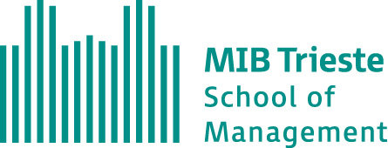

MBA in International Business
XXXVI edition

FINAL REPORT
AI Washing or Credible Disclosure? Patterns and Clusters in Corporate AI Disclosures

By
Germán Oviedo

I declare that this assignment is my own work, which all sources of reference are acknowledged in full, and it has not been submitted for any other course.

Signature:

