Figure 1, Annual cases and deaths averted in 31 VIMC countries by vaccine introduction, 4 doses, age-based administration, from 2023 onwards across simulation period.
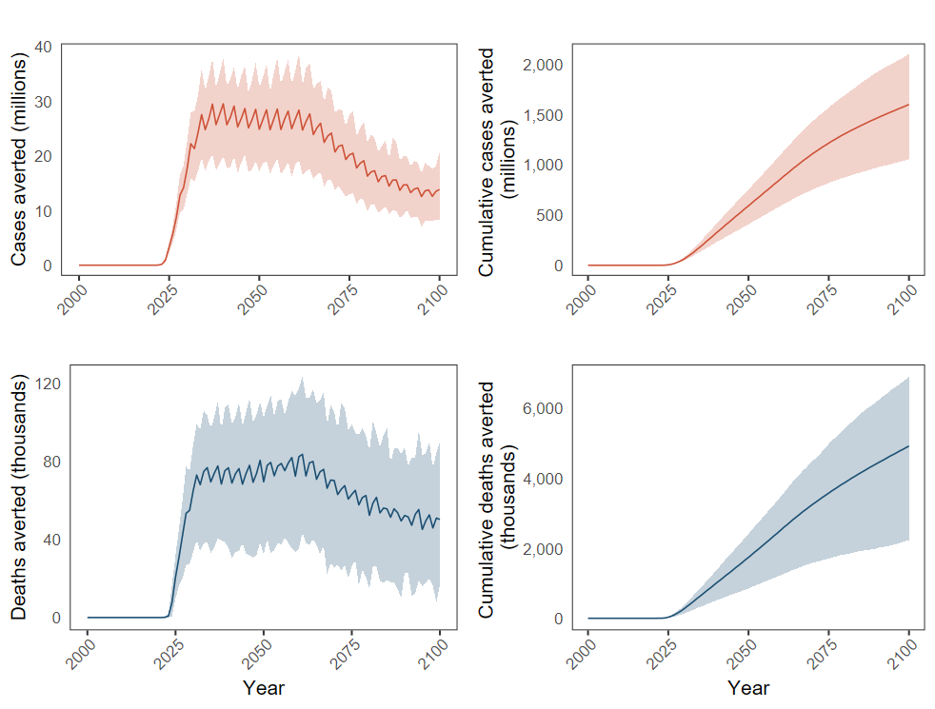
Figure 2, Map of cases and deaths averted per 100,000 fully vaccinated people (FVP) over 15 years (2023 – 2038), VIMC modelled countries, 4-dose routine vaccine scenario.
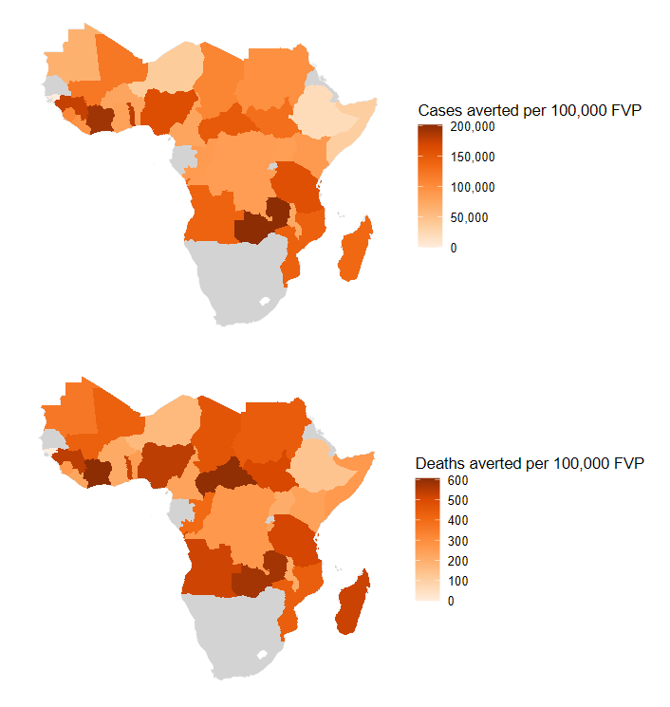

Figure 3, Model predicted cases and deaths averted by age over time relative to scenarios with no vaccination, all 31 VIMC countries, 2000-2100.

