**Force of-Infection model**

We used catalytic model to test weather or not the incidence per -susceptible population has remained constant over time or has recently been introduced.

For a constant FOI ($λ)$, we can express the seroprevalence as for age $a$ in the year of the serosurveys (τ) as:

$$P(a,τ)= 1-exp⁡(-λa)$$

For a stepwise non-constant FOI, we can express the seroprevalence for age $a$ in the year of the serosurveys (τ) as:

$$P(a,τ)= 1- \exp{-\left[λ_{1 }\left(t_{0}-t_{1}\right)+ λ_{2 }\left(t_{1}-\left(t_{0}-a\right)\right)\right]}$$

Where, $λ_{1}$ is the FOI experienced from the year of the serosurveys ($t_{0})$ until the year of introduction of the virus ( $t_{1})$ and $λ_{2 }$ represents the FOI experienced from that point until the year of birth $\left(t_{0}-a\right)$.

Models were fitted to sero-prevalence data for the three viruses (UNA, MAAV and VEEE) using MCMC and metropolis hasting algorithm, with 50,000 iterations. Best model was chosen according to lowest Deviance Criterion (DIC).

**Results**

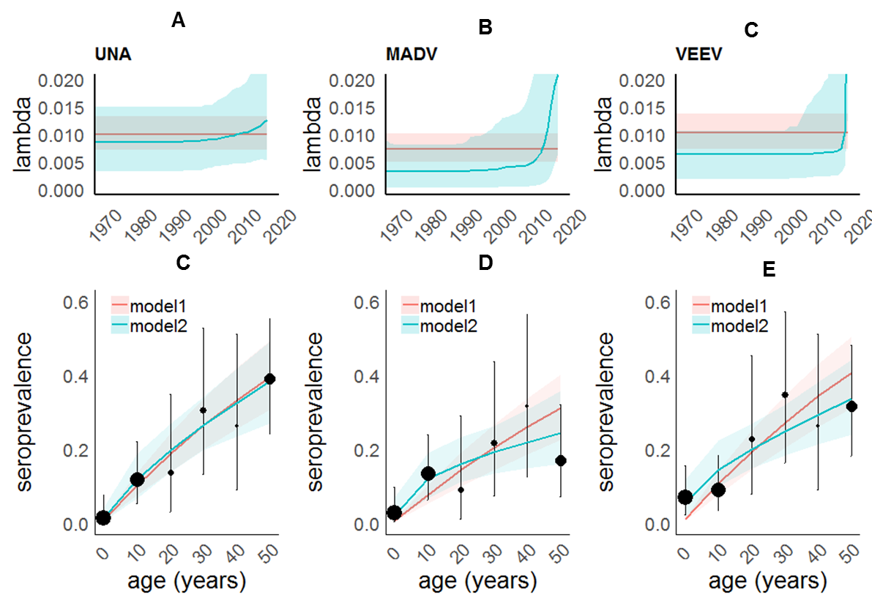

Figure 1. Pink shaded areas represent the model 1 (Constant Force-of-Infection), green shaded areas represent model 2 (stepwise non- constant FOI). A, B and C correspond to the estimated Force-of-Infection and C, D, E to the fitted sero-prevalence models. Black dots and error bars represent the observed data.

Table 1. Deviance Information Criterion

|  |  |  |  |
| --- | --- | --- | --- |
| model | UNA | MADV | VEEN |
| 1. Constant FOI | **21.56** | 30.23 | 35.85 |
| 1. Non-Constant FOI | 23.15 | **26.49** | **28.54** |

**Conclusions**

For all three virus there is no evidence of a single epidemic. In the three cases, the predicted exposure period goes back decades, suggesting some degree of endemicity. For both MADV, VEEN the non-constant FOI model predicts an increase in the FOI in the last decade, probably corresponding to an outbreak.