Contents

Highlights 1

Use new package – joint RT/epsilon estimates 3

Epi data 4

Rt estimates 5

# Highlights

Run epiestim for each variant per region, plot posterior sample of variants against each other

Note:

* only use day where width of 95%Cri of both variants is less than 0.5

gives a rough epsilon

france

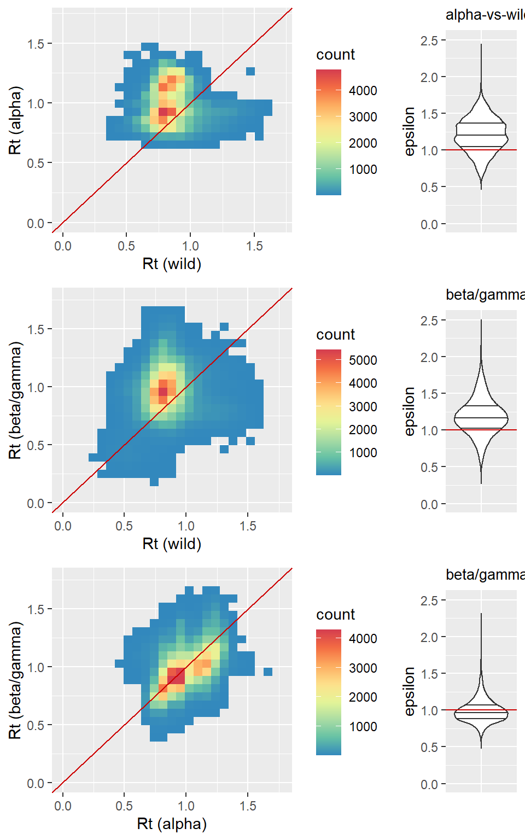

England

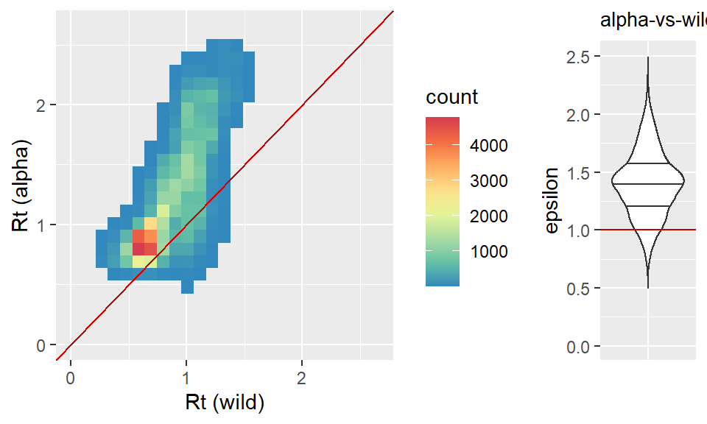

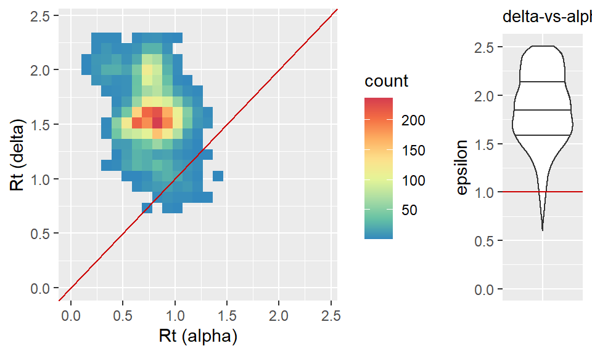

# Use new package – joint RT/epsilon estimates

France

|  |  |  |  |  |  |  |  |  |  |  |
| --- | --- | --- | --- | --- | --- | --- | --- | --- | --- | --- |
|  | Alpha vs wild | | | | | Beta vs wild | | | | |
|  | All period | 1st quarter | 2nd quarter | 3st quarter | 4th quarter | All period | 1st quarter | 2nd quarter | 3st quarter | 4th quarter |
| Med | 1.287121 | 1.247433 | 1.426501 | 1.277561 | 1.232165 | 1.150431 | 1.109402 | 1.197666 | 0.968279 | 0.96609 |
| Low | 1.278665 | 1.234968 | 1.413287 | 1.257948 | 1.218272 | 1.13047 | 1.091578 | 1.172588 | 0.946708 | 0.938991 |
| high | 1.29609 | 1.260411 | 1.438419 | 1.298959 | 1.247289 | 1.172426 | 1.128187 | 1.223439 | 0.990005 | 0.993911 |

England

|  |  |  |  |  |  |  |  |  |  |  |
| --- | --- | --- | --- | --- | --- | --- | --- | --- | --- | --- |
|  | Alpha vs wild | | | | | delta vs alpha | | | | |
|  | All period | 1st quarter | 2nd quarter | 3st quarter | 4th quarter | All period | 1st quarter | 2nd quarter | 3st quarter | 4th quarter |
| Med | 1.457742362 | 1.046530979 | 1.497424831 | 1.500354166 | 1.272903935 | 1.764904 | 1.485984 | 1.690892 | 1.744648 | 1.928779 |
| Low | 1.443289304 | 0.998070768 | 1.467582965 | 1.481176314 | 1.224364315 | 1.684295 | 1.263208 | 1.510033 | 1.627366 | 1.783562 |
| high | 1.472094947 | 1.100318619 | 1.527445565 | 1.519567597 | 1.330456162 | 1.842934 | 1.731055 | 1.869739 | 1.880968 | 2.067647 |

# Epi data

france

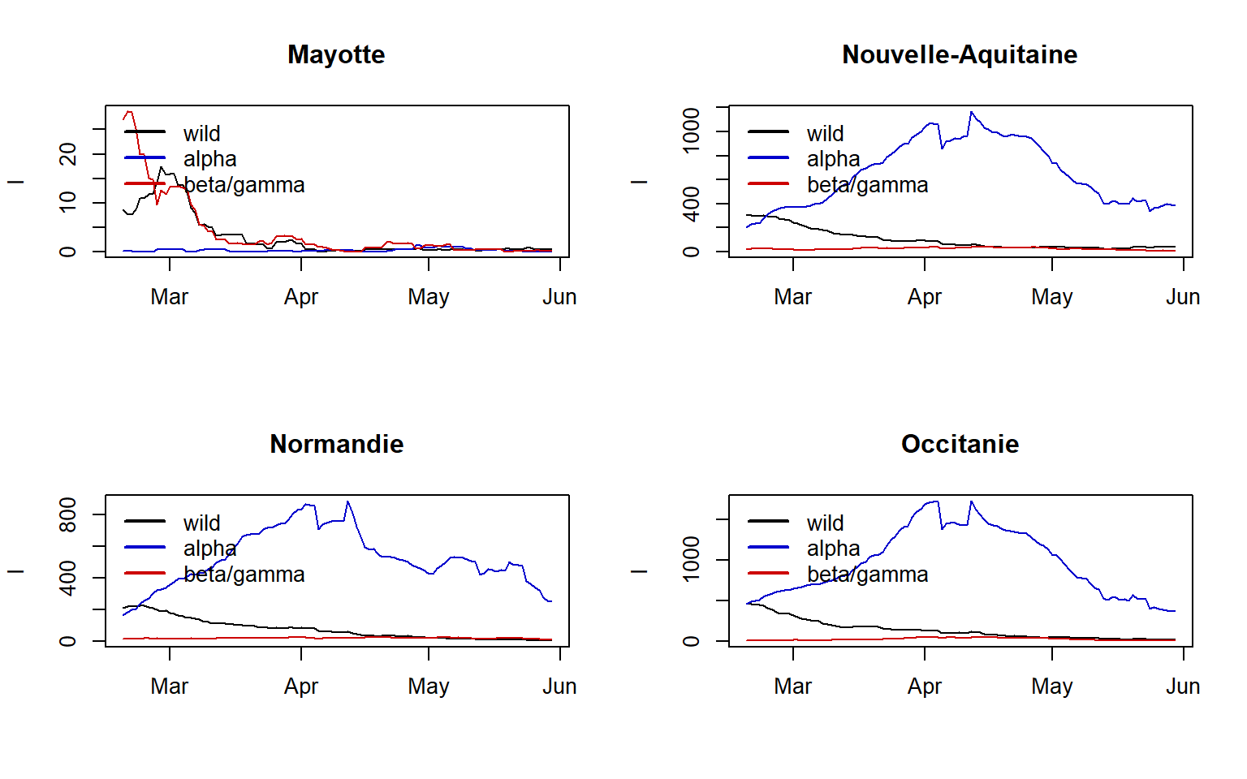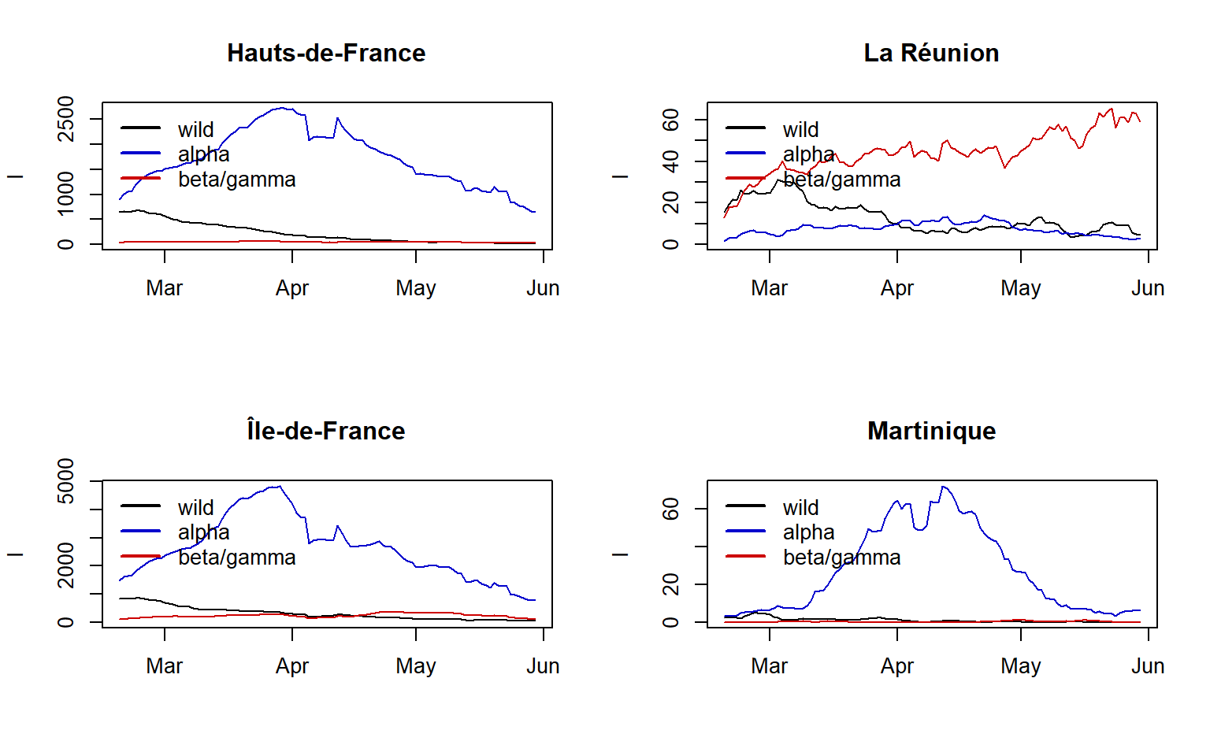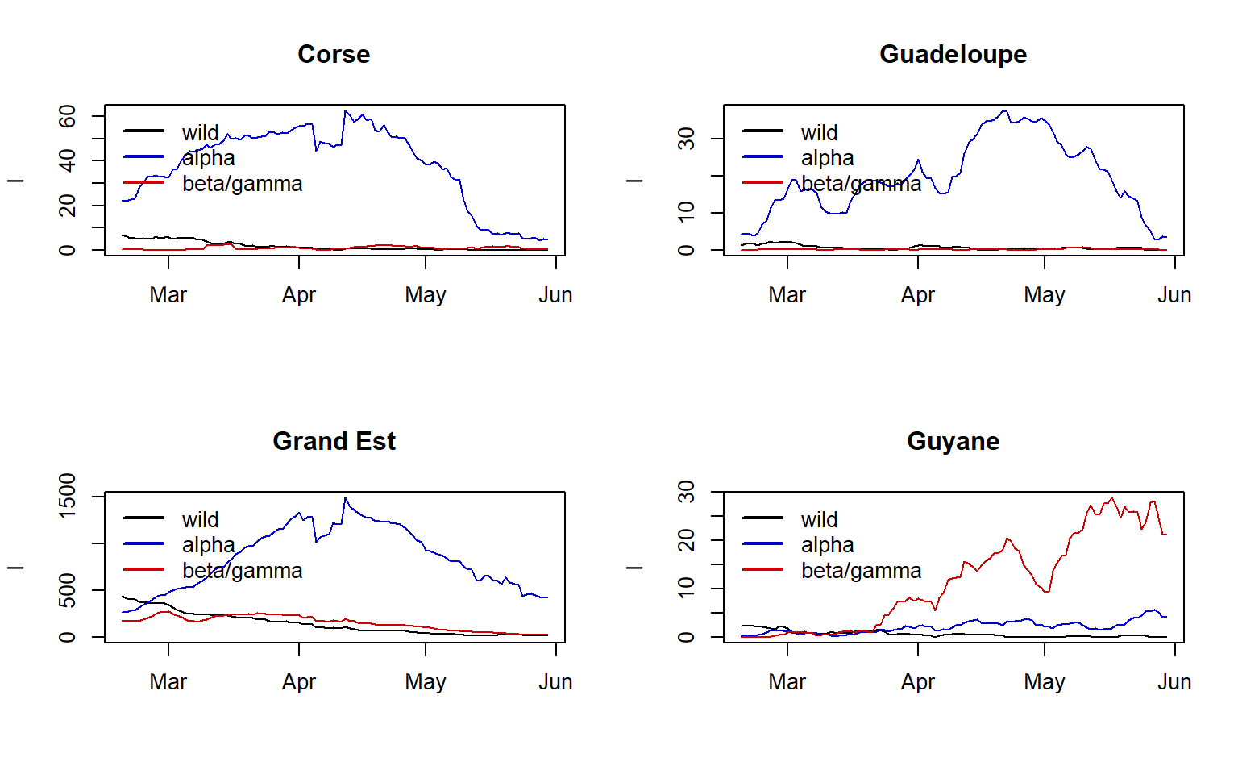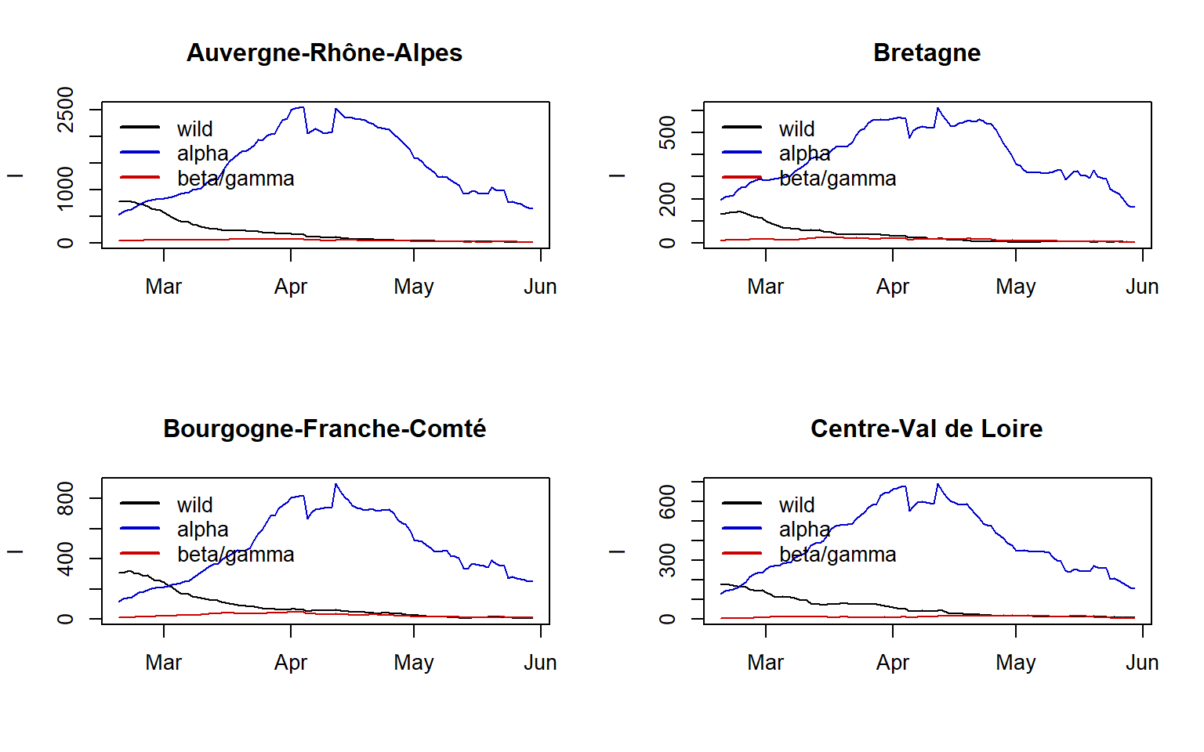

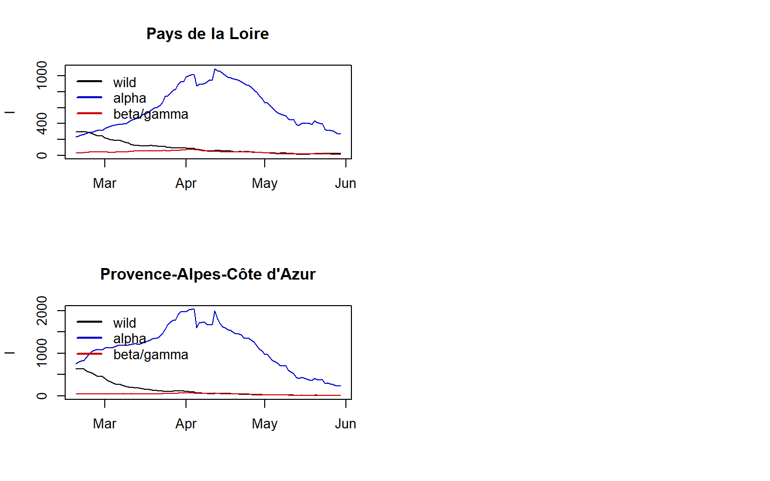

England

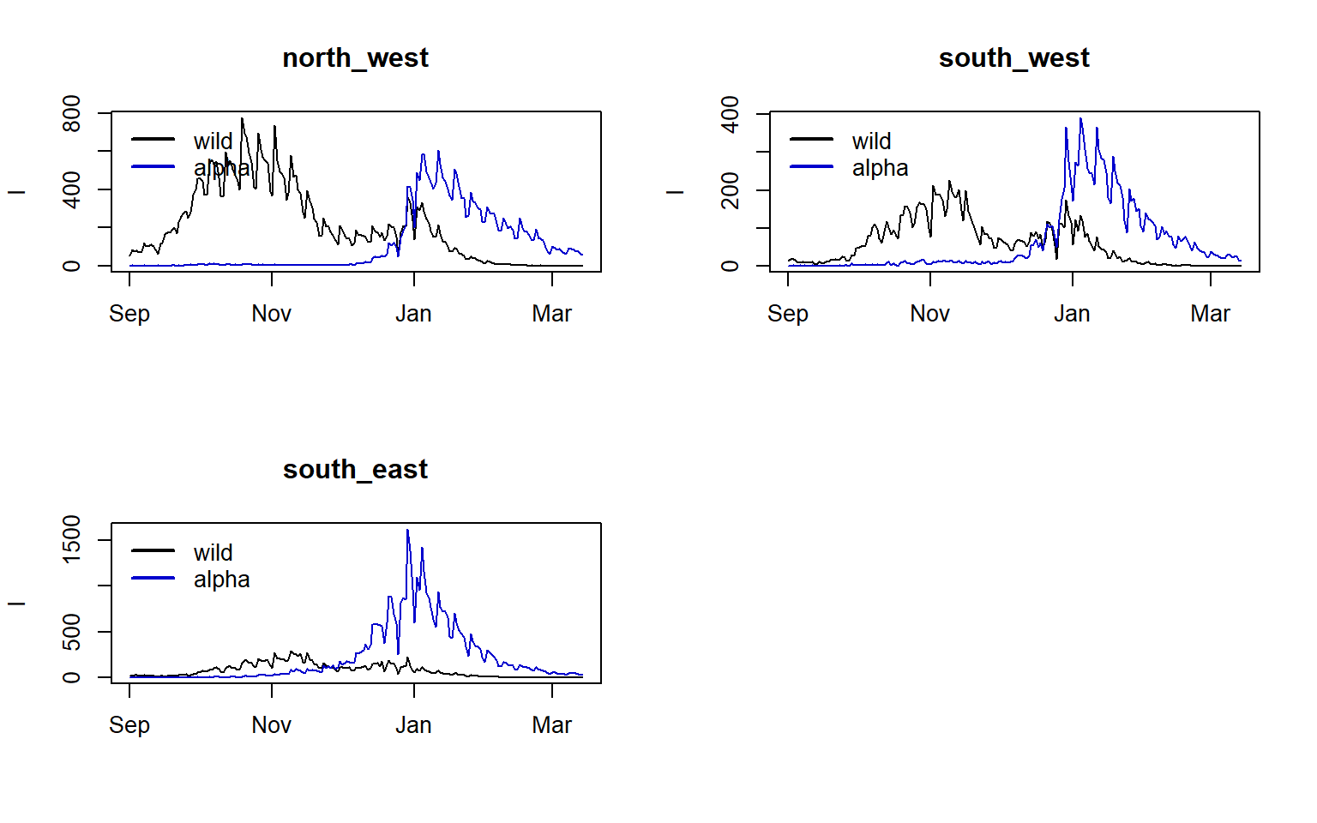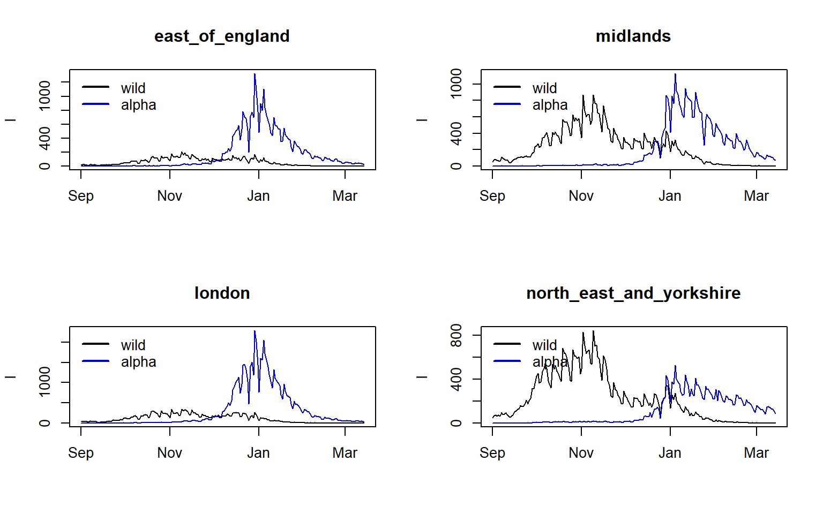

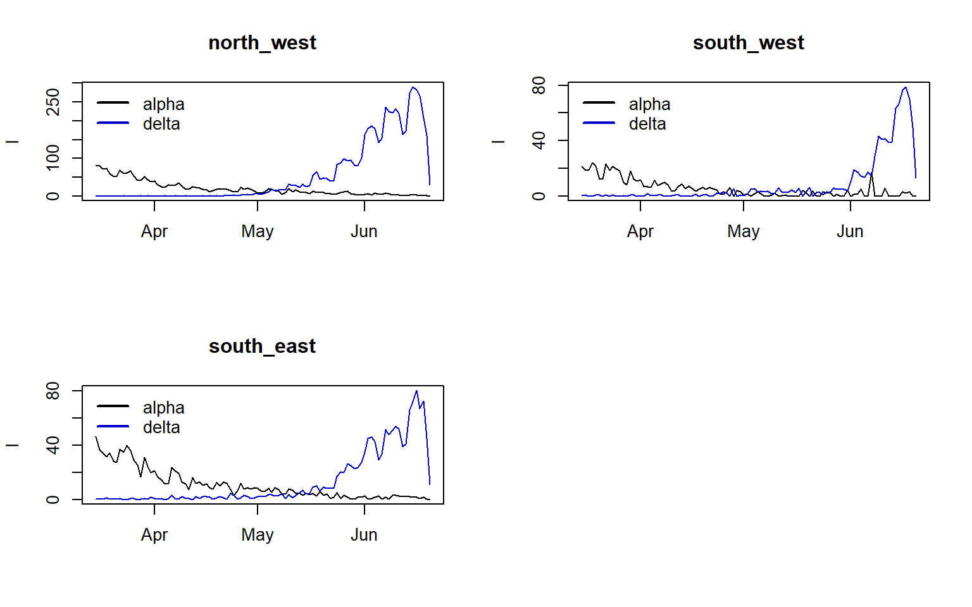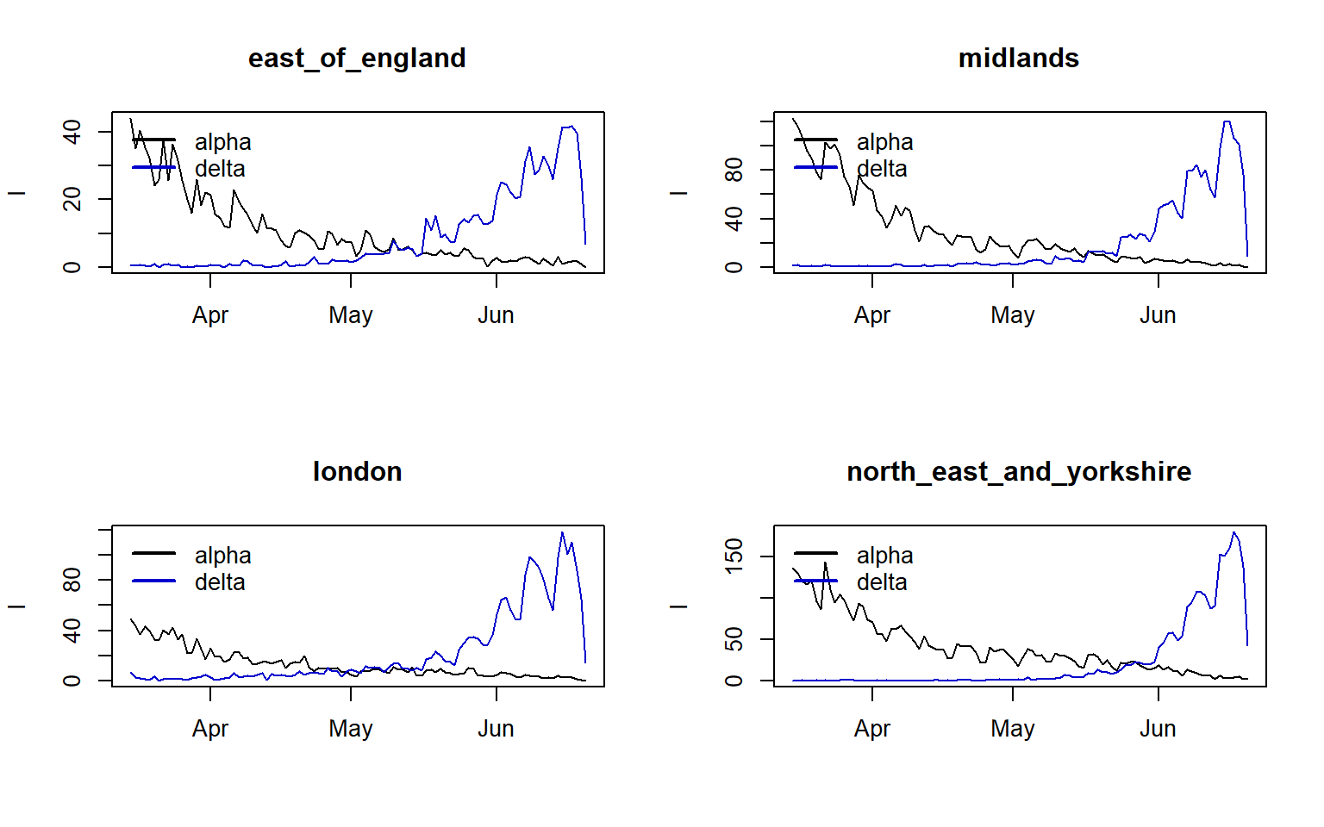

# Rt estimates

Horizontal lines highlight when the 95%Cri width criteria is met

France

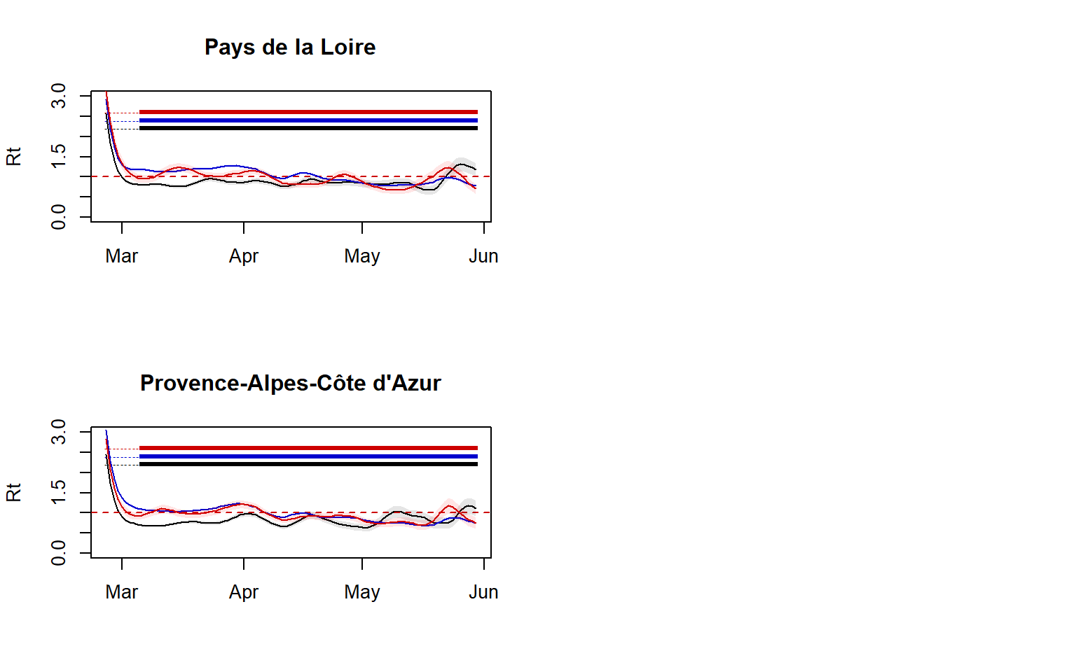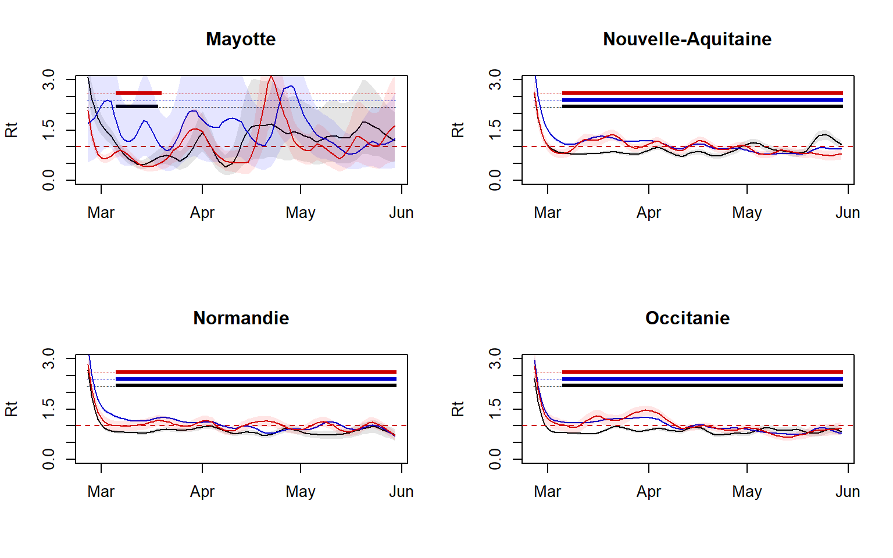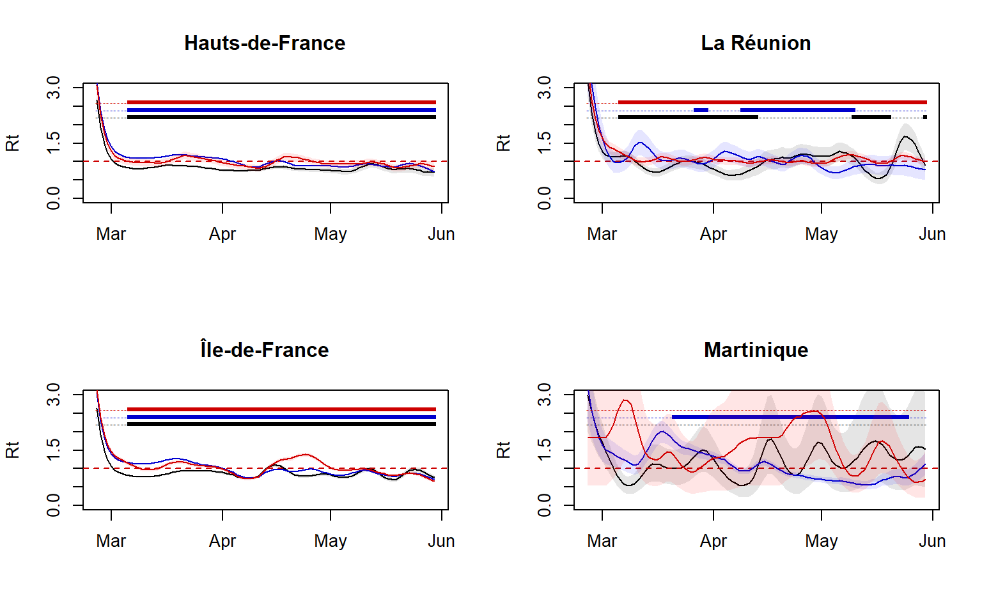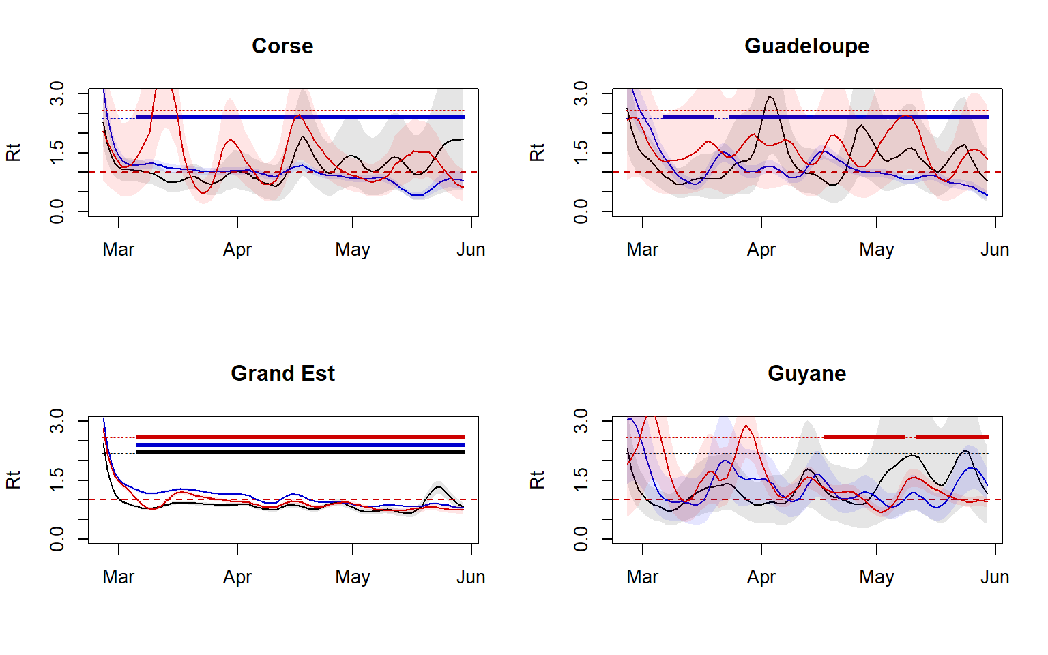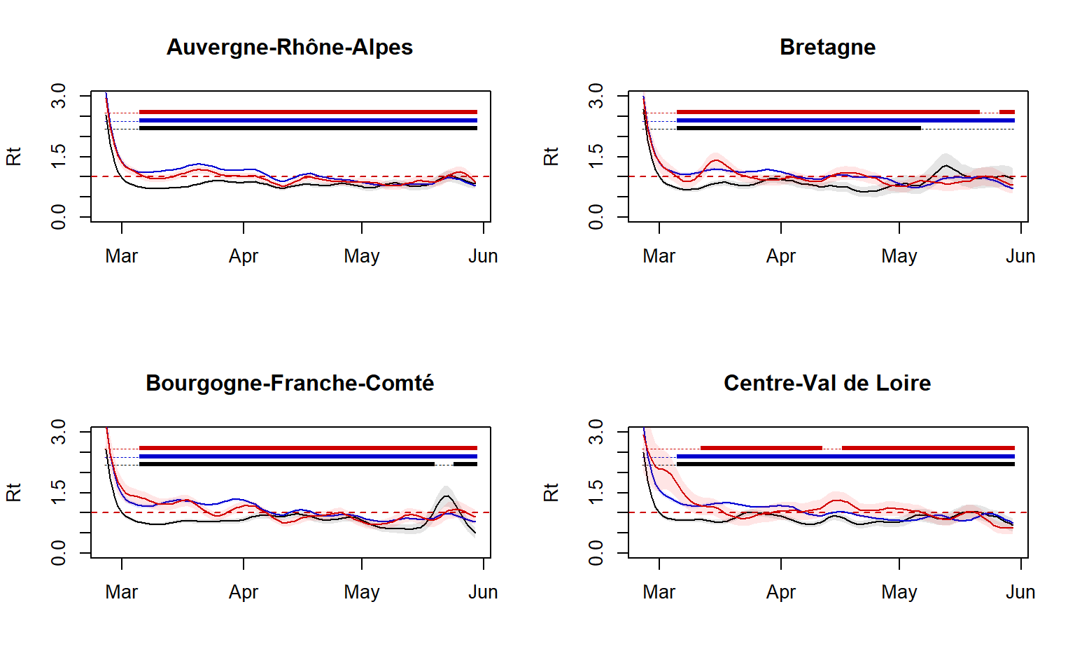

England

Alpha-wild

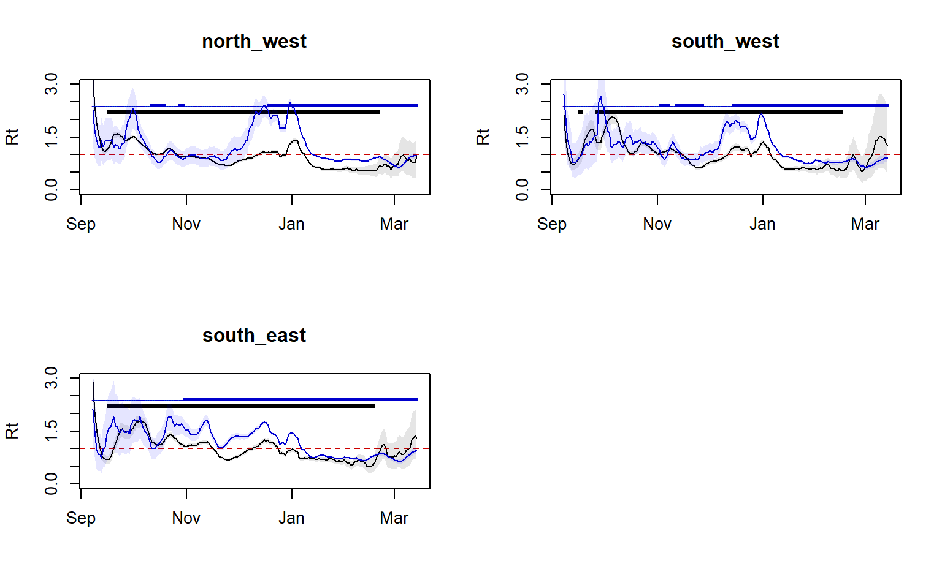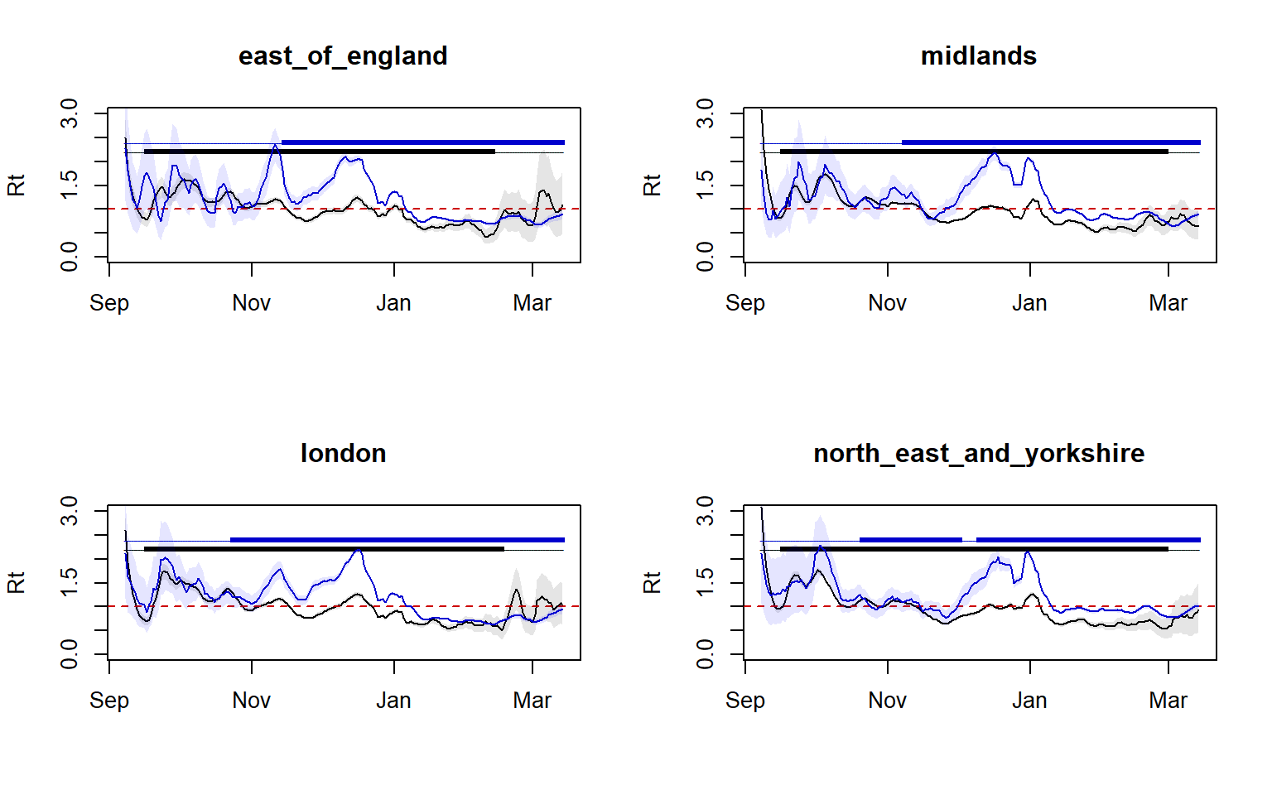

Delta-alpha

