Braze User Guide for MRC Survey

Email Setting
Approach Bee Yan (BeeYan@mediacorp.com.sg) or Meng Hwee (MengHwee.Pek@mediacorp.com.sg) with the following information to configure.
Sender’s Email Address | Reply-to Email Address
Mediacorp Survey  musictest@MRCsurvey.mediacorp.sg | musictest@mediacorp.com.sg
PEI Graduate Employment Survey 2020/2021  peiges@MRCsurvey.mediacorp.sg | PEIGESfeedback@mediacorp.com.sg

Import User

Import users for new project
- Update your contact user list to use Braze user profile fields for the header.
Braze User Profile Fields | Example | Data Attributes
external_id | 123456Z | Default (mandatory)
first_name | Meng Hwee | Default
email | MengHwee.Pek@mediacorp.com.sg | Default
email_subscribe | subscribed | Default
project | PEIGES | Custom
password | 1234567 | Custom
<project>_ subscription_status  (e.g.peiges_subscription_status) | TRUE | Custom

Example:
- Confirm and save in CSV format.
- Name the CSV file properly, to recognize the project and the latest version.
- Braze → MRC Survey environment → User Import
- Click on “Select CSV File”.
- Check the details prompted.
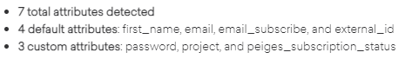
- Choose the following option.
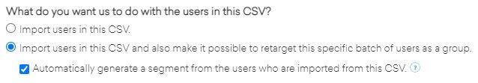
- Click on “Start Import”.
- Once completed, go to Segment to edit the segment. More on Section 3.

Update existing records
Changes to first name, last name and email address can be updated manually. Otherwise, you may update via the CSV import method.
- Remove columns that are not required to be updated. Example:
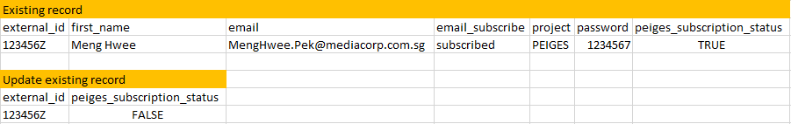
- Once completed, “User Search” to verify if the data is updated.

Segment

Segment for new project
- Click on segment that was auto generated (from Section 2 – Import users for new project).
- Remove the CSVs import or updated in filter.
- Click on “Custom Attribute” in Add Filter, choose “Project” and enter the custom attribute value (case-sensitive).
- Click on “Email Available” in Add Filter, set as TRUE.
- Click on “<project>_subscription_status” in Add Filter, set as TRUE.
- Verify the Total Reachable Users.

Segment for existing project
- Select the segment that you are targeting.
- Verify the Total Reachable Users.

Template
Only if your EDM template is reusable. If the EDM design is not reusable (different design each time), you may skip this section.
- Select “Drag-and-Drop Editor” unless you have HTML knowledge.
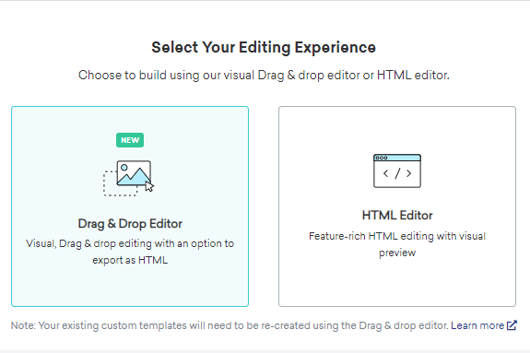
- Click on “Create Email Template”.
- Enter Template Name.
- Proceed to work on the Template Content.
- Click on “Preview and Test” and choose “Test Send”.
- Enter email address to Add Individual User.
- Click on “Send Test”.

Campaign

Compose tab – One-time EDM
If the EDM design is not reusable (different design each time), you may directly create EDM in the Campaign.
- Click on “Create Campaign” and choose “Email”.
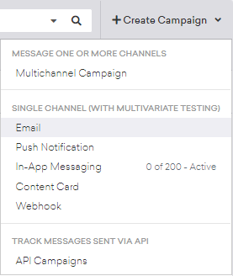
- Enter Campaign Name.
- Select “Drag-and-Drop Editor” unless you have HTML knowledge.
- Click on “Blank Template”.
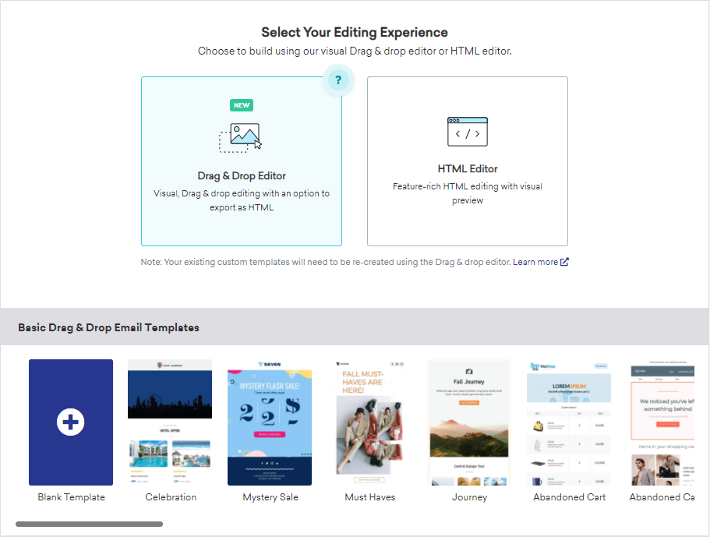
- Start “Edit Sending Info” and “Edit Email Body”.
- Click on “Preview and Test” and choose “Test Send”.
- Enter email address to Add Individual User.
- Click on “Send Test”.
- Once the EDM template is confirmed, click on “Save Draft”.
- Proceed to next tab – Delivery.

Compose tab – Using existing templates
If the EDM template is reusable and already pre-designed in the Template.
- Click on “Create Campaign” and choose “Email”.
- Enter Campaign Name.
- Select “Drag-and-Drop Editor”.
- Go to Saved Drag & Drop Templates.
- Select the template that you want for your EDM.
- Start “Edit Sending Info” and “Edit Email Body” to update the content.
- Click on “Preview and Test” and choose “Test Send”.
- Enter email address to Add Individual User.
- Click on “Send Test”.
- Once the EDM template is confirmed, click on “Save Draft”.
- Proceed to next tab – Delivery.

Delivery tab
- Choose Scheduled Delivery.
- Choose Send at a designated time.
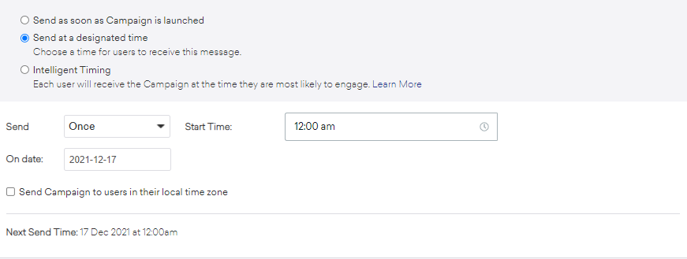
- Keep the option under Delivery Controls unchecked.
- Proceed to next tab – Target Users.

Target Users tab
- Choose the segment that you wish to target.
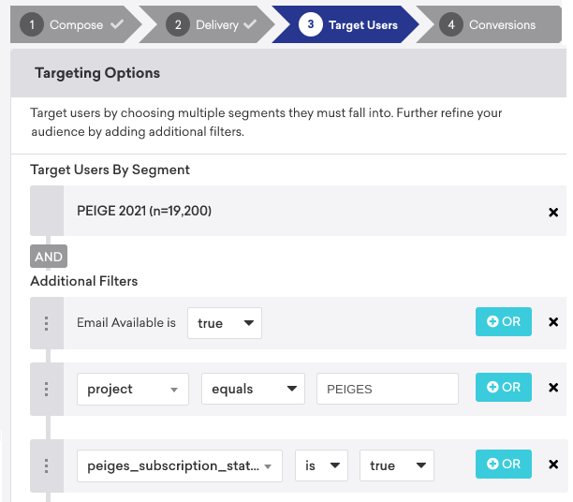

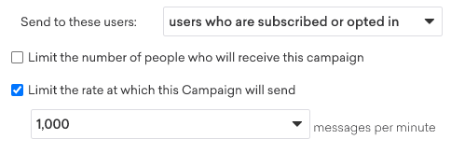

- Keep all the options under A/B Testing unchecked.
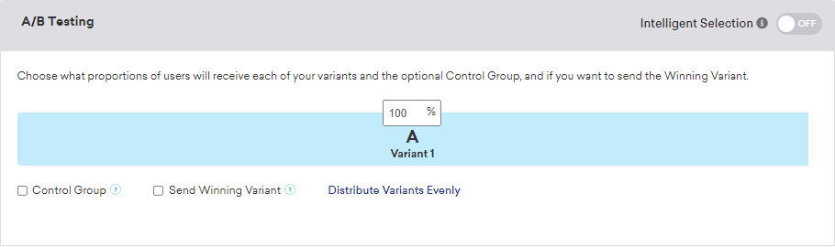
- Verify the total Reachable Users that you will be targeting. If it’s incorrect, you have to go back to the segment to check the filters.
- Proceed to next tab – Conversion.

Conversion tab
- Depends on what MRC Survey would like to measure.
- Click on “Add Conversion Event” if you want to have multiple.
- Proceed to next tab – Confirm.

Confirm tab
Check all the information, and you may click on “Save Draft” or “Launch Campaign”.

Reporting

Finding Invalid email + Bounced + Unsub
Using segment and apply filter as below
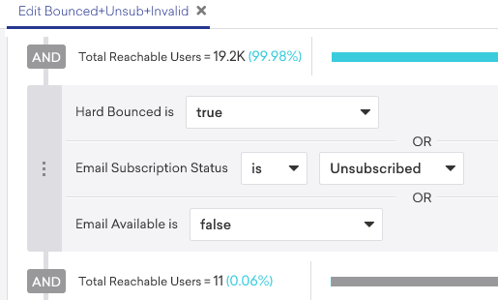

Export CSV ( auto send to Outlook email )
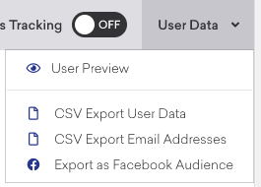
Send to MsTeams
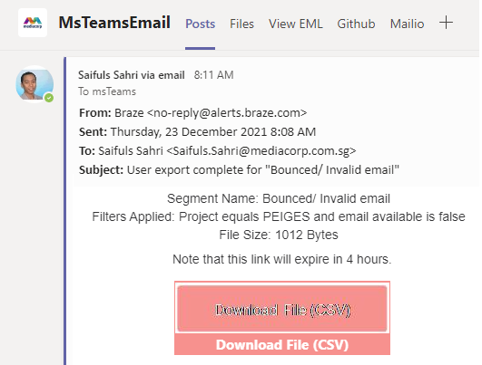
Extract the CSV for info
