**2016103604**

**Varadharajan R**

**Introduction**

The main idea beyond developing this project is to create a user friendly application that will help any course instructor taking the daily attendance of the students very easily.

**Back End Triggers and Procedures SQL PLUS ORACLE DB ☺**

**Table Structures:**

SQL> desc passtab;

Name Null? Type

----------------------------------------- -------- ----------------------------

STAFFID NOT NULL VARCHAR2(30)

PASSWORD NOT NULL VARCHAR2(30)

SQL> desc attendance;

Name Null? Type

----------------------------------------- -------- ----------------------------

STAFFID NOT NULL VARCHAR2(15)

DATES VARCHAR2(50)

S1 NUMBER(38)

S2 NUMBER(38)

S3 NUMBER(38)

S4 NUMBER(38)

S5 NUMBER(38)

S6 NUMBER(38)

S7 NUMBER(38)

S8 NUMBER(38)

S9 NUMBER(38)

S10 NUMBER(38)

S11 NUMBER(38)

S12 NUMBER(38)

S13 NUMBER(38)

S14 NUMBER(38)

S15 NUMBER(38)

S16 NUMBER(38)

S17 NUMBER(38)

S18 NUMBER(38)

S19 NUMBER(38)

S20 NUMBER(38)

S21 NUMBER(38)

S22 NUMBER(38)

S23 NUMBER(38)

S24 NUMBER(38)

S25 NUMBER(38)

S26 NUMBER(38)

S27 NUMBER(38)

S28 NUMBER(38)

S29 NUMBER(38)

S30 NUMBER(38)

S31 NUMBER(38)

S32 NUMBER(38)

S33 NUMBER(38)

S34 NUMBER(38)

S35 NUMBER(38)

S36 NUMBER(38)

S37 NUMBER(38)

S38 NUMBER(38)

S39 NUMBER(38)

S40 NUMBER(38)

S41 NUMBER(38)

S42 NUMBER(38)

S43 NUMBER(38)

S44 NUMBER(38)

S45 NUMBER(38)

S46 NUMBER(38)

S47 NUMBER(38)

S48 NUMBER(38)

S49 NUMBER(38)

S50 NUMBER(38)

S51 NUMBER(38)

S52 NUMBER(38)

S53 NUMBER(38)

S54 NUMBER(38)

S55 NUMBER(38)

S56 NUMBER(38)

S57 NUMBER(38)

S58 NUMBER(38)

S59 NUMBER(38)

S60 NUMBER(38)

**PROCEDURE FOR IDENTIFYING THE STAFFS WHO LOGGED IN ON A PARTICULAR DAY:**

CREATE PROCEDURE a_proc(dt in varchar2)

AS

CURSOR names_cur IS

SELECT staffid

FROM attendance

WHERE dates=dt;

names_t names_cur%ROWTYPE;

TYPE names_ntt IS TABLE OF names_t%TYPE; -- must use type

l_names names_ntt;

BEGIN

OPEN names_cur;

FETCH names_cur BULK COLLECT INTO l_names;

CLOSE names_cur;

FOR indx IN 1..l_names.COUNT LOOP

DBMS_OUTPUT.PUT_LINE(l_names(indx).staffid);

END LOOP;

END a_proc;

**PROCEDURE FOR TAKING STUDENTCOUNT ON A PARTICULAR DAY FOR A PARTICULAR STAFF:**

create or replace procedure studentcount(dt in varchar2,id in varchar2,c out int)

as

begin

select s1+s2+s3+s4+s5+s6+s7+s8+s9+s10+s11+s12+s13+s14+s15+s16+s17+s18+s19+s20+s21+s22+s23+s24+s25+S26+s27+s28

+s29+s30+s31+s32+s33+S34+s35+s36+s37+s38+s39+s40+s41+s42+s43+s44+s45+s46+s47+s48+s49+s50+s51+s52+s53+s54+s55+s56+S57+s58+s59+s60 into c from

attendance where(staffid=id and dates=dt);

dbms_output.put_line("students present today"||c);

end;

/

**TRIGGER FOR BACKINGUP OF PASSTAB TABLE INTO PASSTAB1 TABLE:**

create or replace trigger t1 after insert on passtab

for eeach row

begin

insert into passtab1 values(:new.staffid,:new.password);

end;

/

**TRIGGER FOR BACKINGUP OF ATTENDANCE TABLE INTO ATTENDACNE1 TABLE:**

create or replace trigger t11 after insert on attendance

for each row

begin

insert into attedance1 values(:new.staffid,:new.dates,:new.s1,:new.s2,:new.s3,:new.s4,:new.s5

,:new.s6,:new.s7,:new.s8,:new.s9,:new.s10,:new.s11,:new.s12,:new.s13,:new.s14,:new.s15,:new.s16,:new.s17

,:new.s18,:new.s19,:new.s20,:new.s21,:new.s22,:new.s23,:new.s24,:new.s25,:new.s26,:new.s27,:new.s28

,:new.s29,:new.s30,:new.s31,:new.s32,:new.s33,:new.s34,:new.s35,:new.s36,:new.s37,:new.s38,:new.s39

,:new.s40,:new.s41,:new.s42,:new.s43,:new.s44,:new.s45,:new.s46,:new.s47,:new.s48,:new.s49

,:new.s50,:new.s51,:new.s52,:new.s53,:new.s54,:new.s55,:new.s56,:new.s57,:new.s58,:new.s59,:new.s60);

end;

/

**Abstract**

The main idea beyond developing this project is to create a user friendly application that will help any course instructor taking the daily attendance of the students very easily .It extends its application also in generating the defaulters list who generally have their attendance less than 75%.The application prototype is constructed in a manner such its user interface (front) end being developed with Java Virtual Machine (Netbeans IDE) with Oracle 11g Database as its back (storage) end. In this modern era the very classical way of taking attendances may not be comfortable for everyone. So, it’s essential to build such android applications with the ease of marking daily attendances and in a way helpful to the higher authorities of educat ion division of any government or private institutions have a watch over the particular instructor.

The hierarchical control of the attendance database can be maintained through a separate administrator only granting particular permissions to the users according to their designation. This when further extended as a web supporting app will help the education department have control over the progress of every staff in instruction of the courses they have taken charge of. Instead of a classical way of accessing the app through username and password the parameters can be set like the staff’s fingerprint that would serve as the staff’s username and the password is a location of the classroom where they are supposed to instruct the course.

This application when build with android tools like Speech recognition and Artificial Intelligence software will tend to reduce the workload of staffs too by calling out the student names itself and when voice recognition and face detection methods are applied in avoiding the mismatches of student ID’s by positioning and searching the student on a particular axis where the sound has arouse from and thermal image processing whether the student face matches with his existing face in its Database, will yield better results thereby reducing the workload of the staff. In this world which is tending now towards job automation this application will have a major impact thereby helping the instructed machines to function like a staff obliged to rules and regulations.

**Front end Images:**

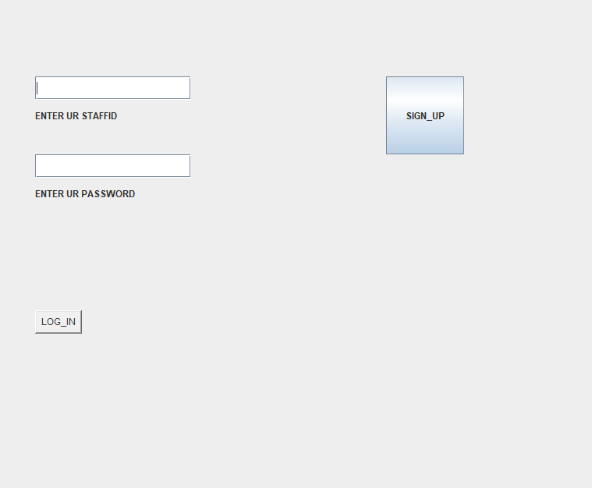

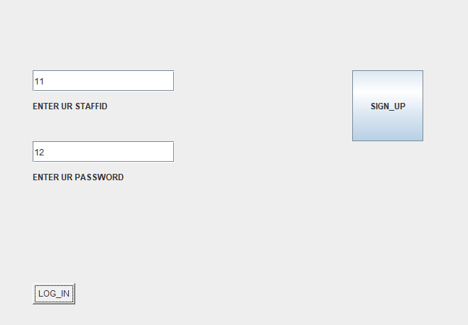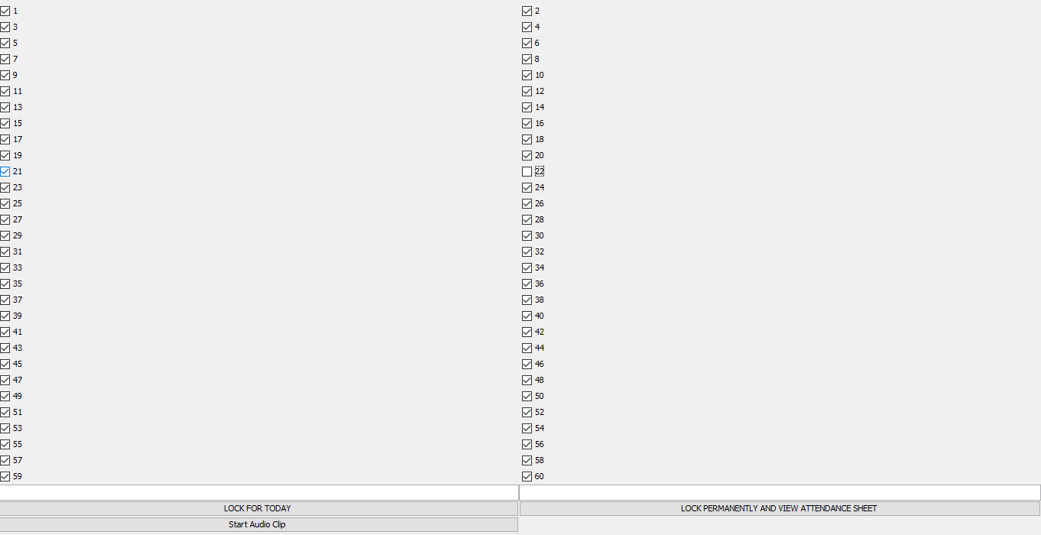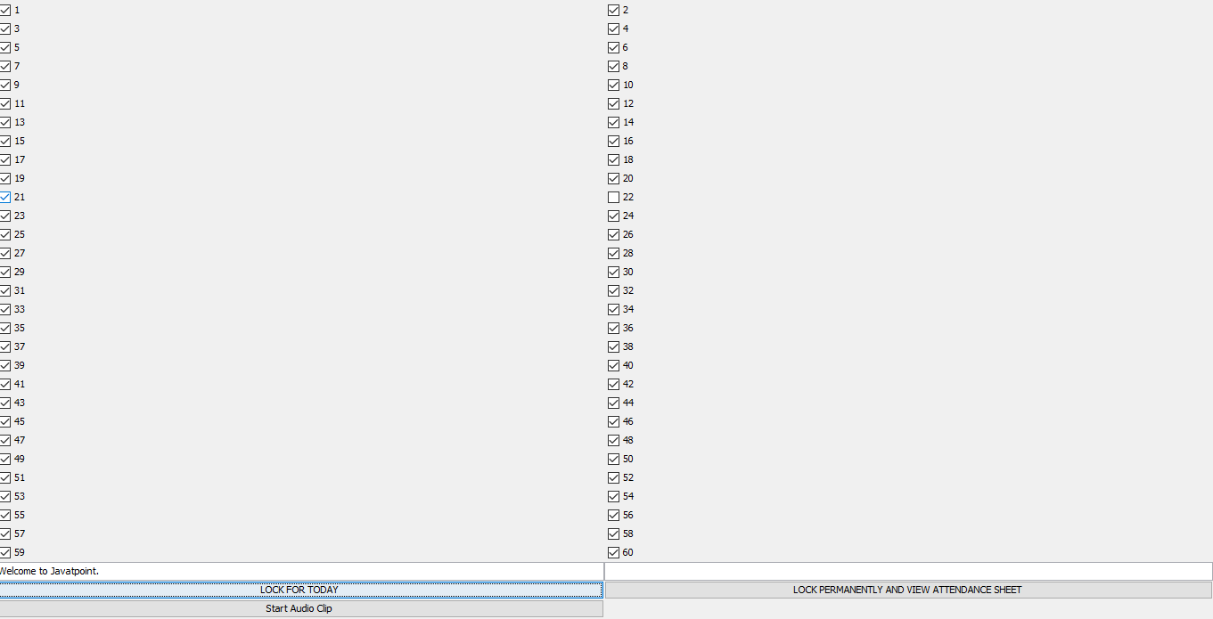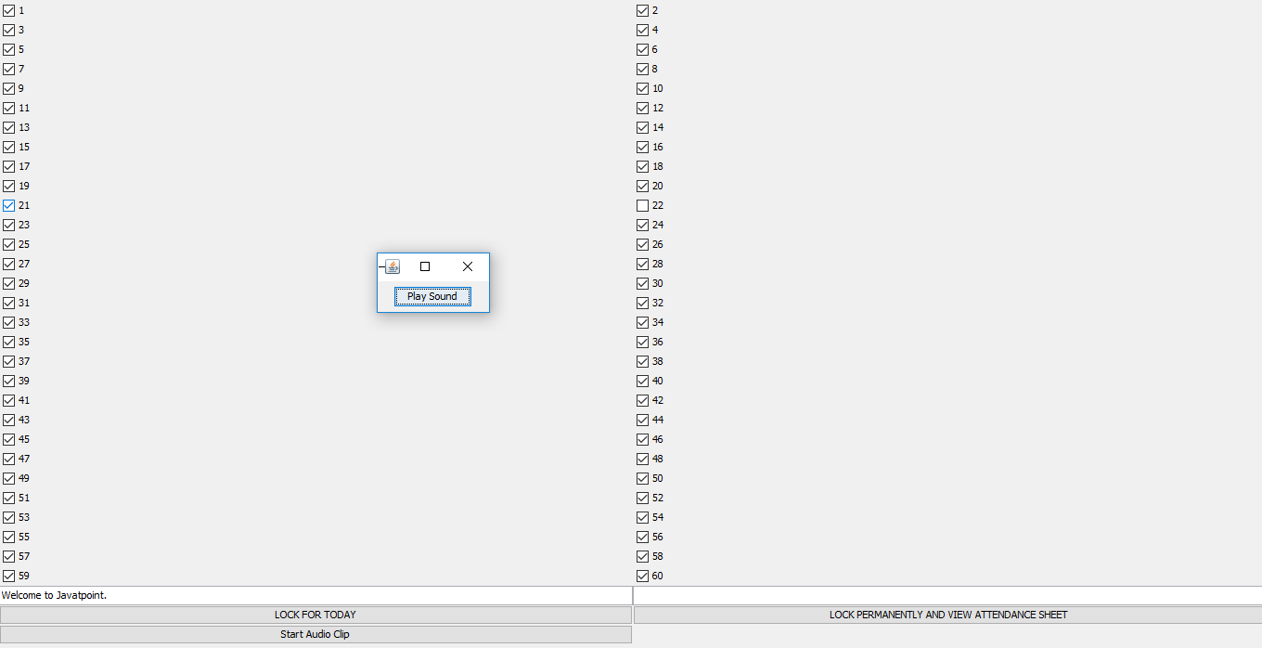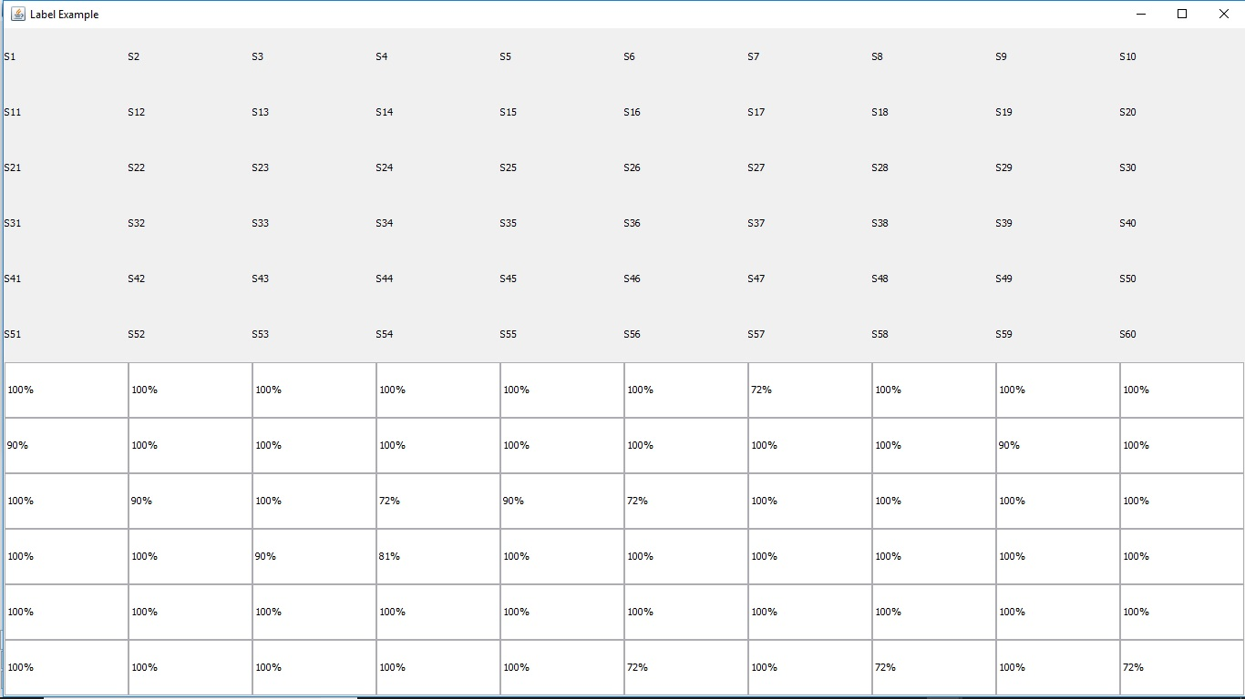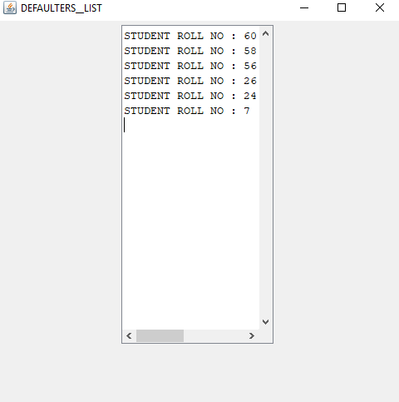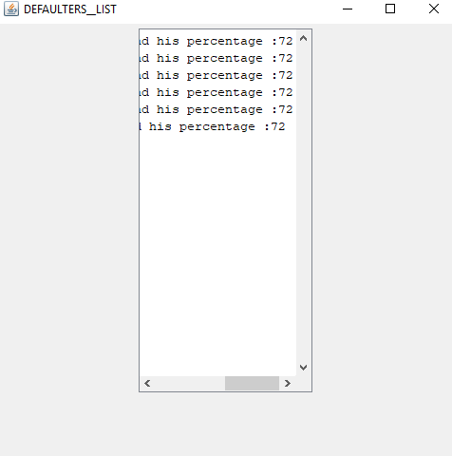

**Conclusion:**

If this project is enhanced with add-on features such as API for voice recognition of students with target identification camera hardware and other such full automation features it will be a very great one for the staff and the administration side to avoid the errors that may arise in attendance calculation.