Apologies for the oversight. Let's ensure we have 5 tables in the schema. We can introduce a table to manage transactions, which would record purchases made by customers for gaming time. Here's the revised schema with 5 tables:

1. **Customers table**:

- customer_id (Primary Key)

- name

- email

- phone_number

2. **Computers table**:

- computer_id (Primary Key)

- computer_name

- computer_type (e.g., gaming, regular)

- status (e.g., available, occupied)

3. **Sessions table**:

- session_id (Primary Key)

- customer_id (Foreign Key referencing Customers table)

- computer_id (Foreign Key referencing Computers table)

- start_time

- end_time

- amount_paid

4. **Games table**:

- game_id (Primary Key)

- title

- genre

- platform (e.g., PC, Xbox, PlayStation)

- price_per_hour

5. **Transactions table**:

- transaction_id (Primary Key)

- customer_id (Foreign Key referencing Customers table)

- computer_id (Foreign Key referencing Computers table)

- game_id (Foreign Key referencing Games table)

- session_id (Foreign Key referencing Sessions table)

- quantity (number of hours)

- total_amount

- transaction_date

With this schema, you have 5 tables that allow you to effectively manage the operations of the gaming cafe. Customers can book sessions on specific computers to play games, and their transactions for gaming time are recorded in the Transactions table. The Games table lists the available games for play, and the Computers table tracks the availability of computers for customer use.

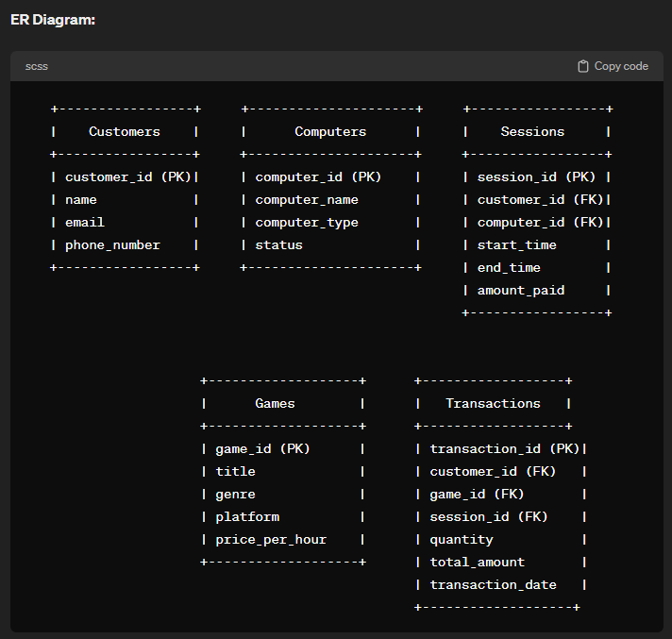

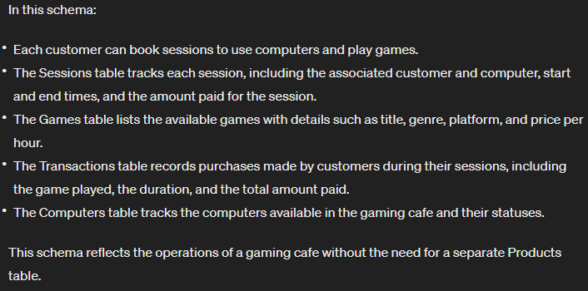

Understood. Here's the revised schema without the Products table:

1. **Customers table**:

- customer_id (Primary Key)

- name

- email

- phone_number

2. **Computers table**:

- computer_id (Primary Key)

- computer_name

- computer_type (e.g., gaming, regular)

- status (e.g., available, occupied)

3. **Sessions table**:

- session_id (Primary Key)

- customer_id (Foreign Key referencing Customers table)

- computer_id (Foreign Key referencing Computers table)

- start_time

- end_time

- amount_paid

4. **Games table**:

- game_id (Primary Key)

- title

- genre

- platform (e.g., PC, Xbox, PlayStation)

- price_per_hour

5. **Transactions table**:

- transaction_id (Primary Key)

- customer_id (Foreign Key referencing Customers table)

- game_id (Foreign Key referencing Games table)

- session_id (Foreign Key referencing Sessions table)

- quantity (number of hours)

- total_amount

- transaction_date

**ER Diagram:**

```

+-----------------+ +---------------------+ +-----------------+

| Customers | | Computers | | Sessions |

+-----------------+ +---------------------+ +-----------------+

| customer_id (PK)| | computer_id (PK) | | session_id (PK) |

| name | | computer_name | | customer_id (FK)|

| email | | computer_type | | computer_id (FK)|

| phone_number | | status | | start_time |

+-----------------+ +---------------------+ | end_time |

| amount_paid |

+-----------------+

+-------------------+ +------------------+

| Games | | Transactions |

+-------------------+ +------------------+

| game_id (PK) | | transaction_id (PK)|

| title | | customer_id (FK) |

| genre | | game_id (FK) |

| platform | | session_id (FK) |

| price_per_hour | | quantity |

+-------------------+ | total_amount |

| transaction_date |

+-------------------+

```

In this schema:

- Each customer can book sessions to use computers and play games.

- The Sessions table tracks each session, including the associated customer and computer, start and end times, and the amount paid for the session.

- The Games table lists the available games with details such as title, genre, platform, and price per hour.

- The Transactions table records purchases made by customers during their sessions, including the game played, the duration, and the total amount paid.

- The Computers table tracks the computers available in the gaming cafe and their statuses.

This schema reflects the operations of a gaming cafe without the need for a separate Products table.