Funeral Expenses Payment for an adult

We have many ways we can communicate with you.

If you would like braille, British Sign Language, email, a hearing

loop, translations, large print, audio or something else please call us

on 0800 731 0469.

If you live in Wales and want this form in Welsh, please call us

on 0800 731 0453.

Calls to 0800 numbers are free from landlines and mobiles.

Treating people fairly

We are commited to the Equality Act 2010 and treating people fairly. To find out

more about this law, search ‘Equality’ on [www.gov.uk](http://www.gov.uk)

About this form

What you need to do:

•

Use this form to claim a Funeral Expenses Payment for an adult if you live

in England or Wales. But remember, the easiest way to claim is by calling

0

800 151 2012. If you are an adult living in Scotland, you may be able to claim

Funeral Support Payment. Go to [www.mygov.scot](http://www.mygov.scot) for more information.

This form and the notes are available in Welsh.

•

•

Before you fill in the claim form, please take a few minutes to read the notes

that came with this form. They contain important information and help explain

some of the questions we ask you and why we are asking them.

Please complete this form carefully. If you fill in this form using a pen, use

black ink and CAPITAL LETTERS.

Please answer all the questions as fully as possible, and send us all the

documents we have asked for, including a final funeral bill or contract. This will

help us decide quickly if you can get a Funeral Expenses Payment or not.

If you have difficulty filling in this form, ask for help. You can ask a relative,

friend or someone at an advice centre to help you but you must sign the

form yourself.

•

•

•

•

You must claim a Funeral Expenses Payment within 6 months of the date of the

funeral. If you are waiting for a decision on a qualifying benefit, you must still

claim within the time limit.

1

0/22

1

SF200 Adult



About you

0

1 Do you have a partner?

05 All your other names, in full

We use partner to mean:

•

a person you live with who is your

husband, wife or civil partner, or

a person you live with as if you are a

married couple

0

6 Your date of birth

•

DD/MM/YYYY

If your partner is the person who has

died do not complete their details in the

partner section below but tell us about

them in question 18.

07 A phone number we can contact you

on, if you have one

No Go to question 2

We may need to contact you by phone to

get more information or to let you know

when we have made a decision on your

claim. Please note that our number may

show as 0800, unknown or withheld.

Yes

Tell us about you from question 2 and

your partner from question 10.

0

2 Your National Insurance (NI) number

You can find the National Insurance

number on a National Insurance number

card, letters about benefit, or payslips.

0

0

8 Your email, if you have one

9 Your address

0

0

3 If you do not know your National

Insurance number, have you ever had

one or used one at any time?

Please tell us your current address.

No

Yes

4 Your surname or family name

Postcode

1

0/22

2

SF200 Adult



About your partner

1

0 Your partner’s National Insurance

(NI) number

15 A phone number we can contact your

partner on, if they have one

You can find the National Insurance

number on a National Insurance number

card, letters about benefit, or payslips.

We may need to contact your partner

by phone to get more information

or to let them know when we have

made a decision on your claim. Please

note that our number may show as

0

800, unknown or withheld.

1

1 If you do not know your partner’s

National Insurance number, has your

partner ever had one or used one at

any time?

1

1

6 Your partner’s email, if they have one

No

Yes

7 Your partner’s address

1

1

1

2 Your partner’s surname or family name

3 All your partner’s other names, in full

Please tell us your partner’s address.

Postcode

4 Your partner’s date of birth

DD/MM/YYYY

About the person who has died

1

1

2

8 Their surname or family name

21 Their address

9 Their other names, in full

Postcode

0 Their date of birth

2

2 Their National Insurance (NI) number

DD/MM/YYYY

1

0/22

3

SF200 Adult

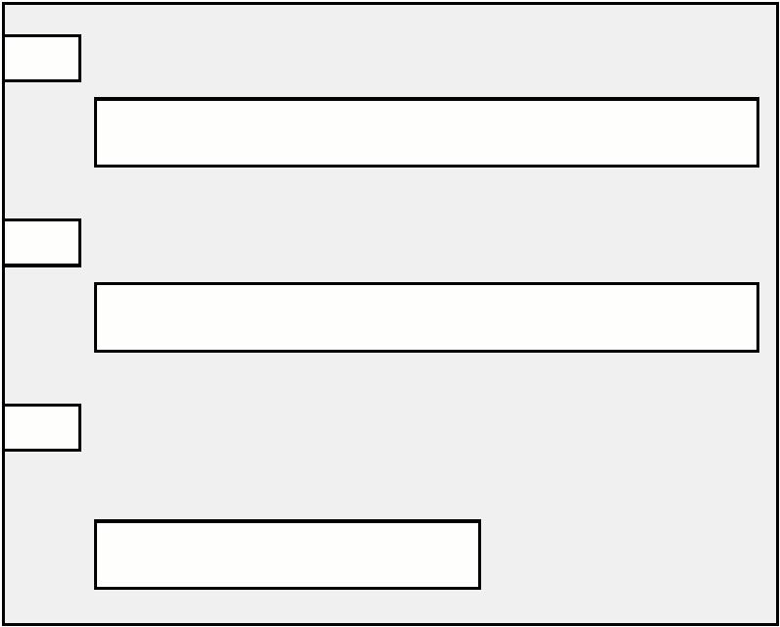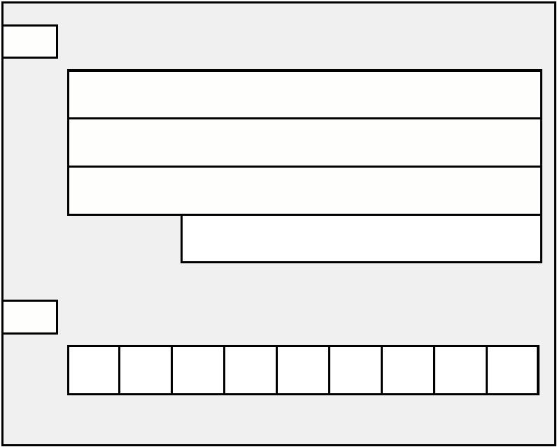

2

2

2

3 The date they died

26 If the funeral is not in the UK, in which

country will it take place?

DD/MM/YYYY

Please see the notes booklet. If the

funeral is not in one of the countries

shown, you cannot get help.

4 The date of funeral if known

DD/MM/YYYY

2

7 Did the person who has died have their

main home in the UK?

5 Will the funeral take place in the

United Kingdom (UK)?

No

We will contact you about this.

The UK is England, Scotland, Wales and

Northern Ireland.

Yes

No

Yes

1

0/22

4

SF200 Adult



About paying for the funeral

2

8 Have you or your partner taken

Their address

responsibility for the funeral expenses?

No

You will not be able to get Funeral

Expenses Payment.

Yes

Postcode

Please tell us why they have claimed

a Funeral Expenses Payment for

this person?

2

9 Is the signed contract or the final bill

for the funeral in either your name or

your partner’s name?

The contract is the signed agreement

between you and the funeral director.

No

Yes

If you ticked No, please say why you

are responsible for paying the bill.

For example, someone may have

made the arrangements on your

behalf because you were ill.

3

1 Has a Funeral Support Payment from

the Scottish Government been paid to

either you or someone else for

this funeral?

No

Yes

Please tell us about them.

Their full name

3

0 Has anyone else claimed a Funeral

Expenses Payment for this person?

Their date of birth

DD/MM/YYYY

No

Yes

Please tell us about them.

Their full name

Their National Insurance number

Their address

Their date of birth

DD/MM/YYYY

Their National Insurance number

Postcode

1

0/22

5

SF200 Adult

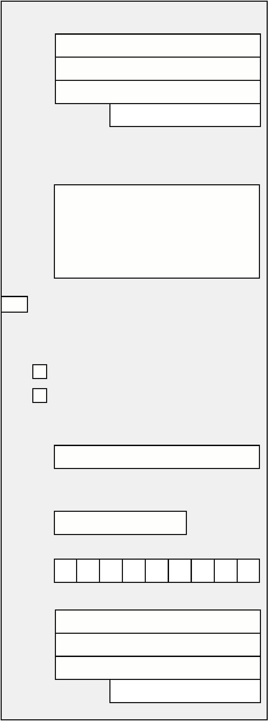

About benefits

3

2 Are you or your partner claiming any

of the following:

33 Are you or your partner waiting to hear

about a claim for any of the following:

•

•

•

•

Universal Credit

Income Support

income-based Jobseeker’s Allowance

income-related Employment and

Support Allowance

• Universal Credit

• Income Support

• income-based Jobseeker’s Allowance

• income-related Employment and

Support Allowance

•

•

Pension Credit

The disability or severe disability

element of Working Tax Credit

• Pension Credit

• The disability or severe disability

element of Working Tax Credit

•

•

•

Child Tax Credit

Housing Benefit

Support for Mortgage Interest.

• Child Tax Credit

• Housing Benefit

• Support for Mortgage Interest.

No

No

Yes

Yes

Please tell us which benefits you

are getting.

Please tell us which benefits you are

waiting to hear about.

If you or your partner are waiting

to hear about a claim for Housing

Benefit, do not wait until you hear

about the claim. Send this form

to us.

You will get a letter from the

council to tell you if you can get

Housing Benefit. Send this letter to

us as soon as you can.

If you or your partner are getting

Housing Benefit, send us the latest

award letter from the council which

shows your claim award details

for Housing Benefit. Send it with

this form.

Now go to question 34.

If you or your partner are

not getting, or waiting to

hear about a claim for any

of the above benefits, you

will not be able to get a

Funeral Expenses Payment.

1

0/22

6

SF200 Adult



About taking responsibility for the funeral

3

4 Was the person who died your partner

and living with you at the time of their

death? Or had you been living together

immediately before one or both of you

moved into a care home?

Please tell us why this person is

not claiming the Funeral Expenses

Payment.

By partner we mean:

•

a person you live with who is your

husband, wife or civil partner, or

•

a person you live with as if you are a

married couple.

3

3

7 Did the person who has died have any

other surviving parents or children?

No

Yes Go to question 133

Do not include yourself or any children of

the person who has died if Child Benefit is

still in payment for them.

3

3

5 Please tell us their relationship to you

For example, they were your son,

daughter, sister, brother, daughter-in-

law, father-in-law, step-parent, step-son,

step-daughter-in-law, close friend.

No Go to question 84

Yes

8 Had the relationship between the

person who has died and any of the

surviving parents or children

broken down?

6 Is there a surviving partner of the

person who has died?

No

No Go to question 37

Please tell us about the other

surviving parents or children on

questions 40 to 83. If you need more

space, please use a separate sheet

of paper. Remember to put your

full name and National Insurance

number on any separate sheet of

paper you use.

Yes

Please tell us about them.

Their full name

Their address

Yes

Tell us their full names

Postcode

1

0/22

7

SF200 Adult



3

9 Please tell us how the family

relationship had broken down and for

how long.

41 Their address

Postcode

4

4

2 Their relationship to the person who

has died

3 Their date of birth

DD/MM/YYYY

4

4

4 Their National Insurance number,

if you know it

5 Do they get a qualifying benefit?

Please see the notes booklet.

No

If they do not get a qualifying benefit,

do they live in a local authority

or local government funded care

establishment where they pay the

costs either in full or partly?

Do not know

We will contact you about this.

No

Yes

Please tell us about any other surviving

parents or children of the person who

has died. It is important that you give

us as much information as possible.

Yes

Please tell us which benefits they are

getting. If you do not know, write ‘Do

not know’ in the box.

Parent or child 1

0 Their full name

4

1

0/22

8

SF200 Adult



4

6 Did they keep in touch with the person

who has died?

Parent or child 2

If the person who had died did not have

any other surviving parents or children

please go to question 84.

No

Yes

How often did they keep in touch?

5

1 Their full name

How did they keep in touch?

For example, by visit, telephone

or letter.

52 Their address

4

4

4

7 Did they give domestic or caring help to

the person who has died?

Postcode

No

5

5

3 Their relationship to the person who

has died

Yes

8 Did they go on social outings or

holidays with the person who has died?

No

4 Their date of birth

DD/MM/YYYY

Yes

9 Was the contact they had with the

person who has died limited because

of work or domestic responsibilities?

55 Their National Insurance number,

if you know it

No

Yes

5

0 Tell us anything else about their

relationship with the person who has

died that might be relevant

1

0/22

9

SF200 Adult



5

6 Do they get a qualifying benefit?

60 Was the contact they had with the

person who has died limited because

of work or domestic responsibilities?

Please see the notes booklet.

Yes

No

Please tell us which benefits they are

getting. If you do not know, write ‘Do

not know’ in the box.

Yes

6

1 Tell us anything else about their

relationship with the person who has

died that might be relevant

No

If they do not get a qualifying

benefit, are they resident in a care

establishment and their expenses are

met in whole or in part by the local

authority or local government?

Do not know

We will contact you about this.

No

Yes

Parent or child 3

5

7 Did they keep in touch with the person

who has died?

If the person who had died did not have

any other surviving parents or children

please go to question 84.

No

Yes

How often did they keep in touch?

62 Their full name

How did they keep in touch?

For example, by visit, telephone

or letter.

6

3 Their address

5

5

8 Did they give domestic or caring help

to the person who has died?

Postcode

No

6

4 Their relationship to the person who

has died

Yes

9 Did they go on social outings or

holidays with the person who has died?

No

65 Their date of birth

DD/MM/YYYY

Yes

1

0/22

10

SF200 Adult

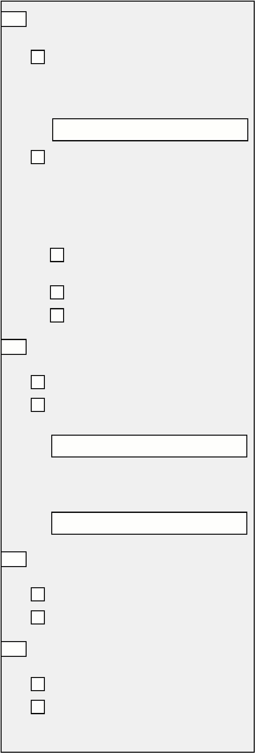

6

6

6 Their National Insurance number,

if you know it

70 Did they go on social outings or

holidays with the person who has died?

No

Yes

7 Do they get a qualifying benefit?

7

7

1 Was the contact they had with the

person who has died limited because of

work or domestic responsibilities?

Please see the notes booklet.

Yes

Please tell us which benefits they are

getting. If you do not know, write ‘Do

not know’ in the box.

No

Yes

2 Tell us anything else about their

relationship with the person who has

died that might be relevant

No

If they do not get a qualifying

benefit, are they resident in a care

establishment and their expenses are

met in whole or in part by the local

authority or local government?

Do not know.

We will contact you about this.

No

Yes

6

8 Did they keep in touch with the person

who has died?

No

Parent or child 4

Yes

How often did they keep in touch?

If the person who had died did not have

any other surviving parents or children

please go to question 84.

How did they keep in touch?

For example, by visit, telephone

or letter.

73 Their full name

7

4 Their address

6

9 Did they give domestic or caring help to

the person who has died?

No

Yes

Postcode

1

0/22

11

SF200 Adult

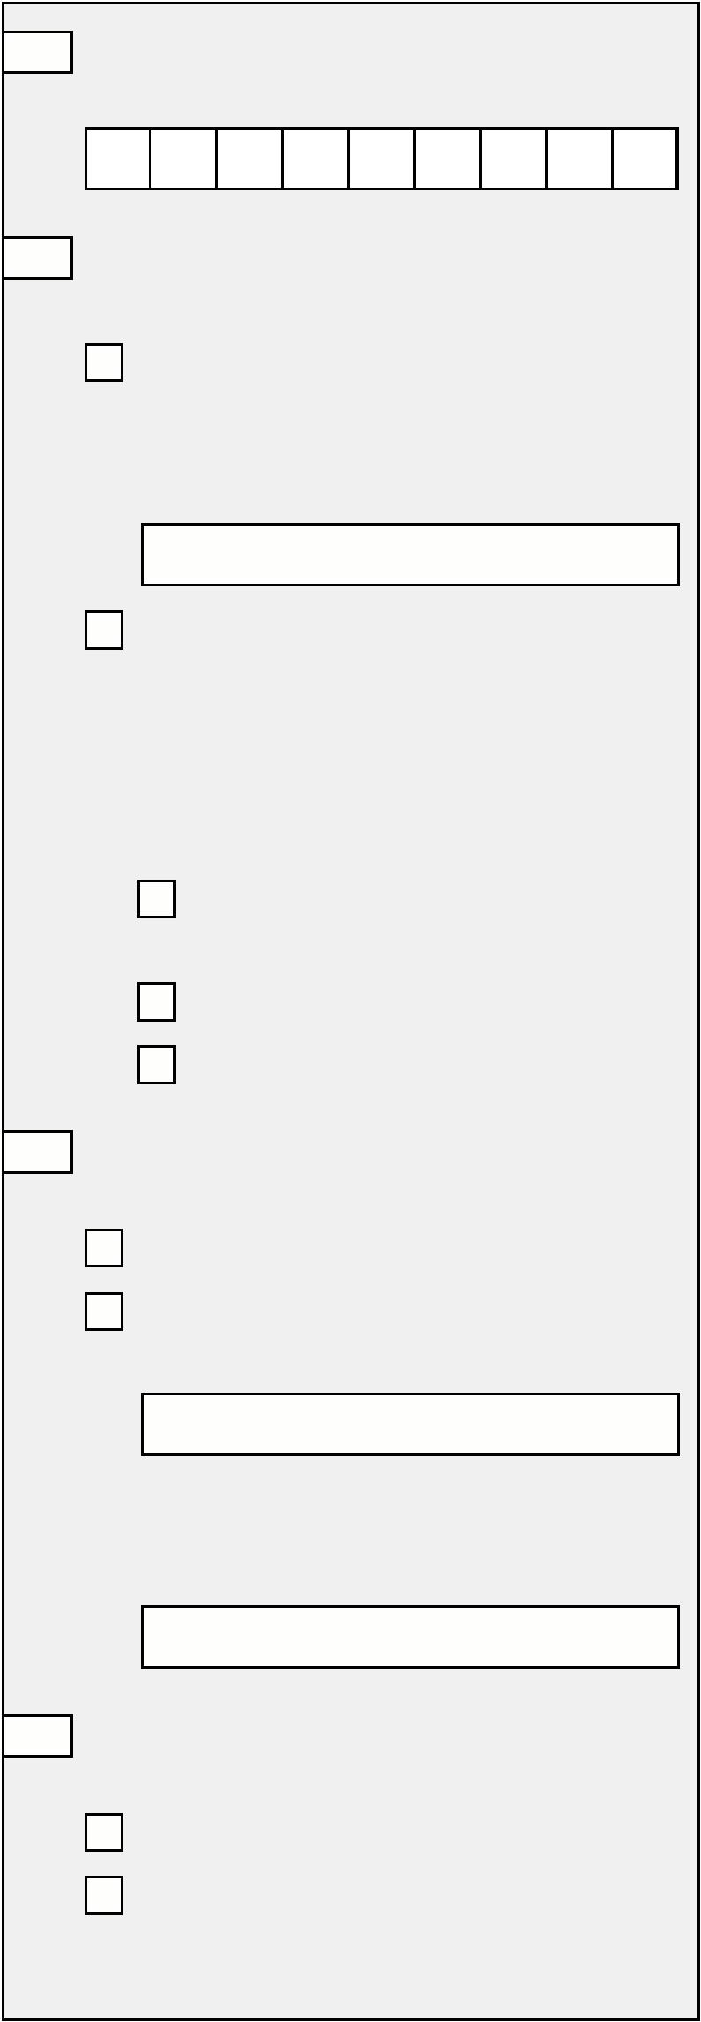

7

7

5 Their relationship to the person who

has died

How did they keep in touch?

For example, by visit, telephone

or letter

6 Their date of birth

8

8

0 Did they give domestic or caring help to

the person who has died?

DD/MM/YYYY

No

Yes

7

7

7 Their National Insurance number,

if you know it

1 Did they go on social outings or

holidays with the person who has died?

No

8 Do they get a qualifying benefit?

Yes

Please see the notes booklet.

No

82 Was the contact they had with the

person who has died limited because of

work or domestic responsibilities?

If they do not get a qualifying

benefit, are they resident in a care

establishment and their expenses are

met in whole or in part by the local

authority or local government?

No

Yes

Do not know

We will contact you about this

8

3 Tell us anything else about their

relationship with the person who has

died that might be relevant

No

Yes

Yes

Please tell us which benefits they are

getting. If you do not know, write ‘Do

not know’ in the box.

7

9 Did they keep in touch with the person

who has died?

No

Yes

How often did they keep in touch?

1

0/22

12

SF200 Adult



8

4 Did the person who has died have any

other surviving close relatives?

89 Their National Insurance number,

if you know it

Do not include yourself even if you are a

close relative. Include your partner if you

have one.

9

0 Do they get a qualifying benefit?

By other close relative we mean a:

Please see the notes booklet.

•

father-in-law, mother-in-law or step-

parent

No

•

•

son-in-law, step-son, or step-son-in-law

daughter-in-law, step-daughter or step-

daughter-in-law

Yes

Please tell us which benefits they are

getting. If you do not know, write

•

•

brother or brother-in-law

sister or sister-in-law.

‘

Do not know’ in the box

No Go to question 133

Yes

91

Did they keep in touch with the person

who has died?

Please answer the following

questions.

No

Tell us about any other surviving close

relatives of the person who has died. It

is important that you give us as much

information as possible.

Yes

How often did they keep in touch?

How did they keep in touch?

For example, by visit, telephone

or letter.

Close relative 1

5 Their full name

8

8

9

9

2 Did they give domestic or caring help to

the person who has died?

6 Their address

No

Yes

3 Did they go on social outings or

holidays with the person who has died?

Postcode

No

8

8

7 Their relationship to the person who

has died

Yes

8 Their date of birth

DD/MM/YYYY

1

0/22

13

SF200 Adult



9

9

4 Was the contact they had with the

person who has died limited because of

work or domestic responsibilities?

100 Their National Insurance number,

if you know it

No

Yes

101 Do they get a qualifying benefit?

Please see the notes booklet.

5 Tell us anything else about their

relationship with the person who has

died that might be relevant

No

Yes

Please tell us which benefits they are

getting. If you do not know, write

‘

Do not know’ in the box

1

02 Did they keep in touch with the person

who has died?

No

Yes

How often did they keep in touch?

Close relative 2

If the person who had died did not have

any other surviving close relatives, please

go to question 133.

How did they keep in touch?

For example, by visit, telephone

or letter.

9

9

6 Their full name

1

1

1

03 Did they give domestic or caring help to

the person who has died?

7 Their address

No

Yes

04 Did they go on social outings or

holidays with the person who has died?

Postcode

No

9

9

8 Their relationship to the person who

has died

Yes

05 Was the contact they had with the

person who has died limited because of

work or domestic responsibilities?

9 Their date of birth

No

DD/MM/YYYY

Yes

1

0/22

14

SF200 Adult



1

06 Tell us anything else about their

relationship with the person who has

died that might be relevant

112 Do they get a qualifying benefit?

Please see the notes booklet.

No

Yes

Please tell us which benefits they are

getting. If you do not know, write

‘

Do not know’ in the box

1

13 Did they keep in touch with the person

who has died?

No

Close relative 3

Yes

How often did they keep in touch?

If the person who had died did not have

any other surviving close relatives, please

go to question 133.

How did they keep in touch?

For example, by visit, telephone

or letter.

1

1

07 Their full name

08 Their address

1

1

1

14 Did they give domestic or caring help

to the person who has died?

No

Yes

Postcode

15 Did they go on social outings or

holidays with the person who has died?

1

1

09 Their relationship to the person who

has died

No

Yes

16 Was the contact they had with the

person who has died limited because

of work or domestic responsibilities?

10 Their date of birth

DD/MM/YYYY

No

Yes

1

11 Their National Insurance number,

if you know it

1

0/22

15

SF200 Adult



1

17 Tell us anything else about their

relationship with the person who has

died that might be relevant

123 Do they get a qualifying benefit?

Please see the notes booklet

No

Yes

Please tell us which benefits they are

getting. If you do not know, write

‘

Do not know’ in the box

1

24 Did they keep in touch with the person

who has died?

No

Close relative 4

Yes

How often did they keep in touch?

If the person who had died did not have

any other surviving close relatives, please

go to question 133.

How did they keep in touch?

For example, by visit, telephone

or letter.

1

1

18 Their full name

19 Their address

1

1

1

25 Did they give domestic or caring help to

the person who has died?

No

Yes

Postcode

26 Did they go on social outings or

holidays with the person who has died?

1

1

20 Their relationship to the person who

has died

No

Yes

27 Was the contact they had with the

person who has died limited because of

work or domestic responsibilities?

21 Their date of birth

DD/MM/YYYY

No

Yes

1

22 Their National Insurance number,

if you know it

1

0/22

16

SF200 Adult



1

28 Tell us anything else about their

relationship with the person who has

died that might be relevant

131 Did you or your partner go on social

outings or holidays with the person

who has died?

No

Yes

1

1

32 Was the contact you or your partner

had with the person who has died

limited because of work or

domestic responsibilities?

No

Yes

Please tell us why you or your partner,

rather than anyone else, are taking

responsibility for the funeral expenses.

We need to decide if this is reasonable.

To do this we need to look at the kind of

relationship you or your partner had with

the person who has died.

33 Please tell us anything else about your

relationship with the person who has

died that might be relevant

1

29 Did you or your partner keep in touch

with the person who has died?

No

Yes

How often did you keep in touch?

How did you keep in touch?

For example, by visit, phone or letter.

1

30 Did you or your partner give domestic

or caring help to the person who

has died?

If you have any more information that

might be relevant, tell us in question 158

Other information.

No

Yes

1

0/22

17

SF200 Adult



About the funeral

Although we will not be able to decide if you can get a Funeral Expenses

Payment until we have received the signed contract of the final bill for the

funeral, you should make your claim straight away.

Remember to tell the funeral director, if you have one, that you are claiming

a Funeral Expenses Payment and that we will contact them about payment

into their bank account.

1

34 Have you used a funeral director to

arrange the funeral?

136 Do you have any other bills for things

not included on the funeral estimate

or bill?

No Go to question 136

Please send us any invoices

or receipts you have from

arranging the funeral.

For example, flowers or a wreath.

No

Yes

Yes

Please tell us what they are for.

Please tell us their details.

Name of the funeral director

How much did you pay?

Please send your receipts with this

form, if you have them.

Their address

1

37 Did you have any travel expenses to

arrange or to attend the funeral?

Postcode

We may be able to pay for either:

•

one return journey to arrange

the funeral, or

A phone number we can contact

them on, if you know it

•

one return journey to go to the funeral.

No

Yes

1

35 Can we get in touch with the funeral

director for more information?

No

Yes

1

0/22

18

SF200 Adult

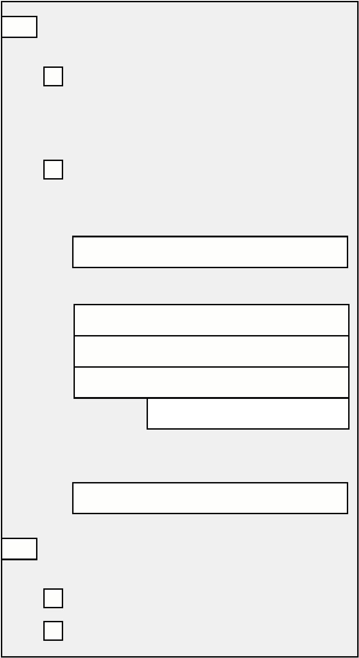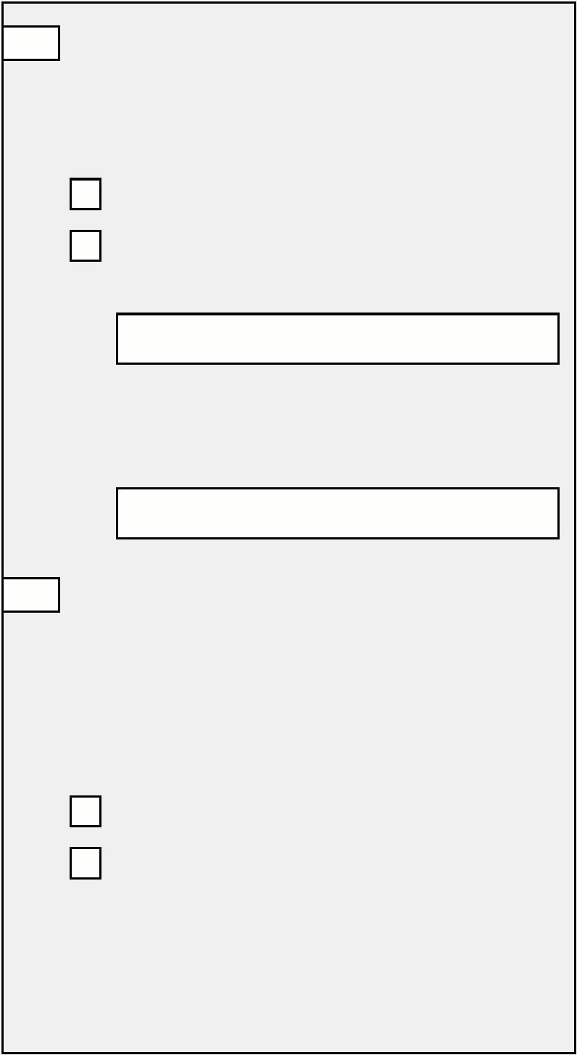

Why are you claiming travel expenses?

Please tick one box.

138 Did you need additional death

certificates or other documents to

release insurance or other money of

the person who has died?

To arrange the funeral

To go to the funeral

For example, a full death certificate.

No

How did you travel?

For example, by car, bus or train.

Yes

Was this to release an insurance

policy or other money of the person

who has died?

How much did you have to pay?

No

Yes

Please send your tickets or receipts

with this form, if you have them.

You must remember to send us all

the documents we ask for. If you

do not, your claim may be delayed.

About the estate

We need to know about the money, savings

and property of the person who has died.

These are sometimes called the assets.

This is when you need to apply to an office

of the court to get a document giving you

permission to collect any assets, pay any debts

and to distribute any remaining assets.

We also need to know who is sorting out the

financial affairs, the assets and the bills, of the You apply for probate or, in Scotland,

person who has died.

confirmation as executor-nominate, if the

person who has died left a will.

We will also need to know if you have applied

for grant of probate, letters of administration

or, in Scotland, confirmation.

You apply for letters of administration or, in

Scotland, confirmation as executor-dative, if

the person who has died did not leave a will.

1

39 Have you already applied for grant of

representation, letters of

Their name

administration or confirmation, or have

you instructed a solicitor to apply on

your behalf?

Their address

No

Yes

Who has applied?

Postcode

You

Your solicitor

Please tell us about them.

A phone number we can contact them

on, if you know it

1

0/22

19

SF200 Adult

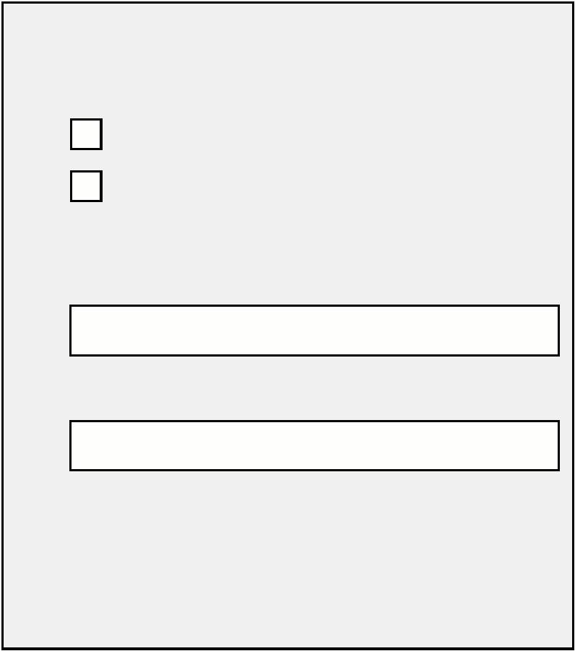

You should tell your solicitor about

your claim for a Funeral Expenses

Payment. We will get in touch

with them about anything that

we pay you.

Their address

Postcode

1

1

40 If you have not already applied for

grant of probate, letters of

Their phone number, if you know it

administration or confirmation, do you

intend to apply, or instruct a solicitor

to apply on your behalf?

No

You should tell them about your

claim for a Funeral Expenses

Payment. We will get in touch

with them about anything that

we pay you.

Yes

41 Is someone else sorting out the

financial affairs of the person who

has died?

No

Yes

Please tell us about them.

Their full name

About money available or due to pay for the funeral

If there is any money available to help pay

for the funeral, we will take this into account

This is in recognition that the total cost of a

funeral may be greater than the value of the

when we work out how much Funeral Payment Funeral Expenses Payment.

we can pay you. Do not include any of your

personal savings.

Remember, money belonging to the person

who has died will sometimes be released to

pay for the funeral if you apply for it. This

can even apply before probate or letters of

administration, or, in Scotland, confirmation,

have been granted.

Any assets of the person who has died must

be used to pay the funeral bill before any

other bills are paid.

We will not take into account any arrears

of benefit or any lump sum Bereavement

Payment. We will also not take into account

any contributions from charities, friends or

relatives towards the cost of the funeral.

1

0/22

20

SF200 Adult

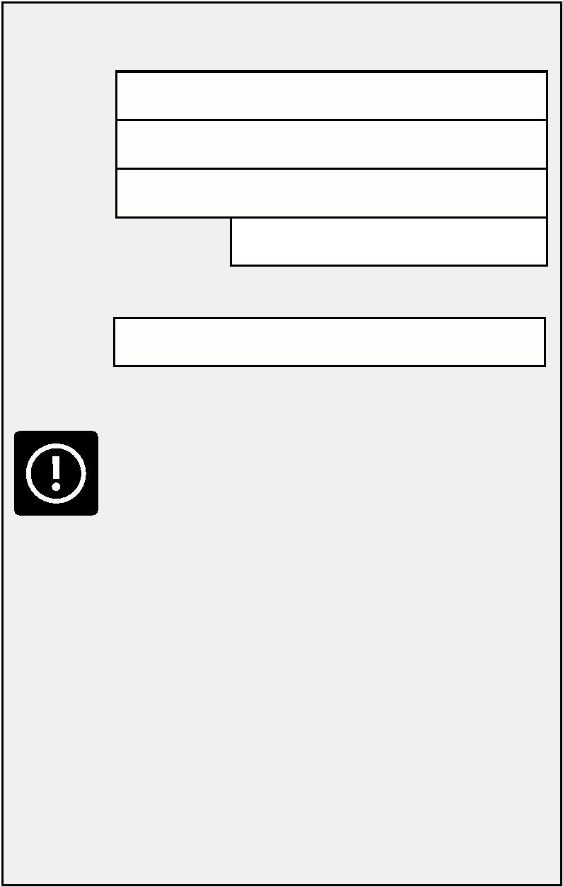

1

42 Is there any money available or due to

you or a member of your family to pay

for the funeral?

Were any of the savings in a joint

account?

No

By your family we mean your partner or

any children or qualifying young persons

living in your household who you are

responsible for.

Yes

Please tell us how much.

We use child to mean a person aged

under 16 who you are getting Child

Benefit for.

Please send us the last bank statement.

We use qualifying young person to mean

a person aged 16, 17, 18 or 19 who you

are getting Child Benefit for.

Have the savings been transferred to the

other joint account holder?

No

No Go to question 152

Yes

Yes

How much was transferred?

Please answer all the following

questions.

1

43 Is there any cash belonging to the

person who has died?

145 Is there any money in an ISA?

Do not know

We will contact you about this.

Do not know

We will contact you about this.

No

No

Yes

Yes

Please tell us how much.

Please tell us how much.

1

46 Is there any money from

insurance policies?

1

44 Is there any money in accounts at date

of death?

Do not know

We will contact you about this.

For example, in a bank, building society,

credit union or post office card account.

Please send us final statements

from the accounts of the person who

has died.

No

Yes

Please tell us how much.

Do not know

We will contact you about this.

No

Yes

Please tell us how much.

1

0/22

21

SF200 Adult

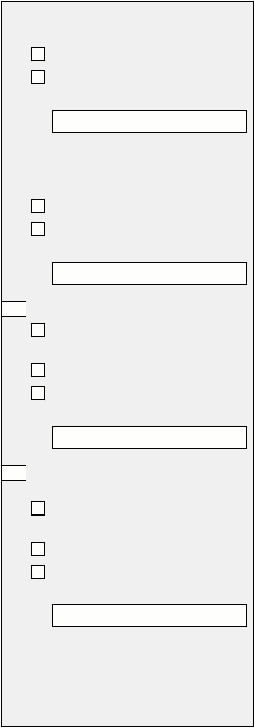

1

47 Is there any money from an

occupational pension scheme?

Can we get in touch with the plan

provider if we need more information?

Do not know

No

We will contact you about this.

Yes

No

1

50 Is there any other money available to

pay for the funeral?

Yes

Please tell us how much.

Do not include any of your personal

savings.

Do not know

1

48 Is there any money from a burial club?

We will contact you about this.

No

Do not know

We will contact you about this.

Yes

Please tell us how much.

No

Yes

Please tell us how much.

Where did this money come from?

1

49 Is there any money from a prepaid

funeral plan?

1

51 Has anyone claimed a War Pension

Funeral Grant for the person who

has died?

Do not know

We will contact you about this.

Do not know

We will contact you about this.

No

No

Yes

Please tell us how much.

Yes

If there has been a payment, tell

us how much.

Has the funeral plan been paid for and

does it meet some or all of the funeral

costs?

You must remember to send us all

the documents we ask for. If you

do not, your claim may be delayed.

No

Yes

Please send us a copy of the original plan

and any documents you have received

from the funeral plan provider showing

the items and services that the plan

provides for this funeral.

1

0/22

22

SF200 Adult

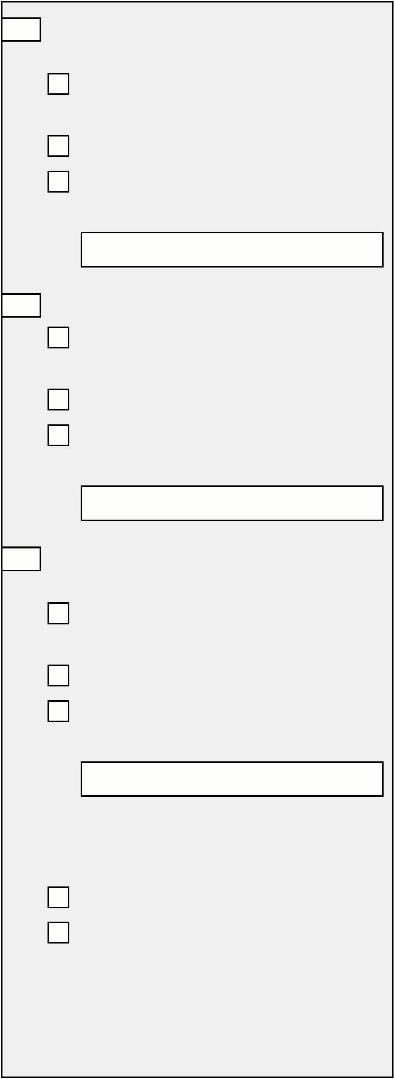

Making payment

We usually pay the funeral director. But if you have already paid all of the

funeral director’s bill, or if you have not used a funeral director, we will pay

you. Please see the notes booklet.

1

52 Have you already paid the funeral bill?

What date was it paid?

DD/MM/YYYY

No Go to Question 158

Yes Did you pay the full

funeral bill?

How much was paid?

No

Yes

If you paid the funeral bill in part,

who else paid part of the bill?

Did you pay part of the

funeral bill?

No

How was the bill paid?

Yes

How we pay you

We normally pay your money direct into

What to do now

an account

•

Tell us about the account you want to use

on the next page. By giving us your account

details you:

Many banks and building societies will let you

collect your money at the post office. We will

tell you when your payment will be made and

how much it will be for.

- agree that we will pay you into an account,

and

-

understand what we have told you above

• If you are going to open an account, please

tell us your account details as soon as you

get them.

Finding out how much we have paid into

your account

You can check your payments on account

statements. The statements may show your

National Insurance number next to any

payments we have made. If you think your

payment is wrong, tell the office that pays you

straight away.

•

If you do not have an account, and do not

intend to open one, please tick the box and

we will contact you.

Fill in the rest of this form. You do

not have to wait until you have

opened an account or contacted us.

1

0/22

23

SF200 Adult

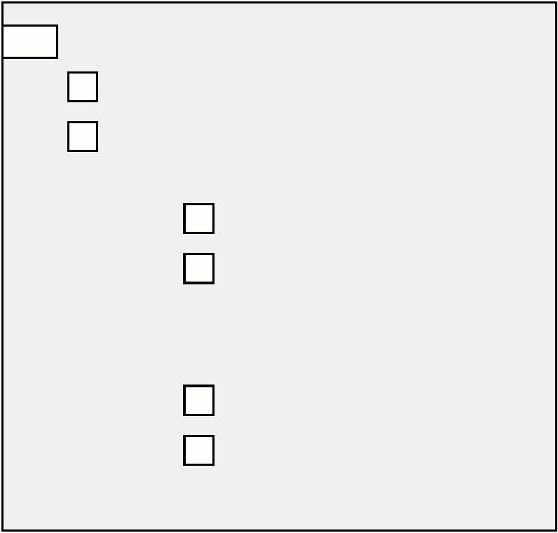

About the account you want to use

Please tell us your account details below.

• You can use an account in your name, or a

joint account

It is very important you fill in all the boxes

correctly, including the building society

roll or reference number, if you have one.

If you tell us the wrong account details

your payment may be delayed or you may

lose money.

•

You can use someone else’s account if:

-

the terms and conditions of their account

allow this, and

-

-

they agree to let you use their account, and

you are sure they will use your money in the

way you tell them

•

•

You can use a credit union account. You must

tell us the credit union’s account details. Your

credit union will be able to help you with this.

If you are an appointee or a legal

representative acting on behalf of the

claimant, the account should be in your

name only.

You can find the account details on your

chequebook or bank statements. If you do

not know the account details, ask the bank or

building society.

1

53 Name of the account holder

Please tell us the name of the account holder exactly as it is shown on the

chequebook or statement.

1

1

54 Full name of the bank or building society

55 Sort code

Tell us all 6 numbers, for example 12-23-56.

—

—

1

1

56 Account number

Most account numbers are 8 numbers long. If your account number has fewer

than 10 numbers, please fill in the numbers from the left.

57 Building society roll or reference number

If you are using a building society account you may need to tell us a roll or reference

number. This may be made up of letters and numbers, and may be up to 18 characters

long. If you are not sure if the account has a roll or reference number, ask the

building society.

1

0/22

24

SF200 Adult

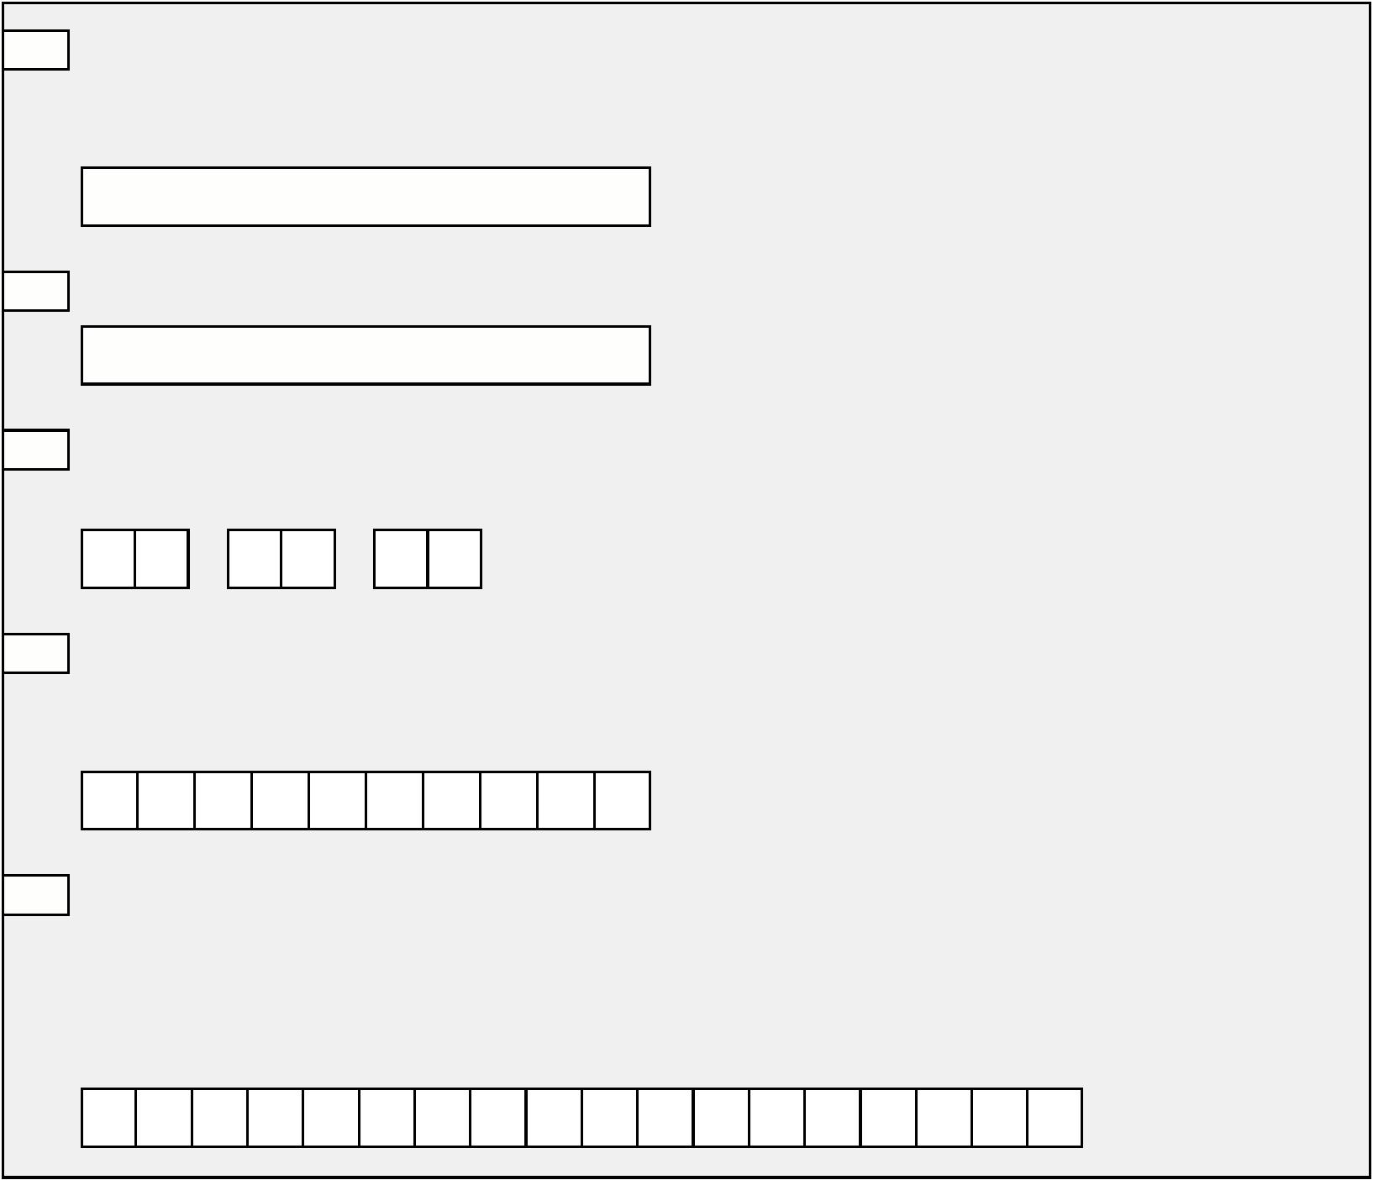

Other information

1

58 Please use this space to tell us anything else you think we might need to know.

If there is not enough space, please use a separate sheet of paper. Make sure that you put

your full name and NI number on each separate sheet of paper you use.

1

0/22

25

SF200 Adult



For people filling in and signing this form for someone else

If you are filling in this form for yourself, please do not fill in question 159

and please go to the declaration on page 26.

1

59 Please tell us why you are filling in and

signing this form for someone else

Your address

I am sending a letter signed by the

claimant with this form. The letter

tells you that they agree to me

making the claim for them.

Postcode

I am their appointee

A phone number we can contact you on,

if you have one.

I have power of attorney

Your full name

Now sign the declaration below.

Your date of birth

DD/MM/YYYY

Declaration

I agree that the information I have given

is complete and correct. If I give wrong or

incomplete information, or I do not report

changes straight away, I may:

Your signature

•

•

•

be prosecuted

need to pay a financial penalty

be paid too much Funeral Expenses Payment

and have to pay back any money that I am

not entitled to

Date

DD/MM/YYYY

If you pay me less than you should, you

may pay me the money that you owe me.

I understand that if I have provided a

signed contract or funeral bill, I must let

the department know straight away if any

later changes are made to this contract.

The contract is the signed agreement

between you and the funeral director.

1

0/22

26

SF200 Adult

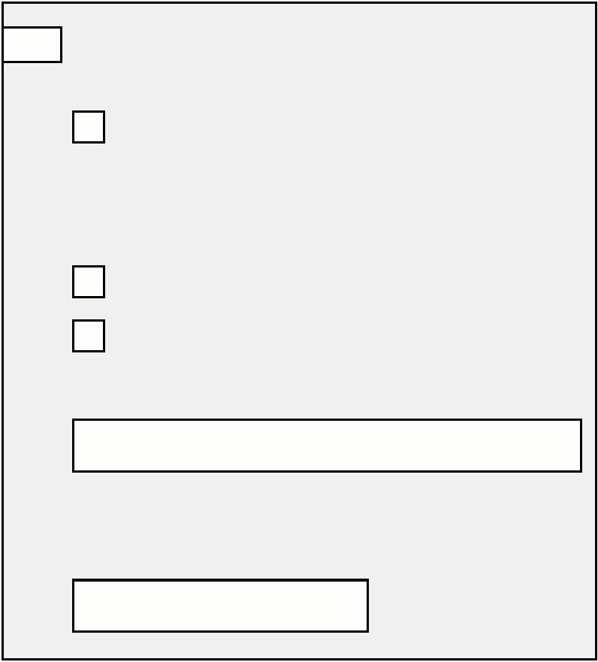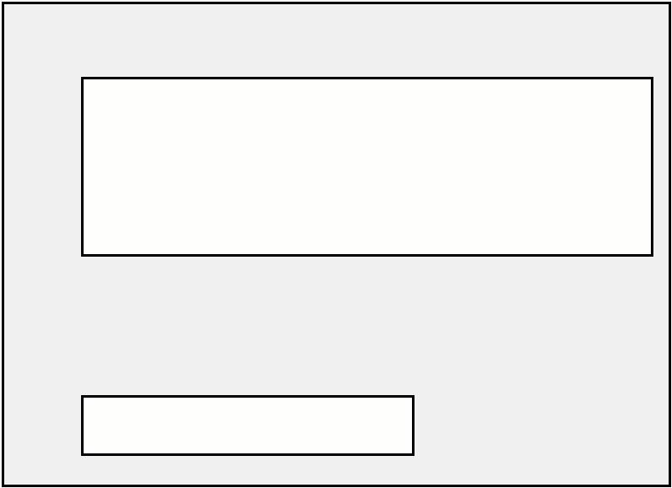

What to do now

How the DWP collects and uses

information

Please check that you have done everything

you need to and are sending all the

documents we have asked for. Use the

checklist below.

When we collect information about you we

may use it for any purposes.

These include:

•

•

•

social security benefits and allowances

child maintenance

investigating and prosecuting tax credits

offences

private pensions policy, and

retirement planning

•

Have you answered all the questions that

apply to you?

Have you signed and dated this form?

If you have the funeral director’s bill or the

signed contract, have you sent it to us?

•

•

•

•

We cannot accept estimated bills. If you

do not have the final bill or signed contract

yet, please send it to us as soon as possible.

Make sure that the final bill or signed

contract has your name, address and NI

number written on it.

We may get information about you from

other parties for any of our purposes as the

law allows to check the information you

provide and improve our services. We may give

information about you to other organisations

as the law allows, for example to protect

against crime.

•

•

•

If the bill has already been paid, have you

told us about the money you have used to

pay the bill in question 142 of this form?

Have you sent any other bills or receipts you

may have in connection with this claim? For

example, for things like flowers.

If the person who has died had a prepaid

funeral plan, have you sent the documents

we have asked for in question 149 of

this form?

To find out more about our purposes, how we

use personal information for those purposes

and your information rights, including how to

request a copy of your information, please visit

DWP Personal Information Charter at

[www.gov.uk](https://www.gov.uk/dwp/personal-information-charter)/dwp/personal-information-charter

•

If you have had to pay for any documents to

release money of the person who has died,

have you sent us the bill or receipt?

What to do with this form and any

documents we have asked for

Send it by post to:

Freepost DWP Funeral Payments

Take it to:

your local Jobcentre Plus.

1

0/22

27

SF200 Adult



1

0/22

28

SF200 Adult