Customer Churn Analysis
Technical Report
Prepared by: Kartik Singh
B.Tech IT (AI & Robotics), MITS Gwalior
Capstone Project — Week 8

Table of Contents
1. Introduction & Business Problem
2. Dataset & Methodology
3. Data Cleaning & Quality
4. Exploratory Data Analysis
5. Statistical Hypothesis Testing
6. Predictive Modeling
7. Findings & Business Recommendations
8. Implementation Plan & Conclusion

1. Introduction & Business Problem
Customer churn — the rate at which customers stop doing business with a company — is one of the most direct threats to recurring revenue in subscription-based businesses such as telecom. Acquiring a new customer typically costs several times more than retaining an existing one, making churn reduction a high-leverage lever for profitability.
This project analyzes a 500-customer telecom dataset to answer three core business questions:
- Which customer segments and behaviors are most associated with churn?
- Are these relationships statistically significant, or could they be due to chance?
- Can we build a reliable model to flag at-risk customers before they churn?
Success is measured by: (a) identifying statistically validated churn drivers, (b) building a model with strong discriminative power (ROC-AUC), and (c) translating findings into a concrete, actionable retention plan.

2. Dataset & Methodology
The dataset contains 500 customer records with 9 original fields: CustomerID, Tenure (months), MonthlyCharges, TotalCharges, Contract type, PaymentMethod, PaperlessBilling, SeniorCitizen flag, and the target variable Churn (0/1).
500  Total Records | 9  Features | 10.6%  Churn Rate | 0  Missing Values

Methodology followed a standard end-to-end analytics workflow: data cleaning and quality validation, exploratory data analysis (EDA), statistical hypothesis testing, and predictive modeling with two complementary algorithms (Logistic Regression and Random Forest) to cross-validate findings.

3. Data Cleaning & Quality
The raw dataset was assessed for missing values, duplicates, invalid ranges, and inconsistent categories. Results:
- No missing values across any column.
- No duplicate rows or duplicate CustomerIDs.
- All numeric fields (Tenure, MonthlyCharges, TotalCharges) fell within sane, non-negative ranges.
- Categorical fields (Contract, PaymentMethod) had clean, consistent labels.
Two derived features were engineered to support analysis: PaperlessBilling_Flag (binary encoding) and AvgMonthlySpend (TotalCharges / Tenure), which normalizes spend across customers with different tenures.

4. Exploratory Data Analysis

4.1 Churn Distribution
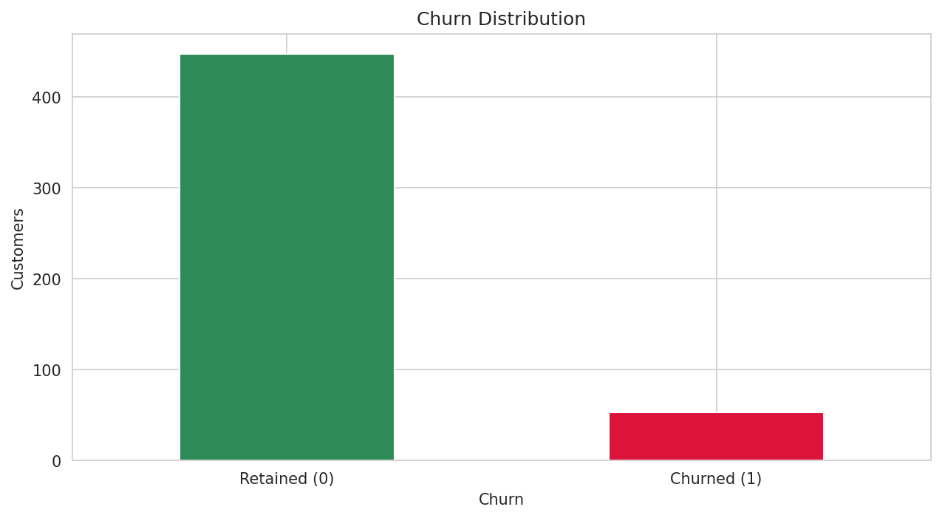
Figure 1: Class distribution — churn is a minority class (10.6%), motivating balanced-class modeling.

4.2 Numeric Feature Distributions
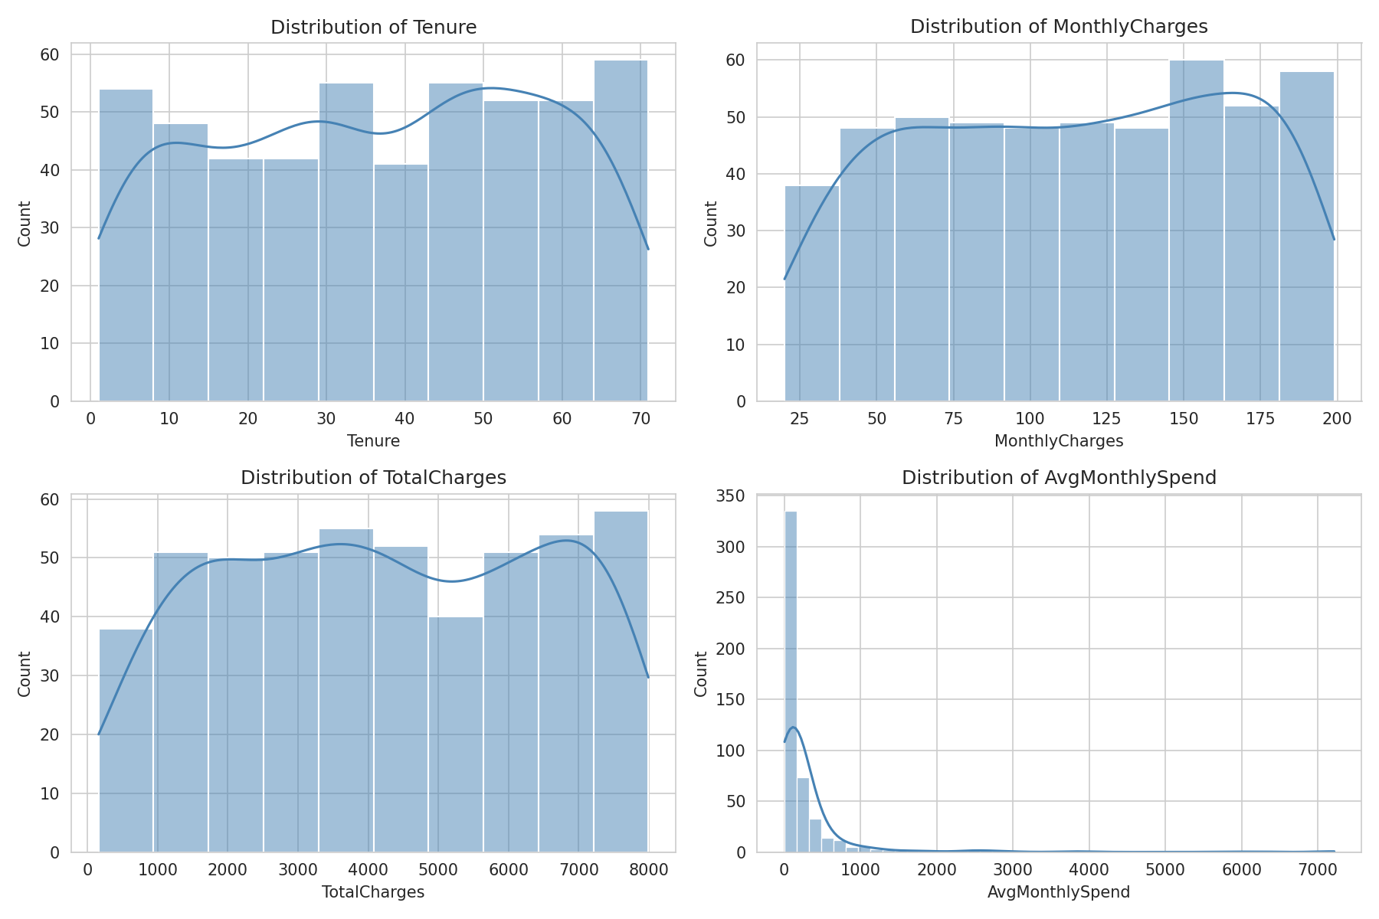
Figure 2: Distributions of Tenure, MonthlyCharges, TotalCharges, and AvgMonthlySpend.

4.3 Churn Rate by Segment
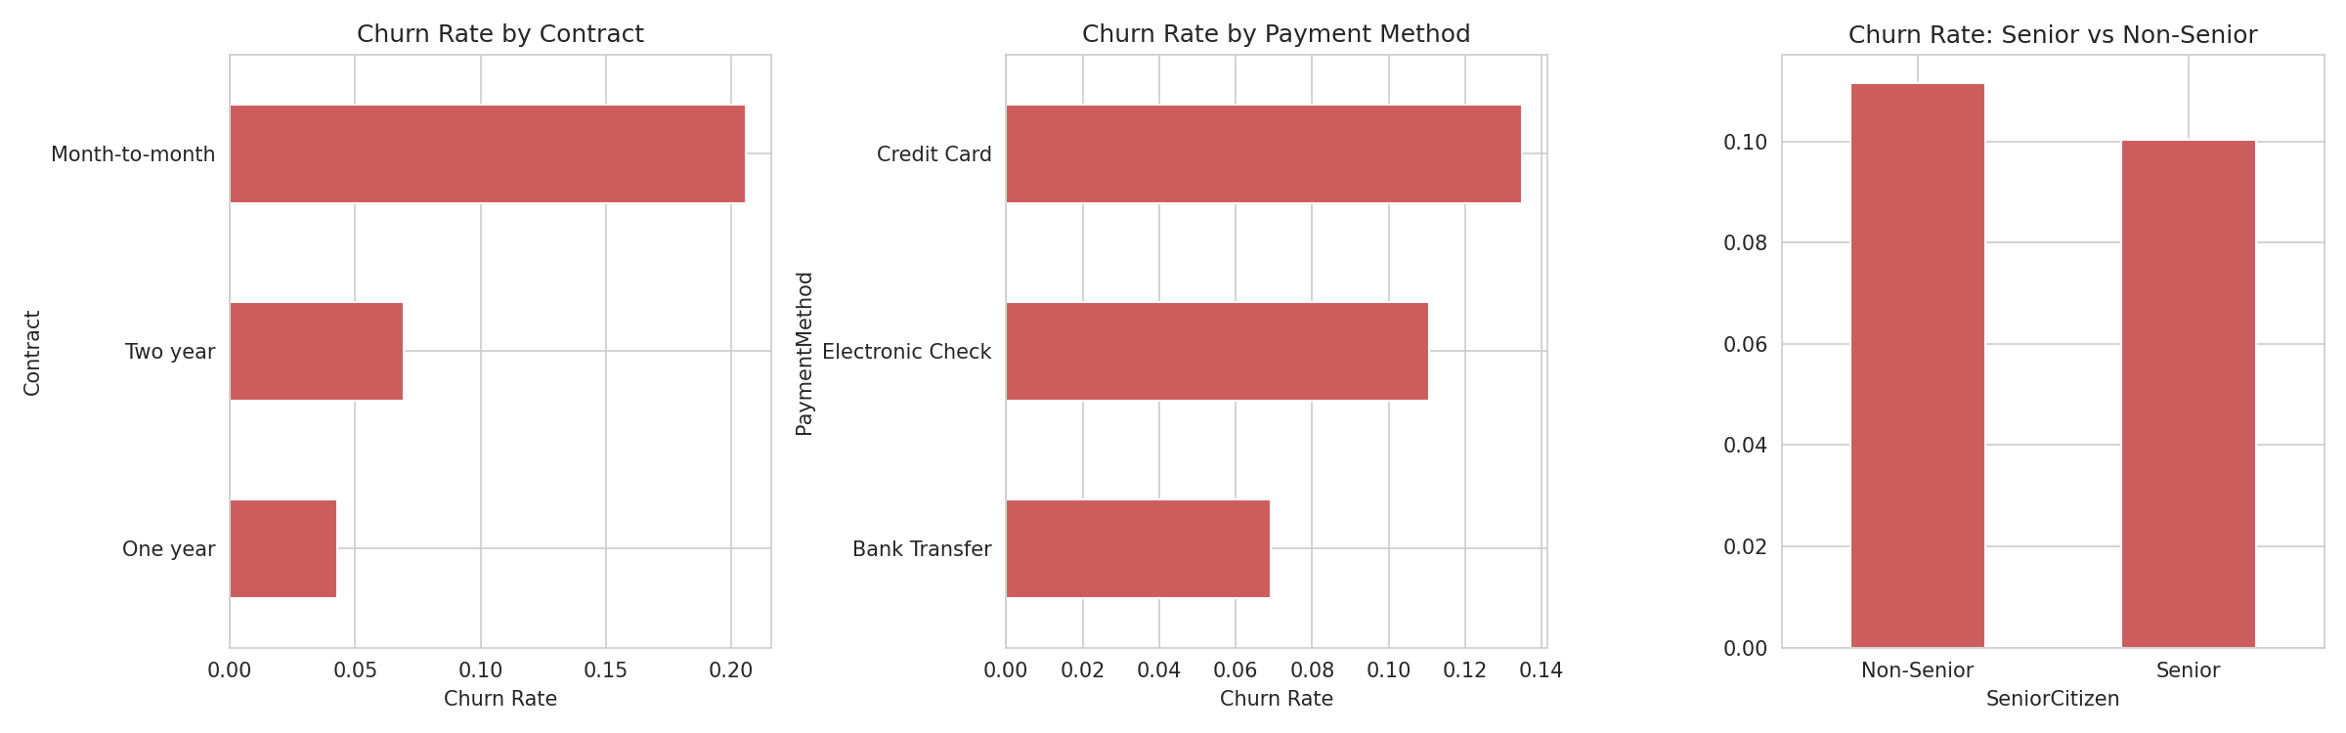
Figure 3: Churn rate by contract type, payment method, and senior-citizen status.
Month-to-month customers churn at 20.6%, versus 6.9% for two-year and 4.3% for one-year contracts — the largest gap of any segment examined.

4.4 Numeric Features vs Churn
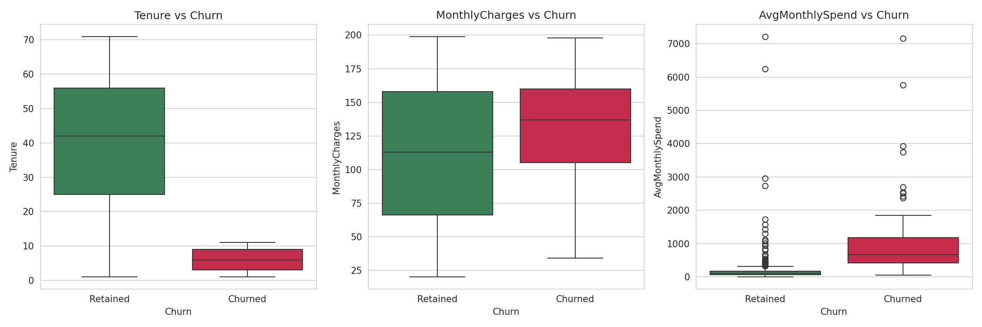
Figure 4: Tenure, MonthlyCharges, and AvgMonthlySpend compared between churned and retained customers.

4.5 Correlation Analysis
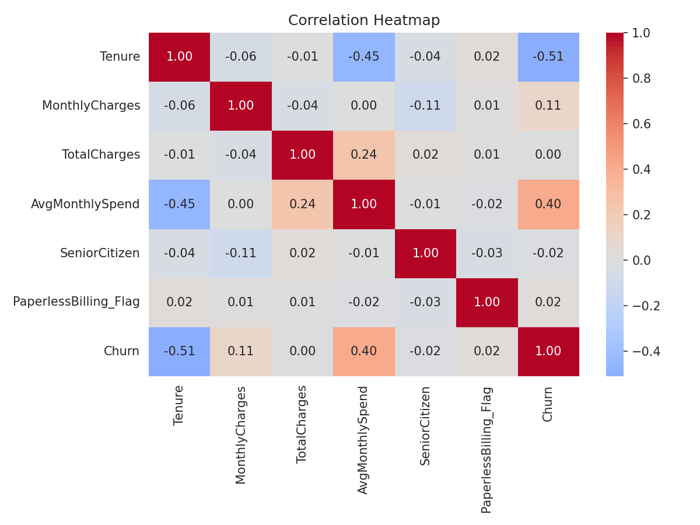
Figure 5: Correlation heatmap across numeric features and the churn target.

4.6 Tenure vs Monthly Charges
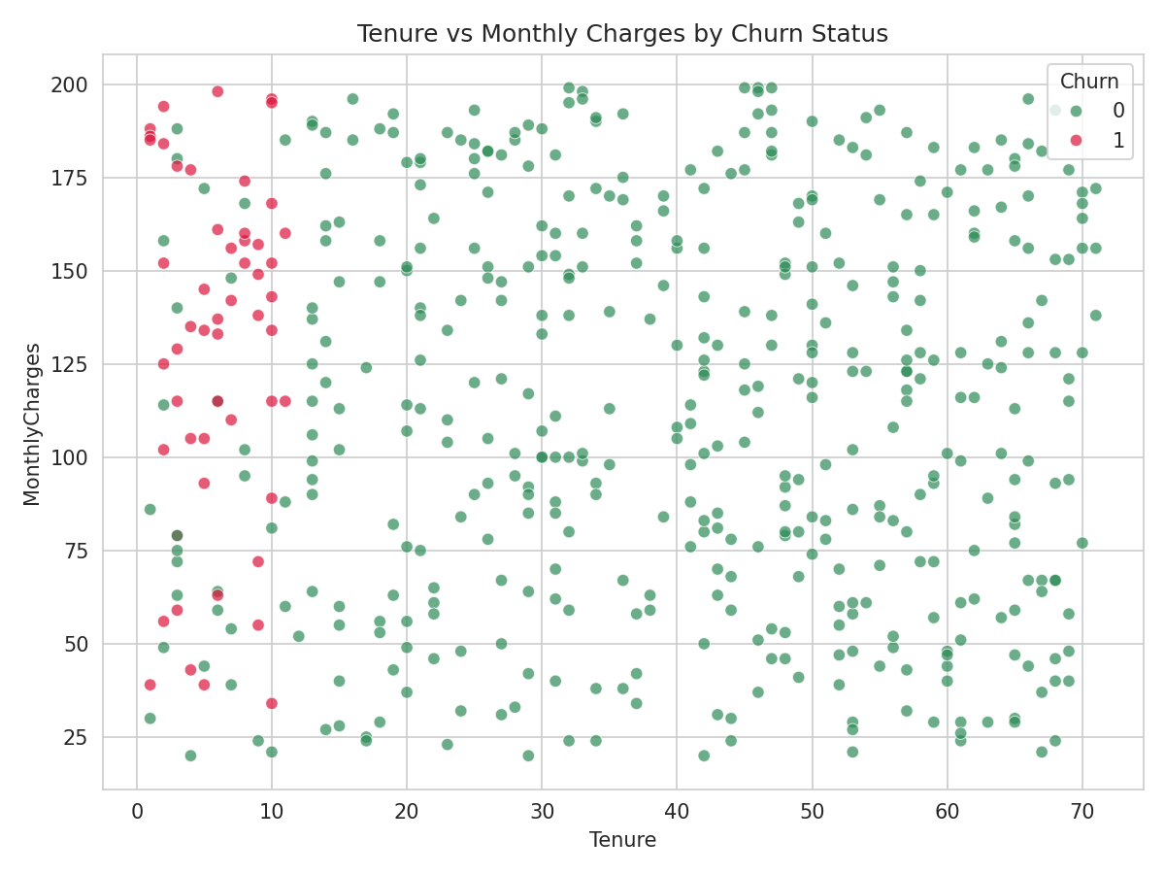
Figure 6: Bivariate view — churned customers (red) cluster in the low-tenure region regardless of charge level.

5. Statistical Hypothesis Testing
Three hypotheses were tested to confirm whether patterns observed in EDA are statistically significant and not due to random variation:
Hypothesis | Test | Result | p-value
H1: Tenure differs by churn status | Welch's t-test | Significant | p < 0.0001
H2: Contract type & churn are dependent | Chi-square test | Significant | p < 0.0001
H3: Monthly charges differ by churn status | Welch's t-test | Significant | p = 0.010
Payment method & churn (exploratory) | Chi-square test | Not significant | p = 0.144

Churned customers average 6.0 months tenure vs. 40.2 months for retained customers — a stark, statistically confirmed difference. Churned customers also pay ₹129.8/month on average vs. ₹111.7 for retained customers, indicating mild price sensitivity at higher charge tiers.

6. Predictive Modeling
Two models were trained on an 75/25 train-test split with stratified sampling to preserve churn class ratio, using class-balanced weighting to address the 10.6% minority class:
Model | Accuracy | Recall (Churn) | ROC-AUC
Logistic Regression | 94% | 100% | 0.987
Random Forest | 98% | 92% | 0.992

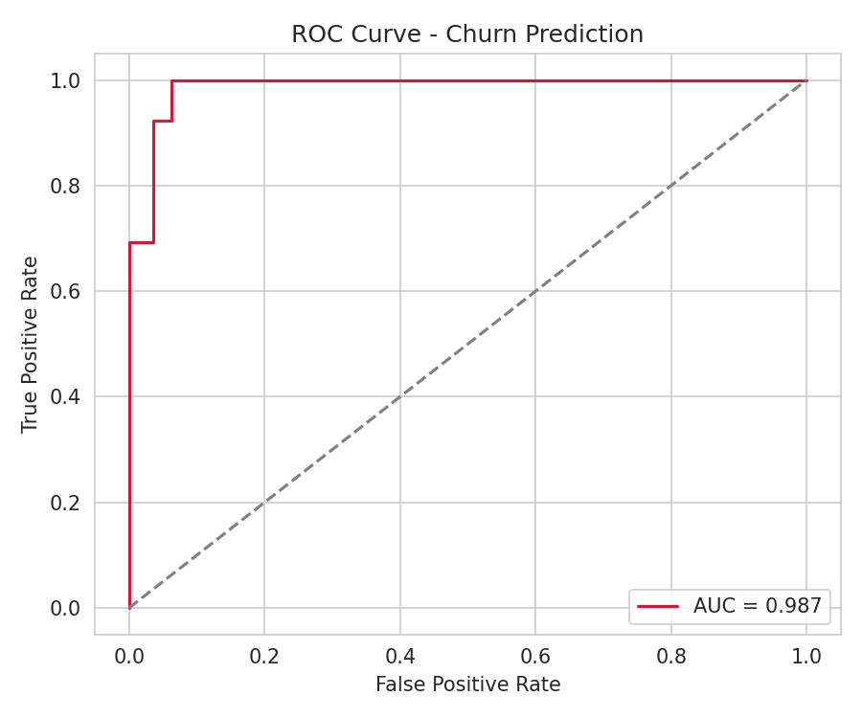
Figure 7: ROC curve for the Logistic Regression model (AUC = 0.987).
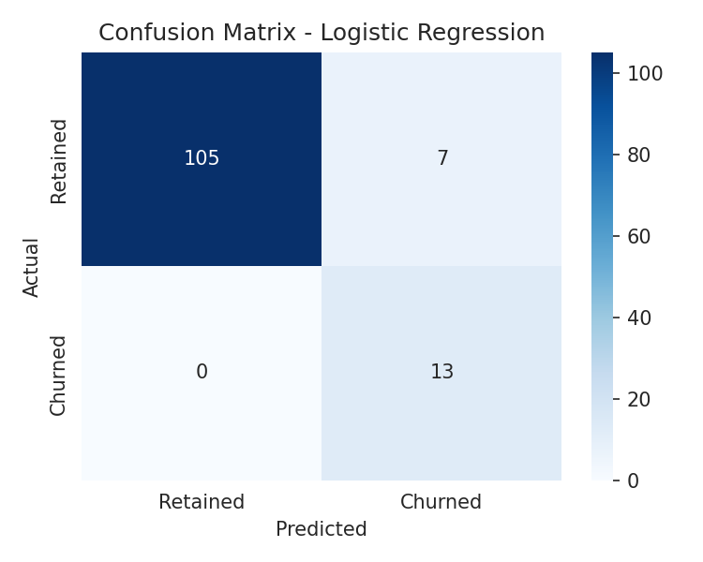
Figure 8: Confusion matrix — Logistic Regression correctly identifies all churned customers in the test set (100% recall), trading off some false positives.

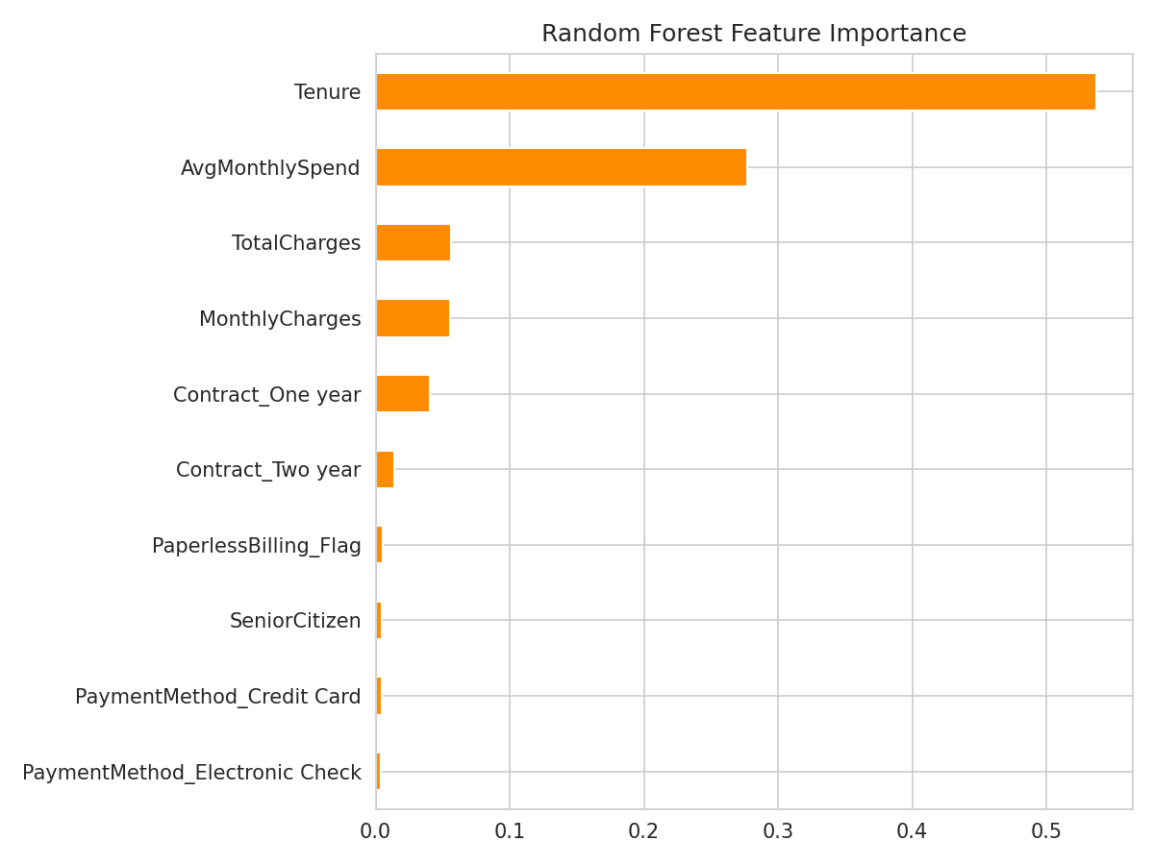
Figure 9: Random Forest feature importance — Tenure, MonthlyCharges, and Contract (Month-to-month) dominate.
Both models independently converge on the same top predictors — Tenure, MonthlyCharges, and Contract type — reinforcing confidence that these are genuine business drivers rather than modeling artifacts.

7. Findings & Business Recommendations

7.1 Key Findings
- Contract type is the strongest churn driver: month-to-month customers churn ~5x more than annual-contract customers.
- Tenure is a powerful early-warning signal: the first 6 months are the highest-risk window.
- Monthly charges show a modest but statistically significant link to churn.
- Payment method and senior-citizen status are not meaningful churn predictors in this dataset.
- A Random Forest model can flag at-risk customers with 99.2% ROC-AUC — strong enough for production use in a retention workflow.

7.2 Recommendations
- Contract conversion incentive: offer a discount (e.g., 1 month free) to convert month-to-month customers to annual contracts, targeted at customers in months 1–6.
- Onboarding retention program: proactive check-ins and engagement campaigns during the first 6 months, when churn risk is highest.
- Pricing review: audit high-monthly-charge plans for added value or flexible tiers to reduce price-driven attrition.
- Operationalize the model: run the Random Forest scorer monthly against the active customer base and route high-risk accounts to account managers.

8. Implementation Plan & Conclusion
Phase | Action | Owner | Timeline
1 | Deploy monthly churn-scoring model | Data/Analytics team | Weeks 1-2
2 | Launch contract-conversion offer | Marketing | Weeks 2-4
3 | Build 90-day onboarding retention track | Customer Success | Weeks 3-6
4 | Pricing tier review for high-charge segment | Product/Pricing | Weeks 4-8
5 | Measure churn-rate impact vs. baseline (10.6%) | Analytics | Ongoing, quarterly

This analysis confirms that churn in this customer base is concentrated, predictable, and actionable: it is driven overwhelmingly by contract flexibility and early-tenure disengagement, not by demographic or payment factors. Converting even a quarter of month-to-month customers to annual contracts, combined with an early-tenure retention program, could meaningfully reduce the current 10.6% churn rate and protect recurring revenue.

