Step 1 – Model Set-up

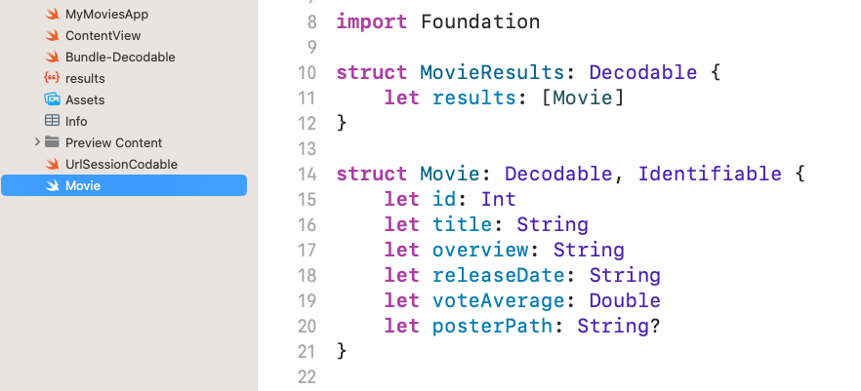

Step 2 – List View and Decoding Json

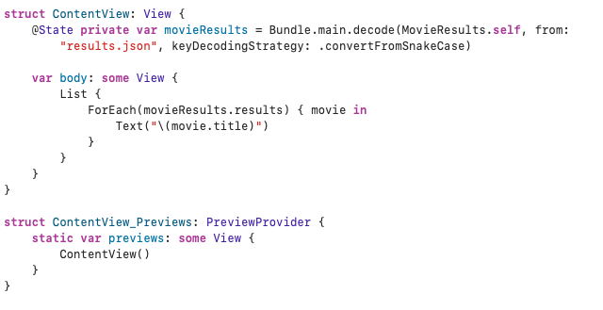

Step 3 – View layout (students don’t copy)

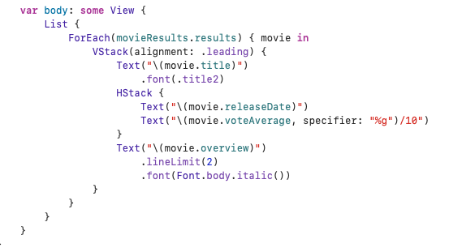

Students explore layout of their app, make it their own. Challenge: Get colour in there!

Step 4 – Images:

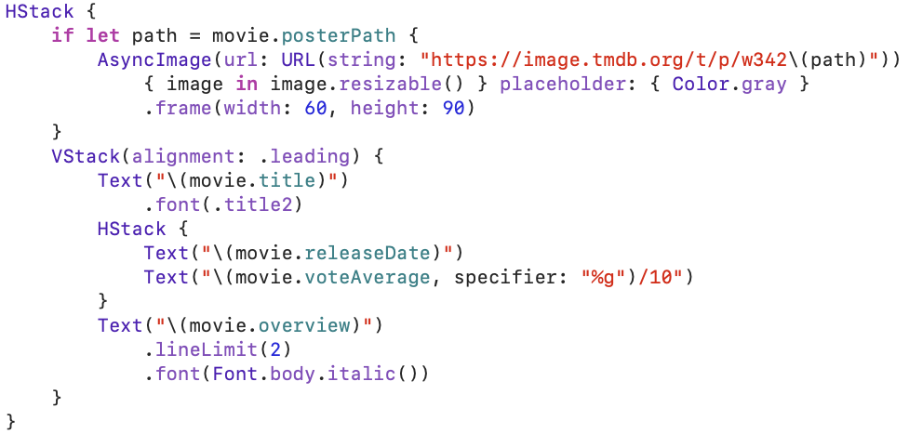

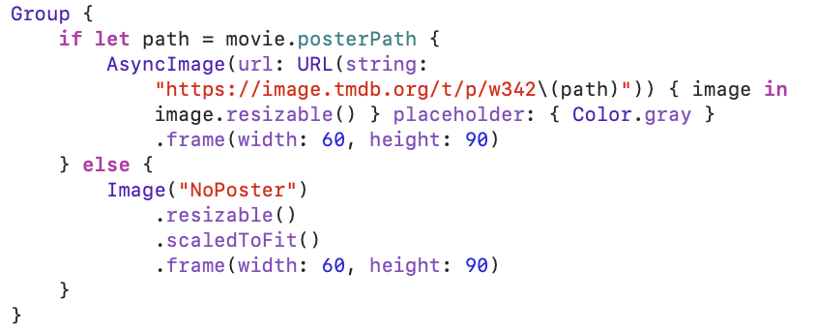

Step 5 – Web API integration

(or movie/popular)

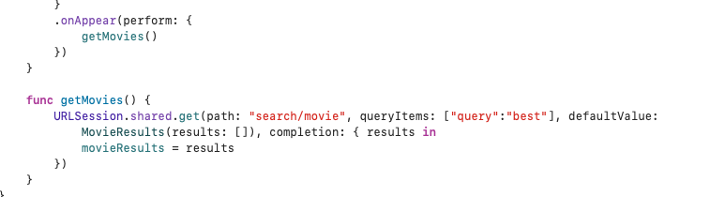



Students explore!