Some of the most interesting effects we have on MOD are the pitch shifters. With them, you can change the pitch of the sound that you are playing and use it for diffent purposes.

One voice standard pitch shifters:

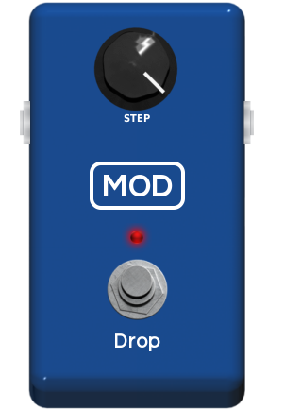 | 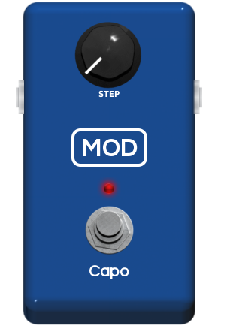 | 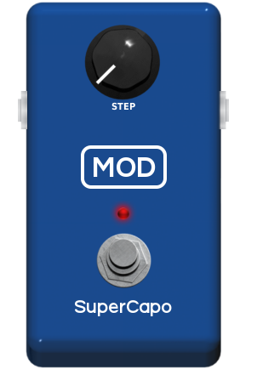

The one voice standard pitch shifters are very useful if you want to transpose your intrument tunning without doing it physically. Thus, you can use them to make your guitar sound like a bass or raise the pitch of the open strings without use a real capo, for example.
Here we have a short description of effects shown above:
- Drop: It's a polyphonic pitch shifter which can drop the pitch until 12 semitones.
- Capo: It's a polyphonic pitch shifter which can rise the pitch until 4 semitones.
- SuperCapo: It's a polyphonic pitch shifter which can rise the pitch until 24 semitones.

Two voices standard pitch shifter:

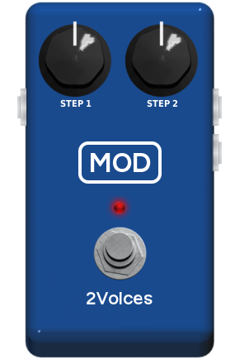
We also have a two voices polyphonic pitch shifter: the 2Voices. It basically makes the same thing that the standard pitch shifter showed before do, but with two independent outputs. You can drop the pitch until 12 semitones or rise the pitch until 24 semitones for each channel.

SuperWhammy

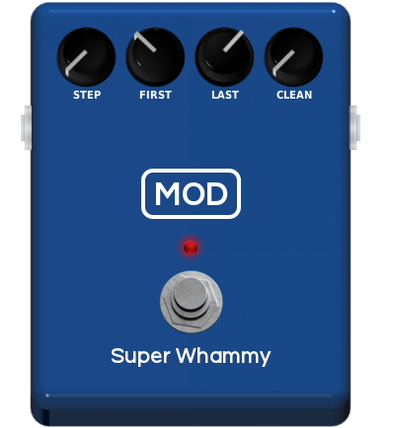

SuperWhammy is a classic whammy effect. Usually the “Exp” parameter should be addressed to an expression pedal. In this case, “First” determines de pitch shifting when the pedal is down and “Last” determines de pitch shifting when the pedal is up. Thus, when you move your expression pedal, you change the pitch continuously beetween the values configured by “First” and “Last”. You can also sum the processed sound to the clean sound, using de toogle switch “Clean”.

Harmonizers:

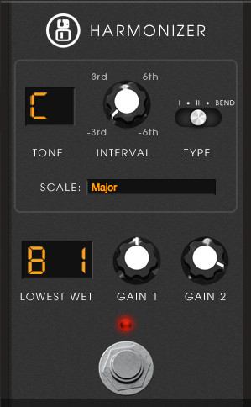

The harmonizer effects are intelligent pitch shifters, i.e., they change the pitch of the input signal according with its pitch. It means you can set an interval for the processed sound harmonize with the clean sound, for a chosen key (C, D, E...) and scale (major, minor, harmonic minor ...). You can control the volume of the clean and the wet signals using the clean gain and wet gain controls. Also, you can choose how the wet signal will behave in notes out of the scale by the control “Mode”.

