-tracking and landing prediction system most important

-GSM/GPS trackers – cheap but unreliable

-SPOT tracker -iridium satellite network. More expensive but less frequent failure

-APRS – radio transmission

-UKHAS tracker – extensive network of tracking stations across UK. Good idea to have a fixed-location listening station and another in a chase car.

UKHAS tracker – GPS receiver, radio transmitter, frequency agile and microprocessor.

Receiving station

-receiving aerial

-radio/radio scanner

-PC and software

Designing a payload

-payload needs plenty of insulation. This protects the equipment, what it lands on and also prevents cold from damaging the equipment.

-make sure things cannot move

-Keep the container light

Cameras

3 options

-stills camera

-Raspberry Pi Camera (since you are likely using it as a tracker)

-Go Pro

Landing predictor -> <http://predict.habhub.org/>

Store -> <https://store.uputronics.com/>

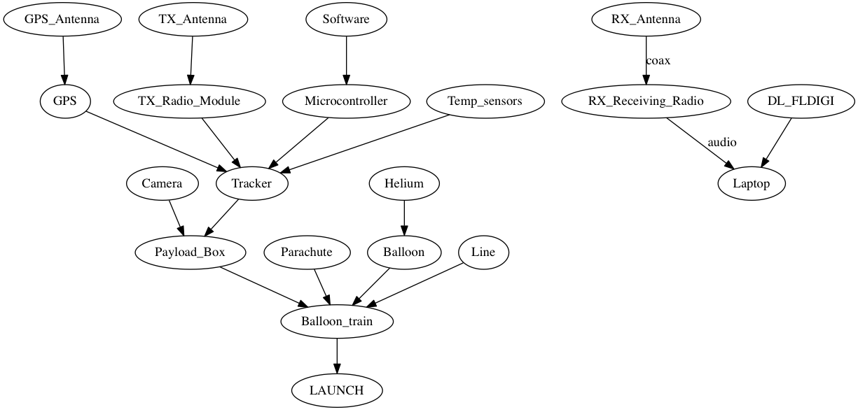

CODE - > <http://www.daveakerman.com/?p=2059>

1. During ascent, it splits the vertical range into 100 metres sections, into which it stores the latitude and longitude deltas as degrees per second.
2. Every few seconds, it runs a prediction of the landing position based on the current position, the data in that array, and an estimated descent profile that uses a simple atmospheric model (from Steve) plus default values for payload weight and parachute effectiveness.
3. During descent, the parachute effectiveness is measured, and the actual figure is used in the above calculation in (2).

So, basically, for each vertical 100m band, the software calculates the estimated time to fall through that band, and applies that to the latitude/longitude deltas measured during ascent.  It then sums all the resulting deltas for descent to 100m (typical landing altitude), adds them to the current position, and emits the result in the telemetry as the predicted landing position.

Although the habhub online map does its own landing prediction, an onboard prediction has some advantages:

* It has more descent data to work with, so can more accurately profile the parachute performance
* It is using more recent wind data, measured during ascent
* Ground chase crews can see the landing prediction without having internet access

There are disadvantages too.  Because it uses wind data from the ascent, if the wind has changed (due to the landing being in a different area, or because the wind is changing with time) then those factors will introduce errors.

Also, I have a suspicion that the live map consistently overestimates the horizontal distance travelled by a descending flight.  This can be seen by watching its landing prediction which, as the flight descends, will move back towards the actual flight position.

So I was keen to see how well the onboard prediction fairs against the habhub prediction.  Steve Randall was also interested in this, and was kind enough to record the descent on his screen.  He has sped up and annotated the video which you can see here:

Noise at low altitudes is less important, as it’s being applied to a short remaining distance to fall, but the noise higher – between say 5000 and 15,000m – is more important.

For my next flight, I’ll apply some filtering to hopefully make the prediction more consistently accurate.  I have all the GPS data from this flight and I can run that back into the tracker code to test how well it would have worked on that last flight.

QUESTIONS TO ASK:

**-over how great a distance can one receive telemetry from the balloon? How far does the balloon normally land from the launch site in general?**

-maximum range is ~200 km beyond which you would terminate flight

**-What, if anything, can affect the quality of the signal?**

-out-of-band interference. Low potential for interference.

**-How often does the balloon transmit data and in what format is it normally encoded?**

RTTY – ASCII format. 300 chars per second. Checksum type algorithm making suremessages are valid.

**-What algorithm is used to predict the landing site? -Just apply kinematic equations and model wind using data from ascent.**

Layers of wind

predict.habhub.org

rivers ses act

tracker.habhub.org

Carrier frequency moving issue – frequency changes over time – find way to address this.

SDR – software defined radio – uSB thing

Tuner software -gqrx (on MAC) – 434.25 MHz – USB modulation

To join tuner and decoding software – virtual patch cable. jack pilot

Decoding software – dl-fldigi - translates into RTTY

1. Start Jack Pilot. click start.

2. Open gqrx – type in 434.25 and USB modulation

3. Click the IO thing. Input device: FUNcube dongle . Set output device to Jack Router

4. Press Play. You should be hearing raipd, intermittent beeping

5. Zoom in until the grey passband is over the two train tracks

6. Open dl-fldigi. Go back to jackpilot and click on routing

7. click on gqrx on send column. Double click on dl-fldigi in receive. If nothing is printing, align the train tracks to the yellow cursor things.

8. DL-Client – configure. ALL PAYLOADS (TESTING). Select YERRA_TEST_11 or latest version

-green flash at the top represents a valid message.