3/10/2026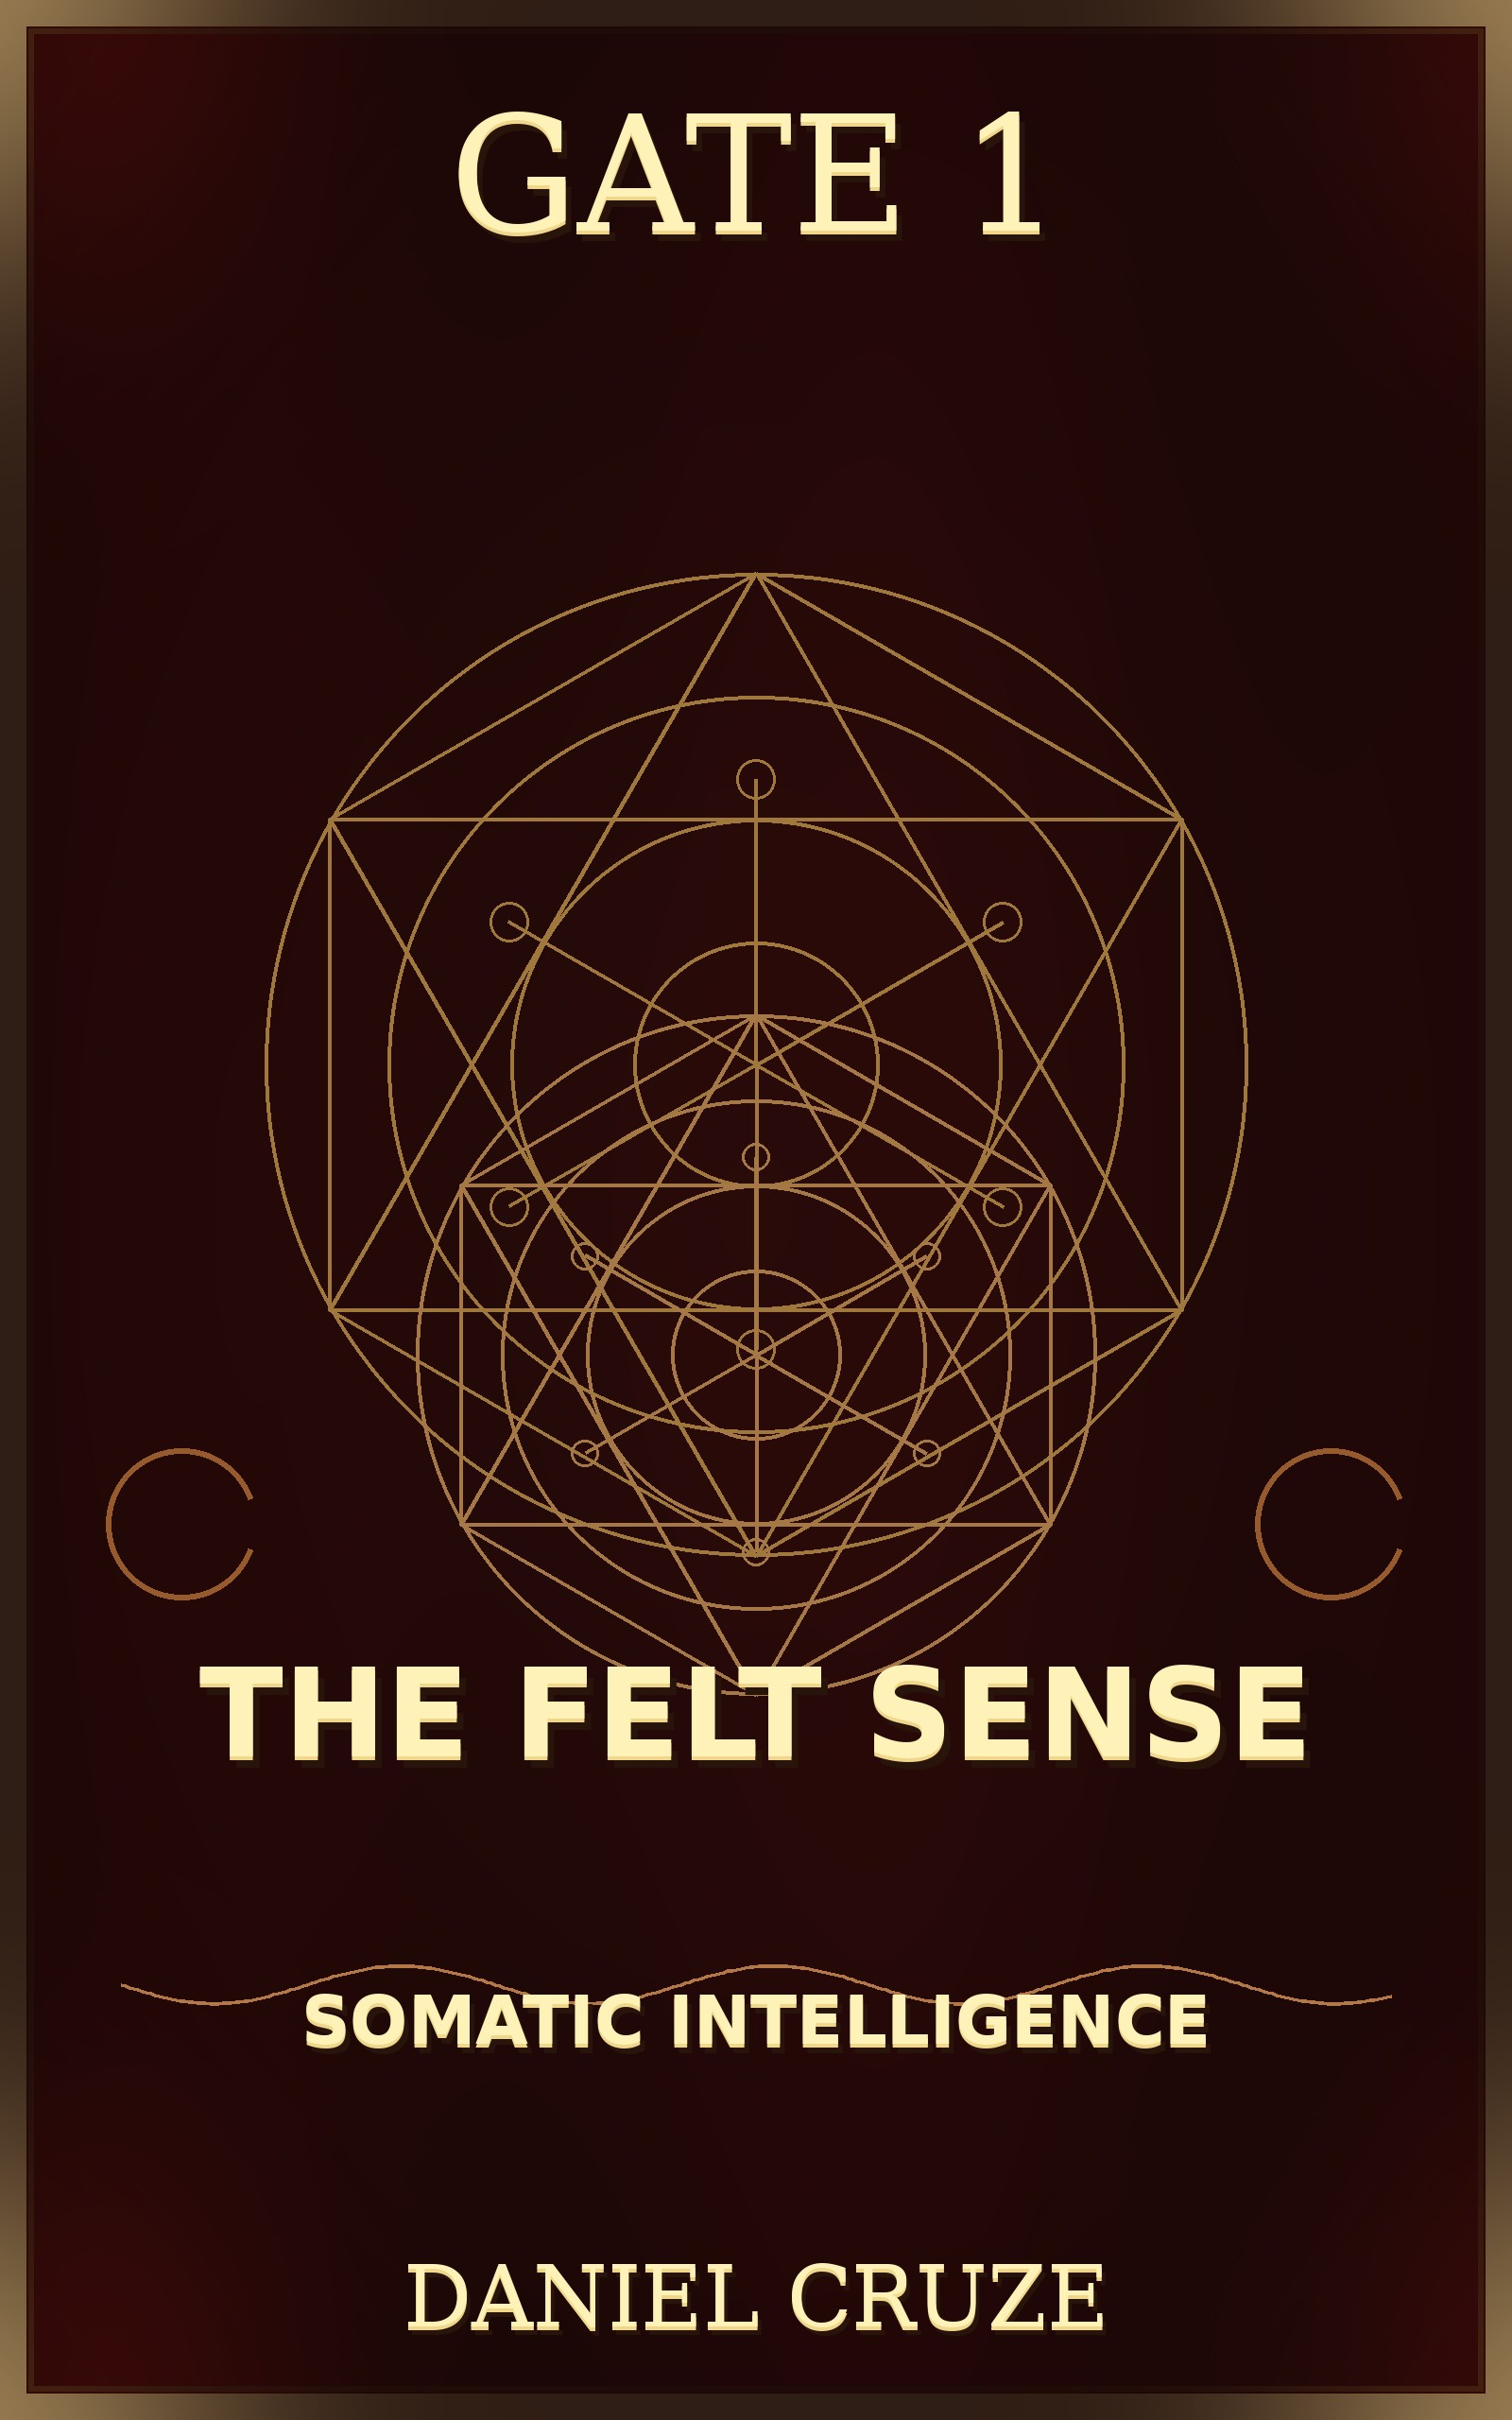

The Felt Sense: Somatic Intelligence
Digital Edition
Daniel Cruze
Published by The 33rd House
By Daniel Cruze

COPYRIGHT & PUBLICATION INFORMATION
Title: The Felt Sense: Somatic Intelligence Author: Daniel Cruze Publisher: The 33rd House Copyright © 2026 by The Cruze Estate Trust. All rights reserved.
No part of this publication may be reproduced, stored in a retrieval system, or transmitted in any form or by any means, electronic, mechanical, photocopying, recording, or otherwise, without the prior written permission of the publisher.
ISBN: 978-1-XXXXX-1-6 (PDF Edition) First Edition: January 2026

TABLE OF CONTENTS
- Foreword: The Body Knows
- Introduction: What Is Somatic Intelligence?
- Chapter 1: The Wisdom of the Body
- Chapter 2: The Gut Brain
- Chapter 3: The Heart Brain
- Chapter 4: Trauma and the Body
- Chapter 5: Developing Somatic Awareness
- Chapter 6: The Language of Sensation
- Chapter 7: Somatic Practices for Healing
- Chapter 8: Living from Somatic Wisdom
- Conclusion: The Intelligent Body
- Resources & Practice Guide

FOREWORD: THE BODY KNOWS
We have been taught to trust our minds. We have been taught that thinking is the highest form of intelligence. We have been taught that the body is separate from the mind, that the body is something to be controlled and disciplined.
But this is a profound mistake. The body is not separate from the mind. The body is not inferior to the mind. The body is intelligent. The body knows things that the mind does not know.
Your body knows when something is safe and when it is dangerous. Your body knows when someone is trustworthy and when they are not. Your body knows what you need and what you do not need. Your body knows when you are out of alignment with your truth.
But we have learned to ignore these signals. We have learned to override the body's wisdom with our thoughts. We have learned to push through pain, to ignore our intuition, to deny our feelings.
The cost of this disconnection is immense. We make decisions that are not aligned with our truth. We stay in situations that are harmful to us. We ignore the signals that our body is sending us. We become disconnected from ourselves.
The practice of developing somatic intelligence is the practice of reconnecting with the body's wisdom. It is the practice of learning to listen to what your body is telling you. It is the practice of honoring the body as a source of deep knowing.
INTRODUCTION: WHAT IS SOMATIC INTELLIGENCE?
Somatic intelligence is the ability to perceive, understand, and work with the information that your body is constantly providing.
Your body is always communicating. It communicates through sensations: tingling, warmth, coolness, tension, relaxation, pain, pleasure. It communicates through emotions: joy, sadness, anger, fear, love. It communicates through intuition: a gut feeling, a sense of knowing, a felt sense of rightness or wrongness.
Somatic intelligence is the ability to access this information and use it to guide your decisions and your life.
Most people are disconnected from their somatic intelligence. They live primarily in their heads, in their thoughts. They ignore or override the signals their body is sending. They make decisions based on logic alone, without consulting their body's wisdom.
But when you develop somatic intelligence, you gain access to a source of wisdom that is deeper than thinking. You gain access to your intuition, your instinct, your inner knowing. You become able to navigate life with more clarity, more authenticity, more wisdom.
Somatic intelligence is not mystical or supernatural. It is grounded in neuroscience. Your body has its own nervous system, its own brain-like structures, its own way of processing information. Your body knows things before your conscious mind knows them.

CHAPTER 1: THE WISDOM OF THE BODY
The body is not just a vehicle for the mind. The body is a source of wisdom in its own right.
The Body Knows Safety: Your body has an innate ability to sense whether a situation is safe or dangerous. This is not based on logical analysis. It is based on subtle cues: tone of voice, body language, energy. Your body picks up on these cues before your conscious mind does.
When you are in a situation that feels unsafe, even if you cannot logically explain why, your body is sending you a signal. It is telling you to be cautious, to pay attention, to protect yourself.
The Body Knows Truth: Your body knows when something is true and when it is false. When someone is lying to you, your body often knows before your mind does. You may feel a tightness in your chest, a knot in your stomach, a sense of unease.
When something is true, your body often feels a sense of openness, of relaxation, of rightness.
The Body Knows What It Needs: Your body knows what it needs to be healthy and whole. It knows when it needs rest, when it needs movement, when it needs nourishment, when it needs connection. But we often override these signals, pushing ourselves beyond our limits, ignoring our body's requests.
The Body Knows Your Truth: Your body knows when you are being authentic and when you are being false. When you are living in alignment with your truth, your body feels open, energized, alive. When you are living out of alignment with your truth, your body feels contracted, tired, dead.
The practice of somatic intelligence is the practice of learning to listen to these signals and honor them.

CHAPTER 2: THE GUT BRAIN
Modern neuroscience has discovered that the gut has its own nervous system, so complex and sophisticated that it is sometimes called "the second brain."
The enteric nervous system (the nervous system of the gut) contains about 500 million neurons. It is connected to the central nervous system (the brain and spinal cord) through the vagus nerve. This connection allows the gut and the brain to communicate constantly.
The gut processes information and makes decisions independently of the brain. The gut can sense the emotional state of the person. The gut can sense whether a situation is safe or dangerous. The gut can sense whether food is nourishing or toxic.
This is why we have gut feelings. This is why we say we have a "gut instinct." The gut is literally sensing information and communicating it to the brain.
When you feel a knot in your stomach, your gut is telling you something. When you feel butterflies in your stomach, your gut is telling you something. When you feel a sense of ease in your stomach, your gut is telling you something.
The practice of developing somatic intelligence includes learning to listen to your gut. It includes developing trust in your gut feelings. It includes honoring your gut's wisdom.

Practice: Gut Awareness
Throughout your day, bring awareness to your gut. Notice how your gut feels in different situations. Notice how it feels when you are with certain people. Notice how it feels when you are making certain decisions. Notice how it feels when you eat certain foods.
Over time, you will begin to recognize the patterns. You will begin to understand what your gut is telling you. You will begin to trust your gut wisdom.

CHAPTER 3: THE HEART BRAIN
The heart also has its own nervous system. The heart contains about 40,000 neurons, making it a brain in its own right.
The heart is not just a pump. The heart is a sensing organ. The heart can sense emotions, intentions, and energy. The heart can sense whether someone is trustworthy. The heart can sense whether a situation is aligned with your values.
The heart is the center of emotional intelligence. The heart is where love, compassion, and wisdom reside. The heart is where you know what truly matters to you.
When you feel your heart opening, your heart is telling you that something is good, that something is aligned with your truth. When you feel your heart closing, your heart is telling you that something is not aligned with your truth.
The practice of developing somatic intelligence includes learning to listen to your heart. It includes developing trust in your heart's wisdom. It includes honoring your heart as a source of deep knowing.

Practice: Heart Awareness
Throughout your day, bring awareness to your heart. Notice how your heart feels in different situations. Notice how it feels when you are with certain people. Notice how it feels when you are making certain decisions. Notice how it feels when you are expressing love or receiving love.
Over time, you will begin to recognize the patterns. You will begin to understand what your heart is telling you. You will begin to trust your heart wisdom.

CHAPTER 4: TRAUMA AND THE BODY
Trauma is stored in the body. When you experience a traumatic event, your body goes into a survival response: fight, flight, or freeze. The nervous system becomes dysregulated. The body holds onto the trauma, even after the event has passed.
This is why trauma survivors often have physical symptoms: tension, pain, numbness, hypervigilance. This is why trauma survivors often feel disconnected from their bodies.
The good news is that the body can heal. The body has an innate capacity to process and release trauma. But this healing requires that you reconnect with your body, that you become aware of the sensations and emotions that are held in your body, that you allow the body to complete the survival response that was interrupted during the trauma.
The practice of somatic therapy is the practice of helping the body process and release trauma. This is done through gentle movement, breathing, and awareness.

Practice: Trauma Release
If you have experienced trauma, work with a somatic therapist or trauma-informed practitioner. They can guide you through the process of releasing trauma from your body.
If you are working with trauma on your own, practice gentle movement and breathing.
Shake your body gently. Make sounds. Allow your body to express what it needs to express. Be patient and compassionate with yourself.

CHAPTER 5: DEVELOPING SOMATIC AWARENESS
Somatic awareness is the ability to perceive the sensations in your body. This is the foundation of somatic intelligence.
Most people are not very somatically aware. They are disconnected from their bodies. They do not notice the subtle sensations that their body is constantly providing.
The practice of developing somatic awareness involves bringing your attention to your body and noticing the sensations that are present.

Practice: Body Scan
- Lie on your back in a comfortable position
- Bring your attention to the top of your head
- Notice any sensations: tingling, warmth, coolness, tension, relaxation, numbness
- Slowly move your attention down through your body
- Notice the sensations in your face, your neck, your shoulders, your arms, your hands
- Notice the sensations in your chest, your heart, your belly, your sides
- Notice the sensations in your lower back, your hips, your legs, your feet
- Take 20-30 minutes for this practice
- Do not try to change anything; simply notice
Over time, your somatic awareness will develop. You will become more sensitive to the subtle sensations in your body.

Practice: Sensation Naming
As you become aware of sensations in your body, practice naming them. Instead of just noticing "tension," notice "a tight, pulling sensation in my shoulders." Instead of just noticing "pain," notice "a sharp, stabbing sensation in my lower back."
The more specifically you can name the sensation, the more information you can extract from it.

CHAPTER 6: THE LANGUAGE OF SENSATION
Your body speaks a language of sensation. Learning to understand this language is the key to somatic intelligence.
Tension often indicates that you are holding onto something: an emotion, a belief, a pattern. Tension is your body's way of protecting you or controlling something.
Relaxation indicates that you feel safe. Relaxation is your body's way of letting go, of trusting, of allowing.
Warmth often indicates openness, connection, love, or activation.
Coolness often indicates withdrawal, protection, or a need for space.
Tingling often indicates activation, awakening, or energy moving.
Numbness often indicates dissociation, disconnection, or a protective response to overwhelming sensation.
Pain is your body's way of getting your attention. Pain indicates that something needs to change. Pain can indicate physical injury, but it can also indicate emotional pain, unmet needs, or misalignment with your truth.
Pleasure indicates that something is good, that something is nourishing, that something is aligned with your wellbeing.

Practice: Sensation Dialogue
When you notice a strong sensation in your body, practice dialoguing with it. Ask the sensation: "What are you trying to tell me? What do you need? What are you protecting me from?"
Listen to the answer that comes. Often, the answer will come as a knowing, an image, a memory, or an emotion.

CHAPTER 7: SOMATIC PRACTICES FOR HEALING
There are many somatic practices that can help you heal and develop somatic intelligence.

Shaking and Tremoring
Gentle shaking and tremoring releases tension and trauma from the body. Stand with your knees slightly bent and gently shake your whole body. Allow your body to tremble. Make sounds. Continue for 5-10 minutes.

Conscious Movement
Move your body with full awareness. Notice how your body wants to move. Allow your body to express itself through movement. Dance, stretch, or move in any way that feels right.

Breathwork
Use your breath to regulate your nervous system. Slow, deep breathing activates the parasympathetic nervous system. Rapid breathing activates the sympathetic nervous system. Use your breath consciously to shift your state.

Sound
Use sound to release emotion and energy. Make sounds: sighing, moaning, humming, toning. Allow your voice to express what your body needs to express.

Touch
Touch yourself with awareness and compassion. Massage your body. Hold yourself. Notice how your body responds to touch.

CHAPTER 8: LIVING FROM SOMATIC WISDOM
The ultimate practice is to live from somatic wisdom. This means making decisions based on what your body is telling you, not just what your mind is telling you.

Decision Making
When you are facing a decision, bring awareness to your body. Notice how your body feels about each option. Does your body feel open or closed? Does your body feel energized or depleted? Trust what your body is telling you.

Relationships
In relationships, bring awareness to your body. Notice how your body feels around certain people. Notice how your body feels when you are being authentic. Trust your body's signals about who is safe and who is not.

Work
In your work, bring awareness to your body. Notice how your body feels when you are doing work that is aligned with your purpose. Notice how your body feels when you are doing work that is not aligned. Honor your body's signals.

Rest and Movement
Listen to your body's signals about what it needs. If your body needs rest, rest. If your body needs movement, move. Do not override your body's signals.

CONCLUSION: THE INTELLIGENT BODY
Your body is intelligent. Your body is wise. Your body is not something to be controlled or disciplined. Your body is a source of deep knowing.
The practice of developing somatic intelligence is the practice of reconnecting with this wisdom. It is the practice of learning to listen to your body. It is the practice of honoring your body as a guide.
When you develop somatic intelligence, you gain access to a source of wisdom that is deeper than thinking. You become able to navigate life with more clarity, more authenticity, more wisdom. You become fully alive.

RESOURCES & PRACTICE GUIDE
Daily Somatic Practices:
- Body scan meditation (10-20 minutes)
- Sensation awareness throughout the day
- Conscious movement or stretching (10-15 minutes)
- Breathwork (5-10 minutes)
Weekly Somatic Practices:
- Yoga or somatic movement class
- Massage or self-massage
- Shaking and tremoring (10-15 minutes)
- Sound practice (5-10 minutes)
Working with a Practitioner:
- Somatic therapy
- Trauma-informed therapy
- Massage therapy
- Yoga therapy
- Movement therapy
Recommended Reading:
- The Body Keeps the Score by Bessel van der Kolk
- Waking the Tiger by Peter Levine
- Come as You Are by Emily Nagoski
- The Wisdom of the Body by Ronald Alexander
The 33rd House *Awakening Consciousness, One Moment at a Time*
Copyright © 2026 by The Cruze Estate Trust All Rights Reserved
*This book is dedicated to all who are learning to listen to their body's wisdom, and to the healing of our disconnection from our somatic intelligence.*

