FROSTY WHITEPAPER

V0.1

***Abstract:***

Some artists require materials like paints and brushes to create art. Today, many others also use modern means of exploring creativity like computers, video technologies and televisions. The ***DIGITAL ART***. Digital art is an artistic work or practice that uses digital technology as part of the creative or presentation process.

As a relatively new market segment, Digital Art still lacks the capacity to generate sustainable and consistent value for the Artists and Developers that are involved in manufacturing these digital assets. Creative artists cannot produce Digital Art assets, and then seamlessly transferred them into native gaming, VR, and other content environments. Not without overcoming substantial legacy technical and business constraints first.

***FROSTY*** implements an optimized architecture for creating NFTs giving the power to verified artists, allowing them to create and deploy digital arts directly into any media layer (Gaming, VR, and other live 3D content environments).

***FROSTY*** vision also aim to relate the dots by somehow connecting the virtual with reality by bringing digital art from virtual to physical enabling physical Blockchain art authenticity to live.

***Industry Insights:***

***Tradition Artwork Trade vs Blockchain Artwork Trade:***

NFTs open the door to immense possibilities for artists to get more commissions and increase the value of their work. What makes an NFT valuable is its exclusivity and scarcity for being the only one in the world. We believe it as the solution to plagiarism. Users will always have the ability to recognize the original owner for an Artwork or asset.

In the conventional artwork trade, artists receive one-time payment when their artwork is sold to buyers. When the buyer sells the artwork to another buyer, the original artist does not get the cut. NFT allows the artists to receive a commission whenever we trade their NFT artwork due to Blockchain authenticity and the open ledger record.

The market for non-fungible tokens (NFTs) surged to new highs in the second quarter of 2021, with $2.5bn in sales compared to just $13.7m in the first half of 2020

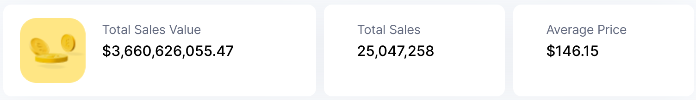

Figure 1 CoinMarketCap Collectible Volume August 2021

Digital art transformed human expressions by enhancing creativity. The new possibilities it gave now limitless. There have been over 2517 graduates in digital arts in 2019 and still growing by 13.2$ and over 2.2 million people working in the digital arts.

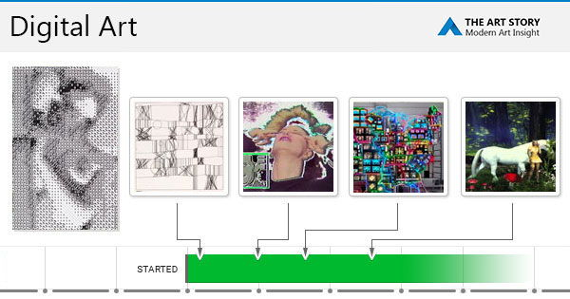

Figure 2 Digital Art evolution (2020)

Gaming, VR:

Virtual Reality (VR) is a simulated experience similar to or completely different from the real world. VR aims to create a sensory experience for the user, sometimes including sight, touch, hearing, smell, or even taste. The industry as a whole is growing at a fast pace, with the global VR market size projected to increase from less than five billion U.S. dollars in 2021 to more than 12 billion U.S dollars by 2024.

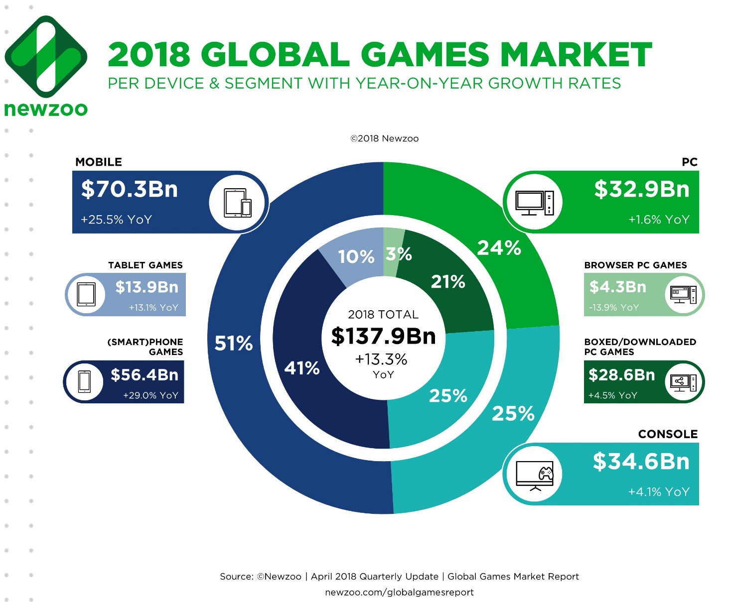

Figure 3 Global Media Market (2018)

The unstoppable pull that is continuing to lead the future of entertainment has rapidly scaled the global market size of gaming and VR to around $180bn USD as of 2020, almost double from the recorded in 2016 at around $100bn USD.

The games market is expected to continue growing in the coming years, exceeding $200 billion at the end of 2023. By then, Newzoo forecasts the games market will grow at a 7.2% compound annual growth rate (CAGR) between 2019 and 2023 to reach $204.6 billion.

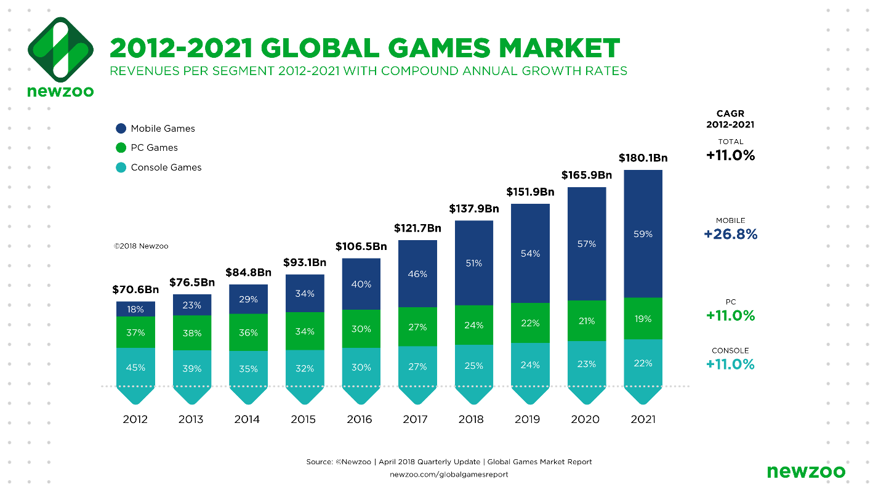

Figure 4 Newzoo 2012-2021 Global Games Market

***ART:***

The global market size for art sales is currently estimated at almost $50.1bn USD and although digital art is still a relatively new market segment, it is already growing in share, with games like The SandboxGame by importing your NFT into an online ART gallery.

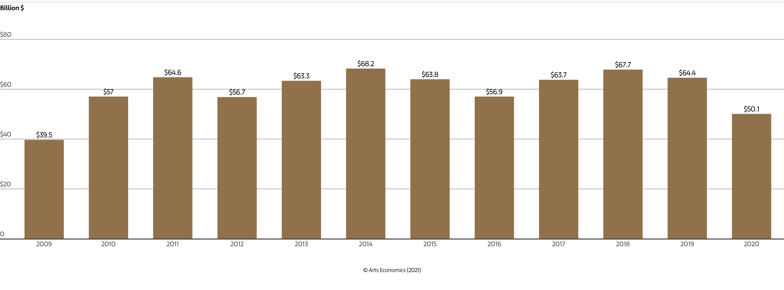

Figure 5 Sales in the Global Art Market 2009–2020

***Motivation and Vision***

Our world today is undeniably digital. In our technological society, everything is changing so fast that we are almost unrecognizable from 20 years ago. Throughout this time, there has been an undeniable and obvious in hindsight, innovation curve in the advancement of gaming and VR.

Each year these digital worlds are becoming more and more photorealistic, pushing our trajectory of technological ubiquity more towards where there is no meaningful difference between the digital and the physical, and creating a compelling argument for a future that is driven by native digital economies. Built around entire virtual world communities and ecosystems comprised of most of humanity, where most will never meet face to face.

Blockchain decentralization play an important role concerning self-expression. By allowing to form customizable, engaging digital experiences that allow us to connect with others and re-create our identity. Agency, individualized identity and self-expression are core human factors. When properly self-expressing in a digital environment, the benefits we receive are so fundamental.

Art has been a core industry for thousands of years and provide a distinct method and channel of communication. Enabling hyper-realistic digital art through both technical and distributive means will unlock enormous new value and opportunities.

Our vision is to enable the development of new digital economies of scale that empower true digital self-expression. In order to achieve meaningful success, it requires us to focus directly on building up the infrastructure for the growth and maturation of the digital art industry.

We are helping birth new tools for the democratization of the digital art supply chain, bridging a global open source ethos to art innovation.

***Protocol Architecture:***

We are bringing to life our very first Digital art infrastructure system -- a multi-layered blueprint that is built on top of the *Binance Chain* Network and levering several ERC Protocols Standards. The result is a streamlined and comprehensive digital content supply chain, concentrated on optimization of content creation and providing access channels for promoting greater creative supply.

Non Fungible Tokens (NFT) are a type of digital ownership certificate that live on the Blockchain. By nature, they are not identical; rather they are able to verify the full life cycle value of an asset by providing an unbreakable link between the original creator and current holder. Bringing native NFT use cases to digital art enables a huge leap for the industry in terms of solving the present pain within digital ownership, open source innovation and multi-platform distribution across virtual environments.

Inside FROSTY supply chain, NFTs give artists a scalable digital distribution channel that enables their assets to be directly verified and authenticated on-chain, backed by immutable ownership. We incorporate diverse degrees of rarity and exclusivity for direct influence on supply and demand. The supply chain architecture reinforces new access channels for greater creative supply.

***Token Economic Model***

$FRST is the native ERC-20 token for the FROSTY platform. Intrinsically incorporated throughout the protocol’s architecture, serving to further incentivize utility and application in the auction platform. $FRST is the gas that ties together a triad of interdependence between Artists, Developers and Collectors in a world that is merging the digital and real.

We present a platform within our Digital Economy Ecosystem where $FRST utility allows artists to feature their games and/or digital art.

Investors receive $FRST as the prize rewards for early integration by Staking their Digital Art NFT into FROSTY Platform. Collectors use $FRST to bid/buy Digital art as a transparent ledger of activity.

$FRST is thus creating a value driver for the users in our ecosystem, creating new streams for democratizing access where every users is able to have the opportunity to make a living through playing on the Blockchain network.

***Token Distribution:***

Both Genesis FRST NFT holders and $FRST token will serve as part of the governance of the platforms. Holders will be eligible to receive a portion of the platform’s revenue and vote on proposals across monetary and treasury policies, protocol development. This revenue redistribution amount will be different across Genesis FRST NFT and $FRST holders, being dependent on the amount of BNB contributed for the Genesis FRST NFT during the Genesis Period and also the amount of $FRST held.

***Genesis FRST NFT and $FRST holders are eligible to receive a portion of the revenue.***

* Revenue from the marketplace protocol fee
* Rewards from ERC-20 $FRST Staking Utility.

***Note:*** *This revenue redistribution amount will be different across Genesis FRST NFT and $FRST holders, being dependent on the amount of BNB contributed for the Genesis FRST NFT during the Genesis Period and also the amount of $FRST held.*

All Genesis NFT and $FRST holders are able to enjoy FRSOTY Rewards.

All Genesis FRST NFT and $FRST holders can vote on monetary policies, security policies and R&D.

***Genesis FRST NFT Distribution:***

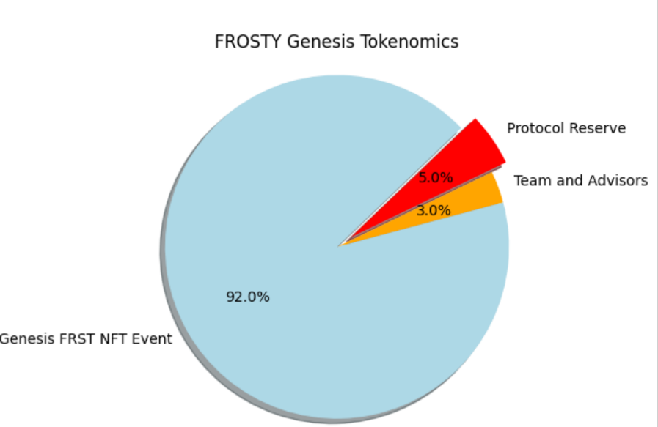

***$FRST Distribution:***

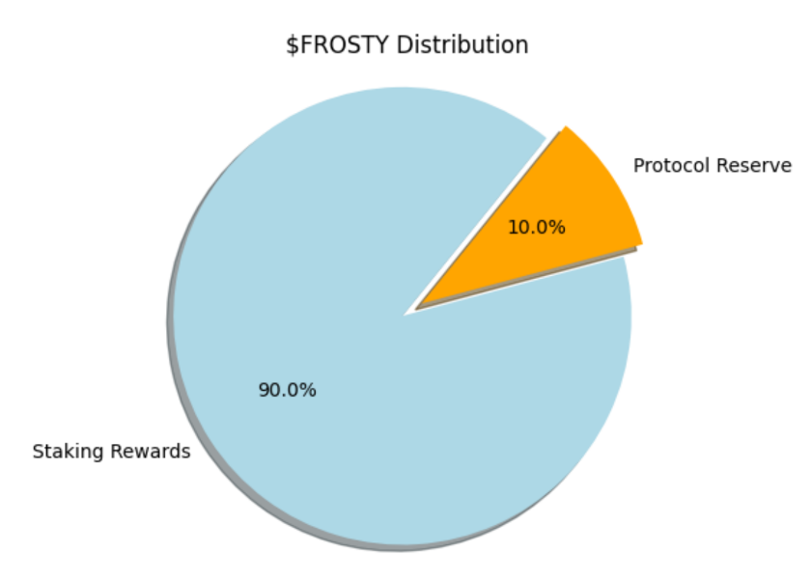

*$FRST is also the ecosystem governance token, where holders are able to maintain an active stake and vote across categories from R&D proposals, future roadmaps, monetary policies. We are on a path* ***towards progressive decentralization****.*

*Max Supply: 10 000 FRST*

*Staking rewards: 88%*

*Initial Pancakeswap Liquidity: 2%*

*Team: 0%*

*Note: 200 $FRST from the staking rewards allocation will be initialized to the Pancakeswap FRST/BNB liquidity pool.*